**The Opening of China**

The Opium Wars and Changing Relations Between China and the West

From: Sites of Encounter: Empires, 2012

**History Standards: 10.4.1**

Describe the rise of industrial economies and their link to imperialism and colonialism (e.g., the role played by national security and strategic advantage; moral issues raised by the search for national hegemony, Social Darwinism, and the missionary impulse; material issues such as land, resources, and technology).

**CCSS Standards: Reading, Grade 9-10**

1. Cite specific textual evidence to support analysis of primary and secondary sources, attending to such features as the date and origin of the information.

2. Determine the central ideas or information of a primary or secondary source; provide an accurate summary of how key events or ideas develop over the course of the text.

3. Analyze in detail a series of events described in a text; determine whether earlier events caused later ones or simply preceded them.

4. Determine the meaning of words and phrases as they are used in a text, including vocabulary describing political, social, or economic aspects of history/social studies.

9. Compare and contrast treatments of the same topic in several primary and secondary sources.

**Writing, Grades 9-10**

1. Write arguments focused on discipline-specific content.

2. Write informative/explanatory texts, including the narration of historical events, scientific procedures/ experiments, or technical processes.

9. Draw evidence from informational texts to support analysis, reflection, and research.

**Guiding Question:**

How did the introduction of opium change relations between China and the West?

**Overview of Lesson:**

***The Opening of China***

**Visualizing Cultures Website**: <http://ocw.mit.edu/ans7870/21f/21f.027/home/index.html>

***\*The following readings were taken from essays on the Visualizing Cultures website. As you read, answer the questions on the student handout.***

**Trade with the West**

From ancient times, China had always traded with the outside world. Camel caravans crossing the silk routes of Central Eurasia carried textiles, tea, and porcelain to the Middle East and Europe since the first century BCE, and a trickle of adventurous priests and travelers had followed these routes eastward to China. Beginning in the 16th century, however, large numbers of ordinary Western and Chinese people met each other in the great trading cities of South China, doing business across a wide cultural divide. Here the large empires of East and West, with their ships, guns, commercial goods, and officials, had to negotiate acceptable rules to support profitable trade. The leasing of Macau to the Portuguese in 1557 began the system of regulated trade on the coast which evolved into the **Canton trade system** of the 18th and early 19th centuries. Under this system, the Chinese state restricted the access of Westerners to the interior of China, but allowed them to conduct trade under the name of “tribute,” or gifts to the emperor, which he gratefully returned. This system of commercial exchange lasted from the 18th century until 1842, when China’s loss in the Opium War caused its abandonment.

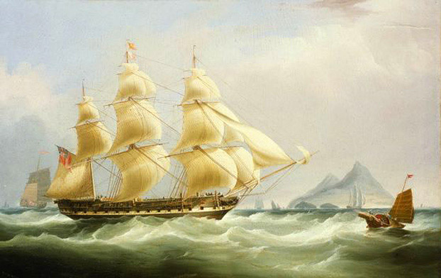Traders sailing to China from the West expected great profits but risked great dangers. Typhoons, pirates, and foreign warships could easily destroy a merchant’s career, but those who succeeded made huge profits, as much as 400 to 500 percent on one voyage. Shipbuilders improved the stability and size of the merchant ships in order to enhance the prospects of the China trade. The huge East Indiamen carried the bulk goods on which the trade was based—tea and textiles. The fast clippers, first designed in the United States and copied by others, carried the freshest teas home and smuggled the valuable illegal opium cargoes

**Image**: “The East Indiaman Asia,” 1836 by William John Huggins; National Maritime Museum [cwSP_1836_nmm_BHC3209]

past Chinese officials. Steamships finally destroyed the Chinese restraints on foreign trade when they arrived in the 1820s, because they could move into shallow waters and help warships bombard Chinese defenses.

The Opium Wars of 1839 to 1842 and 1856 to 1860 marked a new stage in China’s relations with the West. China’s military defeats in these wars forced its rulers to sign treaties opening many ports to foreign trade. The restrictions imposed under the Canton system were abolished. Opium, despite imperial prohibitions, now became a regular item of trade. As opium flooded into China, its price dropped, local consumption increased rapidly, and the drug penetrated all levels of society. In the new treaty ports, foreign traders collaborated with a greater variety of Chinese merchants than under the Canton system, and they ventured deeply into the Chinese interior. Missionaries brought Christian teachings to villagers, protected by the diplomatic rights obtained under the treaties. Popular hostility to the new foreigners began to rise.

Not surprisingly, Chinese historians have regarded the two Opium Wars as unjust impositions of foreign power on the weakened Qing empire. Although the wars, opium trade, and treaties did reflect superior Western military force, focusing only on Western impositions on China gives us too narrow a picture of this period. This was not only a time of Western and Chinese conflict over trade, but a time of great global transformation in which China played one important role. The traders in opium included Britain, the U.S., Turkey, India, and Southeast Asia as well as domestic Chinese merchants. The origins of opium consumption in China are very old, and its first real boom as an item of consumption began after tobacco was introduced from the New World in the 16th century and Chinese smokers took a fancy to mixing it with the drug.

Western traders, for their part, mainly conducted trade through licensed monopoly companies, like Britain’s East India Company and the Dutch VOC. Despite these restrictions, both sides learned how to make profits by cooperating with each other. The Chinese hong merchants, the key intermediaries between the foreign traders and the officials, developed close relations with Western traders, instructing them on how to conduct their business without antagonizing the Chinese bureaucracy. As the volume of trade grew, however, the British demanded greater access to China’s markets. Tea exports from China grew from 92,000 pounds in 1700 to 2.7 million pounds in 1751. By 1800 the East India Company was buying 23 million pounds of tea per year at a cost of 3.6 million pounds of silver. Concerned that the China trade was draining silver out of England, the British searched for a counterpart commodity to trade for tea and porcelain. They found it in opium, which they planted in large quantities after they had taken Bengal, in India, in 1757.

The major India source of British opium bound for China was Patna in Bengal, where the drug was processed and packed into chests holding about 140 pounds. The annual flow to China was around 4,000 chests by 1790, and a little more than double this by the early 1820s. Imports began to increase rapidly in the 1830s; on the eve of the first Opium War, the British were shipping some 40,000 chests to China annually. By this date, it was estimated that there were probably around ten million opium smokers in China, two million of them addicts.

**Image**: *Opium routes between British-controlled India and China*

New fast sailing vessels called clipper ships, built with narrow decks, large sail areas, and multiple masts, first appeared in the Pacific in the 1830s proved very convenient for smuggling opium, and were openly and popularly identified as “opium clippers.” Ships like the *Red Rover* could bring opium quickly from Calcutta to Canton, doubling their owners’ profits by making two voyages a year.

*“The Opium Ships at Lintin in China, 1824”*

*Print based on a painting by “W. J. Huggins, Marine Painter to His late Majesty*

*William the 4th”*

National Maritime Museum

[1824_PZ0240_Lintin_nmm]



*In 1831, it was estimated that between 100 and 200 “fast crab” smuggling boats were operating in the waters around Lintin Island, the rendezvous point for opium imports. Ranging from 30 to 70 feet in length, with crews of upwards of 50 or 60 men, these swift rowboats could put on sail for additional speed. They were critical in navigating China’s often shallow rivers and delivering opium to the interior.*

*“Fast Boat or Smuggler,” from Captain E. Belcher,*

Narrative of a Voyage Round the World *(1843), p. 238*

**Mandarins, Merchants & Missionaries**

The opium trade was so vast and profitable that all kinds of people, Chinese and foreigners, wanted to participate in it. Wealthy literati and merchants were joined by people of lower classes who could now afford cheaper versions of the drug. Hong merchants cooperated with foreign traders to smuggle opium when they could get away with it, bribing local officials to look the other way. Smugglers, peddlers, secret societies, and even banks in certain areas all became complicit in the drug trade.

Opium, as an illegal commodity, brought in no customs revenue, so local officials exacted fees from merchants. Even missionaries who deplored the opium trade on moral grounds commonly found themselves drawn into it, or dependent on it, in one form or another. They relied on the opium clippers for transportation and

communication, for example, and used merchants dealing in opium as their bankers and money changers.

|  |
| --- |
| **OPIUM IMPORTS TO CHINA FROM INDIA**  (1 chest = approximately 140 pounds)  1773 1,000 chests  1790 4,000 chests  early 1820s 10,000 chests  1828 18,000 chests  1839 40,000 chests  1865 76,000 chests  1884 81,000 chests (peak)  **Source**: Jonathan Spence, *Chinese Roundabout* (Norton, 1992), pp. 233-35 |

**Source***: Chinese Mandarins,*

Illustrated London News,

*November 12, 1842*

**The Daoguang Emperor & Commissioner Lin**

By the 1830s, up to 20 percent of central government officials, 30 percent of local officials, and 30 percent of low-level officials regularly consumed opium. The Daoguang emperor (r. 1821–50) himself was an addict, as were most of his court.



**Source***: “The Imperial Portrait of a Chinese Emperor called Daoguang’”*

Wikimedia Commons

As opium infected the Qing military forces, however, the court grew alarmed at its insidious effects on national defense. Opium imports also appeared to be the cause of massive outflows of silver, which destabilized the currency. While the court repeatedly issued edicts demanding punishment of opium dealers, local officials accepted heavy bribes to ignore them. As opium flooded the country despite imperial prohibitions, the court debated its response. On one side, officials concerned about the economic costs of the silver drain and the social costs of addiction argued for stricter prohibitions, aimed not only at Chinese consumers and dealers but also at the foreign importers. On the other side, a mercantile interest including southern coastal officials allied with local traders promoted legalization and taxation of the drug. Debate raged within court circles in the early 1800s as factions lined up patrons and pushed their favorite policies. Ultimately, the Daoguang emperor decided to support hardliners who called for complete prohibition, sending the influential official Lin Zexu to Canton in 1839. Lin was a morally upright, energetic official, who detested the corruption and decadence created by the opium trade.

**OPIUM PRODUCTION & CONSUMPTION**  
  
As the court in China debated opium prohibition, the East India Company developed opium production on an enormous scale in India. The Company established its main production center in Patna, a town in Bihar, 600 kilometers up the Ganges River from Calcutta. There, they forced Indian laborers to work in the extensive poppy fields and prepare the opium in large mixing rooms and examining halls. A skilled workman was required to produce at least 100 balls of opium per day. Then the balls were stacked to be packed in chests made of timber from Nepal. From Patna, a fleet of native boats took the product down the Ganges River to Calcutta.   
  
Two very different runs of graphics produced by eyewitnesses in the 1850s convey a vivid sense of the production process that was followed throughout most of the 19th century. The first is a spectacular suite of lithographs based on drawings by Walter S. Sherwill, a lieutenant colonel who served as a British “boundary commissioner” in Bengal. The second rendering of different stages of opium manufacture consists of 19 paintings on mica by the Indian artist Shiva Lal. Commissioned by Dr. D. R. Lyall, the East India Company’s “personal assistant in charge of opium-making,” Lal’s work was terminated when Lyall was killed in the 1857 Indian Mutiny.

***\*View the following images and answer the questions on the student handout.***

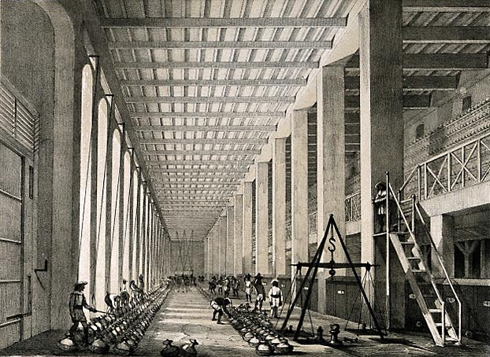

**“The Examining Hall, Opium Factory at Patna India”**  
“In the Examining Hall the consistency of the crude opium as brought from the country in earthen pans is simply tested, either by the touch, or by thrusting a scoop into the mass. A sample from each pot (the pots being numbered and labeled) is further examined for consistency and purity in the chemical test room.”  
**Source**: Prose from The Graphic reproduced in: The Truth about Opium Smoking, 1882. Lithograph after W. S. Sherwill, ca. 1850; Wellcome Images.

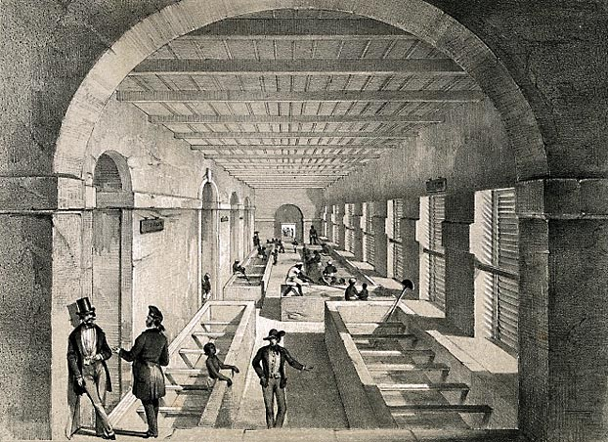

**“The Mixing Room, Opium Factory at Patna India”**  
“In the Mixing Room the contents of the earthen pans are thrown into vats and stirred with blind rakes until the whole mass becomes a homogeneous paste.”

**Source**: Prose from The Graphic reproduced in: The Truth about Opium Smoking, 1882. Lithograph after W. S. Sherwill, ca. 1850. Wellcome Image.

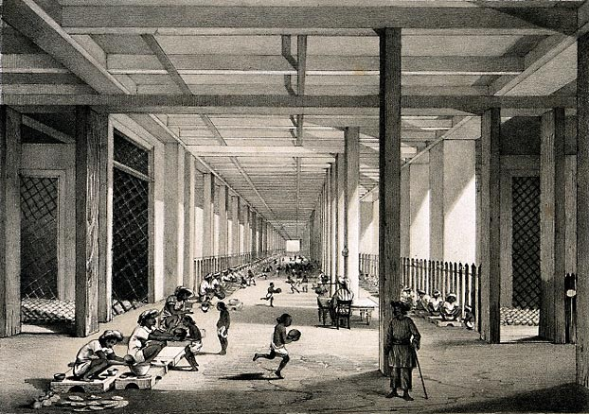

**“The Balling Room, Opium Factory at Patna India”**“From the mixing room the crude opium is conveyed to the Balling Room, where it is made into balls. Each ball-maker is furnished with a small table, a stool, and a brass cup to shape the ball in a certain quantity of opium and water called 'Lewa,' and an allowance of poppy petals, in which the opium balls are rolled. Every man is required to make a certain number of balls, all weighing alike. An expert workman will turn out upwards of a hundred balls a day.”  
**Source**: Prose from The Graphic reproduced in: The Truth about Opium Smoking, 1882. Lithograph after W. S. Sherwill, ca. 1850. Wellcome Images.

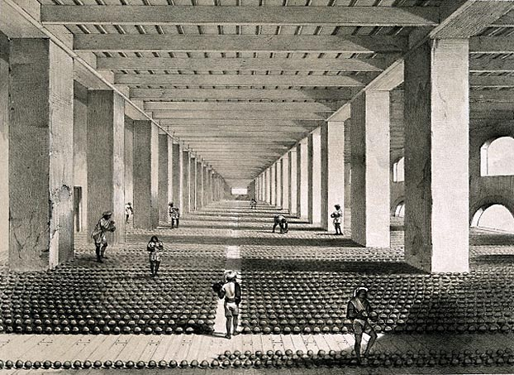

**“The Drying Room, Opium Factory at Patna India”**  
“In the Drying Room the balls are placed to dry before being stacked. Each ball is placed in a small earthenware cup. Men examine the balls, and puncture with a sharp style those in which gas, arising from fermentation, may be forming.” **Source:** Prose from The Graphic reproduced in: The Truth about Opium Smoking, 1882. Lithograph after W. S. Sherwill, ca. 1850.

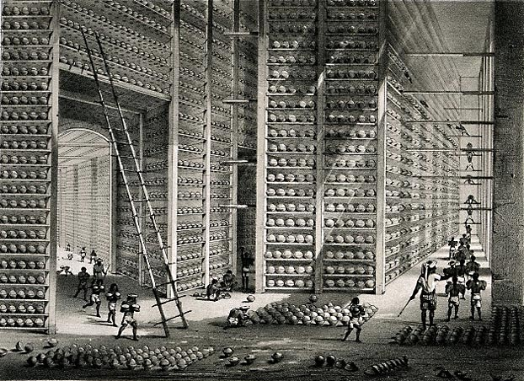

**“The Stacking Room, Opium Factory at Patna India”**“In the Stacking Room the balls are stacked before being packed in boxes for Calcutta en route to China. A number of boys are constantly engaged in stacking, turning, airing, and examining the balls. To clear them of mildew, moths or insects, they are rubbed with dried and crushed poppy petal dust.”  
**Source**: Prose from The Graphic reproduced in: The Truth about Opium Smoking, 1882. Lithograph after W. S. Sherwill, ca. 1850.

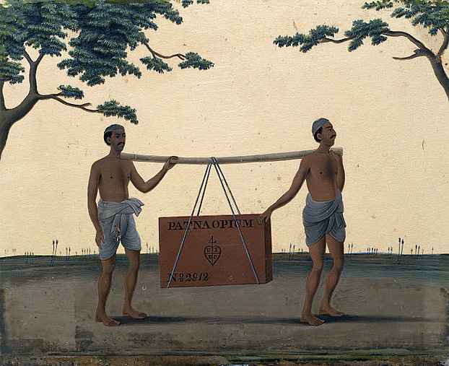

**Source**: Details from an image set illustrating the manufacture  
of opium, 1857–60, by Shiva Lal. Victoria & Albert Museum

***The Opening of China – Student Handout***

**Questions to answer:**

1. Describe how the Canton trade system worked and who benefitted most?
2. Trade with China was incredibly dangerous, so what motivated sailors to risk their lives?
3. List three consequences of the Opium Wars. (How did British interactions with the Chinese change)?
4. The imbalance of trade between the British and China continued to increase as British demand for what Chinese product skyrocketed in the 1800s? (Remember that the I.R. is in full swing and British workers need something).
5. In order to end the imbalance of trade, the British turn to what product grown in their Indian colony?
6. In what part of India was the majority of opium grown?
7. What types of ships were used to smuggle British opium?
8. How widespread was Opium usage among the Chinese? What types of individuals used?
9. When did the Chinese government become increasingly alarmed about the widespread use of opium?
10. There was a debate among the Imperial court about how the government should respond to the illegal opium trade. Describe both sides of this debate and eventually what decision the Daoguang emperor made.

**Image Analysis Questions:**

1. Generate a list of at least 10 adjectives and adverbs to describe the process of opium production as shown in your set of images.
2. **(Class Discussion)** Consider who is pictured in the images by applying the following questions:

A. Are the people British, Indian, or both?

B. What are they doing? What are their roles or jobs?

C. How do the people interact with each other, if at all?

D. What does the people’s clothing say about them and their work?

E. What do their activity and expressions say about them and their work?

1. What is your impression about this aspect of opium production after examining the images?
2. Considering the image collection together, what is your overall impression of opium production in mid-19th century India based on your collection of images?
3. Do you think that you were looking at images created by a British eyewitness or an Indian eyewitness? Why?
4. If one of or several images from this artist’s series was in your textbook, what message would you take away about opium trade?