The Pacific War: Occupied Shanghai
World War II
From: Humanities Out There, Kate Merkel-Hess
History Standards: 10.8.1
Compare the German, Italian, and Japanese drives for empire in the 1930s, including the 1937 Rape of Nanking, other atrocities in China, and the Stalin-Hitler Pact of 1939.

CCSS Standards: Reading, Grades 9-10
1. Cite specific textual evidence to support analysis of primary and secondary sources, attending to such features as the date and origin of the
information.
3. Analyze in detail a series of events described in a text; determine whether earlier events caused later ones or simply preceded them.
10. By the end of grade 10, read and comprehend history/social studies texts in the grades 9–10 text complexity band independently and proficiently.
Guiding Question:
How did the Chinese respond to the occupation of Shanghai by Japanese soldiers?
Overview of Lesson:
Students should be familiar with Japan’s rapid modernization and their lack of resources on the Japanese islands.
Depending on the level of your class, it may be helpful to read the first section aloud, asking text-dependent questions and clarifying thoughts as you go. You may also want to answer the accompanying question for the first section on an overhead, so that students can see what you expect in a full and complete answer.
After modeling, students may work in partners or independently to complete the readings and accompanying questions. Students can create a “game board” for the final section if time allows, and play until the bell rings.

The Pacific War:
Occupied Shanghai

Part One: Shanghai: A Cosmopolitan City, Then and Now
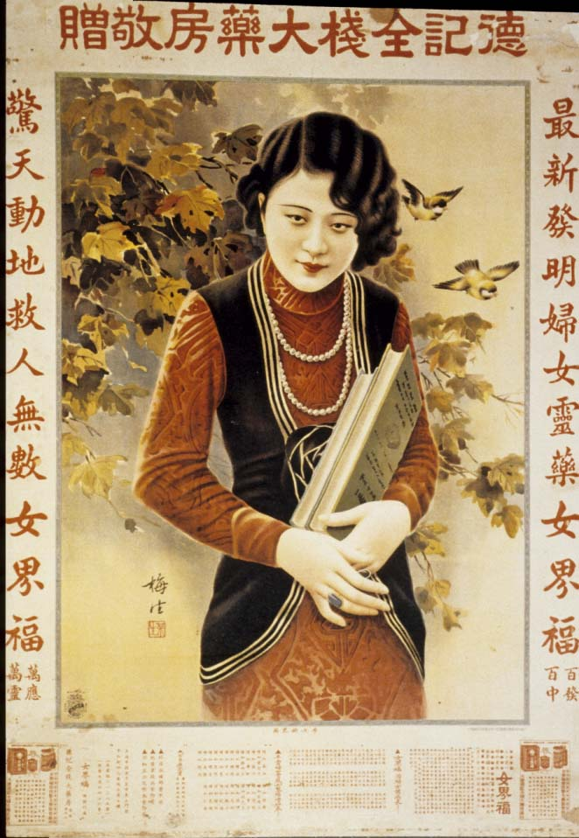
A 1920s calendar picture of a modern
“beauty.”
Shanghai was an important port for hundreds of years prior to its forced opening to the West after the Opium War in 1842. An “international” city, Shanghai was primarily Chinese, but included communities of people from all over the world. Established communities of Americans, Brits, French, Japanese, Middle Eastern Jews, Indians, and Germans, among many others, made their homes in Shanghai’s international districts. Political refugees—Russians fleeing after the Communist Revolution, or Jews fleeing the Nazis during World War II—made their way to Shanghai and found refuge there.

By the early twentieth century, Shanghai was famous around the world for its nightlife and libertine culture. To many Chinese people, Shanghai represented what was “modern” and “cosmopolitan”; in Shanghai, there were cars, banks, electricity, telephones, beauty parlors, radios, dress styles from Paris, dance halls, and movie theaters. During the 1920s, many Chinese intellectuals moved to Shanghai and it became the center of the Chinese literary world.

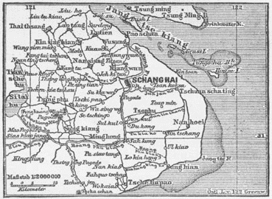
A German map of Shanghai, 1888.
New Words
refuge: protection or safety; a place that provides protection or safety

libertine: unconstrained by convention or morality

cosmopolitan: having international sophistication, worldly

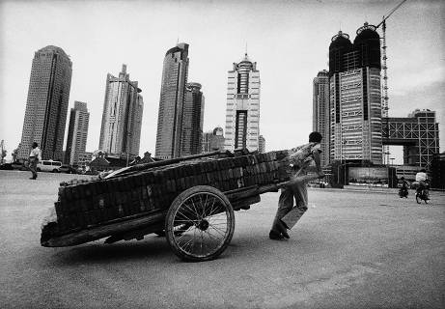
A migrant to Shanghai works below the city’s skyscrapers.
Today, Shanghai is an important city of international trade, commerce, and culture. From 1949 to 1979, the Communist government largely closed China to visits by foreigners, but now Shanghai is again home to people from all over the world. However, like other large, wealthy cities, it is not without its problems. There is a significant population of poor and homeless people in Shanghai, and, as government control weakens, social ills like prostitution and drug use have reemerged.
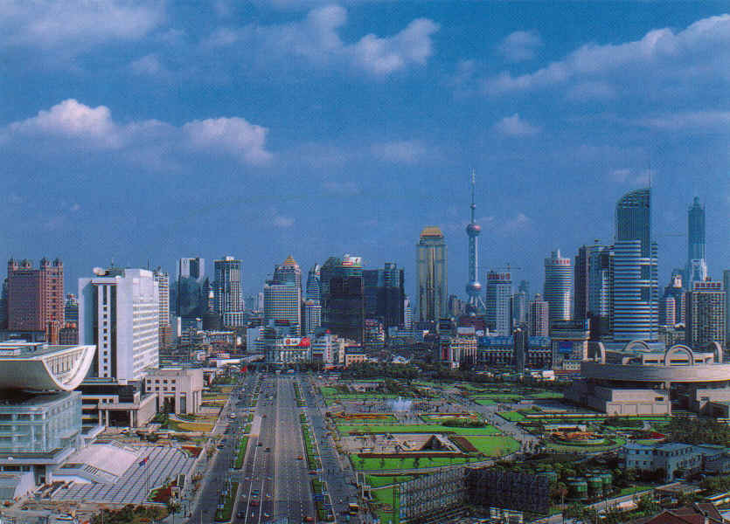
The skyline of Shanghai
Part Two: Occupied Shanghai
New Words
requisition: requiring that something be provided

allotment: a share or portion

blockade: to block or obstruct

subjugation: to bring under control or governance

The Japanese invaded Shanghai in 1937, shortly before invading Nanjing (Nanking). From 1937 to 1945, Shanghai lived under the occupation of Japanese troops. During the occupation, Japanese troops requisitioned what they needed from the population. As a result, those living in Shanghai experienced shortages of rice, gasoline, and other necessities. Most families needed to send one family member to stand in line each day to receive that day’s allotment of rice, and after 1942, the Japanese required each person to stand in line for his or her own rice. To retaliate against the Chinese population for misbehavior—like the killing of Japanese soldiers—the Japanese would blockade the rice supply to the city. Many people then turned to smugglers to obtain the rice they needed to live.

In addition to the practical necessities of daily life, Chinese in occupied Shanghai also felt frustrated by their subjugation to a foreign ruler. During the period of Japanese occupation—not just of Shanghai, but of much of China—many Chinese became involved in resistance activities to oppose the Japanese. Intellectuals living in Shanghai expressed their dissatisfaction with Japanese rule in their writing. For instance, the writer Yi Guan wrote this poem to honor 800 soldiers who attempted to hold out against the Japanese advance on Shanghai:

In the spreading shade of dusk
we pull up the shining national flag.
It represents the unique holiness and purity
of our national uprightness.
Inside our eight hundred lives is hidden
the spirit of China.
We shall win one day.

- From whose perspective is this poem written?
- The Poet Yi Guan
- A resident of Shanghai
- A member of the 800-soldier battalion
- A Japanese soldier

- Write below the words in the poem that you think express the author’s pride in his nation:

- Write down the words that you would use to express your own patriotism:

Part Three: Alphabets, Syllabaries, and Logograms

The Chinese and Japanese languages are very different from English. English, like Spanish, French, and German, uses an alphabet (the Roman alphabet) to represent sounds. Other languages, like Arabic and Russian, use different alphabets—in which, as in English, each symbol represents one consonant or vowel sound.

Chinese and Japanese, however, do not use alphabets.

Chinese
The Chinese written language is based on characters like these:

家 (pronounced jia, 1st tone): family, home
山 (pronounced shan, 1st tone): mountain
好 (pronounced hao, 3rd tone): good
These characters are called logograms. A logogram is a symbol that represents a meaningful unit of language—either a whole word, or part of an idea. There are more than 50,000 different characters (or logograms) in Chinese. The average Chinese person needs to know at least 2,000 characters to get around every day, but a college student would likely know at least 20,000.

Try writing the following Chinese characters yourself:

中国 (zhongguo) (China)

美 (mei) (pretty, beautiful, also the word used for “America”)

文 (wen) (language)

Japanese
As we discussed previously, Japan was influenced by China throughout its history. One thing that Japan adopted from China was the use of written characters. However, Japan also has its own writing system, called hiragana, which was developed by court ladies in the 11th and 12th centuries; they did not have the education necessary to write in Chinese characters, so they began to use hiragana instead.

Hiragana is a syllabary, which means that each symbol represents either a vowel sound (a, i, u, e, o) or a consonant-vowel pair, like ke, tu, or bo. Here is a table of hiragana (read it from right to left, and top to bottom, as this is how both Japanese and Chinese were traditionally written!):

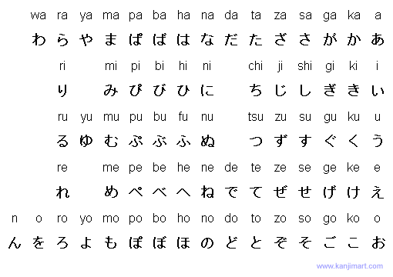

Using the table of hiragana above, can you figure out how to write the following common Japanese words?

kuruma (ku-ru-ma) (car)

ie (i-e) (home)

oyatsu (o-ya-tsu) (snack)

kinu (ki-nu) (silk)
Part Four: “Life in Occupied Shanghai”: The Game

Every day, residents of occupied Shanghai went out to get their ration of rice. Today, your mother has sent you out to get the family’s rice. Can you make it safely back home, without being waylaid by either the dangers or delights of Shanghai? (Play this game with your group!)

You pass a British man on the street and feel some resentment. You remember that the British forcibly opened Shanghai to foreign trade after this war:

- The Taiping Rebellion
- The Opium War
- The Boxer Rebellion
- The Sino-Japanese War

If you answer correctly, move forward three spaces!

On the way to the rice distribution center, you pass a lively storefront and can’t help but wander inside. There, you see a “taxi dancer.” A “taxi dancer” is:

- A cab driver who changes cars frequently
- A person who dances on top of taxis to entertain people stuck in traffic
- A professional dance partner, generally a woman, who is paid by the dance
- A dancer who dresses only in yellow and black

If you answer correctly, move forward two spaces!

You linger outside a teahouse and listen to intellectuals talking inside. You feel pleased to live in such a “cosmopolitan” city. The meaning of “cosmopolitan” is:

- sophisticated and worldly
- stuck-up and elitist
- narrow-minded and boring
- inferior and tiresome

If you answer correctly, move forward three spaces!

You pass a shop that has posted signs in its windows in both Chinese and Japanese. You know that Japanese uses characters, like Chinese, but that they also have their own writing system. This writing system is called:

- harikari
- hiragana
- beriberi
- matahari

If you answer correctly, move forward three spaces!

(Bonus: Move forward one more space if you can name the kind of writing system used—not an alphabet but a…)

You take a wrong turn and end up in the International Settlement. This district is governed by which two foreign powers?

- France and Japan
- Germany and the Netherlands
- Italy and Spain
- Great Britain and the United States

If you answer correctly, move forward two spaces!

You pass an alley where several smugglers have set up shop. One of the things they are selling is rice. You have many neighbors who purchase their rice from smugglers because:

- It is better quality than the rice sold in stores
- There is not enough rice being sold in the shops, due to the Japanese barricade
- It is cheaper to buy from smugglers
- It is more convenient to buy from smugglers than from stores

If you answer correctly, move forward one space!

You pass two elderly women who are complaining about “life in the line.” You know they are referencing:

- Having to stand in police line-ups
- Standing in line all day, every day to get their ration of rice
- Getting up early to get deals at the department stores’ sales
- Working “on the line” at a factory

If you answer correctly, move forward two spaces!

You see a bedraggled woman sitting beside the road begging. She calls out to you that she is homeless because the Japanese invaded her city after they defeated Shanghai, and all of her family was killed. You guess that she lived in:

- Hong Kong
- Taipei
- Nanjing
- Beijing

If you answer correctly, move forward three spaces!

There are many Jewish refugees who made their way to Shanghai during World War II, and they found a home there. However, because Japan had an alliance with this country, the Jews in Shanghai were eventually forced to live in a contained “ghetto”:

- France
- United States
- Russia
- Germany

If you answer correctly, move forward two spaces!

You pass through a Japanese police checkpoint without incident, but a foreigner riding by is stopped and then yelled at by the guards. What do you think he did wrong?

- He failed to pay a bribe
- He did not remove his hat and bow before passing through the gates
- He did not salute
- All foreigners were treated this way, no matter what they did

If you answer correctly, move forward one space!

You have to weave your way across a dangerous busy street. There are a few cars, but for the most part, the traffic is made up of “rickshaws.” A “rickshaw” is:

- A small cart drawn by a human being
- A riding cart that is carried by humans
- A cart drawn by horses
- A sled

If you answer correctly, move forward two spaces!

You stop by noodle shop to get a bowl of noodles, and there overhear two students whispering about their “Marxist” activities in the resistance movement. You guess that they are supporters of this leader:

- Mao Zedong, the leader of the Chinese Communist Party
- Chiang Kaishek, the leader of the Chinese Nationalist Party
- Hirohito, the emperor of Japan
- Franklin D. Roosevelt, the president of the United States

If you answer correctly, move forward two spaces!

An elderly woman passes you, leaning heavily on her cane. Though her condition is now very rare in China, you note that this elderly lady is having trouble walking because:

- She is not accustomed to being outside
- She usually has someone to help her
- She usually gets to ride in a rickshaw
- Her feet were bound as a little girl

If you answer correctly, move forward one space!

You see several very nice, black cars pull up alongside the curb and notice men dressed in Western suits get out. Some of the older kids who live on your alley told you that men who dress like this belong to the gangs that control much of the trade in Shanghai. These gangs make the greatest amount of money off their illegal sales of:

- tea
- rice
- opium
- marijuana

If you answer correctly, move forward two spaces!

You find yourself on the Bund, a famous stretch of European-style buildings in Shanghai along the Huangpu River. Looking at the bustling riverfront, you wonder why the name of Shanghai means:

- “Southern Capital”
- “On the Sea”
- “Black Dragon River”
- “International Settlement”

If you answer correctly, move forward three spaces!

Your father migrated to Shanghai from the countryside in the 1920s, and he has told you stories about how everyone called him “country bumpkin” when he first came. He said the most famous women in town in those days were Shanghai’s “pheasants.” These “pheasants” were:

- Waitresses
- Textile mill workers
- Ballet dancers
- Courtesans

If you answer correctly, move forward two spaces!

When you go past the university, you see a group of female students standing outside, their hair curled and pinned, and wearing Western-style clothing. You have heard other people call women who dress like this “mo-deng.” This is a transliteration of the English word:

- modest
- modern
- model
- modified

If you answer correctly, move forward three spaces!

Fu, Poshek. Passivity, Resistance, and Collaboration: Intellectual Choices in Occupied Shanghai, 1937-1945. Stanford: Stanford UP, 1993. p. 18.

