10th Grade Performance Task

Issue: Should President Wilson commit the United States and its military to the war?
Standard 10.5.3

World War I presented the United States and President Woodrow Wilson with a difficult choice. The war forced the United States to redefine it’s foreign policy goals and determine the scope of its power in the world. Wilson vowed to keep out of the war as part of his presidential election platform. However, by 1917 Americans both for and against the war demanded that Wilson take a stand.

Directions for Part 1
You will now examine and analyze both primary and secondary sources. Take notes because you may want to refer to your notes while writing your argumentative essay. You can re-examine any of the sources as often as you like.

Directions for Part 2
You will now review your sources, take notes, and plan, draft, revise, and edit your essay. You may use your notes and refer to the sources. Now read your assignment and the information about how your argumentative essay will be scored; then begin your work.

Your assignment:
You are a political advisor to Woodrow Wilson in 1917. You have been assigned to research the costs and benefits of committing U.S. troops to war and offer him a position based on what you find. In presenting your case, you must provide evidence to defend your claim and demonstrate you understand opposing views on the matter.

Source 1: John J. Donahue. 1915 “Don’t Blame the Germans”
Headnote: At a time when many American homes had pianos and few had gramophones (early record players), sheet music played an important role in popular culture. People gathered in their living rooms to sing songs or heard them performed at music halls and parades. … Earlier songs, written during Wilson’s policy of neutrality, had featured mothers who didn’t want their boys to go to war. But after April 1917, sheet music almost invariably supported the war effort…
When the war began in Europe, there were 8 million Americans of German or Austrian descent in the United States as well as 4.5 million Irish-Americans. These groups tended to sympathize with Germany or (in the case of the Irish) oppose Britain…
Found at http://dcc.newberry.org/collections/world-war-i-in-us-popular-culture#popular-music-and-the-war
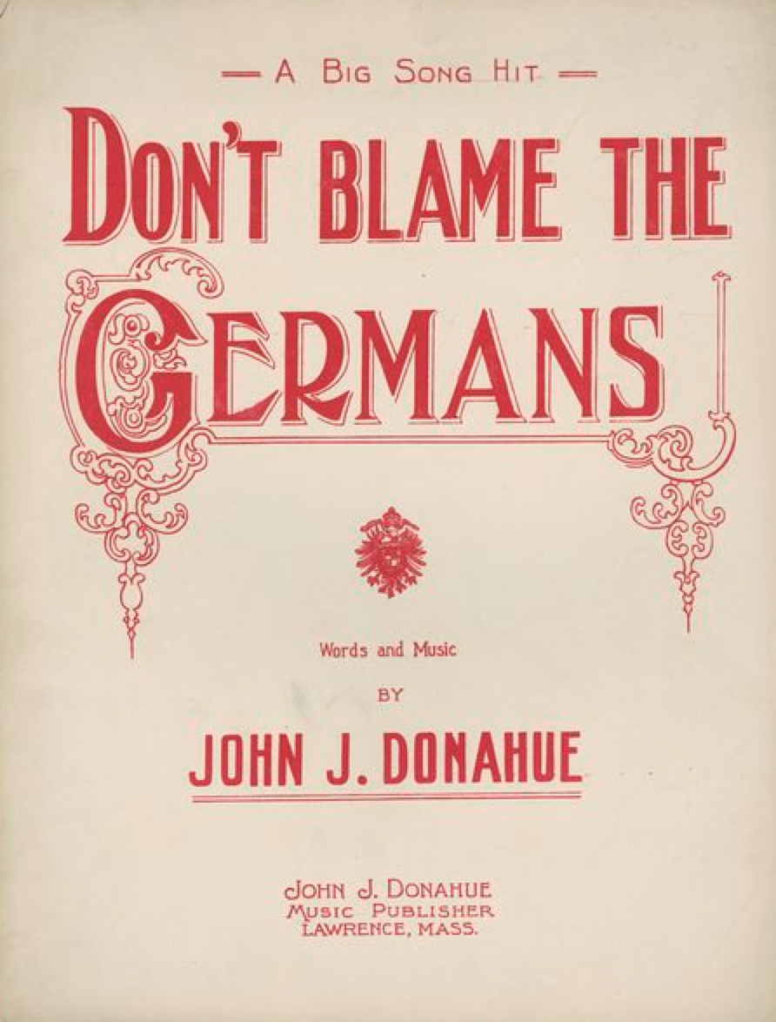

Source 2: Sinking of the Lusitania headline, The Washington Herald, July 18, 1915
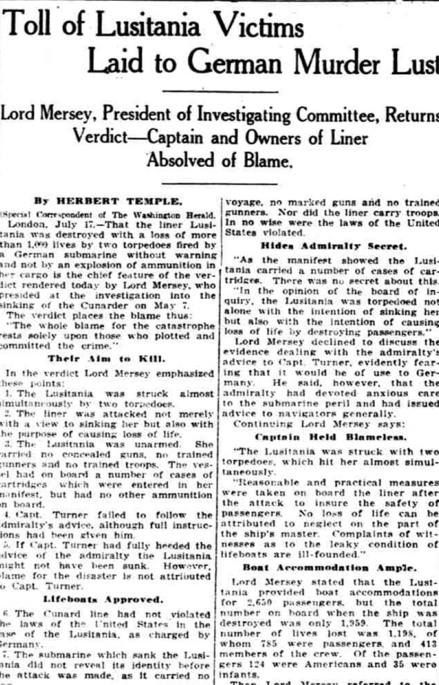 | By HERBERT TEMPLE.  London, July I7. That the liner Lusitania was destroyed with a loss of more than 1,000 lives by two torpedoes fired by a German submarine without warning and not by an explosion of ammunition in her cargo is the chief feature of the verdict rendered today by Lord Mersey, who  presided at the investigation into the  sinking of the Cunarder on May 7.  The verdict places the blame thus:  "The whole blame for the catastrophe  rests solely upon those who plotted and  committed the crime. '  Their Aim to Kill.  In the verdict Lord Mersey emphasized  these points:  1. The Lusitania was struck almost  simultaneously by two torpedoes.  2. The liner was attacked not merely  with a view to sinking her but also with  the purpose of causing loss of life.  3. The Lusitania was unarmed She  carried no concealed
guns, no trained gunners and no trained troops. The vessel had on board a number of cases of cartridges which were entered in her manifest, but had no other ammunition on board.
4 Capt. Turner failed to follow the admiralty's advice, although full instructions had been given to him".
5. If Capt. Turner had fully heeded the advice of the admiralty the Lusitania might not have been sunk. However, blame for the disaster is not attributed to Capt. Turner.
Lifeboats Approved.
6. The Cunard line had not violated the laws of the United States in the
case of the Lusitania, as charged by Germany.
7. The submarine which sank the Lusitania did not reveal its identity before the attack was made, as it carried no flag.
8. Complaints of the survivors about the condition of the life boats on the liner were ill-founded.
9. "Reasonable and practical" measures were taken by those in charge of the ship after the attack was made. "The evidence shows -that the Lusitania was an unarmed ship." said Lord Mersey "The attack was made without warning and no opportunity was given the passengers to leave the ship The Lusitania was not an armed ship….
Hides Admiralty’s Secret
"As the manifest showed the Lusitania carried a number of cases of cartridges. There was no secret about this.
"In the opinion of the board of inquiry, the Lusitania was torpedoed not alone with the intention of sinking her but also with the intention of causing loss of life by destroying passengers."
Lord Mersey declined to discuss the evidence dealing with the admiralty's advice to Capt Turner, evidently fearing that it would he of use to Germany. He said, however, that the admiralty had devoted anxious care to the submarine peril and had issued
advice to navigators generally.
… The total number of lives lost was 1,198 of whom 755 were passengers, and 413
members of the crew. Of the passengers 124 were Americans and 35 were infants.
Then Lord Mersey referred to the warning published in New York news papers by the German Ambassador just before the ship sailed. In the view of Lord Mersey this warning; far from excusing the crime, only aggravated it as it showed that it was deliberate and planned in advance.
It had been said by the German government that the liner was carry ing masked guns and was transporting Canadian troops, but this wasbaseless invention"
found at http://chroniclingamerica.loc.gov/lccn/sn83045433/1915-07-18/ed-1/seq-9.pdf

Source 3: Woodrow Wilson July 21, 1915
The Government of the United States is not unmindful of the extraordinary conditions created by this war or of the radical alterations of circumstance and method of attack produced by the use of instrumentalities of naval warfare which the nations of the world cannot have had in view when the existing rules of international law were formulated, and it is ready to make every reasonable allowance for these novel and unexpected aspects of war at sea; but it cannot consent to abate any essential or fundamental right of its people because of a mere alteration of circumstance. The rights of neutrals in time of war are based upon principle, not upon expediency, and the principles are immutable. It is the duty and obligation of belligerents to find a way to adapt the new circumstances to them…
Found at http://teachingamericanhistory.org/library/document/president-wilsons-protest-to-germany/
Source 4: Senator George W. Norris, April 4, 1917
While I am most emphatically and sincerely opposed to taking any step that will force our country into the useless and senseless war now being waged in Europe, yet, if this resolution passes, I shall not permit my feeling of opposition to its passage to interfere in any way with my duty either as a senator or as a citizen in bringing success and victory to American arms. I am bitterly opposed to my country entering the war, but if, notwithstanding my opposition, we do enter it, all of my energy and all of my power will be behind our flag in carrying it on to victory.
The resolution now before the Senate is a declaration of war. Before taking this momentous step, and while standing on the brink of this terrible vortex, we ought to pause and calmly and judiciously consider the terrible consequences of the step we are about to take…
It is unnecessary to cite authority to show that both of these orders declaring military zones were illegal and contrary to international law. It is sufficient to say that our government has officially declared both of them to be illegal and has officially protested against both of them. The only difference is that in the case of Germany we have persisted in our protest, while in the case of England we have submitted…
We have loaned many hundreds of millions of dollars to the Allies in this controversy. While such action was legal and countenanced by international law, there is no doubt in my mind but the enormous amount of money loaned to the Allies in this country has been instrumental in bringing about a public sentiment in favor of our country taking a course that would make every bond worth a hundred cents on the dollar and making the payment of every debt certain and sure. Through this instrumentality and also through the instrumentality of others who have not only made millions out of the war in the manufacture of munitions, etc., and who would expect to make millions more if our country can be drawn into the catastrophe, a large number of the great newspapers and news agencies of the country have been controlled and enlisted in the greatest propaganda that the world has ever known to manufacture sentiment in favor of war…
Their object in having war and in preparing for war is to make money. Human suffering and the sacrifice of human life are necessary, but Wall Street considers only the dollars and the cents…
Found at http://teachingamericanhistory.org/library/document/opposition-to-wilsons-war-message-2/
Source 5: Zimmerman Telegram 1917
Headnote: In January of 1917, British cryptographers deciphered a telegram from German Foreign Minister Arthur Zimmermann to the German Minister to Mexico, von Eckhardt, offering United States territory to Mexico in return for joining the German cause.
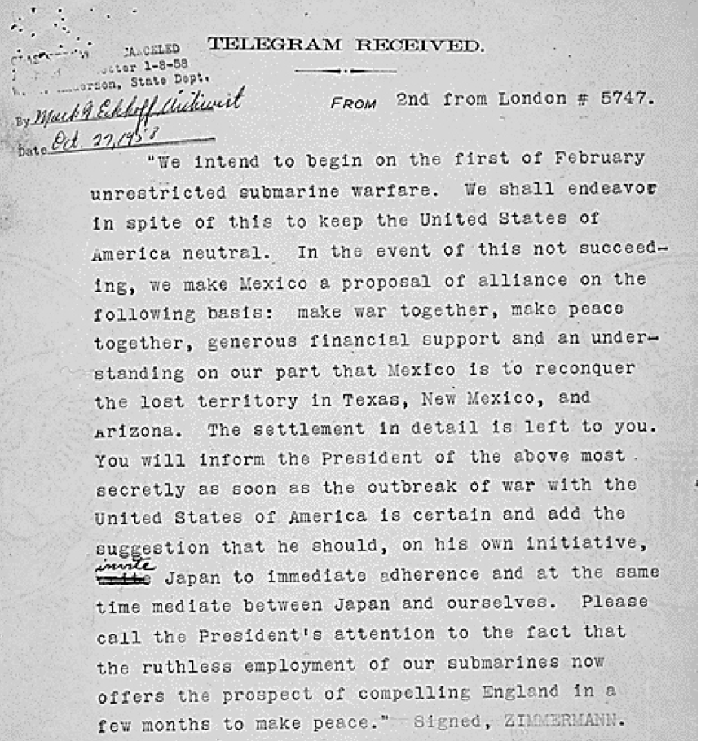 | FROM 2nd from London # 5747.  "We intend to begin on the first of February unrestricted submarine warfare. We shall endeavor in spite of this to keep the United States of America neutral. In the event of this not succeeding, we make Mexico a proposal or alliance on the following basis: make war together, make peace together, generous financial support and an understanding on our part that Mexico is to reconquer the lost territory in Texas, New Mexico, and Arizona. The settlement in detail is left to you. You will inform the President of the above most secretly as soon as the outbreak of war with the United States of America is certain and add the suggestion that he should, on his own initiative, invite Japan to immediate adherence and at the same time mediate between Japan and ourselves. Please call the President's attention to the fact that the ruthless employment of our submarines now offers the prospect of compelling England in a few months to make peace." Signed, ZIMMERMANN.
Found at http://www.archives.gov/education/lessons/zimmermann/

