To Imperialize or Not to Imperialize
Nascent American Imperialism
From: Sites of Encounter: Empires, 2012
History Standards: 11.4
Students trace the rise of the United States to its role as a world power in the twentieth century.
CCSS Standards: Reading, Grade 11-12
1. Cite specific textual evidence to support analysis of primary and secondary sources, connecting insights gained from specific details to an understanding of the text as a whole.
2. Determine the central ideas or information of a primary or secondary source; provide an accurate summary that makes clear the relationships among the key details and ideas.
3. Evaluate various explanations for actions or events and determine which explanation best accords with textual evidence, acknowledging where the text leaves matters uncertain.
5. Analyze in detail how a complex primary source is structured, including how key sentences, paragraphs, and larger portions of the text contribute to the whole.
6. Evaluate authors’ differing points of view on the same historical event or issue by assessing the authors’ claims, reasoning, and evidence.
7. Integrate and evaluate multiple sources of information presented in diverse formats and media (e.g., visually, quantitatively, as well as in words) in order to address a question or solve a problem.
Guiding Question:
How did Americans express their views on imperialism? What guided their reactions?
Overview of Lesson:

Directions: Read the excerpts and fill in the chart.
- Decide which ones are pro-imperialist and write a short list of the stated reasons why the U.S. should take on colonies.
- Decide which ones are anti-imperialist and write a short list of the stated reasons why the U.S. should NOT take on colonies.
Excerpt #1: “The March of the Flag”
Source: Albert Beveridge; US Senator from Indiana (1899-1911), Campaign speech given on September 16, 1898.
Shall the American people continue their march toward the commercial supremacy of the world? Shall we reap the reward that waits on our discharge of our high duty; shall we occupy new markets for what our farmers raise, our factories make, our merchants sell-aye, and please God, new markets for what our ships shall carry?
Hawaii is ours; Porto Rico is to be ours; at the prayer of her people Cuba finally will be ours; in the islands of the East, even to the gates of Asia, coaling stations are to be ours at the very least; the flag of a liberal government is to float over the Philippines…
The Opposition tells us that we ought not to govern a people without their consent. I answer, the rule of liberty that all just government derives its authority from the consent of the governed, applies only to those who are capable of self government. We govern the Indians without their consent, we govern our territories without their consent, we govern our children without their consent. How do they know what our government would be without their consent? Would not the people of the Philippines prefer the just, humane, civilizing government of this Republic to the savage, bloody rule of pillage and extortion from which we have rescued them?
If England can govern foreign lands, so can America. If Germany can govern foreign lands, so can America. If they can supervise protectorates, so can America. Why is it more difficult to administer Hawaii than New Mexico or California? Both had a savage and an alien population: both were more remote from the seat of government when they came under our dominion than the Philippines are today…
Will you remember that we do but what our fathers did-we but pitch the tents of liberty farther westward, farther southward-we only continue the march of the flag?...
Distance and oceans are no arguments. The fact that all the territory our fathers bought and seized is contiguous, is no argument…
And so, while we did not need the territory taken during the past century at the time it was acquired, we do need what we have taken in 1898 and we need it now…
In Cuba, alone, there are 15,000,000 acres of forest unacquainted with the ax, exhaustless mines of iron, priceless deposits of manganese, millions of dollars' worth of which we must buy, today, from the Black Sea districts.
The resources of Porto Rico have only been trifled with. The riches of` the Philippines have hardly been touched by the fingertips of modern methods. And they produce what we consume…
So Hawaii furnishes us a naval base in the heart of the Pacific; Manila another, at the gates of Asia - Asia, to the trade of whose hundreds of millions American merchants, manufacturers, farmers, have as good right as those of Germany or France or Russia or England; Asia, whose commerce with the United Kingdom alone amounts to hundreds of millions of dollars every year; Asia, to whom Germany looks to take her surplus products; Asia, whose doors must not be shut against American trade. Within five decades the bulk of Oriental commerce will be ours.
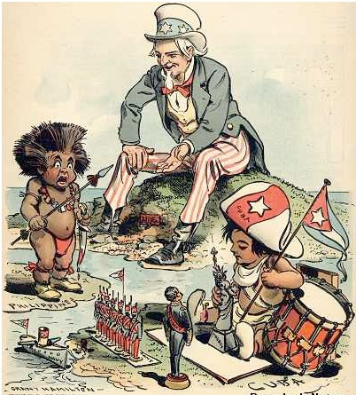
Excerpt #2:

Now, Will You Be Good?
Uncle Sam (to Filipino) — "See what I do for a good little boy?"

Source: Grant Hamilton, Judge, chromolithograph, 14 December 1902.

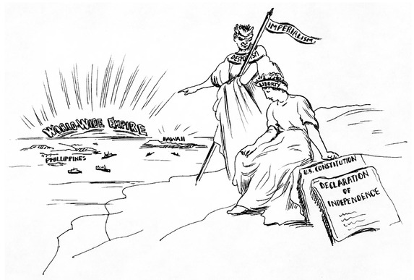
Excerpt #3:

"The New Temptation on the Mount"

Source: [Unknown], American Sentinel, reprinted in Literary Digest, 1 April 1899.

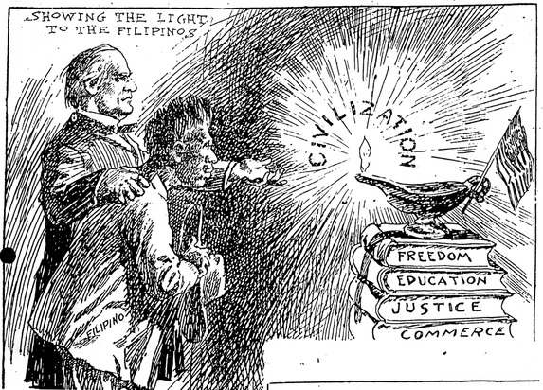
Excerpt #4:

Source: Unknown, "Showing the Light to the Filipinos", Boston Herald, March 1899.

Excerpt #5: "Filipinos Are Preposterously Misrepresented"
A newspaper article from the St. Louis Post-Dispatch, provided one of the few opportunities for a Filipino to address a U.S. audience about the Philippine Reservation exhibit at the 1904 World’s Fair. The article extensively quotes Vicente Nepomuceno, a Philippine lawyer and member of the Philippine honorary commission.
He asserts that the exhibition is but a foil seeking to justify in the public mind the administration’s insincerity toward the Filipino.
“There are 8,000,000 people in the Philippines,” said Senor Nepomuceno, through an interpreter, to the Post-Dispatch, “and of these 7,000,000 are civilized Christians, orderly, peace-loving and law-abiding.
“The remaining 1,000,000 are made up from among the Moros, Negritos, and Igorrotes, and the anthropoids, who live in the mountains in an uncivilized state, and who, like all backward and non-progressive races, are rapidly dying out.
“The Moros, Negritos and Igorrtes no more represent the people of the Philippines than the dying Indian represents the American people, and the Americans would resent such an exhibition for more vigorously than we have.
“When the Filipinos learned that these fragmentary tribes were being brought to this country to represent the islands at the Fair, a mass meeting was held and a protest was sent to Gov. Taft.
“It was of no avail, but as a sort of sop [concession], the Philippine honorary commission was appointed and 50 representative citizens were named to tour the United States. Of course, the damage had been done; the impression has gone abroad that we are barbarians; that we eat dog and all that sort of thing; and no matter how long we stay here we cannot convince the public to the contrary.
“The Filipino people are being preposterously misrepresented at the Fair.
“We are entirely ready for self-government and we were not prepared for it by the United States, but the administration does not seem to want to let it go. “
Excerpt #6:
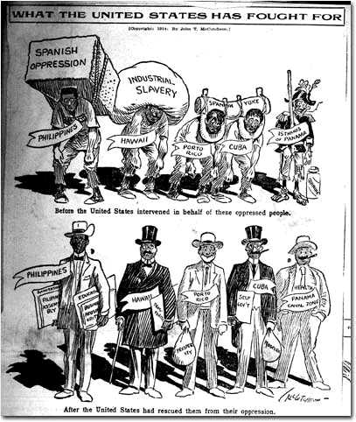

 | Pro or Anti Imperialist? | Reasons stated in source:
Excerpt #1:
Campaign speech
Excerpt #2: cartoon
Now, Will You Be Good?
Excerpt #3: cartoon
"The New Temptation on the Mount"
Excerpt #4: cartoon
"Showing the Light to the Filipinos"
Excerpt #5:
Newspaper article
Excerpt #6: cartoon
“What the U.S. has fought for”

