Performance Task: Water Use and Agriculture
Water Rights
From: Common Core Workshops, Nicole Gilbertson, 2015
History Standards: Economics 12.1.1
Examine the causal relationship between scarcity and the need for choices.
12.1.4 Evaluate the role of private property as an incentive in conserving and improving scarce resources, including renewable and nonrenewable natural resources.
Government
12.2.2 Explain how economic rights are secured and their importance to the individual and to society (e.g., the right to acquire, use, transfer, and dispose of property; right to choose one’s work; right to join or not join labor unions; copyright and patent).
CCSS Standards: Reading, Grade 11-12
1. Cite specific textual evidence to support analysis of primary and secondary sources, connecting insights gained from specific details to an understanding of the text as a whole.
2. Determine the central ideas or information of a primary or secondary source; provide an accurate summary that makes clear the relationships among the key details and ideas.
3. Evaluate various explanations for actions or events and determine which explanation best accords with textual evidence, acknowledging where the text leaves matters uncertain.
4. Determine the meaning of words and phrases as they are used in a text, including analyzing how an author uses and refines the meaning of a key term over the course of a text (e.g., how Madison defines faction in Federalist No. 10).
6. Evaluate authors’ differing points of view on the same historical event or issue by assessing the authors’ claims, reasoning, and evidence
7. Integrate and evaluate multiple sources of information presented in diverse formats and media (e.g., visually, quantitatively, as well as in words) in order to address a question or solve a problem.
8. Evaluate an author’s premises, claims, and evidence by corroborating or challenging them with other information.
9. Integrate information from diverse sources, both primary and secondary, into a coherent understanding of an idea or event, noting discrepancies among sources.
10 . By the end of grade 12, read and comprehend history/social studies texts in the grades 11–CCR text complexity band independently and proficiently.
Writing, Grade 11-12
1. Write arguments focused on discipline-specific content.
4. Produce clear and coherent writing in which the development, organization, and style are appropriate to task, purpose, and audience.
7. Conduct short as well as more sustained research projects to answer a question (including a self-generated question) or solve a problem; narrow or broaden the inquiry when appropriate; synthesize multiple sources on the subject, demonstrating understanding of the subject under investigation.
8. Gather relevant information from multiple authoritative print and digital sources, using advanced searches effectively; assess the strengths and limitations of each source in terms of the specific task, purpose, and audience; integrate information into the text selectively to maintain the flow of ideas, avoiding plagiarism and overreliance on any one source and following a standard format for citation.
10. Write routinely over extended time frames (time for reflection and revision) and shorter time frames (a single sitting or a day or two) for a range of discipline-specific tasks, purposes, and audiences.
Guiding Question:
Should California’s agricultural interests have priority over California’s limited water supply?
Overview of Lesson:
Students will - alone, in partnerships, or in groups, according to their needs – review the sources below and decide which sources support each side of the argument. They will then write an argumentative essay, including a claim and counterclaim, to advise the governor of California on the best course of action.

12th Grade Performance Task

Issue: Should California’s agricultural interests have priority over California’s limited water supply?

In the past year, California has faced one of the worst droughts on record. Although conservation efforts have proven moderately successful, various factions within the state have proposed different measures for relief and made competing claims for greater rights to usage. The state’s agricultural interests have been most vocal in asserting such claims.

Directions for Part 1
You will now examine and analyze a variety of sources on the topic of the water scarcity in California. Take notes because you may want to refer to your notes while writing your argumentative essay. You can re-examine any of the sources as often as you like.

Directions for Part 2
You will now review your sources, take notes, and plan, draft, revise, and edit your essay. You may use your notes and refer to the sources. Now read your assignment and the information about how your argumentative essay will be scored; then begin your work.

Your assignment: You are a policy advisor to the governor assigned to offer advice on water conservation and allocation in the state. Your assignment is to determine whether or not agriculture should receive priority over California’s water supply. In presenting your case, you must provide evidence to defend your claim and demonstrate you understand opposing views on the matter.

Source 1:
San Jose Mercury News, July 14, 2014

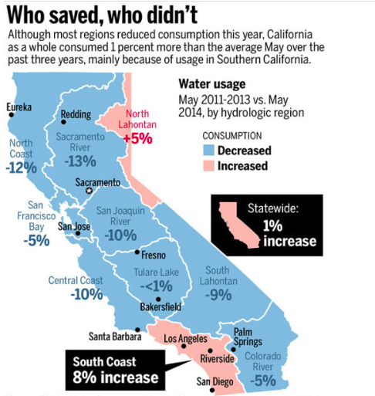

Source 2:

“California Water Prices Soar for Farmers as Drought Grows” Bloomberg
July 23, 2014

…. The primary response of the governor and state agencies has been to demand more subsidized mega-projects, while failing to fundamentally reform a flawed and failing system. Those with senior water rights, many of which date to before 1914, are getting from 50 percent to 75 percent of their water, he said. The rest didn’t get any federal water this year because of the severity of the drought, he said.

…“Those are the areas that are hardest hit and that are seeking water transfers to bring water from other parts of the state that have some that they’re able to share,” Wade said.

… Prices range from $1,000 to $2,000 per acre-foot, with higher costs in the southern part of the state, he said.

The Westlands district, created in 1952, is among those that didn’t get any water from the Bureau of Reclamation this year, Holman said. About 200,000 acres, or a third of the district’s 600,000 acres of farmland, were left unplanted, she said.
“The growers are having to make difficult decisions about how much land they can keep productive,” Holman said. “Some growers have had to remove older trees that they felt needed to be sacrificed for a water supply in another area of their farming operation.”

Daniel Errotabere, 59, a partner at a family-owned farm in Riverdale near Fresno that gets its water from the Westlands district, bought 600 acre-feet of water at rates ranging from $1,000 to $1,800 per acre-foot, about 10 times what he pays normally, he said.
… “It’s unprecedented,” said Errotabere. “These are values that farming doesn’t support, but I have to protect the trees and my operation.”

In the northern Sacramento Valley, 50 rice farmers this year agreed to forfeit part of their crop and sell their water at double the usual price to drought-stricken peers to the south. For the rice farmers who give up some of their water, “the price comes down to what they would get for their rice, so the profits are about the same,” Trimble said.

The water shortage most severely affects the fertile Central Valley with $800 million in lost farm revenue, according to a July 15 report by the University of California at Davis. Direct costs to agriculture total $1.5 billion….

The inflated amounts paid for water reflects “the number of people who don’t have access to underground water, who’ve planted very valuable perennial crops,” said Richard Howitt, one of the authors of the report.

Source 3:

“California Report Warns of Worsening Economic Impacts of Drought”
National Geographic July 15, 2014

A new scientific and economic report commissioned by California's state government warns that the ongoing drought crisis will cost billions in lost farm revenue and thousands of jobs, although wider impacts on the national food system are unlikely. The report also outlines ways officials could act now to avoid the worst effects of the drought…[Richard] Howitt, a UC Davis professor emeritus of agricultural and natural resource economics, said California's economy is expected to lose a total of $2.2 billion this year as a result of the drought.

"What really hurts is we're losing 17,100 jobs," said Howitt. Most of those jobs are seasonal and part-time work in the Central and San Joaquin Valleys.

"They are mostly from the sector of society that is least able to roll with the punches," Howitt added. "There are pockets of extreme deprivation where they are out of water and out of jobs... There are going to be more pockets of pain and poverty."

According to the UC Davis report, the state's agricultural sector faces a net water shortage of 1.6 million acre-feet this year, which will cause losses of $810 million in crop revenue and $203 million in lost dairy and other livestock value, plus additional groundwater pumping costs of $454 million. These direct costs to agriculture total $1.5 billion. When the job losses are factored in, the total economic impact to the state economy is estimated to be $2.2 billion…

Source 4:

The Water Revolution California Needs Los Angeles Times, March 27, 2014

California has 1,400 major dams, thousands of miles of aqueducts and pumps so powerful they lift water nearly 2,000 feet over the Tehachapis. The state uses enough water in an average year to support, in theory, 318 million Californians (and their lawns and dishwashers), more than eight times the actual population of 38 million.

Even with the gargantuan re-engineering of nature, there is never enough water. How could there be, when according to the calculations of fishing and environmental advocates, the state has granted more than five times as many water rights claims as there is water in our main rivers, even in a good year? When our Gold Rush-era laws all but compel water-rights holders to use as much water as they can, as fast as possible, lest they lose their entitlements?

Basic economics tells us that a precious commodity should be priced accordingly and directed toward high-value uses. Instead, California does the opposite with its water resources. About 75% of water used in the state goes to agriculture. California is the top agriculture producer in the United States, but ag contributes just 2% to the state's economic output….

Source 5:

Earth Justice, Who Gets the Water and Who’s Hung out to Dry?

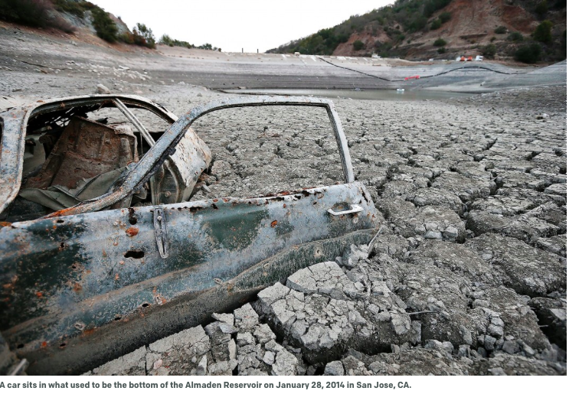

…“How you can favor fish over people is something people in my part of the world would never understand,” Boehner said. Had he looked around, he would have seen the faces of many other farmers, fishermen, Native Americans and consumers whose lives would be disrupted by a mega-water grab.

The Republican-led House later passed a bill that would pump more water from an already taxed Delta, not only gutting environmental protections and threatening the endangered fish, but also potentially imperiling the drinking water supply for northern Californians and jeopardizing the livelihoods of thousands of people in the D The man-made destruction of the natural hydrology of the region through the damming of rivers and diversion of water has decimated the salmon population and forced the upheaval of the tribe from its ancient lands. The tribe now denounces any project that could further ravage the natural waterways, including Governor Brown's Twin Tunnel proposalelta and beyond…

