Sedition Act Performance Task
National Security
From: Common Core Workshop, Nicole Gilbertson, 2015
History Standards: Government 12.1.3
Explain how the U.S. Constitution reflects a balance between the classical republican concern with promotion of the public good and the classical liberal concern with protecting individual rights; and discuss how the basic premises of liberal constitutionalism and democracy are joined in the Declaration of Independence as “self-evident truths.”
CCSS Standards: Reading, Grade 11-12
1. Cite specific textual evidence to support analysis of primary and secondary sources, connecting insights gained from specific details to an understanding of the text as a whole.
2. Determine the central ideas or information of a primary or secondary source; provide an accurate summary that makes clear the relationships among the key details and ideas.
3. Evaluate various explanations for actions or events and determine which explanation best accords with textual evidence, acknowledging where the text leaves matters uncertain.
4. Determine the meaning of words and phrases as they are used in a text, including analyzing how an author uses and refines the meaning of a key term over the course of a text (e.g., how Madison defines faction in Federalist No. 10).
6. Evaluate authors’ differing points of view on the same historical event or issue by assessing the authors’ claims, reasoning, and evidence
7. Integrate and evaluate multiple sources of information presented in diverse formats and media (e.g., visually, quantitatively, as well as in words) in order to address a question or solve a problem.
8. Evaluate an author’s premises, claims, and evidence by corroborating or challenging them with other information.
9. Integrate information from diverse sources, both primary and secondary, into a coherent understanding of an idea or event, noting discrepancies among sources.
10 . By the end of grade 12, read and comprehend history/social studies texts in the grades 11–CCR text complexity band independently and proficiently.
Writing, Grade 11-12
1. Write arguments focused on discipline-specific content.
4. Produce clear and coherent writing in which the development, organization, and style are appropriate to task, purpose, and audience.
7. Conduct short as well as more sustained research projects to answer a question (including a self-generated question) or solve a problem; narrow or broaden the inquiry when appropriate; synthesize multiple sources on the subject, demonstrating understanding of the subject under investigation.
8. Gather relevant information from multiple authoritative print and digital sources, using advanced searches effectively; assess the strengths and limitations of each source in terms of the specific task, purpose, and audience; integrate information into the text selectively to maintain the flow of ideas, avoiding plagiarism and overreliance on any one source and following a standard format for citation.
10. Write routinely over extended time frames (time for reflection and revision) and shorter time frames (a single sitting or a day or two) for a range of discipline-specific tasks, purposes, and audiences.
Guiding Question:
Do concerns of national security outweigh the importance of personal liberty in the United States? Is the public good more important than personal rights?
Overview of Lesson:
Students will - alone, in partnerships, or in groups, according to their needs – review the sources below and decide which sources support each side of the argument. They will then write an argumentative essay, including a claim and counterclaim.

12th Grade Performance Task

Issue: Do concerns of national security outweigh the importance of personal liberty in the United States? Is the public good more important than personal rights?

The Sedition Act of 1798 authorized the president to imprison or deport those accused of speaking against the U.S. government. Although purportedly an effort to minimize the threat of French hostilities, most believe that the act was more effectively used against political opponents. A similar Sedition law re-emerged during World War I in response to fears of radicalism. It likewise made it a felony to “profane” the U.S. government.

If a legitimate concern for public safety exists should the freedom of speech ever be restricted for the sake of national security?

Directions for Part 1
You will now examine and analyze a variety of sources on the topic of the freedom of speech. Take notes because you may want to refer to your notes while writing your argumentative essay. You can re-examine any of the sources as often as you like.

Directions for Part 2
You will now review your sources, take notes, and plan, draft, revise, and edit your essay. You may use your notes and refer to the sources. Now read your assignment and the information about how your argumentative essay will be scored; then begin your work.

Your assignment: Write an argumentative essay exploring whether the historic precedence for limiting freedom of speech is justified. Focusing on the Sedition Acts of both 1798 and 1918, explain whether national security concerns should outweigh individual liberties like the freedom of expression. In presenting your case, you must provide evidence to defend your claim and demonstrate you understand opposing views on the matter.

Source 1:

Jefferson & Madison, Virginia Resolution, 1798

That the General Assembly doth particularly protest against the palpable and alarming infractions of the Constitution, in the two late cases of the "Alien and Sedition Acts" passed at the last session of Congress; the first of which exercises a power no where delegated to the federal government, and which by uniting legislative and judicial powers to those of executive, subverts the general principles of free government; as well as the particular organization, and positive provisions of the federal constitution; and the other of which acts, exercises in like manner, a power not delegated by the constitution, but on the contrary, expressly and positively forbidden by one of the amendments thereto; a power, which more than any other, ought to produce universal alarm, because it is leveled against that right of freely examining public characters and measures, and of free communication among the people thereon, which has ever been justly deemed, the only effectual guardian of every other right.

Source 2:

Congressman Allen of 2nd Session of Congress

Am I free to falsely call you a thief, a murderer, a person who does not believe in God? The freedom of press and opinions was never understood to give the right of printing lies and slanders, nor of calling for revolution and slaughter.
As we are bound hand and foot that we must watch these deadly attacks on our liberty? God deliver us from the liberty of vomiting on the public, floods of lies and hatred to everything we hold dear. If any gentleman doubts the effects of such freedom, let me direct his attention to France; it has made slaves of thirty millions of men.

Source 3:
Schenk v. United States, 1919

It well may be that the prohibition of laws abridging the freedom of speech is not confined to previous restraints, although to prevent them may have been the main purpose….We admit that in many places and in ordinary times the defendants in saying all that was said in the circular would have been within their constitutional rights. But the character of every act depends upon the circumstances in which it is done…The most stringent protection of free speech would not protect a man in falsely shouting fire in a theatre and causing a panic. It does not even protect a man from an injunction against uttering words that may have all the effect of force. …. The question in every case is whether the words used are used in such circumstances and are of such a nature as to create a clear and present danger that they will bring about the substantive evils that Congress has a right to prevent. It is a question of proximity and degree. When a nation is at war many things that might be said in time of peace are such a hindrance to its effort that their utterance will not be endured so long as men fight and that no Court could regard them as protected by any constitutional right.

Source 4:

McCay, Winsor, engraver, 1917 (Note: the Sedition Act was an extension of the Espionage Bill)

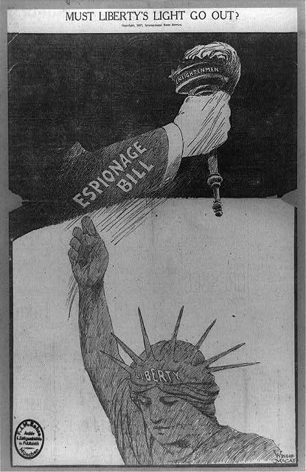

Source 5:

Newark News, 1920

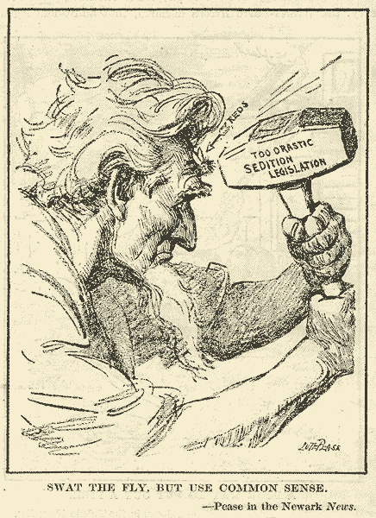

Alternate Source:

U.S. Sedition Acts

U.S. Sedition Act, 1798
SECT. 2. And be it further enacted, That if any person shall write, print, utter, or publish, or shall cause or procure to be written, printed, uttered, or published, or shall knowingly and willingly assist or aid in writing, printing, uttering, or publishing any false, scandalous and malicious writing or writings against the government of the United States, or either House of the Congress of the United States, or the President of the United States, with intent to defame the said government, or either House of the said Congress, or the said President, or to bring them, or either of them, into contempt or disrepute; or to excite against them, or either or any of them, the hatred of the good people of the United States, or to stir up sedition within the United States; or to excite any unlawful combinations therein, for opposing or resisting any law of the United States, or any act of the President of the United States, done in pursuance of any such law, or of the powers in him vested by the Constitution of the United States; or to resist, oppose, or defeat any such law or act; or to aid, encourage or abet any hostile designs of any foreign nation against the United States, their people or government, then such person, being thereof convicted before any court of the United States having jurisdiction thereof, shall be punished by a fine not exceeding two thousand dollars, and by imprisonment not exceeding two years.

SECT. 3. And be it further enacted and declared, That if any person shall be prosecuted under this act for the writing or publishing any libel aforesaid, it shall be lawful for the defendant, upon the trial of the cause, to give in evidence in his defence, the truth of the matter contained in the publication charged as a libel. And the jury who shall try the cause shall have a right to determine the law and the fact, under the direction of the court, as in other cases.

U.S. Sedition Act, 1918
SECTION 3. Whoever, when the United States is at war, shall willfully make or convey false reports or false statements with intent to interfere with the operation or success of the military or naval forces of the United States, or to promote the success of its enemies, or shall willfully make or convey false reports, or false statements, . . . or incite insubordination, disloyalty, mutiny, or refusal of duty, in the military or naval forces of the United States, or shall willfully obstruct . . . the recruiting or enlistment service of the United States, or . . . shall willfully utter, print, write, or publish any disloyal, profane, scurrilous, or abusive language about the form of government of the United States, or the Constitution of the United States, or the military or naval forces of the United States . . . or shall willfully display the flag of any foreign enemy, or shall willfully . . . urge, incite, or advocate any curtailment of production . . . or advocate, teach, defend, or suggest the doing of any of the acts or things in this section enumerated and whoever shall by word or act support or favor the cause of any country with which the United States is at war or by word or act oppose the cause of the United States therein, shall be punished by a fine of not more than $10,000 or imprisonment for not more than twenty years, or both....

