Southern California Rivers: Recreation or Protection?

Government Standards

12.3 Students evaluate and take and defend positions on what the fundamental values and principles of civil society are (i.e., the autonomous sphere of voluntary personal, social, and economic relations that are not part of government), their interdependence, and the meaning and importance of those values and principles for a free society.
- Explain how civil society provides opportunities for individuals to associate for social, cultural, religious, economic, and political purposes.
- Explain how civil society makes it possible for people, individually or in association with others, to bring their influence to bear on government in ways other than voting and elections.
12.7 Students analyze and compare the powers and procedures of the national, state, tribal, and local governments.
    - Explain how conflicts between levels of government and branches of government are resolved.
    - Identify the major responsibilities and sources of revenue for state and local governments.
    - Discuss reserved powers and concurrent powers of state governments.
    - Discuss the Ninth and Tenth Amendments and interpretations of the extent of the federal government’s power.
    - Explain how public policy is formed, including the setting of the public agenda and implementation of it through regulations and executive orders.
    - Compare the processes of lawmaking at each of the three levels of government, including the role of lobbying and the media.

How can too much water be a problem for California? And what can we do about it?

Economics Standards

12.2 Students analyze the elements of America's market economy in a global setting.
- Understand the relationship of the concept of incentives to the law of supply and the relationship of the concept of incentives and substitutes to the law of demand.
- Discuss the effects of changes in supply and/or demand on the relative scarcity, price, and quantity of particular products.

12.3 Students analyze the influence of the federal government on the American economy.
1. Understand how the role of government in a market economy often includes providing for national defense, addressing environmental concerns, defining and enforcing property rights, attempting to make markets more competitive, and protecting consumers’ rights.

What do we gain or lose when rivers are restored to their natural habitats?

The Debate

In the mid-twentieth century, many Southern California rivers, including the Los Angeles River and the Santa Ana River, were “channelized,” or lined with concrete. This development changed the region in several ways.

On the one hand, channelizing reduced chances of catastrophic floods and allowed homes and businesses to be built right alongside the riverbank.

On the other hand, channelization destroyed natural habitats, collected contaminated water, and depleted local water supplies by rapidly sending water downstream.

For several decades, many environmentalists have advocated returning at least portions of each river to a more natural condition to encourage wildlife to return and allow local inhabitants to enjoy the rivers as recreational opportunities. Opponents remain concerned about the possibilities of flooding. Both sides agree that fresh water is an important asset to the region.

Los Angeles River Watershed
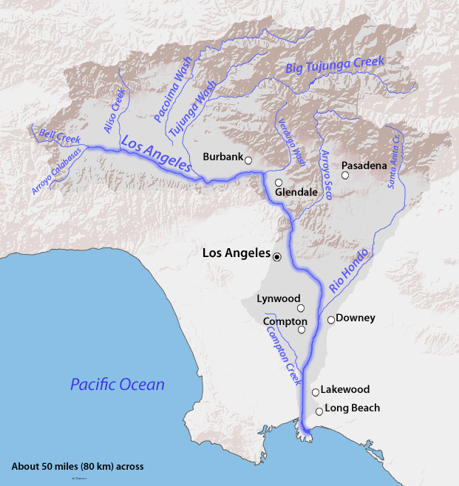
https://en.wikipedia.org/wiki/Los_Angeles_River#/media/File:LARmap.jpg

The Los Angeles River Watershed covers a land area of 834 square miles. The eastern portion spans from the Santa Monica Mountains to the Simi Hills and in the west from the Santa Susana Mountains to the San Gabriel Mountains. The watershed encompasses and is shaped by the path of the Los Angeles River, which flows from its headwaters in the mountains eastward to the northern corner of Griffith Park. Here the channel turns southward through the Glendale Narrows before it flows across the coastal plain and into San Pedro Bay near Long Beach. The Los Angeles River has evolved from an uncontrolled, meandering river providing a valuable source of water for early inhabitants to a major flood protection waterway.

Source: Los Angeles County Department of Public Works, http://dpw.lacounty.gov/wmd/watershed/la/

The Santa Ana River Watershed
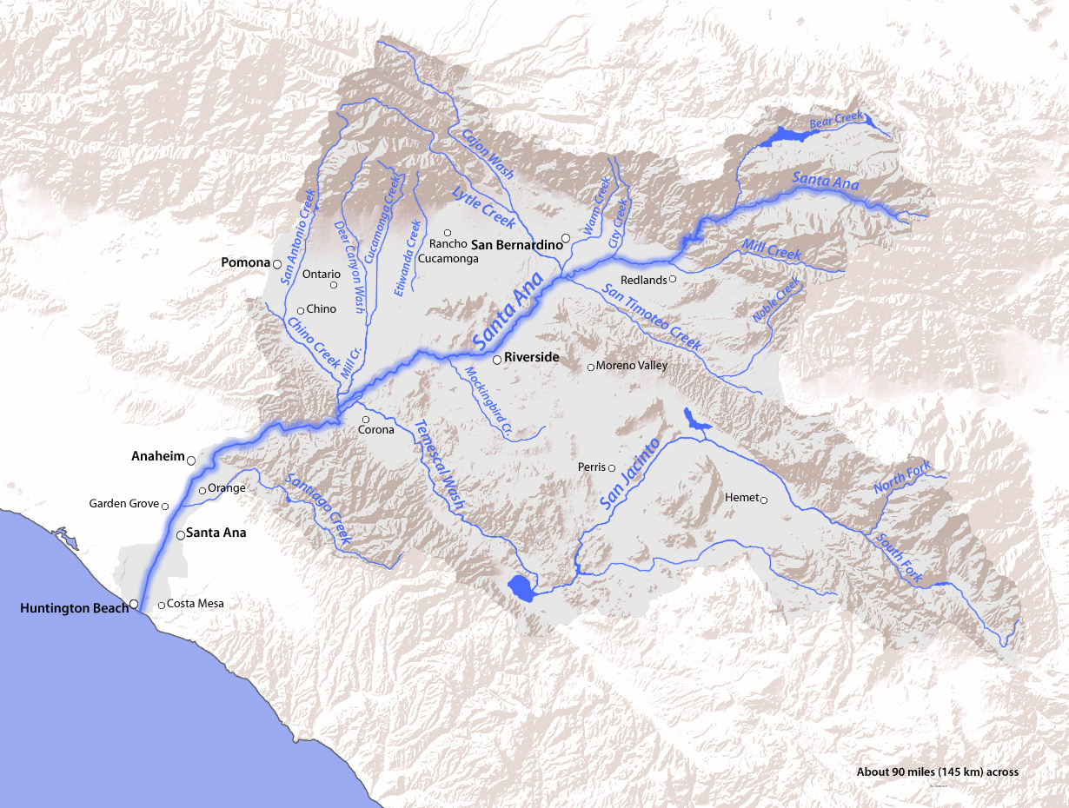

https://en.wikipedia.org/wiki/Temescal_Creek_%28Riverside_County%29#/media/File:SAR_Map.jpg

The Santa Ana River Watershed is Southern California’s largest watershed that has been largely channelized, diverted and urbanized. It begins approximately 96 miles away from the coast and contains over 50 tributaries. The primary waterway is the Santa Ana River, which is about 700 miles long in length with its tributaries. Its headwaters are located high above the valley floors of the Inland Empire, in the San Bernardino Mountains, crossing through central Orange County before emptying into the Pacific Ocean. The watershed catches storm water in 2,650 square miles of mountains, foothills and valleys that drain into the Santa Ana River in four different counties: San Bernardino, Riverside, Orange County and a small portion of Los Angeles County. Today the watershed is home to more than 4.8 million residents.

Source: Aqueduct Futures: Los Angeles Aqueduct Centennial Project at Cal Poly Pomona
https://aqueductfutures.wordpress.com/2013/03/04/santa-ana-river-watershed/
Position A

Document 1:
Bridge over Los Angeles River that was washed away by floods, circa 1927

Santa Ana River flood, Chapman Avenue, Orange, California, 1938
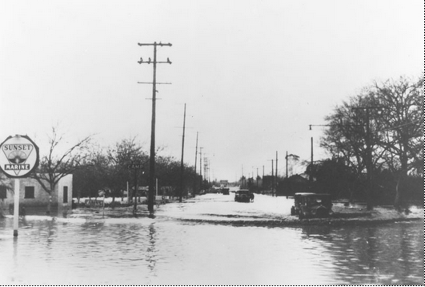
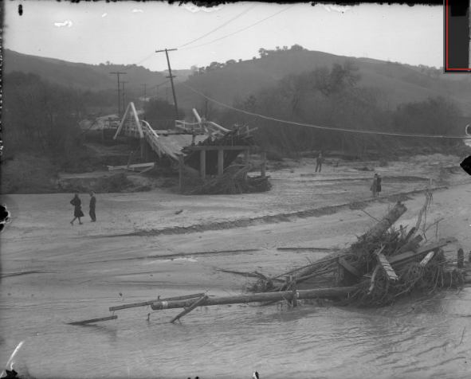

http://digital.library.ucla.edu/collections/
islandora/object/edu.ucla.library.specialCollections.latimes:281

http://oac.cdlib.org/ark:/13030/kt6v19p6hk/?brand=oac4

Document 2:
John T. Andres, “Adapting California’s Water Sector to a Changing Climate” in Allison Lassiter, ed., Sustainable Water: Challenges and Solutions from California (Berkeley: University of California Press, 2015), 12-16.

CLIMATE CHANGE IMPACTS ON CALIFORNIA'S WATER
We are likely already witnessing the impacts of a changing climate on California's water-in precipitation, snowpack, rivers, and estuaries and should not be surprised if these impacts amplify, accelerate, or abruptly adjust in the coming decades...
Precipitation
During the twentieth century, the average amount of California's precipitation remained steady-neither more nor less (California Environmental Protection Agency 2013). But when describing water in California, "average" often means little. For instance, precipitation is about more than the absolute volume of water; details matter, such as precipitation's form, location, timing, intensity, duration, and variability. So though average volume has not changed thus far, the form of precipitation already has, with more precipitation falling as rain rather than snow (California Department of Water Resources 2014).
Hydrology
Because of its snowpack-dominated hydrology, much of California's water supply stands vulnerable to climate change. In fact, across the state, rivers are already exhibiting changes in runoff timing, reflecting changes in the snowpack (California Environmental Protection Agency 2013)…This trend is based upon good old-fashioned data—no computer models, no future-GHG-emission scenarios, and no other assumptions leading to layers of uncertainty about the future. This shift in hydrology is troublesome for California's communal surface water storage system, which must meet multiple objectives: water supply, flood management, hydroelectric generation, environmental protection, and recreation. During winter, reservoirs in the Central Valley are deliberately drained to create reserve capacity, in order to intercept flood peaks and thereby protect people and places downstream.
By early spring, these flood reservations are lifted, allowing water managers to harvest the spring runoff, which is necessary to carry California through the dry months of summer and early fall. However, snow now melts earlier in the year, likewise shifting runoff to earlier in the year, when often there is already too much water to manage…
Although there is anxiety about aridity, too much water remains the clear and present danger. During the twentieth century-again, without relying upon computers, scenarios, or assumptions- it is clear that California's rivers experienced larger flood peaks (Roos and Anderson 2006)…
California's flood infrastructure is aging, and much of it was intended to protect farms instead of cities. Flooding immediately impacts human safety, drinking water quality, and crops, and the long recovery from flooding prolongs the misery, adding ordeals such as disease transmission, mold, housing displacement, business resumption, and mental health distress (California Natural Resources Agency 2014). The increased flood risk from climate change may fall hardest on the poor, because of where they live and their lack of resources and mobility…

Document 3: Big Plans, and Concerns, Surround L.A. River's Revitalization,” Los Angeles Times, May 24, 2014
Plans pending
Final plans and funding for the L.A. River restoration project are pending with the U.S. Army Corps of Engineers, which manages the river as a flood control channel.
Mayor Eric Garcetti and other city officials are lobbying federal officials for a plan that would spend $1 billion in local, state and federal money over several years to overhaul much of an 11-mile soft-bottomed stretch of the river between Griffith Park and downtown. A less costly option would provide about $450 million.
Critics' concerns
Critics of the city's plan argue that the rush to develop the river corridor will place an unsupportable burden on sewers and streets in working-class communities that straddle the waterway. They also wonder whether it will displace families that for generations have called riverfront communities home.
"As things get more attractive, they get more expensive and then folks who live below the income line are impacted," said Joe Edmiston, executive director of the Santa Monica Mountains Conservancy. "Gentrification is the fundamental public policy issue that must addressed."
Old-timers remember similar issues from the past. Many Los Angeles residents opposed construction of five major freeway systems over a 35-year period but were powerless to stop them. Longtime residents of Chavez Ravine were forcibly uprooted in 1959 to build the stadium where the Dodgers now play.
Cecelia Dominguez, 60, is among those who fear for the future. She lives in Elysian Valley.
"My husband's family was among those displaced from Chavez Ravine," Dominguez said. "When we moved to Elysian Valley in the 1970s he vowed, 'They will never take us away from here.'"
The median price of a house in Elysian Valley rose 21% over the last year to $443,400, according to Zillow.com, an online real estate database. "That's a large increase for Elysian Valley," said William Yu, an economist at the UCLA Anderson Forecast. Countywide, median house prices were up 16% over the same period.
City officials say they have not spoken out about such concerns because they are focused on an immediate goal: persuading the Army Corps to invest hundreds of millions of dollars on river improvements.
In an interview, Garcetti said his staff is "doing whatever we can do to balance affordable housing with access for children and students and making sure [the river corridor] doesn't turn into a playground for the rich."
"What we're looking for are creative community builders to work closely with neighborhoods that abut the river," he said. "And that's always a balance — everyone wants the good of gentrification and not the bad."
Major development along the river is essential, said David Bergman, a professor of urban planning at the Southern California Institute of Architecture. Any large-scale ecological restoration would have to include development of surrounding property to help pay for it, he said.
"Forty years ago, when we wanted a library, community center or park, there was money for it," Bergman said. "Not anymore.
"To pay for a new park, for instance, you have to upgrade the land around it with development opportunities," he said. "Any time you do that, there are going to be winners and losers."
FOLAR, or Friends of the Los Angeles River, a 20-year-old nonprofit credited with igniting interest in restoring the river to a more natural state, is also voicing concern. The organization feels overshadowed by what it sees as the Revitalization Corp.'s largely pro-development efforts.
"It's as though they came in and said, 'Thanks, FOLAR, but we're taking it from here,'" FOLAR board Chairman Alejandro Ortiz said.
Los Angeles attorney Robert Garcia, executive director of the City Project, a nonprofit dedicated to broadening access to parks and open space for inner-city residents, said he foresees tumultuous times over the future of the river.
"Historically, the city treated its river as an industrial wasteland with low rents for homes and small businesses," Garcia said, seated on a park bench near a downtown area proposed for riverside development. "Now, developers are urging commercial buyers to snatch up land along the river's shoulders.
"Sadly," he said, "a land grab is underway."
Source: Los Angeles Times, http://www.latimes.com/local/la-me-lariver-development-20140524-story.html

Position B

Document 1: Big Plans, and Concerns, Surround L.A. River's Revitalization,” Los Angeles Times, May 24, 2014
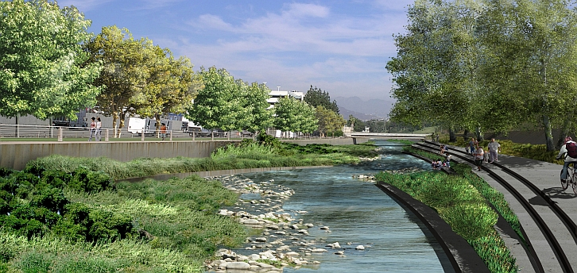
Source: http://www.lariver.org/index.htm

Document 2: Big Plans, and Concerns, Surround L.A. River's Revitalization,” Los Angeles Times, May 24, 2014
Plans pending
Final plans and funding for the L.A. River restoration project are pending with the U.S. Army Corps of Engineers, which manages the river as a flood control channel.
Mayor Eric Garcetti and other city officials are lobbying federal officials for a plan that would spend $1 billion in local, state and federal money over several years to overhaul much of an 11-mile soft-bottomed stretch of the river between Griffith Park and downtown. A less costly option would provide about $450 million.
The corps' decision, expected early next year, will determine how much money the federal government will give to restore portions of the river for habitat and recreational amenities including bikeways, hiking trails, parks and kayak launch points.
Those enhancements are estimated to trigger billions of dollars in residential, commercial and office development along the entire 51-mile length of the river. The Revitalization Corp. says the project could generate up to 18,000 jobs and more than $5 billion in development investment over the next 10 to 15 years.
A recent brochure by Jones Lang LaSalle, a global commercial real estate services firm, contains glossy photos of river-adjacent industrial land touted as a "future hub of the creative economy … ripe for office, multifamily, and retail development."
In Canoga Park, 25 miles northwest of downtown, a newly adopted Warner Center development plan paves the way for investors to build residential towers near the headwaters. At the river's mouth, Long Beach officials envision riverfront villages.
In between, new riverside parks and wetlands are popping up in the communities of Maywood, South Gate, Paramount, Long Beach and elsewhere.
In Elysian Valley, a roughly 2.5-mile section of the river that is at the heart of the 11-mile first-phase section, the blue-collar community is being reshaped by hip architectural firms, design shops, art studios, craft-beer makers and restaurants.
Buyers are picking up World War II-era warehouses and vacant lots with bucolic views of the river shaded by sycamore and oak trees.
The newcomers include Golden Road Brewery, which relocated to be part of the L.A. River culture, said Brian Dewey, vice president of sales at the brewery restaurant business.
"The area was also full of the kinds of creative spaces we like: old warehouses at affordable prices with room for dining rooms, fermenters and loading docks," he said.
Art Yanez, owner of FSY Architects, said he bought land and moved into the area five months ago because of plans for the river and the growing artistic community. "We've already gotten offers to sell, but I turned them down," Yanez said.
A few blocks away, architect Kevin Mulcahy of RAC Design Build said the firm opened in a "tired old warehouse" two years ago.
"The explosive growth here is something you feel and know at a visceral level," Mulcahy said. "At the same time, it is worrisome to hear others talk about the scale of potential development they believe is yet to come — a Century City superimposed on the river."
The city and the Revitalization Corp. are collaborating on plans to designate 10 Elysian Valley streets that dead-end at the river as "Rio Vista" access points for hikers and bicyclists. Later this year, construction will start on a futuristic $6-million steel pedestrian bridge that connects Atwater Village with Griffith Park.
Nearby, Taylor Yard is to become a park of wetlands threaded by bike paths framed by retail, office and residential development.
The city also has its eyes on a still-operating rail yard northeast of the Twin Towers jail, hoping the property can become an urban village of residential towers, shopping and green space with pedestrian links to downtown. But Union Pacific staunchly opposes the plan to abandon its downtown rail center at a time when it is investing $100 million in upgrades.
Source: Los Angeles Times, http://www.latimes.com/local/la-me-lariver-development-20140524-story.html

Document 3:
“How California is Turning Drainage Canals Back to Rivers,” Los Angeles Times, October 27, 2014 (2:46):

Source: Los Angeles Times, http://www.latimes.com/local/california/la-me-adv-santa-ana-river-20141027-story.html

Student Directions for Academic Controversy

What is the issue?______________________________________

____________________________________________________

____________________________________________________

Position A | Position B

I. Partners Prepare

a. Read or watch your materials and find evidence to support your side of the argument. Write this in the chart that you have been provided with.

II. Position Presentation

a. Side A presents their position using supporting evidence from the texts.
b. Side B restates to Side A’s satisfaction.
c. Side B presents their position using supporting evidence from the texts.
d. Side A restates to Side B’s satisfaction.
Students may want to use the following frames:
This source is important because…
The value of this piece of evidence is …
The evidence of this source is convincing because…

III. Consensus-Building

- After each pair has presented their evidence, discuss which evidence is most convincing. What is convincing about the evidence? Write out a quotation and cite it.
- Is there unconvincing evidence? What makes it unconvincing?
Write out a quotation and cite it.

Adapted from: http://teachinghistory.org/teaching-materials/teaching-guides/21731 and http://serc.carleton.edu/sp/library/sac/what.html
And Chauncy Monte-Sano, et al. Reading, Thinking, and Writing About History

