Performance Task: Toilet Scarcity
Toilet Access in the Developing World
From: Common Core Workshop, Nicole Gilbertson, 2015
History Standards: Economics 12.4
Students analyze the elements of the U.S. labor market in a global setting.
CCSS Standards: Reading, Grade 11-12
1. Cite specific textual evidence to support analysis of primary and secondary sources, connecting insights gained from specific details to an understanding of the text as a whole.
2. Determine the central ideas or information of a primary or secondary source; provide an accurate summary that makes clear the relationships among the key details and ideas.
3. Evaluate various explanations for actions or events and determine which explanation best accords with textual evidence, acknowledging where the text leaves matters uncertain.
4. Determine the meaning of words and phrases as they are used in a text, including analyzing how an author uses and refines the meaning of a key term over the course of a text (e.g., how Madison defines faction in Federalist No. 10).
6. Evaluate authors’ differing points of view on the same historical event or issue by assessing the authors’ claims, reasoning, and evidence
7. Integrate and evaluate multiple sources of information presented in diverse formats and media (e.g., visually, quantitatively, as well as in words) in order to address a question or solve a problem.
8. Evaluate an author’s premises, claims, and evidence by corroborating or challenging them with other information.
9. Integrate information from diverse sources, both primary and secondary, into a coherent understanding of an idea or event, noting discrepancies among sources.
10 . By the end of grade 12, read and comprehend history/social studies texts in the grades 11–CCR text complexity band independently and proficiently.
Writing, Grade 11-12
1. Write arguments focused on discipline-specific content.
4. Produce clear and coherent writing in which the development, organization, and style are appropriate to task, purpose, and audience.
7. Conduct short as well as more sustained research projects to answer a question (including a self-generated question) or solve a problem; narrow or broaden the inquiry when appropriate; synthesize multiple sources on the subject, demonstrating understanding of the subject under investigation.
8. Gather relevant information from multiple authoritative print and digital sources, using advanced searches effectively; assess the strengths and limitations of each source in terms of the specific task, purpose, and audience; integrate information into the text selectively to maintain the flow of ideas, avoiding plagiarism and overreliance on any one source and following a standard format for citation.
10. Write routinely over extended time frames (time for reflection and revision) and shorter time frames (a single sitting or a day or two) for a range of discipline-specific tasks, purposes, and audiences.
Guiding Question:
What is the most important impact of the scarcity of toilets in the developing world?
Overview of Lesson:
Students will - alone, in partnerships, or in groups, according to their needs – review the sources below and decide which sources support each side of the argument. They will then write an argumentative essay, including a claim and counterclaim, detailing the most critical impact of toilet scarcity.

12th Grade Performance Task

Issue: What is the most important impact of the scarcity of toilets in the developing world?

Although having to ask permission to use the bathroom may be a hassle for students in US high schools, do you know that some people do not have access to toilets at all? The United Nations estimates that 2.5 billion people lack adequate access to bathrooms or toilets. On November 19 2014, the world celebrated International Toilet Day to raise awareness about this issue and to consider the impact of the scarcity of toilets has on economic development and social equality in the world.

Directions for Part 1
You will now examine and analyze a variety of sources on the topic of toilet scarcity. Take notes because you may want to refer to your notes while writing your argumentative essay. You can re-examine any of the sources as often as you like.

Directions for Part 2
You will now review your sources, take notes, and plan, draft, revise, and edit your essay. You may use your notes and refer to the sources. Now read your assignment and the information about how your argumentative essay will be scored; then begin your work.

Your assignment:
You are working for the Gates Foundation, which has committed to supporting access to toilets in high-poverty areas around the globe. As a way to raise awareness for this issue, you have to use evidence to choose how you will frame the debate about the scarcity of toilets and its effects. Given the evidence, choose the effect you think is most relevant for your organization to address as you advocate for increased access to toilets.

For a brief historical background on toilets, look here:
http://www.history.com/news/ask-history/who-invented-the-flush-toilet

For a brief video introducing the topic, look here:
https://www.youtube.com/watch?t=37&v=K12osl3B8co

Source 1:

mytoilet.org
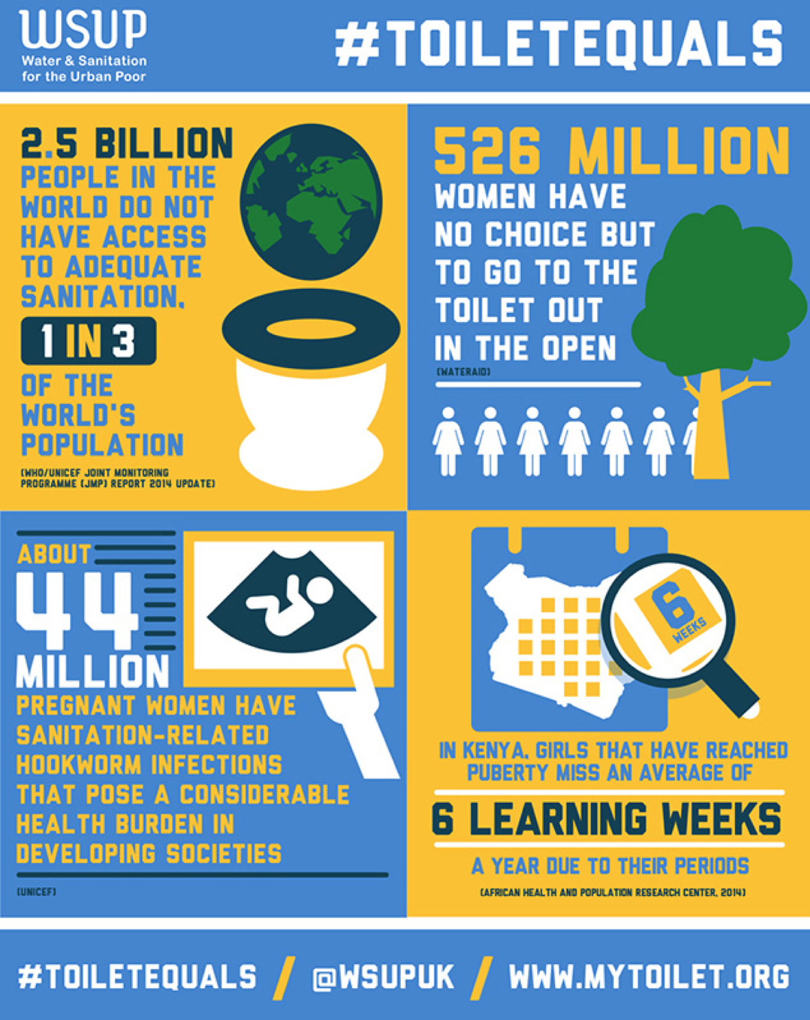

Source 2:

UN News Centre, http://www.un.org/apps/news/story.asp?NewsID=49378#.VItyq6agk28
19 November 2014 – With one out of three women worldwide lacking access to safe toilets, it is a moral imperative to end open defecation to ensure women and girls are not at risk of assault and rape simply because they lack a sanitation facility, United Nations Secretary-General Ban Ki-moon urged today on World Toilet Day.
In his message for the Day, commemorated annually on 19 November – with this year’s theme Equality, Dignity and the Link Between Gender-Based Violence and Sanitation – Mr. Ban said that addressing the sanitation challenge requires a global partnership and called on Member States to “spare no effort to bring equality, dignity and safety” to women and girls around the world.
But although it is the poor who overwhelmingly do not have toilets, everyone suffers from the contaminating effects of open defecation, so everyone should have a sense of urgency about addressing this problem.
“A staggering 1.25 billion women and girls would enjoy greater health and increased safety with improved sanitation. Evidence also shows safe and clean toilets encourage girls to stay in school,” the UN chief said.
In all, some 2.5 billion people worldwide do not have adequate toilets and among them 1 billion defecate in the open – in fields, bushes, or bodies of water – putting them, and especially children, in danger of deadly faecal-oral diseases like diarrhoea.
In 2013, more than 340,000 children under five died from diarrhoeal diseases due to a lack of safe water, sanitation and basic hygiene – an average of almost 1,000 deaths per day.
But women who do not have access to adequate toilets are especially at risk, since they are vulnerable to shame and potential violence when they seek a place to defecate.
Ensuring that women have access to proper sanitation and toilets is especially crucial as countries work to formulate a sustainable development agenda for the period beyond the year 2015, Mr. Ban urged.
“Communities must be supported as they strive to become open defecation-free. Advocacy efforts must step up and taboos must be broken,” the Secretary-General added. These are the objectives of the UN Call to Action on Sanitation to mobilize global, national and community efforts to improve hygiene, change social norms and eliminate open defecation by 2025.
In its remarks on the Day, the UN Children’s Fund (UNICEF) warned that slow progress on sanitation and the entrenched practice of open defecation among millions around the world continue to put children and their communities at risk.
“Lack of sanitation is a reliable marker of how the poorest in a country are faring,” said Sanjay Wijesekera, head of UNICEF’s global water, sanitation and hygiene (WASH) programmes.
“But although it is the poor who overwhelmingly do not have toilets, everyone suffers from the contaminating effects of open defecation, so everyone should have a sense of urgency about addressing this problem,” he added.
The call to end the practice of open defecation is being made with growing insistence as the links with childhood stunting become clearer. India, with 597 million (half the population) practising open defecation, also has high levels of stunting.
“The challenge of open defecation is one of both equity and dignity, and very often of safety as well, particularly for women and girls,” Wijesekera noted. “They have to wait until dark to relieve themselves, putting them in danger of attack, and worse, as we have seen recently.”
In May, the hanging of two teenage girls in Uttar Pradesh who had gone out after dark to defecate caused international shock and dismay, and highlighted the security issues involved in open defecation.
UNICEF’s Community Approaches to Total Sanitation addresses the problem at the local level by involving communities in devising solutions, and has led to some 26 million people across more than 50 countries abandoning the practice of open defecation since 2008.
Eighty-two per cent of the 1 billion people practising open defecation live in just 10 countries: India, Indonesia, Pakistan, Nigeria, Ethiopia, Sudan, Niger, Nepal, China, and Mozambique. The numbers of people practising open defecation are still rising in 26 countries in sub-Saharan Africa, though they have declined in Asia, Latin America and the Caribbean. In Nigeria, numbers of open defecators increased from 23 million in 1990 to 39 million in 2012.
Globally, some 1.9 billion people have gained access to improved sanitation since 1990. However, progress has not kept up with population growth and the Millennium Development Goal target on sanitation is unlikely to be reached by 2015 at current rates of progress…
The issue of sanitation has wide implications as it touches on economic development, waste management and the ever-increasing scarce water resource. Managing sanitation makes good economic sense, he said, adding that one dollar investment in sanitation equals to four dollars in economic growth.
“And then basically, it’s a matter of human rights…and to me it is also a matter of dignity,” Mr. Eliasson said. This year’s focus on women and sanitation is especially important. In some 20 countries, there are horrible examples of girls that go out in the field get attacked, rapped and even hanged.
“This has been a bit of a personal commitment, I actually saw children die in front of me in Somalia in 1992 of dehydration and diarrhoea,” he said.
Many times in schools there is only one hole in the back and that is reserved for boys. Girls are too ashamed to go and so it becomes impossible for them to go to school. Investing in water and sanitation has horizontal benefits.
Singapore’s Representative to the United Nations, Karen Tan, who has also led efforts on the initiative, said that people don’t like to talk about toilets.
“Pooing” and “peeing,” she said, are extremely taboo, but hopefully, even if people laugh and snicker, Governments will make steps to take action and raise awareness about this very serious issue.
There are many critical aspects to this Day, including education, equality, dignity, and human rights. Particularly, it is important to pay special attention to the challenges that women and girls face when they do not have access to toilets and proper sanitation.
Chair of UN-Water, Mr. Michel Jarraud said “we need to talk about open defecation – no matter how taboo it may feel.”
Ending open defecation is a crucial way to speed up development. “We have to work in every possible way to address the vulnerabilities and challenges faced by women who lack access to toilets and sanitation. In a number of countries, there is evidence that girls do not go to school if there are no toilets,” he said, echoing Mr. Eliasson.
“We need to close the gap between the ones who have and the ones who do not have,” he said, urging the need to put water and sanitation at the heart of the post-2015 development agenda.
World Toilet Day was established by the “Sanitation for All” resolution, adopted by the UN General Assembly in July 2013, designating 19 November as World Toilet Day. The Day is coordinated by UN-Water in collaboration with Governments and relevant stakeholders.

Source 3

Image part of exhibition, “My Toilet: Global Stories from Women and Girls” found at:
http://www.npr.org/blogs/goatsandsoda/2014/11/19/364775062/me-myself-and-the-loo-a-womans-future-can-rest-on-a-toilet

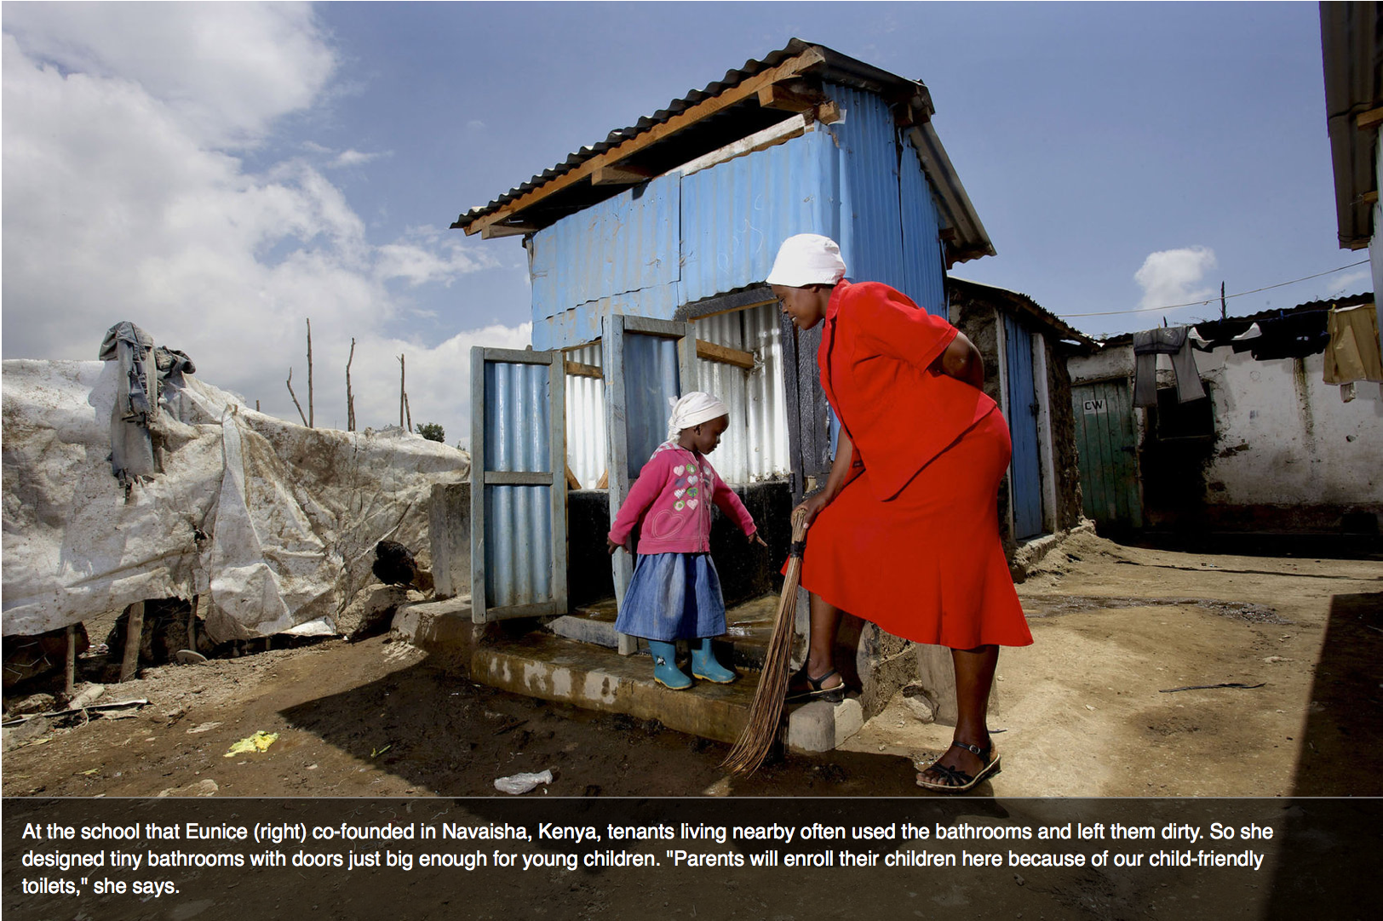

Source 4:

August 20, 2012, “West African desperate for cleaner toilets to save slums from cholera,” The Guardian
Aid agencies are scrambling to treat thousands of cholera patients in Sierra Leone's capital, Freetown, where the number of infections is mounting by more than 250 per day. Most patients are from the city's urban slums, where open defecation is rife, toilets are rare, sewage is improperly disposed of and awareness of cholera is low. Water and sanitation specialists say unless these problems are addressed, cholera will continue to flourish both in Sierra Leone and throughout west Africa.
By 15 August, more than 19,000 people had contracted cholera in west Africa, the most affected countries being Sierra Leone, Ghana, Niger and Guinea, according to the UN Children's Fund Unicef.
"There is a massive failure to take cholera seriously in this region, and to publicise it," said a west Africa cholera specialist. "Ultimately, if you want to get rid of cholera you need to address the structural issues that cause it." The money is there, "it is a question of tapping into it and taking responsibility for your citizens".
Most west African countries are falling far short of their millennium development goal to double the proportion of citizens with access to proper sanitation facilities – only 37% of inhabitants can access a clean toilet, according to the World Health Organisation (pdf).
As in Freetown, a high proportion of the cholera cases in Conakry, the Guinean capital, and Accra, Ghana's capital, are concentrated in urban slums, where there are few clean toilets and most people openly defecate, often dangerously close to open wells that are the source of water for most residents.
Governments tend to clean up the cholera mess once it is in full swing rather than working on prevention, said an independent water, sanitation and hygiene (Wash) specialist, adding: "It is government's responsibility to address the very basic sanitation rights of its citizens…"
In Greater Accra, with 77% of the country's cholera cases, at least 20,000 people have no toilet or use bucket latrines, according to the Accra health department director, Simpson Boateng. Those living near the sea defecate on the beach.
The Ghanaian government banned open defecation and bucket latrines in 2010, and arrests all perpetrators, said Boateng. "We need to continue to educate them [people], but more importantly, you will be arrested when caught," he told IRIN. "As I speak, over 1,000 landlords have been prosecuted for still using pan latrines in their houses." The city council is establishing a "sanitation court" to try the culprits. "We are simply enforcing the bylaws that frown upon this conduct," he said.
Unlike in neighbouring Guinea and Sierra Leone, where the governments are weak and rely on aid agencies to drive the response, the Ghanaian authorities are leading the cholera action but have "underplayed it" for political purposes, said Laurent…
Arrests may be a temporary deterrent, but people will continue to defecate in the open as long as they have no alternative, say aid agency staff. Only 17% of Accra's residents, and 8% of rural Ghanaians, have access to an adequate toilet, according to the government's 2008 health survey.
The key is to get communities across west Africa to want to use and maintain clean toilets. In Sierra Leone, Unicef is pushing community-driven total sanitation, in which communities move away from open defecation once they understand its consequences, and go on to build and maintain clean toilets themselves.
In this model, Unilever, which manufactures cleaning products, has worked with Unicef and local partners in Gambia, and with Water and Sanitation for the Urban Poor, a non-profit group, in Ghana to form the Clean Team. The process is: trigger a demand for toilets through behaviour change; arrive at a price that works for everyone; make clean toilets available.
A project in Kumasi, in south-central Ghana, targeted 100 families, most of whom were sharing dirty latrines. Each was given a free chemical toilet with a sealed waste container that was exchanged two to three times per week. A family of five pays about $15 per month for the service, which is less than it costs to use the public toilets.
The waste is processed in the city's septic tank system, but the municipality hopes to use it to produce biofuel. So far the scheme has improved hygiene, lowered household costs and reduced the use of plastic bags for defecation, said Clean Team manager Asantewa Gyamfi. The plan is to expand it to 1,500 families.

Source 5: Language may be too explicit for students
Jessica Yu, “Meet Mr. Toilet”
https://www.youtube.com/watch?v=ZrCvrAuW5VU

Related articles:
http://www.todayonline.com/world/asia/better-sanitation-key-to-empowering%20women-say-experts

