Gross Domestic Product
Economic Measurement
From: Newport Mesa Unified School District, 2015

History Standards: Economics 12.5.2
Define, calculate, and explain the significance of an unemployment rate, the number of new jobs created monthly, an inflation or deflation rate, and a rate of economic growth.
CCSS Standards: Reading, Grades 11-12
1. Cite specific textual evidence to support analysis of primary and secondary sources, connecting insights gained from specific details to an understanding of the text as a whole.
2. Determine the central ideas or information of a primary or secondary source; provide an accurate summary that makes clear the relationships among the key details and ideas.
3. Evaluate various explanations for actions or events and determine which explanation best accords with textual evidence, acknowledging where the text leaves matters uncertain.
4. Determine the meaning of words and phrases as they are used in a text, including analyzing how an author uses and refines the meaning of a key term over the course of a text (e.g., how Madison defines faction in Federalist No. 10).
6. Evaluate authors’ differing points of view on the same historical event or issue by assessing the authors’ claims, reasoning, and evidence.
7. Integrate and evaluate multiple sources of information presented in diverse formats and media (e.g., visually, quantitatively, as well as in words) in order to address a question or solve a problem.
9. Integrate information from diverse sources, both primary and secondary, into a coherent understanding of an idea or event, noting discrepancies among sources.

Guiding Question: How useful is the GDP as an economic measurement?
Overview of Lesson:
Introduce the guiding question to the lesson and clarify any terms that may be new. As a class, go through the first source and answer the questions, connecting back to the guiding question at the end. Then have students split up into small groups, partnerships, or individuals to address the remaining sources.

Lesson Question: How useful is the GDP as an economic measurement?

Source 1: “The GDP And Its Importance” by Elvis Picardo, CFA
December 12, 2013

Gross Domestic Product (GDP) is one of the most widely used measures of an economy’s output or production. It is defined as the total value of goods and services produced within a country’s borders in a specific time period – monthly, quarterly or annually. GDP is an accurate indication of an economy's size, while GDP per capita has a close correlation [connection] with the trend in living standards over time, and the GDP growth rate is probably the single best indicator of economic growth. As Nobel laureate Paul A. Samuelson and economist William Nordhaus put it, “While GDP and the rest of the national income accounts may seem to be arcane [not understandable] concepts, they are truly among the great inventions of the twentieth century.” Here’s why.

Samuelson and Nordhaus..liken the ability of GDP to give an overall picture of the state of the economy to that of a satellite in space that can survey the weather across an entire continent. GDP enables policymakers and central banks to judge whether the economy is contracting or expanding, whether it needs a boost or restraint, and if a threat such as a recession [downturn] or inflation [rising prices] looms on the horizon.

The national income and product accounts (NIPA), which form the basis for measuring GDP, allow policymakers, economists and business to analyze the impact of such variables as monetary and fiscal policy, economic shocks such as a spike in oil price, as well as tax and spending plans, on the overall economy and on specific components of it. Along with better informed policies and institutions, national accounts have contributed to a significant reduction in the severity of business cycles since the end of world War II.

Investopedia is digital financial education platform that seeks to provide knowledge for intelligent investment and financial decisions.
http://www.investopedia.com/articles/investing/121213/gdp-and-its-importance.asp

1. What is GDP?

2. Why does Samuelson and Nordaus favor the use of a GDP index?

3. How does this source help you answer the question?

Source 2 & 3:
The following graphs compare GDP figures with an alternate measurement known as the Social Progress Index (SPI). The Social Progress Index determines what it means to be a good society according to three dimensions: Basic Human Needs (food, water, shelter, safety); Foundations of Wellbeing (basic education, information, health and a sustainable environment); and Opportunity (do people have rights, freedom of choice, freedom from discrimination, and access to higher education?

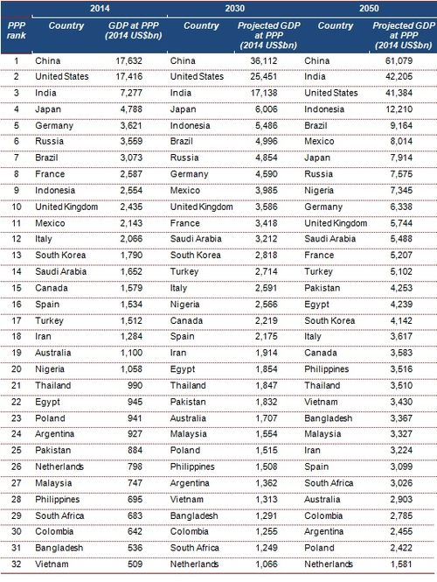
GDP 2014
1. How does this source help you answer the question?

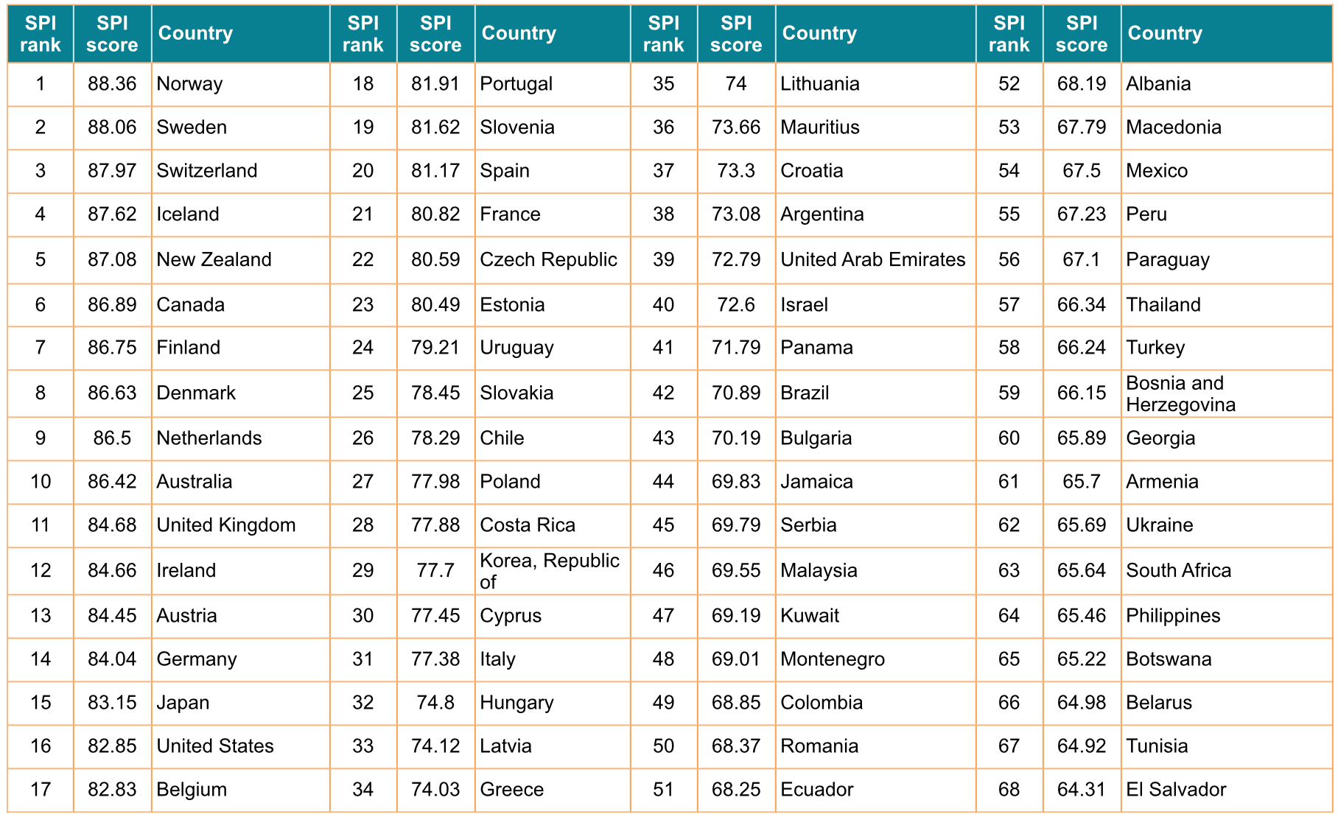
SPI 2014

1. After comparing these two tables, what conclusions can we draw about the use GDP as a measurement?
[GDP doesn’t account for enough—that being a rich society doesn’t mean everyone in that society is cared for.]

2. How does the following graph, fit with or change your ideas about the GDP index?
[This shows that the GDP doesn’t really connect with individual prosperity.]

3. How does this source help you answer the question?

Source 4:

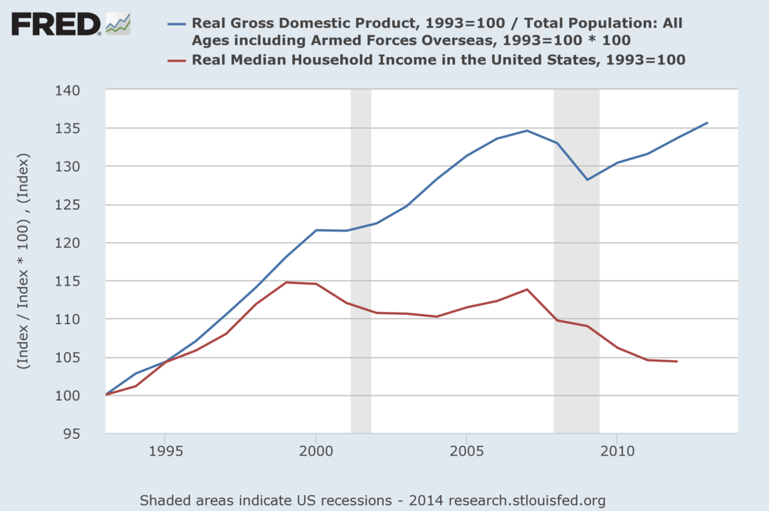
https://research.stlouisfed.org/fred2/graph/?graph_id=195323#

1. What does this source say about the affect the GDP has on the growth of median households income? Do they appear to be correlated? What do you think affects people’s lives more?

2. How does this source help you answer the question?

Source 5:: Excerpt, Speech Robert Kennedy
March 18, 1968

Too much and for too long, we seem to have surrendered personal excellence and community value in the mere accumulation of material things. Our [GDP] ...counts air pollution and cigarette advertising and ambulances to clear our highways of carnage. It counts special locks for our doors and the jails for the people who break them. It counts the destruction of the redwoods and the loss of our natural wonder in chaotic sprawl. It counts napalm and it counts nuclear warheads, and armored cars for the police to fight riots in our cities.

Yet the [GDP] does not allow for the health of our children, the quality of their education, or the joy of their play. It does not include the beauty of our poetry or the strength of our marriages, the intelligence of our public debate or the integrity of our public officials. It measures neither our wit nor our courage, neither our wisdom nor our learning, neither our compassion nor our devotion to our country; it measures everything, in short, except that which makes life worthwhile.

1. What kinds of things does Kennedy say the GDP accounts for (includes in the overall “production” and output of the economy”)?
Lists of things –polution, cigarettes, napalm, etc. that are clearly “bad” for people.

2. Do you think he is considering these things “positive” or encouraging signs of growth? No, he is showing the irony of seeing economic growth as necessarily good for people.

3.What does the GDP not account for? Ultimately, what might he be saying about the significance of this figure?
He says it doesn’t account for quality of life or happiness. Thus, less emphasis should be placed on GDP as an indicator of how country is doing.

4. How does this source help you answer the question?

Source 6: “Growing pains: Measure a country purely against its GDP and you neglect the wellbeing of its people. Yet can that be measured?” Aeon
by Diane Coyle

Does it make sense, then, to ‘adjust’ GDP to acknowledge this range of both positive and negative omissions? That path seems wholly misguided to me. There’d be endless arguments about what to include and exclude, and what weights to give different elements of a new GDP definition…More fundamentally, we need to keep distinct the two concepts of economic activity and well-being, and more aggressively direct policy towards the latter. One option, currently practised by the UK’s Office for National Statistics (ONS), is to measure well-being directly through an annual survey. However… Many of the things we value are notoriously difficult measure in monetary terms, and add up. So why try? Organisations such as the OECD with its Better Life Index, and the Australian Bureau of Statistics, have been working on ‘dashboards’ of the indicators of well-being, including economic indicators such as income and jobs, but also the quality of the natural and urban environment, work-life balance, health, engagement in the local community, and access to education. …

The most important trade-off to measure, and report to citizens, is that between the present and the future; in other words, sustainability…. [A]ssessing sustainability depends on the depletion or accumulation of assets. And the statistics needed to do that – for environmental assets as well as physical ones…This kind of measurement would tell us if we were enjoying the fruits of economic growth (higher GDP) only by eating up tomorrow’s capital. If all the innovation and creativity encapsulated in the measurement of growth proves unsustainable, then we might well be looking at the end of progress. But we do not yet know the answer, and we will not find out by changing or scrapping GDP.
https://aeon.co/essays/has-gdp-reached-its-limits-as-a-useful-measure

Aeon is an on-line publication founded in London, but also has offices in Melbourne and New York. It is not affiliated with any other organisation or political group. Aeon is committed to big ideas, serious enquiry, a humane worldview on science, philosophy and society.

1. What kinds of adjustments can and should be made to the GDP? Are such modifications easily implemented?
There should be two different measures—for economics and well being. However “well-being is very subjective”.

2. What is the most important modification that should be made in the GDP?
Sustainability and environmental impact.

After reading Sources 1-6, respond to the following question:
How useful is the GDP as an economic measurement?

