History of the Hominids
Neolithic Era
From: Bowers Museum Workshop, Emily Markussen Sorsher, 2013

History Standards: 6.1
Students describe what is known through archaeological studies of the early physical and cultural development of humankind from the Paleolithic era to the agricultural revolution.
CCSS Standards: Grades 6-8
History - Reading
2. Determine the central ideas or information of a primary or secondary source; provide an accurate summary of the source distinct from prior knowledge or opinions.
7. Integrate visual information (e.g., in charts, graphs, photographs, videos, or maps) with other information in print and digital texts.
English – Reading Informational Text
2. Determine a theme or central idea of a text and analyze in detail its development over the course of the text, including how it emerges and is shaped and refined by specific details; provide an objective summary of the text.
7. Integrate information presented in different media or formats (e.g., visually, quantitatively) as well as in words to develop a coherent understanding of a topic or issue.
Guiding Question:
Who were the early hominids?
Overview of Lesson:
The completion of the worksheet will be considered the assessment on this assignment, a formative assessment in a longer unit.

As an exit ticket activity, teachers may also have students work in groups to create a “one liner” for the study of early humans. Why should other kids, and adults, learn more about human pre-history? Example: Knowing where we came from may show us where we’re going!

Student Background Knowledge:
Students will need a basic understanding of world geography, and some knowledge of human evolution. The following terminology should also be reviewed, with student friendly definitions provided:
- Archaeology/archaeologist/archaeological
- Anthropology/anthropologist/anthropological
- Evolution/evolve
- Fossils/fossilized
- Upright

Learning Sequence:
- Break students into groups
- Review the 5 Ws – who, what, when, where, why. Explain how historians use these questions to guide their thinking and their research when they read.
- Give students the background reading, maps, and timeline.
- Ask and post on the board some pre-reading questions:
  - What type of information do you need to look for in the reading to learn about who discovered these early humans?
  - What type of information do you need to look for in the reading to learn about what was discovered?
  - What type of information do you need to look for in the reading to learn about where human communities were located?
  - What type of information do you need to look for in the reading to learn about when human communities existed?
- WHO - For the first reading, the teacher may lead the class through the discussion, so that students see a model of our thought process while reading. Read through the piece, stopping at the end of each section to answer questions, and look for evidence of WHO found early hominids. Circle the answers when you find them and have students do the same.
- WHAT - Students may now work in groups. Set the timer and ask the students to read again for WHAT the scientists found. You may ask for whole-group answers when the timer goes off, if you’d like.
- WHERE - Ask students WHERE the remains were found. “Africa” is a good place to start…but where in Africa (hint: the background reading mentions two places)? Show students the small map of the Middle Awash in Ethiopia, and explain that two of the finds were made in this area. Have students work in teams to locate Ethiopia on a map, and shade the Middle Awash. Then, have students find Chad on the large map, and put a star in it. Is it close to Ethiopia? Could early humans have walked all that way? Have students discuss in small groups or whole class.
- WHEN - According to the background reading, each fossil was a different age. Have students work in teams to place each fossil on the timeline…when did Lucy live? When did the Leakey skeleton live? When did the Brunet skull live? Set a timer to ensure that students keep moving along.
- See “Assessment” for exit ticket activity on WHY

Options
- For advanced students, have them read the secondary source “Discoverer of Lucy Fossil Weighs in On Human Evolution”, and find their answers there as well. Discuss how the two pieces are different in their tone and purpose, and ask students what information came from which reading.
- Rather than having students work in groups, some students may be ready to work individually. Assign each of four students one of the first four Ws, and have them search the text specifically for that information. Then, give them time to go around in their groups and have each student share their answers.

Background Reading: The Earliest Humans

What type of information do you need to look for in the reading to learn about who discovered these early humans? List some ideas of what to look for here:
1.
2.
3.

Searching for Our Beginnings: Early Humans
Anthropologists search for the answer to a difficult question – when did the first people appear on Earth? Until the 20th century, no one knew. As archaeologists began to search the globe for evidence, however, they uncovered pieces of our past in the form of fossilized remains.

What is an anthropologist? What is an archaeologist? What is the difference?
An anthropologist studies ____________________________.
An archaeologist studies _________________________________.
They study __________________________, making them different.

In 1959, Mary and Louis Leakey found human fossils. They were located in East Africa, in a place called Olduvai Gorge. The fossils contained large molars, or rear teeth, usually be used for eating plants rather than the meat of animals. Testing revealed that these remains were over 1.75 million years old. More importantly, the discovery suggested that a good place to look for early human remains was Africa.

What is a fossil? _________________
WHO found these fossils? ______________________
Where did they find them? _________________________

Humans in Africa
Fifteen years after the Leakeys’ find, American scientist Donald Johanson was searching for more fossils in Ethiopia. After three years of digging, he took a lunch break on a hot day and took the long route back to camp. As he passed through a dry gully, he noticed a tiny bone sticking out of the ground. It was part of the forearm of a skeleton. As he searched, Johanson found a pelvis, leg, jaw, and skull. Over the next two weeks, his team found hundred of pieces of bone, enough to create 40% of a skeleton.

WHO found these fossils?

These pieces belonged to a woman about 3.5 feet tall. Since they didn’t find two examples of any one bone (i.e., two skulls or three knees), the team knew all of the pieces belonged to her. They named the skeleton Lucy, after a popular Beatles’ song “Lucy in the Sky with Diamonds”.

Lucy’s bones, especially those in her lower half, are very much like our own. Her legs, pelvis, feet, and spine tell anthropologists that she walked upright, or on two legs. Scientists also determined that Lucy lived 3.2 million years ago.
How do we know Lucy walked upright?
We know Lucy walked upright, on two legs, because ____________________________________.

After the discovery of Lucy, many other anthropologists have searched for human remains in Africa. In the 1990s, another American named Tim White found fossils even older than Lucy – the remains of humans that were 4.4 million years old. These, too, were found in Ethiopia. The skull of this individual was crushed, leading White to suspect a larger animal, such as an elephant, may have stepped on it after death.

WHO found these fossils?
Why are these fossils special?

How Old Are We?
Lucy led to many discoveries that taught scientists a great deal about our past. They now believe the first humans lived in Africa about 4.5 million years ago. However, some experts disagree. French scientist Michael Brunet found a skull in Chad, another African nation, that appeared to be human. This skull was nearly 7 million years old. Could humans have existed that long ago?

This find took place in Central Africa, over a thousand miles away from Lucy and the Leakey fossils. Could the first humans have evolved here, instead? The skull Brunet found also looks much more ape-like. Does that mean it isn’t human?

As the search goes on, scientists continue to debate these questions.

Name the scientists who found fossils in Africa.

Who found which fossils?
The Leakey fossils were found by __________________
Lucy was found by ______________________
Human fossils 4.4 million years old were found by ____________________
The 7 million year old skull was found by ____________________

What does it mean to “evolve”?

Second Reading: Go back through the article and circle WHAT was found by each scientist. You may want to make these circles darker and thicker so that they stand out to you. List the items found here – be as specific as you can be.
1.
2.
3.
4.

Map Activity
Using the small map to see where human fossils were found in Ethiopia. Then shade that area with a highlighter or light pencil on the big map.
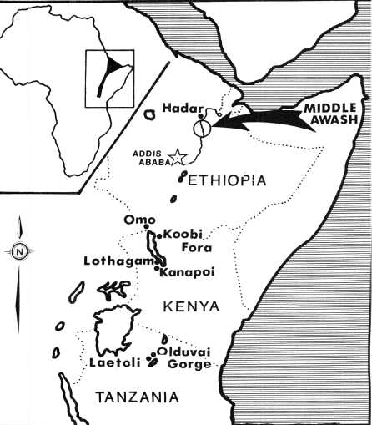
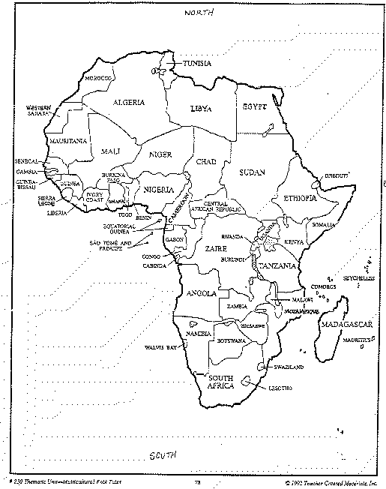
From: Boston University

Timeline Activity

Add the Leakey fossils, the White fossils, the Brunet skull, and Lucy to the timeline in the right spots.

2007 Common Era
Present day

8 million | 7 million | 6 million | 5 million | 4 million | 3 million | 2 million | 1 million  years BCE
+----------------------------------------------------------Early Humans-------------------+

---------------------------------Renaissance-------------------------------------------------------------------------------------------
------------------Reformation-------------------------------------------------
------------------Scientific Revolution-------------------+

WHY – Exit Ticket
With your group, create a “one liner” for the study of early humans. Why should other kids, and adults, learn more about human pre-history?
  - Example: Knowing where we came from may show us where we’re going!

Our “One Liner”:___________________________________________________________________________________

Excerpts from “Discoverer of Lucy Fossil Weighs in On Human Evolution”
Greg Flakus, Houston, April 2007

The fossilized bones of a female hominid creature who lived about three-million years ago in what is now Ethiopia, continues to draw crowds at Houston's Museum of Natural Science. Recently visiting the skeleton called Lucy was the man who discovered her on a rocky slope in Ethiopia back in November 1974, anthropaleontologist and director of the Institute of Human Origins at Arizona State University, Donald Johanson. VOA's Greg Flakus has this report from Houston.

For the past couple of months, school children have been coming to the Houston Museum of Natural Science to see a set of fossilized bones that the world now knows as Lucy.

No visitor has a more special relationship with Lucy than the man who discovered her, anthropaleontologist Donald Johanson.

WHO is Donald Johanson?

"I can say that my heart beat a little faster when I knew that the original fossil is in this room," he said.

Johanson found the fossil while working in northeastern Ethiopia on November 24, 1974.

WHEN did Johanson find the fossil?

"The first bone I found was a little fragment of a right elbow and I looked at it on the ground and knew from the shape of it that it did not belong to a monkey or any other kind of animal and that it had to come from a human ancestor skeleton," he said…

WHAT did Donald Johanson find?

High school students visiting the exhibit had lots of questions for the anthropologist, and teacher Elizabeth Blevins says the visit proved valuable on many levels.

"I think it helps them connect with history, with science, anthropology, and archaeology and all the sciences that go into understanding our world," she said…

WHY should students visit Lucy?

"We are not descended from monkeys. We are descended from a creature that was a common ancestor to the African apes and to us," added Johanson. "If we look at the anatomy, look at the behavior, look at the genetics, who are our closest relatives on the planet today? Chimpanzees and gorillas."

Who are our closest relatives today in the animal kingdom?

Johanson says Lucy and humans share a common ancestor, but she and homo sapiens then evolved along separate branches. He says anthropologists may disagree over some aspects of human evolution, but there is broad agreement on the basic theory of where it all began.

"The one thing that all anthropologists have agreed on now is that the fossil record for humanity is so convincing, from the very earliest, very primitive stages, long before Lucy, going back as much as six million years in Africa, that this is really the cradle of humankind, Africa," he said.

What do all anthropologists now believe about the place where human kind began?

Johanson says the people who live in the vicinity of where Lucy was found are proud of their area's importance and are very willing to help him find more fossils.

"The Afar people who live there today know what these bones look like and sometimes when we come back to the field, they will take me by my hand and they will walk me and say 'look what I found when I was herding my goats.' And they know that you should never pick it up, because then you do not know where it is from," he said.

How are the Afar people of Ethiopia helping anthropologists?

Donald Johanson goes back to Ethiopia every year hoping to find more clues to unlock the mystery of human origins.

Are there more fossils in Ethiopia? What makes you think so?

