UCI Teacher Workshop – American Revolution
September 17, 2014

Birte Pfleger
Professor of History, CSULA
bpflege@calstatela.edu

We begin our analysis of the American Revolution with a very famous image of the Boston Massacre, Paul Revere’s “The Bloody Massacre in King-Street,” and compare it to other renditions of the event.

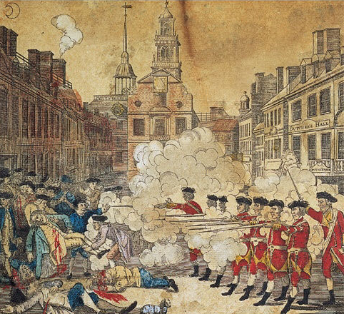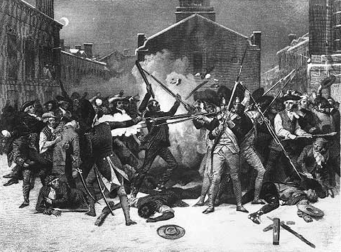
Paul Revere “The Bloody Massacre in King Street” Alonzo Alonzo Chappel, “Boston Massacre,” 1868

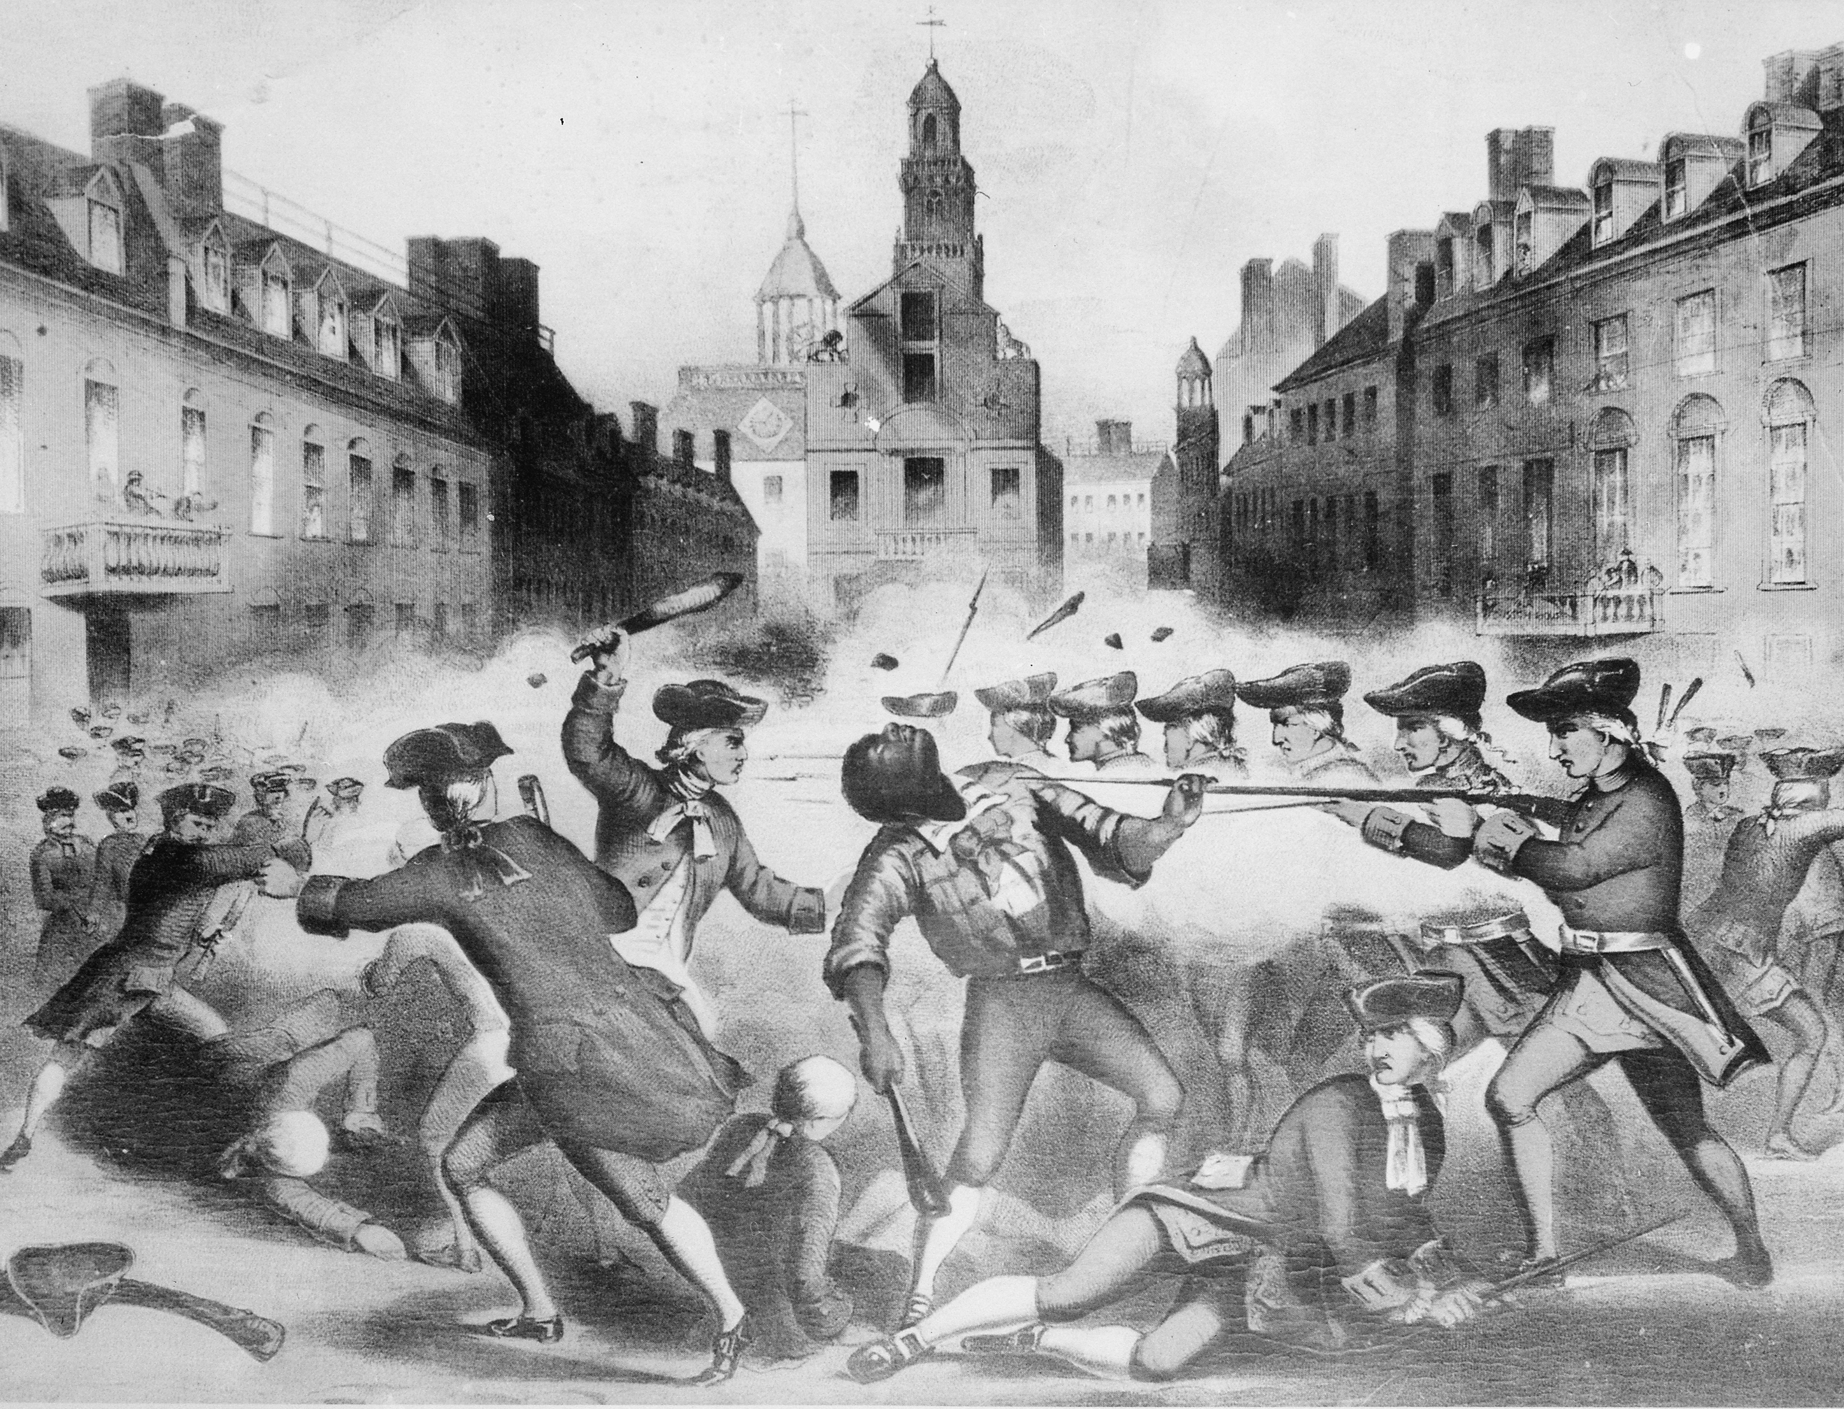

During our group exploration each group will focus on a different aspect of the themes that emerge from the images we looked at and that scholars continue to debate:
• Revolutionary rhetoric and economic sanctions
• Propaganda, national myths and historical memory
• The dichotomy of slavery and freedom
• Who was meant by “We, the people”
• How did women understand the revolutionary rhetoric?

Groups
- Charleston Nonimportation Agreement, 1769
- In Search of Crispus Attucks, 1770: Contemporary Newspaper Coverage
- Slavery in Virginia during and after the American Revolution
- If government is based on the consent of the people, who were the people?
- Women’s understanding of the American Revolution: actions and perceptions

1. “Charleston Merchants Propose a Plan of Nonimportation, 1769”
We, his Majesty’s dutiful and loving subjects, the inhabitants of South Carolina, …being fully convinced of the absolute necessity of stimulating our fellow subjects and sufferers in Great Britain to aid us in this our distress, and of joining the rest of the colonies in some other loyal and vigorous methods that may most probably procure such relief, which we believe may be most effectually promoted by strict economy, and by encouraging the manufactures of America in general, and of this province in particular: we therefore, whose names are underwritten, do solemnly promise, and agree to and with each other, that, until the colonies be restored to their former freedom by the repeal of said Acts, we will most strictly abide by the following[:]
Resolutions:
- That we will encourage and promote the use of North American manufactures in general, and those of this province in particular. And any of us who are vendors thereof, do engage to sell and dispose of them at the same rates as heretofore.
- That we will upon no pretence whatsoever, either upon our own account or on commission, import into this province any of the manufactures of Great Britain, or any other European or East India goods, either from Great Britain, Holland, or any other place, other than such as man have been shipped in consequence of former orders; excepting only Negro cloth, commonly called white and coloured plains, not exceeding one shilling and six pence sterling per yard, canvas, bolting cloths, drugs and family medicines, plantation and workmen’s tools, nails, firearms, bar steel, gun powder, shot lead, flints, wire cards and card wire, mill and grindstones, fishhooks, printed books and pamphlets, salt, coals, and saltpeter. And exclusive of these articles, we do solemnly promise and declare that we will immediately countermand all orders to our correspondents in Great Britain for shipping any such goods, wares and merchandise; and we will sell and dispose of the goods we have on hand, or that may arrive in consequence of former orders at the same rates as heretofore.
- That we will use the utmost economy in our persons, houses, and furniture; particularly, we will give no mourning, or gloves, or scarves at funerals.
- That from and after the 1st day of January, 1770, we will not import, buy, or sell any Negroes that shall be brought into this province from Africa; nor after the 1st of October next, any Negroes that shall be imported from the West Indies, or any other place excepting from Africa as aforesaid; and that if any goods or Negroes shall be sent to us contrary to our agreement in this subscription, such goods shall be re-shipped or stored, and such Negroes re-shipped from this province, and not by any means offered for sale therein.
- That we will not purchase from, or sell for, any masters of vessels, transient persons, or non-subscribers, any kind of European or East India goods whatever, excepting coals and salt, after the 1st day of November next.
- That as wines are subject to heavy duty, we agree not to import any on our account or commission, or purchase fro any master of vessel, transient person, or non-subscriber, after the 1st day of January next.
- Lastly, that we will not purchase any Negroes imported, or any goods or merchandise whatever, from any resident in this province, that refuses or neglects to sign this agreement within one month from the date hereof; excepting it shall appear he has been unavoidably prevented from doing the same. And every subscriber who shall not strictly and literally adhere to this agreement, according to the true intent and meaning hereof, ought to be treated with the utmost contempt.

- How did Charleston merchants describe themselves and their reasons for the plan?
- What do the different exemptions (outlined in II, III, IV, V) to the nonimportation agreement tell you about Virginia’s economy, the role of conspicuous consumption and British imports overall.
- How did Charleston merchants want to enforce the Nonimportation Plan?
- How effective do you think nonimportation was in South Carolina?
- Now take a look at Table 1 to compare your answer to question 4 with the numbers.

Table 1

2. Where is Crispus Attucks? Searching for Answers in contemporary newspaper coverage of the Boston Massacre

- Read and analyze each newspaper article about the Boston Massacre. What are the differences and similarities? How do you explain the differences and similarities? (Think about when the event occurred: late in the evening on March 5, 1770; Boston newspapers were published twice a week)
- Where is Crispus Attucks? What might be the connection to the advertisement from 1750?
- Why do you think Crispus Attucks came to be at the center of the 1856 lithograph of the Boston Massacre? (page 1)

Boston Chronicle, Thursday March 8, 1770
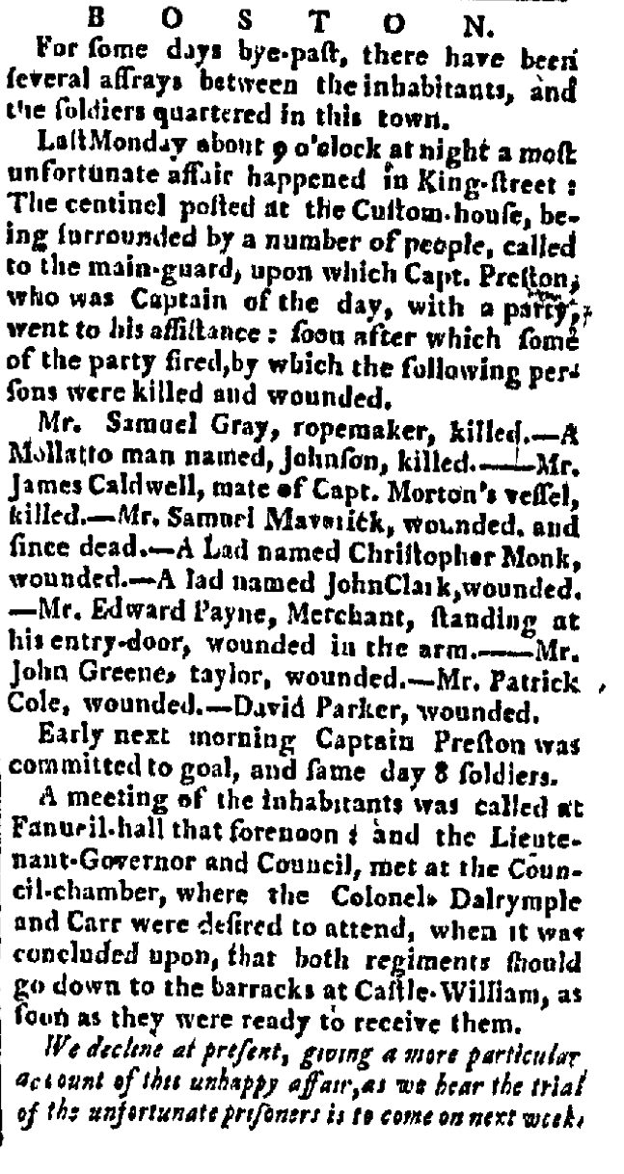

Boston News-Letter, Thursday March 8, 1770

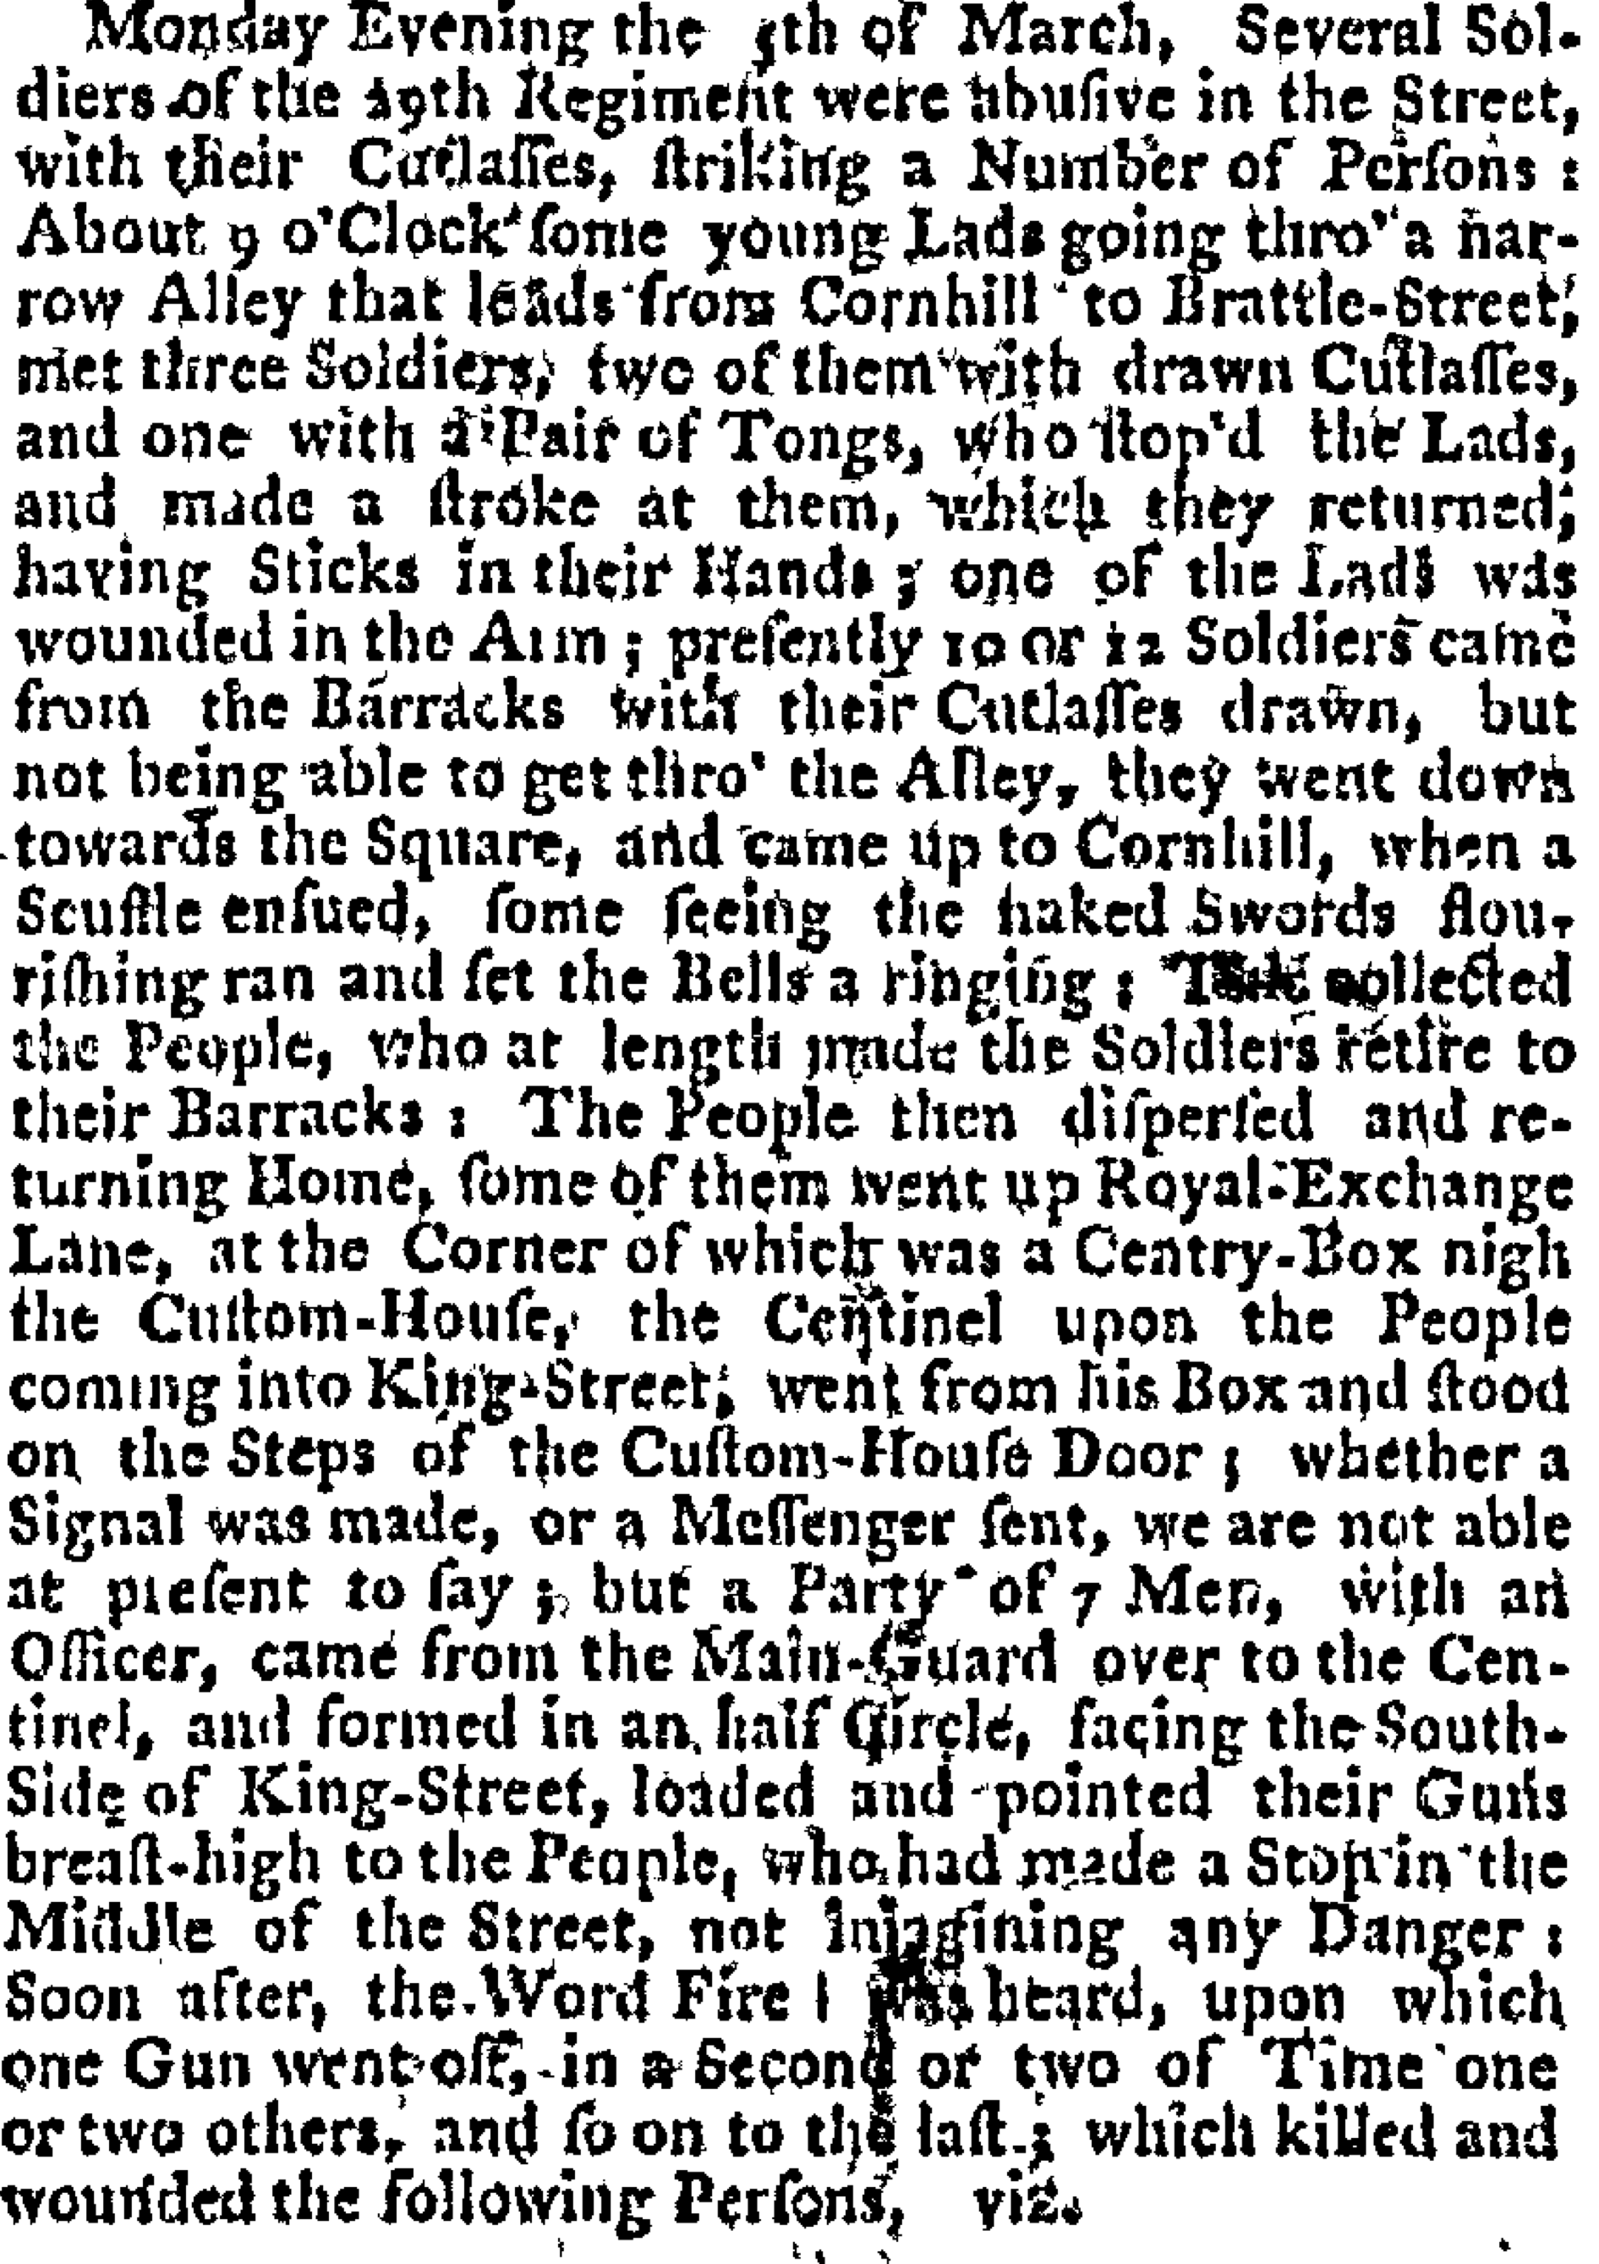 | 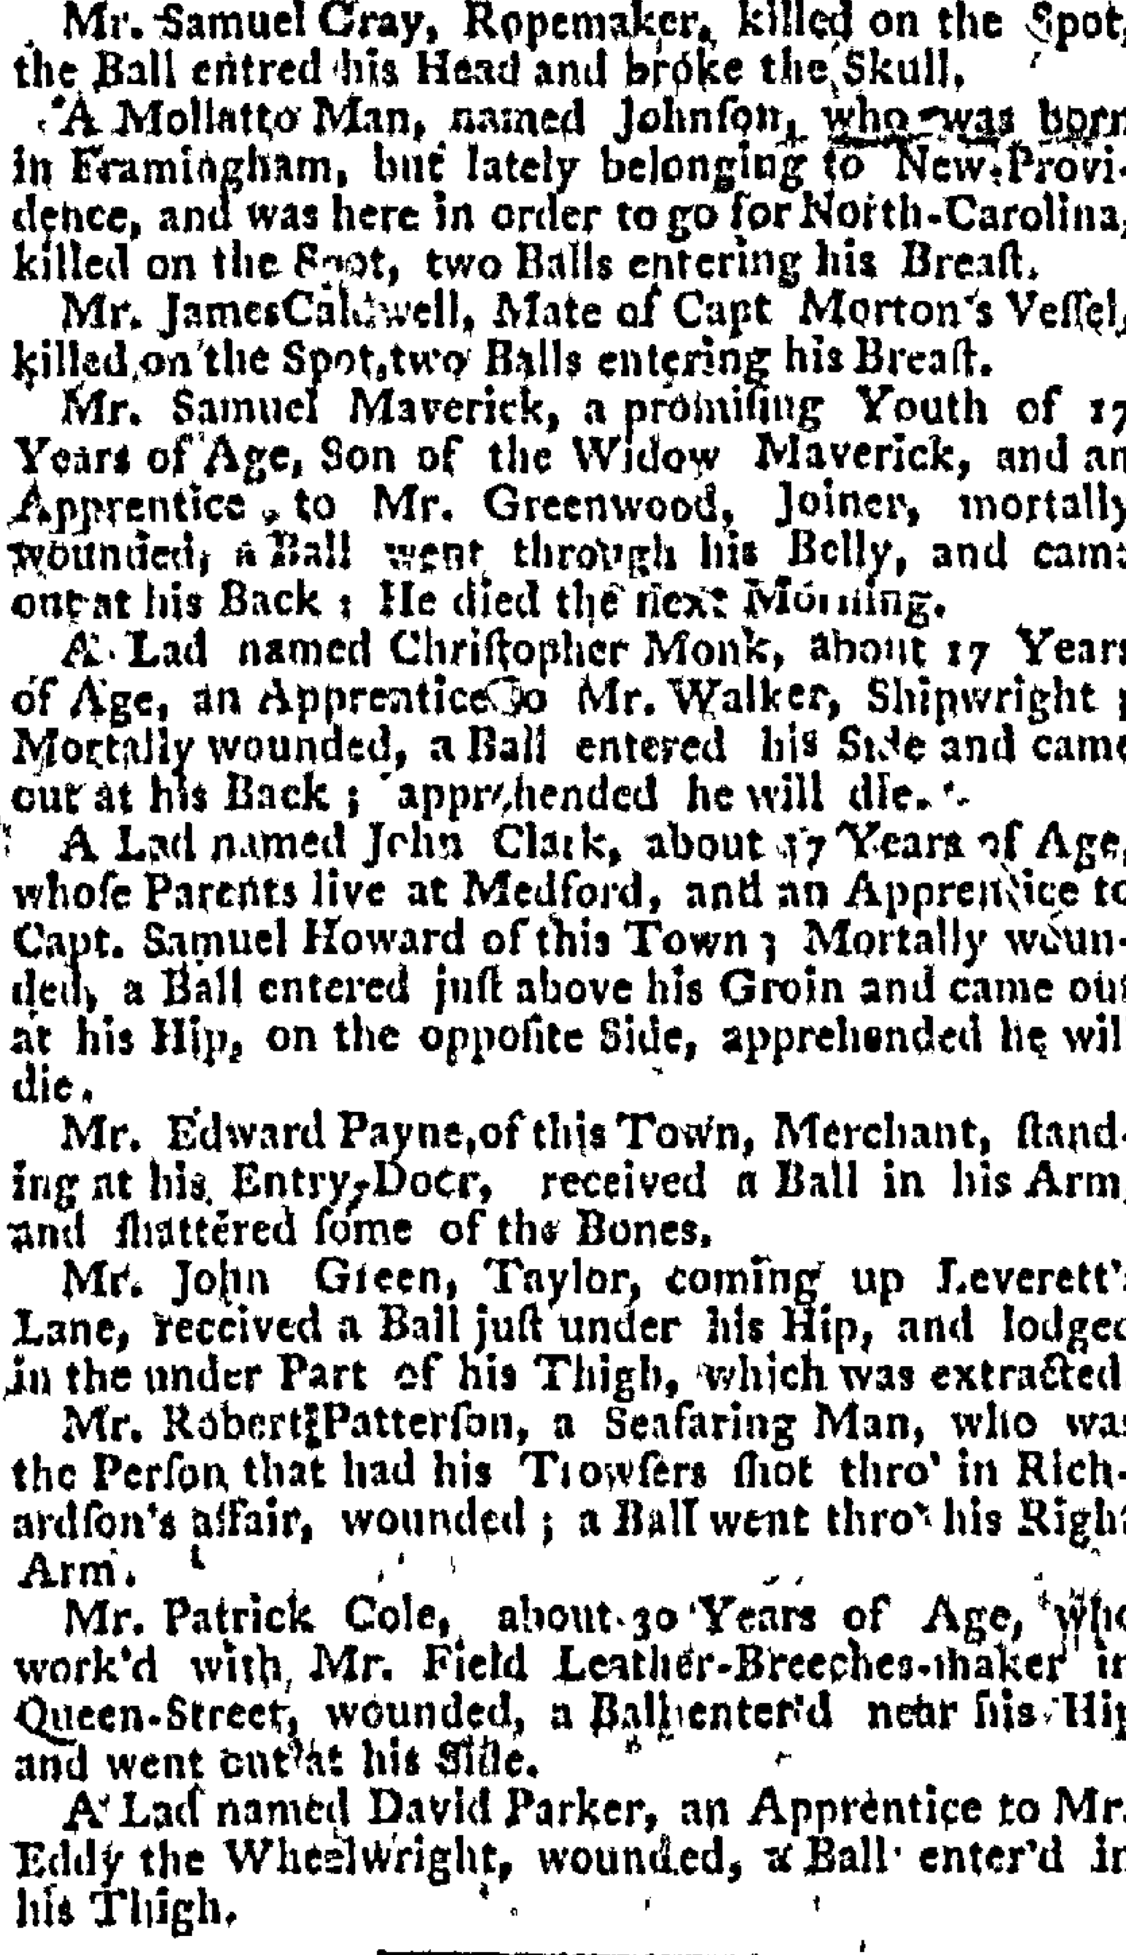
Boston Gazette March 12, 1770
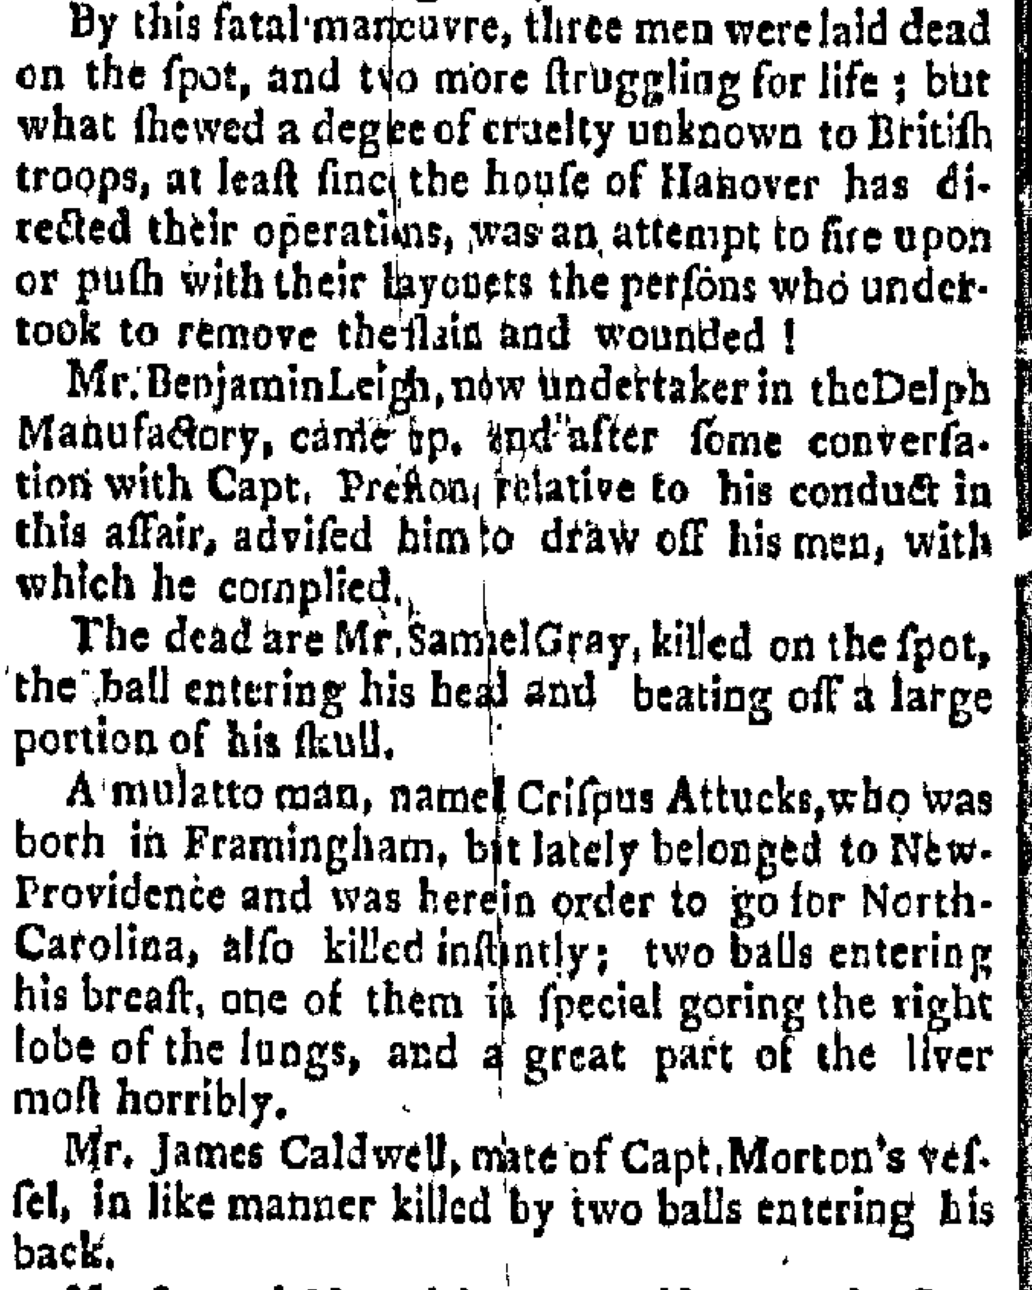 | 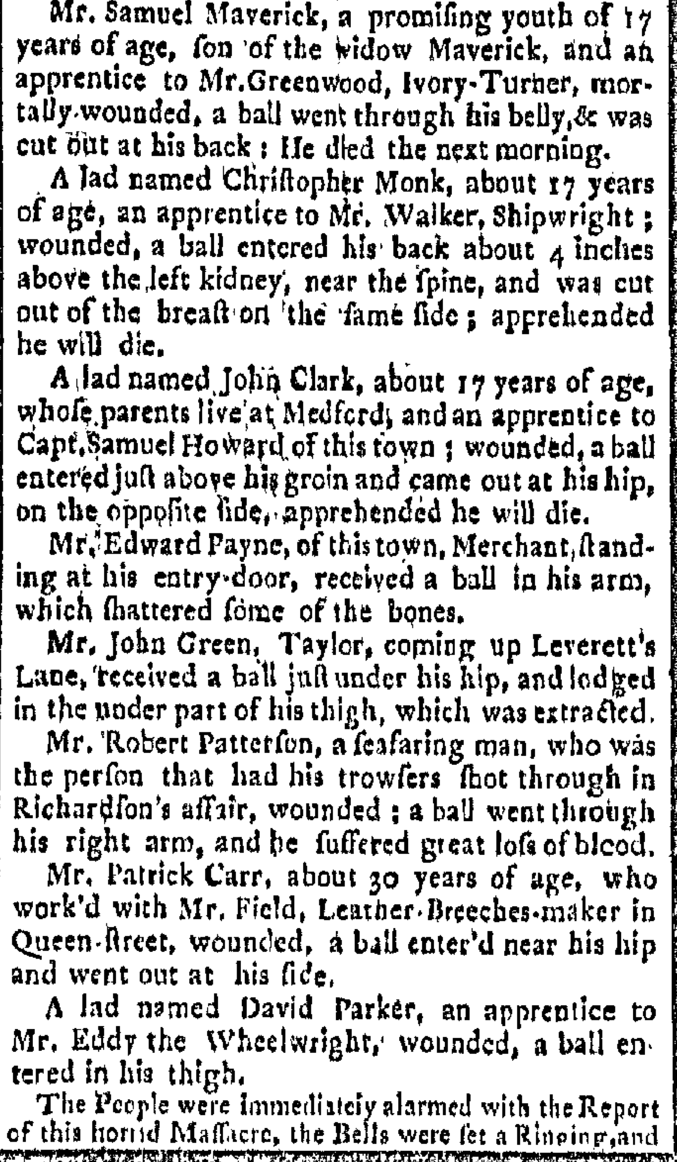
Boston Gazette October 2, 1750

RAN-away from his Master William Brown of Framingham, on the 30th of Sept. last, a Molatto Fellow, about 27 Years of Age, named Crispas, 6 Feet two Inches high, short curl'd Hair, his Knees nearer together than common; had on a light colour'd Bearskin Coat, plain brown Fustian Jacket, or brown all-Wool one, new Buckskin Breeches, blue Yarn Stockings, and a check'd woollen Shirt.
Whoever shall take up said Run-away, and convey him to his abovesaid Master, shall have ten Pounds, old Tenor Reward, and all necessary Charges paid. And all Masters of Vessels and others, are hereby caution'd against concealing or carrying off said Servant on Penalty of the Law. Boston, October 2, 1750.

3. Slavery in Virginia
Understanding slavery in Virginia before, during and after the American Revolution is vital if we want to comprehend what Edmund Morgan called “The American Paradox” – the simultaneous rise of slavery and freedom.

Some Background:
In 1782, the Virginia General Assembly passed “An Act to Authorize the Manumission of Slaves” that allowed slaveholders to free their slaves by their last wills and testaments or other writings that were to be proved in a county court by two witnesses. Before its passage in accordance to a law passed in 1723, a special act of assembly was required to set a slave free. Between 1723 and the American Revolution only about twenty-four enslaved people were legally emancipated in Virginia.... Many free blacks were descendants of other free people who had won their freedom or who had never been enslaved in Virginia. A few enslaved blacks were given their freedom after fighting in the American Revolution. … Enslaved African Americans sometimes purchased their freedom. A small number petitioned the Virginia legislature to win their freedom. After the United States abolished the Atlantic slave trade in 1808, some enslaved blacks successfully sued for their freedom on grounds that they had been imported illegally. Virginia's free black population grew from about 3,000 to 6,000 at the end of the Revolution to perhaps 30,000 by 1810.

3A. “Three Virginia Counties Defend Slavery, 1785.”
To the honourable the General Assembly of Virginia, the Remonstrance and Petition of the Free Inhabitants of Amelia County.
Gentlemen,
When the British Parliament usurped a Right to dispose of our Property without our Consent, we dissolved the Union with our Parent Country, and established a Constitution and Form of Government of our own, that our Property might be secure, in Future. In order to effect this we risked out Lives and Fortunes, and waded through Seas of Blood. By the favourable Interposition of Providence our Attempt was crowned with Success. We were put in the Possession of our Rights of Liberty and Property: And these Rights as well secured, as they can be by any human Constitution or Form of Government. But notwithstanding this, we understand a very subtle and daring Attempt is made to dispossess us of a very important Part of our Property. An Attempt set on Foot, we are informed, by the Enemies of our Country, Tools of the British Administration, and supported by certain Men among us of considerable Weight, TO WREST FROM US OUR SLAVES, by an Act of the Legislature for a general Emancipation of them. An Attempt unsupported by Scripture or sound Policy.
It is unsupported by Scripture. For we find that under the Old Testament Dispensation, Slavery was permitted by the Deity himself. Thus Leviticus Ch. 25. Ver. 44, 45, 46. “Both thy Bond Men and Bond Maids, which thou shalt have, shall be of the Heathen that are round about you; of them shall ye buy Bond Men and Bond Maids. Moreover, of the Children of the Strangers that do sojourn among you, of them shall ye buy, and of their Families that are with you, which they beget in your Land, and they shall be your Possession, and ye shall take them as an Inheritance, for your Children after you, to inherit them for a Possession; they shall be your Bond-men forever.” This Permission to buy and inherit Bond-men and Bond-maids, we have Reason to conclude, continued through all the Revolutions of the Jewish Government, down to the Advent of our Lord. And we do not find, that either he or his Apostles abridged it. The Freedom promised to his Followers, is a Freedom from the Bondage of Sin and Satan, and from the Dominion of Mens Lusts and Passions; but as to their Outward Condition, whatever that was before they embraced the Religion of Jesus, whether Bond or Free, it remained the same afterwards. This St. Paul expressly asserts 1 Cor. Chap. 7 Ver. 20 where he is speaking directly to this Point, ‘Let every Man abide in the same Calling, wherein he is called’; and Ver. 24. ‘Let every Man wherein he is called, therein abide with God.’ Thus it is evident that said Attempt is unsupported by Scripture.
It is also exceedingly impolitic. For it involves in it, and is productive of Want, Poverty, Distress, and Ruin to the Free Citizen; Neglect, Famine and Death to the black Infant and superannuated Parent; The Horrors of all the Rapes, Murders, and Outrages, which is a vast Multitude of unprincipled, unpropertied, revengeful, and remorseless Banditti are capable of perpetrating; inevitable Bankruptcy to the Revenue, and consequently Breach of public Faith, and Loss of Credit with foreign Nations; and lastly, sure and final Ruin to this now flourishing free and happy Country.
We therefore, your Petitioners and Remonstrants, do solemnly adjure and humbly pray you that you will discountenance and utterly reject every Motion and Proposal for emancipating our Slaves; that as the Act lately made, empowering the Owners of Slaves to liberate them has produced, and is still productive of, very bad Effects, you will immediately and totally repeal it; and that as many of the Slaves, liberated by that Act, have been guilty of Thefts and Outrages, Insolences and Violences, destructive to the Peace, Safety and Happiness of Society, you will make effectual Provision for the due Government of them.
[Amelia County, November 10, 1785 with 22 signatures. Also submitted by Mecklenberg County, November 8, 1785, with 223 signatures, and by Pittsylvania County, November 10, 1785, with 54 signatures.)

- How did the Petitioners characterize the American Revolution? How is this connected with the alleged attempt to emancipate slaves?
- What specific arguments does the petition address to defend slavery?
- What questions does this petition raise? How can we answer these questions?

3B. May 1782 - ACT XXI. An act to authorize the manumission of slaves.
I. WHEREAS application hath been made to this present general assembly, that those persons who are disposed to emancipate their slaves may be empowered so to do, and the same hath been judged expedient under certain restrictions: Be it therefore enacted, That it shall hereafter be lawful for any person, by his or her last will and testament, or by any other instrument in writing, under his or her hand and seal, attested and proved in the county court by two witnesses, or acknowledged by the party in the court of the county where he or she resides, to emancipate and set free, his or her slaves, or any of them, who shall thereupon be entirely and fully discharged from the performance of any contract entered into during servitude, and enjoy as full freedom as if they had been particularly named and freed by this act.
II. Provided always, and be it further enacted, That all slaves so set free, not being in the judgment of the court, of sound mind and body, or being above the age of forty-five years, or being males under the age of twenty-one, or females under the age of eighteen years, shall respectively be supported and maintained by the person so liberating them, or by his or her estate; and upon neglect or refusal so to do, the court of the county where such neglect or refusal may be, is hereby empowered and required, upon application to them made, to order the sheriff to distrain and sell so much of the person's estate as shall be sufficient for that purpose. Provided also, That every person by written instrument in his life time, or if by last will and testament, the executors of every person freeing any slave, shall cause to be delivered to him or her, a copy of the instrument of emancipation, attested by the clerk of the court of the county, who shall be paid therefor, by the person emancipating, five shillings, to be collected in the manner of other clerk's fees. Every person neglecting or refusing to deliver to any slave by him or her set free, such copy, shall forfeit and pay ten pounds, to be recovered with costs in any court of record, one half thereof to the person suing for the same, and the other to the person to whom such copy ought to have been delivered. It shall be lawful for any justice of the peace to commit to the gaol of his county, any emancipated slave travelling out of the county of his or her residence without a copy of the instrument of his or her emancipation, there to remain till such copy is produced and the gaoler's fees paid.
III. And be it further enacted, That in case any slave so liberated shall neglect in any year to pay all taxes and levies imposed or to be imposed by law, the court of the county shall order the sheriff to hire out him or her for so long time as will raise the said taxes and levies. Provided sufficient distress cannot be made upon his or her estate. Saving nevertheless to all and every person and persons, bodies politic or corporate, and their heirs and successors, other than the person or persons claiming under those so emancipating their slaves, all such right and title as they or any of them could or might claim if this act had never been made.

- In what ways was emancipation limited?
- What do the limitations and restrictions tell you about legislators’ fears about freeing people of African descent?
- What does this law tell us about white Virginians’ understanding of American Revolutionary ideals?

4. Who Are “We, the People?”
John Adams to James Sullivan: On women, the poor, and voting rights (May 26, 1776)
Adams explains why women, children, and the poor are excluded from the vote.
It is certain in theory, that the only moral foundation of government is the consent of the people. But to what an extent shall we carry this principle? Shall we say, that every individual of the community, old and young, male and female, as well as rich and poor, must consent, expressly, to every act of legislation? No, you will say. This is impossible. How then does the right arise in the majority to govern the minority, against their will? Whence arises the right of the men to govern women, without their consent? Whence the right of the old to bind the young, without theirs?
But let us first suppose, that the whole community of every age, rank, sex, and condition, has a right to vote. This community, is assembled—a motion is made and carried by a majority of one voice. The minority will not agree to this. Whence arises the right of the majority to govern, and the obligation of the minority to obey? from necessity, you will say, because there can be no other rule. But why exclude women? You will say, because their delicacy renders them unfit for practice and experience, in the great business of life, and the hardy enterprises of war, as well as the arduous cares of state. Besides, their attention is so much engaged with the necessary nurture of their children, that nature has made them fittest for domestic cares. And children have not judgment or will of their own. True. But will not these reasons apply to others? Is it not equally true, that men in general in every society, who are wholly destitute of property, are also too little acquainted with public affairs to form a right judgment, and too dependent upon other men to have a will of their own? If this is a fact, if you give to every man, who has no property, a vote, will you not make a fine encouraging provision for corruption by your fundamental law? Such is the frailty of the human heart, that very few men, who have no property, have any judgment of their own. They talk and vote as they are directed by some man of property, who has attached their minds to his interest…
I should think that wisdom and policy would dictate in these times, to be very cautious of making alterations. Our people have never been very rigid in scrutinizing into the qualifications of voters, and I presume they will not now begin to be so. But I would not advise them to make any alteration in the laws, at present, respecting the qualifications of voters.
Your idea, that those laws, which affect the lives and personal liberty of all, or which inflict corporal punishment, affect those, who are not qualified to vote, as well as those who are, is just. But, so they do women, as well as men, children as well as adults. What reason should there be, for excluding a man of twenty years, Eleven months and twenty-seven days old, from a vote when you admit one, who is twenty one? The reason is, you must fix upon some period in life, when the understanding and will of men in general is fit to be trusted by the public. Will not the same reason justify the state in fixing upon some certain quantity of property, as a qualification.
The same reasoning, which will induce you to admit all men, who have no property, to vote, with those who have, for those laws, which affect the person will prove that you ought to admit women and children: for generally speaking, women and children, have as good judgment, and as independent minds as those men who are wholly destitute of property: these last being to all intents and purposes as much dependent upon others, who will please to feed, clothe, and employ them, as women are upon their husbands, or children on their parents…
Society can be governed only by general rules. Government cannot accommodate itself to every particular case, as it happens, nor to the circumstances of particular persons. It must establish general, comprehensive regulations for cases and persons. The only question is, which general rule, will accommodate most cases and most persons.
Depend upon it, sir, it is dangerous to open so fruitful a source of controversy and altercation, as would be opened by attempting to alter the qualifications of voters. There will be no end of it. New claims will arise. Women will demand a vote. Lads from 12 to 21 will think their rights not enough attended to, and every man, who has not a farthing, will demand an equal voice with any other in all acts of state. It tends to confound and destroy all distinctions, and prostrate all ranks, to one common level.

- What are the issues Adams contemplated?
- What arguments did he make to include “every individual in the community?” Why did he conclude?
- Do you think Adams believed that he had arrived at the final and definitive answer about who would be included or excluded?

5. Women and Fertility

5A. Table 2
 |  | Urban |  |  | Rural
Category | Colonial  (N=230) | Rev.  (N=572) | 19th  Century  (N=201) | Colonial | Rev.  (N=428) | 19th  Century  (N=963)
Total fertility  (no. of births ages 20-49) | 9.2 | 8.6 | 8.1 | 9.7 | 9.0 | 8.4
% of births  by age 35 | 69.8% | 73.7% | 75.2% | 71.9% | 72.1% | 69.6%
Actual no. of children | 6.2 | 5.9 | 5.8 | 7.0 | 6.5 | 6.3
Mean age  First marriage | 21.5 | 22.4 | 21.9 | 21.6 | 22.4 | 22.7
Mean age at last birth | 40.0 | 38.5 | 37.6 | 38.9 | 37.3 | 37.6
Childbearing years | 18.5 | 16.1 | 15.7 | 17.3 | 14.9 | 14.9

- What general trends can you identify based on the table in terms of the number of children women bore in the colonial period, during the American Revolution, and in the nineteenth century?
- Can you make a connection between eighteenth-century women’s fertility and women’s understanding of the revolutionary rhetoric about rights, liberty, and happiness ?
- What does the table tell you about some of the strategies American families regarding women’s fertility?

5B. Samuel Williams The Natural and Civil History of Vermont (1794)
The superiority of the American family, in contrast with the European.
Another custom, which everything tends to introduce in a new country, is early marriage. Trained up to a regular industry and economy, the young people grow up to maturity in all the vigor of health, and bloom of natural beauty. Not enervated by idleness, weakened by luxury, or corrupted by debauchery, the inclinations of nature are directed towards their proper objects at an early period; and assume the direction, which nature and society designed they should have. The ease with which a family may be maintained, and the wishes of parents to see their children settled in ways of virtue, reputation, and felicity, are circumstances which also strongly invite to an early settlement in life. The virtuous affections are not corrupted nor retarded by the pride of families, the ambition of ostentation, or the idle notions of useless and dangerous distinctions, under the name of honor and titles. Neither parents nor children have any other prospects, than what are founded upon industry, economy, and virtue.
Where every circumstance thus concurs to promote early marriages, the practice becomes universal, and it generally takes place, as soon as the laws of society suppose the young people of sufficient age and discretion to transact the business of life.
It is not necessary to enumerate the many advantages that arise from the custom of early marriages. They comprehend all the society can receive from this source; from the preservation, to the increase of the human race. Everything useful and beneficial to man, seems to be connected with obedience to the laws of his nature: And where the state of society coincides with the laws of nature, the inclinations, the duties, and the happiness of individuals resolve themselves into customs and habits favorable, in the highest degree, to society. In no case is this more apparent, than in the customs of nations respecting marriage. When wealth, or the imaginary honor of families, is the great object, marriage becomes a matter of trade, pride, and form; in which affection, virtue, and happiness are not consulted; from which the parties derive no felicity, and society receives no advantage. But where nature leads the way, all the lovely train of virtues, domestic happiness, and the greatest of all public benefits, a rapid population, are found to be the fruit.

- What does this author claim about American families?
- How does this claim compare with the table? How do you explain the differences?

In Major Problems in the Era of the American Revolution Houghton Mifflin, 2000, 117-18.
http://boston1775.blogspot.com/ “J. L. Bell offers history, analysis and unabashed gossip about the start of the American Revolution in New England on his website Boston 1775. He contributed the chapter “From Saucy Boys to Sons of Liberty: Politicizing Youth in Pre-Revolutionary Boston” to the book Children in Colonial America (NYU Press, 2006), and articles to several journals and magazines. Bell speaks about Revolutionary history at teachers’ workshops, schools and museums in the Boston area.”
Edmund Morgan, American Slavery, American Freedom: The Ordeal of Colonial Virginia (1975).
Fredrika Teute Schmidt and Barbara Ripel Wilhelm, “Early Proslavery Petitions in Virginia,” William and Mary Quarterly, Vol. 30, No. 1 (January 1973): 133-146. http://www.virginiamemory.com/online_classroom/shaping_the_constitution/doc/drake
http://www2.vcdh.virginia.edu/gos/laws1751-1800.html
http://www.vindicatingthefounders.com/library/adams-to-sullivan.html
Susan Klepp, Revolutionary Conceptions: Women, Fertility, & Family Limitations in America, 1760-1820 (UNC, 2009), 46, Table 2.
From Charles S. Hyneman and Donald S. Lutz, ed., American Political Writing during the Founding Era (Indianapolis: Liberty Press, 1983), 2:952-53. http://www.vindicatingthefounders.com/library/history-of-vermont.html (accessed September 11, 2014).

