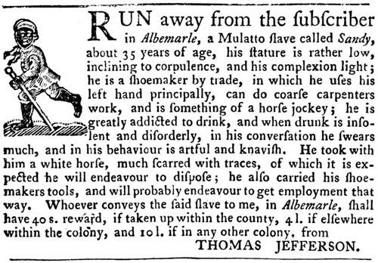

Transcript:
RUN away from the subscriber in Albemarle, a Mulatto slave called Sandy, about 35 years of age, his stature is rather low, inclining to corpulence, and his complexion light; he is a shoemaker by trade, in which he uses his left hand principally, can do coarse carpenters work, and is something of a horse jockey; he is greatly addicted to drink, and when drunk is insolent and disorderly, in his conversation he swears much, and in his behaviour is artful and knavish. He took with him a white horse, much scarred with traces, of which it is expected he will endeavour to dispose; he also carried his shoemakers tools, and will probably endeavor to get employment that way. Whoever conveys the said slave to me, in Albemarle, shall have 40 s. (shillings) reward, if taken up within the county, 4 l. (pounds) if elswhere within the colony, and 10 l. if in any other colony, from
THOMAS JEFFERSON.

Source: The Virginia Gazette, Williamsburg, September 14, 1769.

