Renaissance Artists
Renaissance
From: Nicole Gilbertson 2016

History Standards: 7.8.5
Detail advances made in literature, the arts, science, mathematics, cartography, engineering, and the understanding of human anatomy and astronomy (e.g., by Dante Alighieri, Leonardo da Vinci, Michelangelo di Buonarroti Simoni, Johann Gutenberg, William Shakespeare).

CCSS Standards: CCSS RH 7. Integrate visual information (e.g., in charts, graphs, photographs, videos, or maps) with other information in print and digital texts.

Guiding Question: How did Renaissance artists change our understanding of perspective?

Lesson Outline:
- Begin by showing students “The School of Athens” by Raphael, which can be found at:
https://drive.google.com/file/d/0B2VRzn6Ip2keYWMzMzM0OGItNmQ5Mi00YmQ1LWExZDUtYTlhZjFhMDVkZTlh/view?layout=list&ddrp=1&sort=name&num=50

Conduct the (Harvard Project Zero) see/think/wonder questions one at a time and have students respond to each independently and then discuss as a class.
What do you see?
What do you think about what you see?
What do you wonder about what you see?
Lead class discussion about how this differs from medieval art and what students think is novel about this image.

If you would like to go further into a discussion about this piece of art, the Khan academy has about a 10 minute video deconstructing the image:
https://www.khanacademy.org/humanities/renaissance-reformation/high-ren-florence-rome/high-renaissance1/v/raphael-school-of-athens

Work through the image with students to discuss the concepts of humanism, secularism, and individualism and highlight how this image provides examples of each. For more specific guidance, use the textbook pages 478-80.

- Students engage in gallery walk of the Renaissance artists and answer the questions on the worksheet. The teacher debriefs the students statements and links back to ideas of how these images have fall under the Renaissance ideas of humanism, secularism, and individualism. As a class teacher and students develop an answer to the lesson question using evidence from the gallery walk.

Extension:
If you would like to guide students in an art project around perspective, you can introduce students to the idea of perspective by reading an article:
http://www.scholastic.com/browse/article.jsp?id=3757092&print=2
Review The School of Athens” painting to identify the dimensions of perspective.
Students can engage in an interactive perspective lesson on this website:
http://legacy.mos.org/sln/Leonardo/ExploringLinearPerspective.html
Students can engage in creating their own drawing using perspective at this website:
http://legacy.mos.org/sln/Leonardo/UsingLeosWindow.html

Gallery Walk
Student Handout
How did Renaissance artists change our understanding of perspective?

Source name and creator | Why was this person an important Renaissance artist? | Look at the image for a moment, list 10 things you see in the image. | How is the artwork or object connected to something you know about? | What new ideas or impressions do you have about the image that extended your thinking in new directions?

Choose one of the artists and images you examined in the gallery walk. Describe how the information you learned and the ideas presented in the image has changed your understanding of the Renaissance.

What do you wonder about regarding these images and artists?

Source 1: Michelangelo’s Pieta

Michelangelo was born on March 6, 1475, in Caprese, Italy. Born to a family of moderate means in the banking business, Michelangelo became an apprentice to a painter before studying in the sculpture gardens of the powerful Medici family. What followed was a remarkable career as an artist in the Italian Renaissance, recognized in his own time for his artistic virtuosity. His works include the "David" and "Pieta" statues and the ceiling paintings of Rome's Sistine Chapel, including the "Last Judgment." Although he always considered himself a Florentine, Michelangelo lived most of his life in Rome, where he died in 1564, at age 88.
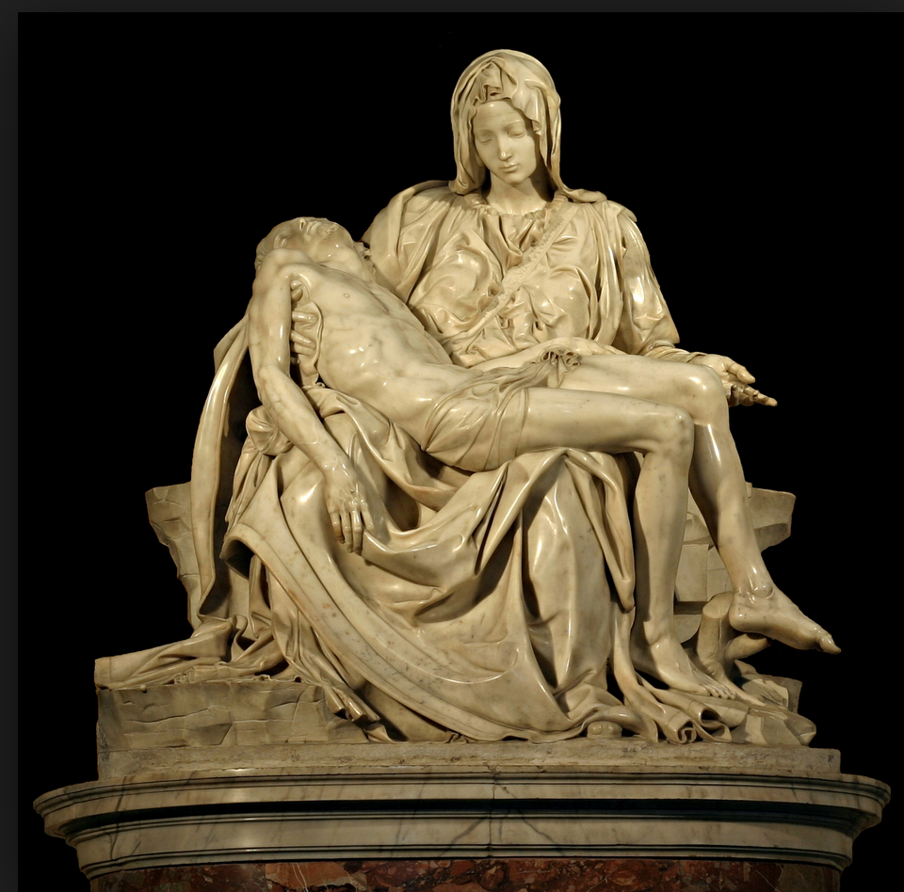
Michelangelo's "Pieta," a sculpture of Mary holding the dead Jesus across her lap, was finished in less than one year, and was erected in the church of the cardinal's tomb. At six feet wide and nearly as tall, the statue has been moved five times since, to its present place of prominence St. Peter's Basilica in Vatican City.
Carved from a single piece of Carrara marble, the fluidity of the fabric, positions of the subjects, and "movement" of the skin of the Piet—meaning "pity" or "compassion"—created awe for its early spectators. Today, the "Pieta" remains an incredibly revered work. Michelangelo was just 25 years old at the time.
Legend has it that he overheard pilgrims attribute the work to another sculptor, so he boldly carved his signature in the sash across Mary's chest. It is the only work to bear his name.
Text from Biography.com:http://www.biography.com/people/michelangelo-9407628#the-pieta-and-the-david
Image from Wikipedia: https://en.wikipedia.org/wiki/Piet%C3%A0

Source 2: Albrecht Durer’s Self-Portraits
A portrait is typically defined as a representation of a specific individual, such as the artist might meet in life. A portrait does not merely record someone’s features, however, but says something about who he or she is, offering a vivid sense of a real person’s presence.
The traditions of portraiture in the West extend back to antiquity and particularly to ancient Greece and Rome, where lifelike depictions of distinguished men and women appeared in sculpture and on coins. After many centuries in which generic representation had been the norm, distinctive portrait likenesses began to reappear in Europe in the fifteenth century. This change reflected a new growth of interest in everyday life and individual identity as well as a revival of Greco-Roman custom. The resurgence of portraiture was thus a significant manifestation of the Renaissance in Europe…
One of the hallmarks of European portraiture is a sense of reality, an apparent intention to depict the unique appearance of a particular person. Each portrait is thus meant to express individual identity…
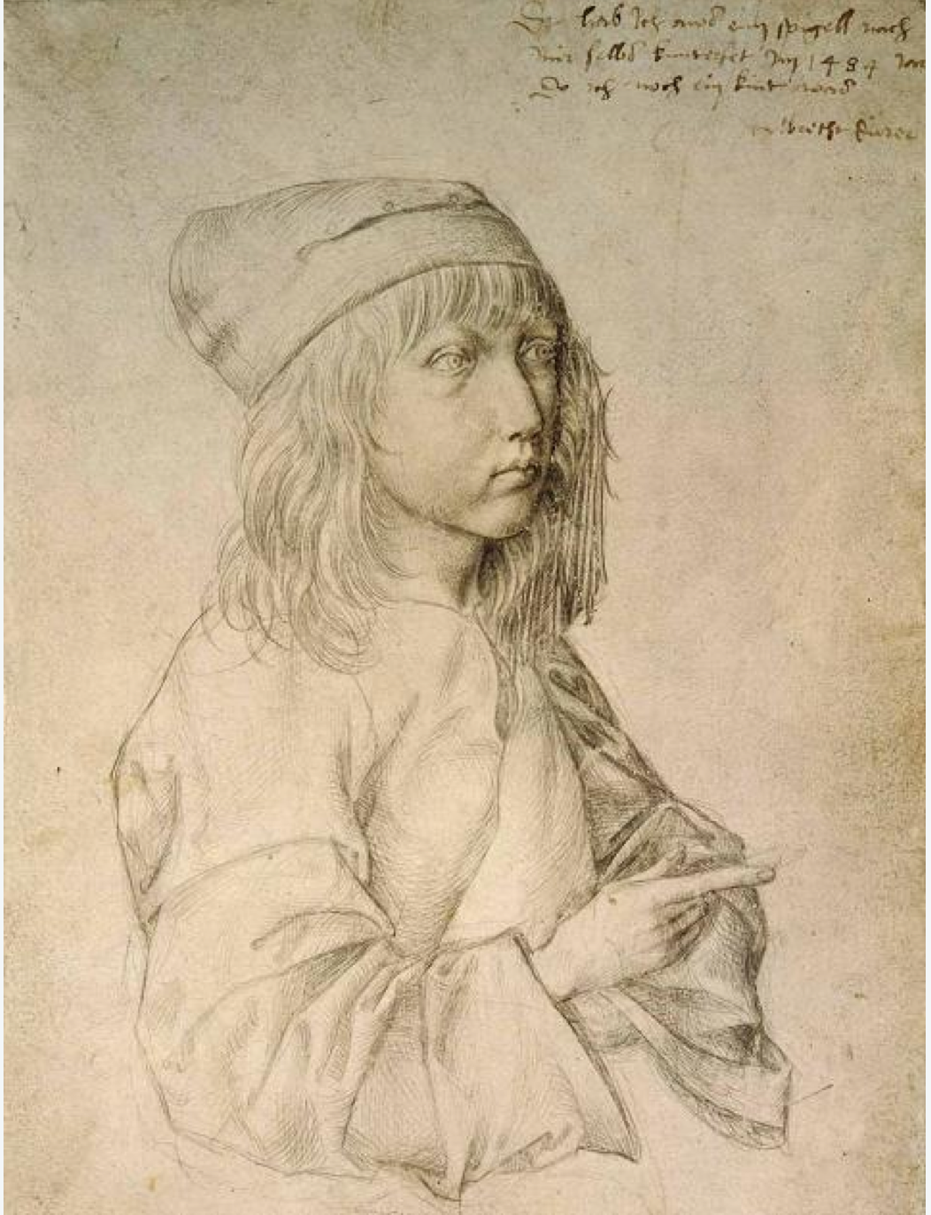
Albrecht Durer, Self-Portrait at Thirteen, 1484
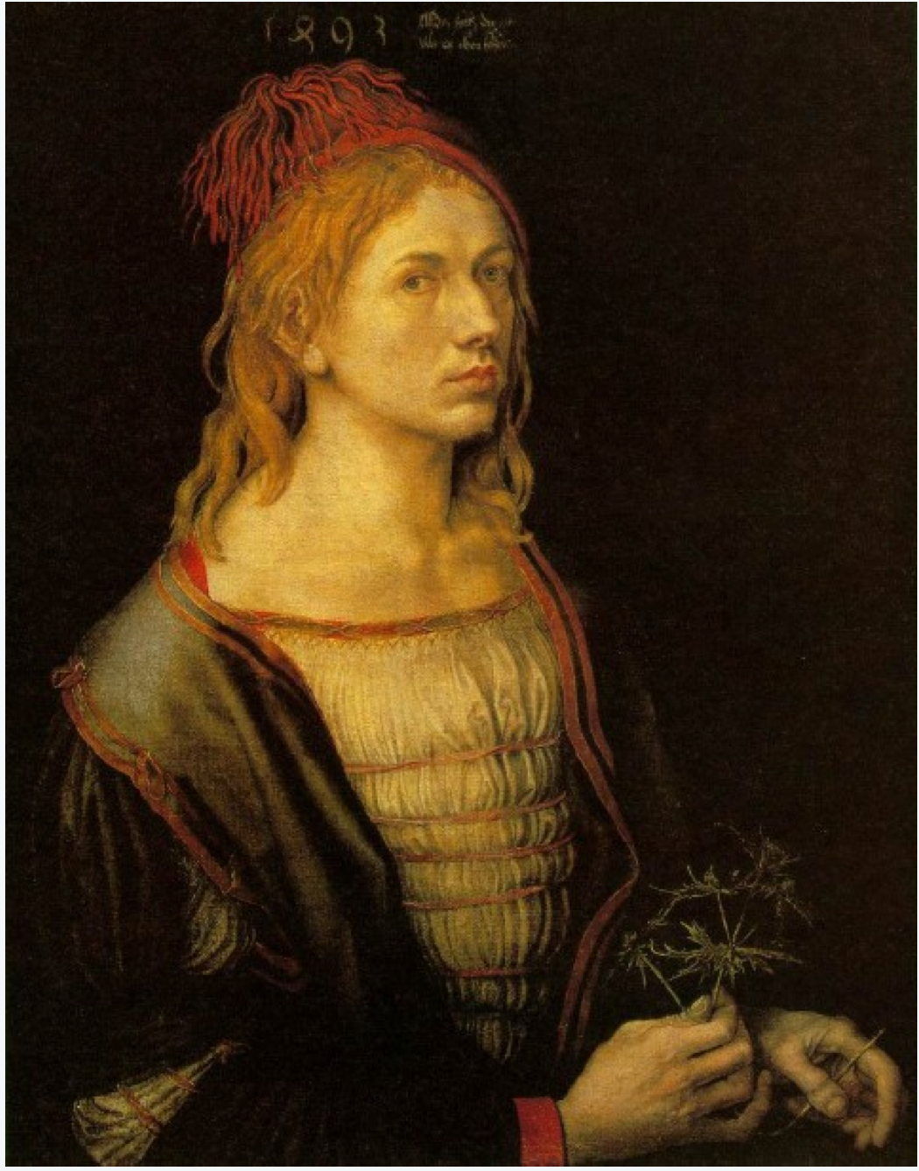
Albrecht Durer, Portrait of the Artist Holding a Thistle, 1493
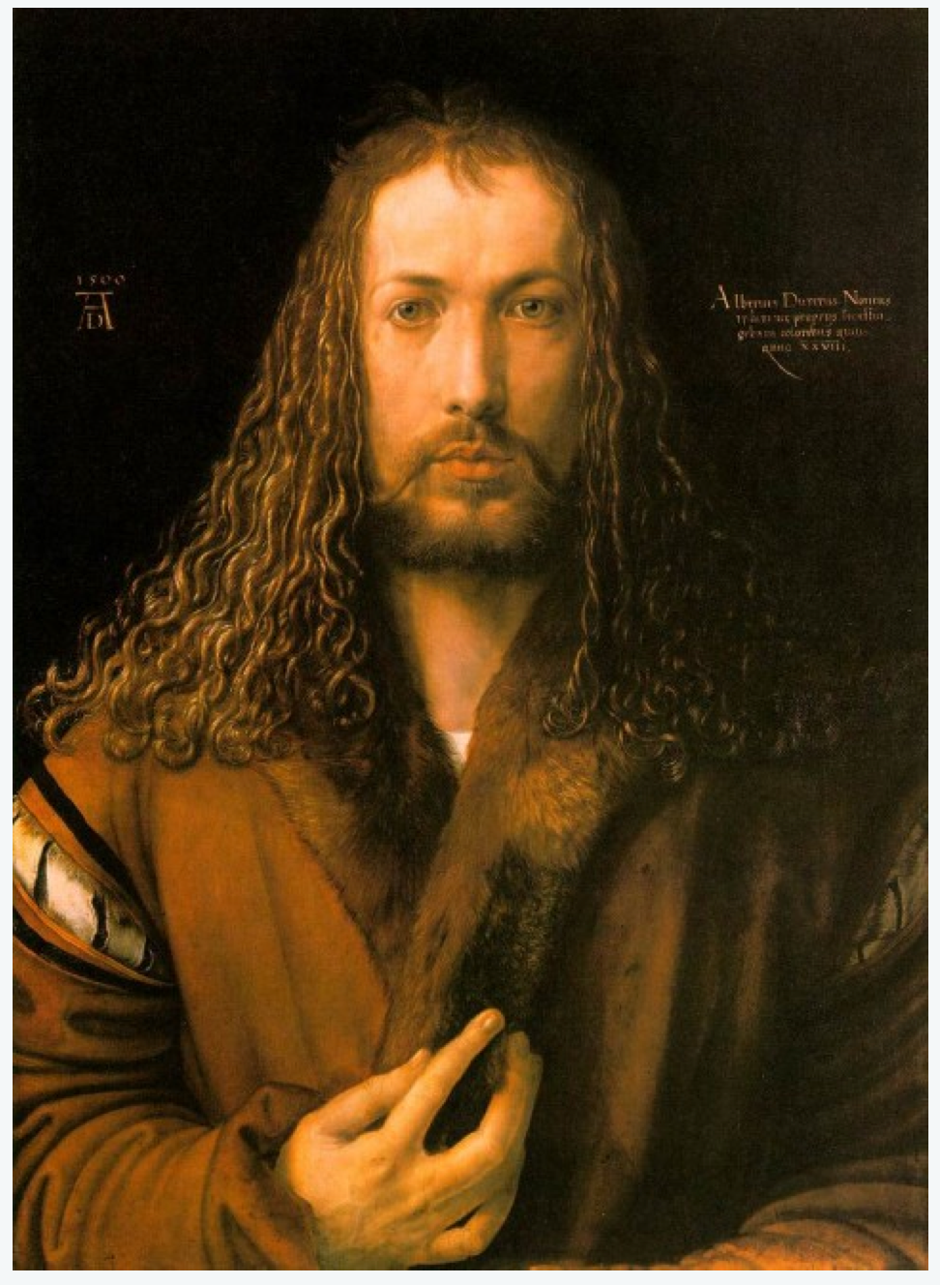
“I, Albrecht Dürer of Nuremberg, portrayed myself in everlasting colors aged twenty-eight years”
The German artist Albrecht Dürer (1471-1528) was one of the greatest figures of the Northern Renaissance. As a draughtsman and painter, he rivaled his elder contemporary Leonardo Da Vinci, and his masterful woodcuts and engravings of mythical and allegorical scenes made him famous across Europe.
Image 1: In the first half of his life, Dürer made a series of exquisite self-portraits. The earliest (above) was made in 1484, when the artist was a precocious boy of 13…
Image 2: After Dürer finished his apprenticeship with Wolegmut at the age of 19, he followed the tradition of young artists and embarked on a guild tour of southern Germany to study the work of various artists and printmakers. He was probably in Strasbourg when he painted his “Portrait of the Artist holding a Thistle” (above) in 1493. He was 22 years old...
Image 3: The Christ-like self-portrait above was painted in 1500, shortly before Dürer’s 29th birthday. The painting was made in oil on a wooden panel, and is now in the collection of the Alte Pinakothek in Munich. Unlike his earlier self-portraits, which were composed in the customary three-quarters view, Dürer’s self-portrait of 1500 depicts the artist faced squarely toward the viewer — a pose usually reserved at that time for images of Christ. His hand, touching the fur collar of his coat, brings to mind the gestures of blessing in religious icons.

Text about portraiture from: https://www.metmuseum.org/toah/hd/port/hd_port.htm
Images and text about Durer from: http://www.openculture.com/2013/07/the_genius_of_albrecht_durer_revealed_in_four_self-portraits.html

Source 3: Lavinia Fontana’s Portrait of a Family
Renaissance painter Lavinia Fontana was commissioned to make not only portraits, the typical subject matter for women painters, but also religious and mythological themes, which sometimes included female nudes.
She made great strides in the field of portraiture, which garnered her fame within and beyond Italy. In fact, Fontana is regarded as the first woman artist, working within the same sphere as her male counterparts, outside a court or convent.
At age 25, Fontana married a fellow painter from a noble family, who acted as his wife’s assistant and managed their growing household (the couple had 11 children, only three of whom outlived their mother). For 20 years beginning in the 1580s, Fontana was the portraitist of choice among Bolognese noblewomen. She also painted likenesses of important individuals connected with the University of Bologna.
Fontana’s fame spread to Rome, where she moved in 1604. There she became a portraitist at the court of Pope Paul V and was the recipient of numerous honors, including a bronze portrait medallion cast in 1611 by sculptor and architect Felice Antonio Casoni.
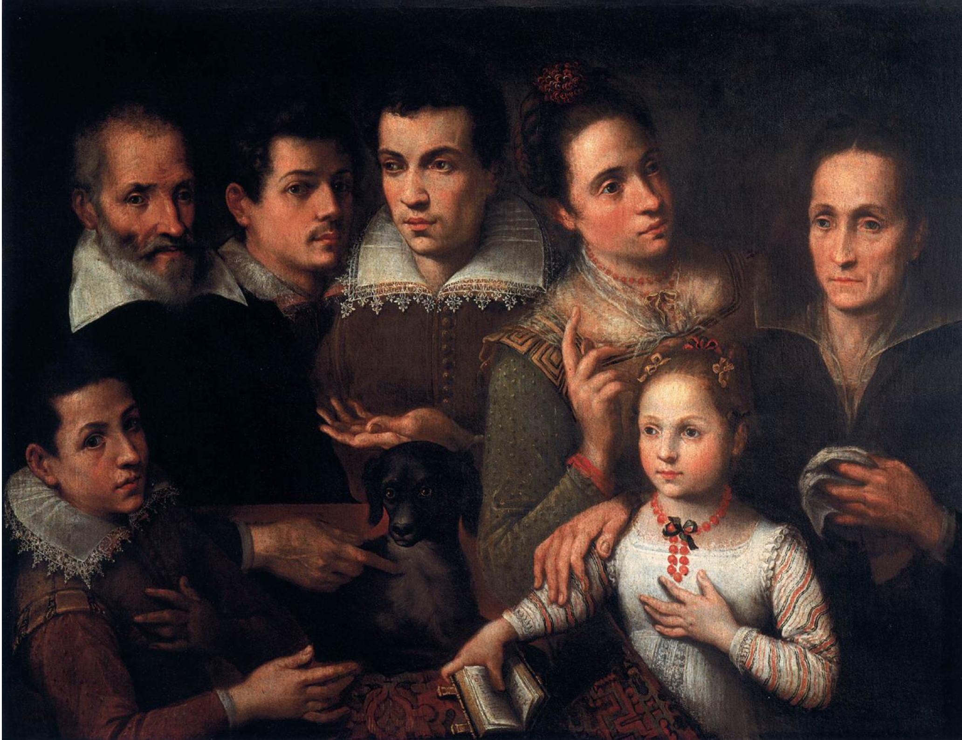
Portrait of a Family by Lavinia Fontana, 1585
Text found at: http://nmwa.org/explore/artist-profiles/lavinia-fontana#sthash.inNBUEuA.dpuf
Image found at: http://www.wga.hu/support/viewer_m/z.html

Source 4: Sandro Botticelli’s Birth of Venus

At the height of his fame, the Florentine painter and draughtsman Sandro Botticelli was one of the most esteemed artists in Italy…

The son of a tanner, he was born Alessandro di Mariano Filipepi, but he was given the nickname 'Botticelli' (derived from the word 'botticello' meaning 'small wine cask'). Smart beyond his years, the young Botticelli became easily bored at school. He was known for his sharp wit and his love of practical jokes, and he quickly earned a reputation as a restless, hyperactive and impatient child. Fortunately, his precocious talent was recognised and he was withdrawn from school and sent to work as an apprentice.
It is thought that Botticelli first trained with Maso Finiguerra, a goldsmith, before entering the studio of the artist Fra Filippo Lippi. He began his career painting frescoes for Florentine churches and cathedrals, and worked with the painter and engraver Antonio del Pollaiuolo. By 1470, he had his own workshop…
Botticelli returned to Florence, to continue with the most prolific stage of his career.
The period from 1478-90 saw Botticelli at his most creative. This was the period during which he produced his famous mythological works, such as 'The Birth of Venus' (in the Uffizi, Florence) and 'Venus and Mars'. In these he successfully combined a decorative use of line (possibly owing much to his early training as a goldsmith) with elements of the classical tradition, seen in the harmony of his composition and the supple contours of his figures…

After his death, his name all but disappeared until the late 19th century, when a developing appreciation for Florentine arts and culture brought about a renewed interest in his work.

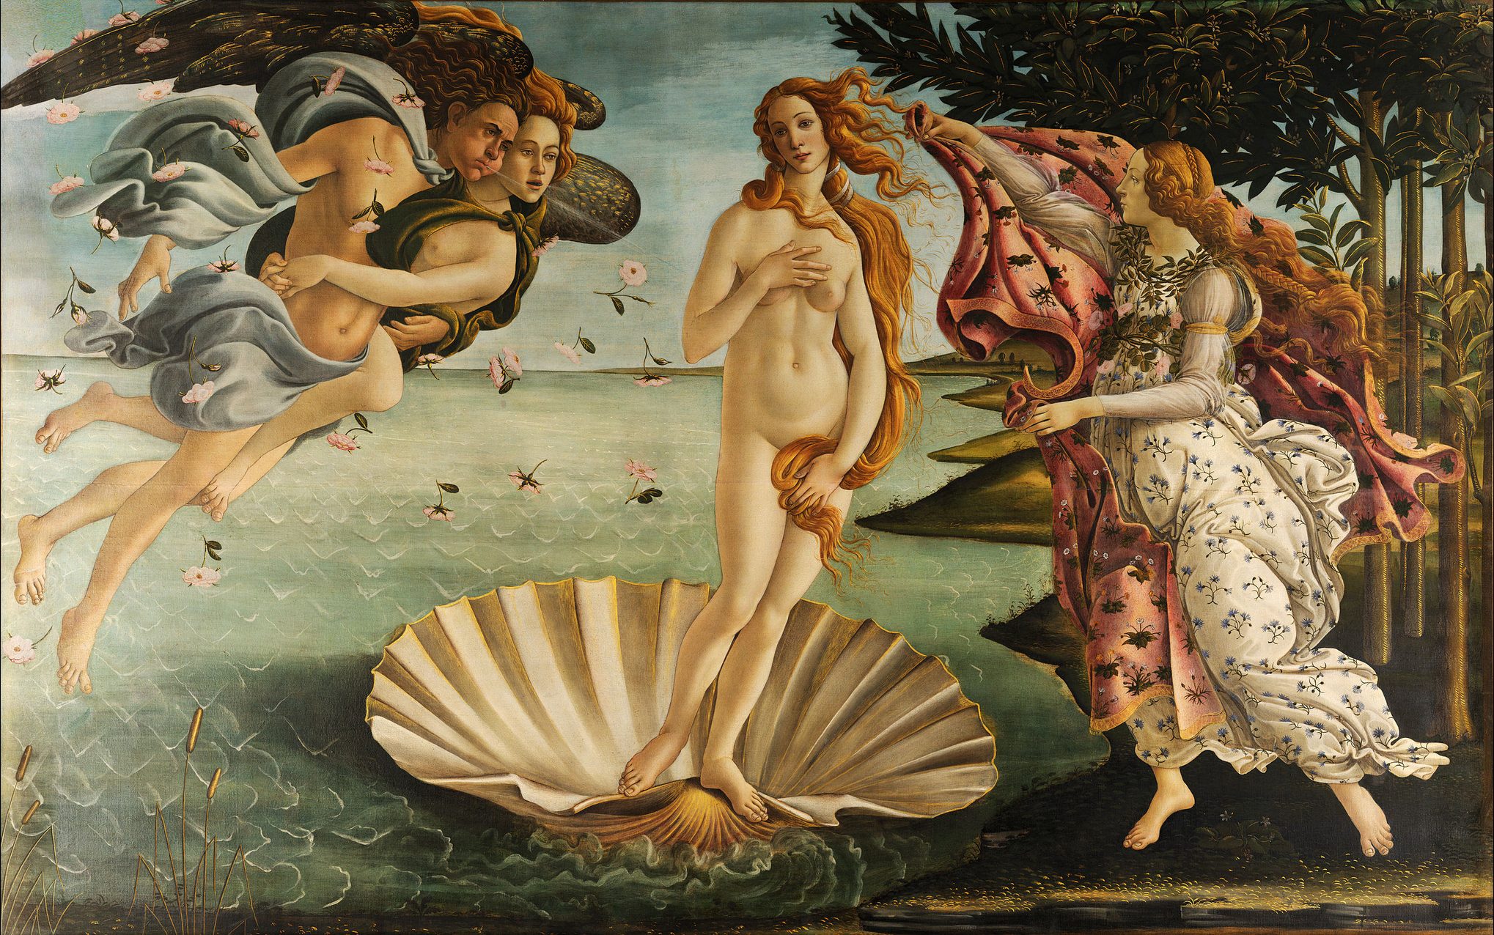
The Birth of Venus, 1486

Text from: http://www.nationalgallery.org.uk/artists/sandro-botticelli
Image from:
https://en.wikipedia.org/wiki/The_Birth_of_Venus#/media/File:Sandro_Botticelli_-_La_nascita_di_Venere_-_Google_Art_Project_-_edited.jpg

