**Slave Narratives**

*The excerpts are from former slaves who were freed after the Civil War. Most were children, or in their early teens, at the time they were in slavery. These interviews were conducted in the 1930’s and then written down. All of these interviews have been obtained from the Library of Congress.*

What is the name of the former slave being interviewed?

How old are they (if it says)?

Where are they living?

Is there a date or year on the document anywhere?

Give a very brief summary of some the experiences the former slave describes:

Is there anything special that stood out to you or that you found really interesting?

Is there anything you have questions about or didn’t understand?

[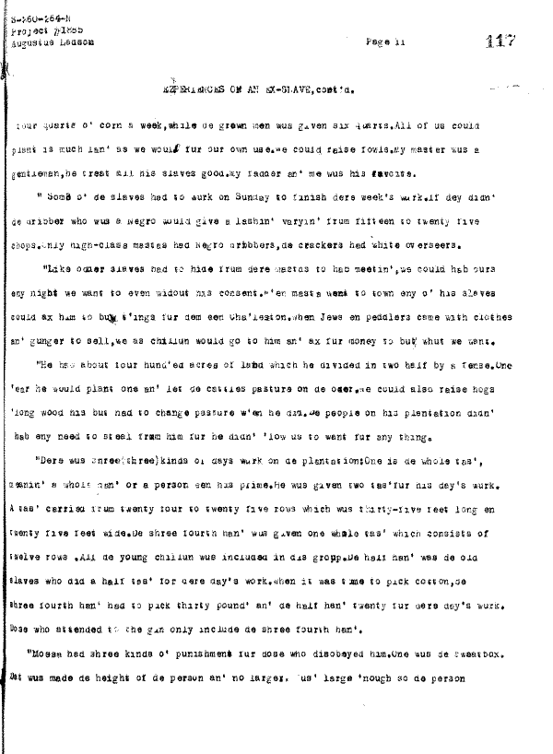](http://memory.loc.gov/mss/mesn/144/121117.tif)

[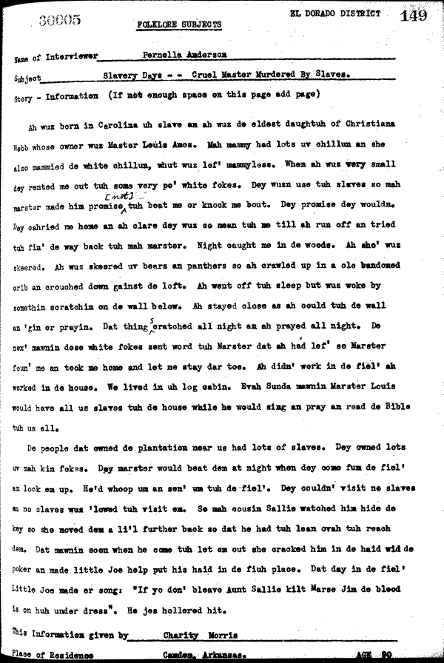](http://memory.loc.gov/mss/mesn/025/154149.tif)

[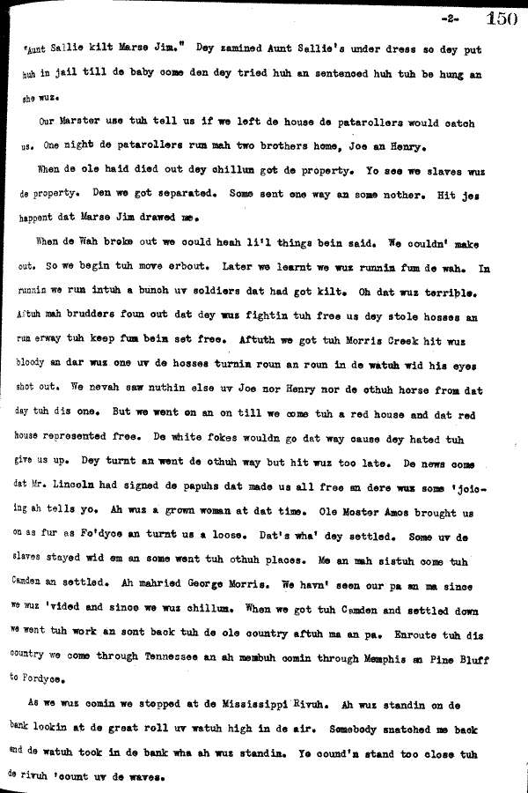](http://memory.loc.gov/mss/mesn/025/155150.tif)

[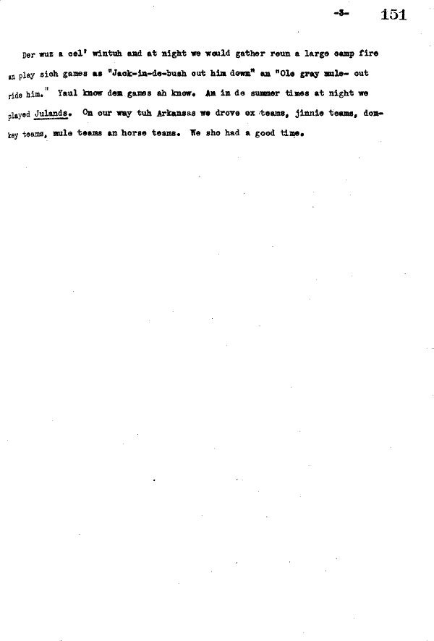](http://memory.loc.gov/mss/mesn/025/156151.tif)

[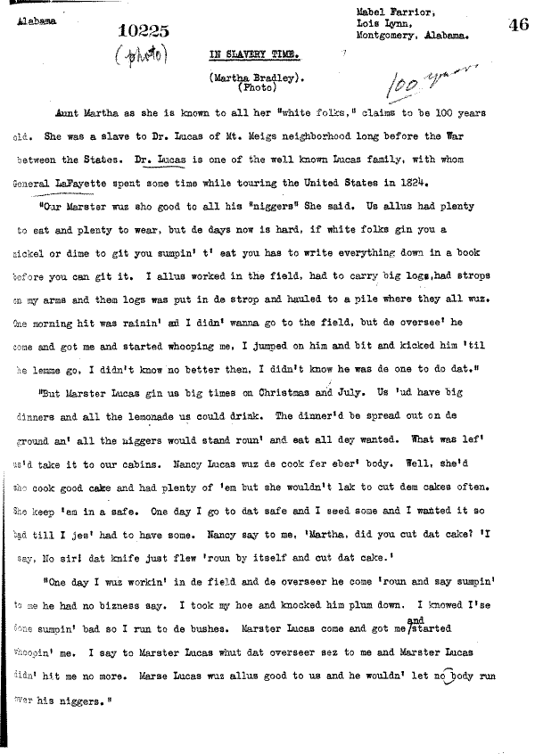](http://memory.loc.gov/mss/mesn/010/052046.tif)

[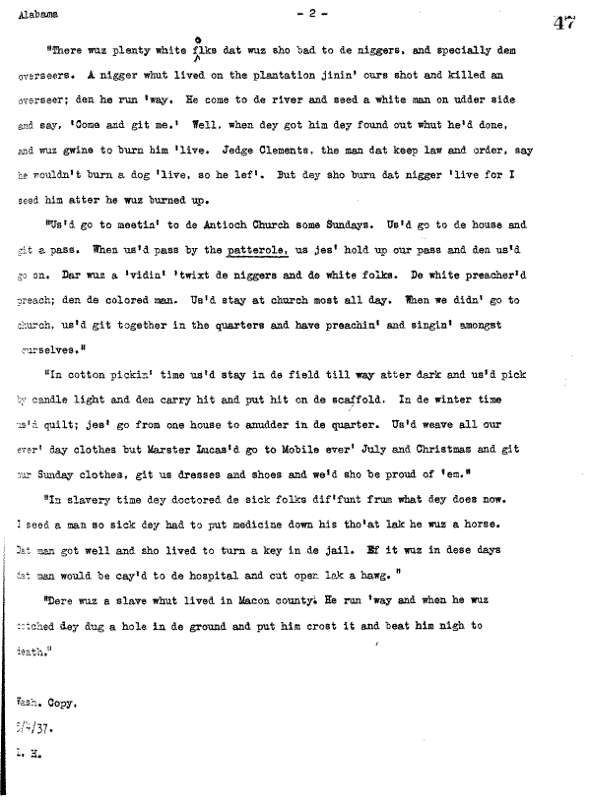](http://memory.loc.gov/mss/mesn/010/053047.tif)

[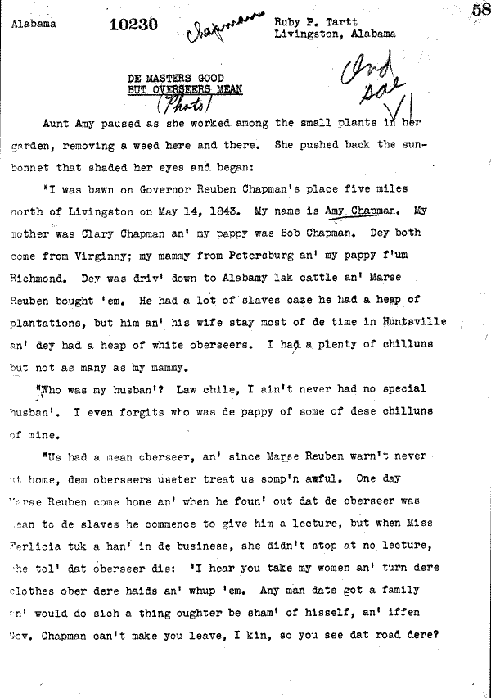](http://memory.loc.gov/mss/mesn/010/064058.tif)

[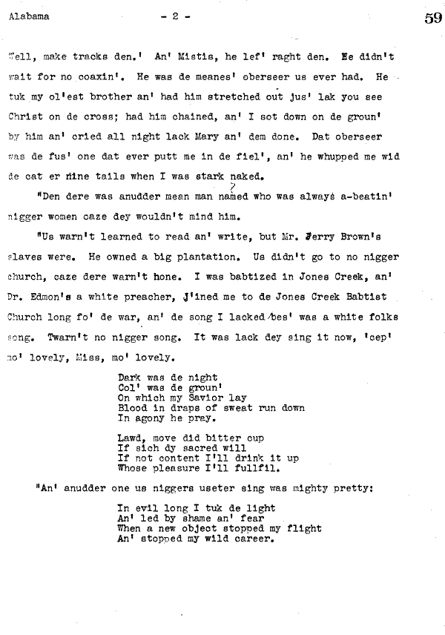](http://memory.loc.gov/mss/mesn/010/065059.tif)

[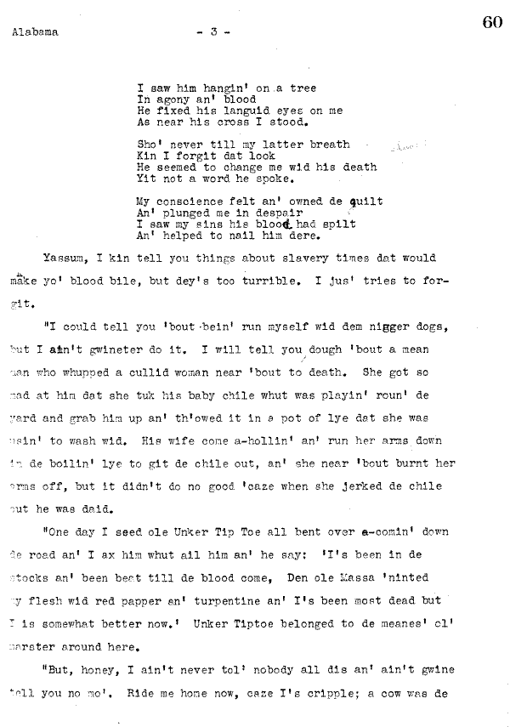](http://memory.loc.gov/mss/mesn/010/066060.tif)

[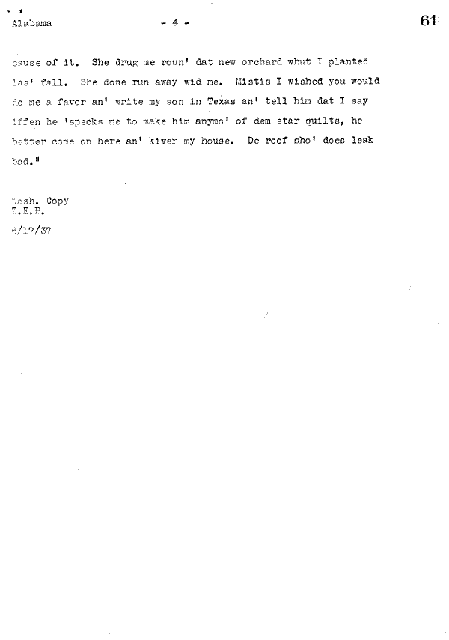](http://memory.loc.gov/mss/mesn/010/067061.tif)

[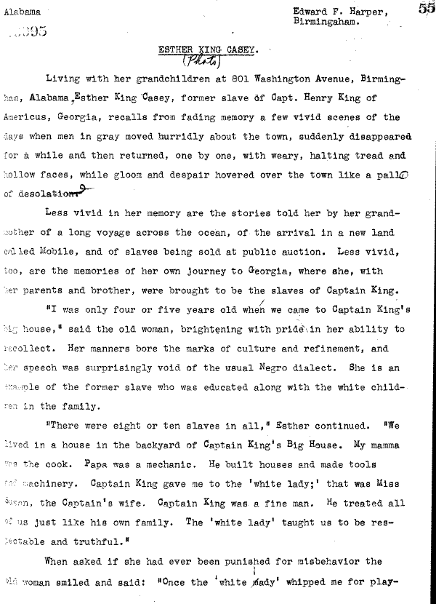](http://memory.loc.gov/mss/mesn/010/061055.tif)

[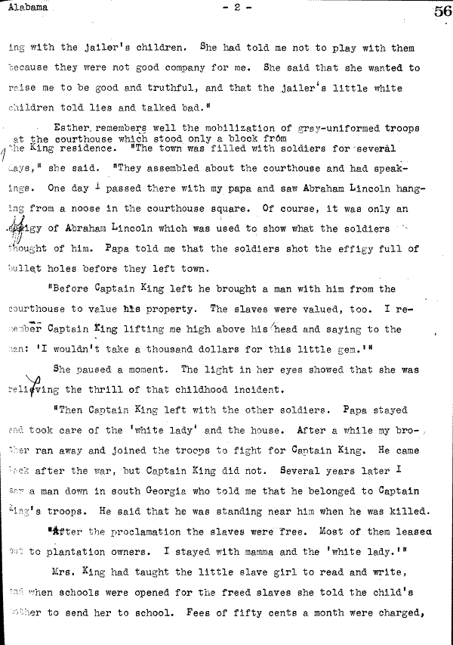](http://memory.loc.gov/mss/mesn/010/062056.tif)

[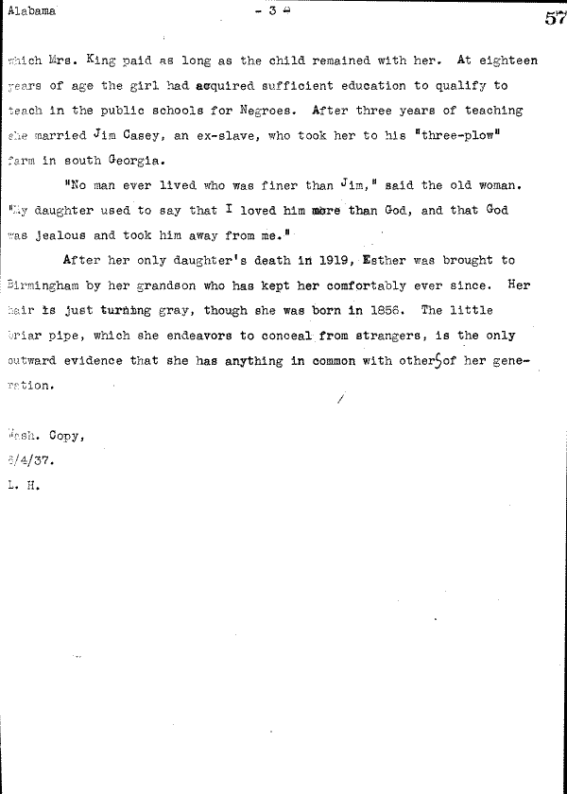](http://memory.loc.gov/mss/mesn/010/063057.tif)

[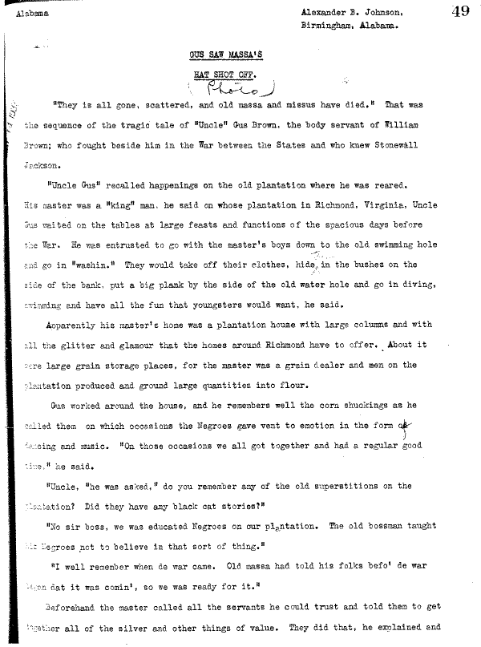](http://memory.loc.gov/mss/mesn/010/055049.tif)

[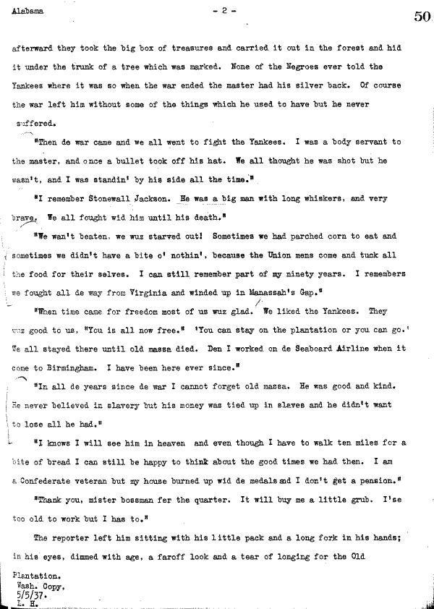](http://memory.loc.gov/mss/mesn/010/056050.tif)