Using Discussion to Enhance Historical Thinking and Writing
Lisa Hutton—CSUDH-Long Beach
Emma Hipolito—UCLA
(revised by) Nicole Gilbertson—UCI

Students do not naturally think like historians by searching for additional, often contradictory, information and supporting a position with evidence. One of the best ways to encourage their awareness of multiple perspectives about an event and to prepare students for historical thinking and writing is by using structured discussions of documents.

“…Some way has to be found to capture people in the act of
contextualized thinking—in the moments of confusion before
an interpretation emerges, while indecision and doubt reign
and coherence remains elusive.”
–Sam Wineburg, Historical Thinking and Other Unnatural Acts, p.91

"Reading and writing float on a sea of talk." - James Britton

“We teach students to think with and between and against texts
by helping them say aloud, in conversations with us and with
others, the thoughts they will eventually be able to develop
without the interaction of conversation. The great Russian
psychologist Lev Vygotsky helped us realize that by giving our
students practice in talking with others, we give them frames for
thinking on their own. If others repeatedly say to us, “So what are
you thinking about this?” or “What in the text makes you say this?”
“Where’s your evidence?” then we, as readers, begin to ask these
questions of ourselves.”
In schools, talk is sometimes valued and sometimes avoided,
but—and this is surprising—talk is rarely taught. It is rare to hear
teachers discuss their efforts to teach students to talk well. Yet,
talk, like reading and writing, is a major motor—I could even say
the major motor—of intellectual development.”
- Lucy Calkins, The Art of Teaching Reading, p.226

Discussion Format
Teacher’s Guide

- Divide students into groups of 3 or 5.

2. Each student individually reads 2 documents looking for possible answers to
the discussion question. They fill out the Sharing Out Chart as they are reading.

3. Students then share out the information on their charts. Students should focus on summarizing the content in their document, explaining what they believe the document says in relation to the discussion question, and discussing how these sources support, build upon, or contest one another. Students discuss how these sources answer the discussion question.

- After all group members have shared, the group should have a discussion on possible hypothesis given what they believe the documents say.

Possible discussion starters:

Document xx does not seem to fit with the other documents, because….
Document xx seems to support the ideas in document xxx…..
Document xx seems more credible than document…
I agree/disagree with what Carmen said, because…..
Why do you think that?
How did you come to that conclusion?
Could you summarize your main point again….
Where is the evidence to support this idea…..

- Individually each student should write out his/her claim to respond to the discussion question as well as the key pieces of evidence that he/she believes support it. Students should also write out any questions that they may have in preparation for a whole group discussion.

6. Whole class discussion---below are some possible questions that a teacher could
ask.
What is your hypothesis?
What evidence supports this claim?
What evidence contradicts that claim?
How do we know that is true?
Who are the authors of some of these documents? What do we know
about them?

Sharing Out Chart

Name: _____________________________________Date: ________________________

Discussion Question: _________________________________________________________________________

Document #1: | Document #2:
Summary: | Summary:
Based on this document, how would you answer the discussion question? | Based on this document, how would you answer the discussion question?
Evidence | Evidence

Corroborating Sources:
How do these two sources describe the same event? What are the similarities? What are the differences?

Which source is more believable? Explain your answer.

What other sources might I need to consult to answer the discussion question?

Sharing Out Chart

Name: _____________________________________Date: ________________________

Discussion Question: _________________________________________________________________________

Document #3: | Document #4:
Summary: | Summary:
Based on this document, how would you answer the discussion question? | Based on this document, how would you answer the discussion question?
Evidence | Evidence

Corroborating Sources:
How do these two sources describe the same event? What are the similarities? What are the differences?

Which source is more believable? Explain your answer.

What other sources might I need to consult to answer the discussion question?

Sharing Out Chart

Name: _____________________________________Date: ________________________

Discussion Question: _________________________________________________________________________

Document #5: | Document #6:
Summary: | Summary:
Based on this document, how would you answer the discussion question? | Based on this document, how would you answer the discussion question?
Evidence | Evidence

Corroborating Sources:
How do these two sources describe the same event? What are the similarities? What are the differences?

Which source is more believable? Explain your answer.

What other sources might I need to consult to answer the discussion question?

Sharing Out Chart

Name: _____________________________________Date: ________________________

Discussion Question: _________________________________________________________________________

Document #7: | Document #8:
Summary: | Summary:
Based on this document, how would you answer the discussion question? | Based on this document, how would you answer the discussion question?
Evidence | Evidence

Corroborating Sources:
How do these two sources describe the same event? What are the similarities? What are the differences?

Which source is more believable? Explain your answer.

What other sources might I need to consult to answer the discussion question?

Sharing Out Chart

Name: _____________________________________Date: ________________________

Discussion Question: _________________________________________________________________________

Document #9: | Document #10:
Summary: | Summary:
Based on this document, how would you answer the discussion question? | Based on this document, how would you answer the discussion question?
Evidence | Evidence

Corroborating Sources:
How do these two sources describe the same event? What are the similarities? What are the differences?

Which source is more believable? Explain your answer.

What other sources might I need to consult to answer the discussion question?

Based on all of documents, my tentative answer to the discussion question is __________________________________
______________________________________________________________________________________________________________________________________________________________________________________________________________________________________

Evidence that supports my claim:

- Source summary and citation
  - explanation

- Source summary and citation
  - explanation

- Source summary and citation
  - explanation

Questions I have: __________________________________________________________________________________

Discussion Directions

- Read your document(s) to find information related to the discussion question. Fill out the Sharing Out Chart as you read.

- Take turns sharing out the information on your chart. Summarize the content in your document, explaining what you believe the document says in relation to the discussion question. Provide supporting evidence.

Person Sharing: Group Members Response:
My documents are about… Tell me more about…
The evidence that supports my idea is… What evidence do you have?
The evidence that I found most reliable is… How did you come to that conclusion?

After a group member shares, take a few moments to fill out the information on your chart. Then go on to the next group member. You will need to have information on each document that your group received on your Sharing Out Chart by the end of the group time.

- After all your group members have shared, discuss if the documents agree or contradict one another. If they contradict each other, are certain documents more credible? Through your discussion, you should answer the discussion question and be able to support your answer with evidence from the documents.

  - Document xx does not seem to fit with the other documents, because….
  - Document xx seems to support the ideas in document xxx…..
  - Document xx seems more credible than document…
  - I agree/disagree with what Carmen said, because…..
  - Why do you think that?
  - How did you come to that conclusion?
  - Could you summarize your main point again….
  - Where is the evidence to support this idea…..

- Write out your Claim as well as the key pieces of evidence and analysis that you believe support your claim. Write out any questions you have about the discussion question.

Teacher Planning Sheet for Discussion Groups

Content Standard

11.9 Students analyze U.S. foreign policy since World War II.
3. Trace the origins and geopolitical consequences (foreign and domestic) of the Cold War and containment policy, including the following:
  - The Korean War

Common Core Standards
Reading Standards for History-Social Science
Key Ideas and Details 1-3
Craft and Structure 6
Integration of Knowledge and Ideas
7-9
What is the objective of the discussion (Engagement for new standard or topic, going in depth for an important issue, extending learning, etc.)?
To provide students with practice analyzing multiple and contradictory primary source texts.
To give students opportunities to learn to summarize and analyze multiple pieces of evidences through a collaborative process.

What do I want students to understand by the end of the discussion?
That the Korean War was an important flashpoint in the Cold War.

Discussion Question (The question is should be open-ended enough to promote thought and discussion)
What caused the Korean War?

Documents I will use for the small group discussions

Korean War Source Packet

Additional questions to promote thought and understanding for the whole group discussion
Why do different sources provide differing accounts of the war?
What trends do I see as I read the documents and learn about them from my colleagues?

What will students do after the discussion to reflect on what they have learned (reflection, further reading, formal writing, etc.)?
Students will write an argumentative essay using evidence from the discussion using the prompt, What was the most significant cause of the Korean war?

Korean War Documents

Source 1

Textbook source written in North Korea

Upset by the fast and astonishing growth of the power of the Republic, the
American invaders hastened the preparation of an aggressive war in order to
destroy it in its infancy....The American imperialists furiously carried out the war
project in 1950....The American invaders who had been preparing the war for a
long time, alongside their puppets, finally initiated the war on June 25th of the
39th year of the Juche calendar. That dawn, the enemies unexpectedly attacked
the North half of the Republic, and the war clouds hung over the once peaceful
country, accompanied by the echoing roar of cannons.
Having passed the 38th parallel, the enemies crawled deeper and deeper into the
North half of the Republic...the invading forces of the enemies had to be
eliminated and the threatened fate of our country and our people had to be
saved.

History of the Revolution of our Great Leader Kim Il-sun: High School. (Pongyang, North
Korea: Textbook Publishing Co., 1999), 125-127.

Source 2

Textbook source written in South Korea

When the overthrow of the South Korean government through social confusion
became too difficult, the North Korean communists switched to a stick-and-carrot
strategy: seeming to offer peaceful negotiations, they were instead analyzing the
right moment of attack and preparing themselves for it.
The North Korean communists prepared themselves for war. Kim Il-sung
secretly visited the Soviet Union and was promised the alliance of the Soviets
and China in case of war. Finally, at dawn on June 25th, 1950 the North began
their southward aggression along the 38th parallel. Taken by surprise at these
unexpected attacks, the army of the Republic of Korea (South Korea) fought
courageously to defend the liberty of the country....The armed provocation of the
North Korean communists brought the UN Security Council around the table. A
decree denounced the North Korean military action as illegal and as a threat to
peace, and a decision was made to help the South. The UN army constituted the
armies of 16 countries—among them, the United States, Great Britain and
France—joined the South Korean forces in the battle against the North.

Doojin Kim, Korean History: Senior High. (Seoul, South Korea: Dae Han Textbook Co.,
2001), 199.

Source 3

“Korea…is a symbol to the watching world both of the East-West struggle for influence and
power and of American sincerity in sponsoring the nationalistic aims of Asiatic peoples. If
we allow Korea to go by default and to fall within the Soviet orbit, the world will feel that
we have lost another round in our match with the Soviet Union, and our prestige and the
hopes of those who place their faith in us will suffer accordingly…”

1947 memorandum by Francis Stevens, assistant chief of the Division
of Eastern European Affairs at the U.S. Department of State.

Source 4

“About the time I was transferred from the Ukraine to Moscow at the end of 1949, Kim Il-sung arrived with his delegation to hold consultations with Stalin. The North Koreans wanted to prod South Korea with the point of a bayonet. Kim Il-sung said that the first thrust would touch off an internal explosion in South Korea and that the power of the people would prevail — that is the power ruled in North Korea. Naturally Stalin didn’t object to the idea. It suited his convictions as a Communist all the more so because the struggle would be an internal matter that the Koreans would be settling among themselves. Stalin persuaded Kim Il-sung to think it over again, make some calculations and then come back with a concrete plan. Kim went home and then returned to Moscow when he had worked everything out. He told Stalin he was absolutely certain of success. I remember Stalin had his doubts. He feared the Americans would jump in, but we were inclined to think that if the war were fought swiftly and Kim Il-sung was sure it could be won swiftly, then intervention by the USA could be avoided. Nevertheless Stalin decided to seek Mao Zedong’s opinion. Mao also answered affirmatively and put forward the opinion that the USA would not interfere. I remember a high-spirited dinner at Stalin’s dacha (villa). We wished every success to Kim Il-sung and toasted the whole North Korean leadership.”

Nikita Khrushchev. “Truth About the Korean War,” in Kim Chullbaum (Editor). The Truth About the Korean War. Seoul: Eulyoo, 1991: 61

Source 5

(82 –June 25, 1950) The Security Council…noting with grave concern, the attack on the
Republic of Korea by forces from North Korea…determines that this act constitutes a
breach of peace…calls for the immediate cessation of hostilities…calls upon the
authorities in North Korea to withdraw their armed forces to the 38th parallel.
(83 – June 27, 1950) The Security Council…recommends that members of the United
Nations furnish such assistance to the Republic of Korea as may be necessary to repel the
armed attack and to restore international peace and security in the area.
(84 – July 7, 1950) The Security Council…recommends that all members providing
military forces and other assistance pursuant to the aforesaid Security Council resolutions
make such forces and other assistance available to a unified command under the United
States of America.
(85 – July 31, 1950) The Security Council…requests the unified command to exercise
responsibility for determining the requirements for the relief and support of the civilian
population of (the Republic of) Korea and for establishing in the field the procedures for
providing such relief and support.

United Nations Security Council resolutions 82, 83, 84, and 85, dated
between June and July, 1950.

Source 6
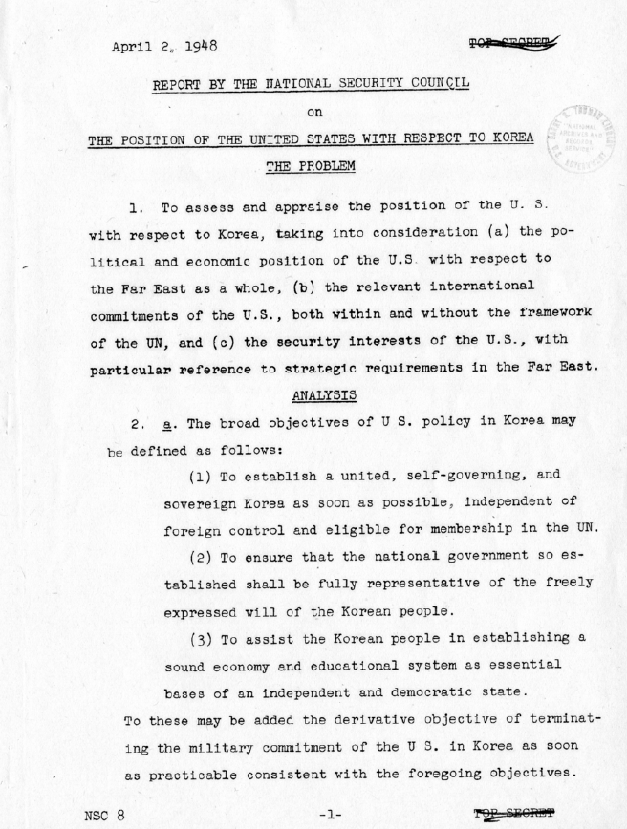
"The Position of the United States With Respect to Korea," National Security Council Report 8, April 2, 1948.

Source 7

“…I told the men some historical facts about American invasions of China in the past and
its recent occupation of Taiwan. We were victims of American imperialism. I argued that
if we didn’t stop Americans in Korea now, we would have to fight them later in China. To
assist Korea was the same as defending our homeland…even though the U.S. military had
modern weapons, the American troops were fighting an unjust war and suffering from low
morale. They were short of manpower, and their support had to come from a great
distance. Our army was dedicated to a just cause. We had the brilliant leadership of the
Chinese Communist Party and Chairman Mao (Zedong), and the full support of our
people, the Korean people, and peace-loving people from around the world. Our weapons
were not as advanced as the Americans, but we enjoyed a numerical advantage.”

An excerpt from the testimony of Captain Zhou Baoshan of the Chinese
People’s Volunteer Force on why Chinese forces attacked UN forces in the Korean War.
(Richard Peters and Xiaobing Li, Voices from the Korean War: Personal Stories of American,
Korean, and Chinese soldiers, 2004)

Source 8

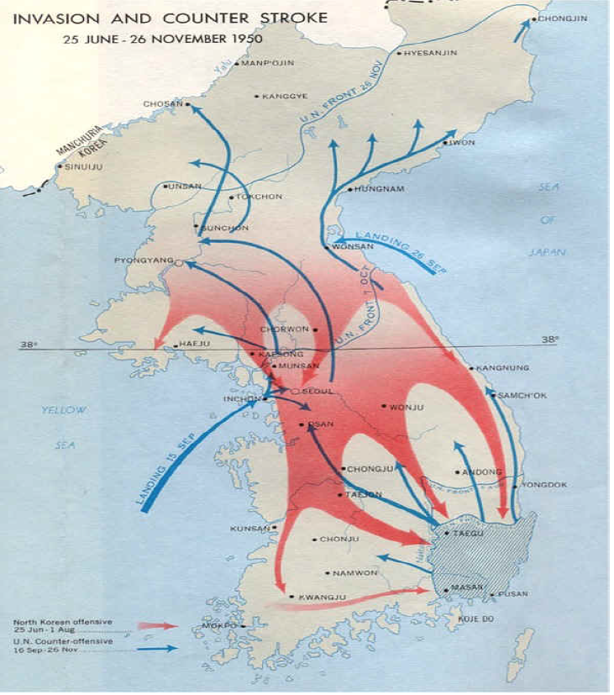

Map of the invasion and counter-strike that led to the Korean War, courtesy of the Department of National Defense, Government of Canada.

Source 9

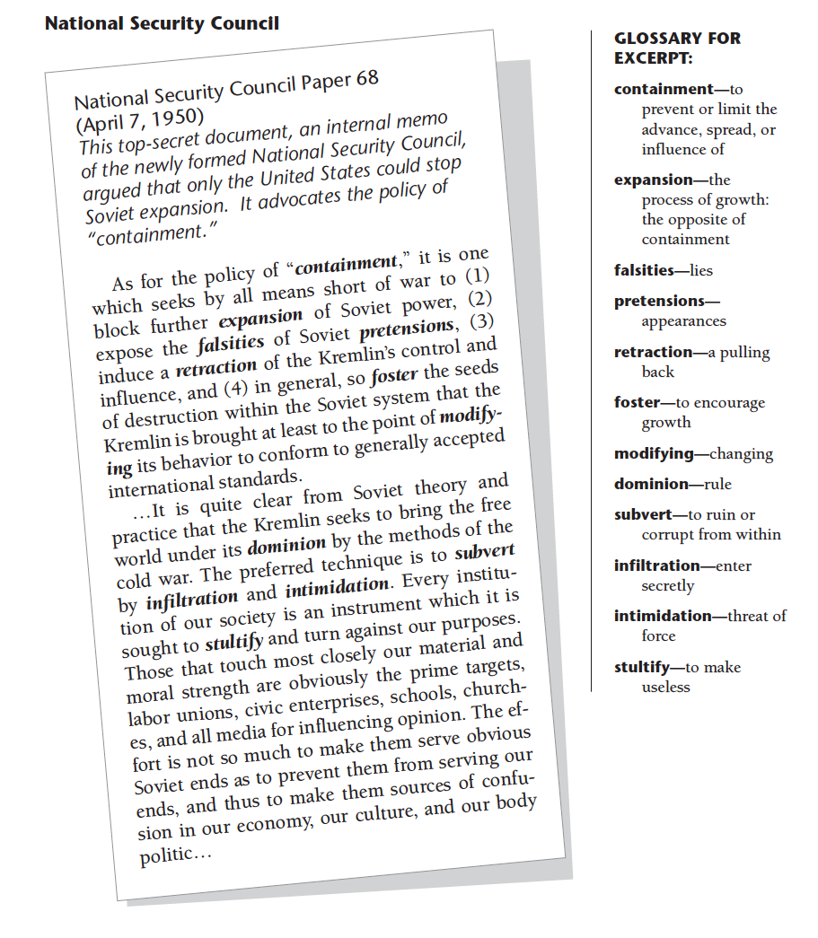

Source 10

Date | Event
August 10, 1945 | The United States and the Soviet Union agree to a temporary division of Korea—formerly a Japanese colony—along the 38th Parallel. U.S. forces were to occupy and administer the southern half, while Soviet troops would occupy and administer the North.
March 1946 | During World War II the two combatants in the Chinese Civil War—the Nationalists under Chiang Kai-shek and the Communists under Mao Tse-tung—had agreed to a temporary truce while both fought the Japanese. However, less than a year after the defeat of Japan the truce fell apart, and large-scale fighting resumed between the two sides.
May 1948 | The United States sponsors elections in South Korea. The Soviets protest the decision, and instruct left-wing parties there to boycott the election. The result is that Syngman Rhee, a dedicated anti-communist who was educated in the United States, becomes head of the government. Soon afterward the Soviets establish a communist regime in North Korea under the leadership of Kim Il-sung.
August 12, 1948 | Eager to rid itself of commitments in East Asia, the United States formally recognizes the independence of South Korea, and arrangements begin for the withdrawal of U.S. forces from the region. The Soviets make a similar announcement regarding North Korea.
December 26, 1948 | The last Soviet troops leave North Korea.
January 1949 | Chinese communist forces under Mao Tse-tung enter city of Peiping. They change the name to Beijing and declare that it is the new capital of China.
June 1949 | The last U.S. troops leave South Korea.
October 1, 1949 | With most of the Chinese countryside, as well as its major cities, in communist hands, Mao Tse-tung declares victory in the civil war. He announces that hence
June 1949 | The last U.S. troops leave South Korea.
April 1950 | Soviet leader Josef Stalin gives Kim Il-sung permission to launch an invasion of South Korea; however, he warns Kim that "If you should get kicked in the teeth, I shall not lift a finger. You have to ask Mao [Tse-tung] for all the help."
June 25, 1950 | At approximately 4:00 am, 90,000 North Korean troops, equipped with Soviet weapons, invade South Korea. South Korean forces are quickly forced to retreat. Truman orders U.S. naval and air forces—but not ground forces—to assist in the defense of South Korea.
June 27, 1950 | The United Nations calls upon its members to come to the aid of South Korea. The proposal only wins the approval of the Security Council because the Soviet delegation is boycotting its proceedings to protest the U.N.’s failure to recognize Mao Tse-tung’s regime as the legitimate government of China.
June 28, 1950 | North Korean forces capture Seoul, the capital of South Korea.

Timeline of Events Related to the Origins of the Korean War

Sources Citation
Bruce Lesh, Why Won’t You Tell Us the Answer?: Teaching Historical Thinking in Grades 7-12, (Portland: Stenhouse Publishing, 2011), 167. (Source 10)

Edsitement! Lesson, “’Police Action:” The Korean War, 1950-1954,” National Endowment for the Humanities, http://edsitement.neh.gov/lesson-plan/korean-war-police-action-1950-1953#sect-thelesson. (Source 10)

Eileen Luhr, “Cold War: Containment at Home and Abroad,” in Humanities Out There United States History, (Regents of the University of California, 2005), 19. (Source 9)

Korea Society, “Remembering the Forgotten War,” http://www.koreasociety.org/102_k-12_teachers/103_by_subject_area/116_history/view_category.html., Accessed February 1, 2013. (Source 4)

B.J. Piel, “How was the Korean War a “Flashpoint” of the Cold War?”, Korea Society, http://www.koreasociety.org/102_k-12_teachers/103_by_subject_area/116_history/view_category.html. (Sources 3, 5, 7, and 8)

Stanford History Education Group, “Korean War,” http://sheg.stanford.edu/?q=node/389, accessed February 1, 2013. (Sources 1 and 2)

Truman Library, "The Position of the United States With Respect to Korea," National Security Council Report 8, April 2, 1948, http://www.trumanlibrary.org/whistlestop/study_collections/koreanwar/index.php, accessed February 1, 2013. (Source 6)

