Mesopotamia Lesson: How did geography affect the trade between ancient city-states?

From: Nicole Gilbertson

History Standards:
6.2.1: Locate and describe the major river systems and discuss the physical settings that supported permanent settlement and early civilizations.
CCSS Standards: Reading, Grade 6-8
- Determine the central ideas or information of a primary or secondary source; provide an accurate summary of the source distinct from prior knowledge or opinions.
7. Integrate visual information (e.g., in charts, graphs, photographs, videos, or maps) with other information in print and digital texts.

Guiding Question:
How did geography affect the trade between ancient city-states?

Lesson Objective: Students engage in the lesson below to consider how geography impacted trade in Mesopotamia.

Investigation Question:
How did geography affect the trade between ancient city-states?

What types of things do we study when we study geography?

Part 1: Map Exploration
Look at the map of Mesopotamia in your textbook. What information can we learn from the map about Mesopotamian geography? List the important geographical features below.

Mountains:

Rivers:

Deserts:

Bodies of Water:

1. What do we learn about geography based on the map?

Look at another map of Mesopotamia showing this area in 2500 B.C.E. What information can we learn about the ancient world from Map 2? List your answer below.
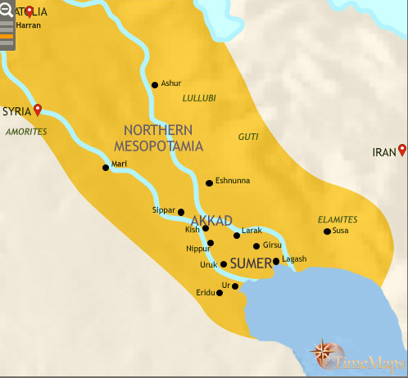
http://www.timemaps.com/history/iraq-3500bc/
We might consider another map if we want to look at how the cities and kingdoms traded with one another. Take a look at Map 3 below and answer the questions.
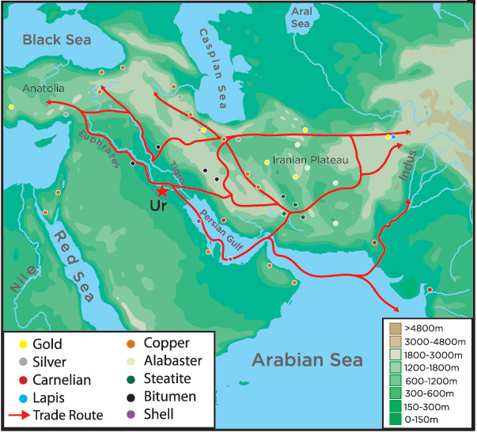
From Penn Museum
http://www.penn.museum/sites/iraq/?page_id=52#

2. What areas were connected by the trade routes?

3. Where the trade routes over land or water or both?

4. Explain why you think routes would extend over land and/or water?

5. What goods were traded?

Part 2: Royal Standard of Ur and Long Distance Trade
Examine the Royal Standard of Ur below and in your textbook, read the accompanying text, and answer the questions.
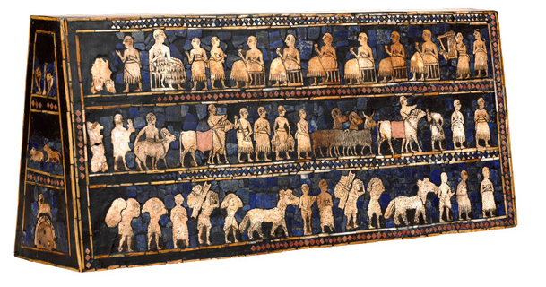
Image and text found at the British Museum
Image:
http://www.britishmuseum.org/explore/highlights/highlight_image.aspx?image=12_standardur.jpg&retpage=19094
Text: http://www.britishmuseum.org/explore/highlights/highlight_objects/me/t/the_standard_of_ur.aspx

This object was found in one of the largest graves in the Royal Cemetery at Ur, lying in the corner of a chamber above the right shoulder of a man. Its original function is not yet understood.

1. Look at the map above and find Ur. Where is it located?

2. What do you see in the image?

3. What might this tell us about daily life in ancient Mesopotamia?
The Standard of Ur is made of shell, red limestone and lapis lazuli. Bitumen, is like asphalt and made from petroleum, it acts as glue holding the pieces together.
4. Look at the trade map above. Where would the materials used in the making of the Standard of Ur have come from?
5. What types of goods are these? Are they everyday objects you need to live or are they luxury goods?

6. Why would people want luxury goods? Who could afford to purchase these items?

Part 3: Regional Trade
Students can explore the interactive trade lesson on trade to understand more about ancient trade:
http://www.mesopotamia.co.uk/trade/explore/exp_set.html

If students don’t have access to technology, teachers can print out the images and corresponding goods and each group can examine the types of goods and the ways that these goods were traded.

Use the questions below to guide exploration. Once students have answered the questions, they can report out in groups.

- How were goods carried from place to place?

- What goods were traded?

- Choose one of the trade items and consider from where it might have originated. For example, timber comes from forests. Look at the map on page 67 in your textbook to see if you can describe where it came from? For example, forests can be found in mountain ranges, so timber may come from the Zagros or Taurus Mountains.

- How did people use these goods?

- Were they everyday objects or luxury goods?

- What does this tell us about everyday life in ancient Mesopotamia? Given what we know about trade, what conclusions can we draw about ancient Mesopotamian life?

Part 4: Conclusion
We have studied the geography of the ancient Middle East, Mesopotamia. We learned about the geographical features of the area. We learned about long distance trade of luxury goods. And we learned about trade of everyday items. Now it is time for us to put it all together to answer our focus question:
How did geography affect the trade between ancient city-states?
Before you begin, you will want to organize your evidence. Use the chart below to list your evidence and the citation. For the citation, you will want to use MLA format.

Evidence Citation
Cities were located along the Tigris and Euphrates river. Map 2

