**Cause and consequence of the Reformation**

**Reformation**

From: Nicole Gilbertson 2016

**History Standards: 7.9.4**

Identify and locate the European regions that remained Catholic and those that became Protestant and explain how the division affected the distribution of religions in the New World.

**CCSS Standards:** CCSS RH 6. Compare and contrast the information gained from experiments, simulations, video, or multimedia sources with that gained from reading a text on the same topic.

CCSS WH 9.Draw evidence from informational texts to support analysis reflection, and research.

**Guiding Question:** How did the Reformation divide people and states?

**Overview of Lesson:**

1. Teachers will review the map of a divided Europe and will hone in on the areas of Germany to ask students to consider how the Reformation created divisions.
2. Teachers will then show a brief overview of the effects of the Reformation on peasants in Germany:

<https://www.youtube.com/watch?v=Y_G9k9FxEuY>

1. Students will partner up to investigate how did the Reformation divide German principalities?

Teachers will post each of the five documents around the room and student partners will each fill out their graphic organizer while visiting each document. Documents include:

1. excerpt from textbook, *Across the Centuries* page 347
2. Germany during the Reformation map: <http://womenineuropeanhistory.org/index.php?title=File:Protestant_small.jpg>

c. Peasant Rebels of 1525 image

d. Durer’s Memorial to the Peasant War image

e. Martin Luther, *Against the Robbing and Murdering Hordes*

1. Students will use evidence to create claim and will have evidence from 3 sources, to answer the question:

How was Germany divided by the Reformation?

1. Teachers then ask students to participate in a “thesis statement throwdown” (<http://catlintucker.com/2015/02/thesis-statement-throwdown/>) where each of the partners creates a thesis statement/claim to respond to the question. The teacher calls on two teams and the teams write their thesis statements on the board. Meanwhile, the teacher plays a fun song to get the students engaged. The teacher then does a think aloud editing each of the thesis statements and discussing specific evidence that could be used for each claim. Then the teacher awards a winner.

1. All partners turn in their thesis statements as an exit ticket.

**Note:** Students should keep the graphic organizer for use on the final assignment.

**Lesson Handouts:** Sources A-E and graphic organizer for gallery walk

**Map of Divided Europe:**

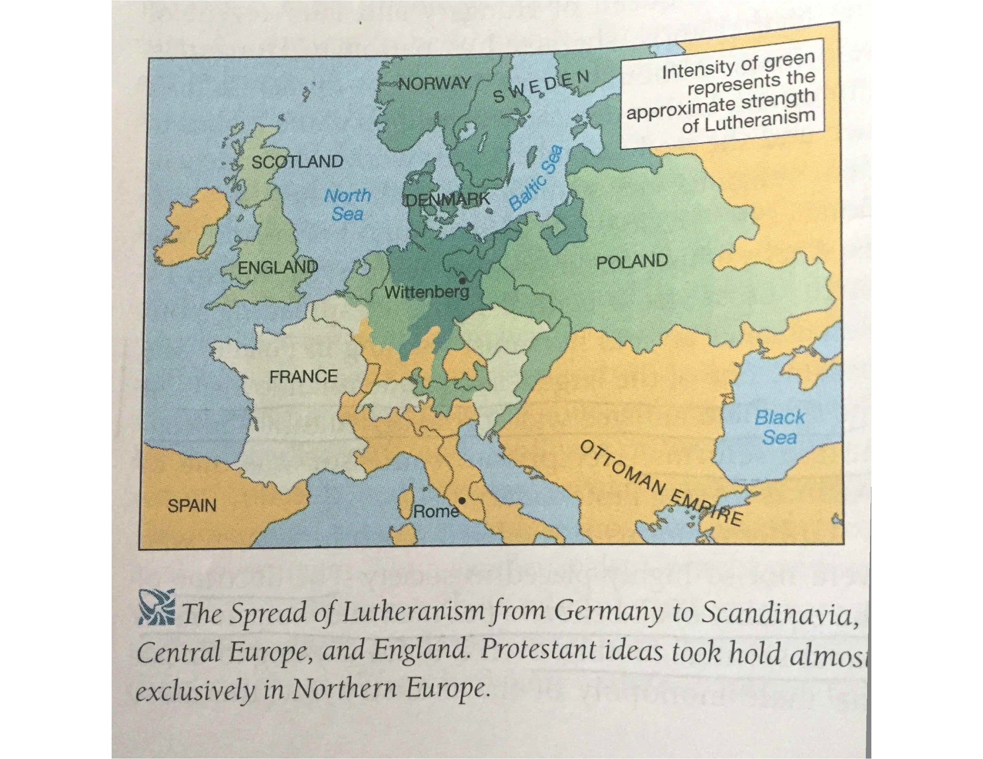

Source A:

*Across the Centuries,* Houghton Mifflin History Textbook, 1999. P. 347

As the Reformation spread, it gained the support of European peasants, In 1524 and 1525, arguing that everyone was equal under God, a group of poor German peasants took up arms against their wealthy landowners. Know as the Peasants’ War, this revolt as badly organized and lacked strong leadership. Government armies quickly crushed the uprising.

The peasants were surprised and disappointed to discover that Martin Luther did not support them in the Peasants’ War. In the pamphlet *Against the Robbing and Murdering Hordes of Peasants,* Luther criticized the rebels for seeking economic gain in the name of GOD. As a result, Luther lost the support of many social reformers…

Many German princes who wanted freedom from the pope’s authority favored Protestantism. Others remained Catholic because they depended on the support of the pope. Eventually, the differences between these German princes erupted in war. From 1546 to 1555, war raged between the Catholic and Protestant princes.

Source B:

Germany during the Reformation. A map of religious divisions within Europe where before there was only unity.

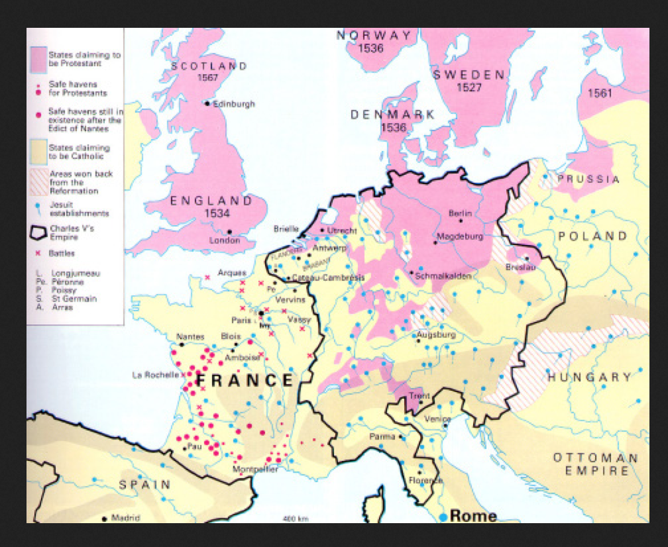

Source C





Source D





Source E

Martin Luther, *Against the Robbing and Murdering Hordes*

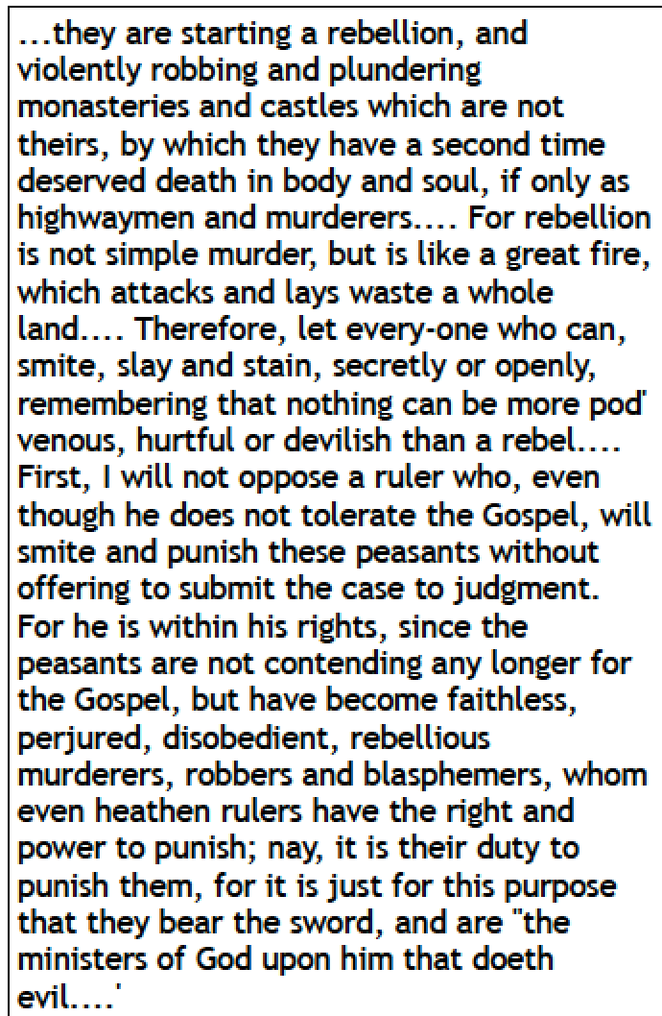

Reformation Gallery Walk Worksheet

|  |  |  |
| --- | --- | --- |
| Source citation | Main idea of Source | How does this source allow us to understand how the Reformation divided people and/or states? |
|  |  |  |
|  |  |  |
|  |  |  |
|  |  |  |
|  |  |  |