How did colonialism work?
Guiding Question: How did Africans respond to colonialism?

Historical Context:
“African Resistance to Colonial Rule”

The success of the European conquest and the nature of African resistance must be seen in light of Western Europe's long history of colonial rule and economic exploitation around the world. In fact, by 1885 Western Europeans had mastered the art of divide, conquer, and rule, honing their skills over four hundred years of imperialism and exploitation in the Americas, Asia, and the Pacific. In addition, the centuries of extremely violent, protracted warfare among themselves, combined with the technological advances of the Industrial Revolution, produced unmatched military might. When, rather late in the period of European colonial expansion, Europeans turned to Africa to satisfy their greed for resources, prestige, and empire, they quickly worked their way into African societies to gain allies and proxies, and to co-opt the conquered kings and chiefs, all to further their exploits. Consequently, the African responses to this process, particularly the ways in which they resisted it, were complex.
Adding to the complexity was the fact that rapid European imperial expansion in Africa did not necessarily change relationships among African communities. Those in conflict with one another tended to remain in conflict, despite the impending threat from the French, British, Germans, and other powers. There was, moreover, no broadly accepted African identity to unite around during this period. The strongest identities were communal and, to a lesser extent, religious, which begins to explain the presence of African participants in European conquests of other African societies...
The complexity of Africans' political relationships among themselves, then, influenced the nature of their resistance to colonial rule. As they resisted European invasions, they confronted both European and African soldiers. That is, they confronted a political hierarchy imposed by Western Europeans that included African proxies. The power was European, but the face of it on the local level was often African. Despite these seeming contradictions, it remains insufficient to speak of African responses to the imposition of colonial rule as a choice between either collaboration or resistance. It was possible to resist colonial rule through collaboration with the colonizers in one instance and in the next to resist European authority. It was also possible to limit European political control through some form of collaboration with European generals or colonial administrators. This is all to suggest that Africans evaluated their circumstances, assessed possible actions and consequences, to make rational responses. Some form of resistance, moreover, remained constant during the period of formal European political dominance. Ethiopia stands alone, however, as the one African society to successfully defend itself against an invading European army and remain free of direct European political domination.
Not all resistance during the early years of European colonial rule took the form of pragmatic violence. Most was more subtle and directed toward local issues of political and economic autonomy. Particularly in British territories, Africans commonly used local movements to resist European colonial policies or practices by the colonial administrations’ African proxies. The 1929 Aba Women's Revolt, or Igbo Women's War, in southeastern Nigeria reflects this trend. What is unique about the movement that produced the revolt is that its leadership was composed entirely of rural women. It is also unique because it was the only mass protest to take place in Nigeria prior to the years leading to independence in 1960.

Source: Benjamin Talton, “African Resistance to Colonial Rule,” http://exhibitions.nypl.org/africanaage/essay-resistance.html

Source 1
Mojimba, African chief, describing a battle in 1877 on the Congo River against British and African mercenaries, as told to a German Catholic missionary in 1907.

And still those bangs went on; the long sticks spat fire, pieces of iron whistled around us, fell into the water with a hissing sound, and our brothers continued to fall. We ran into our village and they ran after us. We fled into the forest and flung ourselves on the ground.

When we returned that evening our eyes beheld fearful things: our brothers, dead, bleeding, our village plundered and burned, and the river full of dead bodies.

You call us wicked men, but you White men are much more wicked! You think because you have guns you can take away our land and our possessions. You have sickness in your heads, for this is not justice.

- How did Mojimba describe the battle?
- How did the Africans resist the Europeans?
- How did the Africans collaborate with the Europeans?

Source 2
German military officer, account of the 1905 Maji Maji Rebellion in German East Africa, German military weekly newspaper, 1906.

The chiefs spread it among their people that a spirit, living in the form of a snake,
had given a magic medicine to a medicine man. The medicine guaranteed a good harvest, so that in future people would no more need to perform wage labor for foreigners in order to obtain accustomed luxuries. The medicine would also give invulnerability, acting in such a way that enemy bullets would fall from their targets like raindrops from a greased body. It would strengthen women and children for the flight customary in wartime, with the associated hardships and privations, and protect them from being seized by the victorious attackers, who were accustomed to taking women and children with them as war prizes. The medicine consisted of water, maize, and sorghum grains. The water was applied by pouring it over the head and by drinking.

- What methods did the chiefs use to resist European rule?

Source 3: Edmund D. Morel, 1902

Europeans tried to gain allies and proxies among the African political elite, in a divide and conquer policy, but some intra-African conflicts predated European interference. In the Gold Coast (Ghana), the Fante sided with the British against the kingdom of Asante, which they saw as a greater threat.

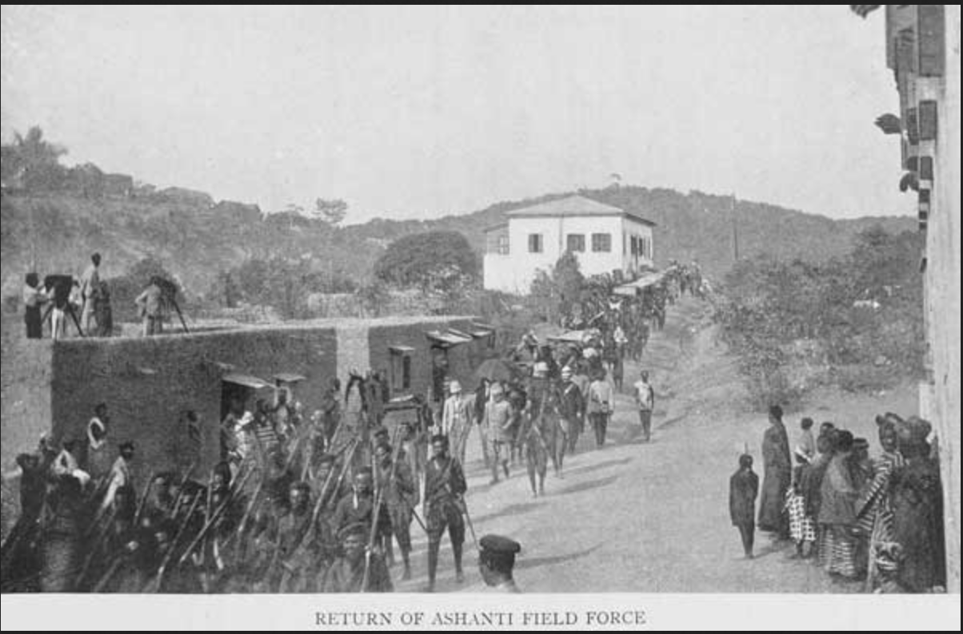

Found at http://exhibitions.nypl.org/africanaage/photos/resistance/1229150.jpg

- What is pictured in this photo?
- How did the Africans resist the Europeans?
- How did the Africans collaborate with the Europeans?

Source 4
Yaa Asantewa, Ashanti queen mother, speech to chiefs, West Africa, 1900.

Now I have seen that some of you fear to go forward and fight for our King. If it were in the brave days of old, chiefs would not sit down to see their King taken away without
firing a shot. No White man could have dared to speak to chiefs of the Ashanti in the way the British governor spoke to you chiefs this morning. Is it true that the bravery of the Ashanti is no more? I cannot believe it. Yea, it cannot be! I must say this; if you the men of Ashanti will not go forward, then we will. We the women will. I shall call upon my fellow women. We will fight the White men. We will fight until the last of us falls on the battlefields.

- Who was Yaa Asantewa addressing her comments to?
- What is her argument?

Source 5
Lorna Lueker Zukas, “Women’s War of 1929”

The confluence of global events in southeastern Nigeria in the late 1920s gave rise to women’s dissatisfaction and ultimate action. A worldwide economic depression caused a reduction in the price of palm oil (a chief export of the Nigerian economy), rising unemployment, and increased school fees and prices for goods. The unceasing British demand for forced labor, increased taxation on the local population, corruption by local administrators, trade restrictions, and newly assessed levies and other fees on women, without corresponding benefits, gave rise to frustration and hostility among women’s groups. Having no place within the colonial structure to air their grievances, they took to the roads, utilizing precolonial practices and political structures to demand a hearing before a colonial administration that ignored them…

In 1928, amidst colonial promises to improve roads, schools, and court buildings and to end forced labor practices, taxes were collected for the first time among the Ibibio, Ibo, and Delta peoples of southeastern Nigeria. People paid the taxes, albeit somewhat reluctantly, assuming this was a one-time fee for the promised improvements. In 1929 when it was realized that tax collection was to be continuous and that women and their personal property were to be counted and taxed, violent protest erupted…

On November 23, 1929, after months of preparations and discussion women mobilized against dehumanizing and humiliating behavior enacted upon them by colonial representatives. Women protested by blockading the road from Ikot Abasi Township to Aba. They knocked down telegraph polls and severed wires. Women leaders met with local administrators but when these talks failed, women attacked the Essene Native Court, releasing prisoners detained there. Calling upon the traditional practice of women’s protest, all women in the local area participated. Before long, rumors of British taxation of women and protests against it had spread to surrounding towns and countryside.

Found at http://www.revolutionprotestencyclopedia.com/fragr_image/media/IEO_Womens_War_of_1929

- What was the Women’s War?
- Did women take up arms or did they resist in other ways?

Source 6
Royal Niger Company, commissioned by the British government to administer and develop the Niger River delta and surrounding areas, standard form signed by multiple African rulers, 1886.

We, the undersigned Chiefs of , with the view to the bettering of our country and people, do this day cede to the Royal Niger Company, forever, the whole of our territory extending .

We pledge ourselves not to enter into any war with other tribes without the sanction of the said Royal Niger Company. . . . The said Royal Niger Company bind themselves not to interfere with any of the native laws or customs of the country, consistently with the maintenance of order and good government.

The said Royal Niger Company agree to pay native owners of land a reasonable amount for any portion they may require. . . . and to pay the said Chiefs measures native value.
The chiefs . . . affixed their marks of their own free will and consent. . . . Done in triplicate at , this day, of , 188 .

- Who created this document?
- What were the Niger chiefs expected to promise with this agreement?
- What did the Niger chiefs gain with this agreement?

