How did the federal government grow between the late nineteenth and twenty-first centuries?
Guiding Question: What was the response to mass immigration in the late nineteenth and early twentieth centuries?

Introduction
The size and scope of the federal government expanded in the late nineteenth and early twentieth centuries. One arena where this change was particularly evident was immigration. The federal government did little to regulate immigration in the early decades of the republic. That all changed after the Civil War. In 1875, Congress barred criminals and prostitutes from immigrating to the US, and in 1882 it passed the landmark Chinese Exclusion Act—the first exclusionary law in US immigration history—and then made the law permanent in 1904 (the initial exclusion act was written to last only ten years). Thereafter, federal officials increasingly sought to restrict all Asian immigrants, as well as immigrants from Southern and Eastern Europe. In 1907, President Theodore Roosevelt struck the so-called Gentlemen’s Agreement with Japan that barred Japanese laborers from legally entering the US. Then, in 1917, Congress overrode the veto of President Woodrow Wilson to pass a law that created an “Asiatic Barred Zone” and required all immigrants sixteen and older to be literate in at least one language. After World War I, Congress sought to regulate immigration even further with the Emergency Quota Act of 1921, a regulation that both restricted total annual immigration to roughly 350,000 persons, and limited immigration from any single foreign nation to three percent of the total number of people from that nation residing in the US in 1910. Three years later, Congress passed the landmark Immigration Act of 1924. Also known as the Johnson-Reed Act, the Immigration Act of 1924 restricted the basic provisions of the Quota Act by reducing the total number of immigrants to a maximum of 150,000 per year and reducing the quota of immigrants from any any foreign nation to two percent of the total number of people from that nation residing in the US in 1890 as opposed to 1910. In essence, the Immigration Act of 1924 was designed to do four things: (1) severely curtail all immigration to the US; (2) further bar Asian immigrants; (3) discourage immigration from Southern and Eastern European nations like Italy and Russia; and (4) give preferential treatment to immigrants from Western and Northern European nations like Great Britain, Germany, and Norway (the ethnic composition of the American population in 1890 skewed heavily towards white ethnics from Western and Northern Europe). Why did federal immigration policy change so rapidly in the late nineteenth century?

I. Chinese Exclusion Act

Source 1
“The only one barred out”
Frank Leslie’s Illustrated Newspaper (April 1, 1882)

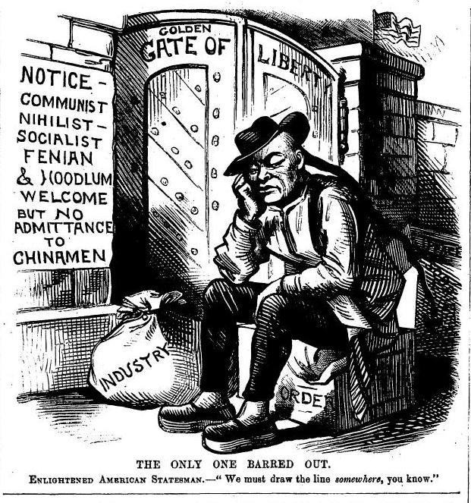
Source: Gale Nineteenth-Century Newspapers

Questions:
1. Is the author of this cartoon criticizing or supporting the policy of excluding Chinese immigrants from the United States?

2. Is the author of this cartoon generally supportive of immigration in the late nineteenth century? Or, is the author generally critical of immigration in the late nineteenth century? Explain you answer in 3-4 sentences.

Source 2
US Congress, Chinese Exclusion Act (1882)

An Act to execute certain treaty stipulations relating to Chinese.…
Be it enacted by the Senate and House of Representatives of the United States of America in Congress assembled, That from and after the expiration of ninety days next after the passage of this act, and until the expiration of ten years next after the passage of this act, the coming of Chinese laborers to the United States be, and the same is hereby, suspended; and during such suspension it shall not be lawful for any Chinese laborer to come, or having so come after the expiration of said ninety days to remain within the United States.…

SEC. 11. That any person who shall knowingly bring into or cause to be brought into the United States by land, or who shall knowingly aid or abet the same, or aid or abet the landing in the United States from any vessel of any Chinese person not lawfully entitled to enter the United States, shall be deemed guilty of a misdemeanor, and shall, on conviction thereof, be fined in a sum not exceeding one thousand dollars, and imprisoned for a term not exceeding one year.

SEC. 12. That no Chinese person shall be permitted to enter the United States by land without producing to the proper officer of customs the certificate in this act required of Chinese persons seeking to land from a vessel. And any Chinese person found unlawfully within the United States shall be caused to be removed therefrom to the country from whence he came, by direction of the President of the United States, and at the cost of the United States, after being brought before some justice, judge, or commissioner of a court of the United States and found to be one not lawfully entitled to be or remain in the United States.

SEC.13. That this act shall not apply to diplomatic and other officers of the Chinese Government traveling upon the business of that government…and shall exempt them and their body and household servants from the provisions of this act as to other Chinese persons.

SEC. 14. That hereafter no State court or court of the United States shall admit Chinese to citizenship; and all laws in conflict with this act are hereby repealed.

SEC.15. That the words "Chinese laborers", wherever used in this act shall be construed to mean both skilled and unskilled laborers and Chinese employed in mining.

Approved, May 6, 1882.

Source: National Archives and Records Administration
https://www.archives.gov/founding-docs/constitution-transcript

Questions:
1. What would you describe as the main provisions, or features, of the Chinese Exclusion Act? Does it restrict all Chinese immigrants?

2. What rights does this law specifically deny Chinese immigrants to the US?

Source 3
Interrogation of “Paper Son” Immigrant by US Inspection Officer
Early Twentieth Century

Introduction

The Chinese Exclusion Act of 1882 was designed to bring an end to Chinese immigration. However, certain groups of Chinese were exempt from the immigration restrictions and were still free to enter the United States. Exempt groups included merchants, government officials, students, teachers, and visitors, but none were eligible to apply for U.S. citizenship.

According to the 1790 Naturalization Act, only “free white persons” were eligible for citizenship. After the Civil War, the Naturalization Act was rewritten to allow persons of “African descent” to apply for citizenship, but worded specifically to ensure that Asians would not gain eligibility. The only Chinese eligible for citizenship were those who were born on U.S. soil or those who were born in China to American parents. The 1870 citizenship law recognized the right of citizenship of Americans born abroad.

By 1900, there were 6657 American-born ethnic Chinese citizens living in the U.S. In 1906, the fires following the earthquake that devastated the city of San Francisco destroyed the office containing birth records. This allowed many Chinese residents to successfully claim citizenship because the government could not dispute their claim. As American citizens, these Chinese were entitled to bring in wives and children from China.

It was common for Chinese immigrants to return to China from time to time to visit their families. Upon returning from such visits, Chinese men would falsely report the births of son or daughters whom they claimed to have fathered while in China. This practice created immigration “slots” by which Chinese could enter by claiming that they were the offspring of an American citizen. Many of these “paper sons” paid Chinese American “fathers” to sign false birth papers for them. The Immigration Service officials believed catching these “paper sons and daughters” was part of their job.

When the Exclusion Act was passed in 1882, an old warehouse on the San Francisco wharf was turned into a processing station for immigrants. In 1910 a new Immigration Station was opened at Angel Island in San Francisco Bay. Here, at what became the Ellis Island of the West Coast, immigrants from China were given medical examinations and then housed in dormitories to await hearing on their applications. The immigration officials, known as luk yi, or “green-clothes men,” grilled the immigrants for hours at a time, attempting to determine whether the applicant was truly the son or daughter of the man who had created the slot and signed the birth papers. In the first two decades of the 20th century, only one in four individuals questioned at Angel Island was allowed to leave the island and enter the United States.

Source: University of Illinois at Urbana-Champaign
http://teachingresources.atlas.illinois.edu/chinese_exp/resources/resource_3_4.pdf

Transcript of Paper Son Interview

Applicant reminded that he is still under oath.
QUESTION. What is your name?
ANSWER. Leong Sem.
Q. Has your house in China two outside doors?
A. Yes.
Q. Who lives opposite the big door?
A. No house opposite.
Q. Who lives opposite the small door?
A. Leong Doo Wui, a farmer in the village; he lives with his wife, no one else.
Q. Describe his wife.
A. Chin Shee, natural feet.
Q. Didn’t that man have any children?
A. No.
Q. How old a man is he?
A. About thirty.
Q. Who lives in the first house in your row?
A. Leong Yik Fook, farmer in the village; he lives with wife, no one else.
Q. Describe his wife.
A. Wong Shee, bound feet.
Q. Didn’t that man ever have any children?
A. I don’t know.
Q. How many houses in your row?
A. Two.
Q. Who lives in the first house, first row from the head?
A. Yik Haw, I don’t know what clan be belongs to.
Q. Why don’t you know what clan he belongs to?
A. I never heard his family name.
Q. Do you expect us to believe that you lived in that village if you don’t know the clan names of the people living there?
A. He never told us his family name.…
Q. According to your testimony today there are only five houses in the village and yesterday you said there were nine.
A. There are nine houses.
Q. Where are the other four?
A. There is Doo Chin’s house, first house, sixth row.
Q. What is the occupation of Leong Doo Chin?
A. He has no occupation; he has a wife, no children.
Q. Describe his wife.
A. Ng Shee, bound feet.…
Q. You have already put Leong Yick Gai first house third row.
A. I am mixed up.
(Applicant is requested to draw a diagram of the village together with the names of the people living in the village houses and does so, marked Exhibit “A”, and signs his name thereto as “Leong Dow Sem.”)
Q. Have you named everybody now living in the Gong Ling village?
A. Yes.
Q. Is there a shrine near that village?
A. Yes, there is one at the tail end of the village.
Q. Is there a fish pond near that village?
A. No.
Q. Is there a school house in that village?
A. No.
Q. Describe your school experience.
A. Started when I was seven to study. See Ak Hock How, located about two lis[**] south outside my village.
**A“li” is a Chinese unit of measurement for distances. Although it can vary, a “li” is most often equal to about a third of a mile, or half a kilometer.
Q. Did you eat and sleep in the school house or at home?
A. I slept in the school house and ate at home. I studied in the school for nine years.
Q. How old are you?
A. Sixteen.
Q. Who was your last teacher?
A. There were three teachers, Leong Yo Wah, Leong Bing, and Leong Yee On.
Q. When was the picture taken that is on your affidavit?
A. When I was ten years old.
Q. Was your father in China then?
A. No.
Q. Was the picture on the affidavit when you received it?
A. Yes.
Q. How did your father get that picture?
A. My mother sent it to him.
Q. How long ago did she send it to him?
A. I’m not sure.
Q. Why are you so excessively nervous during this examination?
A. I am not at all nervous.
Q. How long have you had that gold tooth?
A. About three years.
Q. Was that tooth fixed that way while your father was last in China?
A. I had it crowned while my father was in China.
Q. Where was the work done?
A. In the Ai Gong market.
Q. Do you know how much it cost?
A. A little over $4 Chinese money.
Q. Who is going to testify on your behalf besides your father?
A. Leong Seung.
Q. Have you any changes or corrections you wish to make in your testimony?
A. No.
Q. Have you understood all the questions?
A. Yes.
Q. Is there anything further you wish to say?
A. No.

Source: R. D. McKenzie, Oriental Exclusion, Chicago: University of Chicago Press, 1928, 53-57.

Questions:
1. Who were “paper sons?”

2. Why do you think the inspector is quizzing Leong Sem about his neighborhood in such detail?

3. Do you think you could recount such information regarding your neighborhood—the number of buildings on your block and nearby blocks and who lives where?

4. How effective do you think the Chinese Exclusion Act was at keeping Chinese immigrants from entering the US? What series of events provided the window, or loophole, for “paper sons” to enter the US?

Source 4
“The Americanese Wall, as Congressman [John Lawson] Burnett would build it
Puck Magazine 79 (March 25, 1916).

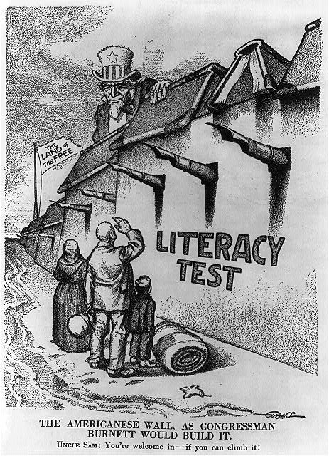

Source: Library of Congress, http://www.loc.gov/pictures/item/2006681433/

Questions:
1. Who is this cartoon criticizing?

2. Which coastline of the United States does this cartoon illustrate? Which foreign nationals, or immigrant groups, does it depict?

3. In what ways is this cartoon similar to, or different from, the cartoon on the Chinese Exclusion Act?

Source 5
1903 Speech on Immigration before US House of Representatives
Representative John Lawson Burnett (D-Alabama)

Mr. CHAIRMAN: I desire at this time to make some remarks on a subject not entirely germane to the bill, but one which I deem the most important that confronts the American people—that of foreign immigration. The vast horde of illiterates from Southern and Eastern Europe that has swarmed to our shores for the past few years presents an issue before which those of finance, tariff, railroad regulation, and the trusts pale into insignificance.…

I am not a “Know Nothing,” nor do I believe in the doctrine of “American for Americans alone.” I have no racial prejudices except those which an almighty God has planted in the heart of every true Southerner who believes that in the keeping of the Caucasian race have been placed the principles of human liberty and the just rights of all people. I am inspired by no narrow sectarianism which would keep out any man because his is Protestant, Catholic, or Jew. I have proven this by the disposition since I have been in Congress.…

My position as to the best way of settling the question embraced in the following section of a bill which was reported to the Fifty-ninth Congress by the Committee on Immigration, of which I was a member:
Sec. 38. That no alien over 16 years of age physically capable of reading shall be admitted to the United States until he has proved to the satisfaction of the proper inspection office that he can read English or some other language or dialect…

Gentlemen, is that a radical proposition? The constitution of many of our States has an educational or property qualification for suffrage. Some have both.…

I do not content that every Italian or Russian or Syrian who is admitted becomes a voter, or even a naturalized citizen, but it should be the wish of all that no male person should come except those who desire and are qualified to become voters.…

It is against those of a different race from ours that my principle objection is aimed. I do not content that because a man is illiterate he is necessarily vicious; nor would I debar him merely by reason of the fact that he can not read if he is of the Caucasian race and otherwise a desirable person. I favor this restriction, because it appears to me to be the only practicable way in which many people of an undesirable race can be excluded. We could not without perhaps becoming involved in serious international complications, enact a law which would say that no Italian or Syrian, Russian or Greek shall be admitted. We have done this as to Chinese, but I doubt if European nations would stand for such legislation. Hence, if the end desired can be reached by the educational text, would it not be better to bring it about in that way?

Source: Harvard University Library Open Collections Program https://iiif.lib.harvard.edu/manifests/view/drs:6100742$4i

Questions
1. Why is Senator Burnett so focused on literacy as a precondition for immigration to the United States?

2. In what ways is Burnett’s logic discriminatory? Provide two examples.

3. What justification does Burnett provide for his racial prejudices?

4. How representative is Senator Burnett of racial attitudes in the early twentieth century? Do you think just a few people though like Burnett? Or do you think a lot of people thought like Burnett? Explain your answer.

Source 6
Data from Statistical Atlas of the United States (1929)
US Census Bureau
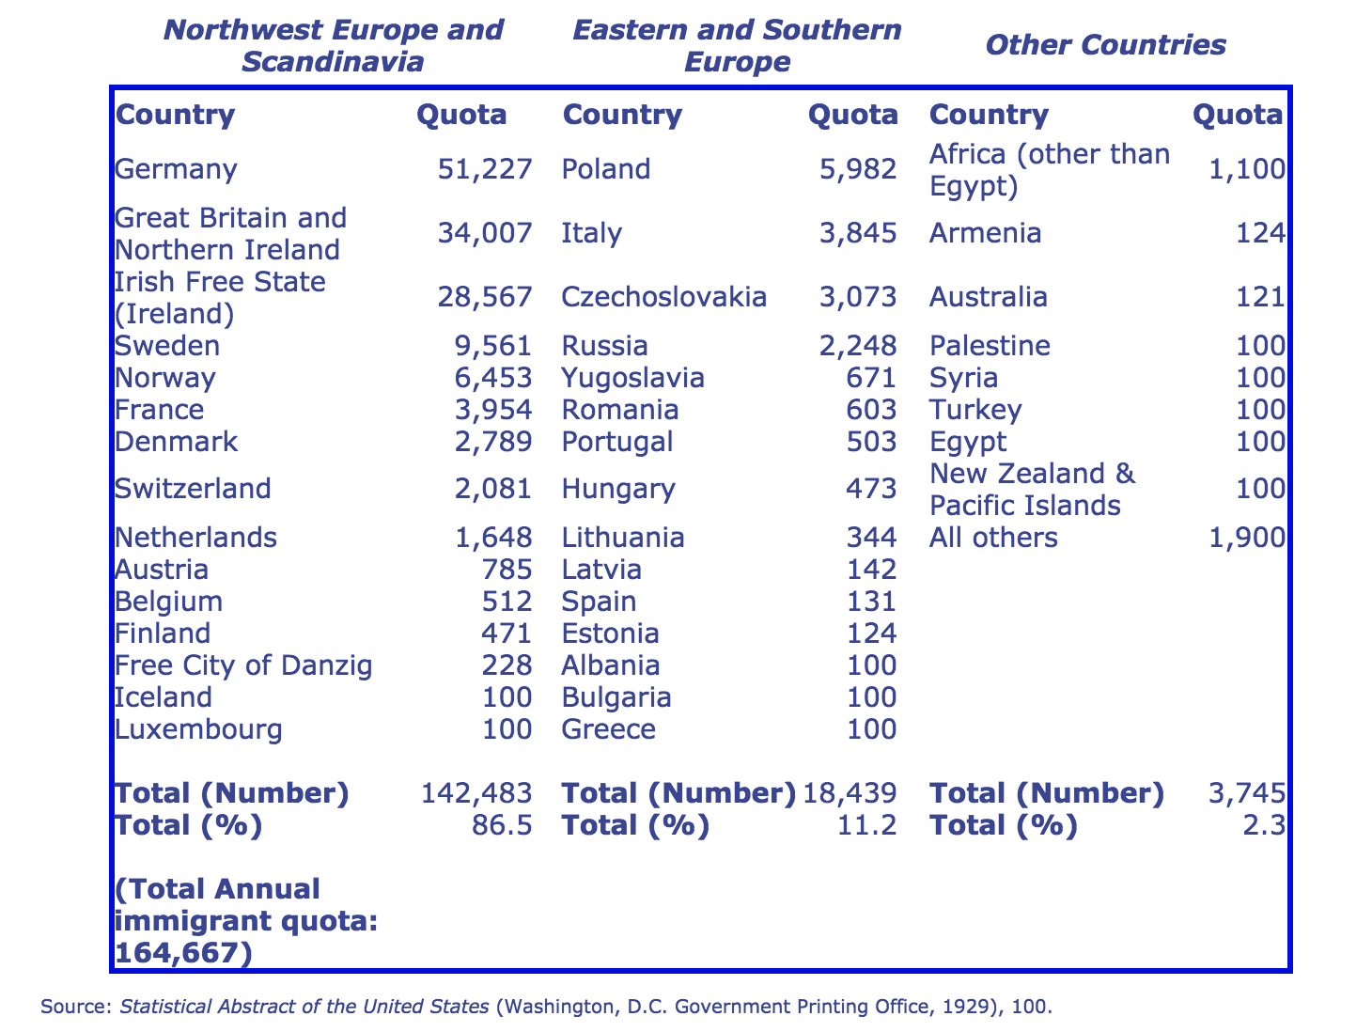
Source: History Matters, http://historymatters.gmu.edu/d/5078/

Questions
1. What does this chart tell us about total immigration to the US in 1929?

2. What do the data tell us about the effectiveness of the Immigration Act of 1924? Was the law effective in reaching its goals? Or was it ineffective in reaching its goals?

