How did Islam spread to multiple cultures?
Guiding Question: How did Islam spread to multiple cultures?

Historical Context:
Islam emerged in the early 600s, and by the time the prophet Muhammad died in 632, the religion had spread across the Arabian Peninsula. Soon after the death of Muhammad, there were military expeditions, called “futuhat,” or literally “openings,” into what is now Egypt and other parts of North Africa. This military conquest was only one of the ways that Islam spread throughout Afroeurasia. Trade and commerce also influenced the spread of the religion following merchants’ trade routes. In the following 100 years, Islam would spread across the Middle East, North Africa, into both Europe and Asia.

Historians have long tried to answer the question: How did Islam spread to multiple cultures? Now it’s your turn to consider this question. You will study the sources below to develop your own interpretation.
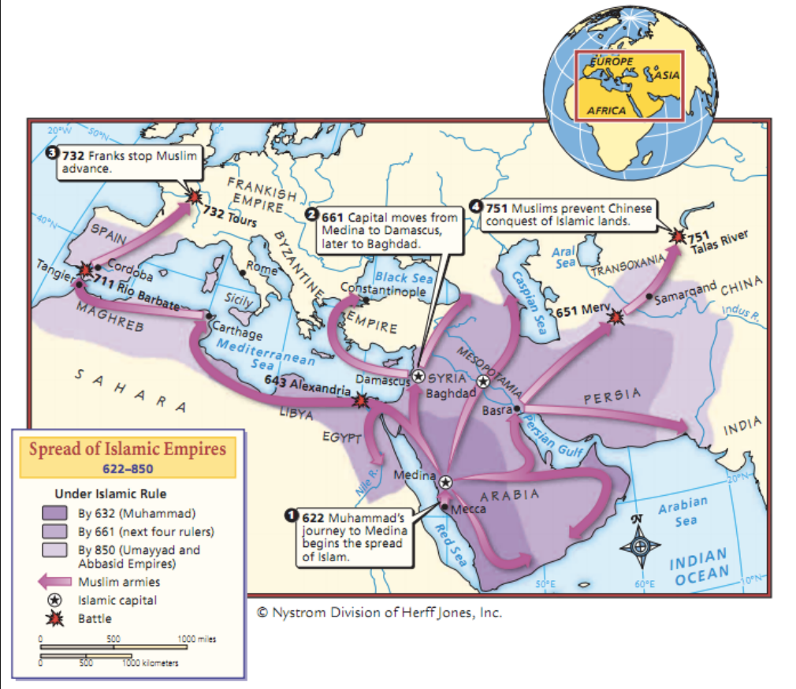

Source 1. Max Rodenbeck, “The Early Days” in the Book Review New York Times, January 6, 2008.

Far from being wild, uneducated Bedouins…the early Muslim leaders were sophisticated townsmen and very good military commanders. Once they had converted people to Islam, the fact that many new tribes in the Arabian Peninsula were believers created a movement that involved people in conquest. Having now submitted to the authority of a single leader, the Muslim caliph, nomadic warriors had to direct their energies outward or risk tearing the newly formed Islamic nation apart. Their fighting spirit was further primed by the doctrine of jihad, which promised both earthly and heavenly rewards. Martyrs were assured a special place in paradise, while soldiers were allowed to keep four-fifths of captured booty.
Yet the Muslims’ military strength, their desert-trained mobility and the cleverness of their generals still cannot explain how such astonishingly small armies — perhaps 30,000 men for the conquest of Syria, 10,000 for Iraq, 16,000 for Egypt — so swiftly conquered these areas that had large populations of people. Several other factors proved crucial. The most important was timing.
Beginning around 540, repeated epidemics of bubonic plague appear to have killed many people across the Near East and the Mediterranean. Political disorder was to weaken the region more… The Byzantine and Persian empires were at war.
But the decades of war… had left both Byzantium and Persia stunned and bleeding. The sudden Muslim advance found them completely unprepared.

[Transcribed so students can access text]
Found at http://www.nytimes.com/2008/01/06/books/review/Rodenbeck-t.html?_r=2.

- What are the strengths of the Muslim military, according to this article?

- The author argues that it was not just military power that led to the successful spread of Islam, what were the other reasons?

Source 2: Ibn Abd al-Hakam describing a battle in Tunisia, North Africa in 647

“He divided the booty between us, having set aside a fifth [for taxes to the Muslim ruler, caliph]. The share of each cavalryman amounted to three thousand dinars: two thousand for the horse, one thousand for his master. Each infantryman received one thousand dinars. One of the soldiers having died at Dhat al-Humam, his family received one thousand dinars.”

Found in Robert Brunschvig’s article “Ibn Abd Al-Hakam and the conquest of North Africa,” in The Expansion of the Islamic State

- What benefits did Muslim soldiers get from conquering territories?

- How might these benefits draw people to fight to spread Islam?

Source 3: The Islam Project
The Qur’an specifies, "Let there be no compulsion in religion" (2: 256). This verse states that no person can ever be forced to accept religion against their will. It tells Muslims never to force people to convert to Islam. Anyone who accepts Islam under pressure might not be sincere, and conversion in name only is useless to them, and harmful to members of the faith community.

Found at http://www.islamproject.org/education/B04_SpreadofIslam.htm

- What does the Quar’an say about how people should convert to Islam?

- Would this source support or contradict the spread of Islam through military conquest?

Source 4: Al-Baladhuri: The Battle Of The Yarmuk, 636
Introduction to the source: In the face of the Muslim expansion, the Byzantine emperor Heraclius gathered a large army which met the Muslim army at the Battle of the Yarmuk in Syria on 20 August 636. It was a crushing victory which gave Syria to the Muslims. The account of al-Baladhuri (d. c. 892) shows the hostility of Syria to Byzantium and the welcome which the Syrians gave to the Muslim invaders.
A description of the battle. Heraclius gathered large bodies of Greeks, Syrians, Mesopotamians and Armenians numbering about 200,000. This army he put under the command of one of his choice men …The Muslims gathered together and the Greek army marched against them. The battle they fought at al-Yarmuk ,was of the fiercest and bloodiest kind. Al-Yarmuk is a river. In this battle 24,000 Muslims took part. The Greeks and their followers in this battle tied themselves to each other by chains, so that no one might set his hope on flight [deserting]. By Allah's help, some 70,000 of them were put to death, and their remnants took to flight, reaching as far as Palestine, Antioch, Aleppo, Mesopotamia and Armenia. In the battle of al-Yarmuk certain Muslem women took part and fought violently. Among them was Hind, … who repeatedly exclaimed, "Cut the arms … with your swords!" Her husband abu-Sufvan had come to Syria as a volunteer desiring to see his sons, and so he brought his wife with him. He then returned to al-Madinah where he died, year 31, at the age of 88. Others say he died in Syria…
Found at http://sourcebooks.fordham.edu/halsall/source/yarmuk.asp
- Which side had more soldiers, Byzantine or the Islamic forces?
- How did the Muslim soldiers fight?
- What evidence does the source give to explain why the Muslim soldiers won the battle?

Source 5: PBS Empire of Faith

https://www.youtube.com/watch?v=UHhbSvOcz4g
Watch 42:00-47:00

- What do the historian’s say about the spread of Islam?
- How did Muslims interact with other religions?

Source 6: Sarah Pruitt, “Islamic Ring Found in 9th-Century Viking Grave,” History Channel, 2015.

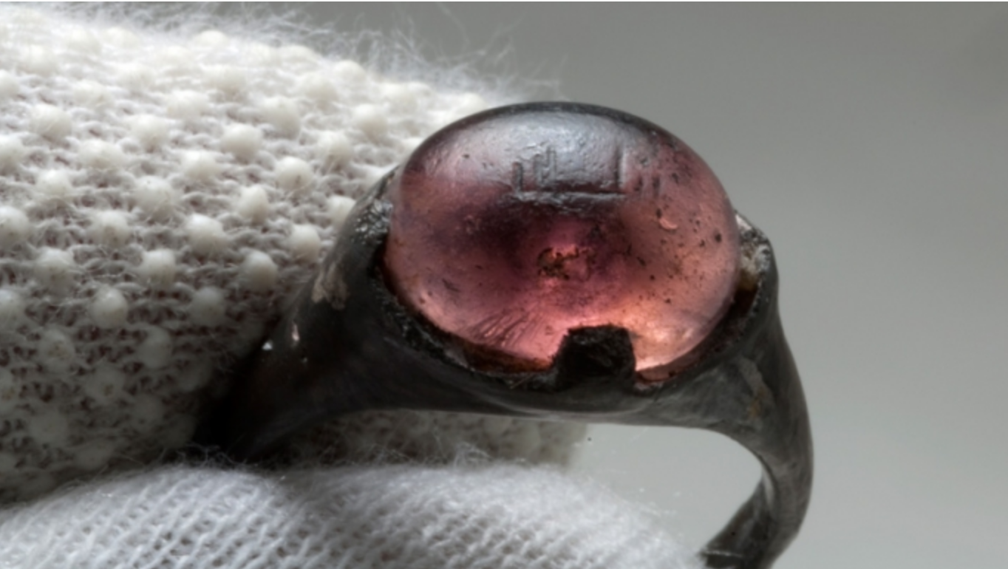

In the late 19th century, the archaeologist Hjalmar Stolpe spent years excavating gravesites near Birka, a town on the Swedish island of Björkö that operated as a key center for trade during the Viking Age. In a grave of a woman buried in the 9th century, his excavations recovered a silver-colored ring with a purple stone, now in the collections of the Swedish History Museum. Researchers confirmed this week that the ring, which is engraved with Arabic script, provides rare physical evidence of contact between Vikings and the Islamic world.

Full article found here:
http://www.history.com/news/islamic-ring-found-in-9th-century-viking-grave

