Who establishes prices in the marketplace? How do government actions impact civil society?
Guiding Questions: What are the consequences of gentrification?

What is gentrification?
Hotly debated, and sometimes referred to as urban renewal, gentrification is a word used to describe urban change—particularly, the transformation of a low-income or economically depressed area of a city into a higher-income more economically prosperous area. Gentrification happens in cities all across the United States (and world), but usually takes place in older cities: cities with little undeveloped land, few unoccupied buildings, and cities or regions where commercial and residential property prices and rents are expensive.

The process of gentrification is usually understood as going something like this: on the look-out for cheaper rents and property prices, new residents and business owners move into a working-class or low-rent district of a city, followed by yet more new residents and businesses. Over time, the newcomers create not just to new forms of economic activity but new residential and commercial patterns—patterns that result in higher rents, property values, and taxes for everyone in the neighborhood.

Two main issues often result from these new patterns: (1) rising rent and property values encourages yet more new businesses and residents to move into the neighborhood; and (2) the higher rents, property values, and taxes force the original residents and business owners to move out of the neighborhood because they can no longer afford to live there. The changes caused by gentrification can therefore be dramatic because the older lower-income residents are slowly replaced by the newer higher-income residents. The word for this process is displacement. Displacement is the main reason why gentrification is controversial and hotly debated.

One final important point: In the United States, gentrification is tied not only to social class but to race and ethnicity as well. Many of the neighborhoods that undergo gentrification in the US are lower income African American or Latino neighborhoods, while many of the gentrifiers (i.e. the new, incoming residents and business owners) are often well-educated, middle- to upper-middle class whites. This leads to difficult social situation where new white residents displace long-term Black or Latino residents.

What are the consequences of gentrification?

Before and After Photos of Gentrification in New York City
Source: James and Karla Murray/Jeremiah’s Vanishing New York Blog
http://vanishingnewyork.blogspot.com/2014/03/nyc-before-after.html

Source 1
“The Myth of Gentrification”
Slate Magazine, January 14, 2015

By John Buntin

…New York isn’t the only city where it spreads. San Francisco, Washington, and Boston have arguably been even more affected by it. Seattle, Atlanta, and Chicago have experienced it on a large scale, too.

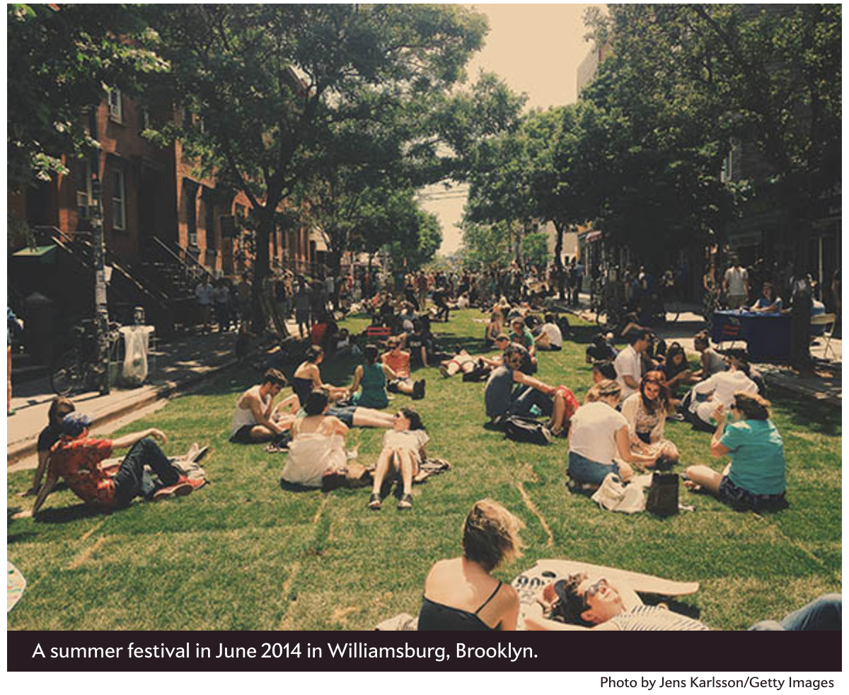

If you live in one of these cities, you probably think you know how [gentrification] works. Artists, bohemians, and gay couples come first. They move into run-down—but charming and historic—homes and loft spaces close to the urban core. Houses are restored. Funky coffee shops appear. Public safety improves. Then rents and home prices start to go up. The open-minded, diversity-loving creative types who were the first wave of gentrifiers give way to lawyers, bankers, and techies. As rents and home prices continue to rise, the earlier residents—often lower-income people of color—are forced out.…

That gentrification displaces poor people of color by well-off white people is a claim so commonplace that most people accept it as a widespread fact of urban life. It’s not. Gentrification of this sort is actually exceedingly rare. The socio-economic status of most neighborhoods is strikingly stable over time.…As for displacement—the most objectionable feature of gentrification—there’s actually very little evidence it happens. In fact, so-called gentrifying neighborhoods appear to experience less displacement than nongentrifying neighborhoods.…

Of course, displacement is not the only way in which gentrification could harm the poor. Residents of gentrifying neighborhoods might stay put but suffer from rising rents. [Columbia University economists Lance] Freeman and [Frank] Braconi found that rents did rise in gentrifying neighborhoods in New York. But rising rents had an unexpected effect: As rents rose, residents moved less.…

In 2010, [another university study] examined gentrification across the nation as a whole over the course of the 1990s.…[That study] found that gentrification created neighborhoods that were attractive to minority households, particularly households with children or elderly homeowners. They found no evidence of displacement or harm. While most of the income gains in these neighborhoods went to white college graduates under the age of 40 (the archetypical gentrifiers), black high school graduates also saw their incomes rise. They also were more likely to stay put. In short, black households with high school degrees seemed to benefit from gentrification.

…For black communities, neighborhood change happens when Latinos begin to arrive. Sometimes these changes can be difficult, resulting as they often do in new political leaders and changes to the character of the communities. But [recent] research suggests they also bring real benefits. Black residents, particularly black youth, living in more diverse neighborhoods find significantly better jobs than peers with the same skill sets who live in less diverse neighborhoods.

In other words, the problem isn’t so much that gentrification hurts black neighborhoods; it’s that it too often bypasses them.

Link to article: http://www.slate.com/articles/news_and_politics/politics/2015/01/the_gentrification_myth_it_s_rare_and_not_as_bad_for_the_poor_as_people.html

Questions
1. Is Buntin for or against gentrification?

2. What is Buntin’s main argument in this article?

3. What evidence does Buntin present regarding the positive effects of gentrification on African American neighborhoods?

Source 2
“Gentrification May Be Complicated, But It’s Not a Myth and Neither Is Displacement”
New York Observer, January 20, 2015

By Kim Velsey

In a recent Slate article, John Buntin…argues that gentrification is a myth, a claim that we’ve certainly heard before. And much like his predecessors, Mr. Buntin bases this claim on two premises: that displacement is a fiction and that gentrification, or what we erroneously call gentrification, is not only incredibly rare, but a good thing for poor minorities living in bad neighborhoods.…

…Mr. Buntin’s argument is simply wrong.…

He… cites several studies from the ’90s that show there’s not much of difference between the number of poor minorities that leave ungentrified neighborhoods versus gentrified ones. This he links to studies which have shown gentrification isn’t that bad for poor people—instead of being marginalized they benefit from financial investment in their neighborhoods. Which is true, to the extent that people can stay and share in the spoils of the rich, two very big ifs that have not really been borne out here in New York.

A gentrified Chelsea [district in Manhattan]. Kevin Gong/flick.

The distinction that he fails to draw is how a neighborhood changes not just during the first wave of gentrification, but over many subsequent ones…as well as the very real distinction between people who are, in his own words “forced out” of a neighborhood and those that chose to leave. While poor people may move away from both gentrifying and ungentrifying neighborhoods, those who leave gentrified neighborhoods often have no choice in the matter. And while gentrification does carry with it some undeniable benefits like lower crime rates and better schools, these are not much good to residents if they aren’t able to stay and take advantage of them. Rent-stabilization and property ownership help to reduce displacement, of course, but over time, gentrifying New York neighborhoods have become richer and whiter.

In Fort Greene, for example, The New York Times reported that between 2000 and 2012, the proportion of whites rose 13 percent, according to census data, while the share of blacks shrunk 15 percent. At the same time, median household income rose from $44,987 to $56,436.…

Meanwhile, in 2011, The Times reported that Bed-Stuy’s white population had soared 633 percent since 2000…The black population dropped from 40,000 to 34,000 and the white population increased from 2,000 to 18,000 people.…

And in Manhattan, as of 2010, Harlem, one of the last minority strongholds in the borough, ceased to be majority black, a shift that was surely not the exclusive result of voluntary relocation.

At the same time, while Mr. Buntin argues that demographic change is largely the result of lower-income Latinos moving into new neighborhoods, in New York, a number of racially-diverse, low- and middle-income neighborhoods have become both whiter and richer. According to a recent article in The Wall Street Journal, as the black middle-class shrunk, white, high-income clusters grew at the fastest rate of any group in the city, increasing 44 percent between 2000 and 2010, and 32 percent in the geographic areas they occupy.…

The South Bronx has the most severe hunger-related problems in the country, as well as some of its highest asthma rates, we have nearly 60,000 homeless people in the city and Manhattan has the highest income gap in the nation. If we want to have a nuanced discussion about poverty and gentrification in this country, we’d do well to remember that poverty, racial segregation and gentrification are not mutually exclusive. In fact, they’re usually intertwined.

Link to article: http://observer.com/2015/01/gentrification-may-be-complicated-but-its-not-a-myth-and-neither-is-displacement/

Questions

4. Is Velsey for or against gentrification?

5. What is her main argument in this article?

6. What is evidence does she present in relation to gentrification in New York City to counter Buntin’s arguments about the positive effects of gentrification?

Source 3
“Gentrification pushes up against Boyle Heights—and vice versa”
Los Angeles Times, March 3, 2016

By Brittny Mejia

For more than 50 years, it was the little cantina that could.

Las Palomas in Boyle Heights was a world of Mexican immigrants who drank earnest beers after a hard day of work. It wasn't especially cool, even in the retro way that hipsters like to ascribe coolness to a place they think gives them the musky scent of danger.

But it had a knack for surviving, even after this western edge of 1st Street, with its sloping vistas of the downtown Los Angeles skyline, started to become cool. When the Eastside Luv wine bar moved in right next door, drawing young professionals — the children of immigrants — the barrio bar trucked on as a refuge for mariachis drinking their goodbye to another day.…

For years, Boyle Heights seemed a neighborhood cooped up in the still embryonic stage of gentrification, or “gentefication,” a term coined to reflect change driven substantially by Latinos with roots in the Eastside neighborhood.

Boyle Heights hasn't seen close to as much gentrification as Silver Lake and Highland Park, or even neighboring Lincoln Heights…But it's hard to imagine a neighborhood that has featured a stronger line-in-the-sand pushback to gentrification.

The sense that the big “G” is just around the corner has loomed over Boyle Heights for years. There has been talk for years about transforming the 14-story Art Deco Sears, Roebuck & Co. building on Olympic Boulevard into a complex of condos, retail space and restaurants.

“I think part of it is people getting pushed out of their other neighborhoods and coming here, and they don't want that to happen here,” said Erick Huerta, who moved into the community when he was 7, left and later returned. “It's like the last bastion. They're holding down the flag.”

Conrado Herrera, the owner of the building that houses Las Palomas and also Eastside Luv, said the neighborhood is changing and business has to change with it.

“You always want to have a space for everybody in the community, but we've also got to deal with what's in front of us,” said Herrera, who added that he's from Boyle Heights.…

In December, a group of university students that ventured into Boyle Heights on a walking tour was escorted out by activist group Serve the People LA, which blogged that the community “is under attack in the form of gentrification and therefore must be defended.”

The group described the visitors as “a diverse but mainly white group — including several urban planning students” from UCLA. Facundo Rompe, a member of Serve the People LA, said they met with the walking tour ahead of the incident to express concerns and ask them not to come into Boyle Heights.

“Our point is we have to defend Boyle Heights at all costs. If that means some people are going to get upset or feel threatened, so be it,” Rompe said.

Rompe, who uses an activist name, said he wants to see more people adopt strategies and tactics that are “more militant in confronting gentrification.”

But others in Boyle Heights say such measures are extreme and do not reflect the community sentiment.

Ralph Carmona, who has sat on the Boyle Heights Chamber of Commerce board for around 25 years, said “militancy is usually [pushed by] people who are not representative of the vast majority. Maybe people have some sympathy for it…but it doesn't necessarily mean that's what's going to make any impact.”

In the first 11 months of last year, the median sale price for homes in the 90033 Zip Code, which accounts for most of Boyle Heights, was $290,000, up 11.5% compared with the same period a year earlier…

When the white owners of Indie Brewing Co. pitched a tasting room to the chamber's board members, they brought their consultant, Ulisses Sanchez, who was raised in Boyle Heights.

“This is really a community process, especially here in Boyle Heights,” Sanchez told the board members. “There's been a strong effort to protect the culture here.”

Indie Brewing Co.'s plans include community art on the walls of the tasting room; the company wants to meet with Boyle Heights organizations to raise the support needed to help get the OK for the tasting room from the city.

“We want to be accepted by the community, we don't want to just try and steamroll our way in," said Kevin O'Malley, part of the brewery team. “You can tell the community is very protective and there's a lot of culture and history here.… We want to fit into the culture that's here.”

Link to article: http://www.latimes.com/local/california/la-me-las-palomas-gentrification-20160303-story.html

Questions
7. What examples of gentrification are provided in this report on Boyle Heights?

8. How is the community of Boyle Heights dealing with the forces of gentrification? Are there differences of opinion regarding gentrification?

Source 4
“On Boyle Heights, art galleries, changing neighborhoods, and rising rents”
AirTalk (radio program interviews), KPCC 89.3, November 4, 2016

The Los Angeles Police Department launched an investigation into three instances of vandalism targeting art galleries in Boyle Heights — including graffiti that read “f--- white art” on one gallery — as potential hate crimes, as longstanding concerns over gentrification in the neighborhood heat up.

Tension between longtime Boyle Heights residents and newcomers has been brewing as artists, homebuyers and renters —many priced out of places like downtown, Echo Park and Silver Lake — look for more affordable housing options in the mostly Latino neighborhood.

In the last several years, a number of art galleries have opened up in Boyle Heights, raising concern from some residents and anti-gentrification activists who are calling on the galleries to leave and fear that the neighborhood is being “art-washed.” The term refers to artists who in seeking cheaper digs inadvertently pave the way for the gentrification of a neighborhood.

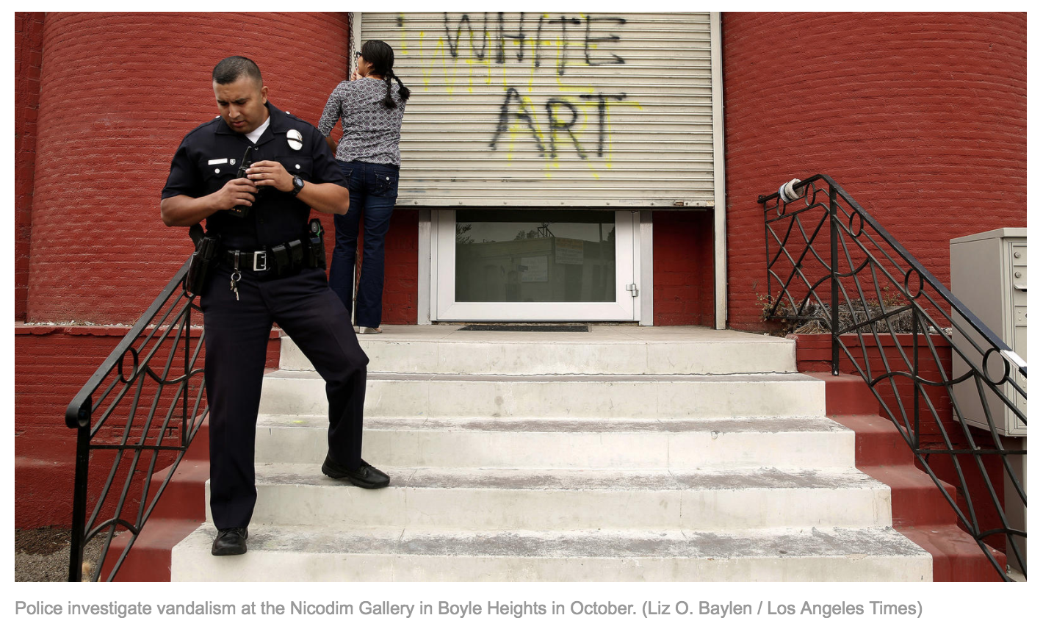

AirTalk’s Larry Mantle talked to Eva Chimento, owner of Chimento Contemporary gallery in Boyle Heights, Elizabeth Blaney, Co-Executive Director of Union De Vecinos and Alessandro Negrete, Civic Engagement and Events Chair with the Boyle Heights Neighborhood Council, as well as listeners to get their perspectives on recent events and their implications for Boyle Heights.

Interview highlights

On the impact of art galleries:

There have been studies after studies...that have shown that galleries coming into communities do cause gentrification and do cause displacement, because of what they bring. Not the art, but because of who they attract and the businesses that tend to serve the needs of future incoming residents and not the needs in this community [...] The galleries say that they're bringing art…and that's their investment in the community. But that is not what the community is asking for...if the community is saying that we need basic services like child care and laundromats and places for youth and places for seniors, that's their role, is to live that up...what they're bringing is displacement, not investment.

I own a business. I'm in the back of a tiny little building, I'm a single mother making it all myself because I adore and love the artists who grew up in this community. There are other businesses in this building…Why is it that the art galleries are told to leave an area that is an industrially zoned area? There was never to be housing slated in this neighborhood...The children who come to visit me after school during the week because their parents are working and they want a place to hang out, they live in this neighborhood. So I'm providing something for them that they're seeking.

On the changing demographics in Boyle Heights and where to go from here:

Progress is good...if it helps rid the neighborhood of gangs, of graffiti and everything else that comes with it...[I've lived in Boyle Heights for] 63 years...I don't know if your on air guests have lived there that long, but they haven't had to put up with a car break-in, they haven't had to put up with getting jumped on the corner...they haven't had to put up with the intimidation and the gangs.

We need to find a balanced approach to preserve the culture and the people that are part of the community of Boyle heights while also creating opportunities to strengthen and enrich it...rather than looking at art as a problem we need to find ways to empower our youth, find ways to get education to our youth and our communities...and create opportunities for people to become vibrant stakeholders in the community.

Link to radio segment: http://www.scpr.org/programs/airtalk/2016/11/04/52960/anti-gentrification-anger-in-boyle-heights-turns-t/

Questions

9. What event prompted this on-air radio program discussion?

10. Why are art galleries at the center of the gentrification debate? What arguments are made for and against the opening of new art galleries in Boyle Heights?

Source 5
“Defend Boyle Heights Action Against Gentrification”
YouTube Video (2:09), Uploaded July 6, 2016

https://www.youtube.com/watch?v=815HFamy9ks

Questions

11. What people, or social forces, are the activists in this video organizing to combat?

12. What objections do the speakers in this video raise against gentrification?

13. What do the activists in this video offer as solutions to gentrification in Boyle Heights?

Source 6
“Accused of gentrification, some Boyle Heights artists push back: ‘We’ve always been here’”
National Public Radio (radio news report), KPCC 89.3
September 20, 2016

http://www.scpr.org/news/2016/09/20/64839/some-say-don-t-throw-all-boyle-heights-art-galleri/

Questions

14. What complication, or problem, does this report raise regarding activism against artists and art galleries in Boyle Heights?

15. Who are the victims of gentrification in this report?

Source 7
“Why Gentrification Is So Hard to Stop”
CityLab/Atlantic Monthly
February 17, 2014

By James Frank Dy Zarsadiaz

Cities are transforming…The reliable no-frills coffeehouse shut down and two months later, there's an artisan bakery selling baguettes for $6. Your favorite barber tells customers he can no longer afford the rent; meanwhile a chain salon around the corner has an hour wait.

These scenes are all too familiar for the urban dweller, from Philadelphia to Portland, Oregon. On the surface, they're hallmarks of gentrification. That narrative starts with educated middle-income (and typically white) 20- and 30-somethings moving into a predominantly working-class community for bigger bang for their buck. Other yuppies follow suit. Eventually the neighborhood is made amenable to their palettes and preferences. Property values rise, minorities are displaced, and the public promenades that reflect urban diversity begin to look and feel otherwise.

A spate of mainstream articles, books, and policy papers published in the last decade have warned civic leaders about this "new" form of urbanization. However, gentrification isn't new -- it's actually baked into the economic forces that have been driving urban development since the 1950s. If we want to address gentrification's ills, we need to address this force that undergirds it.…

When Boston, Chicago, and New York rose to prominence in the late 19th and early 20th centuries, cities were conceptualized as landscapes of innovation, opportunity, and heterogeneity, where people and government pulled together for the common good. Those popular ideas have remained in the broader public imagination.

But in the last 30 years, everyday needs and resources once viewed as governmental responsibilities have been handed over to “outsider” companies whose scope, grasp, and concern for the on-the-ground life in a city is limited. Entertainment is relegated to shopping malls, chain stores, sports stadiums, and for-profit festivals. Small businesses are forced to compete with Best Buy, Staples, and Target. A cashier at a downtown stadium cannot afford to live close to his job, instead settling for a working-class suburb or in the outer rings of the city.

At the same time, those who can afford to live in a city now expect a personalized, “just for you” urban lifestyle. For-profit companies chase these urbanites with upscale housing and creative marketing campaigns, transforming blighted and blue-collar neighborhoods into “livable” urban nooks.

For some, the city has re-earned its cachet. It is an exciting playground if you have the time and money. For others, the city is increasingly un-democratic; the struggles of the concrete geography are harsher than ever. Consumer-driven solutions to stimulate city economies via shopping, tourism, and luxury condos offer up sexy ideas of urban development.…

Link to article: http://www.citylab.com/work/2014/02/why-gentrification-so-hard-stop/7708/

Questions

16. What economic actors does Dy Zarsadiaz identify as the main drivers of gentrification?

17. What historical change in American attitudes does Dy Zarsadiaz identify as the ultimate cause of gentrification?

 | Benefits of Gentrification | Drawbacks of Gentrifications
Short-term

Long-term

Document Gentrification in Your Own City
Step 1: Define gentrification in your own words:

Step 2: Locate a business or site in the city where you live, or a nearby city, that represents gentrification or urban change. Write the name and location of the site below.

Step 3: Take a picture of the business or site. Copy the image into this box. Then give one or two reasons why it represents gentrification.

