Who establishes prices in the marketplace? How do government actions impact civil society?
Guiding Questions: What are the consequences of gentrification?

What is gentrification?
Hotly debated, and sometimes referred to as urban renewal, gentrification is a word used to describe urban change—particularly, the transformation of a low-income or economically depressed area of a city into a higher-income more economically prosperous area. Gentrification happens in cities all across the United States (and world), but usually takes place in older cities: cities with little undeveloped land, few unoccupied buildings, and cities or regions where commercial and residential property prices and rents are expensive.

The process of gentrification is usually understood as going something like this: on the look-out for cheaper rents and property prices, new residents and business owners move into a working-class or low-rent district of a city, followed by yet more new residents and businesses. Over time, the newcomers create not just to new forms of economic activity but new residential and commercial patterns—patterns that result in higher rents, property values, and taxes for everyone in the neighborhood.

Two main issues often result from these new patterns: (1) rising rent and property values encourages yet more new businesses and residents to move into the neighborhood; and (2) the higher rents, property values, and taxes force the original residents and business owners to move out of the neighborhood because they can no longer afford to live there. The changes caused by gentrification can therefore be dramatic because the older lower-income residents are slowly replaced by the newer higher-income residents. The word for this process is displacement. Displacement is the main reason why gentrification is controversial and hotly debated.

One final important point: In the United States, gentrification is tied not only to social class but to race and ethnicity as well. Many of the neighborhoods that undergo gentrification in the US are lower income African American or Latino neighborhoods, while many of the gentrifiers (i.e. the new, incoming residents and business owners) are often well-educated, middle- to upper-middle class whites. This leads to difficult social situation where new white residents displace long-term Black or Latino residents.

What are the consequences of gentrification?

Before and After Photos of Gentrification in New York City
Source: James and Karla Murray/Jeremiah’s Vanishing New York Blog
http://vanishingnewyork.blogspot.com/2014/03/nyc-before-after.html

Source 1
“The Myth of Gentrification”
Slate Magazine, January 14, 2015

By John Buntin

…New York isn’t the only city where it spreads. San Francisco, Washington, and Boston have arguably been even more affected by it. Seattle, Atlanta, and Chicago have experienced it on a large scale, too.

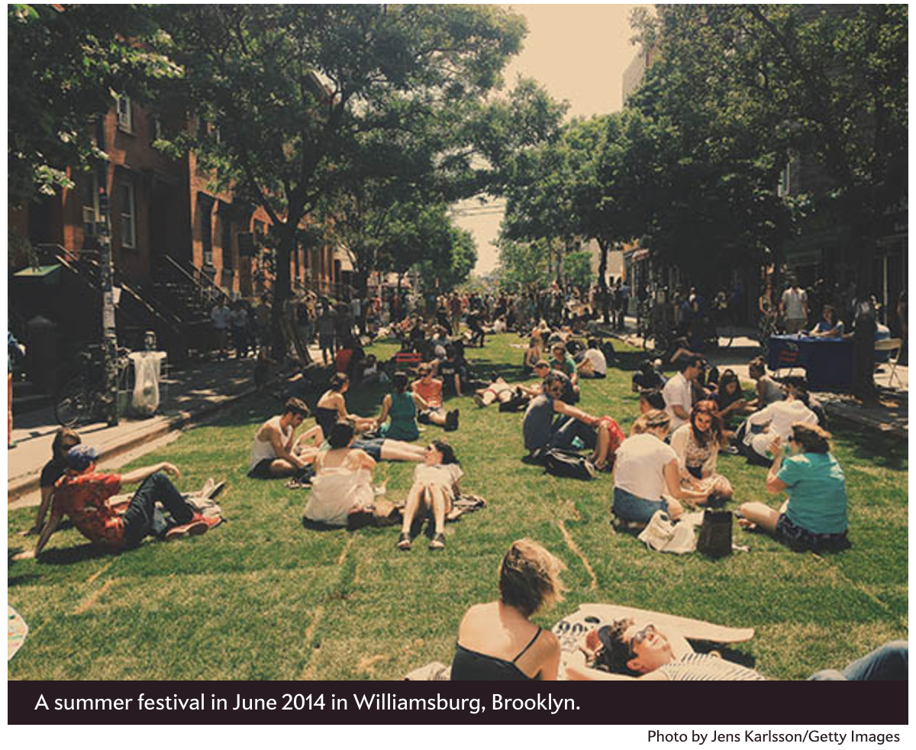

If you live in one of these cities, you probably think you know how [gentrification] works. Artists, bohemians, and gay couples come first. They move into run-down—but charming and historic—homes and loft spaces close to the urban core. Houses are restored. Funky coffee shops appear. Public safety improves. Then rents and home prices start to go up. The open-minded, diversity-loving creative types who were the first wave of gentrifiers give way to lawyers, bankers, and techies. As rents and home prices continue to rise, the earlier residents—often lower-income people of color—are forced out.…

That gentrification displaces poor people of color by well-off white people is a claim so commonplace that most people accept it as a widespread fact of urban life. It’s not. Gentrification of this sort is actually exceedingly rare. The socio-economic status of most neighborhoods is strikingly stable over time.…As for displacement—the most objectionable feature of gentrification—there’s actually very little evidence it happens. In fact, so-called gentrifying neighborhoods appear to experience less displacement than nongentrifying neighborhoods.…

Of course, displacement is not the only way in which gentrification could harm the poor. Residents of gentrifying neighborhoods might stay put but suffer from rising rents. [Columbia University economists Lance] Freeman and [Frank] Braconi found that rents did rise in gentrifying neighborhoods in New York. But rising rents had an unexpected effect: As rents rose, residents moved less.…

In 2010, [another university study] examined gentrification across the nation as a whole over the course of the 1990s.…[That study] found that gentrification created neighborhoods that were attractive to minority households, particularly households with children or elderly homeowners. They found no evidence of displacement or harm. While most of the income gains in these neighborhoods went to white college graduates under the age of 40 (the archetypical gentrifiers), black high school graduates also saw their incomes rise. They also were more likely to stay put. In short, black households with high school degrees seemed to benefit from gentrification.

…For black communities, neighborhood change happens when Latinos begin to arrive. Sometimes these changes can be difficult, resulting as they often do in new political leaders and changes to the character of the communities. But [recent] research suggests they also bring real benefits. Black residents, particularly black youth, living in more diverse neighborhoods find significantly better jobs than peers with the same skill sets who live in less diverse neighborhoods.

In other words, the problem isn’t so much that gentrification hurts black neighborhoods; it’s that it too often bypasses them.

Link to article: http://www.slate.com/articles/news_and_politics/politics/2015/01/the_gentrification_myth_it_s_rare_and_not_as_bad_for_the_poor_as_people.html

Questions
1. Is Buntin for or against gentrification?

2. What is Buntin’s main argument in this article?

3. What evidence does Buntin present regarding the positive effects of gentrification on African American neighborhoods?

Source 2
“Gentrification May Be Complicated, But It’s Not a Myth and Neither Is Displacement”
New York Observer, January 20, 2015

By Kim Velsey

In a recent Slate article, John Buntin…argues that gentrification is a myth, a claim that we’ve certainly heard before. And much like his predecessors, Mr. Buntin bases this claim on two premises: that displacement is a fiction and that gentrification, or what we erroneously call gentrification, is not only incredibly rare, but a good thing for poor minorities living in bad neighborhoods.…

…Mr. Buntin’s argument is simply wrong.…

He… cites several studies from the ’90s that show there’s not much of difference between the number of poor minorities that leave ungentrified neighborhoods versus gentrified ones. This he links to studies which have shown gentrification isn’t that bad for poor people—instead of being marginalized they benefit from financial investment in their neighborhoods. Which is true, to the extent that people can stay and share in the spoils of the rich, two very big ifs that have not really been borne out here in New York.

A gentrified Chelsea [district in Manhattan]. Kevin Gong/flick.

The distinction that he fails to draw is how a neighborhood changes not just during the first wave of gentrification, but over many subsequent ones…as well as the very real distinction between people who are, in his own words “forced out” of a neighborhood and those that chose to leave. While poor people may move away from both gentrifying and ungentrifying neighborhoods, those who leave gentrified neighborhoods often have no choice in the matter. And while gentrification does carry with it some undeniable benefits like lower crime rates and better schools, these are not much good to residents if they aren’t able to stay and take advantage of them. Rent-stabilization and property ownership help to reduce displacement, of course, but over time, gentrifying New York neighborhoods have become richer and whiter.

In Fort Greene, for example, The New York Times reported that between 2000 and 2012, the proportion of whites rose 13 percent, according to census data, while the share of blacks shrunk 15 percent. At the same time, median household income rose from $44,987 to $56,436.…

Meanwhile, in 2011, The Times reported that Bed-Stuy’s white population had soared 633 percent since 2000…The black population dropped from 40,000 to 34,000 and the white population increased from 2,000 to 18,000 people.…

And in Manhattan, as of 2010, Harlem, one of the last minority strongholds in the borough, ceased to be majority black, a shift that was surely not the exclusive result of voluntary relocation.

At the same time, while Mr. Buntin argues that demographic change is largely the result of lower-income Latinos moving into new neighborhoods, in New York, a number of racially-diverse, low- and middle-income neighborhoods have become both whiter and richer. According to a recent article in The Wall Street Journal, as the black middle-class shrunk, white, high-income clusters grew at the fastest rate of any group in the city, increasing 44 percent between 2000 and 2010, and 32 percent in the geographic areas they occupy.…

The South Bronx has the most severe hunger-related problems in the country, as well as some of its highest asthma rates, we have nearly 60,000 homeless people in the city and Manhattan has the highest income gap in the nation. If we want to have a nuanced discussion about poverty and gentrification in this country, we’d do well to remember that poverty, racial segregation and gentrification are not mutually exclusive. In fact, they’re usually intertwined.

Link to article: http://observer.com/2015/01/gentrification-may-be-complicated-but-its-not-a-myth-and-neither-is-displacement/

Questions

4. Is Velsey for or against gentrification?

5. What is her main argument in this article?

6. What is evidence does she present in relation to gentrification in New York City to counter Buntin’s arguments about the positive effects of gentrification?

Source 3
“New Faces and a Conscientious Revival”
New York Times, October 30, 2011
By Jennifer Medina

As the economy has soured, many of these stores have struggled to stay afloat. Some stores closed, others asked their landlords for a reduction in rent. At the same time, several property owners began pressing to create a group to improve downtown Santa Ana. The owners, who were mostly white, were determined to make it more welcoming to English-speaking clients and bring in customers from more affluent parts of Orange County. What they really wanted to do, opponents said, was scrub away any suggestion that it is an immigrant hub, in a city that is 85 percent Latino. Fiesta Marketplace changed its name to “East End,” and the pink buildings that might evoke a Mexican plaza were repainted in muted hues. A few stores put up signs proclaiming, “Stop ethnic cleansing.”

Supporters of the changes say any charge of racism ignores the fact that nearly all of the new businesses that have opened in the last two years are owned and operated by Latinos.
But what is largely left unsaid is that those shop owners and their customers are second- and third-generation Latinos, often far less interested in buying the “goods from back home” that attract more recent arrivals. This generation has more money to spend and is more like the well-heeled shoppers one would find throughout Southern California. “I don’t want to go someplace else to buy my suits,” said Carlos Bustamante, a city councilman and Santa Ana native, the son of Mexican immigrants. “There should be options for everybody here. The city is not changing ethnically; it’s changing socioeconomically.”

On one corner of Fourth Street, a restaurant that served Mexican seafood for decades is being replaced with a high-end hamburger joint. Farther down, a longtime jeweler closed its doors this year. But a T-shirt and tattoo supply shop a block away says business has never been better, as high school students stop in daily.

“All of them are children of immigrants,” said Danielle Barragan, the owner of the store. “Their parents might not want to spend the money, but they will give it to their children, and they will come spend it here.”

But business has dried up for the dozens of quinceañera shop owners like Ms. Madriles. Her husband, Adolfo Lopez, was one of just two immigrants on the board of the Downtown Property Business Improvement District, the group promoting the area. But he was forced to resign when the couple did not pay the taxes required by the group. Ms. Madriles echoes much of the anger of the older merchants downtown: “What are we paying for? They don’t do anything for us. They only care about nightlife and bringing in the wealthy, but those people aren’t going to help my business.”

Link to article: http://www.nytimes.com/2011/10/31/us/in-santa-ana-new-faces-and-a-contentious-revival.html

Questions

7. How would you describe Medina’s report? Is her representation of gentrification in Santa Ana positive or negative?

8. What aspect of gentrification in Santa Ana does Medina identify as being overlooked or “left unsaid?”

9. Medina’s report was published in the New York Times. What do you think this says about the issue of gentrification in Santa Ana and the United States as a whole?

Source 4
“Crowbar Thing”
Spoken-word poem written and performed by Paul S. Flores
YouTube video (3:35)

https://youtu.be/t1LDS70MpqM

Questions

10. Flores wrote his poem to address the problems of gentrification in San Francisco’s Mission District, the place where this recording was made. On November 4, 2016, Flores performed “Crowbar Thing” with the Breath of Fire Latina Theater Ensemble in Santa Ana. Who does Flores seek to give voice to in his poem? Just as important, to whom does he aim to speak?

11. Because the negative impacts of gentrification described by Flores are so widespread, what should be done to combat them? Is poetry an effective form of protest?

Source 5
“Santa Ana: The Heart of Orange County”
Produced by Santa Ana Economic Development Council
Presented at GROW Conference 2015: The Rise of Urbanization in the Heart of Orange County
YouTube Video (2:09)

https://www.youtube.com/watch?v=iGPQPaGDr20&feature=youtu.be

Questions

12. The end of the video proclaims, “This is Santa Ana.” Who and what are highlighted and represented as “Santa Ana” in the video?

13. Who does the video suggest will benefit from investment and development in Santa Ana?

14. How is local government portrayed in the video?

15. What does this video tell us about the role of local government in gentrification?

Source 6
“As Santa Ana cheers ‘Great Neighborhood’ win, activists decry area’s gentrification”
Orange County Register, October 20, 2016

By Jessica Kwong

The mix of preserving a rich Latino history while integrating new ideas and the next generation is what earned downtown Santa Ana the prestigious designation of one of five “Great Neighborhoods” – and the only one in the western U.S. – by the American Planning Association. The planning organization announced the recipients earlier this month and its board members presented the award on Thursday evening at the Spurgeon Promenade before several hundred community members. Since 2007 when it launched the Great Places in America program, the association has recognized five neighborhoods, five streets and five public spaces each year that demonstrate exceptional infrastructure, amenities, cultural identity and innovative and sustainable practices.

Kurt Christiansen, a member of the association’s national board, on Thursday complimented the city’s plazas, the many outdoor eating places and the walkability of the downtown.

“A lot of downtowns close at 5 and there isn’t any nightlife,” he said, as a band played and people enjoyed food from nearby restaurants. “They’ve done a wonderful job with the streetscape.”

Councilwoman Michele Martinez, whose ward includes downtown, said the area began transforming into an inclusive place about four years ago, when affordable housing entered the adjacent Lacy neighborhood and a sunshine ordinance was established.
“At the end of the day, it’s because we finally decentralized government and gave the power to the people,” she said. “We all know when we have the magic of relationships – it’s what makes a place.”

Sales tax revenue annually in the downtown area from general retail, food products and professional services has been on the rise, from $761,864 in 2010 to $1.1 million in 2015, according to the city’s economic development specialist, Marc Morley.

“The biggest thing that is happening is property values are skyrocketing. The density makes us attractive – people can walk everywhere,” City Manager David Cavazos said.
But some residents disagree that the change has been for the better.

About a dozen activists with Chicanos Unidos, an Orange County social justice organization focusing on Santa Ana, crashed the city's celebration, chanting, “Don’t support gentrification!” and “False narrative!” as city officials delivered their speeches.
At least 30, mostly Latino businesses have been displaced from the downtown in the past six years, Chicanos Unidos organizer Gaby Hernandez said.

“The association that gave it to them claims that they were able to develop this community with the inclusion of the community, which has not been the case,” she said.
The protest baffled city leaders and business owners including Ryan Chase, 33, a longtime downtown property owner who rebranded the area where the celebration was held from Fiesta Marketplace to East End and created the foodie destination 4th Street Market.

“We got voted the best downtown in the country,” Chase said. “Somehow it’s a bad thing. I don’t get it.”

Link to article: http://www.ocregister.com/articles/city-732875-downtown-cafe.html

Questions

16. According to those interviewed in this article, what are the goals of those who support gentrification in Santa Ana? How do their goals differ from those who oppose gentrification?

17. Would it be possible for those on opposing sides to compromise? Is there a middle ground between where both sides can agree on what makes Santa Ana a “great neighborhood?”

Source 7
Photo of “Graffiti” in Santa Ana

Rooftop graffiti mural between Fourth and French Streets in Downtown Santa Ana, artist unknown.

The left hand corner tag reads “East End,” the new name for Fiesta Marketplace.

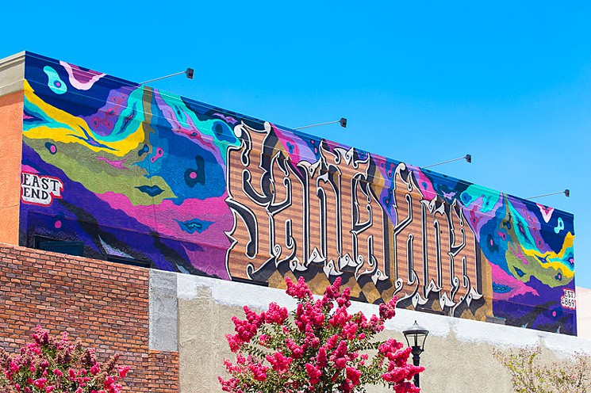
Source: http://www.ocweekly.com/music/is-hip-hop-culture-gentrifying-santa-ana-6589700

Source 8
Photo of “Graffiti” in Santa Ana

Graffiti-inspired mural by artists from the Marcas Gallery in Fourth Street Market.

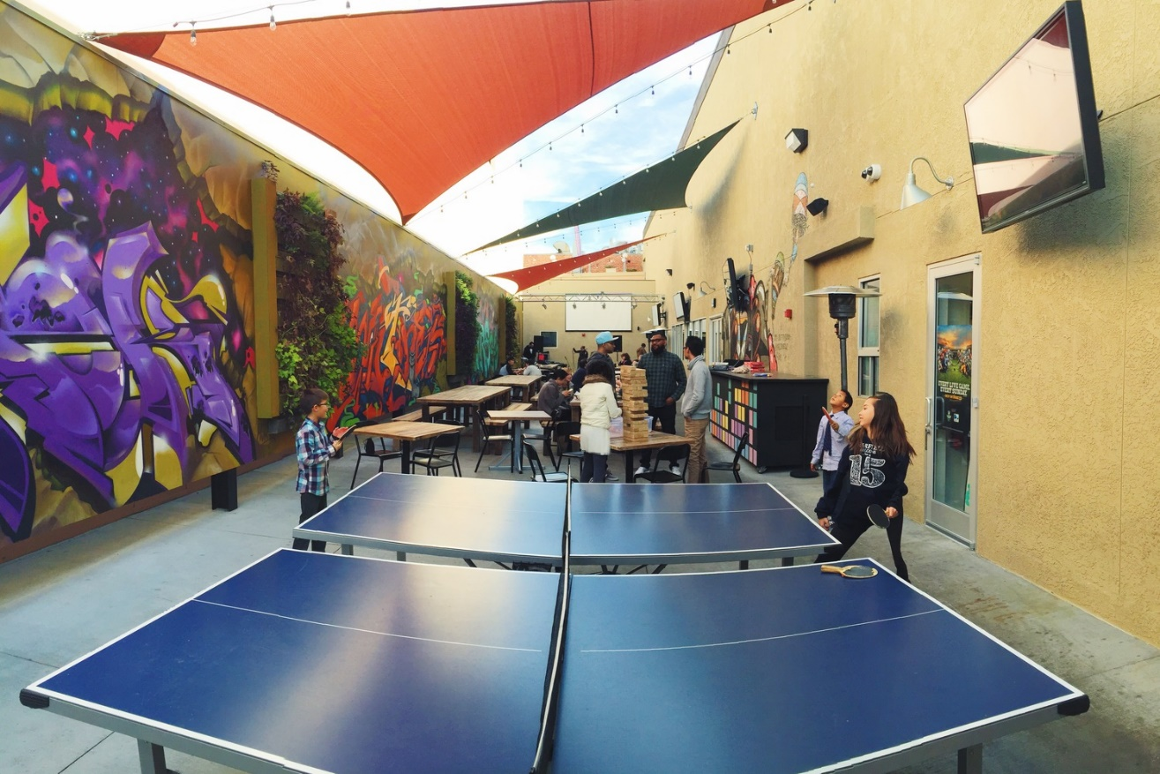
Source: http://www.4thstreetmarket.com/

Questions

18. Is the use of graffiti art and graffiti-inspired art by new businesses and developments in Santa Ana, like the Fourth Street Market, authentic?

19. Do these works of art represent the traditional roots of the hip-hop/graffiti subculture in Santa Ana? Or are these businesses merely using the subculture to attract new clientele to downtown Santa Ana?

Source 9
“Why Gentrification Is So Hard to Stop”
CityLab/Atlantic Monthly
February 17, 2014

By James Frank Dy Zarsadiaz

Cities are transforming…The reliable no-frills coffeehouse shut down and two months later, there's an artisan bakery selling baguettes for $6. Your favorite barber tells customers he can no longer afford the rent; meanwhile a chain salon around the corner has an hour wait.

These scenes are all too familiar for the urban dweller, from Philadelphia to Portland, Oregon. On the surface, they're hallmarks of gentrification. That narrative starts with educated middle-income (and typically white) 20- and 30-somethings moving into a predominantly working-class community for bigger bang for their buck. Other yuppies follow suit. Eventually the neighborhood is made amenable to their palettes and preferences. Property values rise, minorities are displaced, and the public promenades that reflect urban diversity begin to look and feel otherwise.

A spate of mainstream articles, books, and policy papers published in the last decade have warned civic leaders about this "new" form of urbanization. However, gentrification isn't new -- it's actually baked into the economic forces that have been driving urban development since the 1950s. If we want to address gentrification's ills, we need to address this force that undergirds it.…

When Boston, Chicago, and New York rose to prominence in the late 19th and early 20th centuries, cities were conceptualized as landscapes of innovation, opportunity, and heterogeneity, where people and government pulled together for the common good. Those popular ideas have remained in the broader public imagination.
But in the last 30 years, everyday needs and resources once viewed as governmental responsibilities have been handed over to “outsider” companies whose scope, grasp, and concern for the on-the-ground life in a city is limited. Entertainment is relegated to shopping malls, chain stores, sports stadiums, and for-profit festivals. Small businesses are forced to compete with Best Buy, Staples, and Target. A cashier at a downtown stadium cannot afford to live close to his job, instead settling for a working-class suburb or in the outer rings of the city.
At the same time, those who can afford to live in a city now expect a personalized, “just for you” urban lifestyle. For-profit companies chase these urbanites with upscale housing and creative marketing campaigns, transforming blighted and blue-collar neighborhoods into “livable” urban nooks.

For some, the city has re-earned its cachet. It is an exciting playground if you have the time and money. For others, the city is increasingly un-democratic; the struggles of the concrete geography are harsher than ever. Consumer-driven solutions to stimulate city economies via shopping, tourism, and luxury condos offer up sexy ideas of urban development.…

Link to article: http://www.citylab.com/work/2014/02/why-gentrification-so-hard-stop/7708/

Questions

20. What economic actors does Dy Zarsadiaz identify as the main drivers of gentrification?

21. What historical change in American attitudes does Dy Zarsadiaz identify as the ultimate cause of gentrification?

 | Benefits of Gentrification | Drawbacks of Gentrifications
Short-term

Long-term

Document Gentrification in Your Own City
Step 1: Define gentrification in your own words:

Step 2: Locate a business or site in the city where you live, or a nearby city, that represents gentrification or urban change. Write the name and location of the site below.

Step 3: Take a picture of the business or site. Copy the image into this box. Then give one or two reasons why it represents gentrification.

