What were the effects of the exchanges on the Silk Road?
Topics: Trade, cultural exchange
By: Nicole Gilbertson, UC Irvine History Project

History Standards:
6.6.7 Cite the significance of the trans-Eurasian “silk roads” in the period of the Han Dynasty and Roman Empire and their locations.

CCSS Standards: Reading, Grades 6-8
1. Cite specific textual evidence to support analysis of primary and secondary sources.
2. Determine the central ideas or information of a primary or secondary source; provide an accurate summary of the source distinct from prior knowledge or opinions.
5. Determine how a text presents information (e.g. sequentially, comparatively, causally).
6. Identify aspects of a text that reveal an author’s point of view or purpose (e.g., loaded language, inclusion or avoidance of particular facts).
7. Integrate visual information (e.g. in charts, graphs, photographs, videos, or maps) with other information in print or digital texts.

CCSS Standards: Writing, Grades 6-8
1. Write arguments focused on discipline-specific content.
2. Write informative/explanatory texts, including the narration of historical events, scientific procedures/experiments, or technical processes.
4. Produce clear and coherent writing in which the development, organization, and style are appropriate to task, purpose, and audience.

Guiding Question:
What were the effects of the exchanges on the Silk Road?

Overview of Lesson:
This lesson introduces students to the Silk Road, the goods traded on the Silk Road, and how those goods were moved across Eurasian landmass. After acquainting students with the Silk Road, the lesson provides the students with four primary sources illustrating different aspects of exchange across Eurasia. To complete the lesson, follow the steps below.

- Distribute “4C’s of Visual Primary Source Analysis Worksheet.”
- Discuss and analyze “Grapes, ink scroll painting by Xu Wei, Ming Dynasty” (Source 1) whole group and have each student fill in each box in the 4C’s Worksheet in response to the discussion question, “What were the effects of the exchanges on the Silk Road?”
- Divide the students into groups of 3.
- Give each student a “Sharing Out Chart.”
- Each student individually reads 1 document (Source 2, 3, or 4) looking for possible
answers to the discussion question, filling out the “Sharing Out Chart” as they read.
- Students then share out the information on their charts. Students should focus on
summarizing the content in their document, explaining what they believe the document says in relation to the discussion question, and discussing how these sources support, build upon, or contest one another. Students discuss how these sources answer the discussion question.
- After all group members have shared, the group should have a discussion on possible claim given what they believe the documents say.
Possible discussion starters:
Document xx does not seem to fit with the other documents, because….
Document xx seems to support the ideas in document xxx…..
Document xx seems more credible than document…
I agree/disagree with what Carmen said, because…..
Why do you think that?
How did you come to that conclusion?
Could you summarize your main point again….
Where is the evidence to support this idea…..
- Individually each student should write out his/her claim to respond to the discussion
question as well as the key pieces of evidence that he/she believes support it. Students should also write out any questions that they may have in preparation for a whole group discussion.
- Whole class discussion—below are some possible questions that a teacher could
ask.
What is your claim?
What evidence supports this claim?
What evidence contradicts that claim?
How do we know that is true?
Who are the authors of some of these documents? What do we know
about them?

Final Activity:

Documents:
- Grapes, ink scroll painting by Xu Wei, Ming Dynasty
- Xiongnu woolen saddle blanket
- Mediterranean silk wall hanging
- Excerpt of poem by Emperor Wu

4C’s of Visual Primary Source Analysis Worksheet
http://historyproject.uci.edu/files/2016/11/4Cs_VisualPSAnalysis.pdf

Student Introduction:

The Silk Road stretched across Eurasia—the landmass of Europe and Asia—from the Mediterranean Sea all the way to Japan. The Silk Road was not a single road but actually a series of land and sea routes across Eurasia and that linked the different peoples of Eurasia through trade of goods, ideas, and religions. The Silk Road was so named in the 1800s by a German explorer. Long before that, long distance trade flourished across the Silk Road during the time of the Han Dynasty and Roman Empire. While few people traveled the entire distance of these routes, trade goods did travel from Asia to Europe and Europe to Asia. Some of the major commodities traded across the Silk Road were tea, silk, paper, animals, and food.

This trade network began in the Han Chinese capital of Xi’an. The Han emperors were interested in extending the boundaries of their kingdom and learning about the surrounding territories, but Chinese officials were not the primary traders on the Silk Road. Most of the people who traveled the Silk Road were merchants and nomads. The Xiongnu, and other nomadic groups, traveled the various routes of the Silk Road and often traded with sedentary, or settled, civilizations like the Han. We will consider: What were the effects of the exchanges on the Silk Road?

Map of the Silk Road Routes across Eurasia
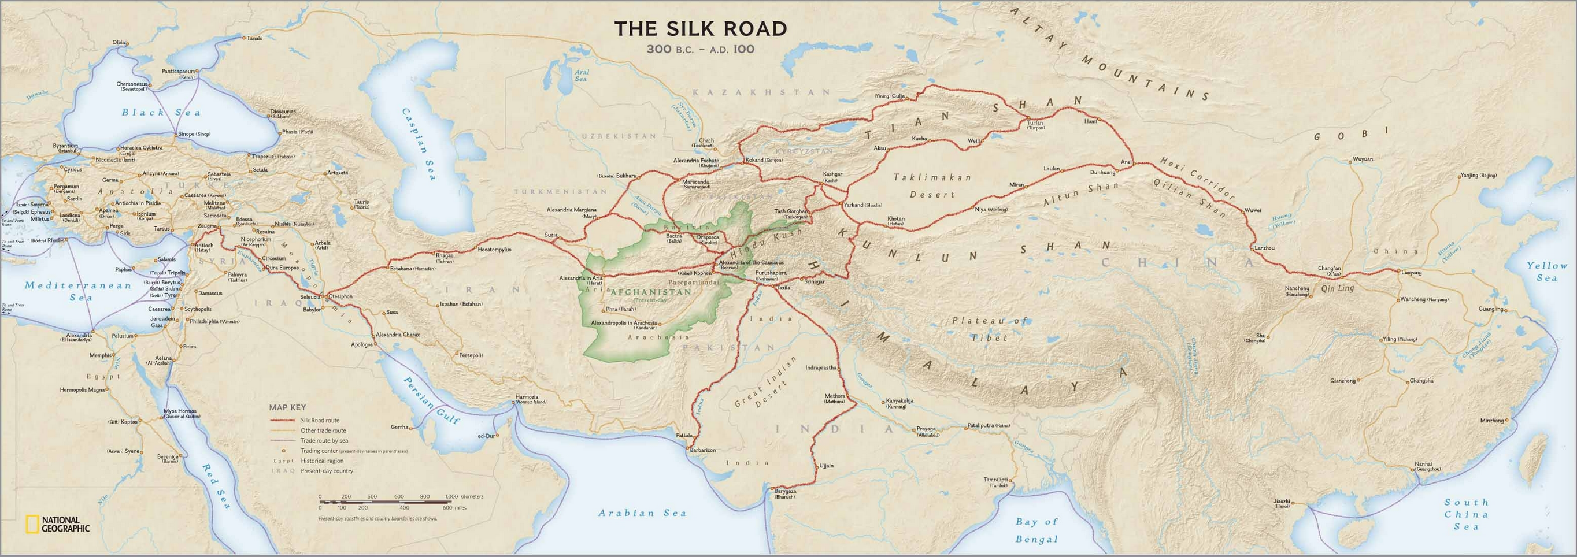
National Geographic map found at https://qmnblog.files.wordpress.com/2013/09/silk-road-map1.jpg

Source 1
Food was one of the most important things traded across the Silk Road. The importation of new foods changed Chinese cuisine. Some of the most basic ingredients in Chinese cooking, such as peas, sesame, and onions, came from the West during the Han dynasty. The image below is of grapes on a Chinese ink scroll painting. Grapes were not native to China, but came from the Mediterranean, the area of the Roman Empire.

Grapes, ink scroll painting by Xu Wei, Ming Dynasty

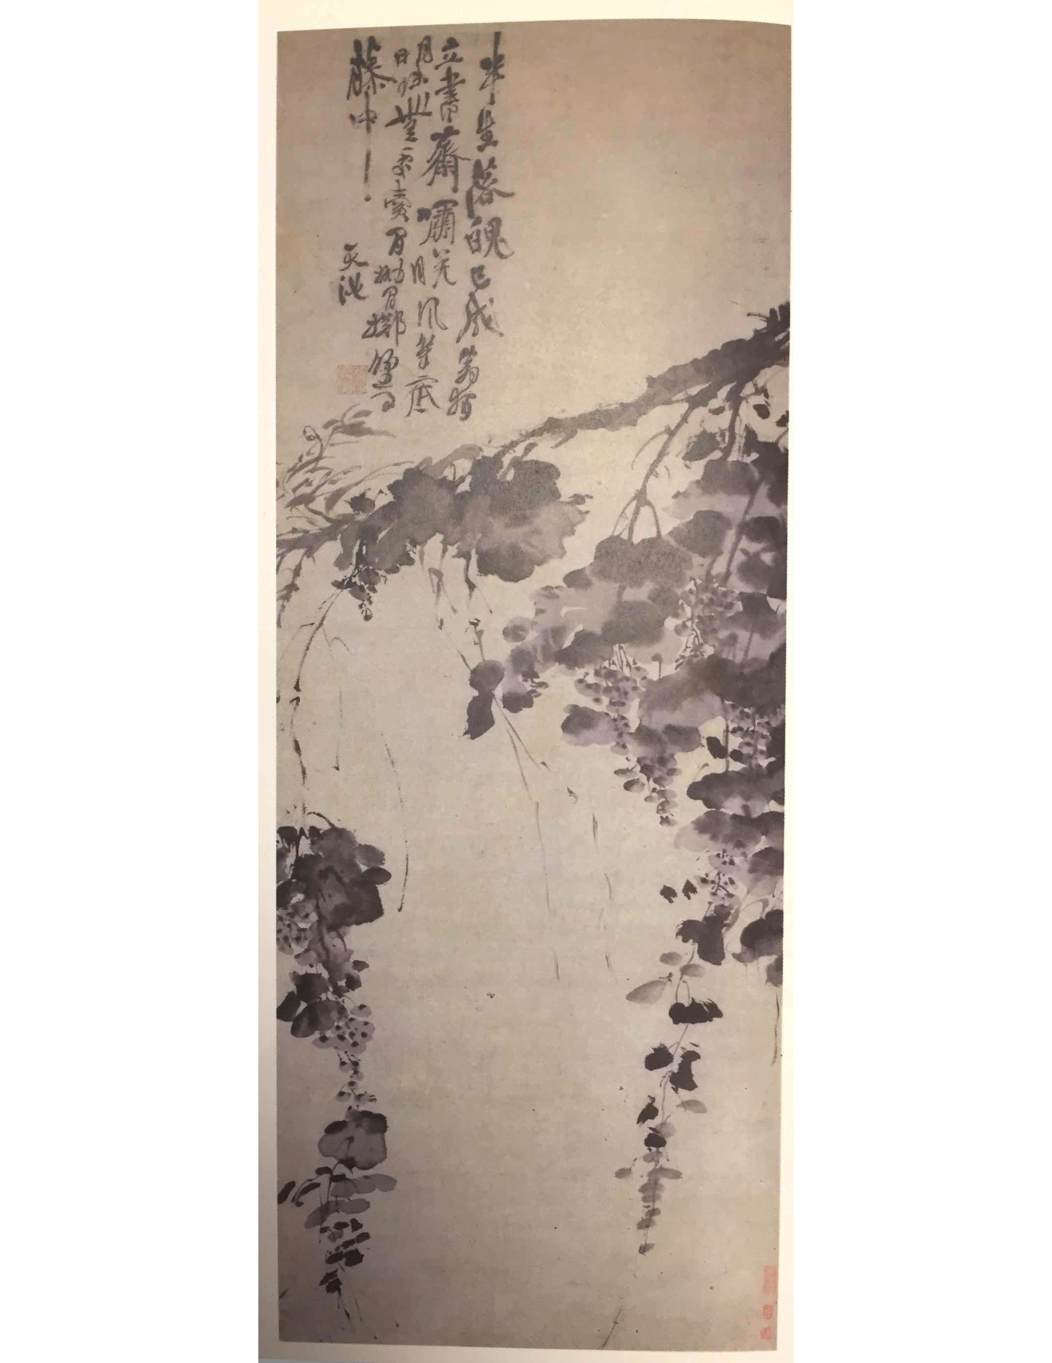
Source 2
The Xiongnu, and other nomadic groups, traveled the various routes of the Silk Road and often traded with sedentary, or settled, civilizations like the Han. The Xiongnu were able to produce goods they needed to survive from their horses. However, they relied on sedentary societies like the Han for goods that they could not produce—goods produced from plants and animals that were not a part of their daily lives. The artifact below is a wool blanket that would have been placed under a saddle and was found in a grave buried with a horse in a desert region where nomadic groups lived. As you look at this artifact you may want to consider where does wool come from and who would have created this blanket?

Woolen Saddle Blanket with Leaves Pattern, 2nd Century BCE- 2nd Century CE (Excavated from Tomb )

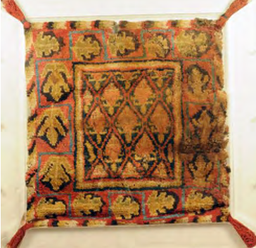

Source 3
Luxury goods played an important role in the long-distance trade of the Silk Road. If a trader, or merchant, wanted to make a bigger profit, or more money, from trade, then he would often look to trade goods that were easy to transport but could sell for a high price. For this reason, luxury goods were an important part of the Silk Road trade. One such luxury good was silk.

Silk production begins with the silkworm. Silkworms eat a special type of food, mulberry leaves, and need to be kept in places that have a warm and constant temperature (about 75 degrees). Only then, do the worms spin silk cocoons. Once they have spun the cocoons, people then boil the cocoons to kill the worms, and then use the cocoons to form silk thread. The silk thread is then woven into silk fabric. Silk thread and fabric was (and still is) an important luxury good. For several hundred years the secret of silk production was only known in the Chinese empire, but this knowledge, as well as silk textiles such as clothing and goods for the home, were exchanged across the Silk Road.

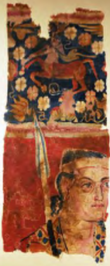 | This artifact is a silk wall hanging. On the top portion is an image of a centaur playing a musical instrument. A centaur is a figure from Greek mythology that is half human and half horse. The bottom portion pictures a warrior carrying a spear. This wall hanging has imagery that looks like many of the decorations and artistic representations of the Classical Mediterranean civilizations.  Silk Wall Hanging with Warrior and Centaur Design, 2nd Century BCE- 2nd Century CE

Source 4
The interactions between the Chinese and the nomadic Xiongnu were often peaceful but at other times war broke out. The Chinese realized that although they had many soldiers, that horses and cavalry of the Xiongnu were superior. In response, the Chinese wanted to trade with the Xiongnu for horses, which the Chinese could not successfully breed on their own.

In 101 BCE, Emperor Wu was waited for the arrival of horses and while he waited he composed this poem:

The Heavenly Horses are coming,  Coming from the Far West.  They crossed the Flowing Sands,  For the barbarians are conquered….  The Heavenly Horses are coming  Across the pastureless wilds  A thousand leagues at a stretch,  Following the eastern road… | Flowing Sands—deserts of Central Asia  barbarians—the nomads the Chinese considered wild and uncivilized  pastureless—a place without agriculture  leagues—long unit of measurement, about 3 miles

