Why did Europeans decide to go Crusade to Jerusalem in the 11th century?
Topics: Crusades,
By: Nicole Gilbertson, UC Irvine History Project

History Standards:
7.6.6 Discuss the causes and course of the religious Crusades and their effects on the Christian, Muslim, and Jewish populations of Europe, with emphasis on the increasing contact by Europeans with cultures of the Eastern Mediterranean world.

CCSS Standards: Reading, Grades 6-8
1. Cite specific textual evidence to support analysis of primary and secondary sources.
2. Determine the central ideas or information of a primary or secondary source; provide an accurate summary of the source distinct from prior knowledge or opinions.
5. Determine how a text presents information (e.g. sequentially, comparatively, causally).
6. Identify aspects of a text that reveal an author’s point of view or purpose (e.g., loaded language, inclusion or avoidance of particular facts).
7. Integrate visual information (e.g. in charts, graphs, photographs, videos, or maps) with other information in print or digital texts.

CCSS Standards: Writing, Grades 6-8
1. Write arguments focused on discipline-specific content.
2. Write informative/explanatory texts, including the narration of historical events, scientific procedures/experiments, or technical processes.
4. Produce clear and coherent writing in which the development, organization, and style are appropriate to task, purpose, and audience.

Guiding Question:
Why did Europeans decide to go Crusade to Jerusalem in the 11th century?

Overview of Lesson:
This lesson examines the origins of the Crusades in medieval Europe. It provides students with multiple viewpoints regarding the motivations of Europeans to travel east during the Crusades. To complete the lesson, follow the steps below.

- Distribute “4C’s of Visual Primary Source Analysis Worksheet.”
- Discuss and analyze “Grapes, ink scroll painting by Xu Wei, Ming Dynasty” (Source 1) whole group and have each student fill in each box in the 4C’s Worksheet in response to the discussion question, “What were the effects of the exchanges on the Silk Road?”
- Divide the students into groups of 3.
- Give each student a “Sharing Out Chart.”
- Each student individually reads 1 document (Source 2, 3, or 4) looking for possible
answers to the discussion question, filling out the “Sharing Out Chart” as they read.
- Students then share out the information on their charts. Students should focus on
summarizing the content in their document, explaining what they believe the document says in relation to the discussion question, and discussing how these sources support, build upon, or contest one another. Students discuss how these sources answer the discussion question.
- After all group members have shared, the group should have a discussion on possible claim given what they believe the documents say.
Possible discussion starters:
Document xx does not seem to fit with the other documents, because….
Document xx seems to support the ideas in document xxx…..
Document xx seems more credible than document…
I agree/disagree with what Carmen said, because…..
Why do you think that?
How did you come to that conclusion?
Could you summarize your main point again….
Where is the evidence to support this idea…..
- Individually each student should write out his/her claim to respond to the discussion
question as well as the key pieces of evidence that he/she believes support it. Students should also write out any questions that they may have in preparation for a whole group discussion.
- Whole class discussion—below are some possible questions that a teacher could
ask.
What is your claim?
What evidence supports this claim?
What evidence contradicts that claim?
How do we know that is true?
Who are the authors of some of these documents? What do we know
about them?

Final Activity:

Documents:
- Plan of Jerusalem, ca. 1200.
- History Channel video clip.
- Excerpt by historian Helen Nicholson
- Excerpt of Gesta Francorum, The Deeds of the Franks (1100)

4C’s of Visual Primary Source Analysis Worksheet
http://historyproject.uci.edu/files/2016/11/4Cs_VisualPSAnalysis.pdf

Student Introduction
Most historians agree that the Crusades began in November 1095 when Pope Urban II preached to a group of religious leaders at the Church Council of Clermont in Southeastern France. What he said exactly is not known, but this started the events known as the Crusades.  The Crusades were a religious war that included Europeans from all classes—from nobles, to knights, to peasants. Men and women joined the Crusades and marched through Europe to the Middle East with the goal to recover Jerusalem for Christianity. The people who went on Crusade believed that they were fighting a religious war, and often took a vow and sewed a cross on their clothes. The map below shows the distance that the Crusaders traveled to reach Jerusalem. While Muslims had controlled Jerusalem for over 400 years (since the 600s CE), it was at this time, at the end of the 11th century, that Europeans left Europe to try to control this holy city. What caused Europeans to go on the Crusades? This is the question we will consider throughout this lesson. | 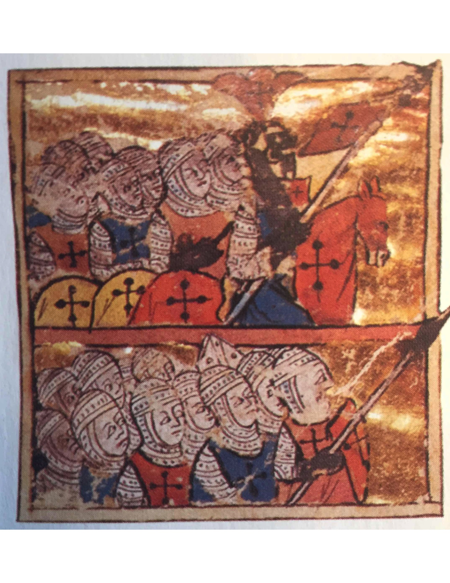
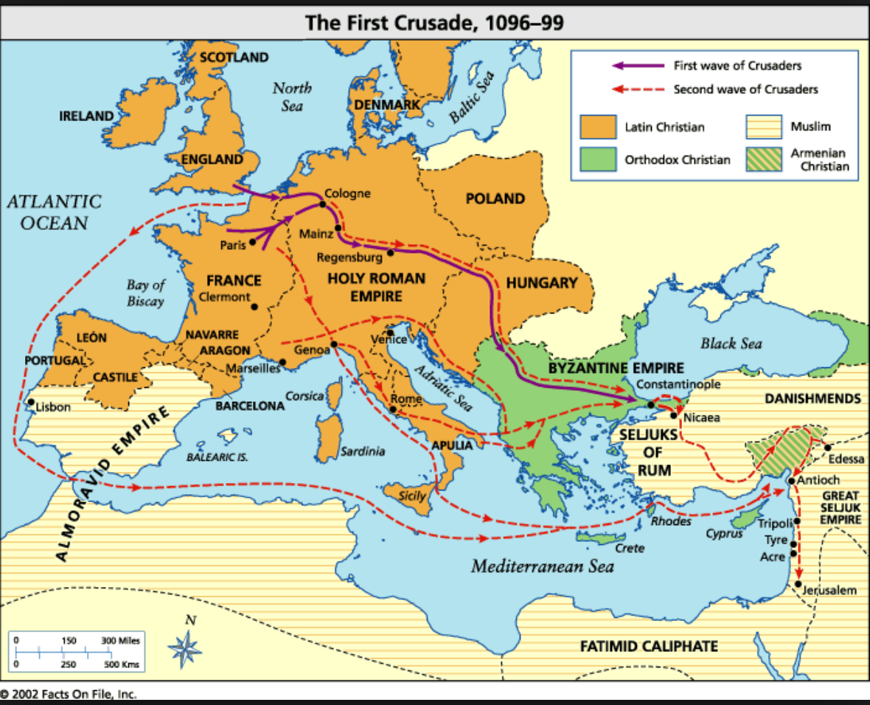
Source 1:
Plan of Jerusalem, ca. 1200, National Library of the Netherlands.
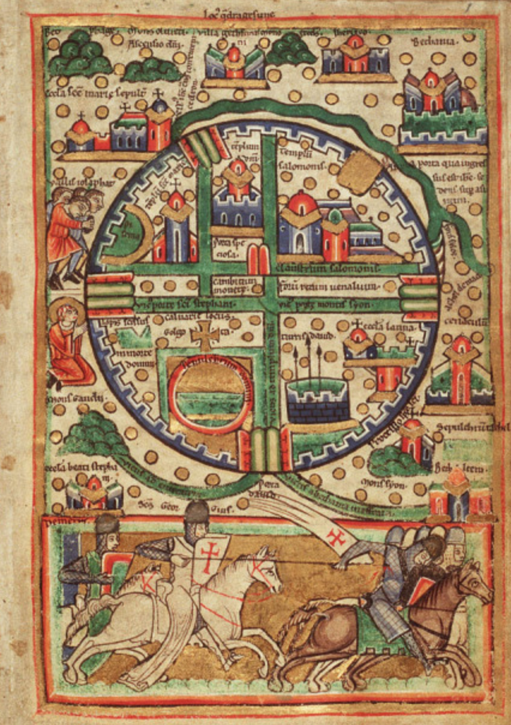

Source 2:
Watch this video from the History Channel. It gives several reasons why people would go on Crusades. As you watch the video consider, what caused Europeans to go on the Crusades?

http://www.history.com/topics/crusades/videos/roots-of-the-crusades

Source 3:
Historians give many reasons why people would go on the Crusade. Read historian Helen Nicholson’s explanation below and fill in the “Sharing Out Chart” once you have read her description.

The eleventh century saw population grown in western Europe, and the result was famine, since there was not enough food being produced to feed the growing population. Young nobles wanted land, because land was wealth and land gave them status, but there was not enough to go around…Another motivation for crusading was the hope of winning glory and honor. Crusading was an honorable activity for a warrior.

Source 4:
In July 1099, the Crusaders arrived at Jerusalem and put the city under siege, which meant that they attacked the walls of the city and tried to enter it. They launched rocks and other items at the walls using catapults and tried to get over the walls. Finally, they entered the city and killed all non-Christians (Jews and Muslims) in the city. Read the primary source below that comes from the Gesta Francorum, The Deeds of the Franks, a chronicle of the First Crusade written by an anonymous author in around 1100. Fill in the “Sharing Out Chart” once you have read the account.

When the pagans [non-Christians] had been overcome, our men seized great numbers, both men and women, either killing them or keeping them captive…Afterward, the army scattered throughout the city and took possession of the gold and silver, the horses and mules, and the houses filled with goods of all kinds.

