Why did the Dust Bowl happen? How did this environmental catastrophe affect ordinary Americans?
Topic: Dust Bowl, Great Depression
By: Erik Altenbernd, UC Irvine History Project

History-Social Science Standards:
11.6.3 Discuss the human toll of the Depression, natural disasters, and unwise agricultural practices and their effects on the depopulation of rural regions and on political movements of the left and right, with particular attention to the Dust Bowl refugees and their social and economic impacts in California.

CCSS Standards: Reading, Grades 11-12
1. Cite specific textual evidence to support analysis of primary and secondary sources, connecting insights gained from specific details to an understanding of the text as a whole.
2. Determine the central ideas or information of a primary or secondary source; provide an accurate summary that makes clear the relationships among the key details and ideas.
7. Integrate and evaluate multiple sources of information presented in diverse formats and media (e.g., visually, quantitatively, as well as in words) in order to address a question or solve a problem.

CCSS Standards: Writing, Grades 11-12
1. Write arguments focused on discipline-specific content.
2. Write informative/explanatory texts, including the narration of historical events, scientific procedures/ experiments, or technical processes.
8. Gather relevant information from multiple authoritative print and digital sources, using advanced searches effectively; assess the strengths and limitations of each source in terms of the specific task, purpose, and audience; integrate information into the text selectively to maintain the flow of ideas, avoiding plagiarism and overreliance on any one source and following a standard format for citation.

Guiding Questions:
Why did the Dust Bowl happen?
How did this environmental catastrophe affect ordinary Americans?

Overview of Lesson:
Students will analyze primary and secondary sources detailing the causes and consequences of the Dust Bowl. The lesson focuses not on migration away from the Dust Bowl, but the social, economic, and environmental conditions that led to the disaster and the hardships encountered by those that survived the hard years of the Dirty Thirties.

Students can work individually or in groups as they progress through each of the three modules of the lesson.

Module One: WebQuest assignment that familiarizes the students with the geography and environmental history of the Great Plains.

Module Two: Students focus on hardships encountered by Dust Bowlers through analysis of three segments of the PBS documentary, “Surviving the Dust Bowl” (1998).

Module Three: Analysis of three photographs from the 1930s documenting the trying social and environmental conditions of the Dust Bowl. Students analyze the photographs using the “6Cs of Primary Source Analysis” worksheet.

Final Activity: a 400-500-word essay written as a newspaper report focusing on the photographs in Module Three and that synthesizes that information gathered from Modules One and Two.

Documents:
- Fast Track Teaching webpage on the geography of the Great Plains
- National Oceanic and Atmospheric Administration website detailing the science behind understanding the Great Plains as a region of recurring drought.
- PBS Documentary “Surviving the Dust Bowl” (1998)
- Associated Press photo of dust storms in Oklahoma (1935)
- Arthur Rothstein photo “Farmer and sons walking in the face of a dust storm. Cimarron County, Oklahoma” (1936)
- Arthur Rothstein photo, Arthur Rothstein, “The winds of the "dust bowl" have piled up large drifts of soil against this farmer's barn near Liberal, Kansas” (1936)
6Cs of Primary Source Analysis Worksheet
http://historyproject.uci.edu/files/2016/11/6Cs_PSAnalysis.pdf

Module One
WebQuest: Geography of the Great Plains
Student Worksheet

Basic Great Plains Geography
http://www.fasttrackteaching.com/ffap/Unit_2_Westward/U2_Great_Plains_Geography.html

1. What states comprise the Great Plains region of the United States?
2. How much rain, on average, does the region receive each year?
3. What kind of native plant life dominates the region?
4. What were some of the features of the Dust Bowl of the 1930s? Why are dust storms common?
5. Main are the main economic activities of the Great Plains today?
6. Why have windfarms been built all across the plains in recent years?

Paleoclimate of the Great Plains
https://web.archive.org/web/20160830025249/http://www.ncdc.noaa.gov/paleo/drought/drght_home.html

The Beginning
7. Why does paleoclimatology present a better picture of the Great Plains climate than rainfall records?
The Story: Why Are We Concerned About Drought?
8. How does this reading define drought and why is it a major environmental problem?
9. How wide a window—what kind of time-span—does paleoclimatic proxy data provide regarding the climate history of the Great Plains?
The Story: 20th Century Drought
10. In which years did the three major waves of drought hit the Southern Plains? How long did the drought last in the worst hit areas?
11. List in bullet point form the different features of the “‘dust bowl’ effect.”
12. List in bullet point form the different human factors, or actions, led to the Dust Bowl in the 1930s?
The Story: Paleoclimatology and Drought
13. What is paleoclimatology?
14. List the different forms of information, or “proxy data,” that paleoclimatologists collect and analyze?
The Data
15. Are the historic droughts found in the 500-year record more or less severe than those of the twentieth century?
16. What conditions are found in the 10,000-year record? What climatic conditions would explain the expansion of the prairie, or grasslands, of the Great Plains into the forests of eastern North America?
17. Based on what you’ve read, what kind of environmental conditions have the native grasses of the Great Plains evolved to tolerate?
A Final Word
18. Were the droughts of the twentieth century characteristic of the long climate history of the Great Plains? Was the drought that caused the Dust Bowl more or less severe than the droughts of the deeper past?
19. How will global climate change affect the Great Plains?
Concluding Activity
Given the paleoclimatic record, was the Dust Bowl an unusual event in the history of the Great Plains? Explain your answer in a 5-7 sentence paragraph that uses 3-5 pieces of evidence from the readings above.

Module Two
Video Analysis: “Surviving the Dust Bowl”
Student Worksheet

PBS Documentary, “Surviving the Dust Bowl” (1998)
https://www.youtube.com/watch?v=fJMidfqiNio

“Surviving the Dust Bowl” (4:22-11:45)
1. What was the “The Great Plow-Up” of the 1920s?
2. What mechanical device played a key role in the “The Great Plow-Up”?
3. Identify the other three causes of the Dust Bowl mentioned in the video?

“Surviving the Dust Bowl” (21:30-24:45)
1. What was a “rabbit drive?”
2. Why did Dust Bowlers organize rabbit drives?

“Surviving the Dust Bowl” (27:30-33:00)
1. What was “dust pneumonia?”
2. How did some Dust Bowlers treat dust pneumonia?
3. Who was the most vulnerable to dust pneumonia?
Concluding Activity
Explain what the Dust Bowl was and include some of the hardships Dust Bowlers experienced. Explain your answer in a 5-7 sentence paragraph that uses 3-5 pieces of evidence from the video clips above.
Module Three
Photo Analysis
Student Worksheet

Directions: Use the “6Cs of Primary Source Analysis” Worksheet to analyze the photograph below.

Photo 1.
Associated Press, “About to be engulfed in a gigantic dust cloud is a peaceful little range in Boise City, Oklahoma where the top soil is being dried and blown away on April 15, 1935.”

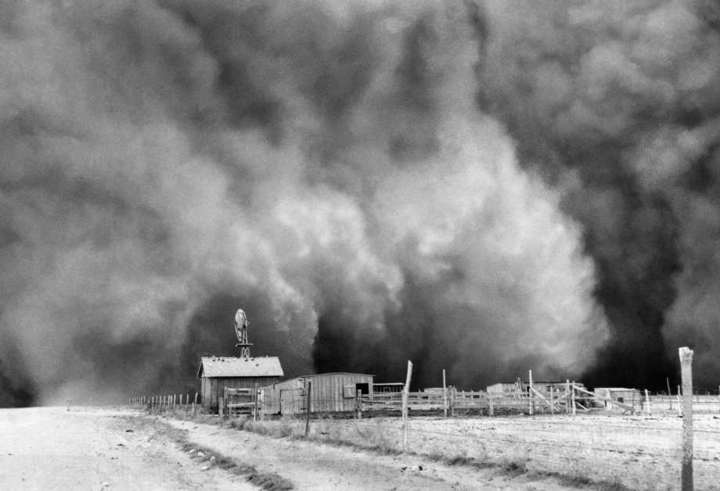

Source: Times Union Newspaper (Albany, NY)
http://www.timesunion.com/entertainment/article/Flawed-Dust-Bowl-tells-a-harrowing-relevant-4044626.php

Module Three
Photo Analysis
Student Worksheet

Directions: Use the “6Cs of Primary Source Analysis” Worksheet to analyze the photograph below.

Photo 2.
Arthur Rothstein, “Farmer and sons walking in the face of a dust storm. Cimarron County, Oklahoma” (1936).

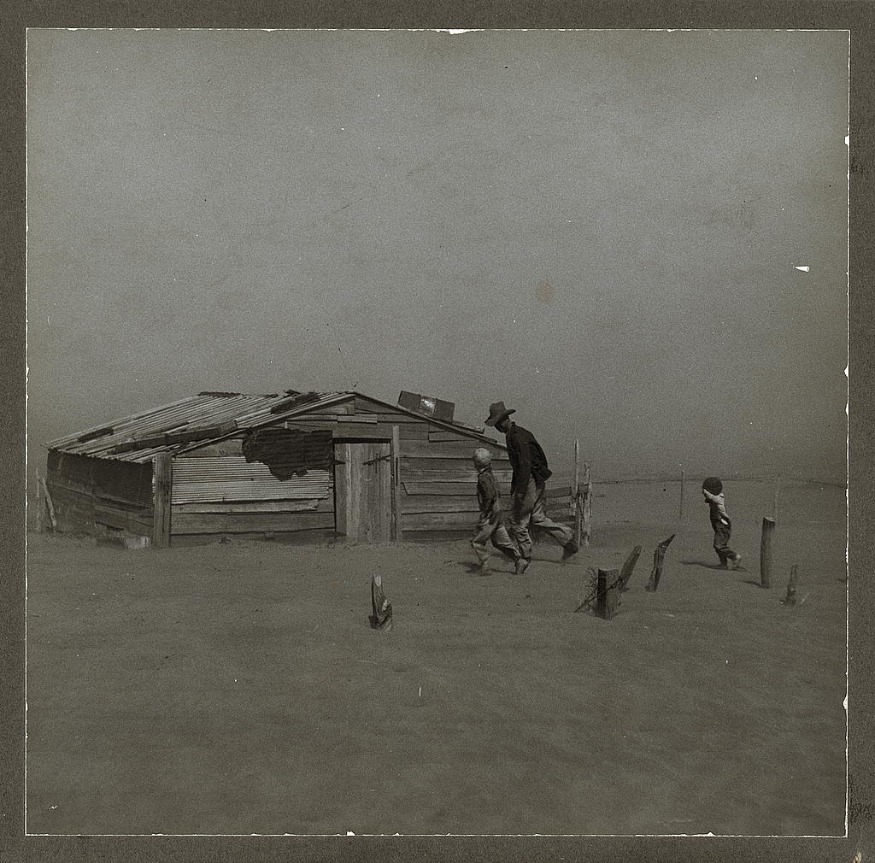

Source: Library of Congress, http://www.loc.gov/pictures/item/fsa1998018983/PP/

Module Three
Photo Analysis
Student Worksheet

Directions: Use the “6Cs of Primary Source Analysis” Worksheet to analyze the photograph below.

Photo 3.
Arthur Rothstein, “The winds of the "dust bowl" have piled up large drifts of soil against this farmer's barn near Liberal, Kansas” (1936).

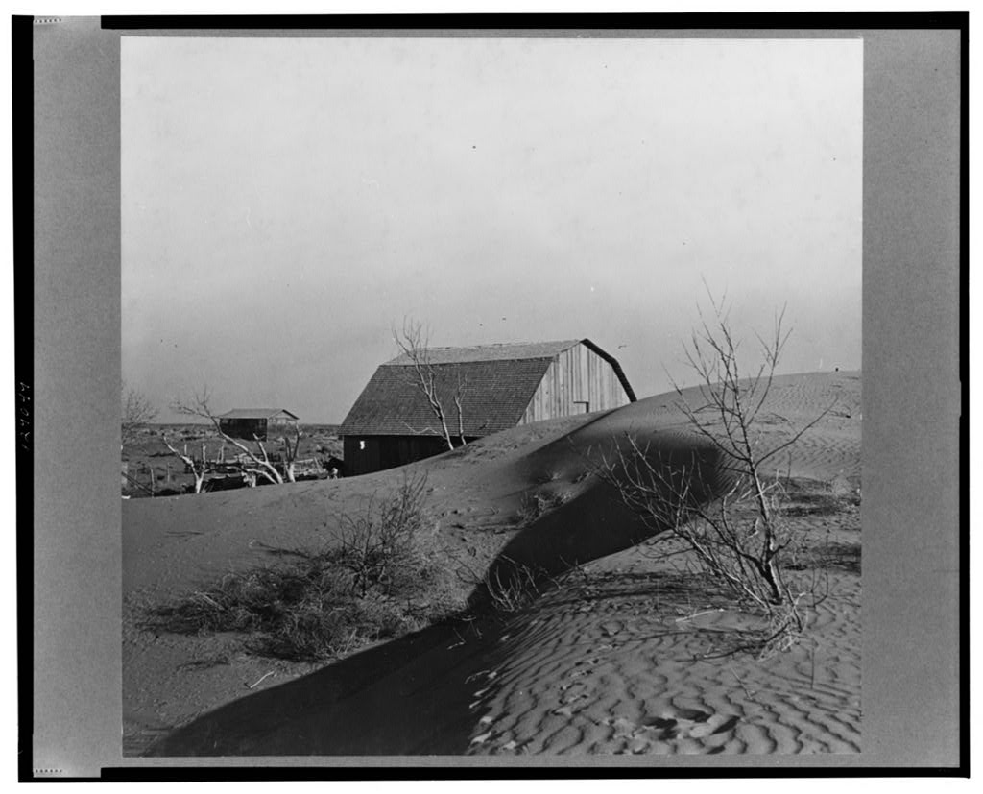

Source: Library of Congress, http://www.loc.gov/pictures/item/fsa1998018503/PP/

Final Activity
Student Worksheet

Why did the Dust Bowl happen? How did this environmental catastrophe affect ordinary Americans?

Dozens of photographers and journalists traveled all across the Southern Plans documenting the disaster that was the Dust Bowl. In addition to the landmark photographs of Arthur Rothstein and Dorothea Lange, and the timeless novel The Grapes of Wrath (1939) by John Steinbeck, countless other photographs, accounts, and newspaper reports detailing the Dust Bowl found their way to every corner of the nation during the 1930s. In fact, it was a newspaper reporter, a reporter with the Associated Press named Bob Geiger, who coined the name “Dust Bowl.”

Your task for this final assignment is to situate yourself in the shoes of a Depression-era newspaper reporter and write a newspaper report detailing the events captured in one of the three photographs included in this lesson.

The point here is to synthesize the various pieces of information you’ve accumulated from this lesson into a coherent narrative about the Dust Bowl.

Start with one of the photos and then use the various other strands of information you have accumulated from the 6C’s worksheet, “Surviving the Dust Bowl,” and WebQuest sources.

Piece all this together into a 400-500-word newspaper report/essay. Since you are emulating a newspaper report, be sure to include the 5W’s and 1H of journalistic writing: who, what, where, when, why, and how.

Finally, before you start writing, keep in mind that your newspaper report should answer the guiding questions for this lesson: Why did the Dust Bowl happen? And how did this environmental catastrophe affect ordinary Americans?

