What kind of courts do we have in California?
Topics: California Judiciary, California Superior Courts, Federal Judiciary
Erik Altenbernd, UC Irvine History Project

History Standards
12.7 Students analyze and compare the powers and procedures of the national, state, tribal, and local governments.
12.7.7 Identify the organization and jurisdiction of federal, state, and local (e.g., California) courts and the interrelationships among them.

CCSS Standards: Reading, Grades 11-12
RH 1. Cite specific textual evidence to support analysis of primary and secondary sources, connecting insights gained from specific details to an understanding of the text as a whole.
RH 2. Determine the central ideas or information of a primary or secondary source; provide an accurate summary that makes clear the relationships among the key details and ideas.
RH4. Determine the meaning of words and phrases as they are used in a text, including analyzing how an author uses and refines the meaning of a key term over the course of a text…
RH7. Integrate and evaluate multiple sources of information presented in diverse formats and media (e.g. visually quantitatively, as well as in words) in order to address a question or solve a problem.
RH9. Integrate information from diverse sources, both primary and secondary, into a coherent understanding of an idea or event, noting discrepancies among sources.

CCSS Standards: Writing, Grades 11-12
WH 1. Write arguments focused on discipline-specific content.
WH2. Write informative/explanatory texts, including the narration of historical events, scientific procedures/experiments, or technical processes.
WH4. Produce clear and coherent writing in which the development and organization, and style are appropriate to the task, purpose, and audience.

Overview of Source Set
The introduction below was written with students in mind. The overall design is modular; each section can be taught separately or in conjunction with the other sections. The topics covered are: the basic structure of the federal and California state judiciaries, similarities and differences between the two federal and California courts, the appellate process, the Orange County Superior Court system, jury duty, and small claims court.

Documents
1. “Types of Cases Heard in Federal and State Courts” (chart)
2. “Structure of Federal and State Courts” (chart)
3. “San Diego concealed weapons case appealed to the US Supreme Court” (2017, excerpt)
4. “California Court System” (flowchart)
5. My Cousin Vinny (1992, video clip)
6. Superior Courts of Orange County (website)
7. “Welcome to the California Courts” (online pdf)
8. “Daniel Wozniak sentenced to death for killing 2 friends to fund his wedding” (2016, excerpt)
9. Runaway Jury (2003, video clip)
10. Judge Judy (video clip)
11. “The Small Claims Process” (video)
12. Small Claims Court Fact Sheet

Introduction
There are two main court systems in the United States: the federal court system and state court systems. For the most part, the federal and state courts operate independently of one another, but the two also overlap in important ways. The Federal Judiciary of the United States (i.e. the federal court system) and Judiciary of California (i.e. court system of California) are organized in similar ways. Like the federal judiciary, the California judiciary is hierarchical—meaning, both systems are organized with a single high court; a system of intermediary, or mid-level, courts; and a larger system of lower-level courts. Each level in the hierarchy is integrated, or connected, with the higher-level courts holding the power to overrule, or overturn, rulings issued by lower-level courts.

The highest-level court in the federal judiciary is the highest-level court in the nation: the Supreme Court of the United States (sometimes abbreviated as SCOTUS or SCotUS). The Supreme Court was established by Article III of the Constitution. Since ratification of the Constitution, Congress has passed a number of laws organizing the federal court system. Today, the federal court system has three main levels. From bottom to top, the three levels are: US District Courts, US Courts of Appeals (i.e. appellate courts), and the Supreme Court. The federal court system is divided into 13 regions called circuits. Within these 13 circuits there are a total of 94 federal district courts and 13 federal appellate courts. California is part of the 9th US Circuit. The 9th Circuit is based in San Francisco, California, and has a total of four separate sub-districts in California. Orange County is part of the 9th Circuit’s Central District of California, which is based in Los Angeles. The 9th Circuit’s Central District of California is the largest federal court district in the entire United States.

Source: Southeast ADA Center, http://adacourse.org/courtconcepts/structure.html
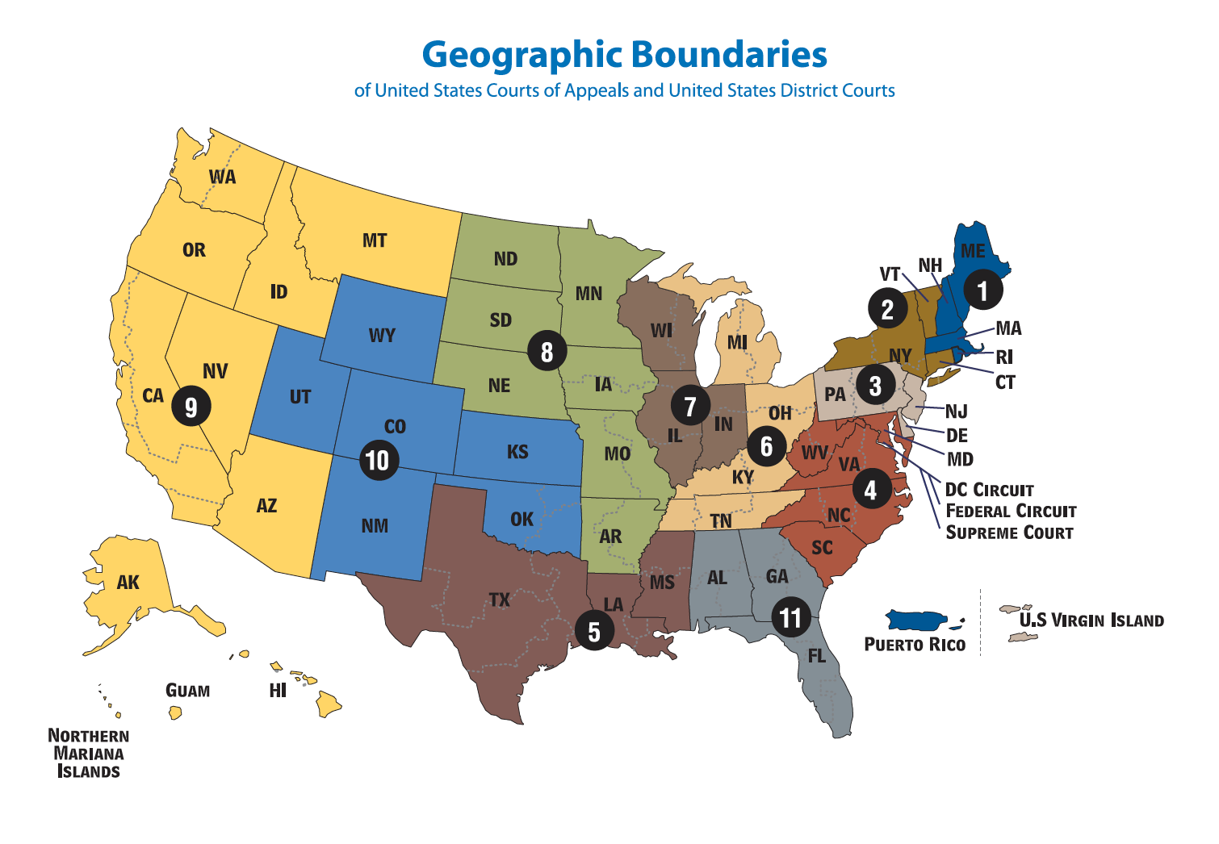
Map of the Circuits (i.e. regions) of the Federal Court System

The Judiciary of California is the largest court system in the United States. The state courts are governed by the constitution and laws of California (the state courts in other states are likewise governed by the constitution and laws of those states). From bottom to top, the three levels of courts in California are: superior (or trial) courts; the California Courts of Appeal; and the Supreme Court of California. The California Supreme Court is based in San Francisco. Six separate districts across the state make up the California Courts of Appeal. Orange County is part of Division Three of the Fourth Appellate District; the state appellate court house for Orange County is located in Santa Ana. In all, California has 58 trial court districts, one for each county. Orange County has several superior courts; the major superior courts are located in southern, central, and northern Orange County.

Relatively few Californians interact the federal court system, or California Supreme Court and Courts of Appeal. Most people’s experience of court—or understanding of court from movies or TV shows—is of superior of trial courts. The reason for this is simple: superior courts handle most of the issues that affect everyday people. When private individuals sue one another, the case is usually heard in superior court. Similarly, when private citizens serve on a jury, it is usually in a superior court.

Orange County Central Justice Center (i.e. superior court) in Santa Ana
Part 1. Federal vs. State Courts

Source 1
Types of Cases Heard in Federal and State Courts

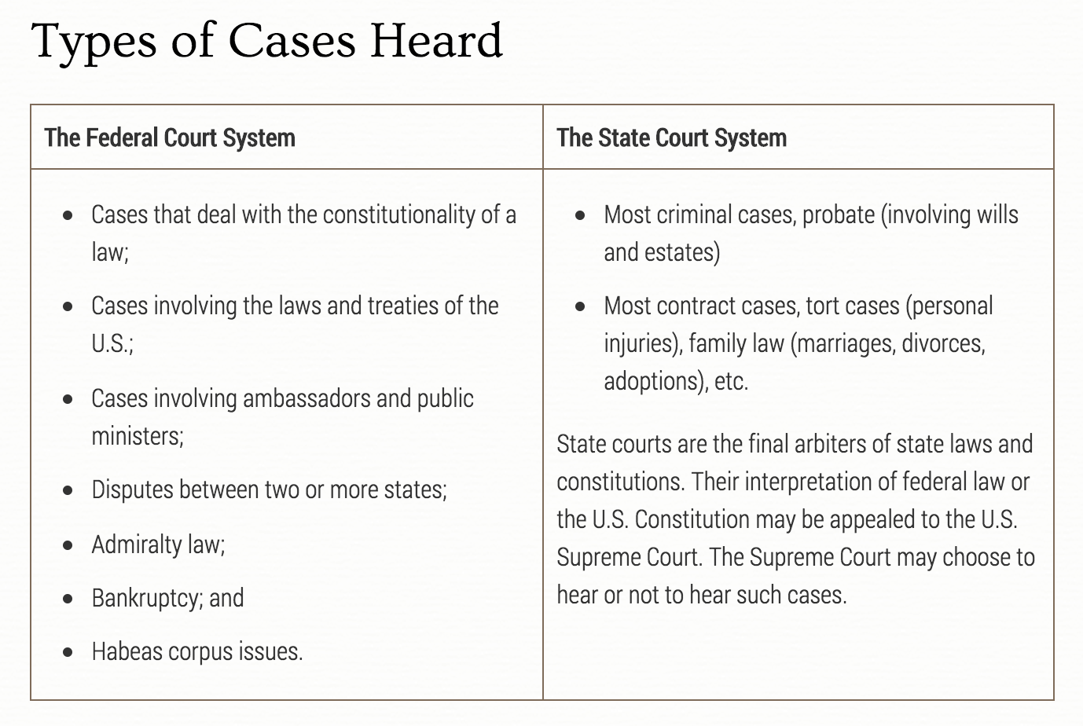
Source: http://www.uscourts.gov/about-federal-courts/court-role-and-structure/comparing-federal-state-courts

Questions

1. What kind of cases, or legal issues, do federal courts handle?

2. What kind of cases, or legal issues do state courts handle?

3. In what crucial way are the two systems integrated or linked?

Source 2
Structure of Federal and State Courts

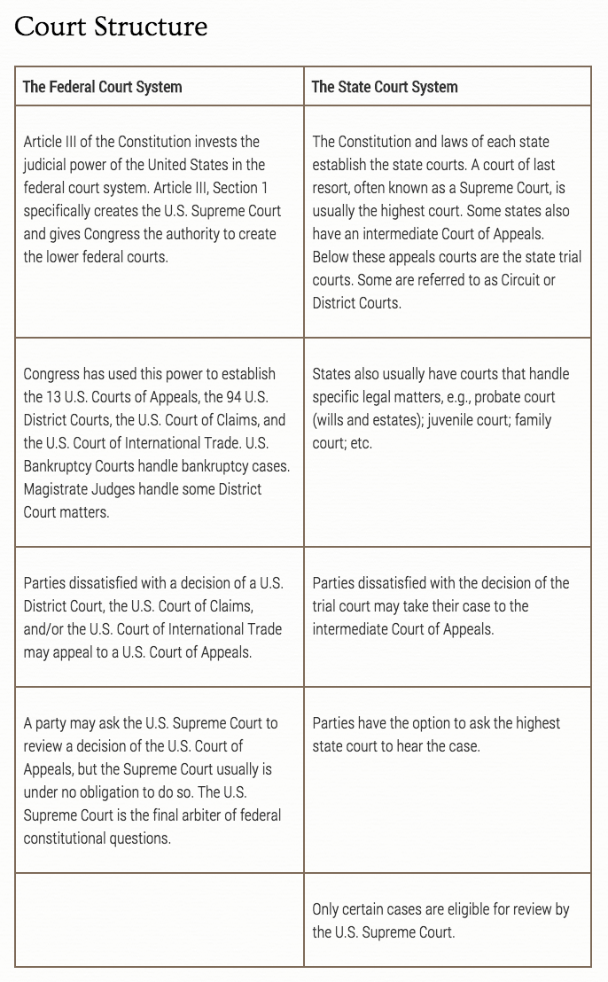
Source: http://www.uscourts.gov/about-federal-courts/court-role-and-structure/comparing-federal-state-courts

4. How does the appellate process work—why do cases move up the ladder from federal district court, to federal appeals court, to the US Supreme Court; or from state trial/superior court, to state appeals court, to a state supreme court?

Part 2. The Appellate Process

Source 3
“San Diego concealed weapons case appealed to the US Supreme Court”
San Diego Union-Tribune, January 12, 2017

The U.S. Supreme Court is being asked to decide whether law-abiding citizens need to provide law enforcement with a specific reason to be able to legally carry a concealed weapon for self-defense.  Part-time San Diegan Edward Peruta and other gun owners who were denied concealed-carry permits by the San Diego County sheriff filed a petition Thursday asking the high court to consider hearing their case, which they lost on appeal in June at the 9th U.S. Circuit Court of Appeals.  The case has been closely watched by gun rights and gun control advocates, law enforcement and legal experts nationwide, and many have predicted that — while the Supreme Court has been unwilling to take on other concealed weapons cases — this one could be the vehicle to decide how far the Second Amendment extends beyond the home.  Courts around the country have been split on the matter.…  The case stems from a 2009 lawsuit that challenged the county’s policy of requiring “good cause” to obtain a concealed-carry weapon permit, or CCW, as unconstitutional.…  The Sheriff’s Department, which handles all permits in the county, requires applicants to state a specific reason they want to carry a concealed firearm, such as having a job that involves transporting large amounts of cash or needing protection from a stalker. Applicants must also pass a background check, be residents, have good moral character and complete firearms training.  Similar guidelines are followed in many of California’s big metropolitan areas, including Los Angeles, Orange County and the Bay Area.  The petition for writ of certiorari argues that self-defense is a good enough reason to want to carry a gun in public, whether it is concealed or openly displayed. State law generally bans the open carry of loaded and unloaded firearms.…  A San Diego federal [district court] judge ruled against Peruta and his fellow plaintiffs in 2010, but a three-judge panel of the 9th Circuit reversed the lower court’s ruling in February 2014.  The 2-1 decision held that law-abiding citizens have the right to carry concealed weapons for self-defense.  However, an anonymous 9th Circuit judge polled fellow judges in the court asking if there was interest in rehearing the case “en banc,” or in front of a larger panel. There was interest.  But San Diego County Sheriff Bill Gore had decided not to appeal the ruling. The California Attorney General’s Office intervened in his place to fight the ruling.  Eleven judges heard arguments on June 16, 2015, in San Francisco. A similar case out of Yolo County was heard at the same time.  The en banc panel took a year to reach its split 7-4 decision, reversing the three-judge panel.  “The right of a member of the general public to carry a concealed firearm in public is not, and never has been, protected by the Second Amendment,” the court said.  Peruta asked for a rehearing in front of the en banc panel, but it was denied.…  As the case continues through the appeals process, the good cause requirement has remained unchanged at the Sheriff’s Department.  In 2016, the department issued 224 new permits, with a total of 1,278 active permits in the county, officials said. | writ—written command issued by a court instructing specific action or lack of action  certiorari—Latin for “to be more fully informed”  writ of certiorari—writ issued by appellate court when it decides to review decision by lower court; US Supreme Court hears most cases by issue this type of writ  en banc—French for “in bench”; term used to describe appellate court case where all judges on appellate court hear case instead of three-judge panel
Source: San Diego Union-Tribune, http://www.sandiegouniontribune.com/news/courts/sd-me-concealed-guns-20170112-story.html

Questions

5. What is the “good cause” policy used by San Diego County Sheriff’s Department?

6. Which levels of the federal judiciary does this report reference?

7. Why is this a federal rather than state court case? Explain your answer in 2-3 sentences using the information provided in Source 2.

8. Which parties—the plaintiffs, the County of San Diego, or state of California—have filed appeals of this case? Map out the process of appeal in this case by filling out the text boxes below.

US District Court
For or against “good cause” policy | District Court Appellant

9th US Court of Appeals
For or against “good cause” policy | Appellant Court Appellant

9th US Court of Appeals en banc
For or against “good cause” policy | Appellant Court (en banc) Appellant

US Supreme Court
For or against “good cause” policy | Court of last resort (no further appeals)

Part 3. California Judiciary

The California Judiciary (or court system) is organized very similarly the federal judiciary. It has three levels of courts and an appellate system that allows parties to appeal decisions made by lower courts. Like the federal system, the state of California also has a court of last resort: the California Supreme Court.

Source 4
Flowchart, or Diagram, or California Court System

Directions:
1. Click on the link below.
2. Read the “About California Courts” webpage.
3. Answer the questions below.

http://www.courts.ca.gov/2113.htm

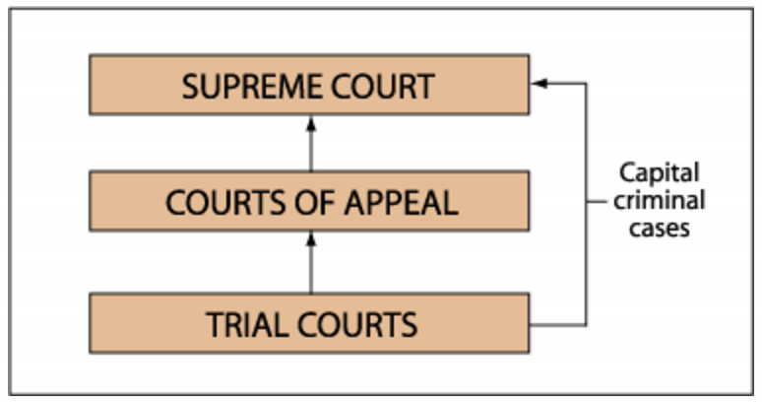
Source: California Courts, http://www.courts.ca.gov/2113.htm

Questions

9. What are the three levels of the Judiciary of California?

10. How much money, and what percentage of the State General Fund (the state government budget), is devoted to the judicial branch of California?

11. How many court cases were heard in California during the 2014-2015 fiscal year?

12. How many justices serve on the California Supreme Court? How many justices serve in the state Courts of Appeal? How many justices serve in the state superior courts?

13. What does the line “Capital criminal cases” mean? Read the webpage and use a direct quotation to explain why the flowchart has a line leading directly from the trial courts to the Supreme Court.
Part 4. Superior Courts of Orange County

The most common courts in California, and other states of the union, are the trial, or superior, courts. How many movies or TV shows have you seen that depict a courtroom? More than likely, that movie or TV show represented a state trial court. The reason is because superior courts handle a wide variety of issues that affect everyday people.

Superior courts handle two kinds of cases: criminal cases and civil cases. Criminal cases are those where an individual or group of individuals (the defendant or defendants) are being prosecuted by the state for a crime that involves fines or jail time. Civil cases involve disputes between private citizens, organizations, or businesses where one party or parties (the plaintiff or plaintiffs) file a law suit claiming to have suffered damages due to the actions of the other party or parties (the defendant or defendants).

Source 5
My Cousin Vinny (1992, 2:00)

https://www.youtube.com/watch?v=YLValMc9XjU

Question

14. Is this a depiction of civil or criminal trial court?

Source 6
Superior Courts of Orange County

Directions:
1. Click on the link and and answer the questions below.

http://www.occourts.org/locations/

Questions

15. List all the superior court locations in Orange County?

16. List the names and locations of each superior court, or justice center, in Orange County.

17. Which superior court, or justice center, is your local court? Which superior court is closest to your home?

Source 7
Business of California Superior Courts

Directions:
1. Click on the link below.
2. Read the PDF file on California superior courts.
3. Answer the questions below.

http://www.courts.ca.gov/documents/supervis.pdf

Questions

18. What does the term jurisdiction mean?

19. Over which two classes, or kinds, of cases do superior courts have trial jurisdiction?

20. What “special departments” do the superior courts have to adjudicate disputes between private citizens?

21. How many civil cases did California superior courts hear on an average year?

22. What is a civil case? Write a 4-5 sentence paragraph that describes a civil case and that includes two direct quotations from the PDF.

23. How many criminal cases did California superior courts hear on an average year?

24. What is a criminal case? Write a 4-5 sentence paragraph that describes a criminal case and that includes two direct quotations from the PDF.

25. Are there ways to settle legal disputes out of court? Explain your answer in 4-5 sentences.

Source 8
Orange County Criminal Superior Court at Work
“Daniel Wozniak sentenced to death for killing 2 friends to fund his wedding”
Orange County Register, September 24, 2016

SANTA ANA – For the families of Samuel Herr and Juri “Julie” Kibuishi, it was the end of a six-year wait for justice.

Daniel Patrick Wozniak, a 31-year-old former community theater actor from Costa Mesa, was sentenced to death on Friday for killing the two in an attempt to fund his 2010 wedding.…

“It’s a relief,” said Julie’s mother, June Kibuishi. “We’ve been waiting more than six years for this day to come.”

A jury on Jan. 11 deliberated for one hour, 14 minutes before recommending the death penalty, one of the shortest death penalty deliberations in Orange County history.

Jury forewoman Jenny Wong was one of several jurors who came for the sentencing. “I’m just glad we were able to in some small way provide closure for the family,” she said.

Sitting quietly next to his attorney, Wozniak stared straight ahead as the judge read the sentence. He will join more than 740 other inmates on San Quentin’s death row.

“We’re happy for the family that justice was finally done,” said Senior Deputy District Attorney Matt Murphy, who prosecuted the case.

THE THEATER ACTOR

Herr and Kibuishi met in anthropology class at Orange Coast College and became good friends.

Kibuishi was a bubbly dancer from Irvine who loved music and fashion. Herr was an Afghanistan war veteran working to earn his college degree so he could re-enlist in the U.S. Army and become an officer.

Herr, an only child, was close to parents Steve and Raquel Herr. When Steve Herr couldn’t reach his son all day on May 22, 2010, he drove to the young man’s Costa Mesa apartment and let himself in with a key.

In the bedroom, he found Kibuishi’s partially clad body and called 911.

Police initially believed Sam Herr was a fugitive. But they grew suspicious when they saw $400 ATM withdrawals from his bank account and charges to a Long Beach pizza parlor.

Days later, they caught a 16-year-old boy using Herr’s ATM card. The boy told police that Wozniak had put him up to it.

Wozniak, an out-of-work community theater actor, was Herr’s neighbor and friend. Police arrested him at his bachelor’s party, at a sushi restaurant in Huntington Beach, two days before his wedding.

Under intense questioning from Costa Mesa detectives, he unraveled a grisly story.

Broke with no money to pay for his wedding and honeymoon, he hatched a plan to kill Herr and drain his $60,000 in savings from combat pay.…

Rachel Buffett, Wozniak’s ex-fiancee, was arrested and charged with being an accessory after the fact for allegedly lying to police. She has pleaded not guilty.
Source: OC Register, http://www.ocregister.com/articles/herr-729941-wozniak-kibuishi.html

Questions

26. Daniel Wozniak was tried in Santa Ana. Which Orange County Superior Court location was he tried at? Refer to the information you collected in response to Source 6.

27. If Wozniak chooses to appeal his conviction and punishment for first degree murder, which court will hear his appeal? Refer back to Source 1.

28. What body of the Superior Court decided whether or not Wozniak deserved capital punishment?

Part 5. Superior Courts – Jury Duty

There are many ways to experience superior court besides being a litigant in a court case. One of the most common ways ordinary people experience trial court is through jury service. When everyday citizens are summoned for jury duty, they are summoned to serve on a criminal or civil case.

Source 9
Runaway Jury (2003, 2:00)

https://www.youtube.com/watch?v=3ppUk18i4UQ

Question
29. What is John Cusack’s character trying to do in this clip?
30. Why does the judge in the film say the jury system was invented?
Sources 10
Jury Duty in California

Directions:
1. Click on the link below.
2. Read the PDF file on jury duty in California.
3. Answer the questions below.

http://www.courts.ca.gov/documents/jury-court-and-community-brochure.pdf

Questions

31. What are the eight basic requirements for serving on jury in California?

32. How long do private citizens serve on a jury? What are the two types of jury service in California?

33. Are private citizens paid for jury service?

34. Why does Chief Justice of the California Supreme Court Tani Cantil-Sakauye say that jury duty is important? Explain your answer in 2-4 sentences with at least one direct quotation.

Sources 9
Jury Duty in Orange County Superior Court

Directions:
1. Click on the link below.
2. Look over the webpage on jury duty in Orange County.
3. Scroll down and click on the FAQs (Frequently Asked Questions) link on the bottom-right of the page.
4. Answer the questions below.

http://www.occourts.org/directory/jury-services/

Questions

35. What four locations do residents of Orange County report to for jury service? (The answer to this question is on the “Jurors/Jury Service” webpage.)

36. How do officials in Orange County select names for jury service?

37. What will happen if you fail to respond to a jury summons?

38. Are students exempt from jury service? Explain your answer in 1-2 sentences.

39. Can potential jurors delay or postpone jury service? Explain your answer in 1-2 sentences.

Part 6. Small Claims Court

One of the most common civil cases heard in superior court are those heard in small claims court. Small claims courts are courts where ordinary people—usually without an attorney—go before a judge to resolve a dispute. The following are common issues heard in small claims court: disputes between landlords and tenants over security deposits; car accidents or damage to other kinds of personal property; minor personal injuries like dog bits; or disputes over work done on someone’s home, home appliances, car, or other form of personal property.

Small claims courts only deal with cases where one party is demanding money from another party. The reason the court is called a small claims court is because the amounts of money, or damages, involved are relatively small. All small claims courts have a cap, or maximum, amount of money that can be awarded by the court.

Source 10
Judge Judy (video, 7:52)

http://www.dailymotion.com/video/x2eprxy_most-ridiculous-judge-judy-episode-ever_fun

Questions

40. What is the nature of the legal dispute in this case? Write 2-3 sentences explaining the case and the final judgement.

41. How much money did the plaintiff receive as a result of Judge Judy’s ruling?

42. What kind of court proceedings take place in Judge Judy’s courtroom?

Source 11
“The Small Claims Process”
California Courts Self Help Video (3:24)

https://www.youtube.com/watch?v=dZwJmV65k9g&list=PL9134B1FDB8A8198E

Questions

43. What is the first step in small claims court if you are the plaintiff?

44. What must the defendant do if they want to issue a counterclaim against the plaintiff?

45. What is service—what does it mean to “serve” the defendant with court papers?

46. How long is a hearing before a small claims court?

Source 12
Small Claims Court Fact Sheet

How much money can I collect in a single small claims court case? | • Natural persons (individuals): No more than $10,000  • Corporations, partnerships, and other legal entities: No more than $5,000
Is there a limit to the amount of money or cases I can file in small claims court? | No claimant—natural person or legal entity—may file more than two small claims court actions for more than $2,500 anywhere in the State during any calendar year.  For example, if you file an action for $4,000 in February 2017, and another action for $4,000 in March 2017, you may not file any more actions for more than $2,500 until January 1, 2018. However, you may file as many claims as you wish for $2,500 or less.
Can a small claims court judge order a party to do something other than pay money? | Small claims courts may be able to order a defendant to do something, as long as a claim for money is also part of the lawsuit. If you are suing to get back the lawn mower you loaned to a neighbor, for instance, the court can order the return of the mower, or payment for the mower if it is not returned.
What kind of issues are handled by small claims courts? | • Former landlord refuses to return the security deposit you paid.  • Someone damages your car and refuses to pay for its repair.  • Your new TV will not work, and the store refuses to fix it or replace it.  • A car dealer sold you a defective or damaged car, and you desire to cancel the purchase and get back the amount of your down payment from the seller.  • You lent money to a friend, and he or she refuses to repay it.
Can a small claims court ruling be appealed? | • Defendant can appeal ruling favoring plaintiff’s claim  • Plaintiff cannot appeal ruling against his/her claim  • Plaintiff can appeal ruling favoring defendant’s counter claim
Source: Adapted from CA Department of Consumer Affairs, http://www.dca.ca.gov/publications/small_claims/small_claims.pdf
Small Claims Court Questions
Directions: Write 2-3 sentence responses to each question below using specific information from the Small Claims Court Fact Sheet and “The Small Claims Process” video.
47. My former landlord refuses to return my $1,000 security deposit and hasn’t answered the emails and letters I sent him asking for the money. Can I sue him in small claims court?
48. A stranger hit my car at a stop light while I was on my way to work. Insurance paid for the damages to my car, but I still have $15,000 in hospital bills from the accident. Can I sue the other driver for my medical expenses?
49. My ex-roommate is suing me in small claims court for $450 that she says I owe her for rent. The reason I didn’t pay is that she owes me $350 for the internet and electric bills. Can I sue her in small claims court as well?
50. My neighbor leaves her dog outside and the dog barks at all hours of the night. I’ve asked my neighbor to put the dog inside her house but she refuses to do so. Can I sue my neighbor in small claims court to force her to put the dog indoors at night?
51. I filed a small claims court claim as a plaintiff but the judge ruled in favor of the defendant. Can I appeal the judge’s ruling?
52. I have six brothers and sisters. To celebrate our parents’ 50th wedding anniversary, my siblings and I agreed to send our parents to Hawai’i. I bought two first-class plane tickets for $12,000, but my siblings refuse to pay me back. Can I sue them for $2000 each in small claims court?
Source: Some questions adapted from UCLA Student Legal Services, https://www.studentlegal.ucla.edu/assets/pdf/articles/SMALL%20CLAIMS%20ARTICLE%201-15.pdf

