How did Americans respond to abolitionism and defend slavery before the Civil War?
Topics: Slavery, Abolitionism, Defense of Slavery
Erik Altenbernd, UC Irvine History Project

History Standards
8.9 Students analyze the early and steady attempts to abolish slavery and to realize the ideals of the Declaration of Independence.

CCSS Standards: Reading, Grades 6-8
1. Cite specific textual evidence to support analysis of primary and secondary sources.
2. Determine the central ideas or information of a primary or secondary source; provide an accurate summary of the source distinct from prior knowledge or opinions.
5. Determine how a text presents information (e.g. sequentially, comparatively, causally).
6. Identify aspects of a text that reveal an author’s point of view or purpose (e.g., loaded language, inclusion or avoidance of particular facts).
7. Integrate visual information (e.g. in charts, graphs, photographs, videos, or maps) with other information in print or digital texts.

CCSS Standards: Writing, Grades 6-8
1. Write arguments focused on discipline-specific content.
2. Write informative/explanatory texts, including the narration of historical events, scientific procedures/experiments, or technical processes.
9. Draw evidence from informational texts to support analysis reflection, and research.

Overview of Lesson
Students will learn about the challenges that faced abolitionists by examining some of the arguments made in defense of slavery before the Civil War. This will require students to understand how Southerners used ideas of race to defend slavery. For more information on this, see Teacher’s Introduction and Additional Sources on Race and Slavery below.

Guiding Questions
1. How did Americans respond to abolitionism and defend slavery before the Civil War?
2. How did people work to end slavery and what opposition did they face?

Documents
- Thomas Jefferson to Joel Nancy, January 17, 1819 (letter)
- Frederick Douglass, My Bondage and My Freedom (1855)
- John C. Calhoun, speech on abolitionism before US Senate (1837, excerpt)
- Samuel A. Cartwright, Report on the Diseases and Physical Peculiarities of the Negro Race (1851, excerpt)
- “Negro Village on a Southern Plantation,” image from Mary H. Eastman’s Aunt Phillis’s Cabin; or, Southern Life As It Is (1852)
- “Gordon,” or “The Scourged Back” (photograph, 1863)

Additional Resources on Race and Slavery

Ethnic Notions (1986), California Newsreel
http://www.dailymotion.com/video/x1afav8_ethnic-notions_news
https://vimeo.com/172765600

Race: The Power of an Illusion (2003), PBS/California Newsreel
http://www.pbs.org/race/000_About/002_04-about-01.htm
Episode 1 (Race and Science in US History)
https://www.youtube.com/watch?v=B7_YHur3G9g
Episode 2 (Race and Slavery in Nineteenth-Century US)
https://www.youtube.com/watch?v=NGLsn8O_Lvk

Teacher Introduction: The Problem of Teaching Race and Slavery

Proslavery sources are useful historical records that illustrate two important ideas. First, they help students understand why the Civil War was always about slavery rather than secondary matters like states’ rights or unionism. Second, they also shed light on the challenges faced by abolitionists and why it took so long—and so much blood—to abolish slavery.

However, teaching proslavery primary sources can be difficult. For one, proslavery sources are virulently racist and often utilize offensive racial stereotypes. They also advance ideas of race theory—the idea that are deep-seated biological differences between blacks and whites, that blacks are inferior to whites, and that blacks should never be freed from slavery because they would never be equal to whites. Together, they make up one of the most vile sets of sources in American history.

The main thing to stress to students studying these documents is this: If understanding the Civil War means understanding that the war was always about slavery, then understanding slavery means understanding the close relationship between slavery and race. At the core of every argument made in favor of slavery is a racial argument—the argument that black Americans were racially inferior to white Americans. The truth of this point is starkly illustrated by Reconstruction, when ideas of race remained paramount even after abolition.

Because of their offensive content, it is vitally important to contextualize these sources for your students. This means helping students understand that race is a social construct—that race has no grounding in nature or biology but is an idea created to explain and justify social hierarchies. For more on this idea, and ideas regarding how to teach it, watch the documentaries referenced in the Additional Sources on Race and Slavery section above.

The proslavery sources included in this lesson provide a wide-angle look at the defense of slavery and contain arguments that appeal to one or more of the following topics:
- History—the idea that slavery has always existed in human and/or American society.
- Racial inferiority—the idea that black Americans are naturally inferior to white Americans.
- Discredited medical science—grossly biased science and pseudoscience.
- Religion—Biblical scripture and other religious texts.
- Law—slavery was sanctioned by the Constitution and state law.
- Art and fiction—in response to abolitionists, proslavery writers used illustrations and novels to present images of happy rather than unhappy slaves.
Student Introduction
Looking back on US history from the perspective of today, it is easy to understand why some nineteenth-century Americans worked hard to free slaves and end slavery. Today, we all agree that slavery was an evil institution that weakened the ideals of freedom and social equality expressed by Thomas Jefferson in the Declaration of Independence. Everyone is an abolitionist at heart today. However, it is important to remember that most nineteenth-century Americans were not abolitionists.

In this lesson, you will look at some of the arguments made by proslavery Americans as well as abolitionists to respond to the question: How did Americans respond to abolitionism and defend slavery before the Civil War?

Document 1. Thomas Jefferson to Joel Nancy, January 17, 1819 (letter)

Thomas Jefferson is most famous for writing the Declaration of Independence, but it is important to remember that he was also a slave owner. Jefferson owned over 600 slaves but freed only ten slaves during his lifetime. In this letter he lays out two main ideas about slavery: first, that the most valuable slave on a plantation is a woman who can bear children (and thus create more slaves); and, second, that making sure slave women and children are taken care of is good not only because it is the right thing to do but because it makes the slave master more money.

They [slaves] are well fed, and well clothed, & I have had no reason to believe that any overseer, since Griffin’s time, has over worked them. Accordingly the deaths among the grown ones seem ascribable to natural causes. But the loss of 5. little ones [slave children] in a year induces me to fear that the overseers do not permit the women to devote as much time as is necessary to the care of their children: that they view their labor as the 1st object and the raising their child but as secondary. I consider the labor of a breeding woman as no object, and that a child raised every 2. years is [of] more profit than the crop of the best laboring man. | overseer—white man who managed slaves on plantation  ascribable—due to  devote—to pay attention to
Source: Founders Online, https://founders.archives.gov/documents/Jefferson/98-01-02-0039

Questions

1. Who does Jefferson blame for the loss of slave children?

2. What does Jefferson value most in female slaves?

3. What is Jefferson’s argument about slavery and what evidence does he use to support that claim? Cite 2 examples from the text to support your answer.

Document 2. Frederick Douglass, My Bondage and My Freedom (1855)

Born a slave in 1818 in Maryland, Frederick Douglass escaped to freedom in 1838. In addition to publishing the abolitionist newspaper The North Star, Douglass was a renowned orator, or public speaker, and wrote several autobiographies, including My Bondage and My Freedom (1855).

The men and the women slaves on Col. Lloyd's farm, received, as their monthly allowance of food, eight pounds of pickled pork, or their equivalent in fish. The pork was often tainted, and the fish was of the poorest quality…With this, one pint of salt was given; and this was the entire monthly allowance of a full grown slave, working constantly in the open field, from morning until night, every day in the month except Sunday, and living on a fraction more than a quarter of a pound of meat per day, and less than a peck of corn-meal per week. There is no kind of work that a man can do which requires a better supply of food to prevent physical exhaustion, than the field-work of a slave.  …More slaves are whipped for oversleeping than for any other fault. … Young mothers who worked in the field, were allowed an hour, about ten o'clock in the morning, to go home to nurse their children. Sometimes they were compelled to take their children with them, and to leave them in the corner of the fences, to prevent loss of time in nursing them. | tainted—contaminated or spoiled  nurse—feed
Frederick Douglass, My Bondage and My Freedom (New York and Auburn: Miller, Orton, and Mulligan, 1855), 100-103, http://docsouth.unc.edu/neh/douglass55/douglass55.html.

Questions

1. How much food does Douglass say Colonel Lloyd’s gave his slaves for the month? How does this compare and contrast to the treatment that Jefferson claims slaves receive?

2. How are mothers with children treated in this account?

3. What is Douglass’ argument about slaver and what evidence does he use to support that claim? Cite 2 examples from the text to support your answer.

Document 3. John C. Calhoun, “Speech on the Reception of Abolitionist Petitions, Delivered in the [US] Senate” (1837)

John C. Calhoun was a leading Southern politician before the Civil War who supported slavery.

…Never before has the black race of Central Africa…attained a condition so civilized and so improved, not only physically, but morally and intellectually. It [Africans/African Americans] came among us in a low, degraded, and savage condition, and in the course of a few generations it has grown up under the fostering care of our institutions… | attained—succeed or achieve  civilized—advanced  degraded—inferior; poor in quality  savage—primitive; uncivilized  fostering—helping
Source: Excerpted from Paul Finkelman, Defending Slavery: Proslavery Thought in the Old South (Boston: Bedford/St. Martin’s, 2003), 55-59.

Questions

1. In what condition does Calhoun say Africans came to America?

2. How, according to Calhoun, did African Americans benefit from slavery?

Document 4. Samuel A. Cartwright, Report on the Diseases and Physical Peculiarities of the Negro Race (1851)
Samuel A. Cartwright was a successful doctor who specialized in treating slaves before the Civil War. In this essay, Cartwright prescribes a simple cure for keeping slaves from running away. Using a racial stereotype that describes African Americans as simple and child-like, Cartwright defends slavery by making the claim that African Americas are happy to remain slaves so long as there are treated with kindness.

If treated kindly, well fed and clothed, with fuel enough to keep a small fire burning all night, separated into families, each family having its own house…and not overworked or exposed too much to the weather, they are very easily governed—more so than any other people in the world.…They have only to be kept in that state [of happiness], and treated like children, with care, kindness, attention and humanity, to prevent and cure them from running away. | governed—managed, controlled  state—condition  humanity—compassion
Source: Excerpted from Paul Finkelman, Defending Slavery: Proslavery Thought in the Old South (Boston: Bedford/St. Martin’s, 2003), 158-159, 165-167.

Question

1. What does Cartwright ultimately prescribe as a “cure” for running away? Cite 2 pieces of evidence from the text.

Document 5. “Negro Village on a Southern Plantation” (1852)
This image is from a proslavery novel titled Aunt Phillis’s Cabin; or, Southern Life As It Is (1852).

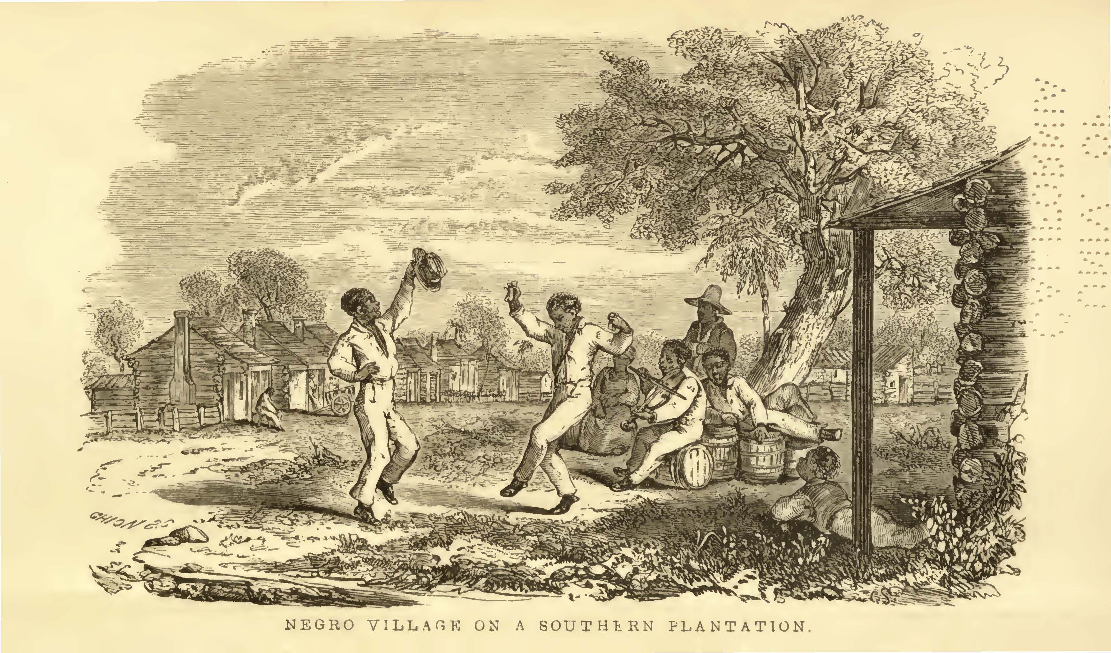

Questions

1. Describe the content of this image. List four things you see.

2. What is the main message of this image?

3. What is this image’s message or argument about slavery and what evidence is used to support that claim? Cite 2 examples from the text to support your answer.

Document 6. “Gordon,” or “The Scourged Back” (1863)
This is a photograph of a fugitive slave known only as Gordon. Gordon ran away from a plantation in Louisiana during the Civil War. Before Gordon enlisted in the Union Army, he was examined by army doctors, who documented his scars with photographs. Abolitionists later used this image to argue about the evils of slavery and encourage Northerners to support emancipation.

Source: Smithsonian National Portrait Gallery, http://npgportraits.si.edu/eMuseumNPG/code/emuseum.asp?rawsearch=ObjectID/,/is/,/93273/,/false/,/false&newstyle=single

Questions

1. How does this photo contradict the image of slaves in Source 5? Explain your answer by citing 2 pieces of evidence.

2. In what ways does this image from Louisiana support Douglass’s claims about slavery in Maryland? Explain your answer by citing 2 pieces of evidence.

3. Looking at the evidence presented in this photo, what conclusion can you draw about the reality of slavery? Explain your answer.

Final Activity

Directions: For the final activity, fill out the graphic organizer below.

Step 1.

1. Fill in the boxes listed “Claims in Defense of Slavery” and “Claims against slavery” by identifying three separate claims made for and against slavery in Sources 1-6.

2. After writing in the claim, write in at least two pieces of evidence offered in support of that particular claim.

3. After writing in the evidence, assess the evidence and label it either “objective” or “biased.”

Which evidence is the most objective? Which evidence is the most biased?

Evidence based on personal experience and factual information should be considered more objective—and thus given higher priority or greater weight—than evidence based on speculation or opinion.

Step 2. After you have filled in all six claim boxes, assess the weight of the evidence presented by writing a claim that incorporates all that you have learned from the lesson to answer the question: How did Americans respond to abolitionism and defend slavery before the Civil War?

Student Worksheet

Claims in Defense of Slavery | Claims against Slavery
Claim 1:  Evidence  Assessment: | Claim 1:  Evidence:  Assessment:
Claim 2:  Evidence:  Assessment: | Claim 2:  Evidence:  Assessment:
Claim 3:  Evidence:  Assessment: | Claim 3:  Evidence  Assessment:

Develop a final claim to the lesson question: How did Americans respond to abolitionism and defend slavery before the Civil War?

Final Claim:

