How revolutionary was the Arab Spring?

Topics: Revolution, civic engagement, public sphere
Nicole Gilbertson, UC Irvine History Project

History-Social Science Content Standards
  - Students analyze instances of nation-building in the contemporary world in at least two of the following regions or countries: the Middle East, Africa, Mexico and other parts of Latin America, and China.
- Discuss the important trends in the regions today and whether they appear to serve the cause of individual freedom and democracy.

CCSS Standards: Reading, Grades 9-10
RH 2. Determine the central ideas or information of a primary or secondary source; provide an accurate summary of how key events or ideas develop over the course of the text.
RH7. Integrate and evaluate multiple sources of information presented in diverse formats and media (e.g. visually quantitatively, as well as in words) in order to address a question or solve a problem.
RH9. Compare and contrast treatments of the same topic in several primary and secondary sources.

CCSS Standards: Writing, Grades 9-10
WH 1. Write arguments focused on discipline-specific content.
WH 7. Conduct short as well as more sustained research projects to answer a question (including a self-generated question) or solve a problem; narrow or broaden the inquiry when appropriate; synthesize multiple sources on the subject, demonstrating understanding of the subject under investigation.
WH 8. Gather relevant information from multiple authoritative print and digital sources (primary and secondary), using advanced searches effectively; assess the usefulness of each source in answering the research question; integrate information into the text selectively to maintain the flow of ideas, avoiding plagiarism and following a standard format for citation.

Guiding Question

How revolutionary was the Arab Spring?

Overview of the Lesson
This lesson provides students with a scaffold to develop an inquiry-based research project on the effects of the Arab Spring. The lesson begins with an introductory text and media clips to provide students with a brief background on Arab Spring and the context of the Middle East. Students can then select one of the research questions provided:
- How does the Arab Spring compare to the French, Haitian, Latin American, Mexican, or Russian Revolutions?
- What were the effects of the Arab Spring in Egypt, Iraq, Syria, or Yemen?
- What were the effects of the Arab Spring on women in Saudi Arabia?
- Why is the refugee crisis resulting from political effects of Arab Spring significant?
- Was the Arab Spring a success or failure?

Once students select a topic, they will receive a handout that guides them through the research process. Research begins with an introductory article or photo story with scaffolded questions. Students then continue with research on the topic—suggested websites are included—and then consider how to do web-based research. For the final project, students develop an interactive presentation for the class. Students can select from one of the final project options below.

- A short video clip with questions for the class to answer
- A political cartoon from a specific point of view and that leads a discussion about similar and different perspectives.
- A song or poem about the revolution that is relevant to the country that the class will read about, as well as follow-up questions to lead a class discussion.
- A Facebook page or Twitter feed that summarizes ideas, concepts, images, and leaders from the revolution, as well as follow-up questions that help fellow students assess and leave comments on page.

These project ideas are from lessons developed by Perri Devon-Sand at the Pulitzer Center.

Additional Sources on the Arab Spring

- http://pulitzercenter.org/reporting/fractured-lands-how-arab-world-came-apart
This article is a detailed report on Arab Spring by a journalist and photographer using case studies from people in each country affected by the Arab Spring. There are many wonderful accompanying lessons on the Pulitzer Center website to support an in-depth look at this article.

- https://www.theguardian.com/world/interactive/2011/mar/22/middle-east-protest-interactive-timeline
Arab Spring interactive timeline with news stories linked to each event.

- http://www.bbc.com/news/av/world-middle-east-16212447/how-the-arab-spring-began
Introductory news clip of the Arab Spring, one year after its beginning.

Research on the Arab Spring: Teacher Chart

Students have the option to do a research topic on a variety of questions, listed below. Each question has an introductory source with corresponding questions. Each student or group, will receive a research handout aligned to a specific research question. The table below has the question, introductory source, and corresponding supports for the structure and research components of the project.

Research Question | Introductory Source and Questions | Focusing the Project Outline | Other Sources
How does the Arab Spring compare to the French, Haitian, Latin American, Mexican, or Russian Revolutions? | http://www.nytimes.com/slideshow/2011/02/06/weekinreview/06revolution-slideshow-12.html  What do these images of revolts and revolutions have in common?  What are different? | Identify the categories you want to compare. Suggestions include:  Reasons for the revolution, ways people engaged in politics, goals of the revolution, leaders, etc.  You may want to use this handout as well:  https://static01.nyt.com/images/blogs/learning/pdf/2011/20110208revolt.pdf | See New York Times lesson in middle section for links to information for different revolutions:  https://learning.blogs.nytimes.com/2011/02/08/revolt-comparing-historical-revolutions/comment-page-1/?_r=0
What were the effects of Arab Spring (in Egypt, Iraq, Syria, or Yemen)? | Joseph V. Micallef,“The Arab Spring Six Years Later”  http://www.huffingtonpost.com/joseph-v-micallef/the-arab-spring-six-years_b_14461896.html  What does the author argue are the long-term effects of the Arab Spring?  What are the political consequence?  What are the economic consequences? | Consider both short-term and long-term effects of the revolution in this state. | http://guides.library.cornell.edu/arab_spring  http://www.bbc.com/news/world-middle-east-25212247
What were the effects of the Arab Spring on women in Saudi Arabia? | Shebab, Khan, “Saudi Arabian Women Take to Twitter to Campaign Male Guardianship”  http://www.independent.co.uk/news/world/middle-east/saudi-arabian-women-campaigning-end-male-guardianship-human-rights-watch-a7221281.html  What is male guardianship?  How does this limit women’s independence? | Consider different responses to revolution | https://www.hrw.org/report/2016/07/16/boxed/women-and-saudi-arabias-male-guardianship-system  https://twitter.com/hashtag/togethertoendmaleguardianship?lang=en
Why is the refugee crisis resulting from political effects of Arab Spring significant? | Carmen George, “Syrian Refugee Family Building New Life in Fresno”  https://newsela.com/articles/syrian-refugee-family-fresno/id/22221/  What caused the family to leave Syria?  How did this family arrive in the US?  Is this similar or different to other refugees from the Middle East? | Explain the importance of the refugee crisis for the people affected. | https://newsela.com/text-sets/22466/refugee-crisis
Was the Arab Spring a success or failure? | Primoz Manfreda, “Arab Spring and the Middle East: How did the uprisings of 2011 change the region?”  https://www.thoughtco.com/arab-spring-impact-on-middle-east-2353038  What are some positive effects of Arab Spring?  What are some negative effects of Arab Spring? | Take a position on whether it was a success or failure. Be sure to explain whose perspective you are using to support your argument. For example, an Isis leader may see it as a success, while a fruit vender in Tunisia may not. | http://www.economist.com/news/middle-east-and-africa/21685503-five-years-after-wave-uprisings-arab-world-worse-ever  http://www.npr.org/sections/thetwo-way/2016/04/12/473929436/young-arabs-reject-isis-worry-about-lack-of-jobs-poll-finds  http://www.bbc.com/news/world-middle-east-25212247

Introduction to the Arab Spring

The events known as Arab Spring began with a violent political act in December 2010 in Tunisia and soon spread across the Middle East as citizens, particularly youth, participated in public demonstrations against their governments. Protesters in urban areas across the Middle East, in the states of Egypt, Lybia, Syria, Yemen and Iraq congregated in public spaces. They used social media, such as Facebook and Twitter, to call for an end to the long and oppressive rule of their political leaders. A slogan in Arabic (translated in English as) "the people want to bring down the regime" resonated across protest movements.

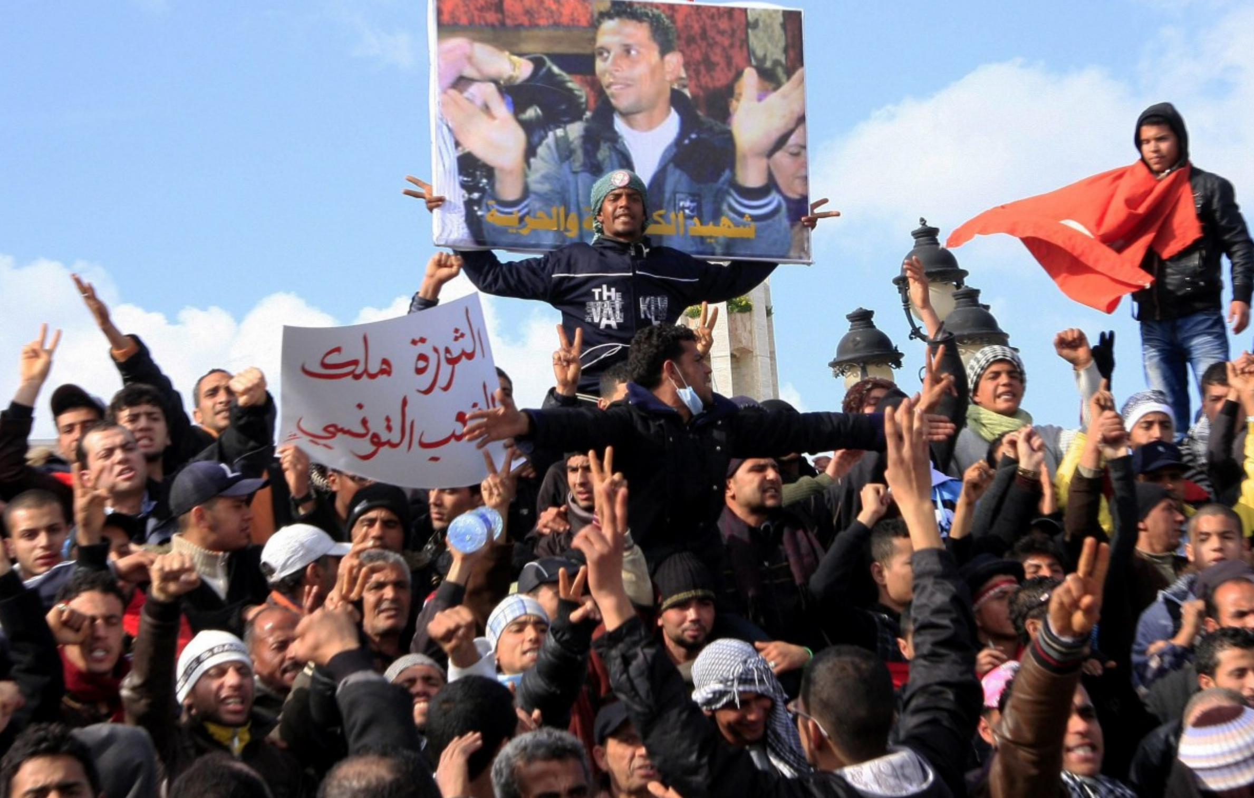

Protesters in Tunisia with picture of Mohamed Bouazizi in January 2011 (Associated Press).

The Arab Spring was the first time people in multiple Arab nations protested publicly en masse. Previously, their governments held total control of the public sphere, including the media. The Arab Spring was rooted in local problems but also reflected greater regional struggles that many in the Middle East faced. In Tunisia, a fruit vender, named Mohamed Bouazizi, was fined for not having a permit to sell his goods on the street by the police. Frustrated with the lack of opportunities to find a job, and encountering challenges put in place by the government to earn money to survive, he went to the police station and set himself on fire. Two weeks later he died, which sparked the Tunisian protests that led to the public outcry that was the Arab Spring. The people involved in the protest had many different grievances and political goals, but were united by two issues: the lack of economic opportunity in their countries and the end to the domination of the political sphere by “strongmen.”

By February 2012, the Muslim was in the grip of major political changes: the leaders of Tunisia, Egypt, Libya, and Yemen had been forced to step down or flee from power; civil uprisings had broken out in Bahrain and Syria; major protests had spread across Algeria, Iraq, Jordan, Kuwait, Morocco, and Sudan; and minor protests had spread across Mauritania, Oman, Saudi Arabia, Djibouti, Western Sahara, and Palestine.”
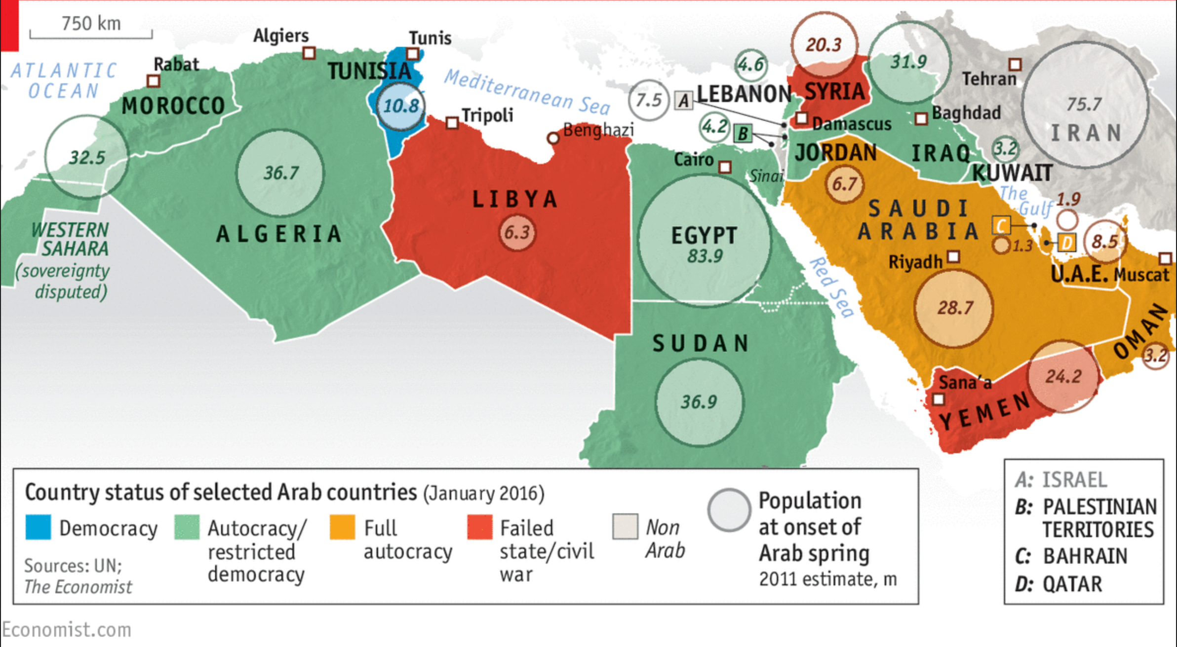

Map of Arab Spring and its effect on states in the Middle East five years later.

The goal of Arab Spring protesters was to remove authoritarian rulers from power. Across the Middle East, these men had come to power decades before by controlling the state, often through military coups that promised social justice and economic development. While the leaders of these regimes ran different forms of government—Egypt’s Hosni Mubarack was (officially, at least) the head of a republic, while Saudi Arabia’s King Abdullah bin Abdulaziz Al-Saud ruled as a monarch—all were (and, in some cases, still are) elites who maintained power by “nationalizing” (i.e. using the government to take control of) large parts of their nation’s industry and economy. Controlling the government, economy, and wealth of their country gave these men and their allies massive amounts of power. They kept this power through several strategies:

- They gave goods and favors to small groups of allies to created bonds and alliances. People benefitted from government handouts such as bread, jobs, and oil. This created a population that was reliant on the government—and, more importantly, the head of the government—for economic opportunity and even survival.
- They pitted different groups against each other, with some receiving benefits and others being deemed enemies of the state. This created social and cultural tensions, often with divisions along ethnic, regional, and religious lines.
- The government’s authority was often supported by a brutal police state. People were imprisoned and killed, often without trial, for being “enemies of the state.”

An example of this type of control—dividing people into groups and rewarding some and punishing other—occurred in its most extreme form under Saddam Hussein in Iraq. Kurds, a minority group in northern Iraq, were singled out by the Iraqi military. Kurdish fighters and civilians were attacked by soldiers, gassed using chemical weapons, and deported over the course of three years from 1986-1989.

The social and political tensions that these authoritarian rulers supported have a long history that were the result of the political division of the Middle East after World War I, a development often called the mandate system. The Allies, Britain and France, divided up the former Ottoman Empire into states the Allies viewed as incapable of self-government. “Greater Syria,” which was carved up into Syria, Lebanon, and Palestine, was governed by France; Iraq and Trans-Jordan were made into the modern nations of Iraq and Jordan and governed by Great Britain. In the words of journalist Scott Anderson, this strategy of political rule encouraged social conflict to keep power in the hands of the few. In Anderson’s words, “To maintain dominion over these fractious territories, the European powers adopted the same divide-and-conquer approach that served them so well in the colonization of sub-Saharan Africa. This consisted of empowering a local ethnic or religious minority to serve as their local administrators, secure in the knowledge that this minority would never rebel against their foreign overseers lest they be engulfed by the disenfranchised majority.”

Again, Iraq illustrates Anderson’s larger point. Iraq was made up from three distinct regions with three different cultural groups. All three groups were Muslim, but all three made up different religious sects, including Shiite Arabs in the south, Sunni Arabs in the center of the country, and non-Arab Kurds in the north. These three groups were governed by a Sunni monarchy that ruled over the majority of the population, which were Shia (Shiites). The mandate system ended after World War II, but the region was then governed by authoritarian leaders who continued to fragment the populations by playing on the divide and conquer ruling strategy.

With the Arab Spring, people across the Middle East came together, for the first time, to call for an end to authoritarian rule. However, due to long-standing tension and conflict, the transition to democratic rule has not been easy or successful.

Watch the video below to see some highlights of the beginning of the Arab Spring in Tunisia, Yemen, and Bahrain.  http://content.time.com/time/specials/packages/article/0,28804,2101745_2102134_2102356,00.html | 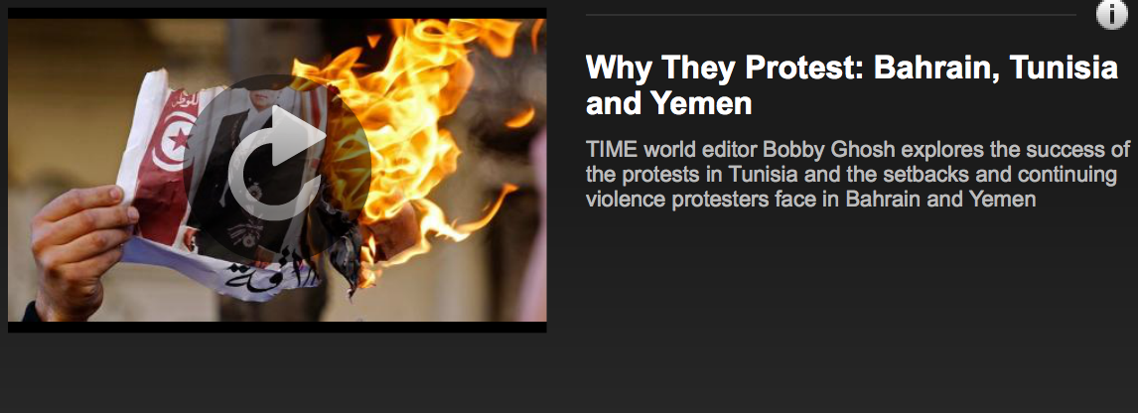

Arab Spring Research Project: Student Overview

The goal of this project is to investigate the topic of the Arab Spring and consider the effects of this monumental political movement and how it continues to impact the Middle East today. You can select from several questions and several research projects to learn more and share your findings with your classmates.

Research Question | Research Projects
- How does the Arab Spring compare to the French, Haitian, Latin American, Mexican, or Russian Revolutions?  - What were the effects of the Arab Spring in Egypt, Iraq, Syria, or Yemen?  - What were the effects of the Arab Spring on women in Saudi Arabia?  - Why is the refugee crisis resulting from political effects of Arab Spring significant?  - Was the Arab Spring a success or failure? | - A short video clip with questions for the class to answer  - A political cartoon from a specific point of view. Lead a discussion about similar and different perspectives.  - A song or poem about the revolution that is relevant to the country that the class will read. Give follow-up questions to lead a discussion.  - A Facebook page or Twitter feed that summarizes ideas, concepts, images, and leaders from the revolution, as well as follow-up questions that help fellow students assess and leave comments on page.

Arab Spring Research Project

How does the Arab Spring compare to the French, Haitian, Latin American, Mexican, or Russian Revolutions?

The goal of this project is to investigate the topic of the Arab Spring and consider the effects of this monumental political movement and how it continues to impact the Middle East today. You can select from several questions and several research projects to learn more and share your findings with your classmates.

Step 1: Learn about the topic

How does the Arab Spring compare to the French, Haitian, Latin American, Mexican, or Russian Revolutions?

View the images of the revolutions developed by the New York Times:
http://www.nytimes.com/slideshow/2011/02/06/weekinreview/06revolution-slideshow-1.html?_r=0

What do these images of revolts and revolutions have in common?

What are some differences between the images?
What stands out to you?
Topic/Focus: What revolution will you compare Arab Spring to?

Identify the categories you want to compare in your study of revolutions. Suggestions include: Reasons for the revolution, ways people engaged in politics, goals of the revolution, ways people communicated their ideas.

You may want to use this handout on revolts as well:
https://static01.nyt.com/images/blogs/learning/pdf/2011/20110208revolt.pdf

Step 2: Do Online Research
Website Evaluation for Research Paper
1. Authority | - Who is the author of the page or article?  - What are the author’s qualifications for the information written on the site?  - If the web site is sponsored by an organization or business, is the sponsoring organization clearly stated?  - Who is the sponsor?  - Can the legitimacy of the organization be verified? If so, how? If not, why not?  - What is the purpose of the web site?
2. Accuracy | - Can information on the site be verified by another source? If so, how?  - Is the page relatively free of grammatical errors? If not, what conclusions can you draw?  - Who has the responsibility for the accuracy of the contents of the site?
3. Objectivity | - Is any sort of bias evident? If so, what seems to be the author’s bias?  - Is the author’s motivation for writing the web site clear? What do you think it was?  - If there is advertising on the page, is it clearly differentiated from the contents?
4. Recency | - When was the site produced?  - Has the web site been updated? If so, when? If not, are the contents out of date?  - Are the links in operation? Are the links accurate? If not, which links are not in operation or are inaccurate?
5. Coverage | - Has the web site been completed, or is it under construction? If it is under construction, is there any indication when it will be finished?  - Are the topics of the web site clearly stated? If not, what is unclear?
Suggested website: See New York Times lesson in middle section for links to information for different revolutions:
https://learning.blogs.nytimes.com/2011/02/08/revolt-comparing-historical-revolutions/comment-page-1/?_r=0

Fill in the Historian’s Toolbox for each source you use.

Step 3: Develop a project.
How do you want to communicate your ideas on Arab Spring?
- Select one project | - A short video clip with questions for the class to answer  - A political cartoon from a specific point of view. Lead a discussion about similar and different perspectives.  - A song or poem about the revolution that is relevant to the country that the class will read. Give follow-up questions to lead a discussion.  - A Facebook page or Twitter feed that summarizes ideas, concepts, images, and leaders from the revolution, as well as follow-up questions that help fellow students assess and leave comments on page.
- Develop your ideas and prepare them to share with your classmates. | - Does the project clearly communicate the ideas you want to share?  - Do you provide evidence to support a claim that answers your research question?  - Do you use visual to communicate your ideas?  - Do you allow your audience to interact with your ideas through questions or comments?
Notes:

Arab Spring Research Project

Checklist
Content and Topic:
Your project should have a clear argument, stay on topic, and be easy to understand.

Claim/Argument and Message:
Your project should have a clear claim/argument and communicate this effectively to the audience.

Evidence:
Your project should present evidence to support the argument; the evidence should be facts that may be cited either in the project or in supporting documents. Include visual evidence as well as textual.

Audience Interaction:
Your project should engage your audience in a conversation about the Arab Spring. Use questions and/or comments to spark discussion.

Arab Spring Research Project

What were the effects of the Arab Spring in Egypt, Iraq, Syria, or Yemen?

The goal of this project is to investigate the topic of the Arab Spring and consider the effects of this monumental political movement and how it continues to impact the Middle East today. You can select from several questions and several research projects to learn more and share your findings with your classmates.

Step 1: Learn about the topic

What were the effects of the Arab Spring in Egypt, Iraq, Syria, or Yemen?

Read the article by Joseph V. Micallef, “The Arab Spring Six Years Later”:
http://www.huffingtonpost.com/joseph-v-micallef/the-arab-spring-six-years_b_14461896.html

What does the author argue are the long-term effects of the Arab Spring?

What are the political consequences of Arab Spring?

What are the economic consequences of Arab Spring?

Topic/Focus: Consider both short-term and long-term effects of the revolution in this state. Outline your ideas.

Step 2: Do Online Research
Website Evaluation for Research Paper
1. Authority | - Who is the author of the page or article?  - What are the author’s qualifications for the information written on the site?  - If the web site is sponsored by an organization or business, is the sponsoring organization clearly stated?  - Who is the sponsor?  - Can the legitimacy of the organization be verified? If so, how? If not, why not?  - What is the purpose of the web site?
2. Accuracy | - Can information on the site be verified by another source? If so, how?  - Is the page relatively free of grammatical errors? If not, what conclusions can you draw?  - Who has the responsibility for the accuracy of the contents of the site?
3. Objectivity | - Is any sort of bias evident? If so, what seems to be the author’s bias?  - Is the author’s motivation for writing the web site clear? What do you think it was?  - If there is advertising on the page, is it clearly differentiated from the contents?
4. Recency | - When was the site produced?  - Has the web site been updated? If so, when? If not, are the contents out of date?  - Are the links in operation? Are the links accurate? If not, which links are not in operation or are inaccurate?
5. Coverage | - Has the web site been completed, or is it under construction? If it is under construction, is there any indication when it will be finished?  - Are the topics of the web site clearly stated? If not, what is unclear?
Suggested website: You may want to consult this research page created for Arab Spring research projects: http://guides.library.cornell.edu/arab_spring

Fill in the Historian’s Toolbox for each source you use.

Step 3: Develop a project.
How do you want to communicate your ideas on Arab Spring?
- Select one project | - A short video clip with questions for the class to answer  - A political cartoon from a specific point of view. Lead a discussion about similar and different perspectives.  - A song or poem about the revolution that is relevant to the country that the class will read. Give follow-up questions to lead a discussion.  - A Facebook page or Twitter feed that summarizes ideas, concepts, images, and leaders from the revolution, as well as follow-up questions that help fellow students assess and leave comments on page.
- Develop your ideas and prepare them to share with your classmates. | - Does the project clearly communicate the ideas you want to share?  - Do you provide evidence to support a claim that answers your research question?  - Do you use visual to communicate your ideas?  - Do you allow your audience to interact with your ideas through questions or comments?
Notes:

Arab Spring Research Project

Checklist
Content and Topic:
Your project should have a clear argument, stay on topic, and be easy to understand.

Claim/Argument and Message:
Your project should have a clear claim/argument and communicate this effectively to the audience.

Evidence:
Your project should present evidence to support the argument; the evidence should be facts that may be cited either in the project or in supporting documents. Include visual evidence as well as textual.

Audience Interaction:
Your project should engage your audience in a conversation about the Arab Spring. Use questions and/or comments to spark discussion.

Arab Spring Research Project

What were the effects of the Arab Spring on women in Saudi Arabia?

The goal of this project is to investigate the topic of the Arab Spring and consider the effects of this monumental political movement and how it continues to impact the Middle East today. You can select from several questions and several research projects to learn more and share your findings with your classmates.

Step 1: Learn about the topic

What were the effects of the Arab Spring on women in Saudi Arabia?

Read the article by Shebab Khan, “Saudi Arabian Women Take to Twitter to Campaign Male Guardianship”:
http://www.independent.co.uk/news/world/middle-east/saudi-arabian-women-campaigning-end-male-guardianship-human-rights-watch-a7221281.html

What is male guardianship?

How does male guardianship limit women’s independence?
What stands out to you?
Topic/Focus: Consider how the Arab Spring affected women in different areas of the Middle East.

Step 2: Do Online Research
Website Evaluation for Research Paper
1. Authority | - Who is the author of the page or article?  - What are the author’s qualifications for the information written on the site?  - If the web site is sponsored by an organization or business, is the sponsoring organization clearly stated?  - Who is the sponsor?  - Can the legitimacy of the organization be verified? If so, how? If not, why not?  - What is the purpose of the web site?
2. Accuracy | - Can information on the site be verified by another source? If so, how?  - Is the page relatively free of grammatical errors? If not, what conclusions can you draw?  - Who has the responsibility for the accuracy of the contents of the site?
3. Objectivity | - Is any sort of bias evident? If so, what seems to be the author’s bias?  - Is the author’s motivation for writing the web site clear? What do you think it was?  - If there is advertising on the page, is it clearly differentiated from the contents?
4. Recency | - When was the site produced?  - Has the web site been updated? If so, when? If not, are the contents out of date?  - Are the links in operation? Are the links accurate? If not, which links are not in operation or are inaccurate?
5. Coverage | - Has the web site been completed, or is it under construction? If it is under construction, is there any indication when it will be finished?  - Are the topics of the web site clearly stated? If not, what is unclear?
Suggested websites:

https://www.hrw.org/report/2016/07/16/boxed/women-and-saudi-arabias-male-guardianship-system

https://twitter.com/hashtag/togethertoendmaleguardianship?lang=en

Fill in the Historian’s Toolbox for each source you use.

Step 3: Develop a project.
How do you want to communicate your ideas on Arab Spring?

- Select one project | - A short video clip with questions for the class to answer  - A political cartoon from a specific point of view. Lead a discussion about similar and different perspectives.  - A song or poem about the revolution that is relevant to the country that the class will read. Give follow-up questions to lead a discussion.  - A Facebook page or Twitter feed that summarizes ideas, concepts, images, and leaders from the revolution, as well as follow-up questions that help fellow students assess and leave comments on page.
- Develop your ideas and prepare them to share with your classmates. | - Does the project clearly communicate the ideas you want to share?  - Do you provide evidence to support a claim that answers your research question?  - Do you use visual to communicate your ideas?  - Do you allow your audience to interact with your ideas through questions or comments?
Notes:

Arab Spring Research Project

Checklist
Content and Topic:
Your project should have a clear argument, stay on topic, and be easy to understand.

Claim/Argument and Message:
Your project should have a clear claim/argument and communicate this effectively to the audience.

Evidence:
Your project should present evidence to support the argument; the evidence should be facts that may be cited either in the project or in supporting documents. Include visual evidence as well as textual.

Audience Interaction:
Your project should engage your audience in a conversation about the Arab Spring. Use questions and/or comments to spark discussion.

Arab Spring Research Project

Why is the refugee crisis resulting from political effects of Arab Spring significant?

The goal of this project is to investigate the topic of the Arab Spring and consider the effects of this monumental political movement and how it continues to impact the Middle East today. You can select from several questions and several research projects to learn more and share your findings with your classmates.

Step 1: Learn about the topic

Why is the refugee crisis resulting from political effects of Arab Spring significant?

Read the article by Carmen George, “Syrian Refugee Family Building New Life in Fresno”:
https://newsela.com/articles/syrian-refugee-family-fresno/id/22221/

Why did this family leave Syria?

How did this family arrive in the US?
Is this family’s journey similar or different to other refugees?
Topic/Focus: Explain the importance of the refugee crisis for the people affected.

Step 2: Do Online Research
Website Evaluation for Research Paper
1. Authority | - Who is the author of the page or article?  - What are the author’s qualifications for the information written on the site?  - If the web site is sponsored by an organization or business, is the sponsoring organization clearly stated?  - Who is the sponsor?  - Can the legitimacy of the organization be verified? If so, how? If not, why not?  - What is the purpose of the web site?
2. Accuracy | - Can information on the site be verified by another source? If so, how?  - Is the page relatively free of grammatical errors? If not, what conclusions can you draw?  - Who has the responsibility for the accuracy of the contents of the site?
3. Objectivity | - Is any sort of bias evident? If so, what seems to be the author’s bias?  - Is the author’s motivation for writing the web site clear? What do you think it was?  - If there is advertising on the page, is it clearly differentiated from the contents?
4. Recency | - When was the site produced?  - Has the web site been updated? If so, when? If not, are the contents out of date?  - Are the links in operation? Are the links accurate? If not, which links are not in operation or are inaccurate?
5. Coverage | - Has the web site been completed, or is it under construction? If it is under construction, is there any indication when it will be finished?  - Are the topics of the web site clearly stated? If not, what is unclear?
Suggested website: See the articles on Newsela to learn more about refugees of the Arab Spring:

https://newsela.com/text-sets/22466/refugee-crisis

Fill in the Historian’s Toolbox for each source you use.

Step 3: Develop a project.
How do you want to communicate your ideas on Arab Spring?
- Select one project | - A short video clip with questions for the class to answer  - A political cartoon from a specific point of view. Lead a discussion about similar and different perspectives.  - A song or poem about the revolution that is relevant to the country that the class will read. Give follow-up questions to lead a discussion.  - A Facebook page or Twitter feed that summarizes ideas, concepts, images, and leaders from the revolution, as well as follow-up questions that help fellow students assess and leave comments on page.
- Develop your ideas and prepare them to share with your classmates. | - Does the project clearly communicate the ideas you want to share?  - Do you provide evidence to support a claim that answers your research question?  - Do you use visual to communicate your ideas?  - Do you allow your audience to interact with your ideas through questions or comments?
Notes:

Arab Spring Research Project

Checklist
Content and Topic:
Your project should have a clear argument, stay on topic, and be easy to understand.

Claim/Argument and Message:
Your project should have a clear claim/argument and communicate this effectively to the audience.

Evidence:
Your project should present evidence to support the argument; the evidence should be facts that may be cited either in the project or in supporting documents. Include visual evidence as well as textual.

Audience Interaction:
Your project should engage your audience in a conversation about the Arab Spring. Use questions and/or comments to spark discussion.

Arab Spring Research Project

Was the Arab Spring a success or failure?

The goal of this project is to investigate the topic of the Arab Spring and consider the effects of this monumental political movement and how it continues to impact the Middle East today. You can select from several questions and several research projects to learn more and share your findings with your classmates.

Step 1: Learn about the topic

Was the Arab Spring a success or failure?

Read the article by Primoz Manfreda, “Arab Spring and the Middle East: How did the uprisings of 2011 change the region?”
https://www.thoughtco.com/arab-spring-impact-on-middle-east-2353038

What are some positive effects of the Arab Spring?

What are some negative effects of the Arab Spring?
What stands out to you?
Topic/Focus: Take a position on whether it was a success or failure. Be sure to explain whose perspective you are using to support your argument. For example, an Isis leader may see it as a success, while a fruit vender in Tunisia may not.

Step 2: Do Online Research
Website Evaluation for Research Paper
1. Authority | - Who is the author of the page or article?  - What are the author’s qualifications for the information written on the site?  - If the web site is sponsored by an organization or business, is the sponsoring organization clearly stated?  - Who is the sponsor?  - Can the legitimacy of the organization be verified? If so, how? If not, why not?  - What is the purpose of the web site?
2. Accuracy | - Can information on the site be verified by another source? If so, how?  - Is the page relatively free of grammatical errors? If not, what conclusions can you draw?  - Who has the responsibility for the accuracy of the contents of the site?
3. Objectivity | - Is any sort of bias evident? If so, what seems to be the author’s bias?  - Is the author’s motivation for writing the web site clear? What do you think it was?  - If there is advertising on the page, is it clearly differentiated from the contents?
4. Recency | - When was the site produced?  - Has the web site been updated? If so, when? If not, are the contents out of date?  - Are the links in operation? Are the links accurate? If not, which links are not in operation or are inaccurate?
5. Coverage | - Has the web site been completed, or is it under construction? If it is under construction, is there any indication when it will be finished?  - Are the topics of the web site clearly stated? If not, what is unclear?
Suggested websites:

http://www.economist.com/news/middle-east-and-africa/21685503-five-years-after-wave-uprisings-arab-world-worse-ever

http://www.npr.org/sections/thetwo-way/2016/04/12/473929436/young-arabs-reject-isis-worry-about-lack-of-jobs-poll-finds

http://www.bbc.com/news/world-middle-east-25212247

Fill in the Historian’s Toolbox for each source you use.

Step 3: Develop a project.
How do you want to communicate your ideas on Arab Spring?
- Select one project | - A short video clip with questions for the class to answer  - A political cartoon from a specific point of view. Lead a discussion about similar and different perspectives.  - A song or poem about the revolution that is relevant to the country that the class will read. Give follow-up questions to lead a discussion.  - A Facebook page or Twitter feed that summarizes ideas, concepts, images, and leaders from the revolution, as well as follow-up questions that help fellow students assess and leave comments on page.
- Develop your ideas and prepare them to share with your classmates. | - Does the project clearly communicate the ideas you want to share?  - Do you provide evidence to support a claim that answers your research question?  - Do you use visual to communicate your ideas?  - Do you allow your audience to interact with your ideas through questions or comments?
Notes:

Arab Spring Research Project

Checklist
Content and Topic:
Your project should have a clear argument, stay on topic, and be easy to understand.

Claim/Argument and Message:
Your project should have a clear claim/argument and communicate this effectively to the audience.

Evidence:
Your project should present evidence to support the argument; the evidence should be facts that may be cited either in the project or in supporting documents. Include visual evidence as well as textual.

Audience Interaction:
Your project should engage your audience in a conversation about the Arab Spring. Use questions and/or comments to spark discussion.

Historian’s Toolbox: Organizing Evidence to Write

Inquiry Question:

Source Citation | Summary:  What is the information presented in the source? | Evidence:  What are some specific quotes or information from the source that allows you to answer the question? | Analysis:  This means that…  This shows that…  This source is important to our understanding because… | Claim:  Explain how this source answers the inquiry question.

- Examine the Claim column and create one claim that unifies the ideas you present. For example, instead of having three sentences about different causes for an event, create one sentence with all of the causes of an event.
Write your Claim here:

- Organize your evidence. Do you want to present the evidence in chronological order or another way? List how you will organize your evidence here:

- How does the evidence support your claim? Give some specific analysis explaining why you think this evidence is important to answer the inquiry question.

You are ready to write! Use the outline below to develop a paragraph:

Introduce the topic (time period, location, major historical figures)
Claim
Evidence #1 and analysis
Evidence #2 and analysis
Evidence #3 and analysis
Concluding sentence restating your claim

