How has the Immigration Act of 1965 made the United States a multicultural society?
Topics: Immigration, Demographic Change.
Erik Altenbernd, UC Irvine History Project

History Standards
11.11 Students analyze the major social problems and domestic policy issues in contemporary American society.
11.11.1. Discuss the reasons for the nation’s changing immigration policy, with emphasis on how the Immigration Act of 1965 and successor acts have transformed American society.

CCSS Standards: Reading, Grades 11-12
RH 1. Cite specific textual evidence to support analysis of primary and secondary sources, connecting insights gained from specific details to an understanding of the text as a whole.
RH 2. Determine the central ideas or information of a primary or secondary source; provide an accurate summary that makes clear the relationships among the key details and ideas.
RH 3. Analyze in detail a series of events described in a text; determine whether earlier events caused late ones or simply preceded them.
RH7. Integrate and evaluate multiple sources of information presented in diverse formats and media (e.g. visually quantitatively, as well as in words) in order to address a question or solve a problem.
RH9. Integrate information from diverse sources, both primary and secondary, into a coherent understanding of an idea or event, noting discrepancies among sources.

CCSS Standards: Writing, Grades 11-12
WH 1a. Introduce precise claim(s), distinguish the claim(s) from alternate or opposing claims, and create an organization that establishes clear relationships among the claim(s), counterclaims, reasons, and evidence.
WH2. Write informative/explanatory texts, including the narration of historical events, scientific procedures/experiments, or technical processes.
WH4. Produce clear and coherent writing in which the development and organization, and style are appropriate to the task, purpose, and audience.

Guiding Question:
How has the Immigration Act of 1965 made the United States a multicultural society?

Overview of Lesson
This lesson provides a data- as well as narrative-driven look at demographic change in the United States since passage of the Immigration Act of 1965.

The lesson begins with an overview of the Immigration Act of 1965 and US immigration policy since the Chinese Exclusion Act of 1884 and the Immigration Act of 1924. The first part of the lesson introduces the 1965 Immigration Act and some of effects it has had on the nation over the last thirty to forty years. Next, the lesson examines the phenomenon of chain migration, how the 1965 law replaced racial preferences for family preferences, and how overall immigration to the US has spiked since 1965 (the part of the lesson relies heavily on charts and graphs). The third part of the lesson examines the effects of the 1965 immigration law on California (particularly Los Angeles County and the City of Irvine), recent changes in patterns of immigration among Latinos and Asians, and California’s status as a minority-majority state. The final activity has the students assess demographic change in their home city, or the city of their high school, by gather data from City-Data.com.

The lesson is designed to be modular. The lesson sections are arranged chronologically, and thus build on the previous sections. However, each section has also been designed to be taught independently of the other sections.

The sections of the lesson are as follows:
- Introduction
- Immigration and Naturalization Act of 1965
- Effects of the Immigration Act of 1965 on the United States
- Effects of the Immigration Act of 1965 on California
- Final Activity

Documents
- Introduction
- “The Immigration Act of 1965 and its Effects,” Dallas TeleLearning (video)
- “1965 Immigration Law Changed the Face of America,” National Public Radio (excerpt)
- “Fifty Years On, the 1965 Immigration and Nationality Act Continues to Reshape the United States,” Migration Policy Institute (excerpt)
- “Annual Number of U.S. Legal Permanent Residents, 1820-2015,” Migration Policy Institute (chart)
- “U.S. Immigration Population by World Region of Birth, 1960-2015,” Migration Policy Institute (chart)
- “Graph of Percentage of Foreign-Born Residents in California,” Public Policy Institute of California (graph)
- “It’s official: Latinos now outnumber whites in California,” LA Times (excerpt)
- Chart of Immigration to California, 2005-2015,” Public Policy Institute of California, (chart)
- “Why Asians have become the dominant group in Irvine—and what that means for the city,” OC Register (excerpt)
- Seal of the State of California (image)
- “The New Face of California,” Ventura County Star (political cartoon)
- Final Activity, City-Data.com (website)

Teacher Outline of Final Activity
The final activity allows the students to assess demographic change in their home city, or the city in which their higher school is located. The inquiry question for the assignment is: Does your home town look like modern California?

To do this, the students simply enter the name of the city in the online database, City-Data.com. The directions are as follows:
To answer this question, click on the City-Data.Com link below and type in the name of the city where you live (or, conversely, the city where your school is located).

http://www.city-data.com/

After you enter the city into the database, press enter and then scroll down to the pie chart titled “Races in [your home city], CA (2015). Underneath the pie chart there will be a link titled “Races in [your home city] detailed stats.” Click the “detailed stats” link and fill in the information into the City-Data.Com chart below.

After you’ve entered all the data, fill out the boxes below and list two ways your city is and is not similar to California as a whole, and two ways your city changed between 2000 and 2015.

Introduction
Today, the US is one of the most culturally diverse nations on Earth. A key moment in the creation of our multicultural society was 1965—the year President Lyndon B. Johnson signed the Immigration and Naturalization Act into law.

Immigration has long been an issue of concern for the federal government. One of the most important early laws passed by Congress dealt with the issue of immigration. The Naturalization Act of 1790 stated that the only type of immigrant that could become a US citizen was a “free white person.” (Naturalization is the word the federal government uses to refer to immigrants who, after living in the United States, decide to become US citizens. Citizens born in the US are called natural-born citizens; citizens born in a foreign nation are called naturalized citizens).

For most of the 1800s, the federal government did not regulate who could and who could not enter the United States. For most of the 1800s, the federal government focused on who could and could not become an American citizen.

That changed in 1882 when Congress passed the Chinese Exclusion Act—the first law in US immigration history to restrict a particular group of immigrants from entering the nation. In the early twentieth century, federal officials sought to restrict all Asian immigrants, as well as immigrants from Southern and Eastern Europe.

After World War I, Congress passed another restrictive law: the Immigration Act of 1924. Also known as the Johnson-Reed Act, the Immigration Act of 1924 limited the total number of immigrants allowed to enter the US to a maximum of 150,000 per year. The law also used a strict quota system. The quota system allowed only certain numbers of people from each nation. However, some nations had larger quotas (or numbers) than others. Whereas African countries like Egypt, or Eastern European nations like Poland, were given small quotas, Western and Northern European nations like Great Britain and Germany were given large quotas (Asian countries like China were given no quota at all). The Immigration Act of 1924, therefore, played favorites. Based on prejudiced, or racist, ideas about certain foreign cultures, the law was set up to limit immigration from cultures many in the US considered to be undesirable or inferior to the white Euro-Americans.

The Immigration and Naturalization Act of 1965 (sometimes also called the Hart-Celler Act) threw out the preferential quota system. Instead, it set up caps based on region (120,000 total people per year from the Western Hemisphere, 170,000 from the Eastern Hemisphere). However, it did establish one important new preference—the law prioritized family reunification. Basically, the law says that any immigrant who already has a family member living in the US will be given preference—no matter their ethnicity, race, or nationality.

Part 1. Immigration and Naturalization Act of 1965

The Immigration Act of 1965 provided a major break from the immigration policies of the early twentieth century. The law is responsible for much of the cultural diversity we see all throughout the United States today. The sources in this section examine this important law and some of the ways it has shaped American life over the last fifty years.

Source 1
“The Immigration Act of 1965 and its Effects” (2005)
Dallas TeleLearning (4:49)

https://www.youtube.com/watch?v=1qohGn7vM0c

Immigration since 1965 | 0:00-4:49
1. What major change does the 1965 immigration act put into place?
2. What is the one of the “top preferences” for immigrants set in place by the 1965 immigration act??
3. How did the Immigration Act of 1965 affect the “Latino” community in the United States?
4. According to the video, where do immigrants settle once they move to the United States?

Source 2
“1965 Immigration Law Changed the Face of America”
All Things Considered, NPR
May 9, 2006

Federal officials supported the Immigration Act of 1965 for a number of reasons. One of the main reasons had to do with the Immigration Act of 1924. After serving for forty years as the law of the land, many around the nation felt the law was racist. Because it was written to give Western and Northern Europeans major advantages over other peoples around the world, the 1924 law was deemed to discriminate against the vast majority of people around the world and thus to be unfair. For many in Washington, D.C., the new 1965 law was something of a fresh start—a moment where the nation could move forward by replacing a bad law with a new and better law.

As Congress considers sweeping changes to immigration law, nearly all the debate has centered on the problem of illegal immigration. Little discussed are the many concerns of legal immigrants, the estimated 3 million to 4 million who are, as it's so often been put —“already standing in line.”  The current system of legal immigration dates to 1965. It marked a radical break with previous policy and has led to profound demographic changes in America. But that's not how the law was seen when it was passed — at the height of the civil rights movement, at a time when ideals of freedom, democracy and equality had seized the nation. Against this backdrop, the manner in which the United States decided which foreigners could and could not enter the country had become an increasing embarrassment.  “The [old] law was just unbelievable in its clarity of racism…It declared that Northern Europeans are a superior subspecies of the white race. The Nordics were superior to the Alpines, who in turn were superior to the Mediterraneans, and all of them were superior to the Jews and the Asians.…”  By the 1960s, Greeks, Poles, Portuguese and Italians were complaining that immigration quotas discriminated against them in favor of Western Europeans.…  The central purpose of the new immigration law was to reunite families.  The influx of refugees and of millions of illegal immigrants over the last several decades have certainly contributed to the United States’ profound demographic transformation. But the chief driver of this change remains the system of family-based immigration put in place in 1965. Over time, in a process critics call “chain migration,” entire families have re-established themselves in the United States.…  …the Asian American Justice Center's Narasaki thinks the family focus makes sense. She notes that in the Asian community, extended families often function as a close-knit unit. Parents will help raise children, while siblings will pool their money to buy homes and businesses together and to help finance college for the younger generation.  “A family is very important not just to the social and emotional well-being, but also to the economic well-being of these communities,” she says.  At a recent naturalization ceremony, 32 immigrants gathered for their oath of citizenship in the ornate rotunda of Washington's National Archives. Of them, three were from Western Europe. The rest were overwhelmingly from Africa, Latin America and Asia.  Later, at a basement reception, the new citizens posed for pictures, holding tiny American flags and a gift bag that included a refrigerator magnet of the U.S. Constitution and an AT&T prepaid calling card. One older woman, dressed in her Sunday best, with a broad-brimmed hat, introduced herself as Hannah Ndubuisi. She is from Nigeria, and her name means “life is first.” Ndubisi was sponsored by her U.S. citizen son, Samuel.  “Everybody in the world — I don't know if you know this — wants to come to the United States of America,” she says. “All you need to do is go to the embassy, any embassy, and see long, long lines of people who want to come here.”  In fact, Ndubisi has a long line of relatives still in Nigeria who'd love to come. It's the same with another brand-new citizen at the reception, Emad Ali from Sudan.  “I have my parents, I have sisters, I have brothers,” Ali says. “I'm going to apply for them to come here soon — definitely. I hope they will be here soon.”  It may not be soon at all, though. The immigration system set up specifically to reunite families is so overwhelmed with applicants, that relatives who wait their turn must endure being divided for years. | radical—complete or far-reaching  demographic—relating to characteristics of population  driver—cause  naturalization ceremony—event where immigrants officially become US citizens  Sunday best—nice clothes (like those you would wear to church on Sunday).  Nigeria—nation in West Africa
Source: NPR, http://www.npr.org/templates/story/story.php?storyId=5391395

Questions

5. Why, according to this article, did Congress pass the Immigration Act of 1965?

6. What were the main problems with the previous immigration laws?

7. How has the Immigration Act of 1965 changed American society?

8. What is chain migration?

9. What is the main problem immigrant family members face when trying to move to the US?

Part 2. Effects of the Immigration Act of 1965 on the United States

When President Lyndon B. Johnson signed the Immigration Act of 1965 into law, he gave a short speech that included these words: “This bill that we will sign today is not a revolutionary bill. It does not affect the lives of millions. It will not reshape the structure of our daily lives…Yet it is still one of the most important acts of this Congress and of this administration [as it] corrects a cruel and enduring wrong in the conduct of the American nation.” Johnson’s words at the end refer to the unfair and prejudiced Immigration Act of 1924. Because Johnson’s words make it clear that the new law was passed to fix an old problem—to make an old wrong right—the 1965 law is mostly understood as a major improvement over the old system.

However, Johnson was wrong about the long-term effects of the 1965 law. The law did affect millions, and it did, in many ways, reshape the daily lives of Americans. The law’s support for family reunification—its preference for family members of legal immigrants already residing in the US—has opened the door to millions of immigrants since 1965. Between 1996 and 2000, 22.8 million legal immigrants moved to the US; the majority of those were family members of recent immigrants. This process is known as chain migration. Since the law’s passage, the US has experienced a new era of mass immigration that has changed the face of American society.

Source 3

“Fifty Years On, the 1965 Immigration and Nationality Act Continues to Reshape the United States” (2015)

Migration Policy Institute

The 1965 Immigration and Nationality Act has had a profound effect on immigration to the United States. In a short amount of time, it has transformed American society. After the law was passed, the number of new lawful permanent residents (or green-card holders) rose from 297,000 in 1965 to an average of about 1 million each year since the mid-2000s. Accordingly, the foreign-born population has risen from 9.6 million in 1965 to a record high of 45 million in 2015…Immigrants accounted for just 5 percent of the U.S. population in 1965 and now comprise 14 percent.  In turn, the law dramatically altered the racial and ethnic makeup of the United States. In 1965, whites of European descent comprised 84 percent of the U.S. population, while Hispanics accounted for 4 percent and Asians for less than 1 percent. Fifty years on, 62 percent of the U.S. population is white, 18 percent is Hispanic, and 6 percent is Asian. By 2065, just 46 percent of the U.S. population will be white, the Hispanic share will rise to 24 percent, Asians will comprise 14 percent—and the country will be home to 78 million foreign born. | lawful—legal  makeup—population
Source: Adapted from Migration Policy Institute, http://www.migrationpolicy.org/article/fifty-years-1965-immigration-and-nationality-act-continues-reshape-united-states

Questions

10. How many new green-card holders (i.e. lawful immigrants) moved to the US in 1965?

11. How many new green-card holders (i.e. lawful immigrants) have moved to the US each year since the mid-2000s?

12. What percentage of the population was foreign born in 1965? What percentage was foreign born today?

13. What was the percentage of the white, or Euro-American, population of the US in 1965? What percent was the white population in 2015?

14. Plug the information from Question 4 into the graph below using the correct percentage for 1965 and the correct percentage for 2015. Then draw a line connecting the 1965 percentage and 2015 percentage.

Percentage of the white, or Euro-American, population
90%
80%
70%
60%
50%
40%
 | 1965 | 1975 | 1985 | 1995 | 2005 | 2015

15. What long-term trend does the chart from Question 5 illustrate?

Source 4

“Annual Number of U.S. Legal Permanent Residents, 1820-2015” (2015)
Migration Policy Institute

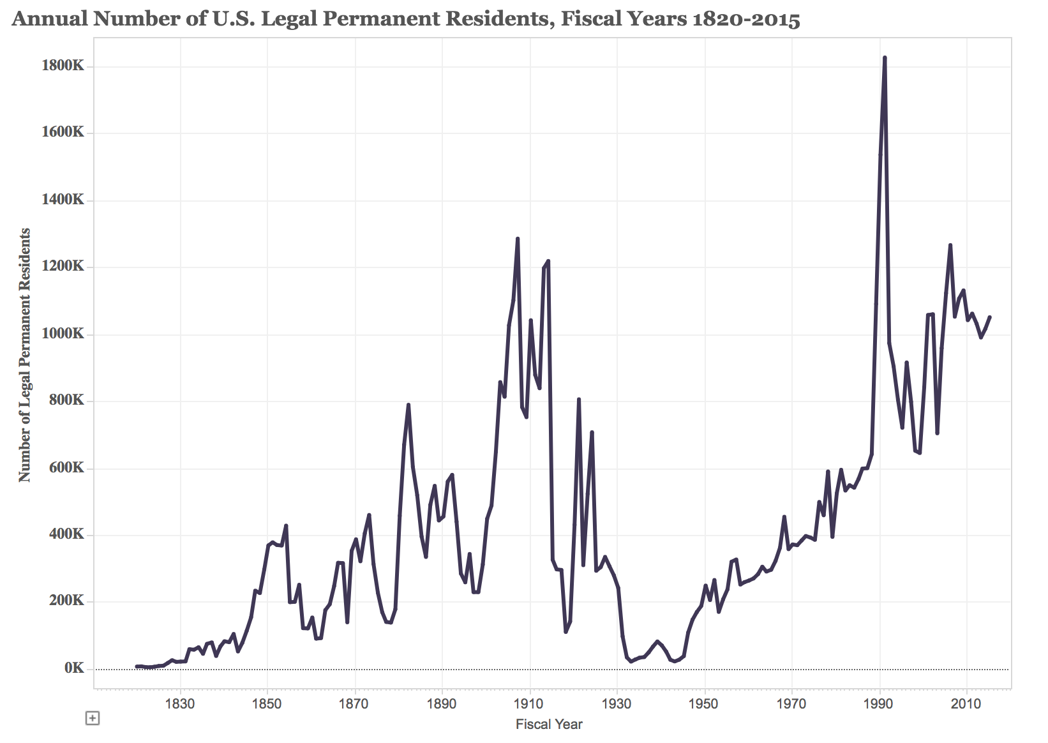
Source: Migration Policy Institute, http://www.migrationpolicy.org/programs/data-hub/charts/Annual-Number-of-US-Legal-Permanent-Residents?width=1000&height=850&iframe=true

Questions

16. Based on this graph, which periods of US history (which years or decades) have experienced the highest levels of immigration?

17. Did immigration increase or decrease after the Immigration Act of 1924?

18. Did immigration increase or decrease after the Immigration Act of 1965?

19. Which year experienced the highest levels of immigration after the Immigration Act of 1965?

Source 5

“U.S. Immigrant Population by World Region of Birth, 1960-2015” (2015)
Migration Policy Institute

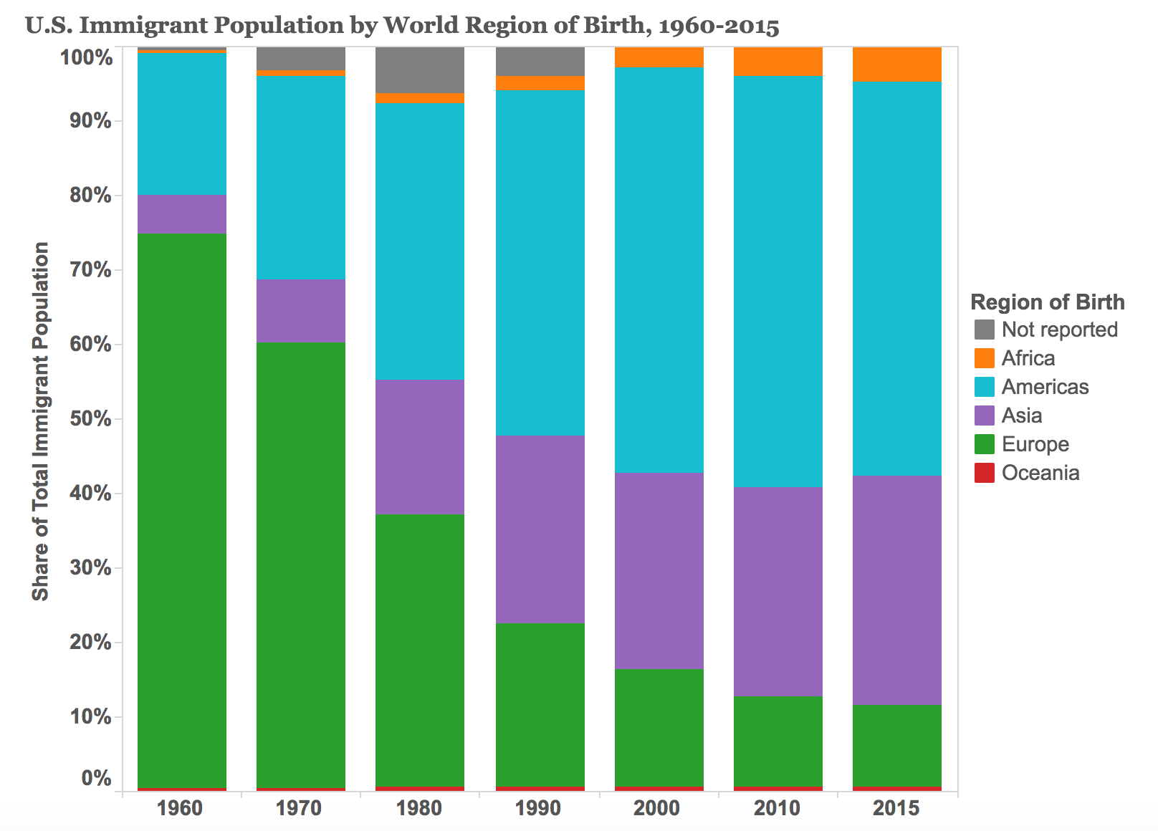
Source: Migration Policy Institute, http://www.migrationpolicy.org/programs/data-hub/charts/regions-immigrant-birth-1960-present?width=1000&height=850&iframe=true

Questions

20. Approximately what percentage of immigrants came from Europe in 1960? Approximately what percentage came from Europe in 2015?

21. Which region of the world has seen the largest percentage increase in immigration to the US since 1965?

22. Approximately what percentage of immigrants came from Asia in 1970? Approximately what percentage came from Asia in 2015?

Part 3. Effects of the Immigration Act of 1965 on California

Few states in the US have undergone as rapid and major a change since 1965 as California. California has always had a larger number of immigrants than other states in the US, but immigration to the California increased significantly as a result of the Immigration Act of 1965. After fifty years, California has become far more multicultural than it was in 1965. Major changes to California’s population over the last fifty years have made California into a minority-majority state—meaning, while white Euro-Americans make up the majority of the population nationwide, they no longer make up the majority of the population in California.

Source 6
Graph of Percentage of Foreign-Born Residents in California
Public Policy Institute of California

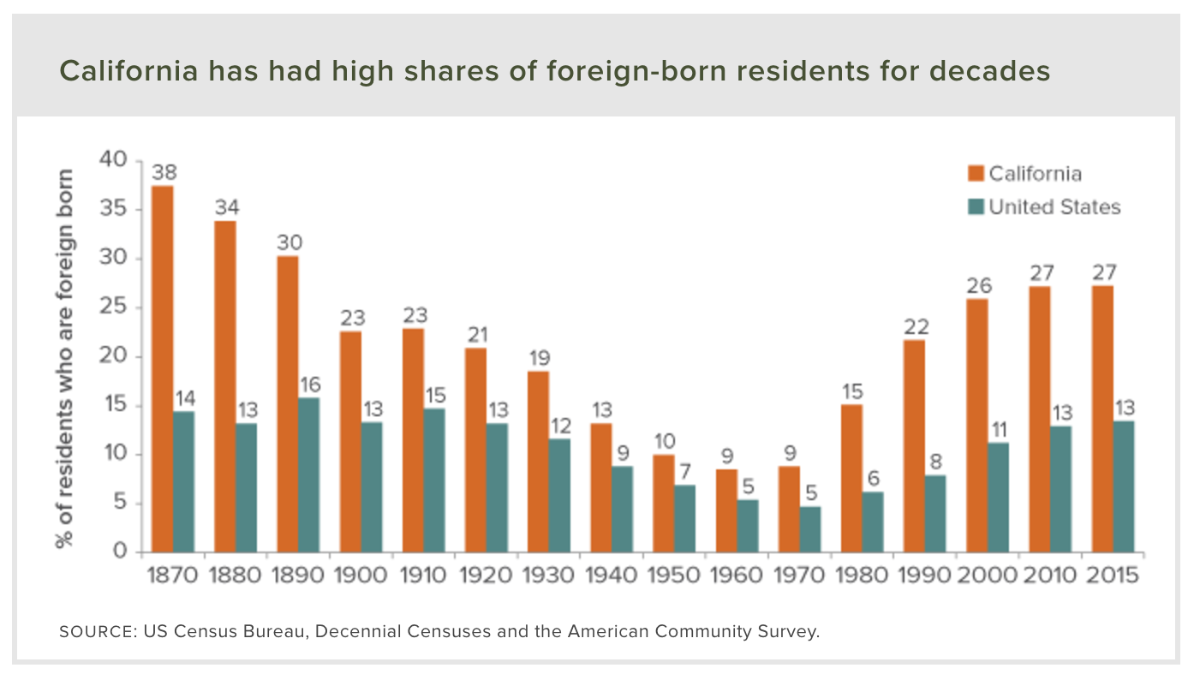
Source: Public Policy Institute of California, http://www.ppic.org/main/publication_show.asp?i=258

Questions

23. What is the central claim of this graph?

24. Based on your knowledge of the Immigration Act of 1965, when does California begin to experience sharp increases immigration and the number of foreign-born residents?

Source 7
“It’s official: Latinos now outnumber whites in California”
Los Angeles Times, July 8, 2015

The demographers agreed: At some point in 2014, Latinos would pass whites as the largest ethnic group in California.  Determining when exactly that milestone would occur was more of a tricky question. Counting people isn't like counting movie ticket receipts.  The official confirmation had to wait until new population figures were released by the Census Bureau this summer. The new tally, released in late June, shows that as of July 1, 2014, about 14.99 million Latinos live in California, edging out the 14.92 million whites in the state.  The shift shouldn’t come as a surprise. State demographers had previously expected the change to occur sometime in 2013, but slow population growth pushed back projections.…  Either way, the moment has officially arrived.  California is now the first large state and the third overall — after Hawaii and New Mexico — without a white plurality, according to state officials.  The country’s Latino population is now 55.4 million. California and Los Angeles County have the largest Latino populations of any state or county in the nation, according to the new figures.  The demographic shift has been a long time coming. In 1970, the 2.4 million Latinos in California accounted for 12% of the population, while the 15.5 million whites in the state made up more than three-quarters of residents, according to state figures. By 1990, the Latino population jumped to 7.7 million, or about 25% of the state's population.  The Latino population is relatively young, with a median age of about 29, while the aging white population has a median age of 45. State demographers project Latinos will account for about 49% of Californians by 2060.  A young Latino workforce helps the economy by backfilling retiring baby boomers, said John Malson, the chief demographer for the state finance department.  The continued influx and growth of Latinos in the United States is not being fueled exclusively by immigration but by second- and third-generation immigrants who are settling down and starting families, said Marcelo Suárez-Orozco, a professor and dean of education at UCLA's Graduate School of Education and Information Studies.  California is a harbinger of the national rise in Latinos. The nation's Latino population has grown 57% since 2000, when Latinos numbered 35.3 million. Latinos accounted for most of the nation's growth — 56% — from 2000 to 2010…  “Where L.A. goes is where the rest of the state goes and where the rest of the country goes,” [Suárez-Orozco] said. “We announce, demographically speaking, the future for the rest of the country.” | demographers—people who study changes in local, state, and national population  plurality—largest of multiple groups but less than 50% of total population  demographic—relating to characteristics of population  baby boomers—large group of Americans born between 1946 and 1964
Source: Los Angeles Times, http://www.latimes.com/local/california/la-me-census-latinos-20150708-story.html

Questions

25. How many Latinos lived in California in 1970? 1990? 2014? List the stats for all three years below.

26. Is immigration the main cause of demographic growth among the Latino community in 2016? If not, what is the main cause of growth today?

27. What major social change does this article describe? Describe the event in 2-3 sentences and cite at least 2 pieces of evidence to support your claim.

Source 8
Chart of Immigration to California, 2005-2015

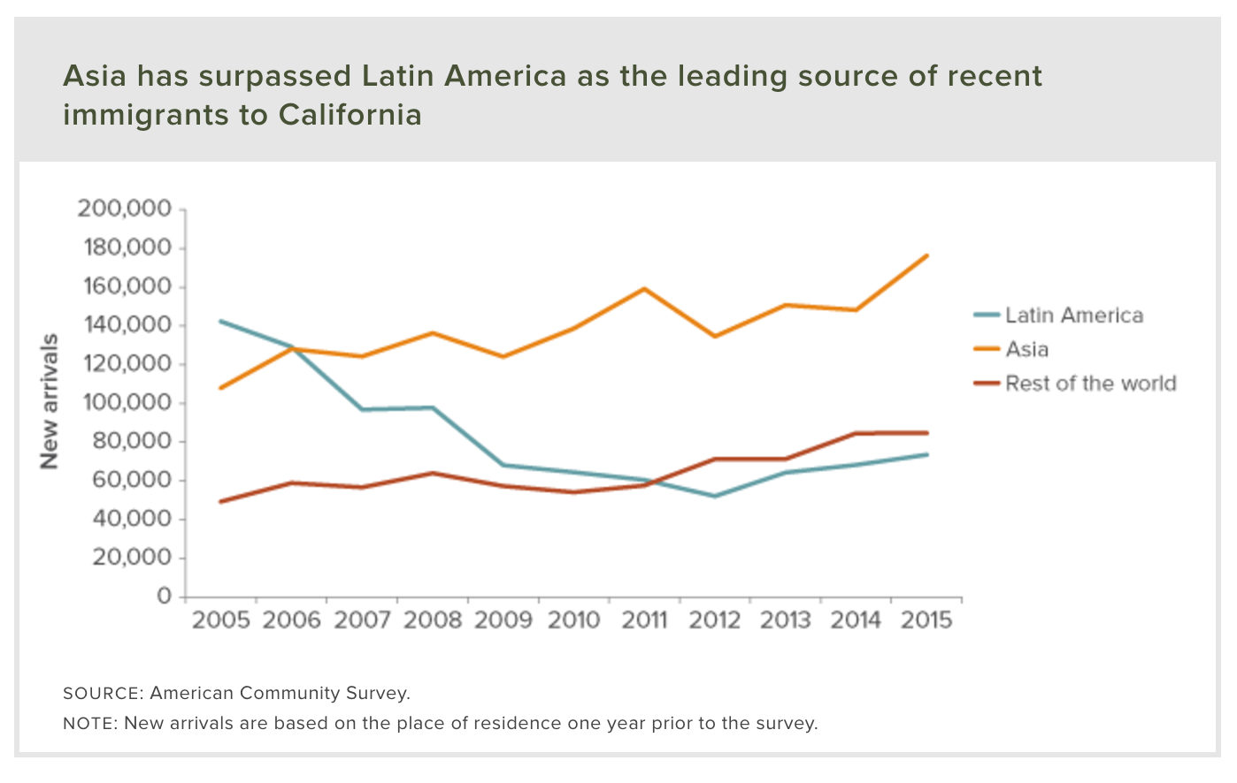
Source: Public Policy Institute of California, http://www.ppic.org/main/publication_show.asp?i=258

Sources

28. What is the central claim of this chart?

29. What year did Asians overtake Latinos as the largest immigrant group in California?

Source 9

“Why Asians have become the dominant group in Irvine – and what that means for the city”
Orange County Register, September 17, 2016

Two years ago, David Nguyen, his wife and his daughter were the first to move into their block in Irvine’s new Portola Springs neighborhood.  Within a few months, they saw the street fill up with two Indian families next door, and Filipino, Korean and Latino families across the way. Their meticulously planned community may appear beige and cookie-cutter to passers-by, but its residents are far from culturally homogenous.  “I was surprised in a positive way,” said Nguyen, whose parents were Vietnamese refugees. “There’s Asian diversity here.”  Portola Springs symbolizes a milestone reached by one of Southern California’s fastest-growing suburbs.  New census estimates show that, for the first time, Irvine has more Asian than white residents. It’s a thin lead…but the strongest evidence yet of what many residents, scholars and real estate professionals see as an accelerating trend.  Using the new census figures, a Register analysis indicates Irvine now is – or soon will be – the largest city in the continental United States with an Asian plurality. Among larger municipalities, only Honolulu has more Asians than any other race.  More than 45 percent of Irvine’s roughly 257,000 residents are Asian, according to American Community Survey estimates released Thursday.…  Irvine has grown steadily since its 1971 incorporation. Its share of Asian residents has climbed more quickly. They accounted for roughly 8 percent of the population in 1980. That number jumped to 18 percent in 1990 and 30 percent in 2000, according to census data.  Just in the decade ending last year, the city added 84,745 people of all races. The share of white residents, which can include people of Middle Eastern and North African origin, fell from 56 percent to just below the Asian population.  Latinos, who can be of any race, were about 7 percent of the population in the latest census report.  Irvine’s Asian population hovered between 35 percent and 40 percent for much of the past decade, before surging last year, according to census estimates.…  The historic roots of the migration can be traced to the Immigration and Nationality Act of 1965, which ended unfair quotas restricting new arrivals from Asia and Africa. It also gave particular preference to newcomers with families already in the U.S.  The lagging impact of the change began to show in the 1980s and 1990s, when increasingly educated immigrants from China, India, Taiwan and South Korea began moving to the U.S. for jobs and schooling opportunities.…  Over the last decade, Chinese residents, the city’s largest Asian group, made up about 10 percent to 13 percent of the population, before jumping last year to 17 percent.  In recent months, 4 of 5 homes in new neighborhoods around the city’s developing Great Park were sold to people from Asia, “including Indians, Persians, Koreans and a significant number of Chinese,” said Steve Churm, spokesman for FivePoint Communities. | cookie-cutter—similar; mass produced goods that all look the same or just slightly different  homogenous—of the same kind; the same  refugee—person who flees country due to war or political problems  suburb—edge of city where people mainly live instead of work  plurality—largest of multiple groups but less than 50% of total population  incorporation—establishment as independent city
Source: OC Register, http://www.ocregister.com/articles/irvine-729359-asian-city.html

Questions

30. What percentage of Irvine’s population was Asian or Asian American in 1980? 1990? 2000? 2016? List the stats for all four years below.

31. According to this article, what is the “historic root” that explains these social changes in Irvine?

32. What major social change does this article describe? Describe the change in 2-3 sentences and cite at least 2 pieces of evidence in support of your claim.

Source 10
Seal of the State of California

Today’s California is far more culturally diverse than 1960s California. Today, majority-minority (or minority-majority) state—meaning, while white Euro-Americans make up the majority of the population nationwide, they no longer make up the majority of the population in California. Another way to think of it is like this: California’s diversity is such that it is made up of a number of different ethnic groups, each of which represents less than 50% of the total population of the state.

Source 11
Political Cartoon about Population of California
Ventura County Star (2007)

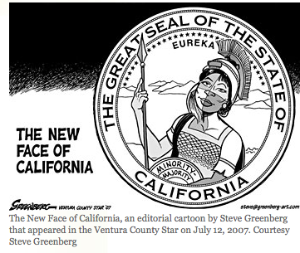

Questions

33. What image does the political cartoon above (Source 13) reference?

34. What aspects of the state seal does the cartoonist, Steve Greenberg, leave out of his “new” state seal? For information about the state seal, go to this website: http://www.statesymbolsusa.org/symbol-official-item/california/state-seal/seal-california

35. What social reality does Greenberg capture in his cartoon? Explain your answer using 2 pieces of evidence from the cartoon.

36. Do you think Greenberg (the artist of the political cartoon) is celebrating California’s diversity or complaining about social changes in California? Write 3-4 sentences and provide at least 2 pieces of evidence to support your claim.

Final Activity: Does your home town look like modern California?

No state in the US has been more affected by immigration over the last fifty years than California. Three years before the Immigration Act of 1965, California overtook New York as the most populous state in the union. For fifty years—ever since California became the most populous state—there has been a saying in American politics: “As California goes, so goes the nation.” The idea behind this adage is this: what happens in California will likely happen elsewhere around the nation. Another way to think of it is like this: if you want to see what’s going to happen across America in the future, then take a look at what is happening in California right now.

Today, California is what is known as a minority-majority state. This term may sound strange, or complicated, but it is not. Minority-majority (or majority-minority) refers to a culturally diverse society where no ethnic group makes up a majority (more than 50%) of the population. Because, white Americans make up more than 50% of the population nation-wide, the term majority-minority is used to describe states like California, or cities like Irvine or Santa Ana, where an ethnic group that is a minority nation-wide makes up a majority of the population of the state or city.

Hispanics, or Latinos, make up roughly 16% of the US population, but 38.8% of the population of California. Whites, by contrast, make up almost 67% of the US population, but just 38% of the population of California. Latinos are the largest ethnic group in California today, and that is why California is sometimes called a majority-minority state.

However, populations vary from place to place, or city to city. Some cities have large white or Latino populations; others have small white or Latino populations. As we have seen, the City of Irvine has a large Asian and Asian American population, but it has a relatively small Latino population (just 9%).

Does your home town look like modern California?

To answer this question, click on the City-Data.Com link below and type in the name of the city where you live (or, conversely, the city where your school is located).

http://www.city-data.com/

After you enter the city into the database, press enter and then scroll down to the pie chart titled “Races in [your home city], CA (2015). Underneath the pie chart there will be a link titled “Races in [your home city] detailed stats.” Click the “detailed stats” link and fill in the information into the City-Data.Com chart below.

After you’ve entered all the data, fill out the boxes below and list two ways your city is and is not similar to California as a whole, and two ways your city changed between 2000 and 2015.

City-Data.Com Activity
http://www.city-data.com/

 | 2000  city | 2000  CA | 2015  city | 2015  CA
Largest Ethnic Group/Race
2nd
Largest Ethnic Group/Race
3rd
Largest Ethnic Group/Race
4th
Largest Ethnic Group/Race
5th
Largest Ethnic Group/Race

Hometown vs. California

Two Ways My City is Like California as a Whole
Write 2-3 sentences for each answer.
1.

2.

Two Ways My City is NOT Like California as a Whole
Write 2-3 sentences for each answer.
1.

2.

Two Ways My City Has Changed between 2000 and 2015
Write 2-3 sentences for each answer.
1.

2.

