What are executive orders? How do they differ from laws passed by Congress?
Topics: Executive orders; executive branch
Erik Altenbernd, UC Irvine History Project

History Standards
12.4 Students analyze the unique roles and responsibilities of the three branches of government as established by the US Constitution.
12.4.4 Discuss Article II of the Constitution as it relates to the executive branch, including eligibility for office and length of term, election to and removal from office, the oath of office, and the enumerated powers.

CCSS Standards: Reading, Grades 11-12
RH 1. Cite specific textual evidence to support analysis of primary and secondary sources, connecting insights gained from specific details to an understanding of the text as a whole.
RH 2. Determine the central ideas or information of a primary or secondary source; provide an accurate summary that makes clear the relationships among the key details and ideas.
RH4. Determine the meaning of words and phrases as they are used in a text, including analyzing how an author uses and refines the meaning of a key term over the course of a text…
RH9. Integrate information from diverse sources, both primary and secondary, into a coherent understanding of an idea or event, noting discrepancies among sources.

CCSS Standards: Writing, Grades 11-12
WH 1. Write arguments focused on discipline-specific content.
WH2. Write informative/explanatory texts, including the narration of historical events, scientific procedures/experiments, or technical processes.
WH4. Produce clear and coherent writing in which the development and organization, and style are appropriate to the task, purpose, and audience.
WH6. Use technology, including the internet, to produce, publish, and update individual and shared writing products…
WH7. Conduct short as well as more sustained research projects to answer a question (including a self-generated question) or solve a problem; narrow or broaden the inquiry when appropriate; synthesize multiple sources on the subject, demonstrating understanding of the subject under investigation.

Inquiry Questions
What are executive orders?
How do they differ from laws passed by Congress?

Overview of Lesson
This lesson examines the three main forms of executive action—executive orders, presidential proclamations, and presidential memoranda. The lesson includes a detailed introduction to executive actions which emphasizes that not all executive actions are “executive orders,” and helps students distinguish between the three main forms of executive action. The rest of the lesson surveys each form of executive action by way of a case study for each: Executive Order 9066, the Emancipation Proclamation, and President Donald J. Trump’s recent presidential memorandum regarding the Dakota Access Pipeline. The final activity provides the students with the opportunity to better understand all three forms of executive action by assessing Trump’s executive actions.

The lesson is organized as follows:
- Introduction
- Executive Orders (Executive Order 9066, the order that resulted in Japanese relocation and incarceration during World War II).
- Presidential proclamations (Emancipation Proclamation)
- Presidential memoranda (President Donald Trump’s memoranda regarding the Dakota Access Pipeline)

Documents
- Executive Order 9066, Franklin D. Roosevelt (excerpt)
- “Korematsu: A Decision That Is Still Questioned Today,” National Constitution Center (excerpt)
- Emancipation Proclamation, Abraham Lincoln (excerpt)
- “Like the Emancipation Proclamation, Obama’s Order Forces Democracy,” Los Angeles Times (excerpt)
- “Presidential Memorandum Regarding Construction of the Dakota Access,” Pipeline,” Donald J. Trump (excerpt)
- “The Surprisingly Contentious History of Executive Orders,” Huffington Post (excerpt)

Teacher Outline of Final Activity
In the final activity, the students will go to the White House website and choose one recent executive action taken by Donald Trump and analyze whether or not the action falls within executive authority or potentially seeks powers best left to the legislature.

Final assessment of Trump’s executive actions will depend entirely on which action the students choose. Some will be mundane and fall well within the bounds of executive authority; others will be more expansive—and controversial—and thus potentially fall within the bounds of legislative authority.

NOTE: At the beginning of the lesson, or at the beginning of the final activity, teachers should review the differences between the legislative and executive branches, and thus the differences between legislative and executive action. This issue is addressed more than once throughout the lesson, but teachers may want to take an additional opportunity to highlight this key point.

The protocol for the activity is as follows:

https://www.whitehouse.gov/briefing-room/presidential-actions

Step 1. Browse the executive actions of Donald Trump—click on the link above and then browse the master list of actions; or, for a smaller list, click on the “Executive Orders,” “Presidential Memoranda,” or “Proclamations” buttons on the left-hand side of the screen.

Step 2. Choose an executive action issued by Trump since January 20, 2017.

Step 3. Break down the action using the graphic organizer below.

Step 4. Assess the action and analyze why Trump used executive authority for that particular issue.

Things to consider:

Is Trump’s action well within the bounds of executive authority?

Or, going back to the lesson introduction, does it does it amount to executive legislation—a power grab by the president and thus better left to the legislature?

Step 5. Pull all your notes together and write a short essay (400-500 words) that introduces the executive action, describes the basic features and aims of the action, and analyzes whether or not the action is within executive authority or an example of executive legislation, or a potential power grab on the part of the president.

Introduction
Shortly after taking office on January 20, 2017, President Donald J. Trump took a series of actions many in the press referred to as “executive orders.” For reasons we’ll get to in a moment, not all of these actions were, technically speaking, executive orders. Nonetheless, during his first 100 days in office Trump issued roughly eighty different executive actions. Some, like his action to designate April 15-23, 2017 National Park Week, did not generate much news. Others, like the one that banned residents of seven Muslim-majority nations from entering the United States, generated headlines around the United States and world.

President Trump at signing ceremony for January 2017 executive order that temporarily bans immigrants from certain Muslim nations from entering the United States.

But what are executive orders?

In the simplest terms, executive orders—or, better yet, executive actions—are orders issued by a president in writing to officials and agencies within the executive branch. The orders are typically based on laws passed by Congress or the Constitution.

In this way, executive orders illustrate two key issues related to US government:

- They illustrate how the president interprets the Constitution or a particular law.
- They illustrate how the president intends, or wants, the federal government to implement the Constitution or enforce a particular law.

Because they are based on the Constitution or existing laws, executive actions have the full force of law. However, much like the laws they are often based on, executive actions can also be overturned. Executive actions can be overturned in one of four ways:

- Executive actions taken by the same president.
- Executive actions taken by subsequent presidents (Newly inaugurated presidents often overturn the executive actions of their predecessors; Trump has overturned a number of President Barack H. Obama’s actions, just as Obama overturned a number of those issued by his predecessor, President George W. Bush).
- Laws passed by Congress.
- Rulings issued by federal judges. Because they are, at root, interpretations of the Constitution or existing laws, the federal courts routinely hear cases related to executive actions. Thus, federal courts sometimes suspend or overturn executive actions. For instance, President Trump’s temporary Muslim travel ban never went into full effect because multiple federal federal judges ordered that it be suspended until their courts heard arguments regarding the constitutionality of the order.

But what do executive actions actually do? In most cases, executive orders cover minor issues related to the day-to-day operations of the federal government. In other cases, executive actions serve as the basis for policies that have far-reaching effects on people across the United States and around the globe. Ambitious executive actions oftentimes prove to be controversial. Trump’s Muslim travel ban is one example of an ambitious, but also controversial, executive action.

Presidents of the United States actually issue three main types of executive actions. The term “executive order” is often times used to refer to all three actions, but actually refers to only one of the three forms of action. For that reason, it is best to use executive order only when referring to executive orders, and the term executive action when referring to any one of the three forms of written orders.

- Executive orders are the best known form of executive action and traditionally the most significant. Since the 1930s, executive orders have been assigned official numbers and included in the federal register, the publication that lists all actions and proposed actions of the federal government. Executive orders usually direct officers of executive agencies regarding policy and the implementation and enforcement of the laws passed by Congress. Executive Order 9066, the order issued by President Franklin D. Roosevelt and that resulted in the incarceration of Japanese Americans during World War II, is one of the most famous—and historically significant—executive orders.

- Presidential proclamations are usually understood to be the second most important form of executive action. They are often ceremonial in nature and thus usually address minor matters of day-to-day governance. President Trump’s designation of April 15-23, 2017 as National Park Week was a presidential proclamation. However, some presidential proclamations have been far more significant. As its title implies, President Abraham Lincoln’s Emancipation Proclamation falls into this category of executive action.

- Presidential memoranda are the third major category of executive action. They do not have to be entered into the federal register, but can be if considered to be important. Memoranda often focus on narrow matters related issues and tasks delegated to the executive branch by Congress. However, in recent years, presidents have begun to rely more heavily on presidential memoranda. Barack Obama issued more presidential memoranda than executive orders, and used memoranda for major policy directives. More recently, Trump issued Presidential Memorandum Regarding Construction of the Dakota Access Pipeline, a memo that overturned a previous Obama administrative action and put the controversial Dakota Access Pipeline on track for completion.

So, how do executive orders, or actions, differ from laws passed by Congress? One of the reasons why executive actions can be controversial is because the Constitution does not specifically authorize the president to issue executive orders. The Constitution is very vague about the powers of the president, and does not specifically provide the president with the power to issue written commands that carry the force of the law. This is why critics of certain executive actions often point out that they amount to executive legislation—power grabs where the executive seeks to take power from the legislative branch and thus make law without input from Congress. As discussed above, executive actions are not laws. They can be undone by subsequent presidents, Congress, or the courts. More than that, because they rely on the laws passed by Congress, do not have the permanency as laws passed by Congress.

President Obama speaking in the Rose Garden of the White House during his 2012 announcement of his executive action, or directive, regarding Deferred Action for Childhood Arrivals (DACA).

Part 1. Executive Order 9066
One of the most famous and impactful executive orders in US history is Executive Order, 9066. Issued on February 19, 1942—just ten weeks after the Japanese Navy’s attack on Pearly Harbor—Executive Order 9066 authorized the US military to declare military exclusion zones along the West. The vast majority of those ultimately removed from the exclusion zone were Japanese Americans. However, the order did not establish the concentration camps where tens of thousands of Japanese Americans were forcibly relocated, but, rather, authorized the military to establish exclusion zone and provide resources for removal of those Americans deemed potentially disloyal to the United States. The Supreme Court eventually reviewed, and upheld, Executive Order 9066 in Korematsu v. United States (1944). Both Executive Order 9066 and the Korematsu decision were controversial in the 1940s; today, both are seen as tragic failures of American governance.

Map of Military Exclusion Area and Japanese American Concentration Camps of World War II
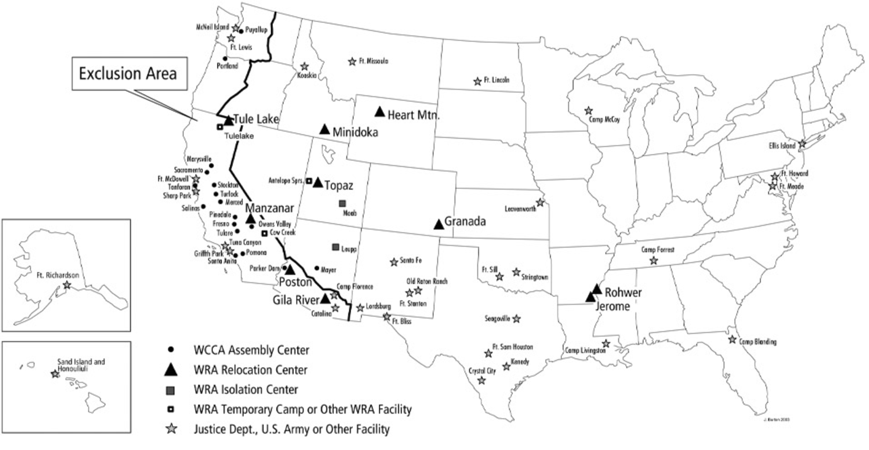
Source: Roger E. Kelly, “America’s World War II Homefront Heritage,” https://www.nps.gov/CRMjournal/Summer2004/article1.html

Source 1
Executive Order 9066 (February 19, 1942)
Franklin Delano Roosevelt

WHEREAS the successful prosecution of the war requires every possible protection against espionage and against sabotage to national-defense…  NOW, THEREFORE, by virtue of the authority vested in me as President of the United States, and Commander in Chief of the Army and Navy, I hereby authorize and direct the Secretary of War, and the Military Commanders…to prescribe military areas…from which any or all persons may be excluded…The Secretary of War is hereby authorized to provide for residents of any such area who are excluded therefrom, such transportation, food, shelter, and other accommodations as may be necessary…  I hereby further authorize and direct the Secretary of War and the said Military Commanders to take such other steps as he or the appropriate Military Commander may deem advisable to enforce compliance with the restrictions…  I hereby further authorize and direct all Executive Departments…to assist the Secretary of War…including the furnishing of medical aid, hospitalization, food, clothing, transportation, use of land, shelter, and other supplies, equipment, utilities, facilities, and services.… | espionage—spying or stealing information for an enemy government  sabotage—destroying property or other objects for an enemy government  prescribe—government-issued rule commanding particular actions
Source: American Presidency Project, http://www.presidency.ucsb.edu/ws/index.php?pid=61698

Questions
1. Which legal document does Roosevelt claim gives him authority to issue Executive Order 9066?

2. Why does Roosevelt say he is issuing Executive Order 9066—what problems is the order trying to combat?

3. What powers does President Roosevelt actually grant to the Secretary of War and Military Commanders?

4. Does Executive Order 9066 specifically mention Japanese Americans or Japanese immigrants?

Source 2
“Korematsu: A Decision That Is Still Questioned Today” (2015)
National Constitution Center

On December 18, 1944, the Supreme Court announced one of its most controversial decisions ever. The Korematsu decision is still controversial, since it allowed the federal government to detain a person based on their race during a wartime situation.  Several years ago, a panel of Supreme Court scholars met at Pepperdine University to discuss what they had determined as the five biggest mistakes made by the Court.  The Korematsu case ranked with the Dred Scott and Plessy v. Ferguson decisions as the worst ever made by the Court.…  To put that in context, the Dred Scott decision said that the descendants of slaves weren’t entitled to protection by the Constitution. The Plessy decision established the “separate but equal” rule that allowed segregation to continue for decades.…  In 2009, Los Angeles Times Supreme Court correspondent David G. Savage wrote in the ABA Journal that Dred Scott, Plessy, and Korematsu were the three Supreme Court decisions that liberals and conservatives agreed were historically bad.  “After that, it depends on which side of the political aisle the experts occupy,” he said.  So what led to the Korematsu decision?  On December 7, 1941, Japanese military forces attacked the United States base in Hawaii without warning. More than 2,000 Americans died in the attack, and a united Congress answered President Franklin Roosevelt’s request for war.  In early 1942, President Roosevelt issued Presidential Executive Order 9066, after fears generated by the Japanese attack made the safety of America's West Coast a priority.  The order started a process that gave the military power to exclude citizens of Japanese ancestry from regions called “military areas.”  Under another provision, called Exclusion Order No. 34, a Japanese-American citizen named Fred Toyosaburo Korematsu was arrested for going into hiding in Northern California after refusing to go to an internment camp.…  Korematsu appealed his conviction through the legal system, and the Supreme Court agreed to hear the case in late 1944.  The court had heard a similar case in 1943, Hirabayashi v. United States, and decided that Gordon Hirabayashi, a college student, was guilty of violating a curfew order.  The Korematsu v. U.S. decision referenced the Hirabayashi case, but it also ruled on the ability of the military, in times of war, to exclude and intern minority groups.  The court ruled by a 6 to 3 vote that the government had the power to arrest and intern Fred Korematsu. Justice Hugo Black, writing for the majority, included a paragraph that is still debated today:  “It should be noted, to begin with, that all legal restrictions which curtail the civil rights of a single racial group are immediately suspect. That is not to say that all such restrictions are unconstitutional.…”  Later in the decision, Black argued the necessity of the military’s decision.  “Korematsu was not excluded from the Military Area because of hostility to him or his race. He was excluded because we are at war with the Japanese Empire, because the properly constituted military authorities feared an invasion of our West Coast and felt constrained to take proper security measures, because they decided that the military urgency of the situation demanded that all citizens of Japanese ancestry be segregated from the West Coast temporarily,” he said.  The three dissenting Justices said Korematsu’s constitutional rights had been clearly violated.  “I dissent, because I think the indisputable facts exhibit a clear violation of Constitutional rights,” said Justice Owen Roberts.  “Such exclusion goes over ‘the very brink of constitutional power,’ and falls into the ugly abyss of racism,” said Justice Frank Murphy. “The broad provisions of the Bill of Rights... are [not] suspended by the mere existence of a state of war. Distinctions based on color and ancestry are utterly inconsistent with our traditions and ideals.” | intern—to confine or imprison a person for an extended period of time  abyss—deep, bottomless chasm
National Constitution Center, https://constitutioncenter.org/blog/korematsu-a-decision-that-will-live-in-infamy/
Questions
5. Did the US Supreme Court uphold or overturn Executive Order 9066?

6. Does this article characterize the Court’s decision in Korematsu as a good or bad decision? Support your answer with at least 2 pieces of evidence from the text.

7. Why, according to Justice Hugo Black and the majority of the court, was the federal government justified in excluding Japanese Americans from American society? Support your answer with at least 2 pieces of evidence from the text.

8. Why, according to Justice Owen Roberts, was majority wrong to support the government actions against Japanese Americans? Support your answer with at least 2 pieces of evidence from the text.

Part 2. The Emancipation Proclamation
The Emancipation Proclamation, Abraham Lincoln’s famous 1863 order ending slavery in states and territories still in open rebellion against the Union, is usually understood in the context of abolition. In the words of Frederick Douglass, the Emancipation Proclamation was “the first step on the part of the nation in its departure from the thralldom of the ages.” This is how most history textbooks teach the Proclamation—as a crucial step in Lincoln’s eventual embrace of abolition, and thus as a critical step towards ratification of the 13th Amendment. For these reasons the Proclamation will forever hold a central place in US history.

However, the Emancipation Proclamation also plays an important role in another facet of US history. In addition to playing a key role in history of the Civil War, the Proclamation also plays a key role in the evolution of the presidency and executive branch. One of the most ambitious executive actions in presidential history, Lincoln, unlike Roosevelt, used the powers of the presidency to expanded rather than restrict personal liberty.

Source 3
Emancipation Proclamation (1863)
Abraham Lincoln

Whereas on the 22d day of September, A.D. 1862, a proclamation was issued by the President of the United States.…  “That on the 1st day of January, A.D. 1863, all persons held as slaves within any State… the people whereof shall then be in rebellion against the United States shall be then, thenceforward, and forever free; and the executive government of the United States, including the military and naval authority thereof, will recognize and maintain the freedom of such persons and will do no act or acts to repress such persons, or any of them, in any efforts they may make for their actual freedom.…  “Now, therefore, I, Abraham Lincoln, President of the United States, by virtue of the power in me vested as Commander in Chief of the Army and Navy of the United States in time of actual armed rebellion against the authority and Government of the United States, and as a fit and necessary war measure for suppressing said rebellion, do, on this 1st day of January, A.D. 1863, and in accordance with my purpose so to do, publicly proclaimed for the full period of one hundred days from the day first above mentioned, order and designate as the States and parts of States wherein the people thereof, respectively, are this day in rebellion against the United States the following…  And I further declare and make known that such persons of suitable condition will be received into the armed service of the United States to garrison forts, positions, stations, and other places and to man vessels of all sorts in said service.  And upon this act, sincerely believed to be an act of justice, warranted by the Constitution upon military necessity, I invoke the considerate judgment of mankind and the gracious favor of Almighty God.  In witness whereof I have hereunto set my hand and caused the seal of the United States to be affixed. | thenceforward—from this time on  garrison—guard, defend  affix—stick, attach, or fasten something to something else
Source: American Presidency Project, http://www.presidency.ucsb.edu/ws/?pid=69880

Questions
9. Which legal document(s) does Lincoln claim gives him authority to issue the Emancipation Proclamation?

10. Why does Lincoln say he is issuing Executive Order 9066—what problems is the order trying to combat?

11. What powers does Lincoln grant to the military and naval authorities?

12. Why did Lincoln abolish slavery by presidential proclamation rather waiting to work with Congress on legislation, or a constitutional amendment?

Source 4
“Like the Emancipation Proclamation, Obama’s Order Forces Democracy”
Los Angeles Times, November 21, 2014

Just months before the Election of 2012, President Barack H. Obama issued a series of executive actions that resulted in the creation of a program called Deferred Action for Childhood Arrivals (DACA). DACA was an immigration program established by Obama to allow DREAMers—undocumented immigrant Americans brought to the United States as young children—to work legally in the US and protect them from deportation. Obama took these actions after the House of Representatives refused to pass the bipartisan DREAM Act, an immigration reform law passed by the Senate that would have provided a path to permanent residency and citizenship to DREAMers. In 2014, Obama issued new directives to expanded DACA. Expansion of DACA was highly controversial, and was overturned in federal court after Texas and number of other states sued the federal government to stop expansion of the program.

The op-ed below, which is written by Bruce Ackerman, a professor of law and political science, analyzes Obama’s expansion of DACA in 2014 by comparing it to Lincoln’s Emancipation Proclamation.

Abraham Lincoln’s Emancipation Proclamation provides the foundational precedent for President Obama's executive order on immigrants in the country illegally.  Before Lincoln issued his pronouncement in September 1862, congressional majorities had expressly affirmed that the war effort only aimed “to preserve the Union” without “overthrowing… established institutions” in the rebel states. The proclamation was an act of executive unilateralism, and as Obama has done in his order, Lincoln limited its scope in recognition of this fact. As a result, both proclamations serve only to initiate, rather than preempt, further democratic debate and decision.  Lincoln did not try to free any blacks in the four slave states that remained loyal to the Union. Nor did he even liberate slaves in the Southern areas under federal control. Instead, the proclamation only affected those areas that remained in active rebellion on New Year's Day 1863.  Even where it applied, it did not commit the country to unconditional emancipation. Lincoln acted only in the name of “military necessity,” leaving it unclear whether Southern states could constitutionally reinstate slavery once the fighting came to an end. As the war wound down, many wanted to defer this issue for at least five years. But the proclamation prevented this evasion, forcing the question to the center of public attention.…  The subsequent enactment of the [13th Amendment]…however, did not conclude the debate that Lincoln had begun. In his proclamation, he promised to “recommend” that all “loyal” citizens “be compensated for all losses… including the loss of slaves.” This recommendation provoked a further round of argument that only ended in 1868 when the 14th Amendment rejected Lincoln's proposal, expressly denying all compensation to slaveholders for their newly emancipated freedmen.  Particulars in Obama's proclamation may well be changed by Americans over time. But like Lincoln’s, its provisional and limited character will have a democracy-forcing effect — spurring officials and citizens to more actively engage in a constitutional dialogue.  Rather than refusing to follow the Constitution and “take care that the laws be faithfully executed,” the president emphasizes that he will continue deportations, using all the budgetary resources Congress has provided.…Given this fact, Obama's initiative has a constitutionally legitimate purpose: to prevent Homeland Security from wasting its scarce resources on breaking up innocent families when it could be targeting immigrants who deserve expeditious removal.…  The democracy-forcing aspect of Obama's initiative distinguishes it from other recent exercises in executive unilateralism.…  But they should not confuse the issue by denouncing the president as imperial when he is engaging in democracy-enhancing actions fully consistent with his [constitutional] obligation to “take care that the laws be faithfully executed.” | unilateralism—to act alone or without support from others; in this case, the executive acting alone or independent of the legislative branch  preempt—to take action to keep or prevent something from happening  defer—to delay or put off until another time  provisional—arranged for the present, but with idea of being changed later  expedite—to act quickly and efficiently
Source: Los Angeles Times, http://www.latimes.com/opinion/op-ed/la-oe-ackerman-obama-immigration-20141123-story.html

Questions

13. What is the main claim of this op-ed—does the author claim that the Emancipation Proclamation and Obama’s DACA program are examples of good forms of executive action or bad examples of executive action? Provide at least 2 pieces of evidence in your response.

14. In what ways did Lincoln limit the scope of the Emancipation Proclamation? Provide at least 2 pieces of evidence in your response. Provide 2 examples in your response.

15. In what ways did Obama limit the scope of his actions creating and expanding DACA? Provide at least 2 pieces of evidence in your response. Provide 2 examples in your response.

Part 3. Presidential Memorandum Regarding Construction of the Dakota Access Pipeline
Executive actions go back deep into the history of the presidency, and are a critical instrument in how presidents manage the federal government. However, they can prove highly controversial and divisive, particularly if the electorate is highly polarized, or divided, as it is today.

In addition to his temporary travel ban on certain groups of Muslims, one of Trump’s more divisive executive actions concerns the presidential memorandum he issued on the Dakota Access Pipeline, an underground pipeline being constructed between North Dakota and Illinois. Construction began in 2016, but was halted after multiple Native American tribes, including the Standing Rock Sioux, protested the pipeline on the grounds that it would pollute the tribe’s land and water supplies. In December 2016, the US Army Corps of Engineers—a federal agency that builds major infrastructure projects—announced that the project would be suspended until alternate routes could be located. Four days after taking office, Trump issued a presidential memorandum to speed up the Corps of Engineers’ review. A week and a half later, the Corps announced it had dropped its review and offered final approval for the project.

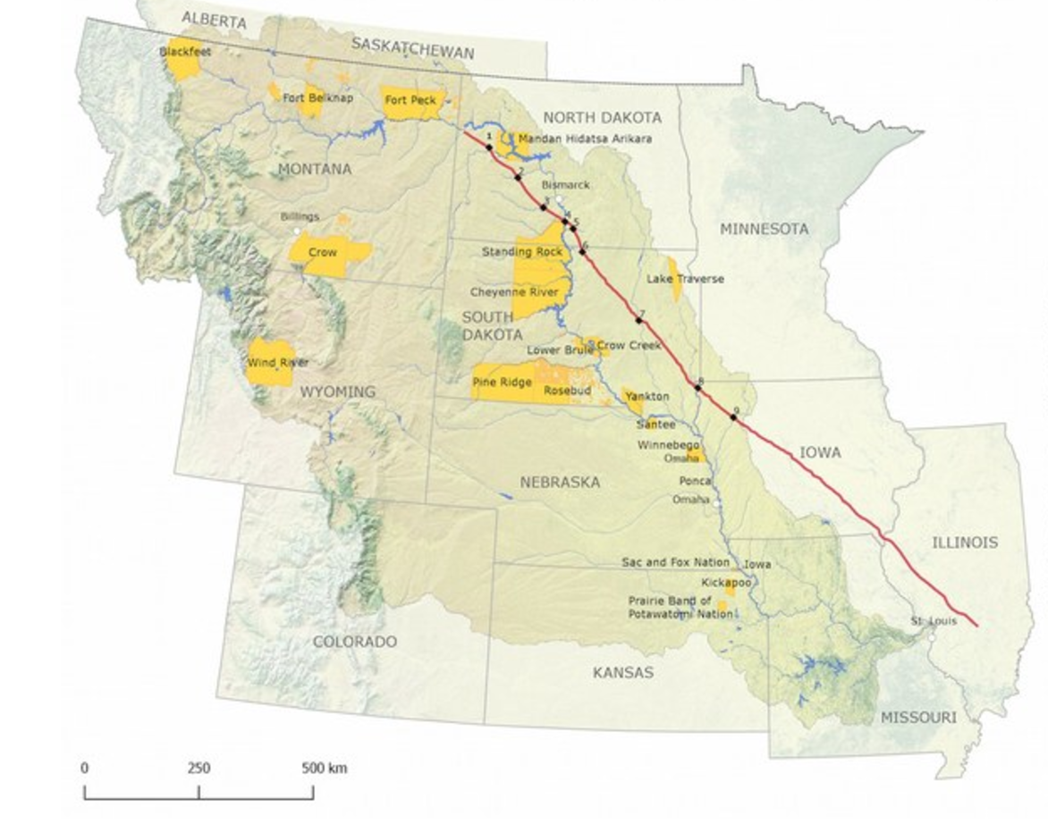
Map of the Dakota Access Pipeline (High Country News)

Source 5
Presidential Memorandum Regarding Construction of the Dakota Access Pipeline (January 24, 2017)
Donald J. Trump

Section 1. Policy. The Dakota Access Pipeline (DAPL) under development by Dakota Access, LLC, represents a substantial, multi-billion-dollar private investment in our Nation's energy infrastructure. This approximately 1,100-mile pipeline is designed to carry approximately 500,000 barrels per day of crude oil from the Bakken and Three Forks oil production areas in North Dakota to oil markets in the United States. At this time, the DAPL is more than 90 percent complete across its entire route. Only a limited portion remains to be constructed.  I believe that construction and operation of lawfully permitted pipeline infrastructure serve the national interest.  Accordingly, pursuant to the authority vested in me as President by the Constitution and the laws of the United States of America, I hereby direct as follows:  Sec. 2. Directives. (a) Pipeline Approval Review. The Secretary of the Army shall instruct the Assistant Secretary of the Army for Civil Works and the U.S. Army Corps of Engineers (USACE), including the Commanding General and Chief of Engineers, to take all actions necessary and appropriate to:  (i) review and approve in an expedited manner, to the extent permitted by law and as warranted, and with such conditions as are necessary or appropriate, requests for approvals to construct and operate the DAPL… | infrastructure—large social and economic systems  like highways, railroads, power lines, pipelines, and buildings  expedite—to act quickly and efficiently
Source: WhiteHouse.gov, https://www.whitehouse.gov/the-press-office/2017/01/24/presidential-memorandum-regarding-construction-dakota-access-pipeline

Protesters march in 2016 against the construction of the Dakota Access Pipeline.

Questions

16. Which legal document(s) does Trump cite as giving him authority to issue this presidential memorandum?

17. Why does Trump say he is issuing this presidential memorandum—what justification(s) does he offer for reversing Obama’s previous policy?

18. Why would Trump address this issue through presidential memorandum rather than work with Congress on drafting a law? Read the text for clues and provide at least 1 pieces of evidence from the text or introduction in your response.

Source 6
“The Surprisingly Contentious History of Executive Orders”
Huffington Post, February 2, 2017

Recently, USA Today savaged President Trump’s executive orders since taking office, from encouraging Keystone XL approval to altering immigration policy, as an “unprecedented blizzard.” In 2014, the Washington Post raked President Obama for his Deferred Action immigration directives, more commonly called DACA and DAPA, deeming them “unprecedented” and “sweeping,” while Ted Cruz published an op-ed in the Wall Street Journal lashing Obama’s “imperial” executive order hiking the minimum wage for federal contractors as one with “no precedent.” A 2009 piece in Mother Jones lamented a President George W. Bush executive order allowing former-presidents and their families to block the release of presidential records as — you guessed it — “unprecedented.”  …But the reality is that presidents have long employed executive actions to accomplish strikingly controversial objectives without congressional approval.…  President Lincoln issued 42 executive orders. His General War Order 1 sent Union troops to war against “insurgent forces”…[and] The Emancipation Proclamation…was both a presidential proclamation and an executive order.…  President Franklin Roosevelt, in contrast, issued nearly 4,000 executive orders. His Executive Order 9066 authorized the removal of any people from military areas “as deemed necessary or desirable.” The military would later define the entire U.S. West Coast as a “military area,” and order the removal of Japanese-Americans to internment camps. (Congress approved funding for internment by statute several months later, after only an hour and a half of debate.)  President Reagan issued 381 executive orders; his Executive Order 12333 established the National Security Agency. President Clinton issued 364 executive orders, including Executive Order 13166, which declared the former Yugoslavia a “combat zone” and initiated military action in Kosovo. The dozen years of both President Bushes saw 457 executive orders on issues ranging from the collapse of the Soviet Union to the War on Terror.  President Obama issued 277 executive orders during his eight-year tenure, which is the fewest for any two-term president since Grover Cleveland.…  Obama also utilized presidential memoranda and proclamations to accomplish significant goals, and to a somewhat greater extent than prior presidents — Obama probably issued about a third more memoranda than his immediate predecessor, President Bush, and perhaps as many as his executive orders. But presidential memoranda aren’t all counted or published, so it’s hard to know how many either issued precisely. Obama’s published memoranda designated Alaskan coasts off-limits to drilling, altered immigration policy for “Dreamers,” and set government research priorities.…  Executive actions can be, and often are, repealed. A new president can simply issue a new executive order or memorandum that withdraws or replaces a previous one. Congress can also legislate to overturn an executive order, or refuse to fund an executive action that requires funding.  The courts have served as an occasional forum for challenging executive orders.…  In his first dozen days in office, Trump signed 18 public executive orders and memoranda. Some were long expected and others rather humdrum…  To be sure, Trump’s 18 executive actions are one less than President Obama’s 19 during the same two-week period. But what is clearly novel is that Trump is making a much bigger and more aggressive show of his early executive actions. Unlike Obama, who tended to sign executive actions privately, Trump likes big signing ceremonies in the Oval Office.…  Ultimately, cries of “unprecedented” executive action on both sides are more histrionic than historical. Yet because they are so easily overturned, repealed, or limited by law, presidents have wisely preferred legislation to executive actions when crafting policy. | savage—sharply criticize  lament—passionate expression of grief or sorrow  humdrum—dull or monotonous, lacking excitement
Source: Huffington Post, http://www.huffingtonpost.com/entry/the-surprisingly-contentious-history-of-executive-orders_us_58914580e4b04c35d583546e

Questions

19. Which president, according to this article, issued the most executive orders?

20. Which form of executive action did Obama use most—executive orders or presidential memoranda?

21. In what ways does Trump’s use of executive actions differ from that of Obama’s?

22. Why does the author claim that presidents generally prefer to work with Congress on passing laws rather than taking executive actions? Provide at least 2 examples from the text.
Final Activity

Executive actions like executive orders, presidential memoranda, and proclamations are an important, but often misunderstood, feature of American government. Every president, beginning with George Washington, has issued executive actions; although, the number of executive actions has increased significantly since Washington’s days. Whereas Washington only issued a total of eight during his entire time in office, Donald Trump issued almost eighty separate actions during his first 100 days in office.

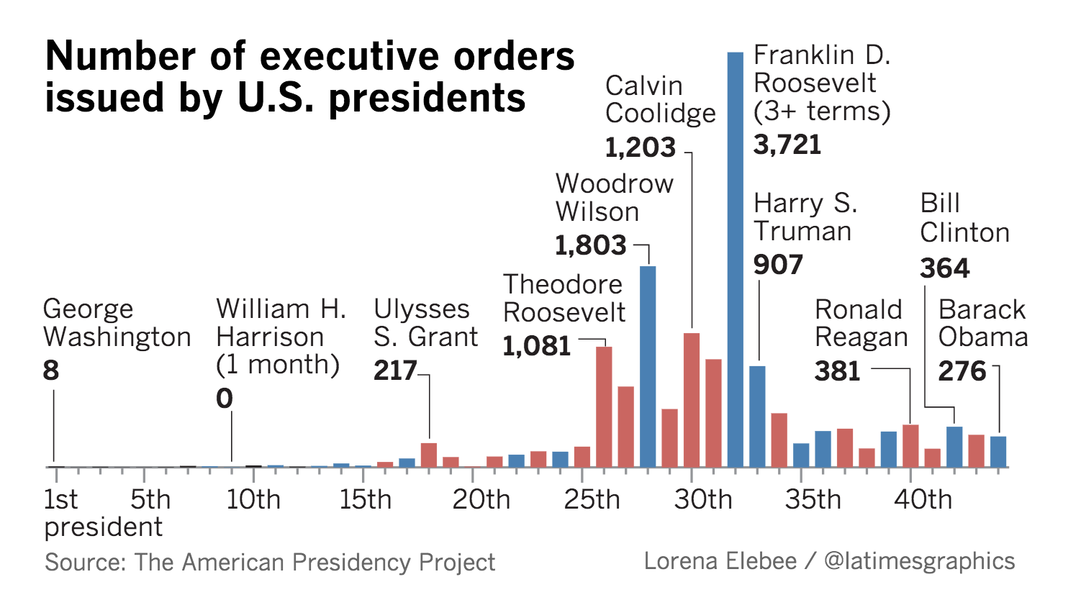
Source: LA Times, http://www.latimes.com/nation/la-na-pol-executive-orders-2017-story.html

For this final activity, your task is to assess the the executive actions of President Trump. To complete the activity, click on the link and then follow the steps below.

https://www.whitehouse.gov/briefing-room/presidential-actions

Step 1. Browse the executive actions of Donald Trump—click on the link above and then browse the master list of actions; or, for a smaller list, click on the “Executive Orders,” “Presidential Memoranda,” or “Proclamations” buttons on the left-hand side of the screen.

Step 2. Choose an executive action issued by Trump since January 20, 2017.

Step 3. Break down the action using the graphic organizer below.

Step 4. Assess the action and analyze why Trump used executive authority for that particular issue.

Things to consider:

Is Trump’s action well within the bounds of executive authority?

Or, going back to the lesson introduction, does it does it amount to executive legislation—a power grab by the president and thus better left to the legislature?

Step 5. Pull all your notes together and write a short essay (400-500 words) that introduces the executive action, describes the basic features and aims of the action, and analyzes whether or not the action is within executive authority or an example of executive legislation, or a potential power grab on the part of the president.

Trump Executive Action Rewrite
Title of Action
Type of Action
(i.e. order, proclamation, or memorandum)
Legal Basis of Action
Justification/Basis of Action
Key Facts/Supporting Information
Key Fact/ Supporting Information
Key Fact/ Supporting Information
Assessing Reasons for Executive Action
Reason for Executive rather than Legislative Action
Reason for Executive rather than Legislative Action
Reason for Executive rather than Legislative Action

