Why is there a Federal Reserve bank? Do most Americans know what the Fed is and what it does?
Topics: Federal Reserve System; History of the Federal Reserve
Erik Altenbernd, UC Irvine History Project

History Standards
12.3 Students analyze the influence of the federal government on the American economy.
12.3.4 Understand the aim and tools of monetary policy and their influence on economic activity (e.g. the Federal Reserve).

CCSS Standards: Reading, Grades 11-12
RH 1. Cite specific textual evidence to support analysis of primary and secondary sources, connecting insights gained from specific details to an understanding of the text as a whole.
RH 2. Determine the central ideas or information of a primary or secondary source; provide an accurate summary that makes clear the relationships among the key details and ideas.
RH4. Determine the meaning of words and phrases as they are used in a text, including analyzing how an author uses and refines the meaning of a key term over the course of a text…
RH7. Integrate and evaluate multiple sources of information presented in diverse formats and media (e.g. visually quantitatively, as well as in words) in order to address a question or solve a problem.
RH9. Integrate information from diverse sources, both primary and secondary, into a coherent understanding of an idea or event, noting discrepancies among sources.

CCSS Standards: Writing, Grades 11-12
WH 1. Write arguments focused on discipline-specific content.
WH2. Write informative/explanatory texts, including the narration of historical events, scientific procedures/experiments, or technical processes.
WH4. Produce clear and coherent writing in which the development and organization, and style are appropriate to the task, purpose, and audience.
WH7. Conduct short as well as more sustained research projects to answer a question (including a self-generated question) or solve a problem; narrow or broaden the inquiry when appropriate; synthesize multiple sources on the subject, demonstrating understanding of the subject under investigation.

Inquiry Questions
Why is there a Federal Reserve bank?
Do most Americans know what the Fed is and what it does?

Overview of Lesson
This lesson examines the history of the Federal Reserve, with particular focus on the modern (post-1970s) Fed and its dual mandate to moderate inflation and unemployment. The lesson includes a detailed introduction about the Fed as well as sections on the dual mandate, why and when the Fed raises and lowers the federal funds rate (i.e. interest rates), Fed policy before and during the Great Depression, Fed policy during stagflation during the 1970s and 1980s, and Fed policy during the Great Recession. The final activity includes a poster activity that requires the students to synthesize what they’ve learned about the Fed and interview a friend or family member about the Fed and its activities.

The organization of the lesson is as follows:
- Introduction
- The Dual Mandate
- When and why does the Fed raise or lower interest rates?
- The Fed and the Great Depression of the 1930s
- The Fed and Stagflation of the 1970s
- The Fed and the Great Recession of 2007-2009
- Final Activity

Documents
- “The Dual Mandate Bullseye,” Chicago Fed (chart)
- “The Dual Mandate Bullseye,” Chicago Fed (excerpt)
- “The Dual Mandate Bullseye,” Chicago Fed (chart)
- “Q&A: How a Key Fed Interest Rate Affects the Economy,” Los Angeles Times (excerpt)
- “1929 Stock Market Crash,” History Channel (video)
- “The and Now: Fed Policy Actions During the Great Depression,” St. Louis Fed (excerpt)
- “Stagflation in the 1970s,” Philadelphia Fed (video)
- “Graph of the Great Inflation of the 1970s and 1980s,” FederalReserveHistory.org, (graph)
- “Causes of the Great Inflation, 1965-1982,” FederalReserveHistory.org (excerpt)
- “Fed’s Response to the Great Inflation, 1965-1982,” FederalReserveHistory.org (excerpt)
- “Federal Reserve Leaders and the Federal Funds Target Rate, 1979-2016,” New York Times (graph)
- “Causes of the Great Recession,” Marginal Revolution University (video)
- “Fed’s Response to the Great Recession,” FederalReserveHistory.org (excerpt)
- “Q&A: How a Key Fed Interest Rate Affects the Economy,” Los Angeles Times (excerpt)

Teacher Outline of Final Activity
The final activity for the lesson is a poster activity that also requires each student to interview at least one person about the duties, actions, and history of the Federal Reserve.

The protocol for the assignment is as follows:

Step 1. Why is there a Federal Reserve bank? Write an “elevator” pitch/summary of the Fed that explains what it does and some of the key moments from its history. (“Elevator pitch” is a term used for a short summary of a complex topic—a summary short enough that you could get through the whole thing in the brief period of time you might talk to someone in an elevator.) Again, your description should be short—100 to 200 words—and written for someone who might be foggy about the Fed, its activities, and its history.

- Brainstorm what you have learned about the activities of the Fed and its history.
- Organize your information into bullet points or categories of information using the graphic organizer below.
- When appropriate link the Fed’s main activities to key events from its history.
- Highlight the activities and events you think are most important.
- Then write your elevator summary/pitch using the activities and events you think are most important.

Step 2. Do most Americans know what the Fed is and what it does? As a group, interview three people (friends, family members, etc.) about the what they know about the Federal Reserve and what it does. NOTE: Each group member will interview one person.
- Take your “Brainstorming the Fed” graphic organizer with you to your interview.
- Be sure to have your elevator pitch on hand in the event your subject doesn’t know what the Fed is and/or asks you to explain what it is and what it does.
- Also take your additional notes regarding the Fed so that you have them on hand in case your interviewee asks follow-up questions about the Fed and its activities and history.
- Conduct your interview using the “Fed Interview” form. Feel free to modify the questions on the form or add questions to the blank boxes (Questions 6 & 7).
- Write down your interviewees responses and other notes taken during the interview on the “Fed Interview” form.

Step 3. With your group partners, assemble a poster that illustrates your work: what you’ve learned about the Fed and its history, and the data you acquired from your interviews. Be sure your poster answers the inquiry questions: Why is there a Federal Reserve bank? Do most Americans know what the Fed is and what it does?

Introduction
The Federal Reserve System is the central bank of the United States, and thus one of the most influential parts of the federal government. Despite its tremendous influence, the Federal Reserve, or “Fed,” as it is often called, is also one of the least understood parts of the federal government.

Almost all advanced industrial nations have a central bank: the Bank of England is the central bank of the United Kingdom; the European Central Bank is the central bank of the European Union; and the People’s Bank of China is the central bank of the People’s Republic of China.

But what is a central bank? What does a central bank do?

Like all central banks, the main job of the Fed is to manage the nation’s monetary policy. In contrast to fiscal policy—which is managed by Congress and the president and focuses on taxation and government spending (i.e. the federal budget)—monetary policy focuses on the supply of money across the whole nation rather than just within the federal government.

Today, the Fed manages US monetary policy in three main ways.
- First, the Fed aims to foster an economic climate where the price of goods remains stable (i.e. an economic climate with low inflation).
- Second, the Fed aims to foster economic conditions that lead to maximum employment (i.e. low unemployment).

These tasks—managing inflation and unemployment—are often referred to as the Fed’s “dual mandate.”

- The third way the Fed directs monetary policy is through the regulation of the federal funds rate, the interest rate banks charge other banks for short-term loans. One of the Fed’s key policy tools, regulation of the federal funds rate allows the Fed to regulate not just short-term interest rates, but long-term rates and other financial assets as well.

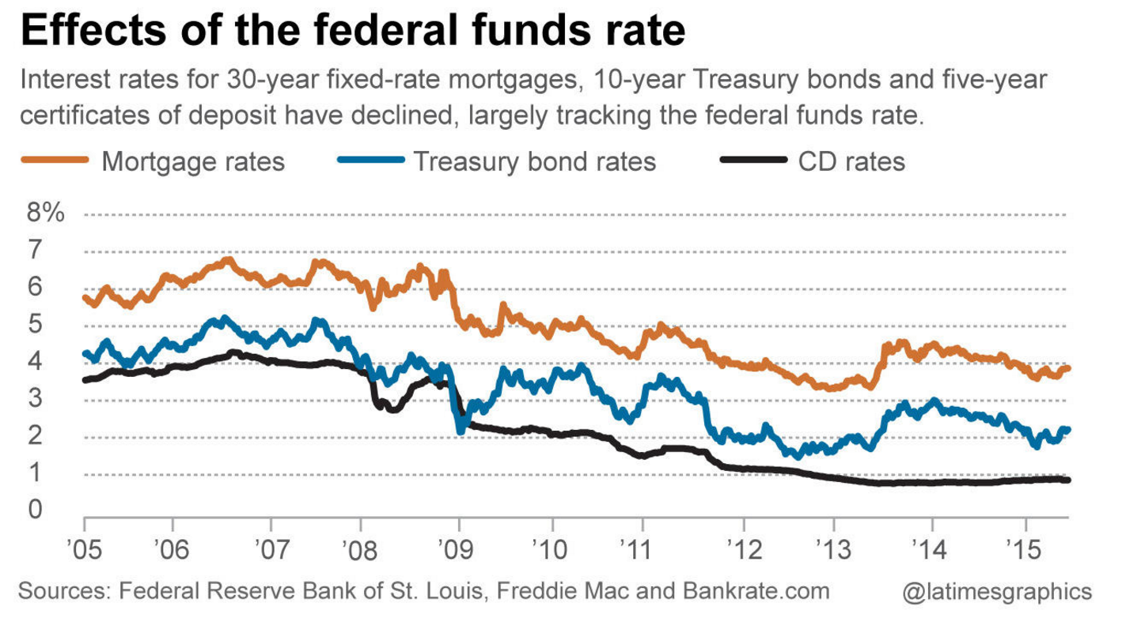
Source: LA Times, http://www.latimes.com/business/la-fi-fed-interest-rate-qa-20150615-story.html
The ability to regulate the federal funds rate gives the Fed tremendous power and authority. However, to understand how the Fed regulates monetary policy and the national economy, it is important to understand how the Fed is organized.

The Federal Reserve was created by the Federal Reserve Act of 1913 and grew in importance over the course of the twentieth century. It was designed by Congress to have autonomy from the legislative and executive branches. For instance, Congress does not appropriate money for the Fed, which means the Fed receives no money out of the federal budget. The Fed generates revenue primarily from federal securities such as bonds, interest on loans issued to private banks, fees for services provided to private banks, and investments in foreign currency. All net income generated by the Fed is turned over to the US Treasury.

Another part of the Fed’s independence is found in its organizational structure. Despite the fact that it is the central bank of the US, the Fed—much like the federal government itself—was designed to be decentralized. The Fed is organized around a central governing body and twelve semi-independent (and semi-private/semi-public) banks. The central governing body of the Federal Reserve System is the Board of Governors, an independent government agency located in Washington, DC. Members of the Board of Governors are appointed by the president and confirmed by the US Senate, and serve 14-year terms that are staggered so that the terms end one after another. The Board is made up of seven members. One member of the board serves as Chair of the Board of Governors and, thus, as head of the entire Federal Reserve System. The current Chair of the Board of Governors is Janet Yellen.

The Fed was organized in this way, and set up to operate according to its own budgets, so that it could be “independent within the government.” All of the Fed’s activities—and all of the decisions its officers make—are made independently of Congress and the president.

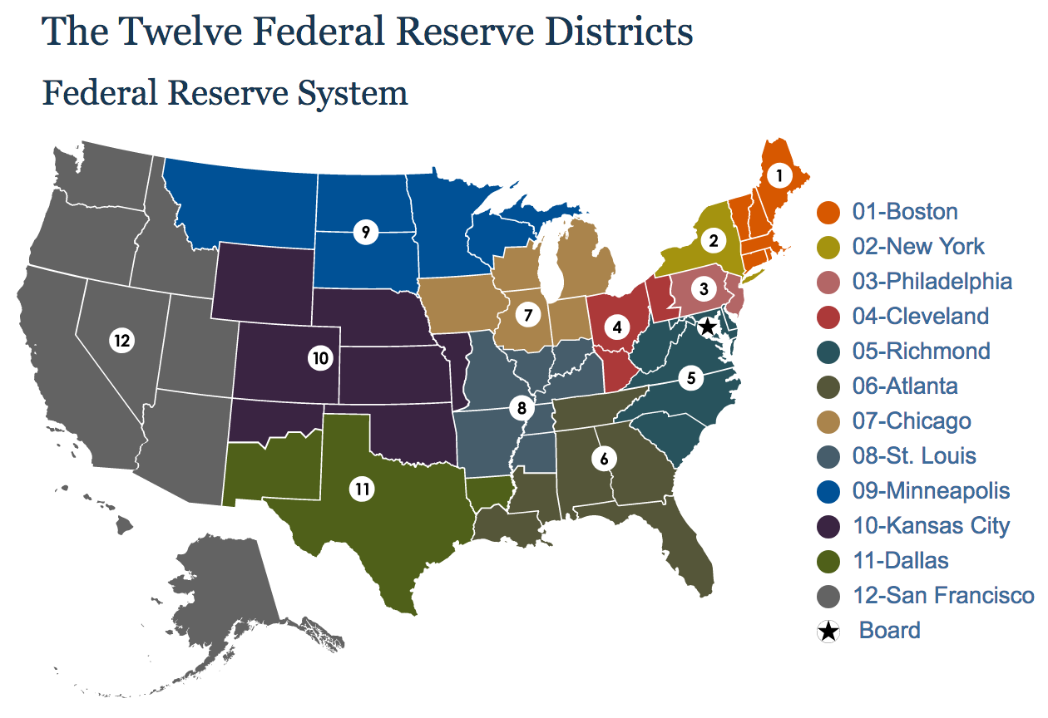
Source: FederalReserve.gov, https://www.federalreserve.gov/aboutthefed/federal-reserve-system.htm
The semi-private part of the Federal Reserve System is comprised of the Federal Reserve Banks. In all, there are twelve Federal Reserve Banks. Each bank is incorporated and organized independently of the Federal Reserve Board of Governors and located in a major city within the Central Bank’s district. The Federal Reserve bank for the Twelfth District, which includes California and all the other states west of the Rocky Mountains, is located in San Francisco. Each Federal Reserve Bank operates like a private commercial bank. Also, all commercial banks located in the Federal Reserve Bank’s region that are members of the Federal Reserve System own stock in the regional Federal Reserve Bank. Thus, each Federal Reserve Banks is designed to be not only responsive to the needs of local and regional banks, but to blend the interests and actions of a public central bank and a private commercial bank.

The Federal Reserve Banks provide a number of services for all the banks located in their respective territory: they provide reserve accounts to individual banks, issue loans to individual banks, take coin and currency in and out of circulation, and process checks and other payments. In many ways Federal Reserve Banks are normal banks, except for the fact that they do business with banks rather than people. They are, in other words, the banks behind the banks—the banks of the banking industry.

Finally, another key part of the Fed is the Federal Open Market Committee (FOMC). It is the FOMC that determines US monetary policy. It is the FOMC that manages the federal funds rate, and thus whether to increase or decrease short-term interest rates and, by extension, the overall cost and availability of credit in the US economy. The FOMC is made up of twelve members: seven members from the Board of Governors and five of the twelve Reserve Bank presidents. The Chair of the Board of Governors also serves as head of the FOMC. The FOMC usually meets eight times a year in Washington, DC.

Meeting of Federal Open Market Committee in Washington, DC with current Fed Chair Janet Yellen.
Part 1. The Federal Reserve’s Dual Mandate
The Federal Reserve was created by the Federal Reserve Act of 1913. Since that time, Congress has passed several laws altering the organization and mission of the Federal Reserve. During the era of stagflation in the late 1970s, Congress passed a series of laws to give the Fed its current “dual mandate” promoting the “goals of maximum employment” and “stable prices.” Sources 1-3 explain how the Fed interprets its dual mandate and adjusts monetary policy to achieve low inflation and low unemployment.

Source 1
Federal Reserve Bank of Chicago
“The Dual Mandate Bullseye” Chart

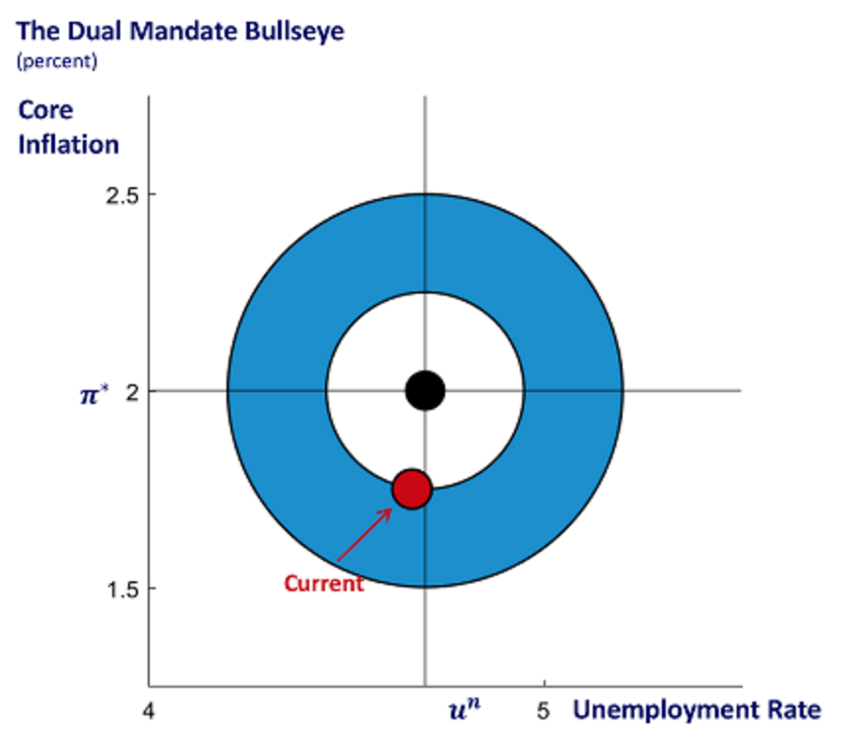
ChicagoFed.org, https://www.chicagofed.org/research/dual-mandate/the-bullseye-chart

Source 2
Federal Reserve Bank of Chicago
“The Federal Reserve’s Dual Mandate”

The monetary policy goals of the Federal Reserve are to foster economic conditions that achieve both stable prices and maximum sustainable employment.

Our two goals of price stability and maximum sustainable employment are known collectively as the “dual mandate.” The Federal Reserve's Federal Open Market Committee (FOMC), which sets U.S. monetary policy, has translated these broad concepts into specific longer run goals and strategies.

Price Stability
The Committee judges that inflation at the rate of 2 percent, as measured by the annual change in the price index for Personal Consumption Expenditures (PCE), is most consistent over the longer run with the Federal Reserve's statutory mandate. The Committee has also explicitly noted that…“would be concerned if inflation were running persistently above or below this objective.”

Maximum Sustainable Employment
Information about FOMC participants’ estimates of the longer-run normal rate of unemployment consistent with the employment mandate can be found in the Summary of Economic Projections (SEP). Most recently, the median Committee participant estimated this rate to be 4.7 percent.
ChicagoFed.org, https://www.chicagofed.org/research/dual-mandate/dual-mandate#note3

Questions for Sources 1 & 2

1. What is the “dual mandate” of the Federal Reserve? In 2-3 sentences, explain the dual mandate in your own words.

2. What percentage does the Federal Reserve's Federal Open Market Committee judge to be the optimal rate of inflation?

3. What percentage does the FOMC judge to be the optimal rate of unemployment?

4. What according to the Bullseye Chart (Source 1) is the current rate of inflation and unemployment in the United States?

5. Are the current rates of inflation and unemployment below or above the FOMC’s target numbers?

Source 3
Federal Reserve Bank of Chicago
“The Federal Reserve’s Dual Mandate”

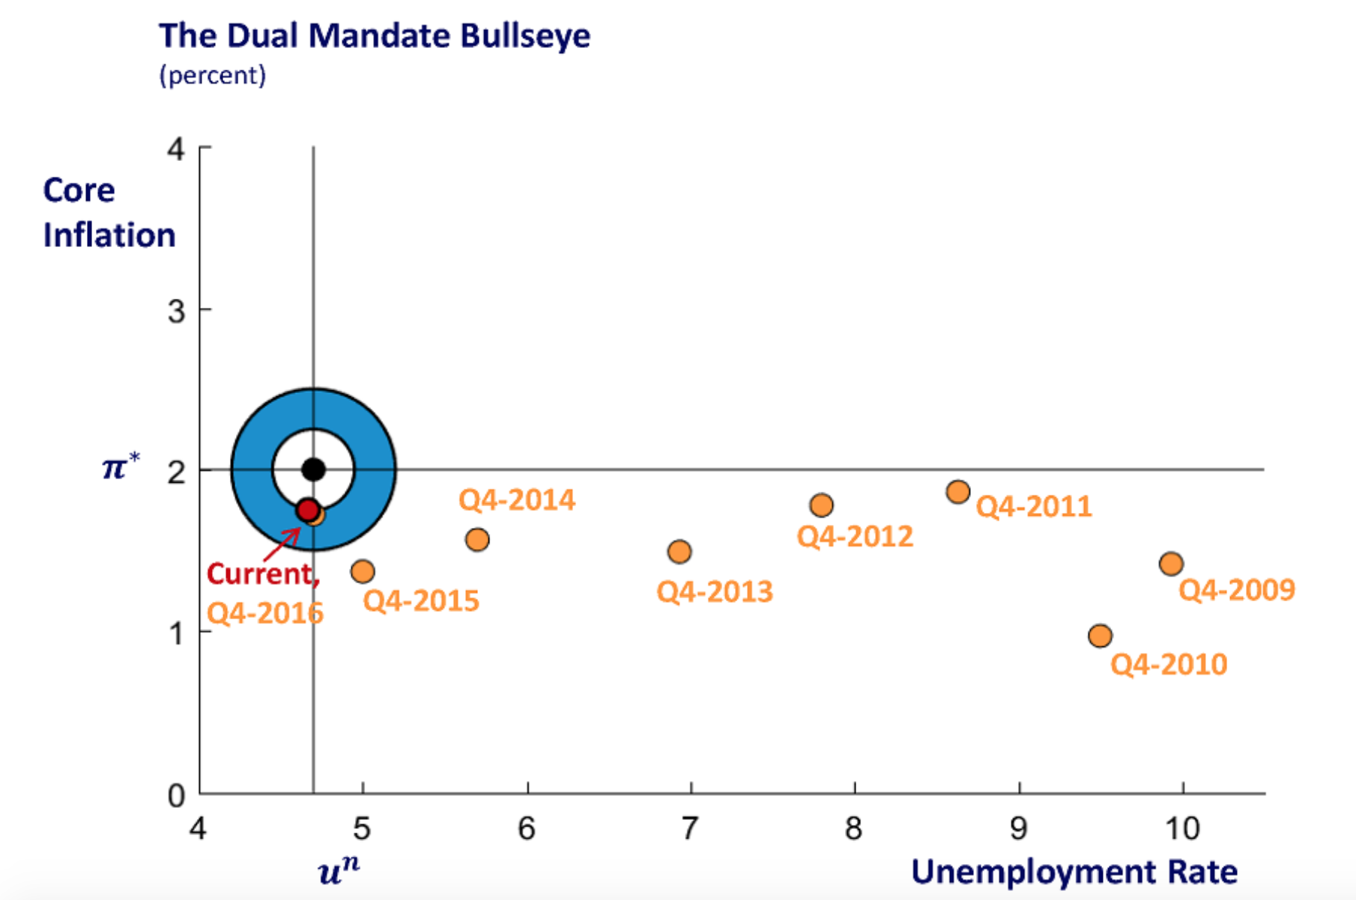
ChicagoFed.org, https://www.chicagofed.org/research/dual-mandate/dual-mandate#note3

Questions

6. How does this bullseye chart (Source 3) differ from the bullseye chart above (Source 1)? Explain your answer in 1-2 sentences.

7. What date range is reflected on the bullseye chart in Source 3?

8. Which year and fiscal quarter represents the worst deviation from the FOMC’s optimal rate of inflation and unemployment?

9. Has the economic recovery since the fourth quarter of 2009 been a steady, straight-line recovery? Use a pen or pencil to connect the dots between the different fiscal quarters represented on this bullseye chart, and then explain your answer in 2-3 sentences.

Part 2. When and why does the Fed raise or lower interest rates?
As discussed in the introduction, one of the ways the Fed seeks to move the economy closer to its target of 2 percent inflation and 4.7 percent unemployment is by raising and lowering the interest rates of the federal funds rate. The Fed usually lowers interest rates when the economy is in recession—an economic decline defined by a fall of Gross Domestic Production over two successive quarters—and raises interest rates when inflation—the general price of goods and services—rises at a rate of two percent. The Fed can also lower interest rates if inflation is lower than two percent. These general policies were put into place due to high unemployment during the Great Depression and high inflation during the 1970s. The policy of adjusting interest rates to manage inflation is often referred to as the Taylor Principle, after the economist John B. Taylor.

Source 4
“Q&A: How a Key Fed Interest Rate Affects the Economy”
Los Angeles Times, June 15, 2015

Exactly what interest rate is the Fed looking to raise?
When people talk about the Fed raising interest rates, they are referring to the federal funds rate.

Banks are required to hold a set amount of reserves at the Fed. Those reserves are known as federal funds.

The reserves fluctuate daily. So banks that have a surplus can lend the money overnight to banks with less than the required amount of reserves. The rate at which banks make those loans is the federal funds rate.

How does the Fed control the federal funds rate?
The 12-member Federal Open Market Committee, which includes the seven members of the Fed's board of governors, votes to set a target for the federal funds rate based on economic conditions.

Normally the target is a specific interest rate. But since December 2008, the federal funds target has been a range — zero to 0.25% — because the Fed wanted to get the rate as low as possible without causing practical problems that would come with paying no interest on bank reserves.

The daily figure, known as the effective rate, has fluctuated from 0.07% to 0.22% since then.

Why does the Fed manipulate the federal funds rate?
The Fed moves the rate up or down to try to keep the economy running smoothly. Its effort is part of the mandate from Congress to enact policies that provide maximum employment, stable prices and moderate long-term interest rates.

If the economy is struggling, the federal funds rate is reduced to lower bank borrowing costs in hopes of stimulating activity. If the economy is overheating, the rate is increased to make borrowing more expensive and keep inflation from rising too much.

One of the most notable rate changes came in 1980-81 when Fed policymakers raised the target as high as 20% to curb runaway inflation. Conversely, the Great Recession spurred the Fed to lower the target rate for the first time to what's known as the zero lower bound — from zero to 0.25%.

The last time the Fed raised the rate was in June 2006, to 5.25%. It was the last of 17 increases during a two-year period as the Fed tried to reduce upward pressure on prices while the economy was expanding.

How does the federal funds rate affect other interest rates?
Although the federal funds rate applies only to short-term lending between banks, it affects other borrowing costs and, therefore, has become a benchmark for consumer and business loan rates.

Bank executives as well as investors also pay close attention to the Fed's views on the economy and tend to adjust their business plans accordingly.

For example, the so-called prime rate is set by commercial banks, supposedly for their best customers. It is used to determine interest rates for credit cards, car loans, small business loans and home equity lines of credit.

The Fed has no direct role in setting the prime rate, but it notes that “many banks choose to set their prime rates based partly on the target level of the federal funds rate.”

Historically, the prime rate has been three percentage points higher than the federal funds rate, so when the Fed makes a change, the banks usually follow.

When the central bank raised the federal funds rate 0.25 percentage point in June 2006, many banks raised their prime rate by the same amount. And when it cut the benchmark rate 0.75 percentage point to near zero in December 2008, banks lowered their prime rate to 3.25% from 4%.

Does the federal funds rate affect mortgage rates?
The federal funds rate has less of a direct effect on mortgage rates, which are longer term and driven more by supply and demand in the mortgage market.

But the Fed's interest rate decisions and other actions can move mortgage rates.

Mortgages are often packaged into securities that are bought by investors. The Fed can influence demand in that market by purchasing those securities.…

Also, some analysts said, long-term rates effectively reflect the way that a series of short-term interest-rate changes are going. So a number of increases in the federal funds rate could send mortgage and other longer-term rates higher.
Los Angeles Times, http://www.latimes.com/business/la-fi-fed-interest-rate-qa-20150615-story.html

Questions

10. Why is the federal funds rate called the “federal funds rate”—what are federal funds?

11. What is the effective rate?

12. When and why did the Fed raise the federal funds rate to 20%?

13. Why did the Fed raise interest rates in the early 2000s?

14. Identify at least 2 reasons why the federal funds rate is a “benchmark for consumer and business loan rates.”

15. Identify at least one way the Fed does and does not affect mortgage interest rates?

Part 3. The Fed and the Great Depression of the 1930s
The modern Federal Reserve we have today is not the same Federal Reserve first established by Congress in 1913. The modern structure of the Fed, as well as the policies of lowering interest rates during recession and raising interest rates during inflation, emerged slowly over the twentieth century.

The Great Depression was the first major crisis faced by the Fed. However, the Fed did little to combat the problems of the Depression. In fact, the Fed not only helped cause the Great Depression, but also hindered the nation’s economic recovery. For instance, the Fed’s decision to raise interest rates in 1928 hurt the economy on the eve of the Crash of 1929. Later, in 1936 and again in 1937, the Fed increased bank reserve requirements (i.e. the amount of money banks must keep in hand rather than loan or invest), which caused the recovering economy to fall back into recession in 1937-1938.

Source 5
“1929 Stock Market Crash” (3:00)
History Channel

http://www.history.com/topics/great-depression/videos/1929-stock-market-crash

Questions
16. What two groups of Americans speculated on stocks during the 1920s?
17.Why did depositors—individuals who deposit money into bank accounts—seek to withdraw their money from the banks after the Crash of 1929?
18. What is a bank run and why does it lead to the collapse of a bank?
19. How many banks had closed in the US by 1933?

Source 6
Federal Reserve Bank of St. Louis
“Then and Now: Fed Policy Actions During the Great Depression and Great Recession”

Scholars have posited a variety of causes for the Great Depression, and the role of central banks in exacerbating the crisis has emerged as a key point.…  Federal Reserve actions in the run-up to the Great Depression were important in hastening the decline in economic conditions. The speculative effects of the stock market boom in 1928-29 caused the Fed to increase interest rates to curtail the bullish trend. While this policy action dampened excessive borrowing to finance stock purchases, it also brought unintended consequences. Capital spending (e.g., for equipment and infrastructure) slowed dramatically in many sectors of the economy, leading to a drop in industrial production and output growth. The infamous stock market collapse in October 1929 finally ground the economy to a halt, and the Depression hit with full force soon after.  In the early 1930s, continued policy missteps by the Fed significantly lengthened the Depression. Specifically, the Fed failed to prevent four massive banking panics from battering the economy in 1930-33. On each occasion, anxious depositors descended on banks to withdraw cash because the public had lost confidence in the ability of financial institutions to service deposit obligations.…[but] banks did not have enough cash on hand to meet this increased demand.  The Federal Reserve, as the lender of last resort, was in a prime position to limit the fallout by providing emergency funds to banks under distress. However, Fed policy at that time dictated that only banks with sufficient collateral or member banks of the Federal Reserve System were eligible for these funds. Consequently, cash-starved banks failed in large numbers.  The effects of the banking panics were catastrophic: The money supply fell precipitously and a prolonged bout of deflation set in. As the institution directed to maintain price stability, the Fed should have flooded the economy with additional liquidity to stop consumer prices from falling. However, policymakers…hampered the prospects of a quick recovery. With a decline in the price level, real (or inflation-adjusted) interest rates soared. As a result, borrowers became saddled with higher debt burdens, contributing to widespread defaults and bankruptcies. In addition, the increase in real borrowing costs depressed consumer and business investment, further slowing economic activity.  By 1933, government policy actions (e.g., provision of deposit insurance) helped stabilize the banking system and the economy improved significantly in the mid-1930s. As investor confidence grew, gold and other funds began to flow into the United States once again, expanding the money supply. Fed officials, though, became increasingly alarmed at the prospect of high inflation and increased reserve requirements for banks (the percentage of deposits that banks must hold in reserve). Some experts suggest that this increase caused a decrease in lending, which in turn caused the money supply to decrease once again. The recession that followed in 1937-38 temporarily derailed the recovery. Although the economy rebounded again in 1939, the nation’s unemployment rate returned to its pre-crisis level only after the United States entered the war in late 1941. | exacerbate—to make a problem worse rather than better  hasten—quicken; speed up  bullish—reference to “bull market,” a period of time where prices of stocks continue to rise, causing increases in buying and selling  bank panic—collapse of multiple banks at same time due to bank runs  distress—extreme pain, anxiety; bank on the verge of collapse  precipitously—very steeply  liquidity—availability of liquid assets, or cash  hamper—hinder or impede
Source: St. Louis Fed,
https://research.stlouisfed.org/pageone-economics/uploads/newsletter/2011/Lib1111ClassrmEdition.pdf

Questions

20. This source identifies two major mistakes by the Federal Reserve during the 1920s and early 1930s. In your own words, describe both mistakes committed by the Fed.

21. Why did the Fed raise interest rates in the 1920s?

22. What unintended consequence, or unexpected problem, did this increase in interest rates cause?

23. What was the main financial problem facing the nation in the early 1930s: inflation or deflation? Explain your answer using 2 pieces of evidence from the source.

24. Why did the Fed increase bank reserve requirements when the economy began to recover in the mid-1930s?

25. What effect did the Fed’s increase bank reserve requirements have on the economy?

Part 4. The Fed and Stagflation of the 1970s
Poor decisions by the governors of the Federal Reserve not only helped cause the Great Depression but lengthened the duration of the crisis. During the 1930s, and several times after World War II, Congress stepped in to reform the Federal Reserve System. The reforms of the 1930s created the Federal Open Market Committee, and subsequent reforms in the 1940s, and 1950s reshaped the Fed into an independent central bank. Thus, the emergence of the Fed as an independent central bank took time and was, in many ways, a process of trial and error. However, the modern Federal Reserve—the Fed we know and understand today—is a creation the Federal Reserve Reform Act of 1977. It was the Fed Reform Act of 1977 that gave the Fed its modern “dual mandate.”

The Fed Reform Act of 1977 gave the Fed its “dual mandate” in part so that the Fed would be better equipped to tackle the economic crisis of the 1970s—stagflation, sometimes also called the Great Inflation. A portmanteau, or joining of the words stagnation and inflation, stagflation was an economic condition where the US (and other nations around the world) experienced simultaneously high levels of inflation, high rates of unemployment, and slow or minimal (i.e. stagnant) economic growth.

Source 7
“Stagflation in the 1970s”
Philadelphia Fed

https://www.youtube.com/watch?v=XfYuA4OL82U

Questions
26. What three economic phenomena create stagflation?
27.What economic problem was the Fed trying to combat when its monetary policies drove high rates of inflation during the 1970s?
28. Which chairman of the Fed reversed stagflation in the late 1970s/early 1980s?
29. What was the Humphrey-Hawkins Act of 1978?
5. Why is it important that the Fed remain independent of the rest of the federal government?

Source 8
Graph of the Great Inflation

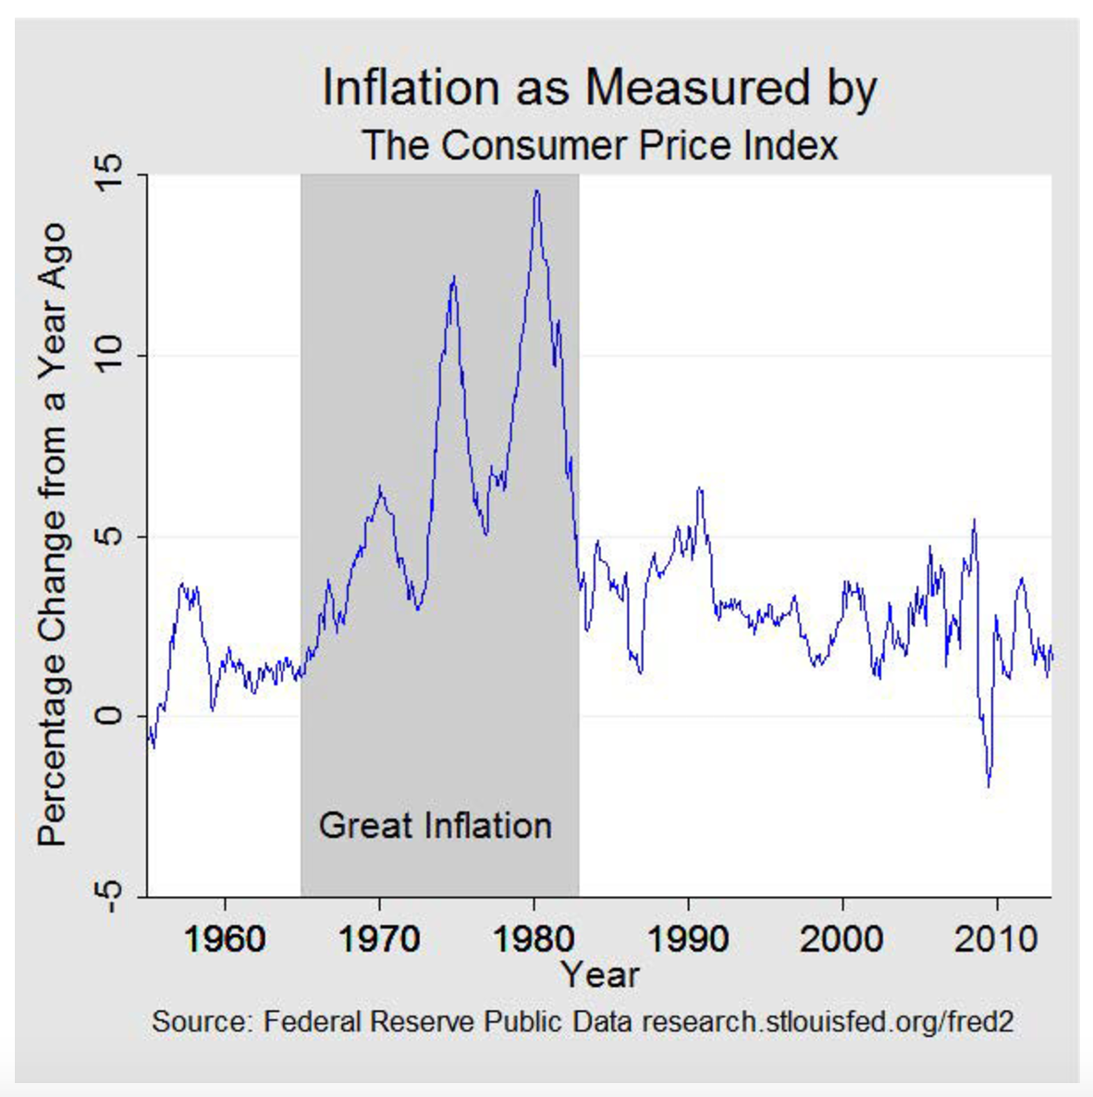
Source: FederalReserveHistory.org, https://www.federalreservehistory.org/essays/great_inflation?WT.si_n=Search&amp;WT.si_x=3

Questions

30. What year did stagflation—or the Great Inflation—begin?

31. What year did the crisis of stagflation end?

32. What (approximately) were the two highest rates of inflation during the crisis? What were the peak years of the crisis?

Source 9
“Causes of the Great Inflation, 1965-1982”
FederalReserveHistory.org

The Great Inflation was the defining macroeconomic event of the second half of the twentieth century. Over the nearly two decades it lasted…there were four economic recessions, two severe energy shortages, and the unprecedented peacetime implementation of wage and price controls. It was, according to one prominent economist, “the greatest failure of American macroeconomic policy in the postwar period.”

While economists debate the secondary factors that caused and worsened inflation for more than a decade, there is little debate about its primary source. The origins of the Great Inflation were policies that allowed for an excessive growth in the supply of money—Federal Reserve policies.

The late 1960s and the early 1970s were a turbulent time for the US economy. President Johnson’s Great Society legislation brought about major spending programs across a broad array of social initiatives at a time when the US fiscal situation was already being strained by the Vietnam War. These growing fiscal imbalances complicated monetary policy.

A more disruptive force was the repeated energy crises that increased oil costs and sapped U.S. growth. The first crisis was an Arab oil embargo that began in October 1973 and lasted about five months. During this period, crude oil prices quadrupled to a plateau that held until the Iranian revolution brought a second energy crisis in 1979. The second crisis tripled the cost of oil.

From the perspective of the central bank, the inflation being caused by the rising price of oil was largely beyond the control of monetary policy. But the rise in unemployment that was occurring in response to the jump in oil prices was not.

Motivated by the Great Depression era mandate to create full employment…the Federal Reserve…[put into place] policies [that] accelerated the expansion of the money supply and raised overall prices without reducing unemployment.

As businesses and households came to anticipate rising prices, the trade-off between inflation and unemployment became a less favorable exchange until…both inflation and unemployment became unacceptably high. This, then, became the era of “stagflation.” In 1964, when this story began, inflation was 1 percent and unemployment was 5 percent. Ten years later, inflation would be over 12 percent and unemployment was above 7 percent. By the summer of 1980, inflation was near 14.5 percent, and unemployment was over 7.5 percent.
Source: Adapted from FederalReserveHistory.org, https://www.federalreservehistory.org/essays/great_inflation?WT.si_n=Search&amp;WT.si_x=3

Questions

33. What government body’s policies led to the stagflation crisis of the 1970s?

34. Name at least 2 political developments during the 1960s and 1970s that contributed to stagflation?
35. Which part of the modern Fed’s dual mandate was already in effect and given priority throughout the early 1970s—inflation or unemployment?
36. Why did the problems of the 1970s—high inflation and high unemployment—lead to establishment of the modern Fed’s dual mandate? Explain your answer using at least 2 pieces of evidence from the source.

Source 10
“Fed’s Response to the Great Inflation, 1965-1982”
FederalReserveHistory.org
Federal Reserve officials were not blind to the inflation that was occurring and were well aware of the dual mandate that required monetary policy to focus on full employment and price stability. Indeed, the Full Employment and Balanced Growth Act of 1978, more commonly known as the Humphrey-Hawkins Act, explicitly charged the Federal Reserve to pursue full employment and price stability.

Nevertheless, the employment half of the mandate appears to have had priority when full employment and inflation came into conflict, and there was also a clear sense that addressing the inflation problem head-on would have been too costly to the economy and jobs.

However, by the late 1970s, Fed officials faced an unhappy dilemma: having unacceptably high inflation and high unemployment. Added to this was another problem: Fighting high unemployment would almost certainly drive inflation higher still, while fighting inflation would just as certainly cause unemployment to spike even higher.

In 1979, Paul Volcker, formerly the president of the Federal Reserve Bank of New York, became chairman of the Federal Reserve Board. When he took office in August, year-over-year inflation was running above 11 percent, and national joblessness was just a shade under 6 percent.…

Fighting inflation was now seen as necessary to achieve both objectives of the dual mandate, even if it temporarily caused a disruption to economic activity and, for a time, a higher unemployment rate.

Over time, greater control of reserve and money growth, while less than perfect, produced a desired slowing in inflation. This tighter reserve management was augmented by the introduction of credit controls in early 1980. Over the course of 1980, interest rates spiked, fell briefly, and then spiked again. Lending activity fell, unemployment rose, and the economy entered a brief recession between January and July. Inflation fell but was still high even as the economy recovered in the second half of 1980.

But the Volcker Fed continued to press the fight against high inflation with a combination of higher interest rates and even slower reserve growth. The economy entered recession again in July 1981 and lasting until November 1982. Unemployment peaked at nearly 11 percent, but inflation continued to move lower and by recession’s end, year-over-year inflation was back under 5 percent. In time, as the Fed’s commitment to low inflation gained credibility, unemployment retreated and the economy entered a period of sustained growth and stability. The Great Inflation was over.

By this time, macroeconomic theory had undergone a transformation.

Today central banks understand that a commitment to price stability is essential for good monetary policy and most, including the Federal Reserve, have adopted specific numerical objectives for inflation. And in so doing, they have enhanced the transparency of monetary policy decisions and reduced uncertainty, now also understood to be necessary antecedents to the achievement of long-term growth and maximum employment.
Source: Adapted from FederalReserveHistory.org, https://www.federalreservehistory.org/essays/great_inflation?WT.si_n=Search&amp;WT.si_x=3

Questions

37. Which side of the dual mandate—unemployment or inflation—did the Fed prioritize during the early phases of the stagflation crisis?

38. What was the central paradox of stagflation during the 1970s? In 2-3 sentences, explain the problem facing policymakers trying to combat unemployment and inflation.

39. Which economic problem—unemployment or inflation—did Paul Volcker decide to combat after he took over as Chair of the Fed?

40. What 2 negative side effects did Volcker’s policies have on the US economy in the early 1980s?

41. Did Volker’s policies bring an end to stagflation?

42. What major lesson did the Fed learn as a result of the stagflation crisis of the 1970s and early 1980s?

Part 5: The Fed and the Great Recession of 2007-2009
After the end of stagflation in the early 1980s, the United States and its central bank entered a period economists refer to as the Great Moderation. A period of time stretching from 1982-2007, the Great Moderation refers to a period where interest rates declined to more moderate levels, the economy experienced a long period of expansion, and, most importantly, inflation increased at a manageable, and therefore, stable rate. It was during the Great Moderation (in the 1990s) that the Fed adopted the Taylor Principle—raising interest rates and tightening monetary policy when inflation is high, and lowering interest rates and loosening monetary policy when inflation is low.

The Great Moderation came to a crashing halt in the early 2000s when, first, the US housing market began collapsing in 2007, and, then, several major investment banks and other financial institutions collapsed in fall 2008. Fed monetary policy would be put to the test after 2008. One of the Fed’s many responses to the financial crisis and Great Recession was to lower interest rates to record lows—zero percent or just above zero percent.

Source 11
Federal Reserve Leaders and the Federal Funds Target Rate, 1979-2016
New York Times

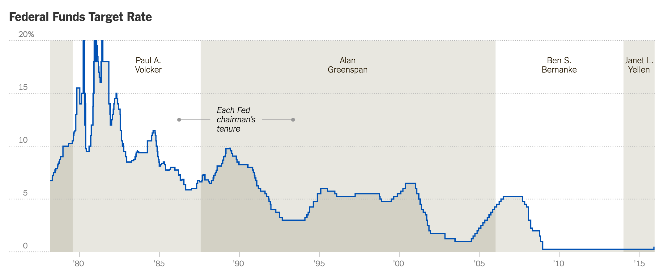
Source: New York Times, “A History of Fed Leaders and Interest Rates”

Questions

43. What has been the general trend regarding interest on the federal funds rate?

44. Why was the federal funds rate so high in the early 1980s?

45. Under whose leadership did the federal funds rate dramatically increase?

46. Under whose leadership did the federal funds rate decline over the course of the Great Moderation?

Source 12
Causes of the Great Recession
Marginal Revolution University
YouTube Clip (12:52)

Causes of the Great Depression (12:52)
https://www.youtube.com/watch?v=dI6HNi5I8d4
47. In 1-2 sentences, explain the term “owner’s equity.”
48. What is the term used to refer to the ratio of debt to equity?
49. What does it mean to be a homeowner “underwater?”

50. Besides homeowners, what other institutions were “underwater” during the lead up to the crash of 2008?
51. What are the four causes of the crash discussed in this video?
52. What is the difference between a commercial bank and an investment bank?
53. What are the five components of the “shadow banking system?” Why did the shadow banking system collapse in 2008?
54. What 2007 event triggered the financial crisis—the run on investment banks like Lehman Brothers in 2008?
55. What, according to this video, is the great lesson of the financial collapse that led to the Great Recession?
Source 13
Fed’s Response to the Great Recession
FederalReserveHistory.org

The Great Recession began in December 2007 and ended in June 2009, which makes it the longest recession since World War II. Beyond its duration, the Great Recession was notably severe…Real gross domestic product (GDP) fell 4.3 percent from its peak in 2007 to its trough in 2009, the largest decline in the postwar era. The unemployment rate, which was 5 percent in December 2007, rose to 9.5 percent in June 2009, and peaked at 10 percent in October 2009.  The financial effects of the Great Recession were similarly outsized: Home prices fell approximately 30 percent, on average, from their mid-2006 peak to mid-2009, while the S&P 500 index fell 57 percent from its October 2007 peak to its trough in March 2009. The net worth of US households and nonprofit organizations fell from a peak of approximately $69 trillion in 2007 to a trough of $55 trillion in 2009.  As the financial crisis and recession deepened, measures intended to revive economic growth were implemented on a global basis. The United States, like many other nations, enacted fiscal stimulus programs that used different combinations of government spending and tax cuts. These programs included the Economic Stimulus Act of 2008 and the American Recovery and Reinvestment Act of 2009.  The Federal Reserve’s response to the crisis evolved over time and took a number of nontraditional avenues. Initially, the Fed employed “traditional” policy actions by reducing the federal funds rate from 5.25 percent in September 2007 to a range of 0-0.25 percent in December 2008, with much of the reduction occurring in January to March 2008 and in September to December 2008. The sharp reduction in those periods reflected a marked downgrade in the economic outlook and the increased downside risks to both output and inflation (including the risk of deflation).… | peak—high point  trough—low point  stimulus—something that stimulates or causes a change in something else
FederalReserveHistory.org, https://www.federalreservehistory.org/essays/great_recession_of_200709?WT.si_n=Search&amp;WT.si_x=3

Questions

56. Identify at least 3 statistics that illustrate the economic severity of the Great Recession.

57. What traditional policy action did the Fed take in the response to the Great Recession? Use 2 pieces of evidence from the source.

58. Based on what you have learned, was the Great Recession—the and Fed’s response to the crisis—more like the crisis of the Great Depression or more like the crisis of stagflation (i.e. the Great Inflation)?

Source 14
“Q&A: How a Key Fed Interest Rate Affects the Economy”
Los Angeles Times, June 15, 2015

The recovery from the Great Recession has generated solid stretches of economic growth and job creation, but has failed to impress Federal Reserve policymakers enough to provide a key validation of the economy's strength — an interest rate increase.

That is poised to change as central bank officials signaled that they could raise their benchmark rate as early as this week's policymaking meeting, though analysts don’t expect a move until at least September.

The last time the Fed raised the rate was in mid-2006, a year and a half before the start of the worst recession since the Great Depression.

As the economy deteriorated, Fed policymakers ratcheted the rate down from 5.25% to near zero in December 2008 in an attempt to stimulate growth. It has been there ever since.

Despite an uneven recovery, the economy is much stronger today, justifying a rate increase.…

“At the end of the day, it really is more symbolic,” said Diane Swonk, chief economist at Mesirow Financial. “It’s going to be an acknowledgment of the economy's strength. It’s not to combat inflation. It’s not to combat an overheating economy.”

Fed Chairwoman Janet L. Yellen has said policymakers would decide when to raise the interest rate based on an assessment of economic data. Even after the initial increase, the rate would probably rise slowly over several years to avoid stalling the economy, she said.

The strategy is known as “lower for longer” and shows how central bank officials are planning to move deliberately to avoid slowing the economy.

“This is a Fed that’s not going to do anything until it sees the whites of the eyes of a self-sustaining recovery,” Swonk said.
Los Angeles Times, http://www.latimes.com/business/la-fi-fed-interest-rate-qa-20150615-story.html

Questions

59. What was the Fed’s policy regarding the “benchmark” (i.e. federal funds) rate during the Great Recession?

60. What major change in Fed policy regarding the federal funds rate does this report address?

61. What conditions justified this change in Fed policy?

Final Activity
The primary job of the Federal Reserve is to manage the money supply of the entire nation. As such, it has a tremendous influence on the daily lives of millions of Americans. But how many people know this history, much less what the Fed actually does?

Inquiry Questions: Why is there a Federal Reserve bank? Do most Americans know what the Fed is and what it does?

For this assignment you will be working in groups of three. Your job for this final assignment is threefold:

Step 1. Why is there a Federal Reserve bank? Write an “elevator” pitch/summary of the Fed that explains what it does and some of the key moments from its history. (“Elevator pitch” is a term used for a short summary of a complex topic—a summary short enough that you could get through the whole thing in the brief period of time you might talk to someone in an elevator.) Again, your description should be short—100 to 200 words—and written for someone who might be foggy about the Fed, its activities, and its history.

- Brainstorm what you have learned about the activities of the Fed and its history.
- Organize your information into bullet points or categories of information using the graphic organizer below.
- When appropriate link the Fed’s main activities to key events from its history.
- Highlight the activities and events you think are most important.
- Then write your elevator summary/pitch using the activities and events you think are most important.

Step 2. Do most Americans know what the Fed is and what it does? As a group, interview three people (friends, family members, etc.) about the what they know about the Federal Reserve and what it does. NOTE: Each group member will interview one person.
- Take your “Brainstorming the Fed” graphic organizer with you to your interview.
- Be sure to have your elevator pitch on hand in the event your subject doesn’t know what the Fed is and/or asks you to explain what it is and what it does.
- Also take your additional notes regarding the Fed so that you have them on hand in case your interviewee asks follow-up questions about the Fed and its activities and history.
- Conduct your interview using the “Fed Interview” form. Feel free to modify the questions on the form or add questions to the blank boxes (Questions 6 & 7).
- Write down your interviewees responses and other notes taken during the interview on the “Fed Interview” form.

Step 3. With your group partners, assemble a poster that illustrates your work: what you’ve learned about the Fed and its history, and the data you acquired from your interviews. Be sure your poster answers the inquiry questions: Why is there a Federal Reserve bank? Do most Americans know what the Fed is and what it does?
Brainstorming the Fed
Key Functions/Actions | Key Historical Events
Fed elevator pitch/description (100-200 words)

Fed Interview
Name of Subject:
Date of Interview:
Additional Information:

Interview Questions | Interview Responses
Question 1. Have you heard of the Federal Reserve?
Question 1. What is the Federal Reserve?
Question 3. What does the Fed do?
Question 4. What other information/facts do you know about the Fed?
Question 5. Do you know the name of the current Fed chairperson?
Question 6.
Question 7.
Interview Notes

