From Divine Right to Natural Rights  10th Grade Summer Institute  UCI 2017 | 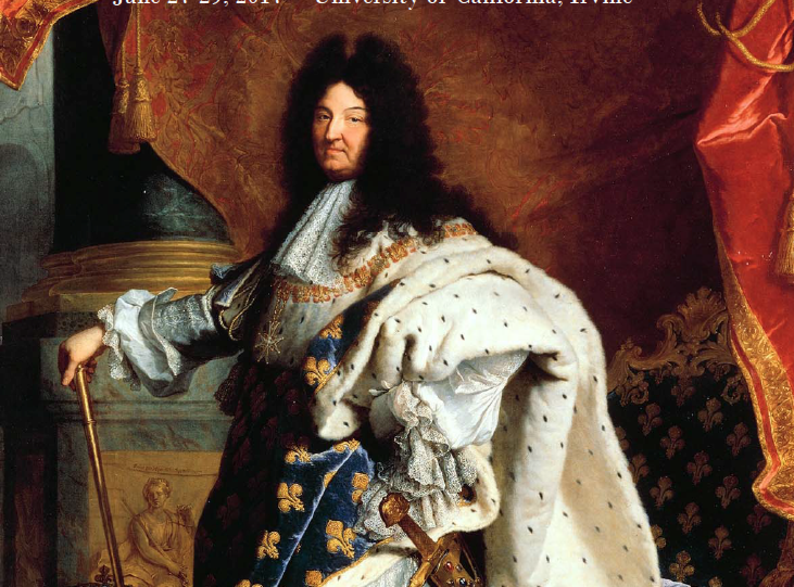

Dates: June 27-29, 2017
Times: 8:45-3:00
Location: UCI Center for Educational Partnerships
Cost: $350
For an additional cost, teachers can earn 2 units through UCI Extension.

Join the UCI History Project to start the summer reenvisioning, revamping, and revising the first unit in the 10th Grade World History course. This institute will introduce teachers to the changes in the new California History­Social Science Framework for 10th grade and link it to the Standards 10.1 and 10.2. We will offer teachers resources to contextualize absolutism, consider the importance of Enlightenment thought, and create curriculum on democratic revolutions. The institute will include content presentations by historians, primary and secondary resources, literacy strategies aligned to Common Core, and time to collaborate. Teachers can also earn UCI Extension Credit.

Topics:
*10th Grade Modern World History Framework
*Inquiry Questions to shape the year and unit 1
* Revolutions in world history and Citizenship in world history
*The French Revolution in World History presentation by Dr. Ian Coller

To Register:
Online using a credit card
https://secure.touchnet.net/C21570_ustores/web/product_detail.jsp?PRODUCTID=508

Using a purchase order or check fill out the form below

For more information, contact Nicole Gilbertson at gilbertn@uci.edu or 949-824-2057

Teacher name:

Teacher school and district:

Teacher email:

Send purchase order or check to:
Nicole Gilbertson
UCI History Project
120 Theory Ste. #150
Irvine, CA 92697

