How did the arrival of European and American traders, and Spanish missionaries, change the lives of California Indians during the 1800s?
Topics: Pacific World; effects of sea otter fur trade on California Indians, Spanish missions and California Indians; Island of the Blue Dolphins
Erik Altenbernd, UC Irvine History Project

History Standards
8.8 Students analyze the divergent paths of the American people in the West from 1800 to the mid-1800s and the challenges they faced.
8.8.5 Discuss Mexican settlements and their locations, cultural traditions, attitudes toward slavery, land-grant system, and economies.

CCSS Standards: Reading, Grades 6-8
RH 1. Cite specific textual evidence to support analysis of primary and secondary sources.
RH 2. Determine the central ideas or information of a primary or secondary source; provide an accurate summary of the source distinct from prior knowledge or opinions.
RH 3. Identify key steps in a text’s description of a process related to history/social studies…
RH 4. Determine the meaning of words and phrases as they are used in a text, including vocabulary specific to domains related history/social studies.

CCSS Standards: Writing, Grades 6-8
WH 1. Write arguments focused on discipline-specific content
WH2. Write informative/explanatory texts, including the narration of historical events, scientific procedures/experiments, or technical processes.
WH4. Produce clear and coherent writing in which the development and organization, and style are appropriate to the task, purpose, and audience.

Guiding Question:
How did the arrival of European and American traders, and Spanish missionaries, change the lives of California Indians during the 1800s?

Overview of Lesson
This lesson is the second of two humanities lessons on California, California Indians, and the Pacific World of the eighteenth and nineteenth centuries.

Building on recent research on California and the Pacific World before the US-Mexico War of 1846-1848, and using excerpts from the Scott O’Dell’s novel Island of the Blue Dolphins (1960), the lesson examines the long-term impact of the international sea otter pelt trade and Spanish missions on California Indians, particularly the Chumash Indians and the Native people of San Nicolas Island, the most remote of the Channel Islands of Southern California. More so that lesson one, this lesson examines the life and experiences of Juana Maria, the Nicoleña who serves as the inspiration for Karana, the protagonist of Island of the Blue Dolphins.

The lesson is organized as follows:
1. A detailed introduction on the peopling of Native America and the history of the Nicoleños up to 1800.
2. A section that details the life of Juana Maria, the real Karana.
3. A section that begins where Island of the Blue Dolphins ends—with the story of Juana Maria and the Nicoleño after their fateful battle with Russian and Aleut otter hunters in 1814.
4. A final section that examines the impact of the California missions on California Indians, and how the missions intersect with the story of Juana Maria and the Nicoleños.
5. Final activity that has students write a first-person story that continues the story of Karana beyond the point where Island of the Blue Dolphins ends.

Each section includes excerpts from Island of the Blue Dolphins and highlights the historical figures and events that inspired the novel.

Documents
- “Juana Maria, the Lone Woman of San Nicolas Island” (excerpt)
- Island of the Blue Dolphins (excerpt)
- The Life and Adventures of a California Pioneer Since 1834 (1878, excerpt)
- Island of the Blue Dolphins (excerpt)
- The Life and Adventures of a California Pioneer Since 1834 (1878, excerpt)
- Diary of Otto von Kotzebue (1816, excerpt)
- Journal of Jean-Francois de Galaup de la Perouse (1786, excerpt)
- Island of the Blue Dolphins (excerpt)
- Mission Santa Barbara and the Chumash Indians (excerpt)

Teacher Outline for Final Activity
The final activity instructs students to write a creative first-person story that continues the story of Karana beyond the point where Island of the Blue Dolphins ends. The central question here is What happens to Karana after she leaves the Island of the Blue Dolphins? To answer the question, the students have a choice of following three different story tracks. Each track has its own guiding question:

I. Story Options

1. What happens to Karana during her first three days at Mission Santa Barbara?

2. What people—new friends or old friends and family—does Karana meet at Mission Santa Barbara?

3. What happens to Karana over the long term—what is her life like a year after arriving at Mission Santa Barbara.

II. Story Requirements

1. Each essay should be a first-person account written from Karana’s perspective.

2. Each story should be three paragraphs long.

3. Like Island of the Blue Dolphins, each should also be based on three historical sources from the lesson. Use one source per paragraph.

III. Additional Information

As students brainstorm or bullet point their drafts, they should consider the larger inquiry question for the lesson: How did the arrival of European and American traders, and Spanish missionaries, change the lives of California Indians during the 1800s?

To gather their ideas, students should use the graphic organizer below to identify the three historical sources, they want to use as the basis of their plot points—or story events—and to bullet-point/brainstorm each of the paragraphs.

The students should also pay attention to chronology and take care to arrange their paragraphs in a logical order.

They can begin writing their story after they have mapped out all three plot points.

Introduction
The original peopling of the Americas (i.e. North and South America) by the Paleoindians—the ancient ancestors of Native Americans—began about 13,000 to 15,000 years ago during the last Ice Age, a period in the Earth’s history when much of North America (and the Northern Hemisphere) was trapped underneath massive glaciers, or sheets of ice, hundreds of miles long and wide.

When the first Paleoindians arrived in the Americas, and how they spread out across North and South America, is not clear. One of the oldest theories about the Paleoindians focuses on a place called Beringia. Beringia is the name used to refer to the large piece of land that connected North America to Asia during the last Ice Age. The basic idea, or theory, is that Asian peoples, who hunted various large animals, followed large game into North America and migrated across Beringia into Alaska, Canada, and then the rest of North America. The first evidence in support of this theory—spear points used for hunting wooly mammoths—was found near Clovis, New Mexico in 1932. These Paleoindians are referred to as the Clovis people. Many objects of the Clovis people have been found across North America, and they date back as far as 13,000 years.

Maps of Asia and North America Today and Paleoindian Migrations during Last Ice Age
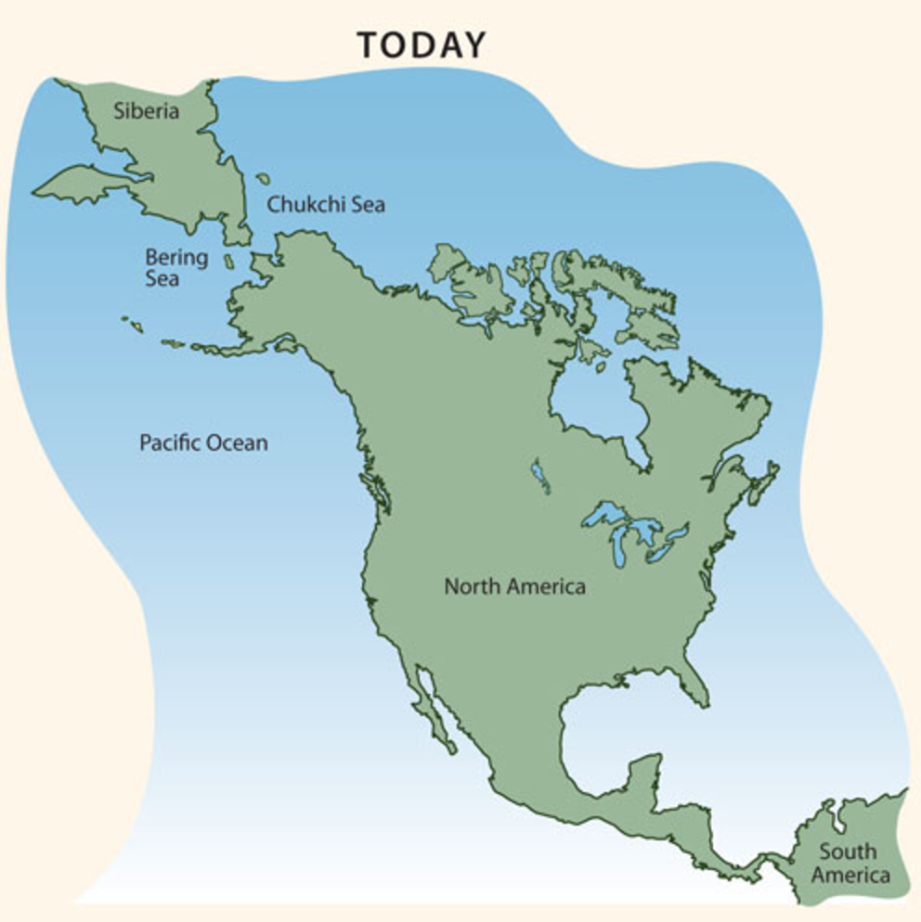

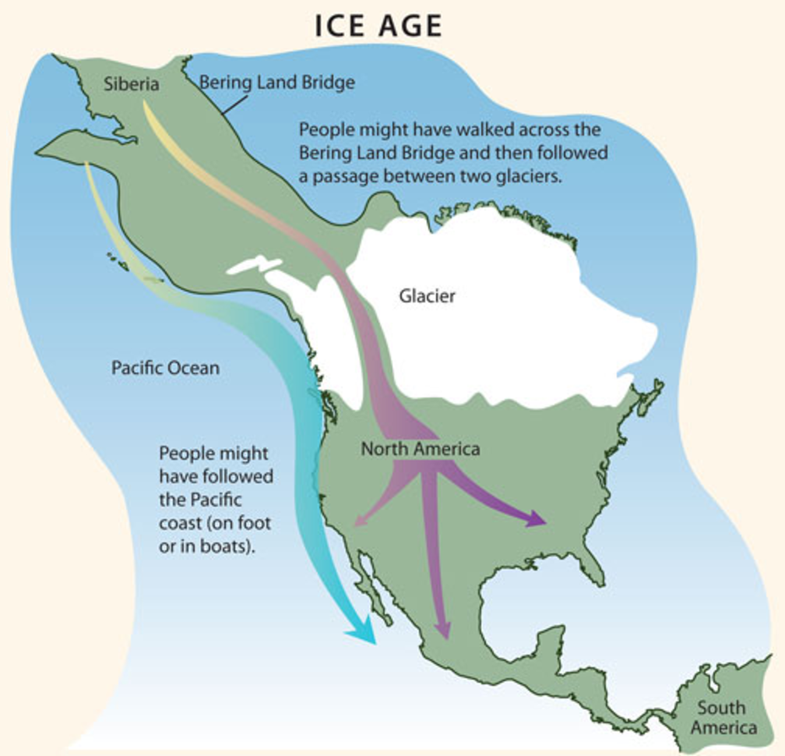
In 1997, anthropologists and archaeologists found Paleoindian objects older than those found at Clovis, New Mexico. This newer site is called Monte Verde and it is located far away from Asia and Alaska—in southern Chile not far from the southern tip of South America. The archaeological objects found at Monte Verde are 14,500 years old—2000 years older than the objects found at Clovis, New Mexico. These objects provide evidence for a second theory: that Paleoindians, much like the Russian sea otter hunters of the 1700s and 1800s, used boats to cross the ocean between Asia and North America and migrate down the west coast of North and South America.

Paleoindians began living on the Channel Islands of Southern California around the time other Paleoindians began living near Clovis, New Mexico and Monte Verde, Chile. In 1959, archaeologists found human bones on Santa Rosa Island that date back roughly 13,000 years. Evidence collected from San Miguel Island shows continuous human occupation dating back 8000-11,000 years. The history of San Nicolas Island, the Channel Island that inspired the novel Island of the Blue Dolphins, goes back almost as far. Archaeological evidence from San Nicolas shows human occupation going back 7000 years.

Map of Channel Islands and Coast of Southern California
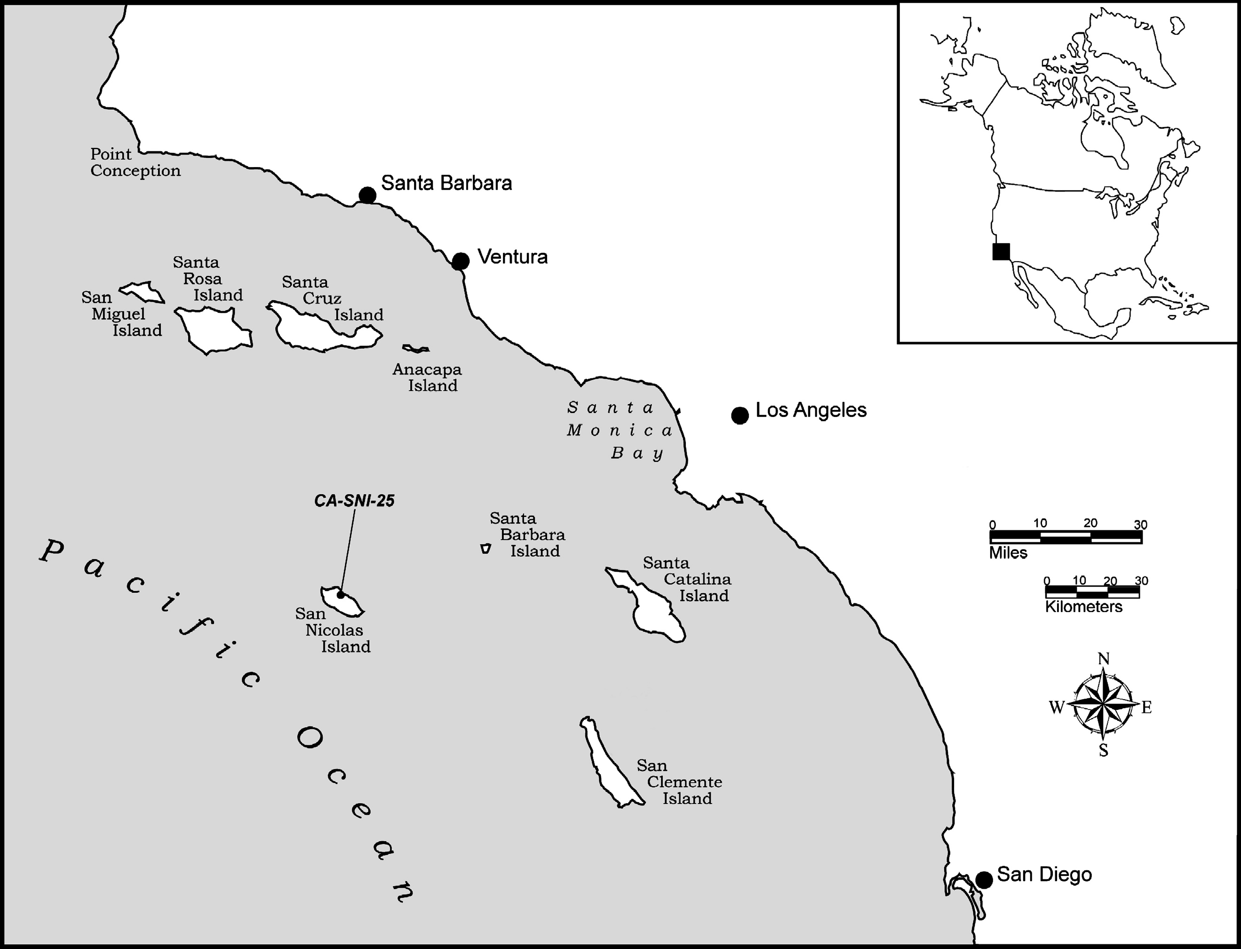

The history of the Nicoleños, the Native American tribe of San Nicolas Island that serves as the inspiration for Karana and the other Indians in Island of the Blue Dolphins, goes back 1000 years or more. At that time, a group of Indians referred to as the Tongva or Gabrieleno migrated into Southern California and became the dominant culture in the area around Los Angeles, Orange County, and the Southern Channel Islands of San Nicolas, Santa Catalina, San Clemente, and Santa Barbara. Nicoleño is the term used to refer to the group of Tongva/Gabrieleno Indians that lived on San Nicolas Island. By the time the explorer Sebastián Vizcaíno claimed San Nicolas Island for the King of Spain in 1602, there were two main villages and approximately 200-300 Nicoleños living on the island. Historians and archaeologists assume a similar number of Nicoleños lived on the island when Spanish missionaries began establishing missions along the coast of California in 1769, and when, forty-five years later, Russian and Aleut hunters arrived on the island in 1814.

The lives of California Indians like the Nicoleños and Chumash of the Santa Barbara changed dramatically during the nineteenth century (1800s). Trade, violence, disease, and colonization efforts like Spanish missions were the main causes of change. And the changes they caused often did not improve the lives of California Indians like the the Nicoleños and Chumash.

Part 1. Juana Maria: The Real Karana
Karana, the main character of Island of the Blue Dolphins, is based on the story of the “Lone Woman of San Nicolas,” a Nicoleña named Juana Maria who lived alone on San Nicolas Island for eighteen years. As we learned in Lesson 1, one of the major currents of Pacific World history—sea other hunting—had a major impact on the Nicoleño people. Several Nicoleños died when violence broke out between the Nicoleños and Russian and Aleut (Native Alaskan) sea otter hunters in 1814. But what happened to the Nicoleños, and Juana Maria, after 1814?

Source 1

“Juana Maria, the Lone Woman of San Nicolas Island”

California Missions Resource Center

In 1853 an Indian woman speaking a language unknown to the mainland Indians of California was found on San Nicolas Island by Captain George Nidever (1802-1883).  Nidever arrived in California in 1834. He was a renowned sailor and hunter known for his skill in tracking sea otters along the coast and on the Channel Islands.  San Nicolas is the most remote of the Channel Islands, and lies about 53 miles off the Coast, west of Los Angeles.  The Spanish explorer Sebastian Vizcaino landed on the island on December 6, 1602 and reported it densely populated.…  Not much is known about the San Nicolas Islanders from 1602 to 1800 except that by 1800 the population had declined markedly.  In 1811, a group of 25-30 Kodiaks from the Russian camp at Sitka (Alaska) landed on the island to hunt otter and seal. The Kodiaks apparently feuded with the island men over the island women.  By the time the Kodiaks were finally removed, there were less than one hundred Indians left.  By the early 1830s, with the Indian population in decline and many villages abandoned, Spanish missionaries on the mainland organized the removal of all remaining Indians from the Channel Islands. The last island to be evacuated was San Nicolas.  The Peor es Nada (Better than Nothing), a ship captained by Charles Hubbard, landed on the island in 1835 and began to load the Indians on board. As the ship was leaving, a woman jumped overboard saying her child had been left behind. She was described as a light complexioned woman between 20-30 years of age.  The crew of the Peor es Nada intended to return when the weather cleared but the ship struck an object entering into the harbor at San Francisco, and sank. Several efforts were made in subsequent years to find the “last” Indian but none succeeded until Captain Nidever discovered her in 1853.…  In his memoir, Nidever writes that padres of the Mission Santa Barbara requested that he “bring the lost woman off [the island] in case we found her,” and that is what Nidever did about a month later.  Upon the group’s arrival in Santa Barbara the woman was astonished and delighted at the signs of civilization. She was particularly intrigued by an ox-cart and all the horses. Word spread of her arrival and soon “half the town came down to see her.” The good Captain took the woman to stay at his home, where she was nursed by his wife Sinforosa Sanchez Nidever.  The “Lone Woman of San Nicolas” became an object of considerable fascination. She often visited Santa Barbara and seldom returned without some present. The Fathers from the Mission also often visited her. Everyone was taken with her attitude. She was “always in good humor and sang and danced, to the great delight of the children....” Through sign language it was determined that she was indeed the woman left in 1835 and, sadly, she never did find her child.  Juana Maria, the name given her by the padres, later became ill of dysentery, and died after just seven weeks on the mainland. She was buried in the cemetery at Mission Santa Barbara. All her personal possessions were given to California Academy of Sciences but these were destroyed in San Francisco earthquake and fire of 1906. | mainland—large piece of land as opposed to an island or chain of islands  renowned—well-known; famous  Channel Islands—chain of islands off the coast of Southern California  markedly—noticeably, significantly  Kodiak—Island located in the Aleutian Islands of Alaska  Sitka—Russian fur trading colony established in southern Alaska in 1799  memoir—written work that details events based on first-hand experiences  padre—Spanish for “father”; title used when referring to a Catholic priest  nurse—to help someone recover from injury or trauma  dysentery—severe and painful infection of the intestines
Adapted from http://www.missionscalifornia.com/stories/lone-woman-san-nicolas-island.html

Questions

1. Construct a timeline of five major events discussed in Source 1. Follow the instructions below.

A. Before filling in the graphic organizer, use a highlighter to mark the dates of the major events
discussed in Source 1.

B. Use a highlighter to highlight the significance—or effect—of those events on the Nicoleños and

Juana Maria.

C. After you have highlighted all the major events and their effects, write in the events and their
effects/significance in the graphic organizer.

NOTE: Be sure to write the events and their effects in chronological order.

Timeline of Events Related to Nicoleño Indians and Juana Maria

Event & Year | Effect/Significance

Event & Year | Effect/Significance

Event & Year | Effect/Significance

Event & Year | Effect/Significance

Event & Year | Effect/Significance

2. Where did Juana Maria, the “Lone Woman of San Nicolas,” go after she left San Nicolas? What happened to her after she arrived there? Explain your answer in 2-3 sentences.

Portrait of Indian Woman, Possibly of Juana Maria
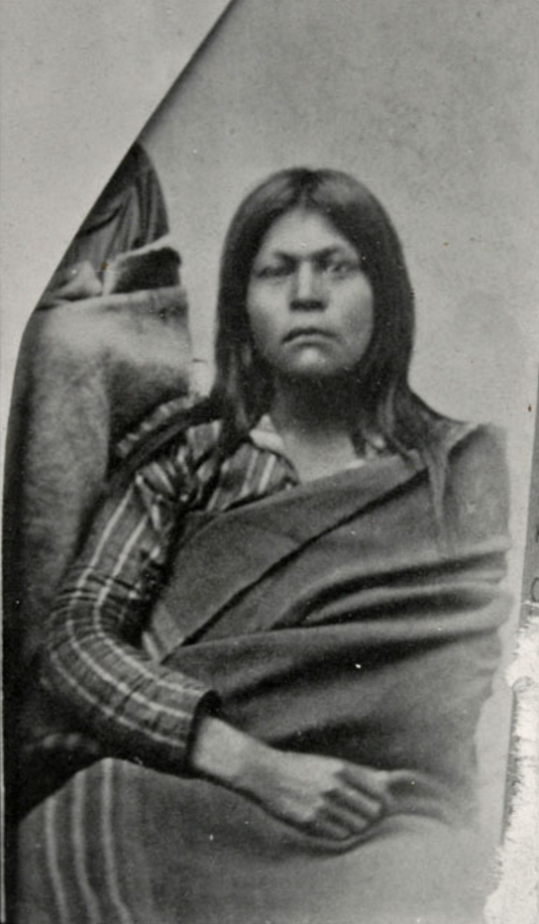
Source: http://collections.theautry.org/mwebcgi/mweb.exe?request=record;id=M138326;type=102

Part 2. Juana Maria and the Nicoleño Indians
In 1835, most of the Indians of San Nicolas were removed from the island and taken to San Pedro, a small port town located south of the small city of Los Angeles (less than 1000 people lived in Los Angeles in 1835). From there, most of the of the Nicoleños went on to Los Angeles and Mission San Gabriel, a Spanish Catholic mission located northeast of Los Angeles near the modern city of Pasadena. Juana Maria’s experiences were different. In addition to being left behind on the island, Juana Maria left San Nicolas for Santa Barbara and Mission Santa Barbara. Santa Barbara is located on the coast about 95 miles northwest of Los Angeles.

Image of Mission San Gabriel (1878), the mission where most of the Nicoleños went in 1835.
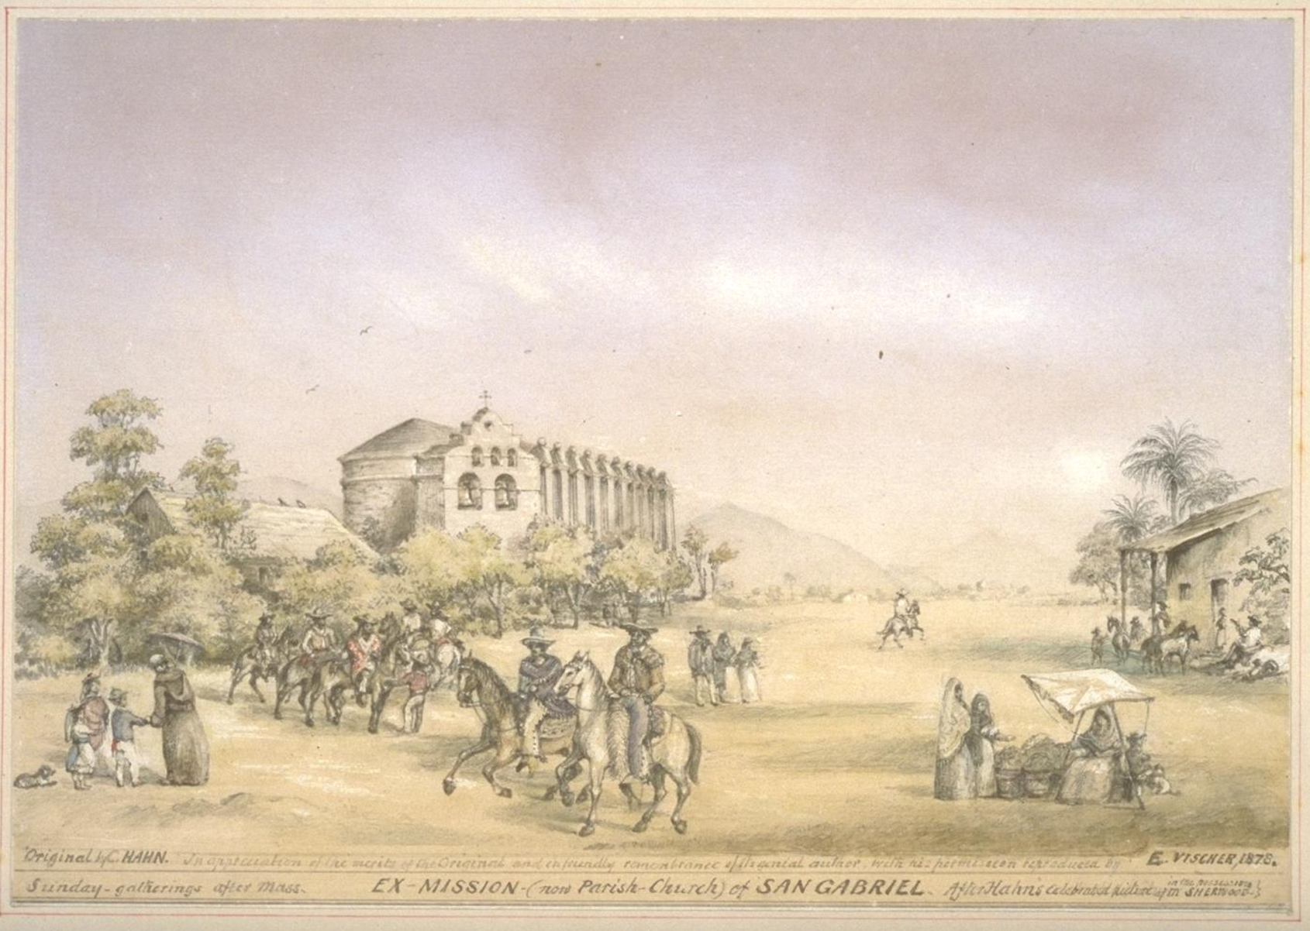
Source: http://oac.cdlib.org/ark:/13030/tf0580053r/?brand=oac4

Source 2

Scott O’Dell

Island of the Blue Dolphins

In this excerpt of Island of the Blue Dolphins Karana describes her panicked search for her brother, Ramo, and her heroic actions when she realizes that Ramo is not aboard the ship and will be left alone on the island.

The ship was large, many times the size of our biggest canoes. It had two full masts and between them stood a young man with blue eyes and a black beard. He was the chieftain of the white men, for he began to shout orders which they quickly obeyed. Sails rose on the tall masts and two of the men began to pull on the rope that held the anchor.  I called to my bother, knowing that he was very curious and therefore would be in the way of the men who were working. The wind drowned my voice and he did not answer. The deck was so crowded that it was hard to move, but I went from one end of it to the other, calling his name. Still there was no answer. No one had seen him.  At last I found Nanko.  I was overcome with fear. “Where is my brother?” I cried.  He repeated what he had told me on the beach, but as he spoke Ulape who stood my him pointed toward the island. I looked out across the deck and the sea. There, running along the cliff, the fishing speak held over his head, was Ramo.  The sails had filled and the ship was now moving slowly away. Everyone was looking toward the cliff, even the white men. I ran to one of them and pointed, but he shook his head and turned from me. The ship began to move faster. Against my will, I screamed.  Chief Matasaip grasped my arm.  “We cannot wait for Ramo,” he said. “If we do, the ship will be driven into the rocks.”  “We must!” I shouted. “We must!”  “The ship will come back for him on another day,” Matasaip said. “He will be safe. There is food for him to eat and water to drink and places to sleep.”  “No,” I cried.  Matasaip’s face was like stone. He was not listening.…  Ramo had disappeared from the cliff and I knew that he was now running along the trail that led to the beach.  The ship began to circle the kelp bed and I thought surely that it was going to return to the shore. I held my breath, waiting. Then slowly its direction change. It pointed toward the east. At that moment I walked across the deck and, though my hands tried to hold me back, flung myself into the sea.  A wave passed over my head and I went down and down until I thought I would never held the day again. The ship was far away when I rose. Only the sails showed through the spray. I was still clutching the basket that held all of my things, but it was very heavy and I realized that I could not swim with it in my arms. Letting it sink, I started toward the shore.  I could barely see the two rocks that guarded the entrance to Coral Cove, but I was not fearful. Many times I had swum farther than this, although not in a storm.  I kept thinking over and over as I swam how I would punish Ramo when I reached the shore, yet when I felt the sand under my feet and saw him standing at the edge of the waves, holding his fishing spear and looking so forlorn, I forgot all those things I had planned to do. Instead I fell to my knees and put my arms around him.  The ship had disappeared.  “When will it come back? Ramo asked. There were tears in his eyes.  “Soon,” I said.  The only thing that made me angry was that my beautiful skirt of yucca fibers, which I had worked on so long and carefully, was ruined. | chieftain—captain or leader; chief  Nanko—young man in village of Ghalas-at who Ulape, Karana’s sister, likes  Ulape—Karana’s sister  Ramo—Karana’s brother  Matasaip—chief of Ghalas-at after Karana’s father, Chowig, and Kimki  kelp bed—area underwater with a large amount of the seaweed kelp
Scott O’Dell, Island of the Blue Dolphins (New York: Dell Laurel-Leaf, 1960), 40-43.

Questions

3. Why does Karana decide to jump off the ship?

4. Why is the situation on the ship so desperate—why can’t the ship wait for Ramo? Explain your answer using at least 2 pieces of evidence from the text.

5. Why is Karana angry when she reaches the shore? Explain your answer in 2-3 sentences.

Source 3

George Nidever

The Life and Adventures of a California Pioneer Since 1834 (1878)

George Nidever was an American hunter, fur trader, rancher and ship captain. Nidever made three separate trips to San Nicolas Island in the early 1850s. On his third voyage in 1853, he and his crew located Juana Maria, the “Lone Woman of San Nicolas,” and convinced her to sail with them to Santa Barbara. In this excerpt, George Nidever remembers how he and his crew found Juana Maria.

Portrait of George Nidever
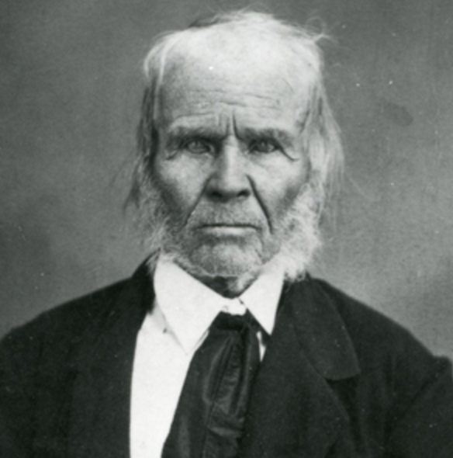

Source: https://www.nps.gov/subjects/islandofthebluedolphins/george-nidever.htm

In May of 1853 I fitted out my [schooner] for a trip to Turtle Bay to prospect for gold. Beside[s] us two there were Charley Brown, Tom Jefferies, & 4 Mission [Indians].…  Ten days after our return [to Santa Barbara] I again fitted out for a thorough [sea otter] hunt among the Islands, & principally around the San Nicolas.…  Reaching the place where he had seen the footprints the day before he followed [them] up the ridge. Near its top he found several huts made of whale's ribs & covered with brush. Although it was so long since they had been occupied…Looking about in all directions from this point, [Charley] discovered at a distance, along the ridge, a small black object about the size of a crow which appeared to be in motion. Advancing cautiously towards it, he soon discovered it to be the Indian woman her head & shoulders only visible…  In the mean time, the old woman was busily employed in stripping the blubber from a piece of seal skin which she held across one knee, using in the operation a rude knife made from a piece of iron hoop stuck into a piece of rough wood for a handle. She kept up a continual jabbering to herself & every few moments would stop & look in the direction of our men, whom she had evidently been watching, her hand placed over her eyes to shade them from the sun.…  The old woman was of medium height, but rather thick. She must have been about 50 yrs. old, but she was still strong & active. Her face was pleasing, as she was continually smiling.…  Having been requested by the Fathers at the Mission of Santa Barbara, to bring her off in case we found her…I thereupon made signs to her to go with us but she stared at me seemingly without comprehending what was wanted. Charley then placed his hand on her shoulder to call her attention & then went through the motions of putting her things in baskets & then these on his back, at the conclusion of which he said vamoose. This she understood without any difficulty, for she at once began putting her things into her baskets.… | fitted out—prepared  schooner—small ship with two masts  mission Indians—Christianized Indians from Mission Santa Barbara  principally—mainly, primarily  vamoose—to leave a place quickly; 19th-century Spanish for vamos, “let’s go”
Robert F. Heizer and Albert B. Elsasser, “Original Accounts of the Lone Woman of San Nicolas Island,” University of California Archaeological Survey, no. 55 (1961): Source: 16-22.

Questions

6. What was the main reason for Nidever and his crew’s visit to San Nicolas Island in 1853?

7. In 2-3 sentences, describe how Nidever explains how he and his crew found Juana Maria.

8. How did Nidever and his crew communicate with Juana Maria?

Beach on San Nicolas Island near Corral Harbor, inspiration for Coral Cove on The Island of the Blue Dolphins
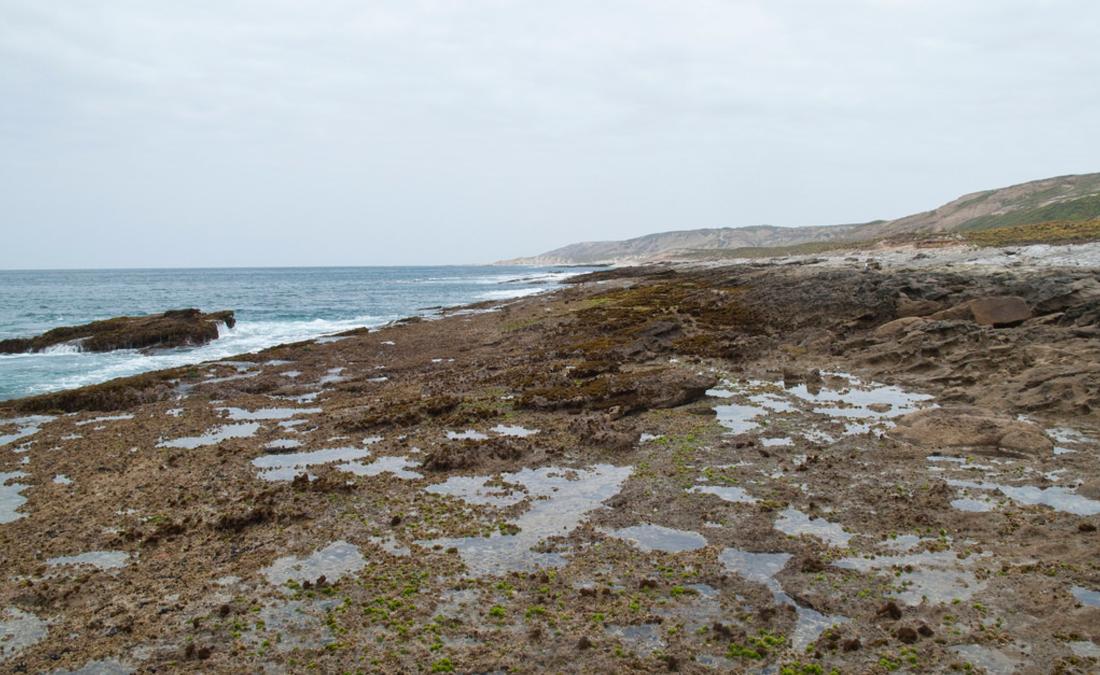

Source: https://www.flickr.com/photos/47945928@N02/4526650249/in/photostream/

Source 4

Scott O’Dell

Island of the Blue Dolphins

In this excerpt from Island of the Blue Dolphins Karana describes her first encounter with the European, and possibly American, men who have come to take her off the island, and some of her thoughts and feelings about leaving the island for good.

Now that the white men had come back, I could not think of what I would do when I went across the sea, or make a picture in my mind of the white men and what they did there, or see my people who had been gone so long. Nor, thinking of the past, of the many summers and winters and springs that had gone, could I see each of them. They were all one, a tight feeling in my breast and nothing more.  The morning was full of sun. The wind smelled of the sea and the things that lived in it.…  I crawled under the fence and stood facing them. The man in the gray robe had a string of beads around his neck and at the end of it was an ornament of polished wood. He raised his hand and made a motion toward me which was the shape of the ornament he wore. Then one of the two men who stood behind him spoke to me. His words made the strangest sounds I have ever heard. At first I wanted to laugh, but I bit my tongue.  I shook my head and smiled at him. He spoke again, slowly this time, and though his words sounded the same as before and meant nothing to me, they now seemed sweet. They were the sound of a human voice. There is no sound like this in the world.…  The ship stayed in Coral Cove nine days. It had come for otter, but the otter had gone. Some must have been left, after all, who remembered the Aleuts, for on that morning there were none to be seen.  I knew where they had gone.…  I asked them then about the ship that had taken my people away many years before, making the signs of the ship and pointing to the east, but they did not understand. Not until I came to Mission Santa Barbara and met Father Gonzales did I learn from him that this ship had sunk in a great storm soon after it reached his country and that on the whole ocean thereabouts there was no other. For this reason, the white men had not come back for me.  On the tenth day we sailed. It was a morning of blue skies and no wind. We went straight toward the sun.  For a long time I stood and looked back at the Island of the Blue Dolphins. The last thing I saw of it was the high headland. I thought of Rontu lying there beneath the stones of many colors, and of Won-a-nee, wherever she was, and the little red fox that would scratch in vain at my fence, and my canoe hidden in the cave, and of all the happy days. | headland—high piece of coastal land with cliffs that sticks out into the water  Rontu—Karana’s brother  Won-a-nee—wounded sea otter saved by Karana
Scott O’Dell, Island of the Blue Dolphins (New York: Dell Laurel-Leaf, 1960), 190-194.

Questions

9. Does Karana find the white men visiting San Nicolas, or do they find her?

10. Who is “the man in the gray robe?”

11. How does Karana respond to the men when they try speaking to her? Explain your answer in 2-3 sentences.

12. When—and where—does Karana find out about the ship that took her family and people away from the Island of the Blue Dolphins?

13. How does Karana describe the sky and air on the day she left the island?

14. How does O’Dell’s description of Karana and the white men at the end of Island of the Blue Dolphins differ from Nidever’s story of finding Juana Maria (Source 3)? Explain your answer in 2-3 sentences using at least 1 piece of evidence from Source 3 and Source 4.

Source 5

George Nidever
The Life and Adventures of a California Pioneer Since 1834 (1878)

This excerpt continues Nidever’s story of Juana Maria after she left San Nicolas Island. The priests of Mission Santa Barbara baptized Juana Maria, but she never went to live at the mission. She lived instead at the home of Nidever and his wife, Maria Sinforosa Ramona Sanchez Nidever.

We remained here hunting [sea otters] about a month…  When we left the Island for Santa Barbara, we were caught in such a violent gale that we were several times on the point of turning back, but we finally…[made it] to Santa Barbara…  The news was not long in spreading of the arrival of the old woman & we had barely reached my house with her when half of the town came down to see her.…  For months after[,] she & her thing[s], such as her dress, baskets, needle[s], &c., were visited by every body in the town & for miles around outside of it.  The old woman was always in good humor & sang & danced, to the great delight of the children & even old ones. She often visited the town & seldom returned without some present. The vessels that touched here usually brought passengers who[,] hearing of her[,] came to my house.…  The same day we arrived here th[e] Fathers from the Mission came down to see her. They continued to visit her & also sent for [Indians] from different parts of this section, & speaking different [Indian] tongues, in hopes of finding some one who could converse with her. Several came…but none of them could understand her or make themselves understood.…She expressed a great many ideas by signs so plainly that we readily understood them.…she told us that she did not find her child, that she wandered about for days without tasting hardly any food or drink…  After a time she forgot her child & sang & danced. She also told that she was very sick at one time; that she had seen vessels passing two [to] & fro but none came to take her off; that she saw us on the Island before we found her.  Her dresses, bone needles & other curiosities where [were] taken possession of by Father Gonzal[e]s, with my consent & sent to Rome.  About 5 weeks after she was brought over, she was taken sick from eating too much fruit & 7 weeks from the day of her arrival died. The Fathers of the Mission baptised her…& named her Juana Maria. I left here for San Francisco just before she died having first made her a rough coffin. My wife can tell you better about her after I brought her ashore. | gale—very strong wind  good humor—good mood  vessels—ships  converse—talk, speak
Robert F. Heizer and Albert B. Elsasser, “Original Accounts of the Lone Woman of San Nicolas Island,” University of California Archaeological Survey, no. 55 (1961): Source: 16-22.

Questions

15. Where did Juana Maria live after arriving in Santa Barbara?

16. How did Nidever and the other people of Santa Barbara communicate with Juana Maria?

17. How does Nidever describe Juana Maria’s experiences of being alone on San Nicolas? Cite at least 2 pieces of evidence from the text.

18. How did Juana Maria die? How long was she in Santa Barbara before her death?

Part 3. California Indians and Mission Santa Barbara
Juana Maria did not live at Mission Santa Barbara after she left San Nicolas Island. However, in many ways, her experiences, and those of all the Nicoleños, are similar to the experiences of those Indians who did live in the California missions during the eighteenth and nineteenth centuries.

Beginning with Mission San Diego, twenty-one missions were built along or near the coast of California between 1769 and 1823. The planning and building of the missions was managed by Spanish Catholic missionaries. Thus one of the main purposes of the missions was to spread Roman Catholicism among the Indians peoples of California.

Map of Missions, Presidios, and Pueblos of Spanish California
Source: http://www.missionscalifornia.com/sites/default/files/imagecache/full/Missions%20Map%2024%20x%2018%20100%20dpi.jpg

However, the missions were also built so that the Spanish Empire could establish greater control over California. Government officials in New Spain (Mexico) hoped that those Indians who converted to Catholicism would also become loyal subjects of the king and defend the empire from the increasing numbers of Russians, English, French, and (later) Americans interested in settling in, or trading goods in, California.

The missions were built in two main ways. First, most of the actual buildings that made up the missions were built by Indians, although Catholic priests and other Spanish settlers also contributed some labor and special skills to the construction process. The second way the missions were built was through rudección (reduction)—a process that involved persuading or forcing Native peoples to leave their homes and live at the mission. The efforts of Spanish missionaries to remove the Nicoliños and other Indians of the Channel Islands, and bring them to Mission San Gabriel and Mission Santa Barbara, are examples of rudección.

The missions had a major impact on the Native peoples of California, especially those who went to live in the missions. Everyday life at the missions was difficult and often involved hard work building and fixing the missions, and working as farmers, blacksmiths, carpenters, and other jobs. Also, once Indians were baptized, or officially converted into practicing Catholics, they were not allowed to leave the mission and return to their family or home village. Finally, large numbers of mission Indians died at the missions due to diseases like smallpox, malaria, and dysentery.

Image of Mission (Dolores) San Francisco
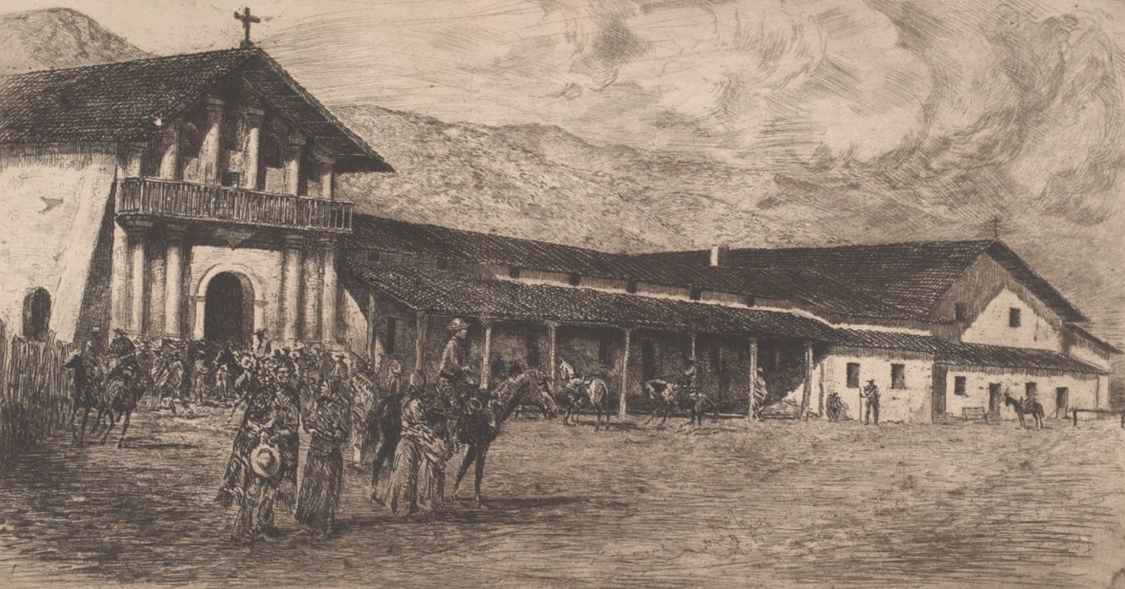
Source: http://oac.cdlib.org/ark:/13030/tf6m3nb7g6/?brand=oac4

Source 6

Diary of Otto von Kotzebue (1816)

Otto von Kotzebue was born to German family inside the Russian Empire and served as an officer in the Russian navy during the early nineteenth century. In 1815, von Kotzebue led a scientific voyage around the world that visited Fort Ross (the Russian fur trading colony in Northern California) and the area around San Francisco Bay. In this excerpt, von Kotzebue talks about disease and the poor living conditions among the Indians who lived at Mission San Francisco.

Two leagues to the southeast of the presidio and on the southern shore of the harbor is the Mission of San Francisco, which makes a fair-sized village.…The mission always has a guard of three or four soldiers from the presidio. The village is inhabited by fifteen hundred Indians; there they are given protection, clothing, and an abundance of food. In return, they cultivate the land for the community. Corn, wheat, beans, peas, and potatoes – in a word, all kinds of produce – are to be found in the general warehouse.…a general cooking of food takes place, at a given hour each day, in the large square in the middle of the village; each family comes there for its ration which is apportioned with regard to the number of its members. They are also given a certain quantity of raw provisions. Two or three families occupy the same house. In their free time, the Indians work in gardens that are given them; they raise therein onions, garlic, cantaloupes, watermelons, pumpkins, and fruit trees. The products belong to them, and they can dispose of them as they see fit.  In winter, bands of Indians come from the mountains to be admitted to the mission, but the greater part of them leave in the spring. They do not like the life at the mission.…After several months spent in the missions, they usually begin to grow fretful and thin, and they constantly gaze with sadness at the mountains which they can see in the distance. Once or twice a year the missionaries permit those Indians upon whose return they believe they can rely to visit their own country, but it often happens that few of these return…  The Indian children are more disposed to adopt to mission life. They learn to make coarse cloth from sheep’s wool for the community.…Other young Indians are instructed in various trades by the missionaries. There is a house at the mission in which some two hundred and fifty women…reside.…They are placed there at the request of the Indians…to protect them from mischief.  On Sundays and holidays they celebrate divine service. All the Indians of both sexes, without regard to age, are obliged to go to church and worship.  On Sunday… Indians gather in the cemetery…and dance.…Men adorn themselves with feathers and with girdles ornamented with feathers and with bits of shell that pass for money among them, or they paint their bodies.…  Severe fevers occur constantly among the Indians. These maladies commonly carry off a very great number. Several missions in Lower California have gone out of existence in the pasty twenty years by reason of the extinction of their Indians. | league—distance equal to about three miles  presidio—Spanish fortress, army base  inhabited—occupied; place where people live  cultivate—farm  ration—allowance  apportioned—divided up; assigned to  raw provisions—basic food supplies like fruit, vegetables, and flour  bands—groups  fretful—fearful  more disposed to adopt—more willing to accept  sexes—men and women  ornamented—decorated  severe fevers—deadly diseases  carry off—kill  maladies—sicknesses  out of existence—emptied of people; depopulated
Source: Edward Mornin, Otto von Kotzebue, et al. “Through Alien Eyes: The Visit of the Russian Ship to San Francisco in 1816 and the Men Behind the Visit,” North American Studies in 19th Century German Literature Vol 32.

Questions

19. How many Indians lived at Mission San Francisco?

20. What jobs did the Indians perform at the mission?

21. What time of year did most Indians join, or move, to the mission?

22. Did most Indians like living at the mission? Explain your answer using 2-3 pieces of evidence from the text.

23. What did the Indians do on Sundays? Explain your answer using 2-3 pieces of evidence from the text.

24. What does von Kotzebue say about disease and its effects on missions Indians elsewhere in California? Explain your answer using 2-3 pieces of evidence from the text.

Source 7

Journal of Jean-Francois de Galaup de la Perouse (1786)

Jean-Francois de Galaup de la Perouse was a French explorer and leader of a French naval voyage around the world. In 1786, the ships of his expedition reached California and visited both San Francisco Bay and Monterey Bay. While at Monterey, de la Perouse was given a tour of the area and Mission San Carlos Borromeo at Carmel by Spanish officials. Like Otto von Kotzebue, de la Perouse describes poor living conditions and harsh treatment of Indians at Carmel.

The Indian village stands on the right [of the church], consisting of about fifty huts which serve for seven hundred and forty persons of both sexes, including their children…  The day consists in general of seven hours labor and two hours prayer, but there are four or five hours of prayer on Sundays and feast days.…Corporal punishment is inflicted on the Indians of both sexes who neglect the exercises of piety…are here punished by irons and the stocks. And lastly…it must be observed that the moment an Indian is baptized, the effect is the same as if he had pronounced a vow for life. If he escapes to reside with his relations in the independent villages, he is summoned three times to return; if he refuses, the missionaries apply to the governor, who sends soldiers to seize him in the midst of his family and conduct him to the mission, where he is condemned to receive a certain number of lashes with the whip.…  The slightest embezzlement [of grain] is punished by the whip, though it seldom happens that they expose themselves to the danger. | sexes—men and women  labor—hard work  corporal punishment—physical punishment like whippings  neglect the exercises of piety—refuse to worship Christian God  irons and stocks—wood and iron device called a pillory that locked arms and head of person  relations—family  embezzle—to steal
Source: John Dunmore translation, “Journal of Jean-Francois de Galaup de la Perouse, 1785-1788,” London: Hakluyt Society.

Questions

25. What was a normal day like for a mission Indian—how many hours did he or she work and pray?

26. What happened to mission Indians who did not correctly practice Catholicism? Cite at least 2 examples of evidence from the text.

27. What happened to mission Indians who ran away from the mission?

28. How is de la Perouse’s description similar to that of Otto von Kotzebue (Source 6)? Explain your answer in 2-3 sentences using at least 1 piece of evidence from Source 6 and Source 7.

Source 8

Scott O’Dell

Island of the Blue Dolphins

In this excerpt from Island of the Blue Dolphins Karana describes her response to the dress she is given by the priest and white men who come to take her off the island.

The man lifted his hand and pointed toward the cove and made a picture in the air of what could have been a ship.  To this I nodded and myself pointed tow the three baskets I had placed by the fire, making a gesture of taking them with me to the ship. Also the cage in which I put two young birds.  There were many gestures before we left, though the two men spoke among themselves. They liked my necklace, the cape, and the cormorant skirt that shone in the sun. But when we got to the beach, where their camp was, the first thing the man who spoke the most did was tell the other men to make me a dress.  I knew this was what he said because one of them stood in front of me and held up a string from my neck to my feet and across my shoulders.  The dress was blue. It was made of two trousers, just like those the white men were wearing. The trousers were cut up into pieces and then one of the men sat down on a rock and put them together again with white string. He had a long nose, which looked like the needle he used. He sat all afternoon on the rock and the needle went back and forth, in and out, flashing in the sun.  From time to time he would hold up the dress and nod his head as if he were pleased. I nodded as if I were pleased, too, but I was not. I wanted to wear my cormorant skirt and my otter cape, which were much more beautiful than the thing he was making.  The dress reached from my throat to my feet and I did not like it, either the color [of] it or the way it scratched. It was also hot. But I smiled and put my cormorant skirt away in one of the baskets to wear when I got across the sea, sometime when the men were not around. | cormorant—large bird with long neck and dark feathers  trousers—pants
Scott O’Dell, Island of the Blue Dolphins (New York: Dell Laurel-Leaf, 1960), 192-193.

Questions

29. In 1-2 sentences, summarize the action taking place in the text.

30. Why does Karana dislike the dress made for her by the white men? Cite at least 2 pieces of evidence from the text.

31. Why do you think the European (or American) man made a new dress for Karana? Explain your answer in 2-3 sentences.

32. In what ways is Karana’s experience here similar to the mission Indians described by Otto von Kotzebue (Source 6)? Explain your answer in 2-3 sentences using at least 1 piece of evidence from Source 6 and Source 8.

Source 9

Mission Santa Barbara and the Chumash Indians

PBS, Indian Country Diaries (2006)

This brief history discusses the history of Mission Santa Barbara and the fate of those Chumash Indians who went to live there.

Painting of Mission Santa Barbara (1852)
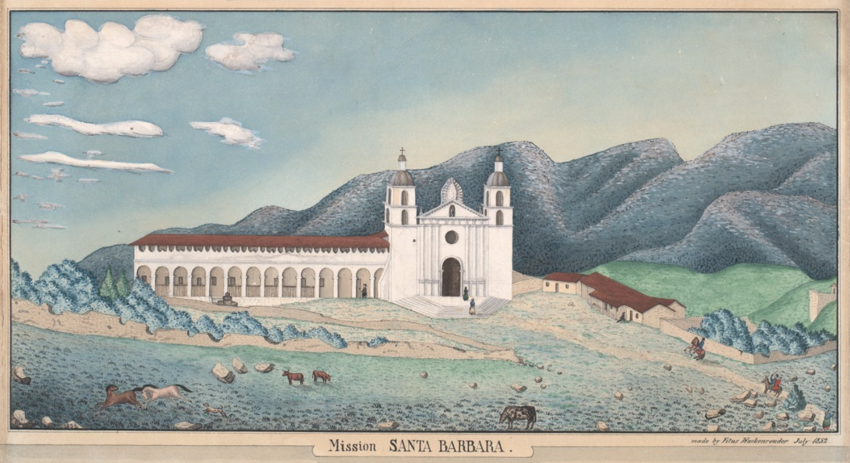

Source: http://oac.cdlib.org/ark:/13030/tf2x0nb4q3/?brand=oac4

For thousands of years, the southern and central Pacific coast region [of California] was one of the most densely populated areas north of Mexico. Population estimates range as high as 300,000 American Indians speaking 80 distinct languages. Because of the bounty of the sea, the pastures and hills, the Indians didn’t have to farm to survive. They fished, hunted and gathered an enormous variety of wild food. Acorns ground up and cooked into a soup, mush or bread was the staple for many groups.  At that time, the Chumash tribe was the largest group with around 20,000 members.…  Then in 1769, a Franciscan missionary named Father Junipero Serra led a Spanish army up from Mexico and reached present-day San Diego. It was he who built the first of 21 missions that would extend up north to San Francisco. When he encountered the Chumash, Fr. Serra failed to recognize a centuries-old religious tradition. “Believe me,” he wrote, “when I saw their general behavior, their pleasing ways and engaging manners, my heart was broken to think that they were still deprived of the light of the Holy Gospel.” He promptly set out to convert all the Indians he encountered to Christianity.  He also set out to make the native populations slaves to the farms supporting the missions. Spanish soldiers kidnapped Indians by the thousands. They were given Spanish names…became farm workers — something they had never done.…forced to care for livestock, tanned hides, and produced candles, bricks, tiles, shoes, saddles, soap and other necessities.  If they misbehaved, they were whipped, branded, mutilated or even executed. Hundreds and thousands of Indians — both in the missions and in surrounding areas — died of malaria, smallpox or other new diseases…  Beginning in 1775, many of the mission Indians began to revolt. Some 800 Ipai and Tipai Indians burned down the San Diego mission that year. The revolt was brutally put down by the Spanish soldiers, as were all of the revolts.  The years of warfare and mistreatment took their toll. At the Santa Barbara mission alone, more than 4,600 Chumash names fill the burial registry. Indians were put in mass graves near the church, and were denied either traditional or Christian burials. | bounty—something given or that exists in large amounts  acorn—fruit of an oak tree  staple—primary item of a culture or people’s diet  Chumash—large and influential band of California Indians that lived in and around area of Mission Santa Barbara  Franciscan—refers to group of Catholic priests and monks that follow the teachings of Saint Francis of Assisi  livestock—domesticated animals like cows, horses, and pigs  tanned hides—process of making leather from skin of cows  brand—to burn symbol on the skin with hot metal  mutilate—violent act that leaves permanent injury, like removal of hand
Source: http://www.pbs.org/indiancountry/history/calif.html

Questions

33. How did Native Californians like the Chumash live before the arrival of the Spanish—how did they get food, clothing, and shelter?

34. What was the population of the Chumash Indians around the time Mission Santa Barbara was built?

35. What Franciscan missionary oversaw the establishment of the mission system in California?

36. Why did Father Junipero Serra want to convert Indians like the Chumash?

37. What problems did the Chumash Indians experience at Mission Santa Barbara? Explain your answer using at least 3 pieces of evidence from the text.

38. What was one of the main consequences of disease and violence at Mission Santa Barbara—how many Chumash Indians died at Mission Santa Barbara?

39. How did some Indians respond to the bad conditions of mission life?

Final Activity. What happens to Karana after she leaves the Island of the Blue Dolphins?

In this lesson, you have learned about two related historical problems: (1) the long-term effects of the violent encounter between the Nicoleños and Russian and Aleut hunters in 1814; and (2) the long-term effects of the Spanish missions on the Native peoples of California during the eighteenth and nineteenth centuries (1700s and 1800s).

You have learned about these problems by reading passages from Island of the Blue Dolphins that are based on Nicoleño history, or the history of the California missions (the Spanish priest at the end of the novel is a missionary from Mission Santa Barbara). As the novel and other historical sources show, Pacific World trade and the Spanish missions had a major—and often negative---impact on Native peoples all over California.

This is not really the story Scott O’Dell tells in Island of the Blue Dolphins. The novel shows the bad things that happen to the village of Ghalas-at after the battle with the Russian and Aleut hunters, but O’Dell doesn’t tell us what happens to Karana after she leaves the island. By ending the story this way, O’Dell ends the novel on optimistic note. Karana is happy to leave the island and is confident about the future and her new life at Mission Santa Barbara.

Perhaps Juana Maria felt the same way as Karana when she left San Nicolas Island. But, what happened to Juana Maria after she arrived at Santa Barbara?

Your task for this final activity is to finish Karana’s story. What happens to Karana after she leaves the Island of the Blue Dolphins?

Your job is to write a brief story that answers this question.

I. Story Options

Your story should focus on one of the three guiding questions:

1. What happens to Karana during her first three days at Mission Santa Barbara?

2. What people—new friends or old friends and family—does Karana meet at Mission Santa Barbara?

3. What happens to Karana over the long term—what is her life like a year after arriving at Mission Santa Barbara.

II. Story Requirements

1. Your essay should be written like the novel, which means it should be a first-person account written from Karana’s perspective. Write as if you are Karana.

2. Your story should be three paragraphs long.

3. Also just as Scott O’Dell based his story of Karana on historical sources, your story should also be based on three historical sources from this lesson (Lesson 2). Use one source per paragraph.

III. Drafting Your Story

As you think about what might happen to Karana after she leaves the island, also think about what you have learned in this lesson and the lesson’s main inquiry question: How did the arrival of European and American traders, and Spanish missionaries, change the lives of California Indians during the 1800s?

Use the graphic organizer below to identify your three historical sources, your three plot points—or story events—and to bullet-point or brainstorm each of the paragraphs.

Finally, be sure to think about chronology or historical sequence. Use the information from this lesson to arrange the plot points in a logical order.

After you have mapped out all three plot points, begin writing your story.

What happens to Karana after she leaves the Island of the Blue Dolphins?
Story Guiding Question:

Historical Source 1
Plot Point/Event 1
Paragraph 1
Brainstorm/
Bullet Points
Historical Source 2
Plot Point/Event 2
Paragraph 2
Brainstorm/
Bullet Points
Historical Source 3
Plot Point/Event 3
Paragraph 3
Brainstorm/
Bullet Points

