Income taxes: What is a fair way to collect income taxes?

Standard: 12.3 Students analyze the influence of the federal government on the American economy.
- Describe the aims of government fiscal policies (taxation, borrowing, spending) and their influence on production, employment, and price levels.

Guiding Question: How does the government generate income? What is the fairest way to collect income tax?

Overview of Lesson:
The debate over taxes and spending is always political. This lesson allows students to learn about the ways that income tax is currently structured and to consider how they think that our tax system can best reflect their values. While Congress debates revising the tax code. Students can also consider how they would organize the collection of individual income taxes. What is a fair way to collect income taxes? How does this reflect their priorities as American citizens, professionals, and consumers?

The following documents show different perspectives of the ways that income taxes are and can be collected. Students will review these, consider their own priorities and then develop a policy for their Congressional representative to review. This policy statement will deveop a claim based on evidence that supports what each student considers a fair form of income taxation.

Teachers may want to start the lesson by playing a short video on government income and spending from the Council of Economic Education found here:
https://player.vimeo.com/video/200075375

Possible scaffolds:
- Teachers might consider only assigning the EL version depending on the needs and abilities of students.
- Teachers might consider developing heterogenous groups to tackle this assignment. More advanced readers can be responsible for the longer articles, while others can use the videos, visuals, and cartoon sources. They can then share and discuss their findings as they complete the policy statement together.

12th Grade Performance Task

Issue: How does the government generate income? What is the fairest way to collect income tax?

The government requires income to cover its spending priorities. One of the most effective ways that the government can get the money it needs is to tax its citizens. According to the Library of Congress, “The origin of the income tax on individuals is generally cited as the passage of the 16th Amendment, passed by Congress on July 2, 1909, and ratified February 3, 1913; however, its history actually goes back even further. During the Civil War Congress passed the Revenue Act of 1861 which included a tax on personal incomes to help pay war expenses. The tax was repealed ten years later… The 16th amendment, ratified in 1913…allowing the Federal government to tax the income of individuals without regard to the population of each State.” Since that time income tax has come to make up almost half of the federal government’s revenue.
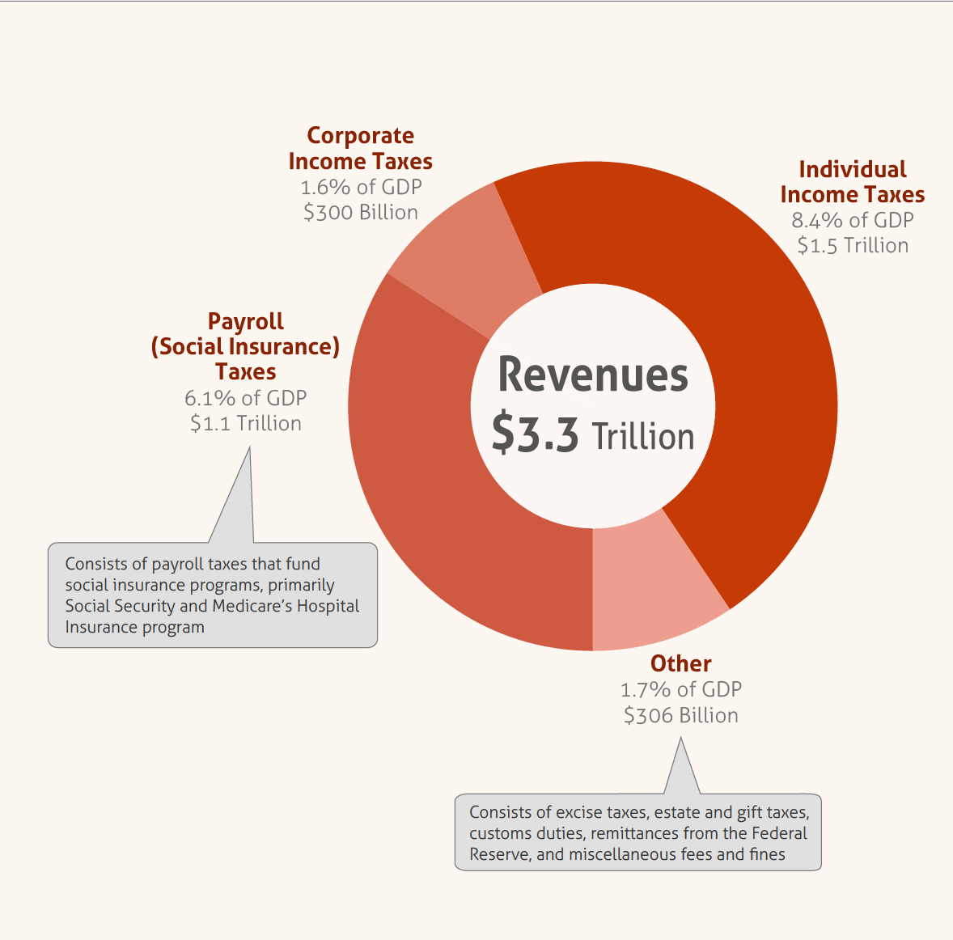
Image and data from the Congressional Budget Office reflecting the 2016 Federal Budget. Found at: https://www.cbo.gov/publication/52408

Directions for Part 1
You will now examine and analyze a variety of sources about income tax. Take notes because you may want to refer to your notes while developing the policy statement for Part 2. You can re-examine any of the sources as often as you like.

Directions for Part 2
The U.S. Congress is currently debating the revision of our current tax policy. You will develop a policy statement for your Congressional representative using the template at the end of the lesson. Make sure you use evidence from the task or from outside sources to develop your statement.

Directions for Part 3
You will now review your work to this point and plan, draft, revise, and edit an essay in response to the question, “What is the fairest way to collect income tax?” You may use your notes and refer to the sources.

Background Information

Taxation is essential to the functioning of the modern state. To pay for the things that we need to live our daily lives, such as water, roads, security, and education, the state must collect taxes to pay for these expenses. We all have to pay taxes so it is important for us to know more about how the U.S. government decides to collect income taxes. If you are working now and when you work in the future, you will pay taxes. You will notice that several types of taxes are withheld from your paycheck. These include payroll taxes and deductions for income tax. Payroll taxes are automatically withheld and pay for Social Security and other government services such as unemployment and disability insurance. The other portion of taxes withheld from your paycheck is for income tax. The amount withheld is defined when you fill out the W-4 form from the Internal Revenue Service (IRS) before you start your job. This form allows you to identify whether you are dependent of your parents or not, are single or married, and whether you have children and how many. All of these selections put you in a different tax category and your employer will calculate how much tax is withheld from your paycheck for income tax requirements. Income from working, along with income from property (such as rentals), and income from savings and investments (such as stocks and mutual funds), are all taxed by the federal government. Each year, every individual who is working or earning income must submit their taxes to the IRS by April 15.
Because you already pay income tax or will in the future, it is important that you know how this tax is calculated and also have an opinion about what is a fair policy for income taxation. While taxation is essential to the functioning of the government, there are many perspectives on how people should be taxed and what is most fair. The Council for Economic Education has created a set of criteria for evaluating taxes. Read the criteria below and consider which reflects your current understanding of what is a fair income tax policy. Rank these according to your position. There is also a blank spot for you to create your own criterion if your position is not reflected below.
For more information on the structure of our current income tax system, watch this video from the Basic Gist.

Criteria for Evaluating Tax Plans
Read each of the criteria below and rank these 1-6 (with 1 being the most important and 6 being the least important) based on your own beliefs about income and taxation.

Rank | Criterion
 | People are able to keep what they earn. They have a right to make choices as to what is best for them and their family and not obligated to provide for other people. People know best what they want, and resources are allocated most efficiently when people have maximum freedom.
 | Taxes should be simple, clear, and consistent; people shouldn’t need to think too much about them or devote much time to figuring out how much they owe (or how they might avoid paying).
 | People should pay taxes in proportion with their wealth. People who have more can more easily make sacrifices, and should pay more to support those in need.
 | Taxes should be based on strict equity—just like anything else, everybody pays the same.
 | Taxes should create the right incentives; they should encourage economically productive and socially desirable activities, like working, saving, and investing, and discourage undesirable behaviors like polluting the environment.
 | Taxes should generate enough revenue to provide a “social safety net,” including Social Security and Medicare, for everyone.

Source 1:

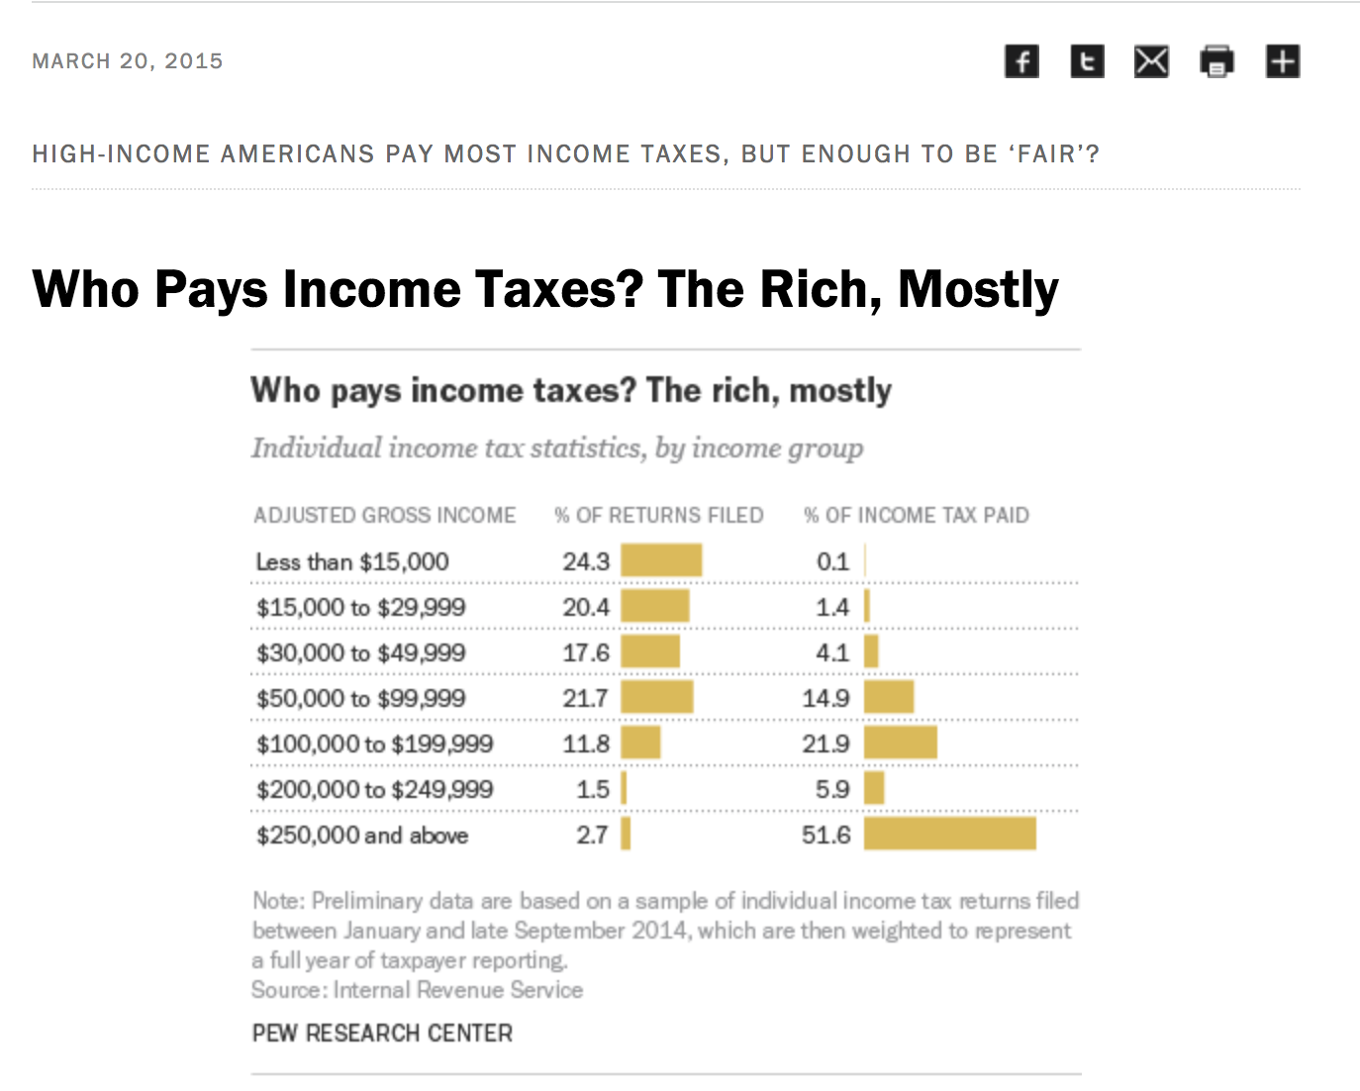
Found at: http://www.pewresearch.org/fact-tank/2016/04/13/high-income-americans-pay-most-income-taxes-but-enough-to-be-fair/ft_15-03-23_taxesind/

- What is the main idea of this data?
- Do you think the current tax policy is fair? Explain using evidence from the source.

Source 2:
June 19, 1935, message from President Franklin Delano Roosevelt to Congress
To the Congress:
As the fiscal year draws to its close it becomes our duty to consider the broad question of tax methods and policies. I wish to acknowledge the timely efforts of the Congress to lay the basis, through its committees, for administrative improvements, by careful study of the revenue systems of our own and of other countries. These studies have made it very clear that we need to simplify and clarify our revenue laws…
I am able to make a number of suggestions of important changes in our policy of taxation. These are based on the broad principle that if a government is to be prudent its taxes must produce ample revenues without discouraging enterprise; and if it is to be just it must distribute the burden of taxes equitably...
With the enactment of the Income Tax Law of 1913, the Federal Government began to apply effectively the widely accepted principle that taxes should be levied in proportion to ability to pay and in proportion to the benefits received. Income was wisely chosen as the measure of benefits and of ability to pay. This was, and still is, a wholesome guide for national policy. It should be retained as the governing principle of Federal taxation. The use of other forms of taxes is often justifiable, particularly for temporary periods; but taxation according to income is the most effective instrument yet devised to obtain just contribution from those best able to bear it and to avoid placing onerous burdens upon the mass of our people.
The movement toward progressive taxation of wealth and of income has accompanied the growing diversification and interrelation of effort which marks our industrial society. Wealth in the modern world does not come merely from individual effort; it results from a combination of individual effort and of the manifold uses to which the community puts that effort. The individual does not create the product of his industry with his own hands; he utilizes the many processes and forces of mass production to meet the demands of a national and international market.
Therefore, in spite of the great importance in our national life of the efforts and ingenuity of unusual individuals, the people in the mass have inevitably helped to make large fortunes possible. Without mass cooperation great accumulations of wealth would be impossible save by unhealthy speculation. As Andrew Carnegie put it, "Where wealth accrues honorably, the people are · always silent partners." Whether it be wealth achieved through the cooperation of the entire community or riches gained by speculation—in either case the ownership of such wealth or riches represents a great public interest and a great ability to pay…
Found at: https://www.treasury.gov/resource-center/faqs/Taxes/Pages/historyrooseveltmessage.aspx
- What did Roosevelt say the goal, or governing principle of taxation, should be?
- According to Roosevelt, who generates wealth in the U.S.?
- How does the U.S. tax policy reflect fairness according to Roosevelt?
- Do you think this is fair? Explain using evidence from the source.

Source 3:
Chip Bok, September 29, 2017
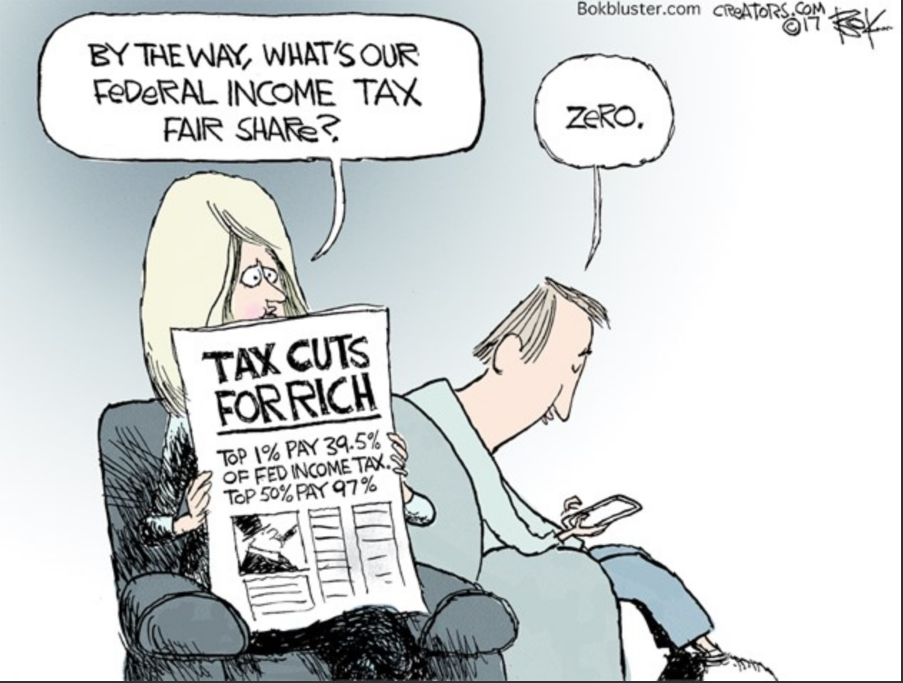

- What is the main idea of this cartoon?
- What does a “fair share” mean according to the cartoon?

Source 4
Robert Reich, “Why taxes have to be raised on the rich?”
https://www.youtube.com/watch?v=ozMpjCSUuWk

Note: Robert Reich is a Professor of Public Policy at UC Berkeley and served in the Clinton administration as the Secretary of Labor.

1. What is Reich’s argument?
2. What evidence does he give to support his argument?
3. What types of income tax plans support the middle and lower classes, according to Reich?
4. Do you think Reich’s proposal is fair? Give evidence to support your claim.
Source 5
Tax Brackets for 2017
Found at https://taxfoundation.org/2017-tax-brackets/
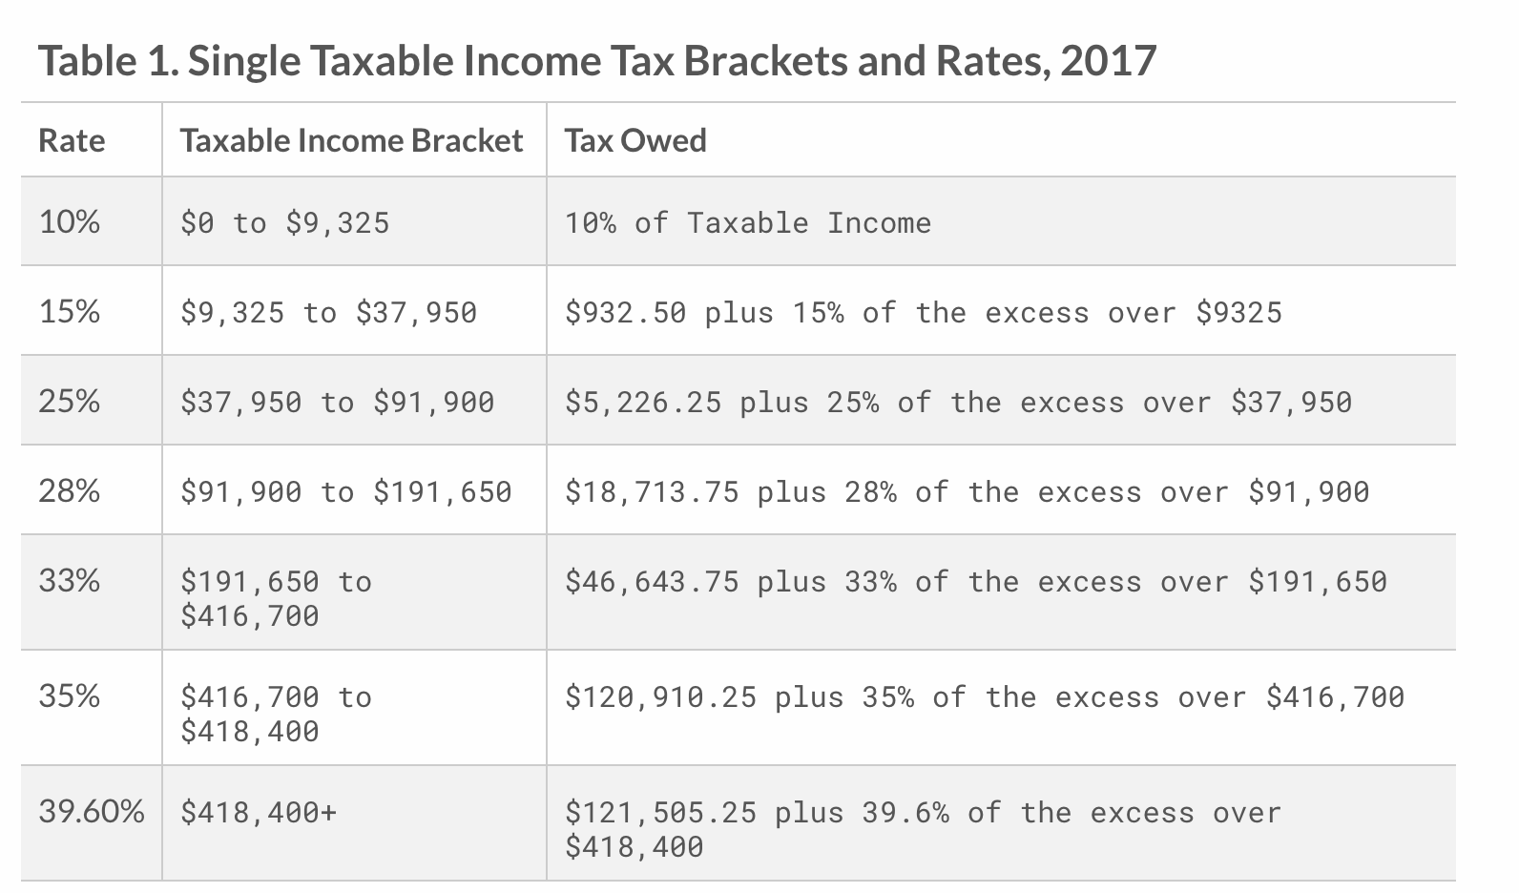

1. Do all income earners pay taxes?
2. How does this progressive taxation work?
3. Do you think this progressive income tax is fair? Give evidence to support your claim.

Source 6
Tonya Moreno, “What is a Flat Tax System?” April 7, 2017-10-27
https://www.thebalance.com/what-is-a-flat-tax-system-3193253
The "flat tax" is an income tax system in which everyone pays the same tax rate regardless of income. These systems are in place in eight U.S. states as of 2016, but legislation is afoot in at least one state to change to a progressive system.
The Flat Tax Simplifies Taxation

Advocates of the flat tax system contend that it's fair because everyone pays the same tax rate. This system eliminates deductions, tax credits and most exemptions, which in theory curbs biases toward certain behaviors and activities.
It also simplifies the tax code, making compliance easier. Some proponents would like to see Federal Form 1040 replaced by a simple post card on which you would write your wages and multiply it by one tax rate…
Economic Growth and the Flat Tax
Supporters of a flat tax system claim that it encourages economic growth by avoiding a system in which earners with higher incomes are penalized for being productive and earning more money. They argue that a progressive tax creates penalties for things like hard work, risk-taking and entrepreneurship. The flat tax is supposed to avoid this by taxing every dollar at the same rate.
At the state level, reducing the top income tax rate by moving to a lower flat tax rate is thought to attract and encourage business investment and to bring in high-income individuals, increasing overall tax revenue and economic stability.

Arguments Against a Flat Tax System
Opponents argue that a flat tax system places an undue burden on the lower and middle class by removing deductions and expanding the tax base to include every level of income.
They claim that moving to such a system shifts the tax burden from the rich to the poor, those who are most affected by taxation and who are the least able to pay. They contend that the working class supports the idle rich when unearned income is exempted. Some flat tax systems in the U.S. get around this by exempting individuals who fall below certain income levels and by offering special exemptions or tax credits for low-income individuals.
Opponents of the flat tax argue that progressive tax systems are fair because they tax disposable earnings -- income minus certain deductible expenses. They argue that the wealthy should pay more because they have more disposable income and therefore a greater ability to pay, and that the economy would be better stimulated by decreasing taxes on the middle class, who make up the largest part of the general public. This would give more people additional disposable income to spend on products.
1. What is a flat income tax?
2. What evidence does this author give to support the flat tax?
3. What evidence does this author give opposing the flat tax?
4. Do you think a flat tax policy is fair? Give evidence to support your claim.

Source 7:
Jane McGrath, “How Trickle Down Economics Works,”
https://money.howstuffworks.com/trickle-down-economics.htm

…In a nutshell, trickle-down theory is based on the premise that within an economy, giving tax breaks to the top earners makes them more likely to earn more. Top earners invest that extra money in productive economic activities or spend more of their time at the high-paying trade they do best (whether that be creating inventions or performing heart surgeries). Either way, these activities will be productive, reinvigorate economic growth and, in the end, generate more tax revenue from these earners and the people they've helped. According to the theory, this boost in growth will ultimately help those in lower income brackets as well. Although trickle-down economics is often associated with the policies of Ronald Reagan in the 1980s, the theory dates back to the 1920s. The name also has roots in the '20s, when humorist Will Rogers coined the term, saying, "The money was all appropriated for the top in the hopes it would trickle down to the needy…

Why anyone would give huge tax breaks to the wealthy eludes many of us. Some would argue that because the rich have used the freedoms of an economy to make much more money than they need, they should give back a larger share than those who are struggling. This is the very idea behind the progressive income tax in the United States: When income reaches higher brackets, the government taxes that excess at a higher rate. But under the logic of trickle-down theory, tax breaks for the wealthy benefit all…"
Tax breaks improve tax revenues, and … they also boost production. Giving tax breaks to the wealthy stands as a policy meant to improve the overall health of the economy.
Opponents of this economic theory tend to believe that politicians who support it are in the pockets of wealthy businessmen. They often summarize trickle-down economics to something resembling Will Rogers' definition: The policy of giving breaks to the rich first and hoping the benefits will eventually make their way to the working classes. Proponents of trickle-down (or supply-side) economics object to this evaluation, calling it not just an oversimplification but a misinterpretation of what they hypothesize will happen…
In 1981, Reagan passed his Economic Recovery Tax Act (ERTA), which cut all marginal tax rates dramatically (the top fell from 70 percent to 50 percent). Since then, trickle-down theory has been tied closely to Reagan's policies, collectively named Reaganomics.
Trickle-down economics remains highly controversial. Recently, George W. Bush faced harsh criticism for his tax cuts. Despite staunch political opponents to trickle-down policies, some maintain that the general consensus among economists today is that the theory works. Nevertheless, you'll still find plenty of controversy surrounding trickle-down economics among politicians. Many, including Barack Obama, contend that it failed. During a hurting economy, Obama won the support of voters by promising to tax the wealthy and ease the tax burden on the lower-income bracket. So as of 2008, the tide of public opinion certainly shifted away from supply-side thinking yet again. Time will tell if opinion will shift back again.
- What is trickle-down economics?
- What would an income tax policy that reflects the trickle-down theory look like?
- What do opponents of trickle-down argue?
- Do you think a trickle-down income tax policy is fair? Give evidence to support your claim.

Source 8
60 Minutes, “The Pledge: Grover Norquist's hold on the GOP”
https://www.youtube.com/watch?v=K25kqP0YdZ0 watch the first 6 minutes

1. What is the pledge?
2. What does Norquist argue about income taxes and federal spending?
3. Why is Norquist so effective lobbying the Republican party?
4. Do you think a the tax policy supported by Norquist is fair? Give evidence to support your claim.

Source 9
Christopher Matthews, “How much do taxes affect our bahavior?” Time, March 5, 2012
http://business.time.com/2012/03/05/how-much-do-income-taxes-affect-our-behavior/

Note: Marginal rate is the tax applied to your income for each tax bracket.
During the 1980 Republican Presidential primary, Ronald Reagan promulgated the idea that by lowering taxes on the rich, the government could actually increase the federal government’s revenue. George H.W. Bush famously derided that idea as “Voodoo Economics.” After all, how could lowering tax rates actually increase revenue?
The idea isn’t as far-fetched as it might seem at first blush. To illustrate, think about tax rates in the extreme. If the government took 100% of your income, surely many people would simply not work. Perhaps nobody would work. And if the government lowered the 100% tax rate to, say, 80%, it seems very likely that at least some more people would work and the government would take in more revenue.
On the other hand, if the government starts with very low tax rates, lowering them further probably wouldn’t increase the incentive to work much, if at all…
[A] working paper issued in February by the National Bureau of Economic Research and co-written by the former chair of President Obama’s Council of Economic Advisors, Christina Romer, and her husband David, suggests that tax rates have a much lower effect on investing and labor decisions than previously thought. In fact, the paper argues that revenue-maximizing tax rate is as high as 84%.
The paper also finds that taxes generally have less effect on behavior than previously thought. What separates this study from others of its kind is that it looks at tax rates in the period between the two world wars, as opposed to more recent times. The advantage of this approach is that there were many changes in the marginal tax rates during this time, giving researchers many opportunities to study how those changes effect citizen behavior. In addition, the income tax regime during this period was much more progressive than it is now. For instance, for most of the period studied, the top 1/200th of one percent of earners bore between 30 and 40 percent of the total federal income tax burden.
As Baseline Scenario blogger James Kwak argues, these are the folks who would most likely change their behavior based on tax rates. They have enough money to stop working if they wanted to, but the evidence suggests that this is not what people do. Kwak argues that the real danger is not that the wealthy will stop working, but that they’ll pour more and more resources into shielding their income from taxes, and that a simplified tax code is should therefore be a priority.
Of course there are other considerations besides revenue maximization to take into account when deciding upon marginal tax rates. Fairness is one. Conservatives don’t usually like to explicitly raise the fairness argument because once fairness is a consideration, it opens up the door for all kinds of wealth redistribution. But when it comes to taxes, fairness can be a compelling argument to make even for those who wish to lower taxes on the rich.
A recent poll conducted by The Hill illustrates this point perfectly. The poll shows that 3/4 of the American electorate believe that the top marginal tax rate should be lower than it actually is. That flies in the face of a much-cited Pew poll that showed that 66% of Americans thought that taxes should be raised on the highest earners. The difference between these two polls comes down to how the questions were worded. The Hill poll asks respondents what the ‘most appropriate’ rate is for those earning above $250,000 a year, while the The Pew poll simply asked whether taxes on the rich should be raised. According to The Hill:
“One possible explanation is voters may not know how much the nation’s top earners are already being taxed. The poll did not ask voters to identify current tax rates before saying what rate they favored.”
So it seems Americans recoil from tax rates much higher than 30%, regardless of how rich those paying the tax are. Of course, the disconnect between what Americans demand from their government and what they think is fair that the government demand of them is not new. What the Romer study does show us is that the government’s taxing and spending affect our professional and investing decisions much less than we thought.
- What is the main argument of this article?
- How does tax policy influence people’s behavior?
- What do opinion polls report about American’s beliefs regarding fairness and tax policy?
- Do you think a fair income tax will affect the way that people make economic decisions? Give evidence to support your claim.

Income Tax Policy Statement:
What is a fair way to collect income taxes?

Policy Name and date:

Characteristics | Response
Rationale and Purpose:
Why is the tax policy being proposed? Explain why we need a revised income tax policy.
Policy Statement: What is the policy? Describe the policy.

Evidence:
What evidence supports your policy?

Explanation:
Why is your policy more fair than our current policy?

Implementation:
How will this policy be put into place? Highlight specific steps to complete the goal(s) outlined in your policy.

