The Fourth Estate: The Role of the Media on American Public Life
By Kate Harris

Standard: 12.8 Students evaluate and take and defend positions on the influence of the media on American political life.
- Discuss the meaning and importance of a free and responsible press.
- Describe the roles of broadcast, print, and electronic media, including the Internet, as means of communication in American politics.
- Explain how public officials use the media to communicate with the citizenry and to shape public opinion.

Guiding Question: What are the roles and responsibilities of the media in relation to American government? Is today's press fulfilling those roles responsibly?

Overview of Lesson:
The press in America today is often under fire--sometimes even taking criticism from the president himself. In a democracy, we depend on the press to perform a variety of roles in order to help us become informed citizens. We expect the press to be independent, informative, investigative (“watchdog journalism”) and to help set the agenda and frame political issues wisely. But is today’s press fulfilling those roles responsibly? Or has journalism become too tied to money, political bias, and ratings?

The following documents show different contemporary attitudes towards the press today across a variety of media. After reviewing the sources here and thinking about the media they are exposed to regularly, students will--alone, in partnerships, or in groups, according to their need--complete the Report Card, grading the press on the characteristics listed and offering next steps. As an summative assessment, teachers may require a written essay response to the guiding questions.

Possible scaffolds:
- Teachers might consider only assigning parts 1 & 2 depending on the needs and abilities of students.
Teachers might consider developing heterogenous groups to tackle this assignment. More advanced readers can be responsible for the longer articles, while others can use the video and cartoon sources. They can then share and discuss their findings as they complete the report card together.

12th Grade Performance Task

Issue: What are the roles and responsibilities of the media in relation to American government? Is today's press fulfilling those roles responsibly?

The press in America today is often under fire--sometimes even taking criticism from the president himself. In a democracy, we depend on the press to perform a variety of roles in order to help us become informed citizens. We expect the press to be independent, informative, investigative (“watchdog journalism”) and to help set the agenda and frame political issues wisely. But is today’s press fulfilling those roles responsibly? Or has journalism become too tied to money, political bias, and ratings?

Directions for Part 1
You will now examine and analyze a variety of sources about the press today. Be sure to begin with the background reading that explores the characteristics demanded of today’s press. Take notes because you may want to refer to your notes while completing the Report Card. You can re-examine any of the sources as often as you like.

Directions for Part 2
Complete the attached Report Card using the notes you took while reviewing the sources, in addition to any outside knowledge you may have on the topic. Consider the news reporting you see and hear. Does it seem to meet our criteria? In addition to offering a grade for each characteristic, you will need to highlight the evidence you used to come to your conclusions and suggest next steps.

Directions for Part 3
You will now review your work to this point and plan, draft, revise, and edit an essay in response to the questions “What are the roles and responsibilities of the media in relation to American government? Is today's press fulfilling those roles responsibly?” You may use your notes and refer to the sources.

Background Information

Journalism in the United States plays an important role in politics. Reporters and editors make choices about what to cover, research issues deeply, and provide information to the public. Why does that matter? Since the founding of our nation, it has been suggested that the press can act as a check on government by sharing information about changing times and the politicians in power. These quotes from our “founding fathers” below support the belief that journalism is essential to protecting individuals against the growing power of the government:
- The freedom of the press is one of the greatest bulwarks of liberty, and can never be restrained but by despotic governments. --George Mason (1776)
- The liberty of the press is essential to the security of freedom in a state: it ought not, therefore, to be restrained in this commonwealth. --John Adams, Samuel Adams, and James Bowdoin (1780).
- The basis of our government being the opinion of the people, the very first object should be to keep that right; and were it left to me to decide whether we should have a government without newspapers, or newspapers without a government, I should not hesitate a moment to prefer the latter. But I should mean that every man should receive those papers and be capable of reading them. --Thomas Jefferson (1787).

The most basic expectation of the press is that it is informative. Whether in newspapers and magazines, on television, radio, or the internet, news is useful because it tells its audience information that it wants to know, from the weather that day to upcoming Congressional legislation or Supreme Court cases.

In addition, we expect that the press is independent. In the Code of Ethics from the Society of Professional Journalists, they note that the reporters’ main obligation is to the public. Accepting payment, gifts, or special treatment from individuals or businesses could change the way a story is reported and lead to bias. Then the news becomes less trustworthy, and far less useful.

An important role of journalism is that it is investigative. This means that reporters don’t just report the bare facts, they dig deeper into the why and how of issues. This kind of research provides readers with more background information and keeps a tight eye on those in power. This is sometimes known as “watchdog journalism,” and the work of investigative reporters is known for blowing the whistle on unethical politicians (former President Nixon resigned in part due to reporting from the Washington Post) and organizations. This role has been affirmed and supported by the Supreme Court in several cases; Justice Hugo Black noted in 1971 that, “In the First Amendment, the Founding Fathers gave the free press the protection it must have to fulfill its essential role in our democracy. The press was to serve the governed, not the governors. The Government's power to censor the press was abolished so that the press would remain forever free to censure the Government. The press was protected so that it could bare the secrets of government and inform the people.”

When editors and reporters make choices about what types of stories to feature and write about, they are helping to set the agenda and frame political issues. For example, if a newspaper does a series of articles on problems with landlords and low-income housing in a city, this might influence people to ask their City Council or Mayor to look into the issue and develop solutions. This kind of agenda-setting can have an impact on local or national levels. Journalists help frame political issues by choosing to present information in different ways. When writing about self-driving cars, one reporter might choose to look at the possible safety impacts of using these vehicles, while another might focus on how this will effect the car manufacturing industry. These editorial choices will affect the ways that people talk and think about the issues, and one hopes that reporters make these decisions in a fair and responsible manner.

Frequent criticism of the press suggest that it has become too biased, too tied to certain politicians or interest groups, and too concerned about making money. Your task today will be to evaluate these claims using the sources that follow. What do you think: does today’s journalism make the grade?

For more information on the role of media in politics today, watch this video from Crash Course Government and Politics.

Source 1:

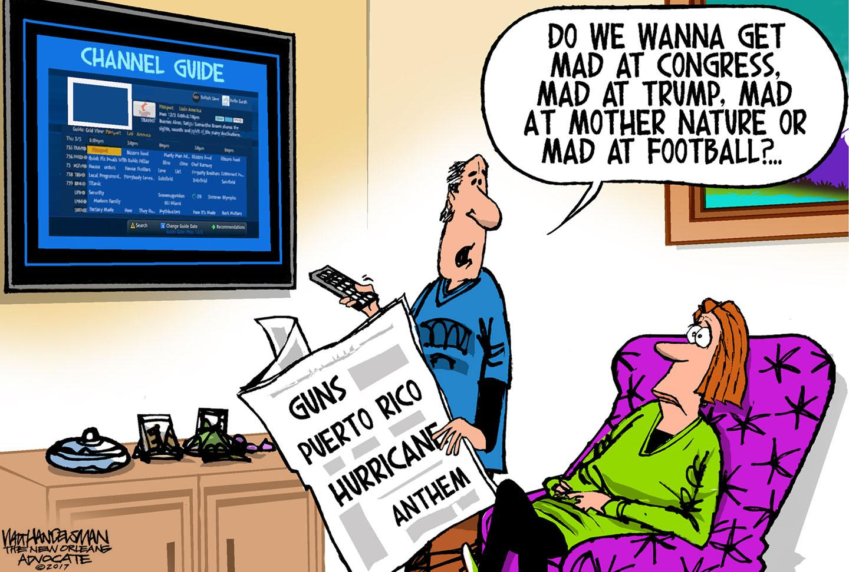
Walt Handelsman, © 2017 Tribune Content Agency.
From The Week’s newsletter “Today’s Best Political Cartoons.” 10/9/17.

- What does the creator of this cartoon suggest are the issues dominating the news at the time it was made?
- How are the people in the cartoon responding to the news?
- What do you think the cartoonist is saying about news coverage today?

Source 2:
The Hill
Trump: 'Fake NBC News' nuke story 'pure fiction'
BY JORDAN FABIAN - 10/11/17 09:56 AM EDT

President Trump on Wednesday forcefully denied an NBC News report that he asked to dramatically expand the U.S. nuclear arsenal and suggested he might pull the network’s broadcasting license.
“Fake @NBCNews made up a story that I wanted a ‘tenfold’ increase in our U.S. nuclear arsenal. Pure fiction, made up to demean. NBC = CNN!” he tweeted.
In a subsequent tweet, the president wrote: “With all of the Fake News coming out of NBC and the Networks, at what point is it appropriate to challenge their License? Bad for country!”
The news network on Wednesday reported the president’s request, which it said shocked top military brass and senior administration officials.
The request was what reportedly led Secretary of State Rex Tillerson to call Trump a “moron.” A State Department spokesperson later denied Tillerson used that word to insult Trump.
At a July meeting at the Pentagon, the president said he wanted to expand the country’s nuclear capabilities after seeing data showing the U.S. weapons stockpile decreasing over the past 50 years, according to the report.
Top military officials reportedly told him that such a buildup would be prohibitively expensive and violate international disarmament treaties.
Trump’s threat against NBC alarmed some media figures and policy makers, who viewed it as an attempt to infringe on free-speech rights. Others said stripping a broadcast license is not feasible.
“Not how it works,” tweeted Jessica Rosenworcel, a Democratic member of the Federal Communications Commission (FCC).
Television and radio stations require a license from the FCC in order to broadcast. They are issued to individual stations and local affiliates, not entire networks like NBC.
A 2008 commission document states that the First Amendment “protects broadcasts that criticize or ridicule established customs and institutions, including the government and its officials.”
It also said the FCC "generally will not intervene" in "allegations that stations have aired inaccurate or one-sided news reports or comments."
- Why was President Trump criticizing NBC? What did he threaten to do?
- When President Trump calls the press “fake news,”what does he mean?
- Can the government revoke a broadcast license for a news network? What problems might result if it could?
- Do you think NBC was wrong to publish their report? Why or why not?

Source 3:
Vox.com
CNN treats politics like a sport--that’s bad for all of us
By Carlos Maza, 17 April 2017.

President Trump has directed much of his anti-media shtick at CNN over the past few months, publicly attacking the network for its coverage of his administration. But the truth is, a lot of the feud between Trump and CNN is theater.
CNN has played an important role in mainstreaming and normalizing Trump’s misinformation, thanks in large part to the small army of Trump surrogates the network has hired to defend the president during panel debates.
In an interview with the New York Times Magazine, CNN president Jeff Zucker described the network’s approach to covering politics, saying, “The idea that politics is sport is undeniable, and we understood that and approached it that way.” That politics-as-sport approach has placed a heavy emphasis on drama, with much of CNN’s programming revolving around sensationalist arguments between hosts, guests, and paid pundits.
That fighting-based approach to covering politics has created a huge demand for Trump supporters willing to appear on the network, which is why CNN hired Trump supporters like Jeffrey Lord and Kayleigh McEnany to defend Trump full time.
But CNN’s fixation on drama and debate has turned the network’s coverage into a circus of misinformation. CNN’s Trump supporters derail segments critical of the president, misrepresent Trump’s positions to avoid tough questions, and peddle false and misleading information on national TV while being paid by the network. In many cases, CNN’s Trump supporters repeat the same lies and talking points that CNN’s serious journalists spend all day trying to debunk. That might explain why Trump has quietly pushed his surrogates to appear on CNN, even while publicly feuding with the network.
All of this would be fine and normal for a network like ESPN — but when you treat politics like a sport, you end up with news coverage that cares more about fighting and drama than it does about serious truth telling.

- According to this author, what are the results when you “treat politics like a sport”?
- What evidence does this author give to support his point of view?
- Why might a news station want to create broadcasts that are high drama?
Source 4:
The Atlantic
The Populist Press Tears Down a Press It Can’t Replace
Conor Friedersdorf, 18 Oct 2017.
https://www.theatlantic.com/amp/article/543069/

Last week, the New York Times and The New Yorker published multiple allegations of abhorrent sexual misconduct against the movie producer Harvey Weinstein, drawing on years of costly investigative reporting; risking legal retaliation that could cost millions to litigate; and forcing its subject from his powerful perch in Hollywood, where his ability to lure aspiring film stars into hotel rooms is all but gone.
The episode was a credit to the reporters, editors, and publishers who broke the story; an example of why it is vital to support an independent press that probes wrongdoing; and a spur to examine all the factors that delayed the truth outing for so long, including apparent failures by some journalists and news-gathering organizations.
Still, it was surreal to see pundits employed by populist news organizations that didn’t break the story characterizing it as a dark moment for the liberal mainstream media.
Take Sean Hannity, who works at the Fox News, which didn’t break the story, and beneath Rupert Murdoch, who owns all sorts of media properties that didn’t break the story. “Everybody in Hollywood knew. This wasn't a secret,” Hannity declared. “Everybody knew apparently in the news media too, and everybody in the political world.”
Did Brit Hume know? Did Bret Baier? Did Chris Wallace?
His guest, [Republican National Committee] spokesperson Kayleigh McEnany, called out NBC, which employed Ronan Farrow before he took his reporting to The New Yorker. “I just have to say Sean, this is sick,” she said. “This is the media elite covering for the Hollywood elite.” But she wouldn’t know the story save for liberal media elites in L.A. and New York City!
Nevertheless, the segment ended with this surreal exchange:
Hannity: Journalism is dead, Kayleigh, I've been telling people forever. Is this now the final nail in the coffin?
McEnany: It should be!

- What was the news story that The New Yorker and The New York Times uncovered? What were the results of their reporting?
- Why are some people criticizing the journalists who broke this story?
- What do you think the phrase “the populist press” means in the headline?
- Do you think the author of this article believes that “Journalism is dead”? Why or hwy not?

Source 5:
We the Voters--Mediaocracy
Video: https://vimeo.com/180771524

- According to the video, where do most people get their news and information?
- What are the positive and negative impacts of using social media to get the news?
- What does “incestuous amplification” mean?
- What are four suggestions the video gives to improve your news sources?
- How has social media impacted journalism today?

Source 6:
FiveThirtyEight
The Media Really Has Neglected Puerto Rico
By Dhrumil Mehta, 28 Sept. 2017
https://fivethirtyeight.com/features/the-media-really-has-neglected-puerto-rico/

While Puerto Rico suffers after Hurricane Maria, much of the U.S. media (FiveThirtyEight not excepted) has been occupied with other things: a health care bill that failed to pass, a primary election in Alabama, and a spat between the president and sports players, just to name a few. Last Sunday alone, after President Trump’s tweets about the NFL, the phrase “national anthem” was said in more sentences on TV news than “Puerto Rico” and “Hurricane Maria” combined.
Those other stories are worth covering, of course. But compared to the other natural disasters of the past few weeks, Hurricane Maria has been relatively ignored. Data from Media Cloud, a database that collects news published on the internet every day, shows that the devastation in Puerto Rico is getting comparatively little attention.¹
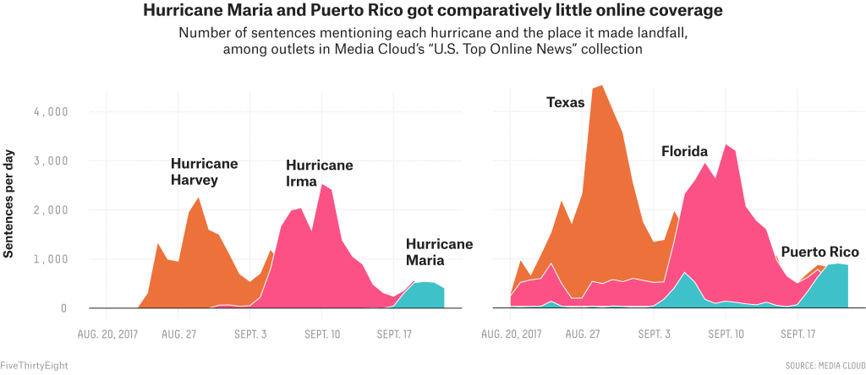
TV news coverage reveals a similar trend. Data we collected from the TV News Archive shows that people on TV news shows spoke significantly fewer sentences about Hurricane Maria than about Hurricanes Harvey and Irma.² The spike in conversation about Puerto Rico right as the hurricane hit was also much smaller than the spike in mentions of Texas and Florida on television as each of those states was hit by a hurricane.

...
Of the cable news networks that covered Hurricane Maria, the BBC, a British network, initially mentioned Hurricane Maria on air more than the U.S. networks did. CNN seems to have aired more coverage of Maria than its competitors in the U.S. did, and the data hints that the network may again be ramping up its coverage.
...
But it is not just the media that isn’t paying attention. A recent poll showed that less than half of Americans are even aware that Puerto Ricans are American citizens. Google searches from the rest of the U.S. show that public interest was also higher for the two storms that hit the mainland than it was for the storm that hit Puerto Rico.
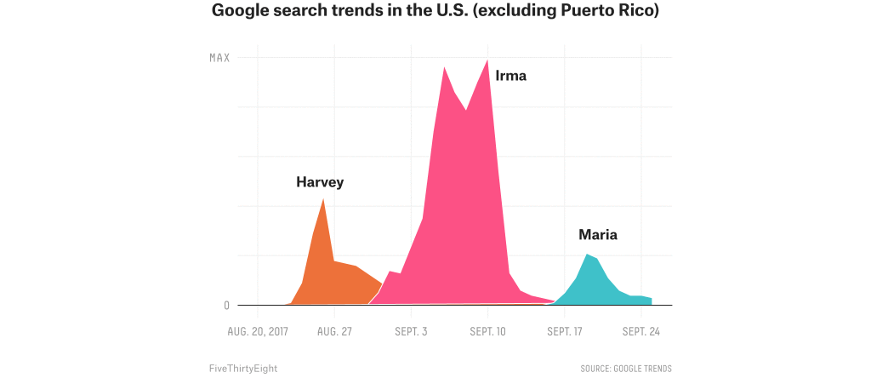
After his initial silence on the issue, President Trump has a visit to Puerto Rico planned in the coming week. Perhaps his presence will bring more media and citizen engagement from the mainland.
- What does this source say about news coverage of Hurricane Maria? How does it compare to coverage of the hurricanes that hit Florida and Texas?
- Why did Hurricane Maria get less attention than the other hurricanes?
- Who does the author of this source blame for this phenomenon?

Source 7:
The chart below shows how many times stories on Facebook were liked, commented on, or shared by Facebook users from February 2016 through November 2016. It compares stories from the mainstream news with stories from fake news sites that create false stories in order to attract readers to their pages (and earn advertising money).
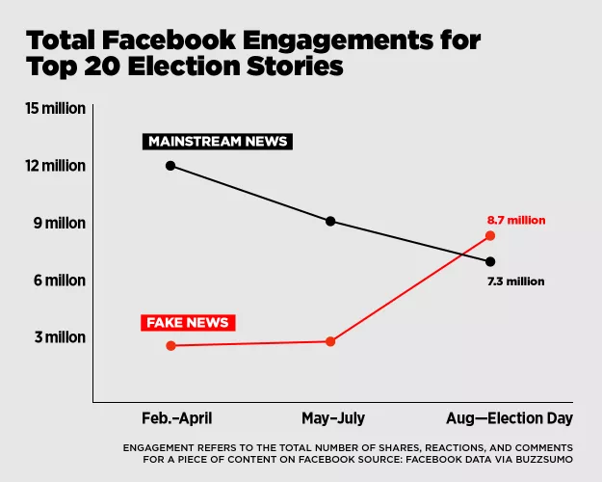
https://www.vox.com/new-money/2016/11/16/13659840/facebook-fake-news-chart
- How many shares, likes, or comments did “fake news” get in February-April 2016? How many shares, likes, or comments did “mainstream news” get in the same period?
- When did “fake news” start to get more attention than “mainstream news”?
- How might the results of this chart have impacted the 2016 election?
- What does this chart suggest about Facebook as a news source?

Alternate Sources:
1)
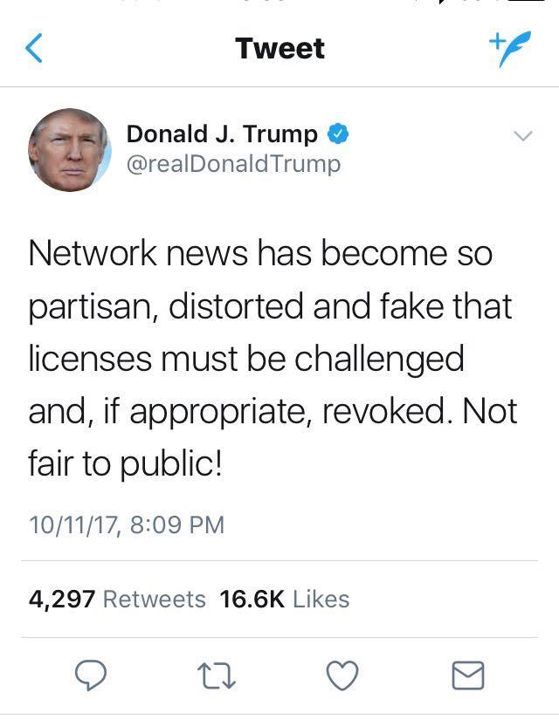

2)
Jon Stewart on Crossfire: https://www.youtube.com/watch?v=aFQFB5YpDZE
Transcript: http://transcripts.cnn.com/TRANSCRIPTS/0410/15/cf.01.html

Report Card

Name: The American Press Grade: 11
Year: 2017 GPA:
Characteristics | Grade | Evidence | Comments/Suggestion for Improvement
Independent
Informative
Investigative
Agenda-Setting
Issue-Framing

