Animal Farm: What caused the Russian Revolution?

Content Standards | 10.5 Students analyze the causes and course of the First World War.  3. Explain how the Russian Revolution and the entry of the United States affected the course and outcome of the war.  10.7 Students analyze the rise of totalitarian governments after World War  - Understand the causes and consequences of the Russian Revolution, including Lenin's use of totalitarian means to seize and maintain control (e.g., the Gulag).  - Trace Stalin's rise to power in the Soviet Union and the connection between economic policies, political policies, the absence of a free press, and systematic violations of human rights (e.g., the Terror Famine in Ukraine).
Common Core State Standards | RH 9-10 1. Cite specific textual evidence to support analysis of primary and secondary sources, attending to such features as the date and origin of the information.  RH 9-10 2. Determine the central ideas or information of a primary or secondary source; provide an accurate summary of how key events or ideas develop over the course of the text.  RH 9-10 3. Analyze in detail a series of events described in a text; determine whether earlier events caused later ones or simply preceded them.  RH 9-10 6. Compare the point of view of two or more authors for how they treat the same or similar topics, including which details they include and emphasize in their respective accounts.  RH 9-10 9. Compare and contrast treatments of the same topic in several primary and secondary sources.  WH6-8 2. Write informative/explanatory texts, including the  narration of historical events, scientific procedures/experiments, or technical processes.  WH46-8. Produce clear and coherent writing in which the  development and organization, and style are appropriate to the task, purpose, and audience.

This lesson teaches the causes of the Russian Revolution with the novella, Animal Farm, by George Orwell. As an beginning exercise teachers can show an introductory video that highlights key ideas for both literature and history in Animal Farm. The teacher can play the video to the whole class and discuss the following questions by pausing in between sections of the video, “Animal Farm: Context and Background” by Clickview UK
https://www.youtube.com/watch?v=zDrhX2DrKjk

- Who was George Orwell?
- What is totalitarianism?
- Why was there a Russian Revolution
- What is communism?
- How did Stalin maintain totalitarian power?
- What is an allegory?
- What was Orwell’s main concern or goal in creating Animal Farm?

To support students to understand the concept of allegory, the chart will provide students with a key about each of the main characters. Teachers and students can work together to fill in the chart with appropriate quotes while reading the first several chapters. As the lesson continues new characters will be introduced and students can fill in each of these characters descriptions and quotes to better understand the causes of the Russian Revolution.

Key
- Life for the animals is very difficult under Farmer Jones. They are like slaves, always working and not controlling their lives or labor. Seeing no benefit to their hard work.
- The animals work by giving of themselves—their muscle energy, their coats/fur, their milk, their babies.
- Old Major believes the animals give up their entire lives to labor for Mr Jones who does nothing by steal what the animals produce.
- Answers will vary. Old Major ends of suggesting that the animals revolt and take control of their labor.
- Uspenskii describes the peasants as looking even more poor than most—they are skinny, unclean, and wear few clothes. They look sick and undernourished.
- The challenges faced by the peasants are that they have no resources on which to survive and flourish. They lost their cow and do not seem to have any additional resources. The man talks of a possible job in the future, but all income is uncertain.
- Answers will vary. Life for the peasants will be uncertain. If the peasant doesn’t get the job and another cow, the family may have even less. If this does occur they will still only be subsisting.
- Students describe image
- Answers vary
- Based on Uspenskii’s account and the photo, life for Russian peasants looks like they have few resources. Families live together with no luxuries of modernity. They seem to have few options for increasing their wealth.
- Students may recognize the following classes (from top down): czar, the Orthodox Church, the judge, the police or military, the capitalists, and the workers.
- The czar is at the top and the workers are at the bottom.
- The workers are bent over and look disfigured by being literally crushed by the classes above them. Life is work and little justice.
- The working class’s perspective is being shown in this cartoon because they upper classes are depicted as fat and behaving in a gluttonous way. The working class is depicted as oppressed by the upper classes. They are hard working and their lives look difficult.
- This cartoon argues that the power in Russian society is being held by a few men who do not deserve it. Rather the hard-working peasant and worker should be able to have some wealth and power as well.
- Causes: Mr. Jones went into Willingdon and got drunk, the animals were not fed, one of the cows broke in the door of the store-shed with her horn and all the animals began to help themselves from the bins, when the men got the whips, the animals flung themselves upon their tormentors and that led to the revolution.
- The animals chose to revolt at this point because they were hungry and did not see that the humans were even providing the basic necessities. After Old Major’s speech the animals were all aware of their oppression.
- Long term causes: Farmer Jones increasing neglect, the continuity of hard work and no reprieve for the animals, Short term: the farm staff did not feed the animals and Farmer Jones was too drunk to do so. The animals were hungry and frustrated at not being fed and cared for by the men.
- Working women led the protest that sparked the revolution. They did so because they worked all day and then at home and the government was not able to provide the food and other necessities required for them to provide the barest standards of living for their families.
- Specific causes: The Russian government failed to supply food and fuel to its civilian population. Because of this failure, the women in Petrograd [St. Petersburg] launched a communal strike on International Women’s Day.
- The Animal Farm rebellion and the women’s rebellion were both sparked by the lack of food and necessities. The differences are that women came together for a communal strike (that was non-violent) on a day that was a notable moment of women’s activism. The Animal Farm rebellion was completely spontaneous and did not have any long-term goals, just the animals initial goal of getting food.
- The photo shows that the crowd is made up mostly of women. There are some children and men in the front, some of the men are soldiers.
- This image supports Kaplan’s description in that it seems that women make up the bulk of the people in the protest.
- Shortages and hunger for many people.
- Germany allowed him to return to Russia in the hopes that he would cause a revolution.
- The Russian government led a battle against the Germans and the army’s soldiers rebelled.
- They fought and overthrew the government in November 1917.
- Answers will vary.
- In the western part of the Soviet Union
- The USSR controlled a huge land mass that stretched across Eurasia and included nationalities such as Georgia and Ukraine.
- To create electricity to give the animals comfort and better lives.
- He criticizes the plan and then calls on the dogs to chase Snowball.
- The dogs use violence to bring Napoleon to power and to enforce his rule.
- Napoleon says there will be no more meetings that he will make the decisions. Snowball was asking the animals to vote and have a say in the decision-making process.
- Napoleon did not treat Snowball like a friend, but as an enemy. Napoleon claimed that Snowball was linked to Farmer Jones. Napoleon had Snowball killed by the dogs.

What caused the Russian Revolution?
Russian Revolution. Causes. Animal Farm.

Introduction

Animal Farm tells the story of Farmer Jones’s animals that rebel and take over the farm. The animals no longer want humans to be the ones who benefit from their hard labor. Instead, the animals want to create a new society on the farm, one that is based on equality and justice. The story is a fable and an allegory. A fable is a short story that has as its main characters animals with human attributes, much like the pigs, horses, sheep, chickens, and dogs of Animal Farm. A fable also ends with a moral and Orwell has many morals in this story—the struggle against tyranny, the evil of totalitarian leaders, and the importance of a free press.
The importance of the story of Animal Farm is that it is an allegory, a story that is a metaphor or a comparison of real world events. Animal Farm is the story, or allegory, of the Russian Revolution. Manor Farm provides the setting where the animals revolt against Farmer Jones, like the people of Russia rebelled against their leader, Czar Nicholas II.

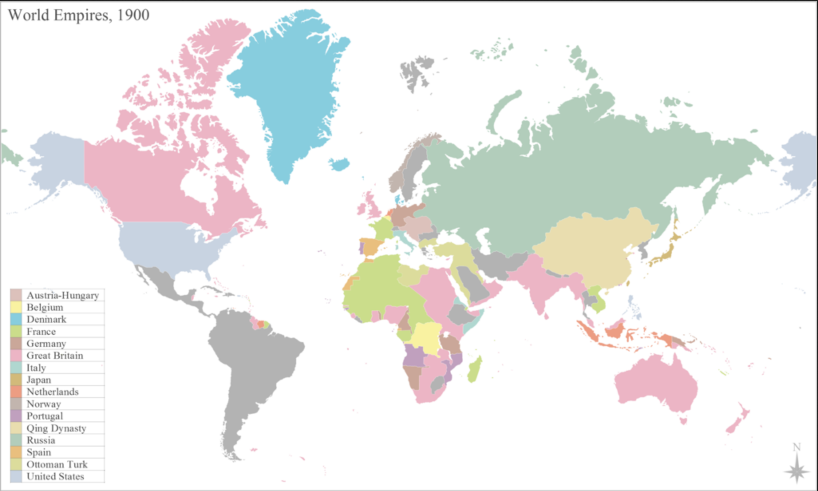 | In the early 1900s, Russia’s Czar Nicholas II ruled over a huge empire. The Russian empire included people of over 200 national and ethnic groups and 125 languages. The majority of these people were peasants, or poor farmers, who lived in poverty and did not benefit from the technological innovations of the beginning of the modern era.

Under the rule of the Czar many peasants found life in the villages hopeless and left the countryside to find better opportunities for employment and living in the major cities, such as Moscow and St. Petersburg. The Czar wanted Russia to become a modern and powerful state like the other European nations. By the time World War I started, Russia had started to industrialize, but the majority of its people were poor and worked on the land. The divide between these poor “have-nots” and the few elites, or “haves” was very large.

By 1917, the Russian army and soldiers had endured major casualties and suffering in World War I. The Russian people at home also faced many hardships including food shortages and starvation. With the backdrop of the war, the Czar’s government was overthrown and replaced by the Communist Bolsheviks under the leadership of Vladimir Lenin. When Lenin died in 1924, his Communist Party colleagues, Leon Trotsky, the leader of the Red Army, and Joseph Stalin, head of the Communist Party, struggled for power of the new state, the Union of Soviet Socialist Republics (USSR). Stalin won the battle, and he deported Trotsky into permanent exile. He ended up in Mexico City where he was assassinated by a Stalinist agent in 1940.
This story of the causes and consequences of the Russian Revolution are told through the allegory of the Animal Farm. The characters in the book represent real people. Each of the characters is an example of a real historical figure. As you read the book, identify a quote or excerpt that you think represents the ideas associated with this character.

Historical Figure | Character | Description | Quote
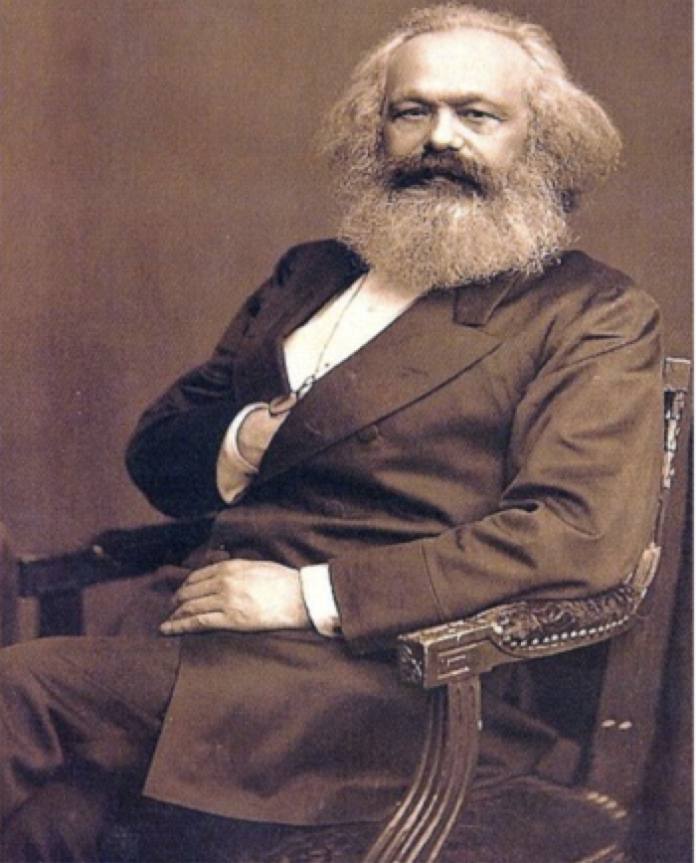  Karl Marx—Founder of Communism | Old Major | Old Major is the originator of the idea that becomes the basis of the animal rebellion-Animalism. However, like Marx, the ideals behind it are soon forgotten.  Like Lenin, Old Major calls for rebellion and his words and ideas are inspirational for the overthrow of the old order (the Czar/ Farmer Jones). | Example: Is it not crystal clear, then, comrades, that all the evils of this life of ours spring from the tyranny of human beings? Only get rid of Man, and the produce of our labour would be our own. (pg. 30)
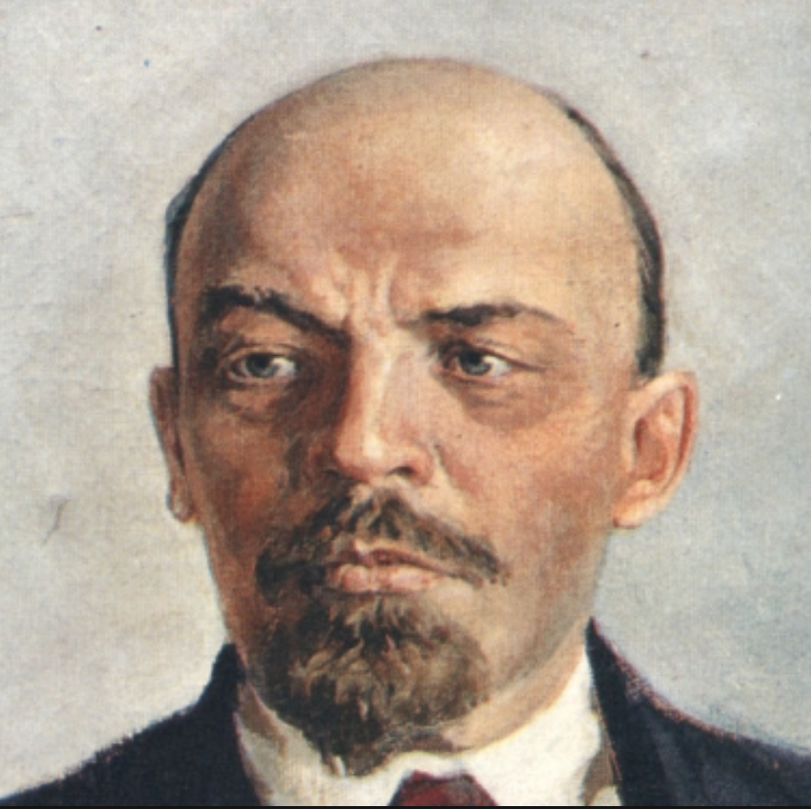
Vladimir Lenin—Leader of the Bolsheviks and first leader of the USSR
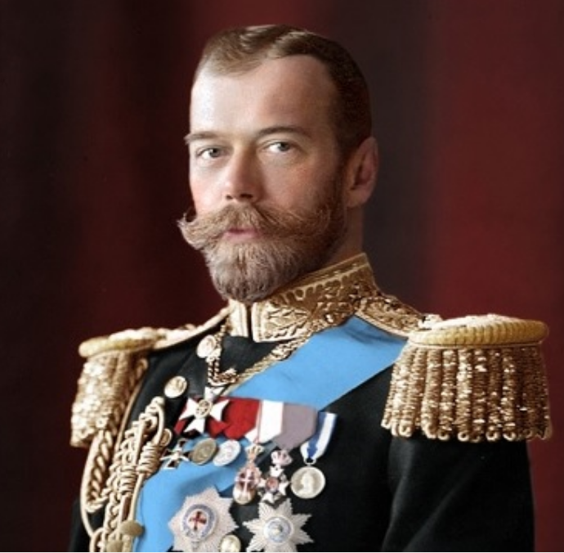  Czar Nicholas II | Farmer Jones | Old Major describes Mr. Jones and humans he represents as the only animals who consume without producing. Under the czarist regime, elite landowners produced nothing, and collected rent and goods from the peasantry.
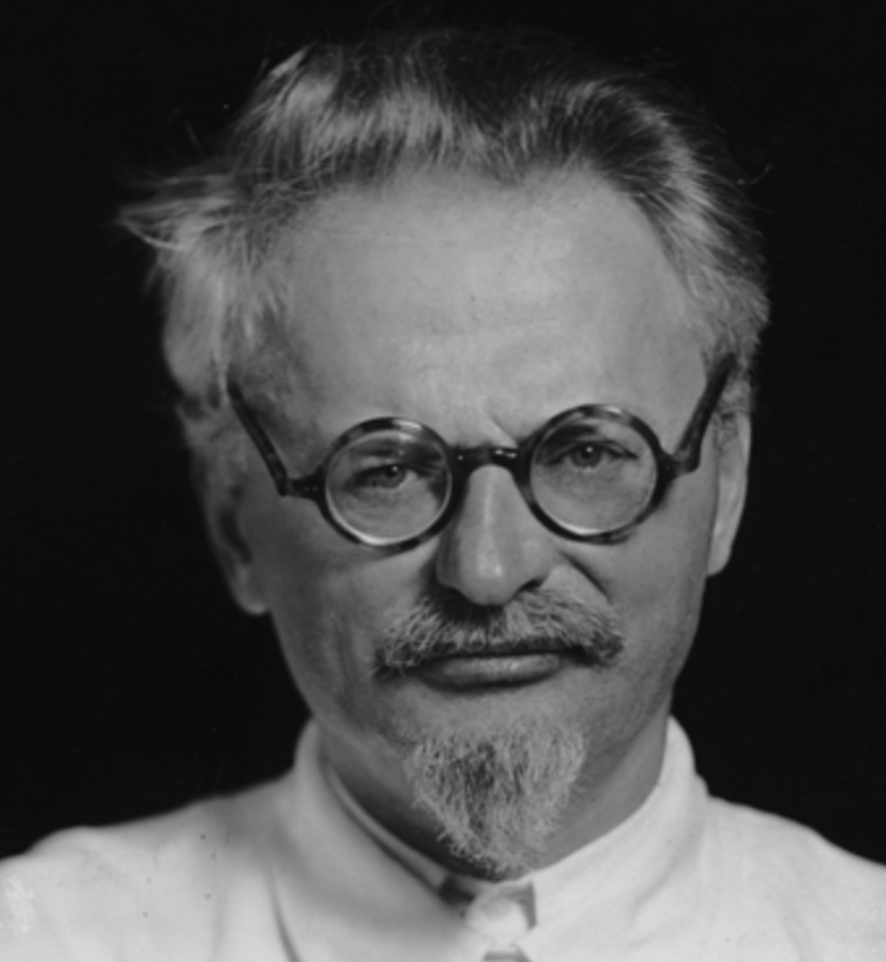  Leon Trotsky | Snowball | Trotsky was the leader of the Red Army who organized committees of workers. Trotsky escaped from the Soviet Union after losing a power struggle with Stalin. Trotsky went into exile in Mexico, where he was later murdered by Stalin’s agents.
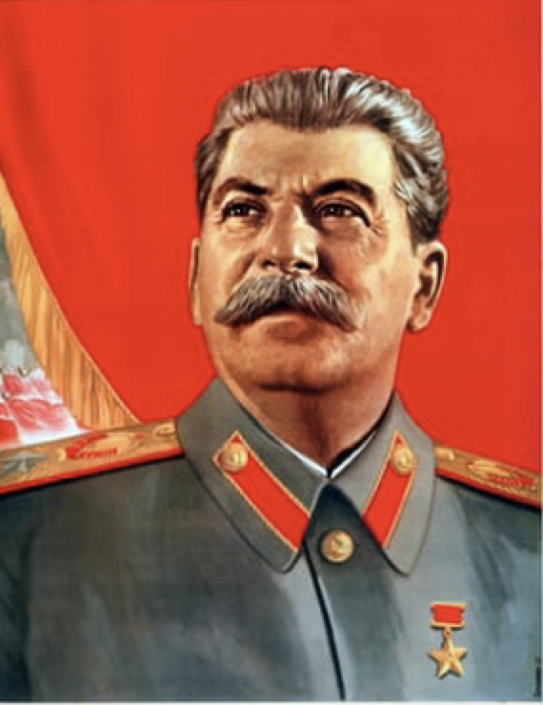  Joseph Stalin | Napoleon | Napoleon is an example of the tyranny that overtakes all humans when they gain too much power. His greed for more power and wealth overtakes any ideals he may have initially had- much as it did with Stalin, who ultimately was responsible for the deaths of millions of Soviet citizens.
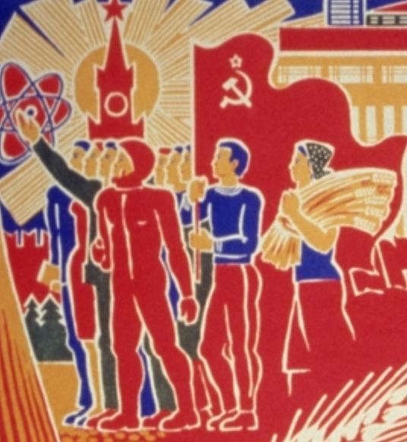  The Proletariat—the working class | Boxer | Boxer is an example of the peasants and other members of the working class who do not have enough information or education to understand the effects of the decisions made by their bosses or leaders. Boxer believes Napoleon, and his refusal to question what doesn’t seem right ultimately costs him his life. Orwell saw this as parallel to the fate of much of the working class under communism.

Part 1: Long-term Causes of the Revolution
We will begin to consider the long-term causes of the Russian Revolution. Long-term causes are often social structures (the way that society is organized) or economic structures (the ways that the economy is organized) that have endured over long periods of time. Russian society was highly unequal and this inequality led to long-term divisions between the elites, led by the Czar, and the working classes.

Source 1: Animal Farm
In the novel, Animal Farm, Old Major describes the terrible conditions that the animals endured. Read the excerpt below and then answer the questions.

[Old Major says] “Now comrades, what is the nature of this life of ours? Let us face it: our lives are miserable, laborious, and short. We are born we are given just so much food as will keep the breath in our bodies, and those of us who are capable of it are forced to work to the last atom of our strength, and the very instant that our usefulness has come to an end we are slaughtered with hideous cruelty...The life of an animal is misery and slavery: this is the plain truth.
…Man is the only creature that consumes without producing. He does not give milk, he does not lay eggs, he is too weak to pull the plough, he cannot run fast enough to catch rabbits. Yet he is lord of all the animals. He sets them to work, he gives back to them the bare minimum that will prevent them for starving, and the rest he keeps for himself. Our labour tills the soil, our dung fertilizes it, and yet there is not one of us that owns more than his bare skin. You cows that I see before me, how many thousands of gallons of milk have you given during this last year? And what has happened to that milk which should have been breeding up sturdy calves? Every drop of it has gone down the throats of our enemies. And you hens, how many eggs have you laid in this last year, and how many of those eggs ever hatched into chickens? The rest have all gone to market to bring in money for Jones and his men…
pages 28-29
Summarize the main ideas in the text
- What is life like for the animals on the farm?
- How do the animals provide their labor for Farmer Jones?

Draw Inferences: Make a claim based on what you know from the text above
- What is Old Major’s argument?
Old Major believes that the animals ________________________________________

and that Mr. Jones ___________________________________________________

- Do you think that Old Major will propose as a solution to improve the animals’ lives? If so what will it be?

Source 2: Gleb Uspenskii, “From a Village Diary”
Uspenskii was a journalist living in rural Russia in the late 19th century. He wrote about the living and working conditions of Russian peasants based on conversations he had with them about their lives. Read the primary source below and then answer the questions.

While strolling about the country place where I spent the summer of 1878 I could see an old peasant walking toward me. He was carrying a little girl, about one-and-a-half years old. Another about twelve, was walking beside him…They resembled beggars,…in their outward appearance. Even for country folk they were poorly dressed. The man’s trousers were ragged and torn, exposing his bare body beneath, and he was barefoot. The little girl was so thin and jaundiced that she seemed ill. Her blond hair was disheveled and hung in uneven dirty strands, with little cakes of dirt visible between them. The other girl’s appearance also bespoke poverty…
I…begged his pardon, and said:
“The little girls are so thin,…”
“That they are, my friend, and how else when there’s no food for them?”
“How is it they have no food?”
“There isn’t any, that’s all. We had a cow, but the Lord took her from us---she died—So, no milk.”
“Then what do you feed this little one?” I asked.
“What do we feed her? Same thing as we eat—kvas, bread—“
“To such a little child?!”
“And just what would you do?—God willing, this fall the heifer will be grown, and we’ll sell her. And for the summer I have to be watchman for the master—Adding in what I make from that, God willing we’ll buy a cow before winter. But in the meantime, we have to endure—can’t be helped!”

Summarize the main ideas in the text
- How does Uspenskii describe the Russian peasants?
- What are the main challenges faced by this peasant family?

Draw Inferences: Make a claim based on what you know from the text above
- Based on the peasant’s description, what do you think life will be like for his family in the next year?

Source 3: Photo of Russian peasants before the Revolution
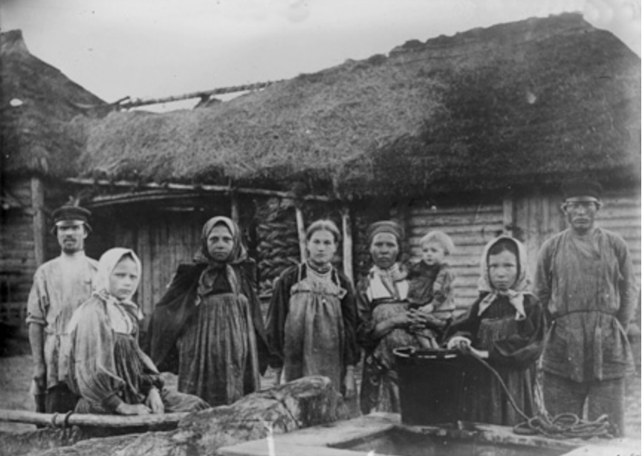
Image found at: http://sites.bu.edu/revolutionaryrussia/student-research/karine-ter-grigoryan/

Summarize what you see in the image
- What do you see in the photo?
- What does life (clothing, housing, family) look like for the peasants?

Comparison: Make a claim based on what you know from the text and image above
- How does Uspenskii’s description of peasant life compare and contrast to the image?
Based on Uspenskii’s account and the photo, life for Russian peasants __________________________________________________________________________________________________________________________________

Source 4:
This is a cartoon created in 1917 showing the social structure of Russian society created by Aleksei Radakov and entitled, “The Autocratic System,” an autocrat is a single ruler, like a king or czar. The words on the image from the top state: We reign; we pray for you; we judge you; we guard you; we feed you; AND YOU WORK!
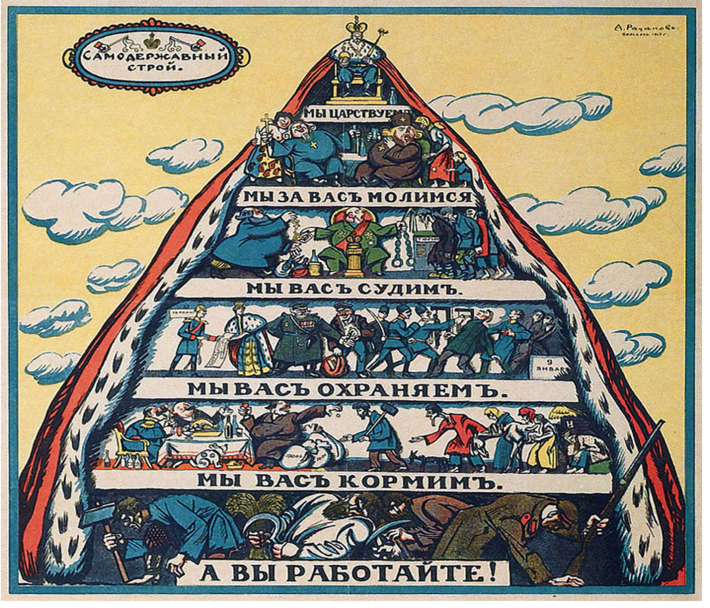
Summarize what you see in the image
- What social classes do you recognize in the image?
- Who is at the top and who is at the bottom?
- What does life look like for the workers?

Draw Inferences: Make a claim based on what you know from the image above
- What class’ point of view is represented in this image? Give evidence to support your claim.
The ________________ class point of view is represented in this image because they are represented_________________________________________________________

- What is the argument that this cartoon is making about power in Russia in 1917? Give evidence to support your claim.
Part 2: Short-term causes of the Russian Revolution
The Russian Revolution was also caused by specific historical events that led to the Russian Revolution. Like many important historical events, it was not caused by just one thing, but many factors that led people to the streets to overthrow the Czar. You will consider several sources that present multiple short-term causes of the Russian Revolution.

Source 5: Animal Farm
In the novel, Animal Farm, there is a specific event is the turning point that leads the animals to revolt. Read the excerpt below and then answer the questions.

Now, as it turned out, the Rebellion was achieved much earlier and more easily than anyone had expected. In past years Mr. Jones, although a hard master, had been a capable farmer, but of late he had fallen on evil days. He had become much disheartened after losing money in a lawsuit, and had taken to drinking more than was good for him. For whole days at a time he would lounge in his Windsor chair in the kitchen, reading the newspapers, drinking, and occasionally feeding Moses on crusts of bread soaked in beer. His men were idle and dishonest, the fields were full of weeds, the buildings wanted roofing, the hedges were neglected, and the animals were underfed.
June came and the hay was almost ready for cutting. On Midsummer's Eve, which was a Saturday, Mr. Jones went into Willingdon and got so drunk at the Red Lion that he did not come back till midday on Sunday. The men had milked the cows in the early morning and then had gone out rabbiting, without bothering to feed the animals. When Mr. Jones got back he immediately went to sleep on the drawing-room sofa with the News of the World over his face, so that when evening came, the animals were still unfed. At last they could stand it no longer. One of the cows broke in the door of the store-shed with her horn and all the animals began to help themselves from the bins. It was just then that Mr. Jones woke up. The next moment he and his four men were in the store-shed with whips in their hands, lashing out in all directions. This was more than the hungry animals could bear. With one accord, though nothing of the kind had been planned beforehand, they flung themselves upon their tormentors. Jones and his men suddenly found themselves being butted and kicked from all sides. The situation was quite out of their control. They had never seen animals behave like this before, and this sudden uprising of creatures whom they were used to thrashing and maltreating just as they chose, frightened them almost out of their wits. After only a moment or two they gave up trying to defend themselves and took to their heels. A minute later all five of them were in full flight down the cart-track that led to the main road, with the animals pursuing them in triumph.
Mrs. Jones looked out of the bedroom window, saw what was happening, hurriedly flung a few possessions into a carpet bag, and slipped out of the farm by another way... Meanwhile the animals had chased Jones and his men out on to the road and slammed the five-barred gate behind them. And so, almost before they knew what was happening, the Rebellion had been successfully carried through: Jones was expelled, and the Manor Farm was theirs.
pages 38-39

Summarize the main ideas in the text
- Read over the text again and highlight the events that led to the animals’ successful rebellion.

Draw Inferences: Make a claim based on what you know from the text
- Why was this moment in the novel the turning point, or a moment of major change, in the story?
The animals chose to revolt at this point because _______________________________
_________________________________________________________________
- What long-term and short-term causes led to the rebellion?

Source 6: Women lead the Revolution
In her article, “Women and the Communal Strikes in the Crisis of 1917 to 1922,” Temma Kaplan describes the turning point that marked the start of the Russian Revolution. Read below and answer the questions.

In February 1917, after three years of war during which over two million Russian soldiers died, the Russian government failed to supply food and fuel to its civilian population. Because of this failure, the women in Petrograd [St. Petersburg] launched a communal strike that in its final stages culminated in the overthrow of the Tsarist autocracy, against which there had been revolutionary activity for decades…The upheaval began with a communal strike in 1917, however, removed the Tsar and resulted in the creation of the Provisional Government, which was meant to lay the foundations of the liberal system in Russia…Acting in advance of the unionized working class, women precipitated the fall of the Tsar in February 1917 with demands for bread…
Most of the female 55 percent labor force of Petrograd in 1917 worked unskilled positions, especially in the textile industries. After eleven or twelve hour shifts, the women returned home to wash, mend, take care of children and get food. They joined their mothers, sisters, and daughters in bread lines…
Russian women used the occasion of International Women’s Day (March 8 in the West but February 23 on the Julian calendar, observed in Russia) to call a meeting for “Bread and Peace,” which provoked a communal strike.
Temma Kaplan is a Distinguished Professor of History at Rutgers University. She specializes on women’s and gender history in Spain, Latin America, South Africa, and the US.

Summarize what you read in the text
- What social classes led the revolution according to Kaplan? Why would women have been such active political participants in the revolution?
- What caused the communal strike that led to revolution? Underline the specific causes the Kaplan mentions.

Comparison: Make a claim based on what you know from the texts above
- How is the turning point that Kaplan describes similar and different to the causes of the rebellion in Animal Farm?

Source 7: Street demonstrations
One week after the women’s demonstrations and protests, Czar Nicholas II abdicated, or gave up his power. Workers and soldiers organized themselves into soviets, which means council in Russian. These soviets represented the interests of workers, soldiers, and peasants. View this image of street protest in 1917. This photo is entitled, “Long live the Council of Workmen's and Soldiers' Deputees!”

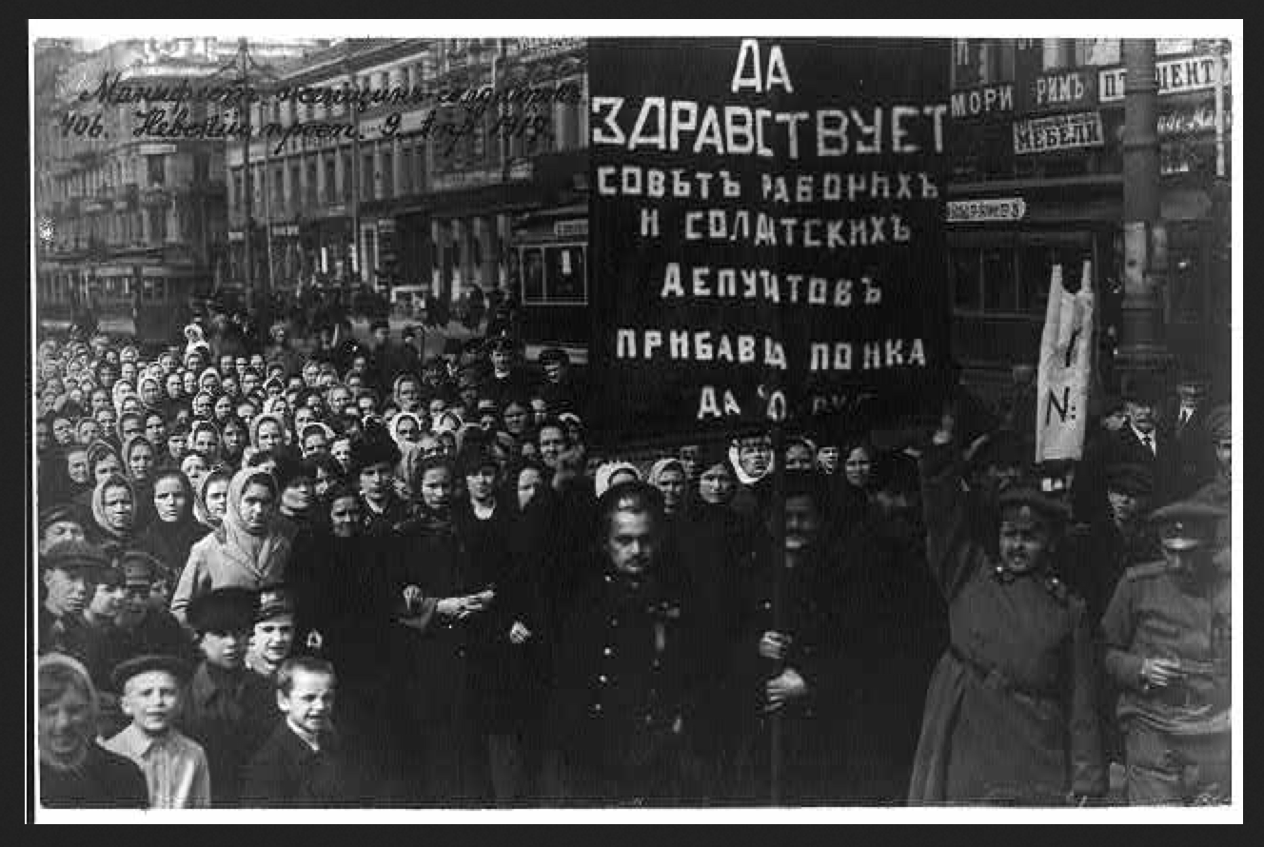
Found at http://hdl.loc.gov/loc.pnp/cph.3a32370

Summarize what you see in the photo
- Who is pictured in the street protests?

Comparison: Make a claim based on what you know from the texts above
- How is this similar and different to what is described by Kaplan?

Source 8: Lenin and the Bolsheviks, Pearson Realize
https://www.pearsonrealize.com/community/program/90a7e2cd-c96d-398e-8dfd-e13416155879/14/tier/7a36fb25-45bb-3b4b-8ee1-719bba942a64/12/lesson/57b3e100-2e6e-3537-ae78-8fe155602c50/16/content/4c56e459-27cb-3321-848e-540b4b17faad/16

21. What were the effects of World War I in Russia? | Shortages and hunger for many people
22.How did Lenin get to Russia? | Germany allowed him to return to Russia in the hopes that he would cause a revolution
23. What happened in July 1917? | The Russian government led a battle against the Germans and the army’s soldiers rebelled
24. How did Lenin and the Bolsheviks organize a revolution? | They fought and overthrew the government in November 1917.

Part 3: Immediately after the Revolution

After the Czar abdicated workers organized themselves into soviets. These soviets set about organizing themselves to protect workers interests. According to historian, S.A. Smith, these soviets, “took on a wide range of functions, including guarding factory property, overseeing hiring and firing, labour discipline, and organizing food supplies.” The peasants also participated in the soviets and were interested in land redistribution. These groups attempted to develop rules and laws that would end the control of the Czar and other elites over the property and land so workers and peasants would have the opportunity to be equal socially, politically and economically.  This poster, created in 1918 is an idealized image of the new Russia, or Soviet Union. The main figures are the worker and peasant who are looking at the dawn of their new society. Under their feet are the symbols of the Czar’s power. | 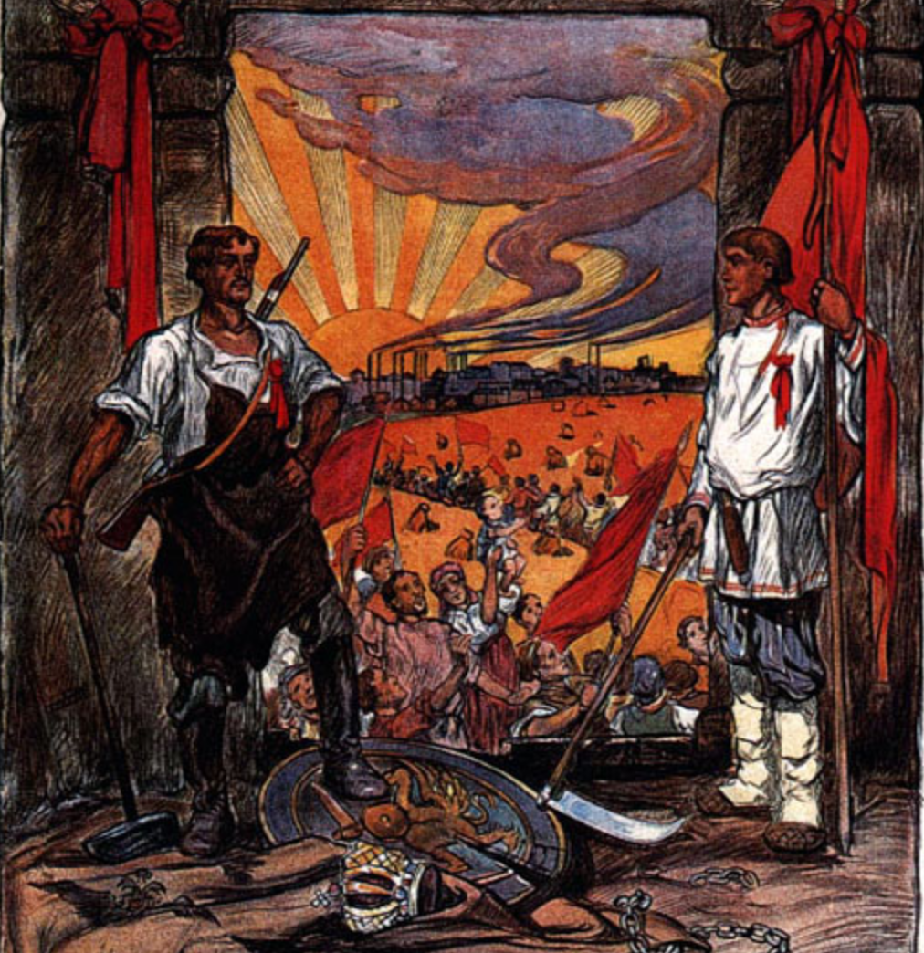  Found at: http://soviethistory.msu.edu/1917-2/workers-organization/workers-organization-images/#bwg27/308

Source 9: Animal Farm
The animals, like the Russian peasants, are empowered to finally benefit from their own labor. In the book, the animals work to create a new system that represents each member of Animal Farm. To do so, they create a list of “Seven Commandments.” Read the commandments below and fill in the chart describing the importance of each of the commandments. The first one has been done for you.

Commandment | Why do the animals make this a law? | What does this commandment suggest society should look like? Or, what is the significance of this commandment.
- Whatever goes upon two legs is an enemy. | The animals want to be in charge of animal farm and not be controlled by humans. | The animals believe that all humans are enemies who want to steal what they produce with their labor.
- Whatever goes upon four legs, or has wings, is a friend.
- No animal shall wear clothes.
- No animal shall sleep in a bed.
- No animal shall drink alcohol.
- No animal shall kill any other animal.
- All animals are equal.

Civil War Erupts in Russia
After the Bolshevik Revolution, Lenin quickly sought peace with Germany. Russia signed the Treaty of Brest-Litovsk in March 1918, giving up a huge chunk of its territory and its population. The cost of peace was extremely high, but the Communist leaders knew that they needed all their energy to defeat a collection of enemies at home. Russia’s withdrawal affected the hopes of both the Allies and the Central Powers.
The Opposing Forces For three years, civil war raged between the “Reds,” as the Communists were known, and the counterrevolutionary “Whites.” The “White” armies were made up of tsarist imperial officers, Mensheviks [another communist political group], democrats, and others, all of whom were united only by their desire to defeat the Bolsheviks. Nationalist groups from many of the former empire’s non-Russian regions joined them in their fight. Poland, Estonia, Latvia, and Lithuania broke free, but nationalists in Ukraine, the Caucasus, and central Asia were eventually subdued.
Text from World History, Pearson Realize, Topic 16, Lesson 4, Text 4

Source 10: Maps of the Russian Empire to Soviet Union, 1914–1923, Pearson Realize
https://www.pearsonrealize.com/community/program/90a7e2cd-c96d-398e-8dfd-e13416155879/14/tier/7a36fb25-45bb-3b4b-8ee1-719bba942a64/12/lesson/57b3e100-2e6e-3537-ae78-8fe155602c50/16/content/5a0c8734-54d2-3188-aafa-f4cfe635147b/16
25. View the three maps and describe what you see in each in your own words.

26.Where was the Civil War fought? | In the western part of the Soviet Union
27. What were the boundaries of the Soviet Union after the Civil War? | The USSR controlled a huge land mass that stretched across Eurasia and included nationalities such as Georgia and Ukraine.
Stalin: USSR’s Leader
After the Bolshevik Communists won the Civil War, their leader, Vladimir Lenin died in 1924 without a clear successor. The USSR was not a democracy, where people elected their leader. Rather, the USSR was ruled by the Communist party and the head of the Party was the ruler, or dictator, who controlled all aspects of life in the country. Therefore, after during and after the Civil War, the party had great control over people’s lives. After Lenin’s death, two men battled to control the USSR, Joseph Stalin, and Leon Trotsky. Stalin controlled the Party and won over popular support with his idea of “socialism in one country,” which excited Russians who were exhausted from revolution and war. With Stalin’s dominance of the Communist Party, Trotsky lost power and was exiled from the USSR and eventually murdered.
This power struggle is represented in Animal Farm by the conflict between Napoleon (Stalin) and Snowball (Trotsky). Watch the film clip below from the animated movie Animal Farm and answer the questions.

Source 11: Animal Farm, 1954.
https://www.youtube.com/watch?v=e78Fi4csAVY
minutes 33:18-38:00
28. What ideas does Snowball propose to the animals? | To create electricity to give the animals comfort and better lives.
29.How does Napoleon respond? | He criticizes the plan and then calls on the dogs to chase Snowball
30. The dogs represent the USSR’s secret security force that supports Stalin. What is their role on the farm? | The dogs use violence to bring Napoleon to power and to enforce his rule.
31. How does Napoleon’s rule differ from Snowball’s? | Napoleon says there will be no more meetings that he will make the decisions. Snowball was asking the animals to vote and have a say in the decision-making process.
32. Review the Seven Commandments of Animal Farm above. What commandments has Napoleon violated? | Napoleon did not treat Snowball like a friend, but as an enemy. Napoleon claimed that Snowball was linked to Farmer Jones. Napoleon had Snowball killed by the dogs.

Final Assignment
The Russian Revolution occurred 100 years ago and was an important moment in world history, the first successful revolution that promoted equality between classes and between men and women. Workers who had always been dominated by the Czar and the elite class led a successful revolution to take control of a huge empire. As the Centennial, or the 100th year anniversary of the Russian Revolution, is celebrated your goal is to create a presentation that highlights the causes of the revolution using sources from this lesson. You can use the graphic organizer below to develop your ideas. You can present your ideas in a presentation to the class, as a news article, or through another form that is agreed upon by you and your teacher. Your assignment is to answer the question:
What caused the Russian Revolution?

Final Response
What caused the Russian Revolution? Use your graphic organizer to answer the question below.

Claim
Long-term cause
Evidence
(Provide evidence to support the example)
Analysis (Explain why this cause led to revolution)
Short-term cause
Evidence
(Provide evidence to support the example)
Analysis (Explain why this cause led to revolution)
Conclusion
(Explain whether you think whether the revolution was successful given what you know from the lesson)

