How did the Cold War affect ordinary Americans?
Who fought in the Vietnam War? Why did they fight?

Content Standards | 11.9 Students analyze U.S. foreign policy since World War II.  11.9.2 Understand the role of military alliances, including NATO and SEATO, in deterring communist aggression and maintaining security during the Cold War.  11.9.3 Trace the origins and geopolitical consequences (foreign and domestic) of the Cold War and containment policy, including the following:  - The era of McCarthyism, instances of domestic Communism (e.g., Alger Hiss) and blacklisting  - The Truman Doctrine  - The Berlin Blockade  - The Korean War  - The Bay of Pigs invasion and the Cuban Missile Crisis  - Atomic testing in the American West, the “mutual assured destruction” doctrine, and disarmament policies  - The Vietnam War  - Latin American policy  11.9.4 List the effects of foreign policy on domestic policies and vice versa (e.g., protests during the war in Vietnam, the “nuclear freeze” movement).
Common Core Standards | RH3. Determine the central ideas or information of a primary or secondary source; provide an accurate summary that makes clear the relationships among the key details and ideas.  RH 4. Determine the meaning of words and phrases as they are used in a text, including analyzing how an author uses and refines the meaning of a key term over the course of a text  RH6. Evaluate authors’ differing points of view on the same historical event or issue by assessing the authors’ claims, reasoning, and evidence.  RH7. Integrate and evaluate multiple sources of information presented in diverse formats and media (e.g., visually, quantitatively, as well as in words) in order to address a question or solve a problem.  RH9. Integrate information from diverse sources, both primary and secondary, into a coherent understanding of an idea or event, noting discrepancies among sources.  WH7. Conduct short as well as more sustained research projects to answer a question (including a self-generated question) or solve a problem; narrow or broaden the inquiry when appropriate; synthesize multiple sources on the subject, demonstrating understanding of the subject under investigation.

Teachers may want to read “Machine Gun Blues” (Chapter 5) in Kimberley L. Phillips’, War! What is it Good For? Black Freedom Struggles and the US Military from WWII to Iraq for background on African Americans in Vietnam.

Who fought in the Vietnam War? Why did they fight?

The Vietnam War was one of the United States’ longest wars. While the U.S. sent military forces to Vietnam to lend assistance to the French and South Vietnamese, the war did not officially begin until the administration of President Johnson. Review the chart below and answer the questions.

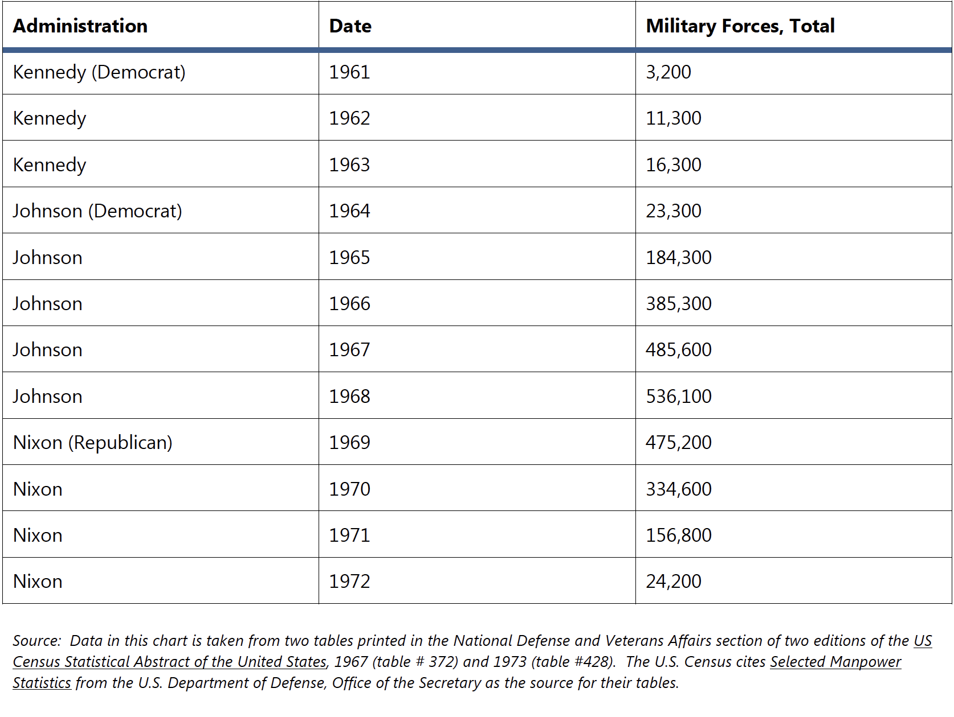
Source 1: Chart of US Military involvement in Vietnam

This chart is found in the History Blueprint: Cold War curriculum in the Vietnam lesson on page 29.

Summarize the information in the chart
- How long were US military forces in Vietnam?

- What years saw the highest involvement of the US military in Vietnam?

Draw Inferences: Make a claim based on what you know from the chart above
- What conclusions can you draw about US involvement in Vietnam based on the chart?
Based on the information about military forces in Vietnam, I conclude that _________________

Source 2: CBS Evening News, Vietnam War 1970
https://www.youtube.com/watch?v=89_3DgW_7mg
4. What are the backgrounds of the soldiers in the news clip?

5.What is combat like for these soldiers?
7.What happened to Hero?

Source 3: Christian. G Appy, Working Class War, 1993.
Dr. Appy is a historian who researches and writes about the Vietnam war. Read this excerpt below from his book and consider who fought in the Vietnam war and what their backgrounds were.
Drawn from the largest generation in U.S. history, from the 27 million men who came of draft age during the war, American troops represented a distinct and relatively small subset of those born during the post World War II baby boom. However, this subset was not representative of the generation as a whole. Roughly 80 percent came from working class and poor backgrounds. Vietnam, more than any other American war in the twentieth century, perhaps in our history, was a working class war. The institutions most responsible for channeling men into the military—the draft, the schools, and the job market—  directed working class children to the armed forces and their wealthier peers toward college. Most young men from prosperous families were able to avoid the draft, and very few volunteered. Thus, America's most unpopular war was fought primarily by the nineteen year old children of waitresses, factory workers, truck drivers, secretaries, firefighters, carpenters, custodians, police officers, salespeople, clerks, mechanics, miners, and farmworkers: people whose work lives are not only physically demanding but in many cases physically dangerous...  In Vietnam, American soldiers encountered a reality utterly at odds with the  official justifications of the war presented by American policymakers. Though  many men arrived in Vietnam believing they had been sent to stop communism  and to help the people of South Vietnam preserve democracy, their experience  fundamentally contradicted those explanations. Told they were in Vietnam to  help the people, soldiers found widespread antagonism to their presence. Told  they were there to protect villagers from aggression, they carried out military  orders that destroyed villages and brought terror to civilians. Told they were  fighting to prevent the spread of communism, they discovered that support for  revolution already flourished throughout the country and could not be  contained behind fixed boundaries. | Subset-a group that is a small part of a larger group  Prosperous- financial success ; well –to-do person  Utterly-completely or absolutely; without question  Contradicted-to be against or oppose  Antagonism-to oppose something; act of hostility

Summarize the main ideas in the text
- What is the argument that Appy makes about class and the Vietnam war?

- List two pieces of evidence from the source that support Appy’s argument:

Conclusion: Make a claim based on what you know from the texts above
- Why is Appy’s argument about class and the Vietnam war important? Should wars be fought by only certain groups of citizens? Make a claim and support it by two pieces of evidence.

Part 2: How did soldiers come to serve in Vietnam?
Men who served as soldiers in Vietnam either volunteered for military service or were drafted through a lottery system. Read the sources below to learn more about how soldiers came to be in Vietnam.

Source 4: PBS The Vietnam War, “Who Served and Why?”
https://www.pbslearningmedia.org/resource/339beb92-9faf-4d85-8e8a-ae0754bd845c/who-served-and-why-clip-the-vietnam-war/#.WmYySSO-Kgx

11. Give some examples of why these men enlisted to serve in the military.

12. What did it mean to be a Marine to these soldiers?

Source 5: Story Corps, Barry Romo https://storycorps.org/listen/barry-romo/
Story Corps is an oral history archive of Americans daily lives. This story is told by Barry Romo, a Vietnam veteran. Listen to his story and answer the question below.

13. Did Barry enlist or get drafted for the Vietnam war? What about Bobby?

14. What does Barry mean by saying, “"I had my ticket punched by my nephew’s blood."

Source 6: History Blueprint, The Draft Lottery

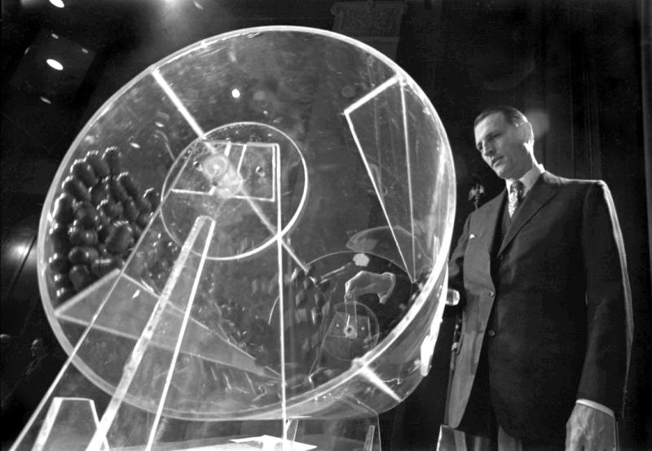
From 1948 to 1973, young men were drafted into the military services to fill vacancies that could not be filled by volunteers. From 1948 to 1969, American males were selected for the draft based upon their age, with the oldest man in the age category drafted first. Starting on December 1, 1969, the Selective Service System launched the first lottery draft.
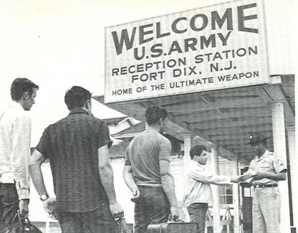
The 1969 lottery drawing determined the order in which men, born from 1944 through 1950, were called to report for induction into the military. 366 capsules, each containing a birthday (including the leap year) were put into a canister. On national television, officials assigned each birth date to a lottery number. The first capsule Congressman Alexander Pirnie drew had the date September 14, so every man born between the years 1944 and 1950 with that birth date had a lottery number of 1. Pirnie drew 366 capsules until each birth date was assigned a number. For the year 1970, numbers 1-195 were drafted. The highest lottery number called for this group was 195; all men assigned that lottery number or any lower number, and who were classified 1-A or 1-A-O (available for military service), were called to report for possible induction. Draftees could be exempt from or defer their military service for medical reasons, if they were religious ministers, if they were students, or if they could prove they were conscientious objectors (opposed to all forms of violence). Thousands of draft-age young men also fled the country to avoid the draft.

In 1973, the draft ended and the U.S. converted to an all-volunteer military. Registering for the draft was suspended between 1975 and 1980, when President Carter resumed the requirement in response to the Soviet invasion of Afghanistan. Even today, young American males are required to register, although there has not been a draft since 1973.

Look at the table on the next page and answer the following questions.
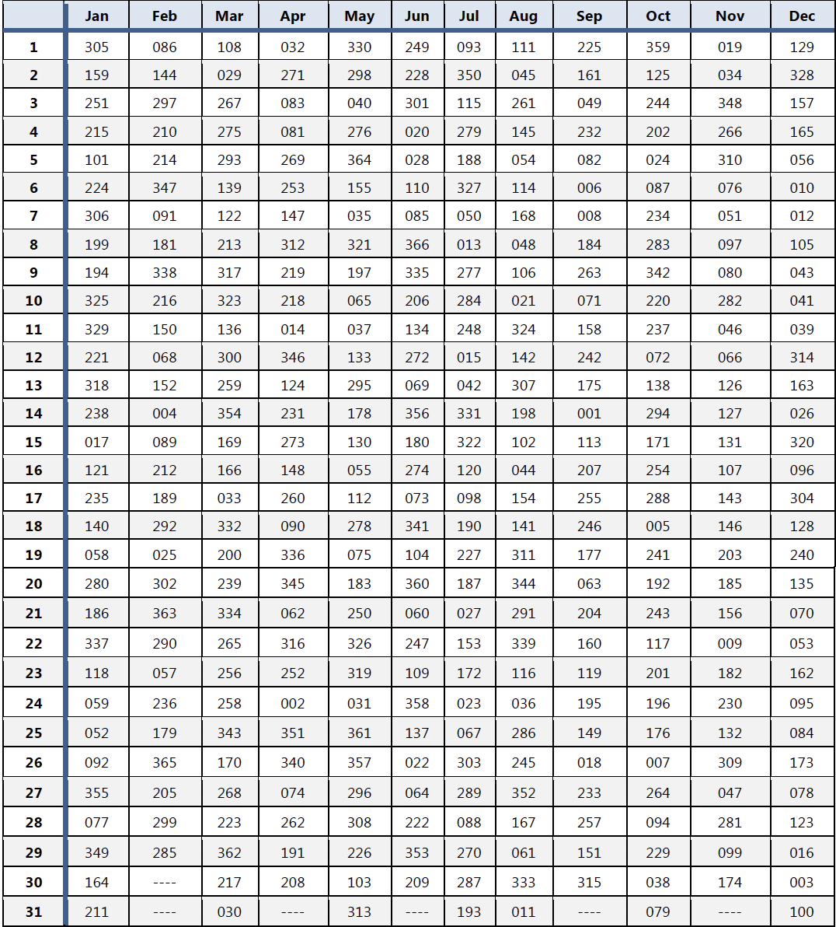

15. Pretend it is 1969 and you were born between 1944 and 1950. Find your birthday on the chart.

Would you have been drafted? ______________________________________________

(Not sure? If your birthday is March 7, in 1969 your draft lottery number would have been 122 and since numbers 1-195 were called up for the draft, you would have been selected). (Source: Selective Service System, U.S. Department of Defense, http://www.sss.gov/lotter1.htm)
16. If you had been selected for the draft in 1969, what would you have done?

Would you have willingly served?

Would you have pursued deferment?

If so, what would you claim as the reason for your deferment?

Source 7: PBS On Two Fronts: Latinos and Vietnam, “The Draft”
https://www.pbslearningmedia.org/resource/e6361021-bf68-4c02-a66a-2ee004433588/the-draft-on-two-fronts-latinos-vietnam/?#.WmuYTktG2nc

17. Why were Latinos more likely to serve in Vietnam than other social groups?

18. What were the roles of draft boards in sending men to Vietnam?
19. How did Mr. Camacho and Mr. Nunez protest against the draft?

Part 3: How did soldiers in Vietnam experience race and racism?
The 1960’s was the high-point for the Civil Rights movement in the United States. This occurred at the same time as the surge in American involvement in Vietnam. As we have seen from the sources above, race and class were important for soldiers and their experiences of Vietnam. In many cases, as Christian Appy argues, this was a working class war. In addition, the war was fought by African-American and Latino soldiers. According to the Gerald Goodwin, a historian writing an article about race and the Vietnam war in the New York Times, “African-Americans represented approximately 11 percent of the civilian population. Yet in 1967, they represented 16.3 percent of all draftees and 23 percent of all combat troops in Vietnam. In 1965, African-Americans accounted for nearly 25 percent of all combat deaths in Vietnam. By 1967 this percentage had dropped considerably, to 12.7, but the perception that blacks were more likely to be drafted and killed remained widespread.” (https://www.nytimes.com/2017/07/18/opinion/racism-vietnam-war.html) These statistics highlight the inequalities that African American soldiers experienced during the war, but first-hand accounts and stories like Fallen Angels may allow us to understand what life was like for soldiers in Vietnam.

Source 8: Soldados: Chicanos in Vietnam
https://www.youtube.com/watch?v=NsdizlRrf1U
Watch :42-5:00 and 13:00-14:00
20. What were Charley and his friends childhoods like? What was Corcoran like for them?

21. Why did they decide to go to Vietnam?
22. What does the Vietnamese peasant mean by “same”? How did that affect Charley?

Source 9: Anti-war poster
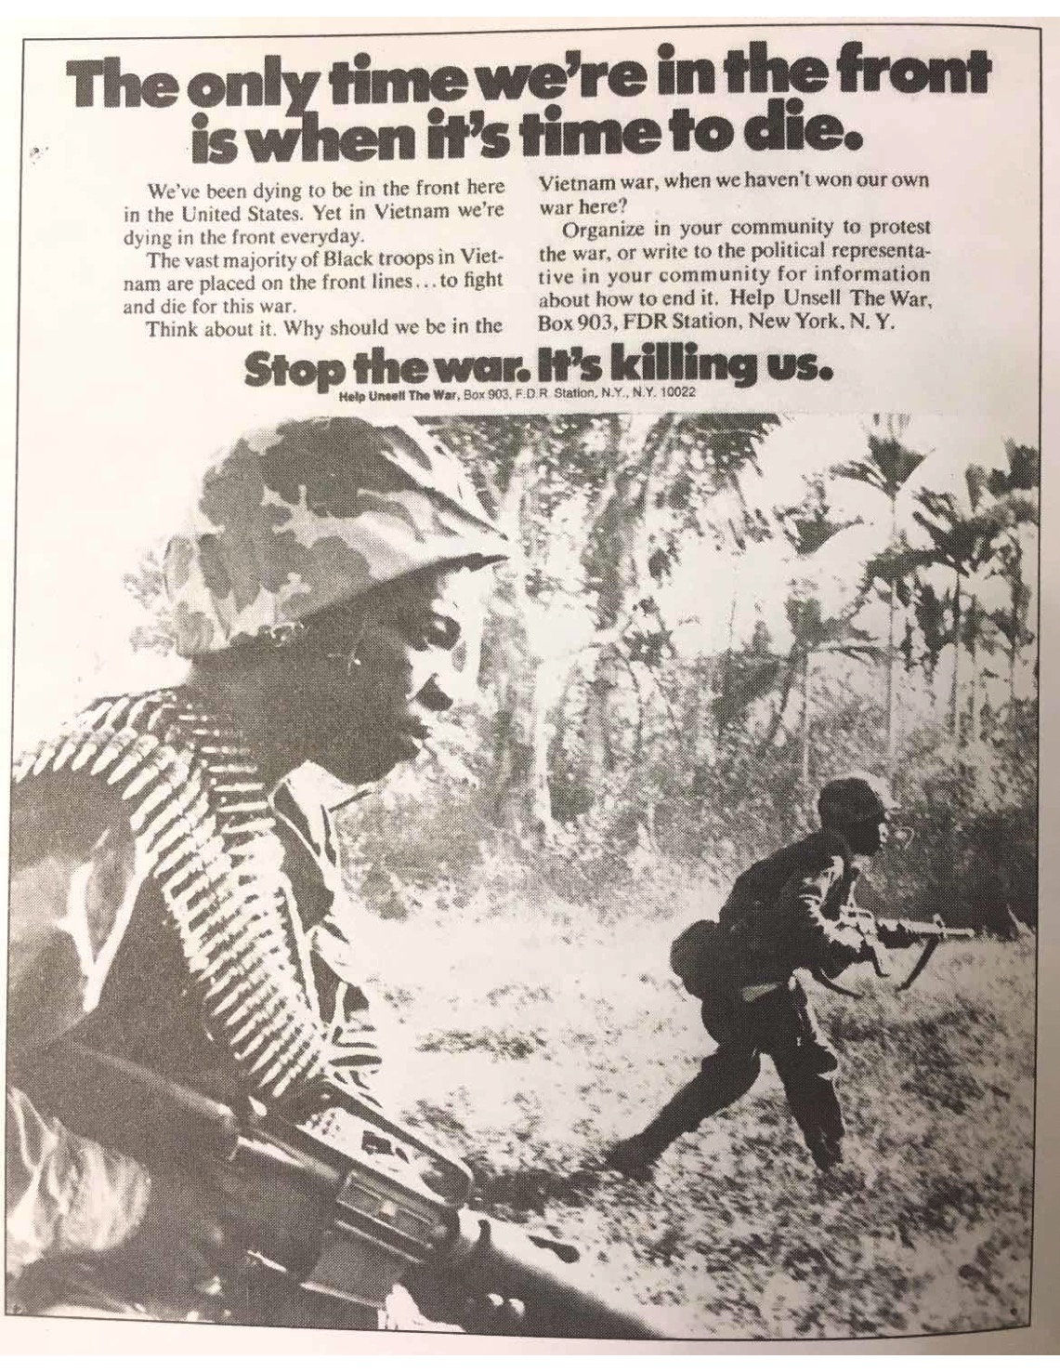
Summarize the main ideas in the poster
- Describe what you see in the poster. What words stand out to you in the text.

Perspective: Use the images and text to consider point-of-view
- Who is the audience for the poster?
The poster’s message is aimed at __________________________________________

- How does the poster use the idea of a “front”? What are the meanings of “front” in the poster?

- What does the poster want the viewer to do?

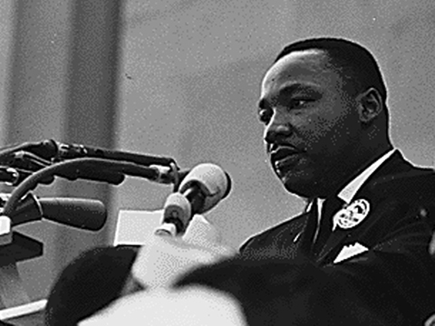
Source 10: Martin Luther King Jr. article on “This Day in History” April 4, 1967

The Reverend Martin Luther King, Jr., head of the Southern Christian Leadership Conference, delivers a speech entitled “Beyond Vietnam” in front of 3,000 people at Riverside Church in New York City. In it, he says that there is a common link forming between the civil rights and peace movements. King proposed that the United States stop all bombing of North and South Vietnam; declare a unilateral truce in the hope that it would lead to peace talks; set a date for withdrawal of all troops from Vietnam; and give the National Liberation Front a role in negotiations.  King had been a solid supporter of President Lyndon B. Johnson and his Great Society, but he became increasingly concerned about U.S. involvement in Vietnam and, as his concerns became more public, his relationship with the Johnson administration deteriorated. King came to view U.S. intervention in Southeast Asia as little more than imperialism. Additionally, he believed that the Vietnam War diverted money and attention from domestic programs created to aid the black poor. Furthermore, he said, ‘the war was doing far more than devastating the hopes of the poor at home…We were taking the black young men who had been crippled by our society and sending them eight thousand miles away to guarantee liberties in Southeast Asia which they had not found in southwest Georgia and East Harlem.'” King maintained his antiwar stance and supported peace movements until he was assassinated on April 4, 1968, one year to the day after delivering his Beyond Vietnam speech.  Found at: http://www.history.com/this-day-in-history/martin-luther-king-jr-speaks-out-against-the-war | Unilateral-involving only one side; benefit to one person or group  Imperialism-one nation or empire acquiring and holding other countries

Summarize the main ideas in the text
- What are Martin Luther King Jr.’s (MLK’s) proposals for the Vietnam war?

- What did MLK propose the US government do instead of fight the war in Vietnam?

Draw Inferences: Make a claim based on what you know from the text above
39. MLK was known for peaceful protest called civil disobedience. How was his stance on Vietnam a continuation of this policy?

Final Project: Oral History

For the final assignment you will do an oral history of a Vietnam veteran. Oral histories are a form of research where you interview a person or listen to interviews. It typically consists of a recorded conversation between two people: 1) the “interviewer” who asks the questions and 2) the “interviewee” who answers the questions. In the videos and Story Corps interviews in the sources above you have viewed oral histories of Vietnam Veterans.

With this oral history, you will have an opportunity to use first-hand evidence from an interview to answer our lesson question:
Who fought in the Vietnam War? Why did they fight?

You can interview a family member, friend, or someone from your community who is a Vietnam veteran. Or, you can listen to an interview that has been recorded and saved in the archive. Before you interview someone or listen to an interview, you should consider what questions to ask and what you want to know. Use the chart to write out some questions related to the historical topic we are studying, the Vietnam War.

Key Events or Topics | Questions related to topics

What issue/event are you most interested in asking your interviewee about or learning from the oral history archives?

Now interview someone or listen to a recorded oral history at one of these archives. Take notes based on your questions and on anything else that you find interesting.

Texas Tech University: The Oral History Project of the Vietnam Archive
http://www.vietnam.ttu.edu/oralhistory/

In 1999 the Vietnam Center and Archive initiated the Oral History Project (OHP). The history of the wars in Southeast Asia is not complete without the inclusion of the voices of those who were in some way involved. To that end, the mission of the OHP is to create and preserve a more complete record of the wars in Southeast Asia by preserving, through recorded interviews, the recollections and experiences of all who were involved in those wars.

Ball State University Digital Media Repository
Vietnam Era Veterans Oral Histories
http://libx.bsu.edu/cdm/landingpage/collection/VtnmOrHis

The Vietnam War Era Veterans Oral Histories digital collection includes 26 oral histories conducted by students from Michael W. Doyle's HIST 499 Oral History Workshop course in Fall 2009.
Learning from an Interviewee’s story:
How did the interview add to what you already know about this historical period?

Topic 1: | What does this tell you about the history of this period? (synthesis)
Topic 2:
Topic 3:

Summary Question: Based on what you have learned from the interview, Who fought in the Vietnam War? Why did they fight?

What did you learn about the background of the soldier?
Why did he fight in Vietnam?
What were his experiences there?
How are interviews useful as a research tool to learn about history?

