How did the arrival of European and American traders, and Spanish missionaries, change the lives of California Indians during the nineteenth century?
Topics: Juana Maria, Nicoleño Indians, Missionization
Erik Altenbernd, UC Irvine History Project

California History-Social Science Standards
4.2 Students describe the social, political, cultural, and economic life and interactions
among people of California from the pre-Columbian societies to the Spanish mission
and Mexican rancho periods.
4.2.1. Discuss the major nations of California Indians, including their geographic distribution, economic activities, legends, and religious beliefs; and describe how they depended on, adapted to, and modified the physical environment by cultivation of land and use of sea resources.
4.2.2 Identify the early land and sea routes to, and European settlements in, California with a focus on the exploration of the North Pacific (e.g., by Captain James Cook, Vitus Bering, Juan Cabrillo), noting especially the importance of mountains, deserts, ocean currents, and wind patterns.
4.2.3 Describe the Spanish exploration and colonization of California, including the relationships among soldiers, missionaries, and Indians (e.g., Juan Crespi, Junipero Serra, Gaspar dePortola).
4.2.5 Describe the daily lives of the people, native and nonnative, who occupied the presidios, missions, ranchos, and pueblos.
4.2.6 Discuss the role of the Franciscans in changing the economy of California from a hunter-gatherer economy to an agricultural economy.

5.1 Students describe the major pre-Columbian settlements, including the cliff dwellers and pueblo people of the desert Southwest, the American Indians of the Pacific Northwest, the nomadic nations of the Great Plains, and the woodland peoples east of the Mississippi River.
5.1.1 Describe how geography and climate influenced the way various nations lived and adjusted to the natural environment, including locations of villages, the distinct structures that they built, and how they obtained food, clothing, tools, and utensils.

5.2 Students trace the routes of early explorers and describe the early explorations of the Americas.
5.2.1 Describe the entrepreneurial characteristics of early explorers (e.g., Christopher Columbus, Francisco Vásquez de Coronado) and the technological developments that made sea exploration by latitude and longitude possible (e.g., compass, sextant, astrolabe, seaworthy ships, chronometers, gunpowder).
5.2.2 Explain the aims, obstacles, and accomplishments of the explorers, sponsors, and leaders of key European expeditions and the reasons Europeans chose to explore and colonize the world (e.g., the Spanish Reconquista, the Protestant Reformation, the Counter Reformation).
5.2.3 Trace the routes of the major land explorers of the United States, the distances traveled by explorers, and the Atlantic trade routes that linked Africa, the West Indies, the British colonies, and Europe.
5.2.4 Locate on maps of North and South America land claimed by Spain, France, England, Portugal, the Netherlands, Sweden, and Russia.

8.8 Students analyze the divergent paths of the American people in the West from 1800 to the mid-1800s and the challenges they faced.
8.8.5 Discuss Mexican settlements and their locations, cultural traditions, attitudes toward slavery, land-grant system, and economies.

CCSS Standards: Reading, Grade 4
RH 1. Refer to details and examples in a text when explaining what the text says explicitly and when drawing inferences from the text.
RH 2. Determine the main idea of a text and explain how it is supported by key details; summarize the text.
RH 3. Explain events, procedures, ideas, or concepts in a historical, scientific, or technical text, including what happened and why, based on specific information in the text.
RH 5. Describe the overall structure (e.g., chronology, comparison, cause/effect, problem/solution) of events, ideas, concepts, or information in a text or part of a text.
RH 6. Compare and contrast a firsthand and secondhand account of the same event or topic; describe the differences in focus and the information provided.
RH 7. Interpret information presented visually, orally, or quantitatively (e.g., in charts, graphs, diagrams, time lines, animations, or interactive elements on Web pages) and explain how the information contributes to an understanding of the text in which it appears.
RH 9. Integrate information from two texts on the same topic in order to write or speak about the subject knowledgeably.

CCSS Standards: Reading, Grade 5
RH 1. Quote accurately from a text when explaining what the text says explicitly and when drawing inferences from the text.
RH 2. Determine two or more main ideas of a text and explain how they are supported by key details; summarize the text.
RH 3. Explain the relationships or interactions between two or more individuals, events, ideas, or concepts in a historical, scientific, or technical text based on specific information in the text.
RH 5. Compare and contrast the overall structure (e.g., chronology, comparison, cause/effect, problem/solution) of events, ideas, concepts, or information in two or more texts.
RH 6. Compare and contrast a firsthand and secondhand account of the same event or topic; describe the differences in focus and the information provided.
RH 7. Draw on information from multiple print or digital sources, demonstrating the ability to locate an answer to a question quickly or to solve a problem efficiently.
RH 9. Integrate information from two texts on the same topic in order to write or speak about the subject knowledgeably.

CCSS Standards: Writing, Grades 4 & 5
WH. 1. Write opinion pieces on topics or texts, supporting a point of view with reasons and information.
WH 2. Write informative/explanatory texts to examine a topic and convey ideas and information clearly.
WH 3. Write narratives to develop real or imagined experiences or events using effective technique, descriptive details, and clear event sequences.

CCSS Standards: Reading, Grades 6-8
RH 1. Cite specific textual evidence to support analysis of primary and secondary sources.
RH 2. Determine the central ideas or information of a primary or secondary source; provide an accurate summary of the source distinct from prior knowledge or opinions.
RH 5. Determine how a text presents information (e.g. sequentially, comparatively, causally).
RH 6. Identify aspects of a text that reveal an author’s point of view or purpose (e.g., loaded language, inclusion or avoidance of particular facts).
RH 7. Integrate visual information (e.g. in charts, graphs, photographs, videos, or maps) with other information in print or digital texts.

CCSS Standards: Writing, Grades 6-8
WH 1. Write arguments focused on discipline-specific content.
WH 2. Write informative/explanatory texts, including the narration of historical events, scientific procedures/experiments, or technical processes.
WH 4. Produce clear and coherent writing in which the development, organization, and style are appropriate to task, purpose, and audience.
WH 9. Draw evidence from informational texts to support analysis, reflection, and research.

Smithsonian National Museum of the American Indian Essential Understandings
NMAI Essential Understanding 2: Time, Continuity, and Change
Indigenous people of the Americas shaped life in the Western Hemisphere for millennia. After contact, American Indians and the events involving them greatly influenced the histories of the European colonies and the modern nations of North, Central, and South America. Today, this influence continues to play significant roles in many aspects of political, legal, cultural, environmental, and economic issues. To understand the history and cultures of the Americas requires understanding American Indian history from Indian perspectives.
NMAI Essential Understanding 3: People, Places, and Environments
For thousands of years, indigenous people have studied, managed, honored, and thrived in their homelands. These foundations continue to influence American Indian relationships and interactions with the land today.

Overview of Source Set
This source set addresses the Lone Woman of San Nicolas Island, the Nicoleño Indian woman named Juana Maria whose life served as the basis for the famous children’s novel, The Island of the Blue Dolphins (1960). The story of Juana Maria ties together different strands of Native American history: colonization of Native peoples by Europeans; missionization of Alta California; cultural exchange; violence; disease and death.

The source set is divided into five parts: a general introduction, three sections on Juana Maria and the Nicoleño Indians, and a final activity that culminates in an essay that analyzes a key primary source. The introduction provides a detailed overview of the Paleoindians and the origins of the Nicoleño Indians. Part One includes excerpts of a secondary source that relays key details regarding Juana Maria and the Nicoleño Indians. Part Two focuses on Juana Maria’s decision to leave San Nicolas Island and includes two excerpts from the memoir of George Nidever, the American ship captain and fur trader that helped Juana Maria leave the island. Part Three focuses on Native Americans in the California missions and includes excerpts from two primary sources and one secondary source. Finally, the final activity includes detailed instructions, as well as a graphic organizer, that help students develop an essay on the usefulness of George Nidever as a source about Juana Maria.

Documents

1. “Juana Maria, the Lone Woman of San Nicolas Island,” California Missions Resource Center (webpage, excerpt)

2. George Nidever, The Life and Adventures of a California Pioneer Since 1834 (1878, excerpt)

3. George Nidever, The Life and Adventures of a California Pioneer Since 1834 (1878, excerpt)

4. Diary of Otto von Kotzebue (1816, excerpt)

5. Journal of Jean-Francois de Galaup de la Pérouse (1786, excerpt)

6. “Mission Santa Barbara and the Chumash Indians,” PBS, Indian Country Diaries (Webpage, excerpt)

Introduction
The sources below concern a Native American woman named Juan Maria. For many years, Juana Maria was known throughout California as the Lone Woman of San Nicolas Island. San Nicolas Island is part of the chain of islands off the coast of Southern California known as the Channel Islands. The best known of the Channel Islands is Santa Catalina Island (in Southern California we usually just call it “Catalina Island”). San Nicolas Island is one of the smallest and the most remote (the furthest from the coast) of the Channel Islands. Juana Maria lived alone on San Nicolas island for eighteen years. Due to the efforts of Mexican missionaries in the Los Angeles area, Juan Maria’s people, the Nicoleño Indians, abandoned San Nicolas Island in 1835. For some reason or another, Juana Maria was left behind during the evacuation. After that, she lived entirely by herself until an American trader named George Nidever located her and convinced her to leave the island for Mission Santa Barbara in 1853.

Who were the Nicoleños? Why did they leave San Nicolas Island? To answer these questions, we have to go back not just to the earliest days of Spanish colonization of California, but to the arrival of the first people—the Paleoindians—to North American and California.

The original peopling of the Americas (i.e. North and South America) by the Paleoindians—the ancient ancestors of Native Americans—began about 13,000 to 15,000 years ago during the last Ice Age, a period in the Earth’s history when much of North America was trapped underneath massive glaciers, or sheets of ice, hundreds of miles long and hundreds of miles wide.

Maps of Asia and North America Today and Paleoindian Migrations during Last Ice Age
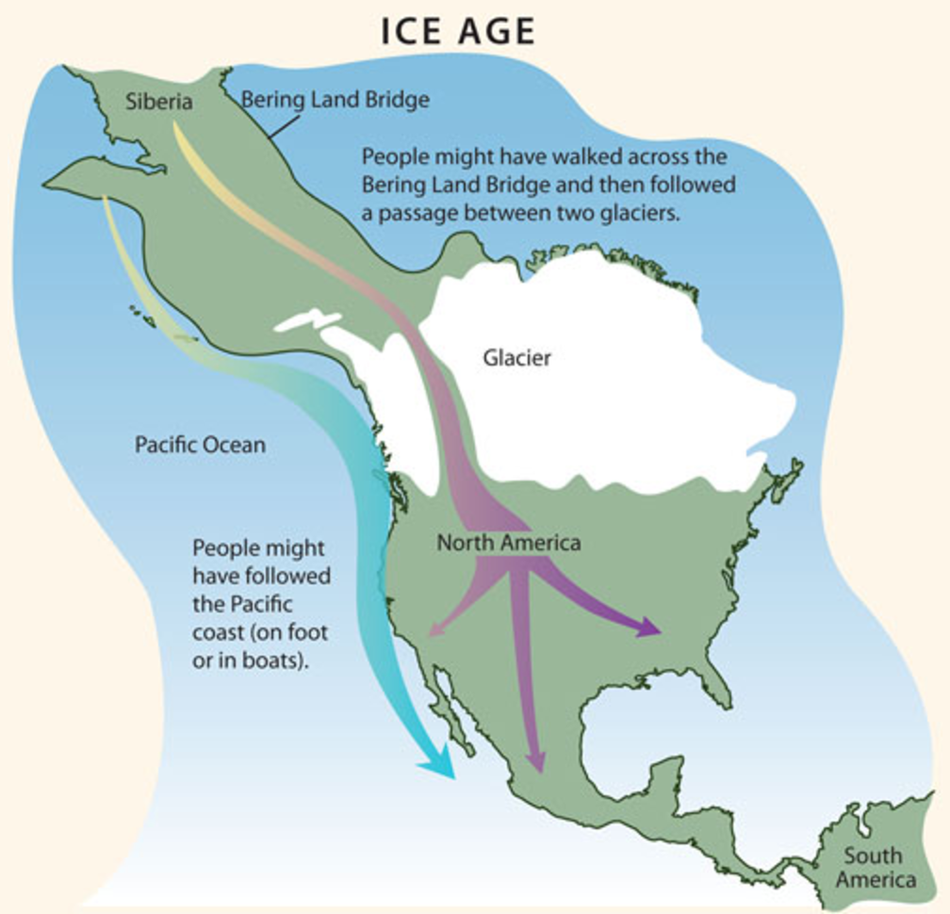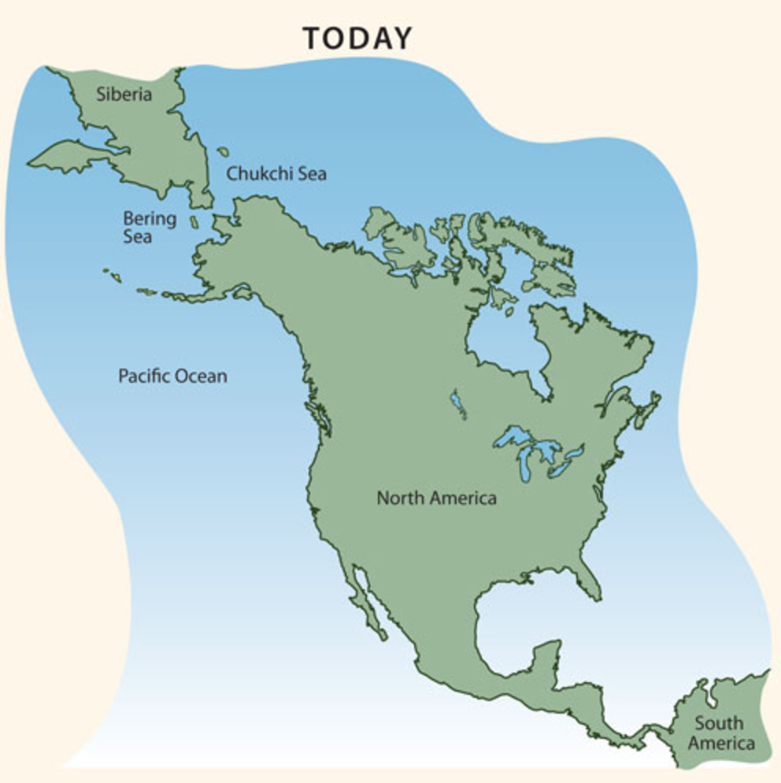

We do not know exactly when the first Paleoindians arrived in the Americas. We also do not know for sure how they spread out across North and South America. One of the oldest theories about the Paleoindians focuses on a place called Beringia. Beringia is the name used to refer to the large piece of land that connected North America to Asia during the last Ice Age. The basic theory, or idea, is that Asian peoples, who hunted various large animals, followed game into North America and migrated across Beringia into Alaska, Canada, and then the rest of North America. The first evidence in support of this theory—spear points used for hunting wooly mammoths—was found near Clovis, New Mexico in 1932. For this reason, certain groups of Paleoindians are referred to as the Clovis people. Many objects of the Clovis people have been found across North America, and they date as far back as 13,000 years.

In 1997, anthropologists and archaeologists found Paleoindian objects older than those found at Clovis, New Mexico. This newer site is called Monte Verde, but it is located hundreds of miles south of New Mexico in southern Chile not too far from Cape Horn (the southern tip of South America). The archaeological objects found at Monte Verde are 14,500 years old—2000 years older than the objects found at Clovis, New Mexico. These objects provide evidence for a second theory: that Paleoindians used boats to cross the ocean between Asia and North America and migrate down the west coast of North and South America. This theory is sometimes called the “Kelp Highway” theory because kelp, or seaweed, is found all over the Pacific Ocean. Anthropologists and archaeologists think the Paleoindians knew how to survive in these coastal environments and thus settled the coasts of North and South America because the coast of North and South America was similar to that of Japan.

Map of Major Kelp Highway Sites in Asia and North and South America
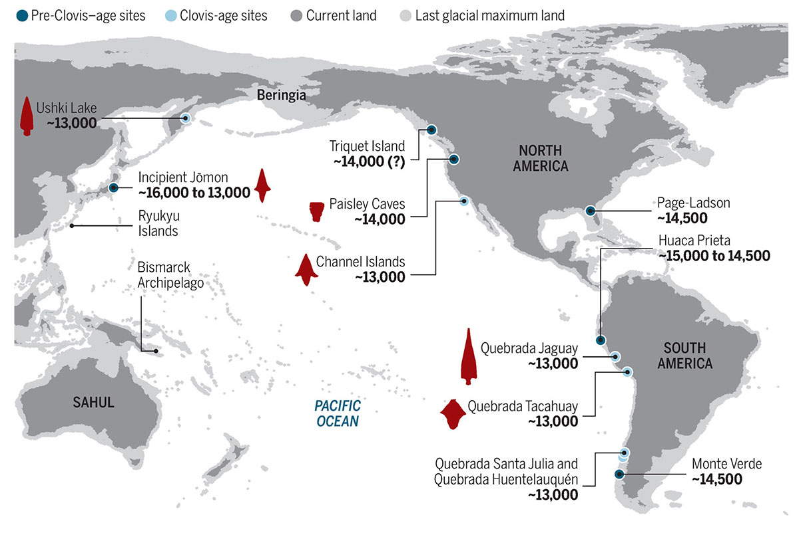

Paleoindians began living on the Channel Islands of Southern California around the time other Paleoindians began living near Clovis, New Mexico and Monte Verde, Chile. In 1959, archaeologists found human bones on Santa Rosa Island that date back roughly 13,000 years. Evidence collected from San Miguel Island shows continuous human occupation of the island dating back 8000-11,000 years. The history of San Nicolas Island goes back almost as far. Archaeological evidence from San Nicolas shows human occupation going back 7000 years.

The history of Juana Maria’s people, the Nicoleños, goes back 1000 years or more. At that time, a group of Indians referred to as the Tongva or Gabrieleno Indians migrated into Southern California and became the dominant culture in the area around Los Angeles, Orange County, and the Southern Channel Islands of San Nicolas, Santa Catalina, San Clemente, and Santa Barbara. Nicoleño is the term used to refer to the group of Tongva/Gabrieleno Indians that lived on San Nicolas Island. By the time the explorer Sebastián Vizcaíno claimed San Nicolas Island for the King of Spain in 1602, there were two main villages and approximately 200-300 Nicoleños living on the island. Historians and archaeologists assume a similar number of Nicoleños lived on the island when Spanish missionaries began establishing missions along the coast of California in 1769, and when, forty-five years later, Russian and Aleut hunters arrived on the island in 1814.

Map of Channel Islands and Coast of Southern California
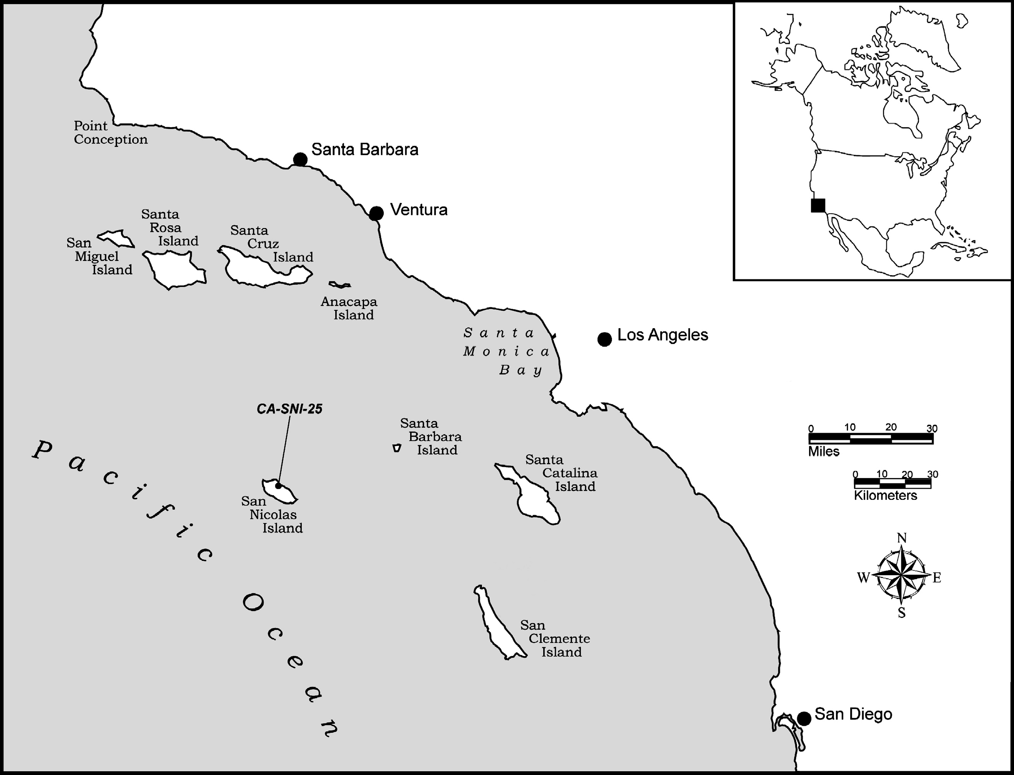

The lives of California Indians like the and Nicoleños (Juana Maria’s people) and the Chumash of the Santa Barbara area changed dramatically during the nineteenth century (1800s). Trade, violence, disease, and colonization efforts like the Spanish missions were the main causes of change. And the changes they caused often did not help or improve the lives of California Indians like Juana Maria.

Portrait of Indian Woman, Possibly Juana Maria
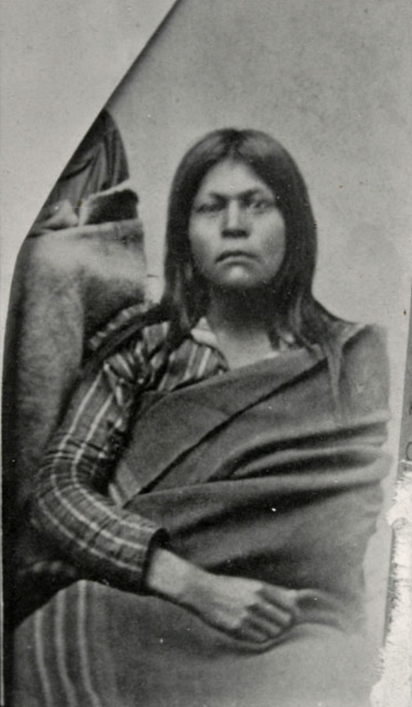

Source: http://collections.theautry.org/mwebcgi/mweb.exe?request=record;id=M138326;type=102

Part 1. Juan Maria & the Nicoleño Indians

The source below is a secondary source (a secondary source is a historical source produced after, often many years after, the events the source describes). This secondary source relays key facts regarding Juana Maria and her people, the Nicoleño Indians.

Source 1

“Juana Maria, the Lone Woman of San Nicolas Island”

California Missions Resource Center

In 1853 an Indian woman speaking a language unknown to the mainland Indians of California was found on San Nicolas Island by Captain George Nidever (1802-1883).  Nidever arrived in California in 1834. He was a renowned sailor and hunter known for his skill in tracking sea otters along the coast and on the Channel Islands.  San Nicolas is the most remote of the Channel Islands, and lies about 53 miles off the Coast, west of Los Angeles.  The Spanish explorer Sebastian Vizcaino landed on the island on December 6, 1602 and reported it densely populated.…  Not much is known about the San Nicolas Islanders from 1602 to 1800 except that by 1800 the population had declined markedly.  In 1811, a group of 25-30 Kodiaks from the Russian camp at Sitka (Alaska) landed on the island to hunt otter and seal. The Kodiaks apparently feuded with the island men over the island women.  By the time the Kodiaks were finally removed, there were less than one hundred Indians left.  By the early 1830s, with the Indian population in decline and many villages abandoned, Spanish missionaries on the mainland organized the removal of all remaining Indians from the Channel Islands. The last island to be evacuated was San Nicolas.  The Peor es Nada (Better than Nothing), a ship captained by Charles Hubbard, landed on the island in 1835 and began to load the Indians on board. As the ship was leaving, a woman jumped overboard saying her child had been left behind. She was described as a light complexioned woman between 20-30 years of age.  The crew of the Peor es Nada intended to return when the weather cleared but the ship struck an object entering into the harbor at San Francisco, and sank. Several efforts were made in subsequent years to find the “last” Indian but none succeeded until Captain Nidever discovered her in 1853.…  In his memoir, Nidever writes that padres of the Mission Santa Barbara requested that he “bring the lost woman off [the island] in case we found her,” and that is what Nidever did about a month later.  Upon the group’s arrival in Santa Barbara the woman was astonished and delighted at the signs of civilization. She was particularly intrigued by an ox-cart and all the horses. Word spread of her arrival and soon “half the town came down to see her.” The good Captain took the woman to stay at his home, where she was nursed by his wife Sinforosa Sanchez Nidever.  The “Lone Woman of San Nicolas” became an object of considerable fascination. She often visited Santa Barbara and seldom returned without some present. The Fathers from the Mission also often visited her. Everyone was taken with her attitude. She was “always in good humor and sang and danced, to the great delight of the children....” Through sign language it was determined that she was indeed the woman left in 1835 and, sadly, she never did find her child.  Juana Maria, the name given her by the padres, later became ill of dysentery, and died after just seven weeks on the mainland. She was buried in the cemetery at Mission Santa Barbara. All her personal possessions were given to California Academy of Sciences but these were destroyed in San Francisco earthquake and fire of 1906. | mainland—large piece of land as opposed to an island or chain of islands  renowned—well-known; famous  Channel Islands—chain of islands off the coast of Southern California  markedly—noticeably, significantly  Kodiak—Island located in the Aleutian Islands of Alaska  Sitka—Russian fur trading colony established in southern Alaska in 1799  memoir—written work that details events based on first-hand experiences  padre—Spanish for “father”; title used when referring to a Catholic priest  nurse—to help someone recover from injury or trauma  dysentery—severe and painful infection of the intestines
Adapted from http://www.missionscalifornia.com/stories/lone-woman-san-nicolas-island.html

Questions

1. Construct a timeline of five major events discussed in Source 1. Follow the instructions below.

A. Before filling in the graphic organizer, use a highlighter to mark the dates of the major events
discussed in Source 1.

B. Use a highlighter to highlight the significance—or effect—of those events on the Nicoleños and

Juana Maria.

C. After you have highlighted all the major events and their effects, write in the events and as well
as their effects/significance in the graphic organizer.

NOTE: Be sure to write the events and their effects in chronological order.

2. Where did Juana Maria, the “Lone Woman of San Nicolas,” go after she left San Nicolas? What happened to her after she arrived there? Explain your answer in 2-3 sentences.

Timeline of Events Related to Nicoleño Indians and Juana Maria

Event & Year | Effect/Significance

Event & Year | Effect/Significance

Event & Year | Effect/Significance

Event & Year | Effect/Significance

Event & Year | Effect/Significance

Part 2. Leaving San Nicolas Island
In 1835, most of the Indians of San Nicolas were removed from the island and taken to San Pedro, a small port town located south of the pueblo (town) of Los Angeles (less than 1000 people lived in Los Angeles in 1835). From there, most of the of the Nicoleños went on to Los Angeles and Mission San Gabriel, a Spanish Catholic mission located northeast of Los Angeles near the modern city of Pasadena. Juana Maria’s experiences were different. In addition to being left behind on the island, Juana Maria left San Nicolas for Mission Santa Barbara. Santa Barbara is located on the coast about 95 miles northwest of Los Angeles.

Image of Mission San Gabriel (1878), the mission where most of the Nicoleños went in 1835.
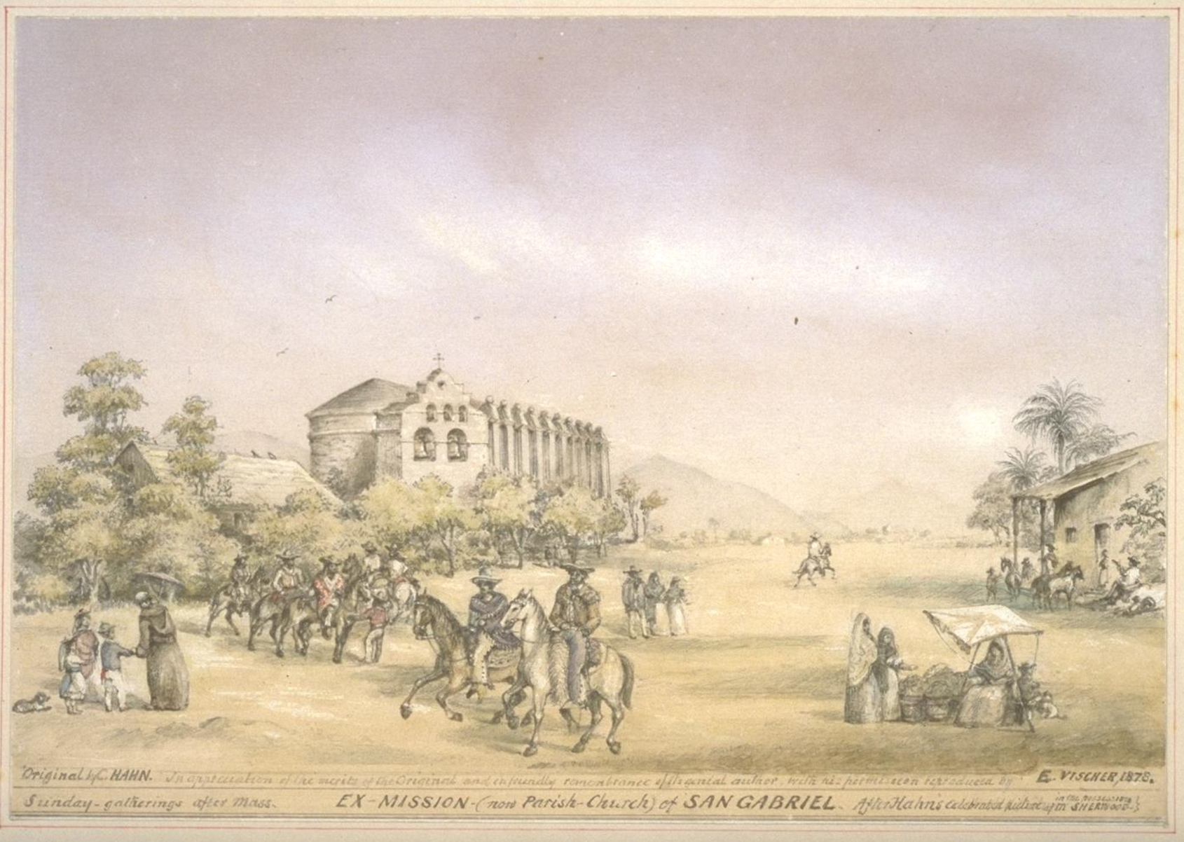
Source: http://oac.cdlib.org/ark:/13030/tf0580053r/?brand=oac4

Source 2

George Nidever

The Life and Adventures of a California Pioneer Since 1834 (1878)

George Nidever was an American hunter, fur trader, rancher and ship captain. Nidever made three separate trips to San Nicolas Island in the early 1850s. On his third voyage in 1853, he and his crew located Juana Maria, the “Lone Woman of San Nicolas,” and convinced her to sail with them to Santa Barbara. In this excerpt from the memoir he wrote much later in his life, George Nidever remembers how he and his crew found Juana Maria.

Portrait of George Nidever
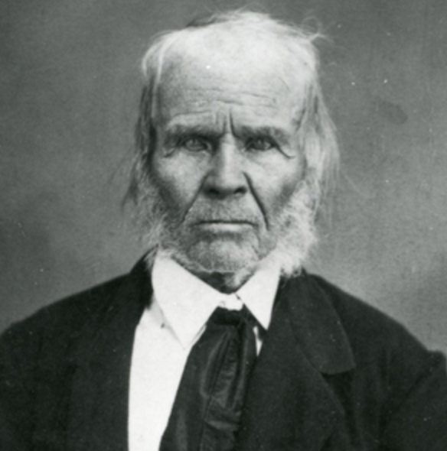

Source: https://www.nps.gov/subjects/islandofthebluedolphins/george-nidever.htm

In May of 1853 I fitted out my [schooner] for a trip to Turtle Bay to prospect for gold. Beside[s] us two there were Charley Brown, Tom Jefferies, & 4 Mission [Indians].…  Ten days after our return [to Santa Barbara] I again fitted out for a thorough [sea otter] hunt among the Islands, & principally around the San Nicolas.…  Reaching the place where he had seen the footprints the day before he followed [them] up the ridge. Near its top he found several huts made of whale's ribs & covered with brush. Although it was so long since they had been occupied…Looking about in all directions from this point, [Charley] discovered at a distance, along the ridge, a small black object about the size of a crow which appeared to be in motion. Advancing cautiously towards it, he soon discovered it to be the Indian woman her head & shoulders only visible…  In the mean time, the old woman was busily employed in stripping the blubber from a piece of seal skin which she held across one knee, using in the operation a rude knife made from a piece of iron hoop stuck into a piece of rough wood for a handle. She kept up a continual jabbering to herself & every few moments would stop & look in the direction of our men, whom she had evidently been watching, her hand placed over her eyes to shade them from the sun.…  The old woman was of medium height, but rather thick. She must have been about 50 yrs. old, but she was still strong & active. Her face was pleasing, as she was continually smiling.…  Having been requested by the Fathers at the Mission of Santa Barbara, to bring her off in case we found her…I thereupon made signs to her to go with us but she stared at me seemingly without comprehending what was wanted. Charley then placed his hand on her shoulder to call her attention & then went through the motions of putting her things in baskets & then these on his back, at the conclusion of which he said vamoose. This she understood without any difficulty, for she at once began putting her things into her baskets.… | schooner—small ship with two masts  mission Indians—Christianized Indians from Mission Santa Barbara  fitted out—prepared  principally—mainly, primarily  vamoose—to leave a place quickly; 19th-century Spanish for vamos, “let’s go”
Robert F. Heizer and Albert B. Elsasser, “Original Accounts of the Lone Woman of San Nicolas Island,” University of California Archaeological Survey, no. 55 (1961): Source: 16-22.

Questions

3. Why did Nidever and his crew’s visit San Nicolas Island in 1853?

4. In 2-3 sentences, describe how Nidever explains how he and his crew found Juana Maria.

5. How did Nidever and his crew communicate with Juana Maria?

Source 3

George Nidever
The Life and Adventures of a California Pioneer Since 1834 (1878)

This excerpt continues Nidever’s story of Juana Maria. After arriving in Santa Barbara, the priests of Mission Santa Barbara baptized Juana Maria (that’s when she received the name Juana Maria), but she never went to live at the mission. Instead, she lived with Nidever and his wife, Maria Sinforosa Ramona Sanchez Nidever.

We remained here hunting [sea otters] about a month…  When we left the Island for Santa Barbara, we were caught in such a violent gale that we were several times on the point of turning back, but we finally…[made it] to Santa Barbara…  The news was not long in spreading of the arrival of the old woman & we had barely reached my house with her when half of the town came down to see her.…  For months after[,] she & her thing[s], such as her dress, baskets, needle[s], &c., were visited by every body in the town & for miles around outside of it.  The old woman was always in good humor & sang & danced, to the great delight of the children & even old ones. She often visited the town & seldom returned without some present. The vessels that touched here usually brought passengers who[,] hearing of her[,] came to my house.…  The same day we arrived here th[e] Fathers from the Mission came down to see her. They continued to visit her & also sent for [Indians] from different parts of this section, & speaking different [Indian] tongues, in hopes of finding some one who could converse with her. Several came…but none of them could understand her or make themselves understood.…She expressed a great many ideas by signs so plainly that we readily understood them.…she told us that she did not find her child, that she wandered about for days without tasting hardly any food or drink…  After a time she forgot her child & sang & danced. She also told that she was very sick at one time; that she had seen vessels passing two [to] & fro but none came to take her off; that she saw us on the Island before we found her.  Her dresses, bone needles & other curiosities where [were] taken possession of by Father Gonzal[e]s, with my consent & sent to Rome.  About 5 weeks after she was brought over, she was taken sick from eating too much fruit & 7 weeks from the day of her arrival died. The Fathers of the Mission baptised her…& named her Juana Maria. I left here for San Francisco just before she died having first made her a rough coffin. My wife can tell you better about her after I brought her ashore. | gale—very strong wind  good humor—good mood  vessels—ships  tongues—languages  converse—talk, speak
Robert F. Heizer and Albert B. Elsasser, “Original Accounts of the Lone Woman of San Nicolas Island,” University of California Archaeological Survey, no. 55 (1961): Source: 16-22.

Questions

6. Where did Juana Maria live after arriving in Santa Barbara?

7. How did Nidever and the other people of Santa Barbara communicate with Juana Maria?

8. How does Nidever describe Juana Maria’s experiences of being alone on San Nicolas? Cite at least 2 pieces of evidence from the text.

9. How did Juana Maria die? How long was she in Santa Barbara before her death?

Beach on San Nicolas Island near Corral Harbor
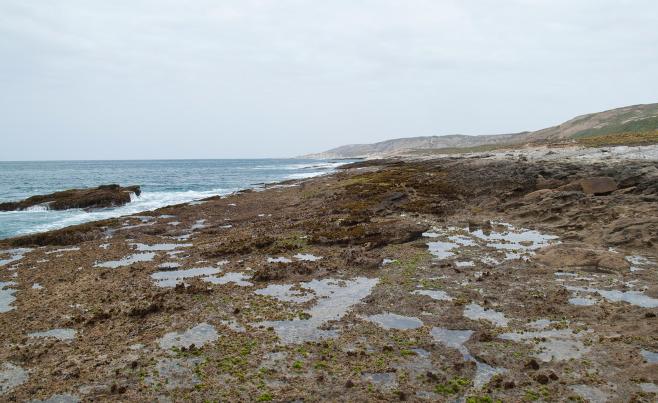
Source: https://www.flickr.com/photos/47945928@N02/4526650249/in/photostream/

Part 3. California Indians and Mission Santa Barbara
Juana Maria did not live at Mission Santa Barbara after she left San Nicolas Island. However, in many ways, her experiences, and those of all the Nicoleños, are similar to the experiences of those Indians who did live in the California missions during the eighteenth and nineteenth centuries.

Beginning with Mission San Diego, twenty-one missions were built along or near the coast of California between 1769 and 1823. The planning and building of the missions was managed by Spanish Catholic missionaries. Thus, the main purpose of the missions was to spread Roman Catholicism among the Indians peoples of California.

Map of Missions, Presidios, and Pueblos of Spanish California
Source: http://www.missionscalifornia.com/sites/default/files/imagecache/full/Missions%20Map%2024%20x%2018%20100%20dpi.jpg

However, the missions were also built so that the Spanish Empire could establish greater control over California. Government officials in New Spain (Mexico) hoped that those Indians who converted to Catholicism would also become loyal subjects of the king and defend the empire from the increasing numbers of Russians, English, French, and (later) Americans interested in settling in, or trading goods in, California.

The missions were built in two main ways. First, most of the actual buildings that made up the missions were built by Indians, although Catholic priests and other Spanish settlers also contributed some labor and special skills to the construction process. The second way the missions were built was through rudección (reduction)—a process that involved persuading or forcing Native peoples to leave their homes and live at the mission. The efforts of Spanish missionaries to remove the Nicoliños and other Indians of the Channel Islands, and bring them to Mission San Gabriel and Mission Santa Barbara, are examples of rudección.

The missions had a major impact on the Native peoples of California, especially those who went to live in the missions. Everyday life at the missions was difficult and often involved hard work building and fixing the missions, or working as farmers, blacksmiths, carpenters, and other jobs. Also, once Indians were baptized, or officially converted into practicing Catholics, they were not allowed to leave the mission and return to their family or home village. Finally, large numbers of mission Indians died at the missions due to diseases like smallpox, malaria, and dysentery.

Image of Mission (Dolores) San Francisco
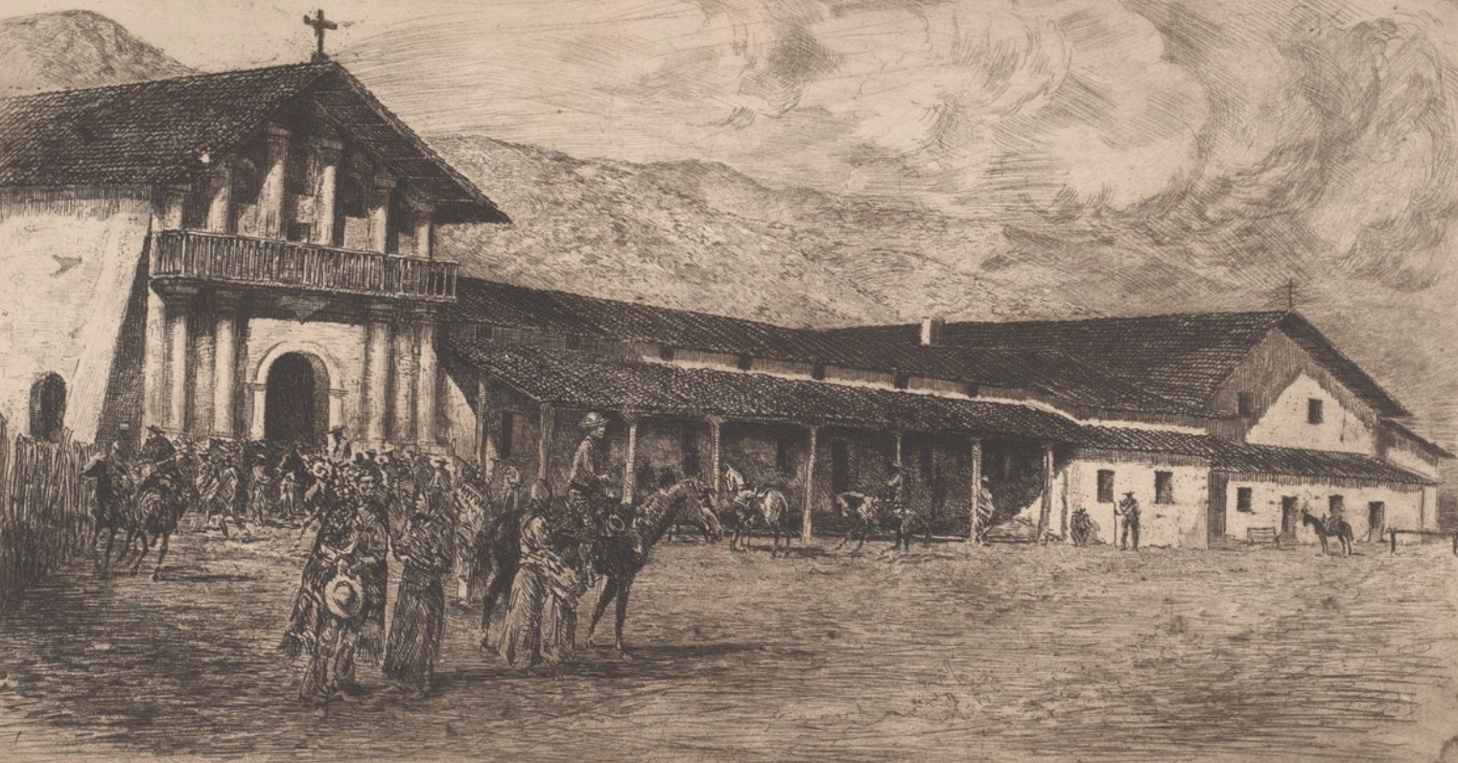
Source: http://oac.cdlib.org/ark:/13030/tf6m3nb7g6/?brand=oac4

Source 4

Diary of Otto von Kotzebue (1816)

Otto von Kotzebue was born to German family inside the Russian Empire and served as an officer in the Russian navy during the early nineteenth century. In 1815, von Kotzebue led a scientific voyage around the world that visited Fort Ross (a Russian fur trading colony in Northern California) and the area around San Francisco Bay. In this excerpt, von Kotzebue talks about disease and the poor living conditions among the Indians who lived at Mission San Francisco.

Two leagues to the southeast of the presidio and on the southern shore of the harbor is the Mission of San Francisco, which makes a fair-sized village.…The mission always has a guard of three or four soldiers from the presidio. The village is inhabited by fifteen hundred Indians; there they are given protection, clothing, and an abundance of food. In return, they cultivate the land for the community. Corn, wheat, beans, peas, and potatoes – in a word, all kinds of produce – are to be found in the general warehouse.…a general cooking of food takes place, at a given hour each day, in the large square in the middle of the village; each family comes there for its ration which is apportioned with regard to the number of its members. They are also given a certain quantity of raw provisions. Two or three families occupy the same house. In their free time, the Indians work in gardens that are given them; they raise therein onions, garlic, cantaloupes, watermelons, pumpkins, and fruit trees. The products belong to them, and they can dispose of them as they see fit.  In winter, bands of Indians come from the mountains to be admitted to the mission, but the greater part of them leave in the spring. They do not like the life at the mission.…After several months spent in the missions, they usually begin to grow fretful and thin, and they constantly gaze with sadness at the mountains which they can see in the distance. Once or twice a year the missionaries permit those Indians upon whose return they believe they can rely to visit their own country, but it often happens that few of these return…  The Indian children are more disposed to adopt to mission life. They learn to make coarse cloth from sheep’s wool for the community.…Other young Indians are instructed in various trades by the missionaries. There is a house at the mission in which some two hundred and fifty women…reside.…They are placed there at the request of the Indians…to protect them from mischief.  On Sundays and holidays they celebrate divine service. All the Indians of both sexes, without regard to age, are obliged to go to church and worship.  On Sunday… Indians gather in the cemetery…and dance.…Men adorn themselves with feathers and with girdles ornamented with feathers and with bits of shell that pass for money among them, or they paint their bodies.…  Severe fevers occur constantly among the Indians. These maladies commonly carry off a very great number. Several missions in Lower California have gone out of existence in the pasty twenty years by reason of the extinction of their Indians. | league—distance equal to about three miles  presidio—Spanish fortress, army base  inhabited—occupied; place where people live  cultivate—farm  ration—allowance  apportioned—divided up; assigned to  raw provisions—basic food supplies like fruit, vegetables, and flour  bands—groups  fretful—fearful  more disposed to adopt—more willing to accept  sexes—men and women  ornamented—decorated  severe fevers—deadly diseases  carry off—kill  maladies—sicknesses  out of existence—emptied of people; depopulated
Source: Edward Mornin, Otto von Kotzebue, et al. “Through Alien Eyes: The Visit of the Russian Ship to San Francisco in 1816 and the Men Behind the Visit,” North American Studies in 19th Century German Literature Vol 32.

Questions

10. How many Indians lived at Mission San Francisco?

11. What jobs did the Indians perform at the mission?

12. What time of year did most Indians join, or move, to the mission?

13. Did most Indians like living at the mission? Explain your answer using 2-3 pieces of evidence from the text.

14. What did the Indians do on Sundays? Explain your answer using 2-3 pieces of evidence from the text.

15. What does von Kotzebue say about disease and its effects on missions Indians elsewhere in California? Explain your answer using 2-3 pieces of evidence from the text.

Source 5

Journal of Jean-Francois de Galaup de la Pérouse (1786)

Jean-Francois de Galaup de la Pérouse was a French explorer and leader of a French naval voyage to the Pacific Ocean during the 1780s. In 1786, the ships of his expedition reached California and visited both San Francisco Bay and Monterey Bay. While at Monterey, de la Perouse was given a tour of the area and Mission San Carlos Borromeo at Carmel by Spanish officials. Like Otto von Kotzebue, de la Perouse describes poor living conditions and harsh treatment of Indians at Carmel.

The Indian village stands on the right [of the church], consisting of about fifty huts which serve for seven hundred and forty persons of both sexes, including their children…  The day consists in general of seven hours labor and two hours prayer, but there are four or five hours of prayer on Sundays and feast days.…Corporal punishment is inflicted on the Indians of both sexes who neglect the exercises of piety…are here punished by irons and the stocks. And lastly…it must be observed that the moment an Indian is baptized, the effect is the same as if he had pronounced a vow for life. If he escapes to reside with his relations in the independent villages, he is summoned three times to return; if he refuses, the missionaries apply to the governor, who sends soldiers to seize him in the midst of his family and conduct him to the mission, where he is condemned to receive a certain number of lashes with the whip.…  The slightest embezzlement [of grain] is punished by the whip, though it seldom happens that they expose themselves to the danger. | sexes—men and women  labor—hard work  corporal punishment—physical punishment like whippings  neglect the exercises of piety—refuse to worship Christian God  irons and stocks—wood and iron device called a pillory that locked arms and head of person  relations—family  embezzle—to steal
Source: John Dunmore translation, “Journal of Jean-Francois de Galaup de la Perouse, 1785-1788,” London: Hakluyt Society.

Questions

16. What was a normal day like for a mission Indian—how many hours did he or she work and pray?

17. What happened to mission Indians who did not correctly practice Catholicism? Cite at least 2 examples of evidence from the text.

18. What happened to mission Indians who ran away from the mission?

19. How is de la Perouse’s description similar to that of Otto von Kotzebue (Source 6)? Explain your answer in 2-3 sentences using at least 1 piece of evidence from Source 6 and Source 7.

Source 6

Mission Santa Barbara and the Chumash Indians

PBS, Indian Country Diaries (2006)

This brief history discusses the history of Mission Santa Barbara and the fate of those Chumash Indians who lived there.

Painting of Mission Santa Barbara (1852)
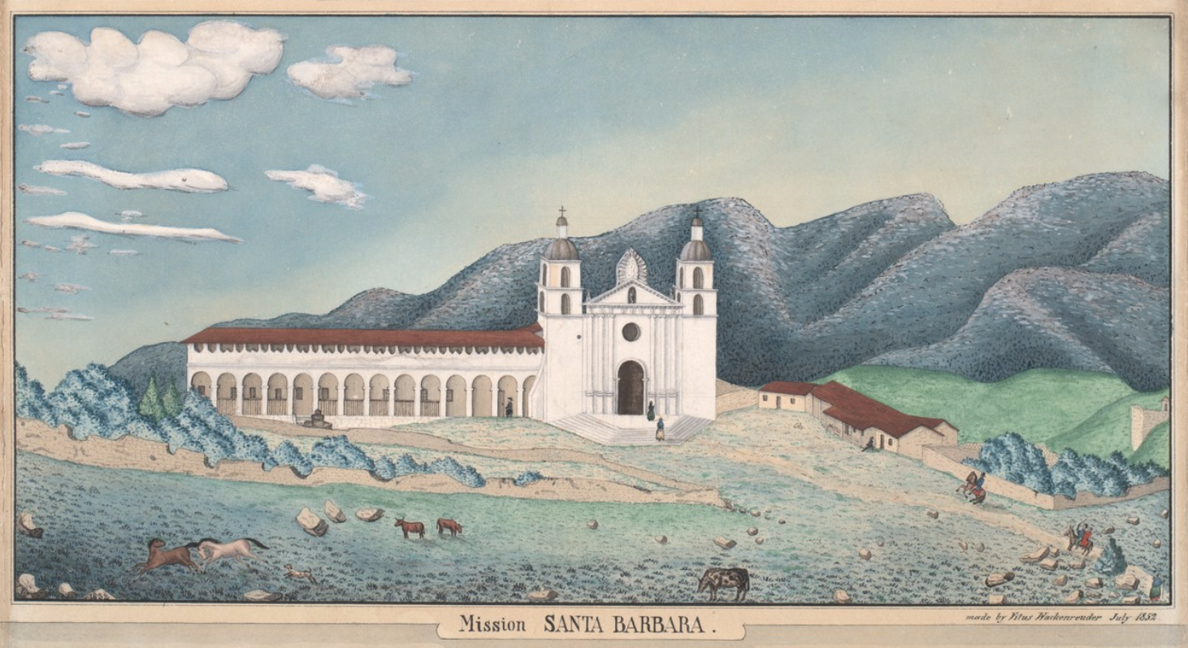

Source: http://oac.cdlib.org/ark:/13030/tf2x0nb4q3/?brand=oac4

For thousands of years, the southern and central Pacific coast region [of California] was one of the most densely populated areas north of Mexico. Population estimates range as high as 300,000 American Indians speaking 80 distinct languages. Because of the bounty of the sea, the pastures and hills, the Indians didn’t have to farm to survive. They fished, hunted and gathered an enormous variety of wild food. Acorns ground up and cooked into a soup, mush or bread was the staple for many groups.  At that time, the Chumash tribe was the largest group with around 20,000 members.…  Then in 1769, a Franciscan missionary named Father Junipero Serra led a Spanish army up from Mexico and reached present-day San Diego. It was he who built the first of 21 missions that would extend up north to San Francisco. When he encountered the Chumash, Fr. Serra failed to recognize a centuries-old religious tradition. “Believe me,” he wrote, “when I saw their general behavior, their pleasing ways and engaging manners, my heart was broken to think that they were still deprived of the light of the Holy Gospel.” He promptly set out to convert all the Indians he encountered to Christianity.  He also set out to make the native populations slaves to the farms supporting the missions. Spanish soldiers kidnapped Indians by the thousands. They were given Spanish names…became farm workers — something they had never done.…forced to care for livestock, tanned hides, and produced candles, bricks, tiles, shoes, saddles, soap and other necessities.  If they misbehaved, they were whipped, branded, mutilated or even executed. Hundreds and thousands of Indians — both in the missions and in surrounding areas — died of malaria, smallpox or other new diseases…  Beginning in 1775, many of the mission Indians began to revolt. Some 800 Ipai and Tipai Indians burned down the San Diego mission that year. The revolt was brutally put down by the Spanish soldiers, as were all of the revolts.  The years of warfare and mistreatment took their toll. At the Santa Barbara mission alone, more than 4,600 Chumash names fill the burial registry. Indians were put in mass graves near the church, and were denied either traditional or Christian burials. | bounty—something given or that exists in large amounts  acorn—fruit of an oak tree  staple—primary item of a culture or people’s diet  Chumash—large and influential band of California Indians that lived in and around area of Mission Santa Barbara  Franciscan—refers to group of Catholic priests and monks that follow the teachings of Saint Francis of Assisi  livestock—domesticated animals like cows, horses, and pigs  tanned hides—process of making leather from skin of cows  brand—to burn symbol on the skin with hot metal  mutilate—violent act that leaves permanent injury, like removal of a hand
Source: http://web.archive.org/web/20170615053844/http://www.pbs.org/indiancountry/history/calif.html

Questions

20. How did Native Californians like the Chumash live before the arrival of the Spanish—how did they get food, clothing, and shelter?

21. What was the population of the Chumash Indians around the time Mission Santa Barbara was built?

22. What Franciscan missionary oversaw the establishment of the mission system in California?

23. Why did Father Junipero Serra want to convert Indians like the Chumash?

24. What problems did the Chumash Indians experience at Mission Santa Barbara? Explain your answer using at least 3 pieces of evidence from the text.

25. What was one of the main consequences of disease and violence at Mission Santa Barbara—how many Chumash Indians died at Mission Santa Barbara?

26. How did some Indians respond to the bad conditions of mission life?

Final Activity. How much do we really know about Juana Maria?

In this lesson, you have learned about three overlapping, or closely related, historical topics:
- The history of the Nicoleño Indians;
- The life and death of the Nicoleña Juana Maria;
- The effects of the Spanish missions on the Native peoples of California during the eighteenth and nineteenth centuries (1700s and 1800s).

Much has been written about Juana Maria over the years. Several newspaper and magazine articles were written about her in the nineteenth and twentieth centuries. The most famous work about Juana Maria is Scott O’Dell’s children’s novel, The Island of the Blue Dolphins (1960): the main character of the novel, Karana, is based directly on Juana Maria, and the people of Karana’s home village, Ghalas-at, are based on Karana’s people, the Nicoleño Indians.

But, how do we know what we know about Juana Maria? The most complete primary source we have we have about Juana Maria was not produced by Juana Maria, or, for that matter, another Native Californian. Instead, the most complete source we have about Juana Maria is the source you read in this lesson: the memoir of George Nidever. Nidever is an important source of information not only because he knew Juana Maria personally, but because he visited with her on San Nicolas Island and lived with her before she died of disease in Santa Barbara.

But, Nidever is only one source. Nidever tells us many things about Juana Maria, but he tells the story of Juana Maria from his own point of view. Like any historical actor, he cannot give us direct access to Juana Maria. Only Juana Maria could do that. Sadly, no primary sources produced by Juana Maria are extant—meaning, no such primary is currently known to exist. Which means we are mostly left to wonder and speculate about any number of things: why she decided to leave San Nicolas Island; how she felt about losing her child and being separated from the Nicoleño community; what she thought of Santa Barbara; or even if she liked (or disliked) George Nidever and his wife, Maria.

Your task for this final activity is to re-read Nidever’s account of Juana Maria and then write a short essay that answers the question: How much do we really know about Juana Maria?

What does Nidever actually tell us about Juana Maria—what important information does he include?

What does Nidever not tell us about Juana Maria—what important information does he not include?

I. Essay Requirements

1. Your essay should be well organized and focus not just on Juana Maria, but on what Nidever does and does not tell us about Juana Maria.

2. Your essay should be five paragraphs long. It should include the following:
- An introduction that does two things:
  - Briefly explains who Juana Maria and George Nidever were;
  - Provides a thesis statement regarding whether or not Nidever is a useful source of information about Juana Maria.
- A body paragraph that analyzes one key piece of information from Nidever’s memoir;
- A body paragraph that analyzes a second key piece of information from Nidever’s memoir;
- A body paragraph that reads between the lines and identifies one key piece of information not included in Nidever’s memoir;
- A conclusion that briefly summarizes your essay and restates your thesis regarding whether or not Nidever is a useful source of information about Juana Maria.

III. Drafting Your Essay

As you re-read Nidever, use the graphic organizer below to gather ideas and identify what you think are the crucial facts Nidever records—and does not record—about Juana Maria. You can also use the graphic organizer to highlight key quotations from Nidever and bullet-point or brainstorm each of the paragraphs.

After you have mapped out your body paragraphs, develop a thesis statement and then write your thesis statement in the second box of the graphic organizer.

After you complete these tasks, begin drafting your essay.

How much do we really know about Juana Maria?
Thesis Statement:

#1 Piece of Evidence from Nidever
Quotation from Nidever
Paragraph 2
Brainstorm/
Bullet Points
#2 Piece of Evidence from Nidever
Quotation from Nidever
Paragraph 3
Brainstorm/
Bullet Points
Evidence NOT provided by Nidever
Quotation from Nidever
Paragraph 4
Brainstorm/
Bullet Points

