African Point of View
South Africa and the Age of Apartheid
From: Got Citizenship?, 2013

History Standards: 10.10.1

Understand the challenges in the regions, including their geopolitical, cultural, military, and economic significance and the international relationships in which they are involved.
CCSS Standards: Reading, Grade 9-10
2. Determine the central ideas or information of a primary or secondary source; provide an accurate summary of how key events or ideas develop over the course of the text.
3. Analyze in detail a series of events described in a text; determine whether earlier events caused later ones or simply preceded them.
4. Determine the meaning of words and phrases as they are used in a text, including vocabulary describing political, social, or economic aspects of history/social studies.
5. Analyze how a text uses structure to emphasize key points or advance an explanation or analysis.
9. Compare and contrast treatments of the same topic in several primary and secondary sources.
Guiding Question:
How did apartheid shape the experience of black South Africans?
Overview of Lesson:
Students will use the activities and graphic organizer below to guide them through a text selection, including excerpts from primary sources. This may be done in partners, teams, or as a class, depending on the abilities of your class. After completing all three activities, students should have some understanding of the ways in which apartheid influenced life for black South Africans.

South Africa Unit: Mayibuye! Afrika!
Activity 1: Analyzing different sources to gain understanding
- What are the criticisms of the ANC discussed in Sources A and B?

- Music was an important aspect of the Defiance Campaign in South Africa. Using the sources, explain why you think music was so important to the movement.

- Study the Freedom Charter. Which demands in the Charter show
  - Democracy:

  - Redistribution of land and wealth:

  - Work:

  - Education:

  - Which of the demands do you think is the most important? Explain your answer.

- Study the Treason Trial photograph. Does the fact that you know that this photograph was constructed affect its meaning in any way? Explain.

Activity 2: 1960s - The Road to Armed Struggle
- Read the Interview with Robert Sobukwe.
  - What does Robert Sobukwe mean by a “nationalist struggle”?

  - Why did Sobukwe break away from the ANC?

  - Do you think Sobukwe’s views are racist? Explain your reasoning.

- Why does Ruth Mompati believe that the ANC had no choice but to start using violence?

- What event in South African history, forced the ANC and the PAC to rethink their approach to the struggle?

- Who was Steven Biko and what was the Black Consciousness movement?

Activity 3: The Soweto Uprising
- If only 20% of homes had electricity, 5% of homes had hot water and there was only one hospital for 1.5 million people, what do these statistics tell us about the general living conditions in Soweto in 1976?

- Was there adequate schooling in Soweto? Use the statistics to prove your answer.

- How do these statistics help you to understand why there was such anger in the townships in 1976?

- Fill in the chart: Sources A-F each emphasize a particular cause of the Soweto Uprising. Identify what each source states as the major cause of the uprising and then decide whether it is a long-term, short-term, or immediate cause.

 | Major Cause of Soweto Uprising | Is this a long-term/short-term/ or immediate cause of uprising?
Source A
Source B
Source C
Source D
Source E
Source F

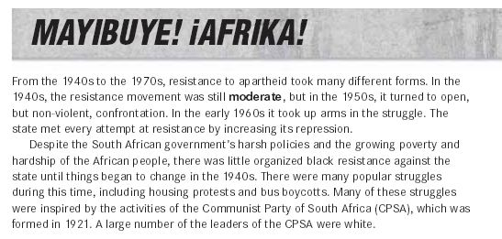
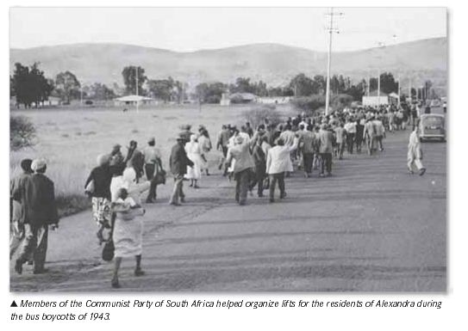
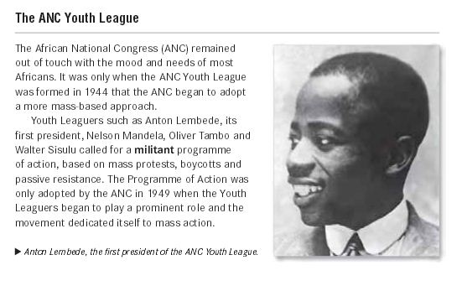
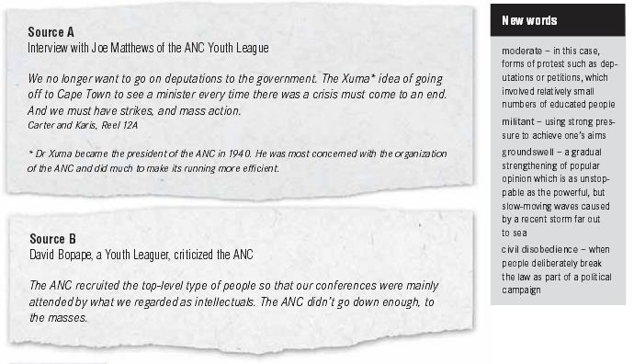

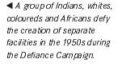
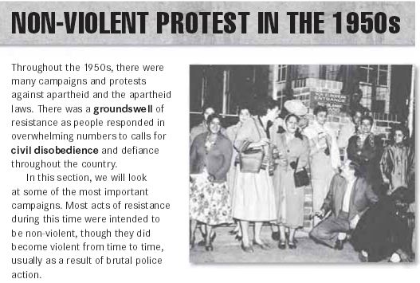

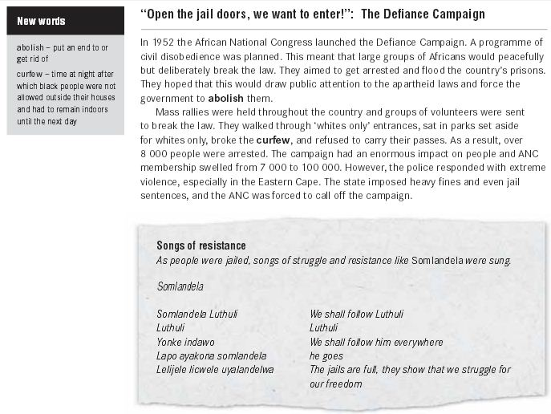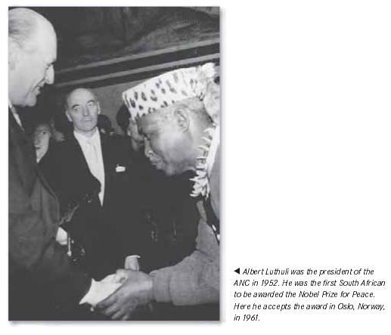

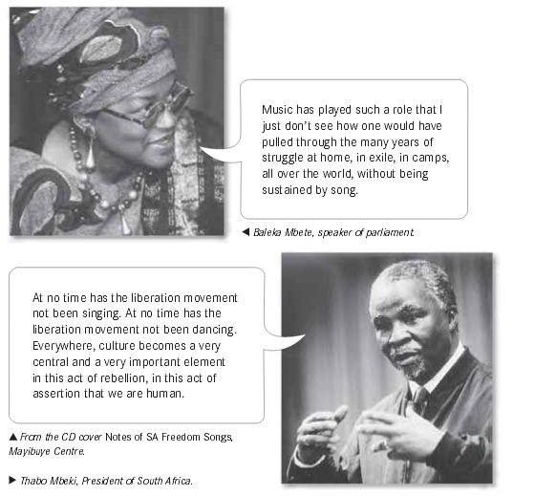
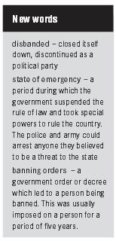

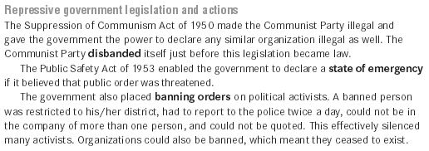

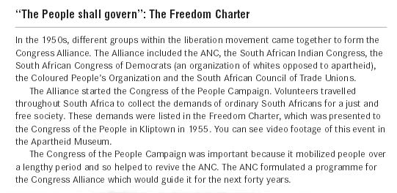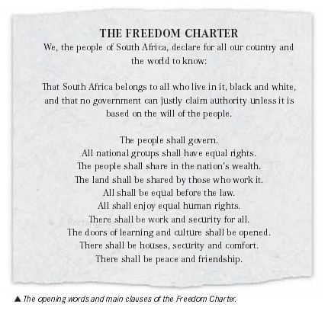
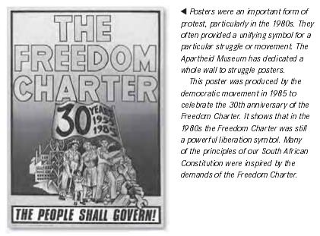

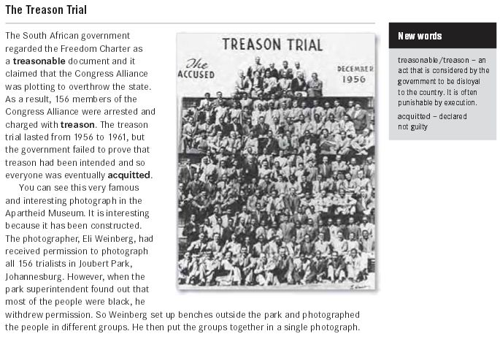
*Activity 1: Analyzing Different Sources to Gain Understanding

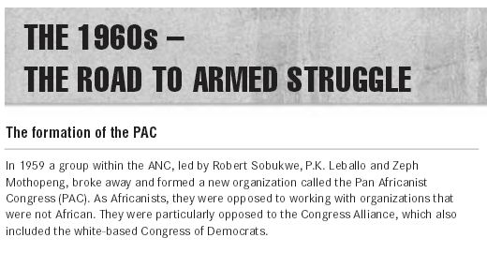
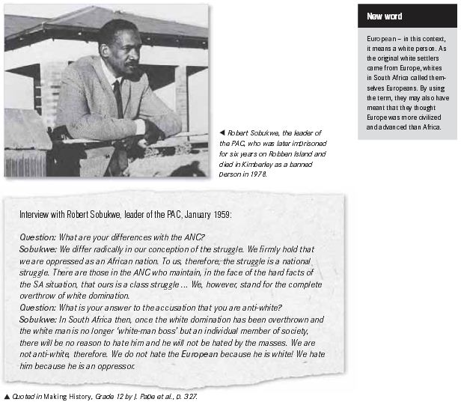

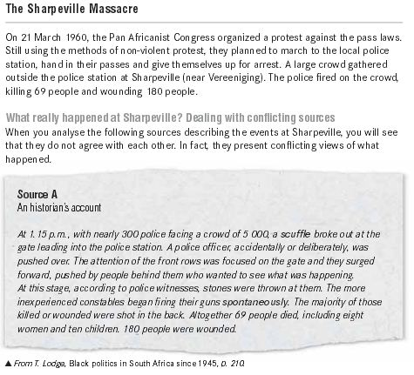
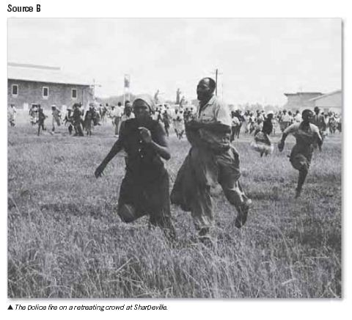
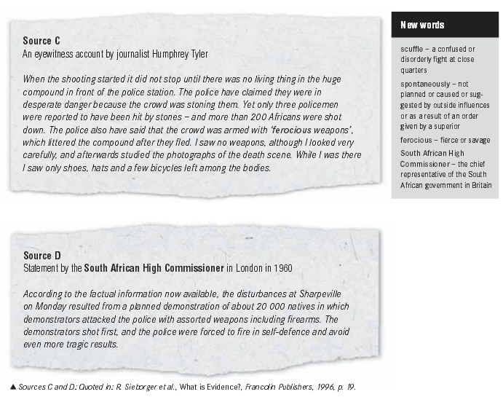

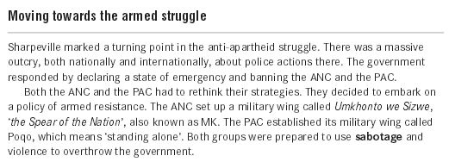

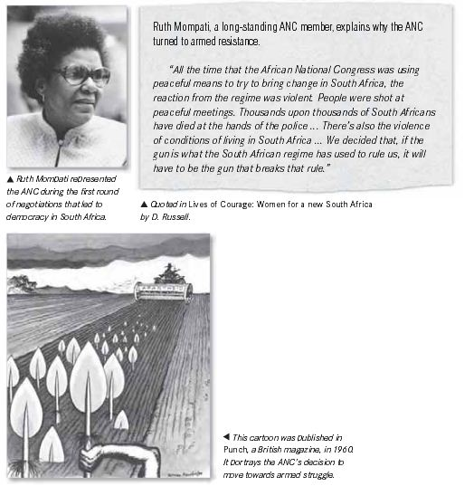
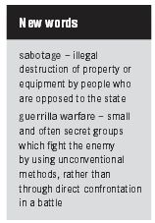
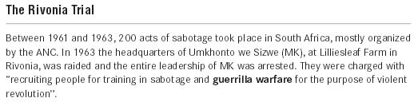

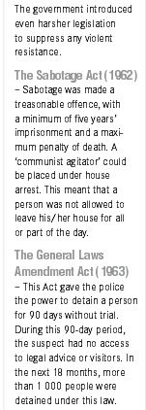
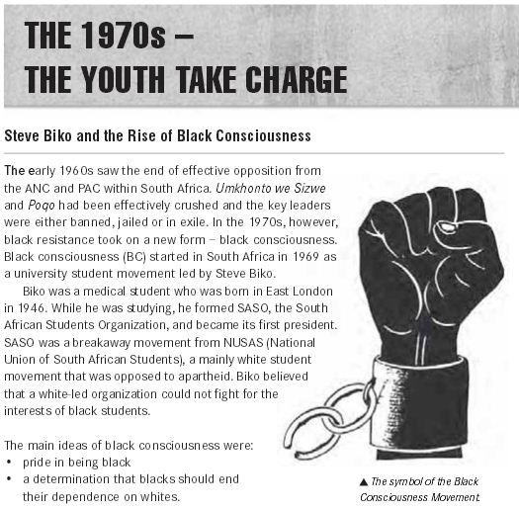
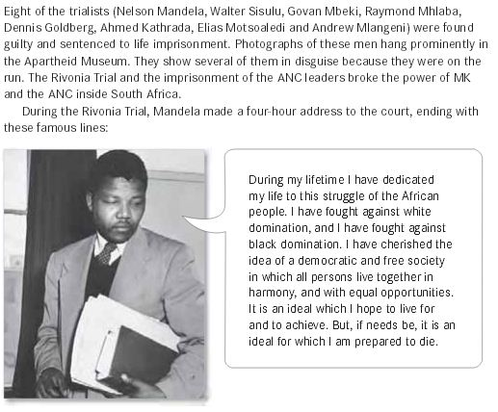

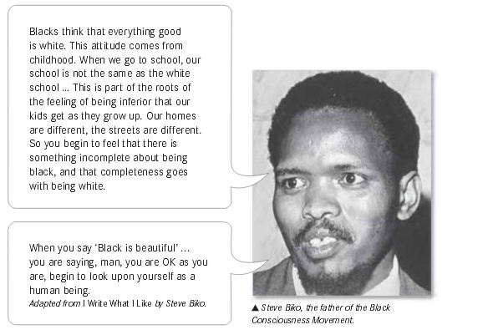
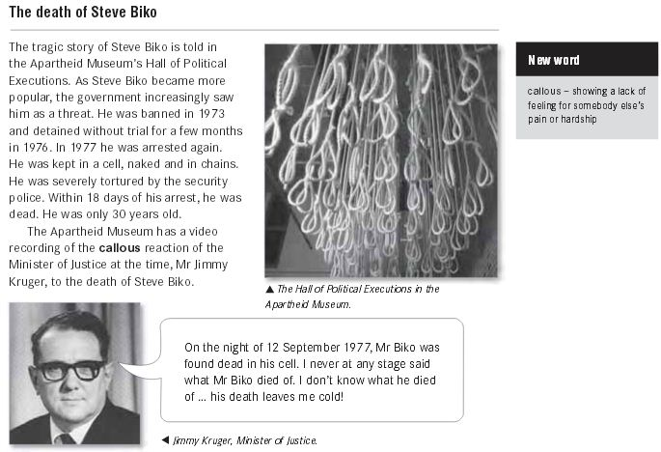

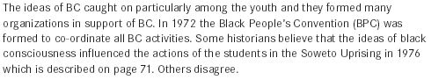
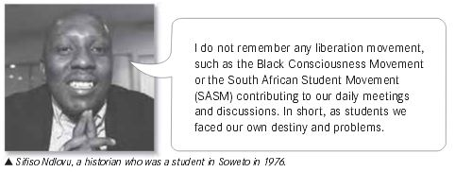
*Activity 2: The Road to Armed Struggle
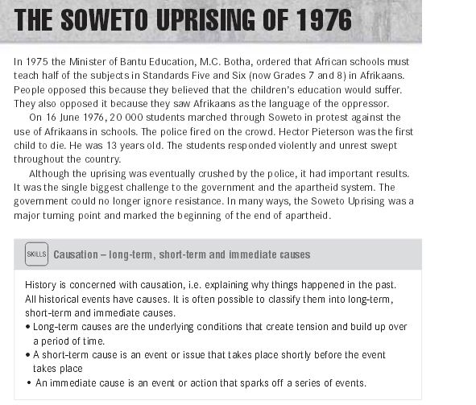
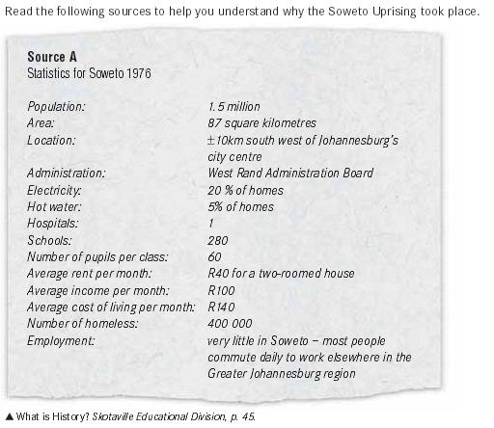

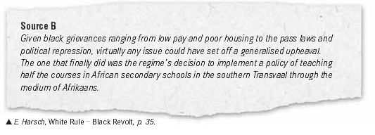

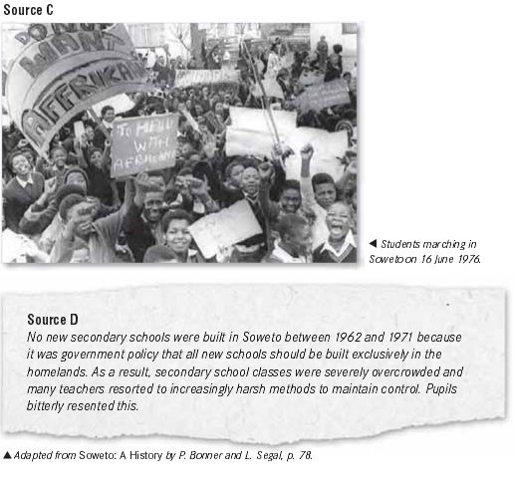
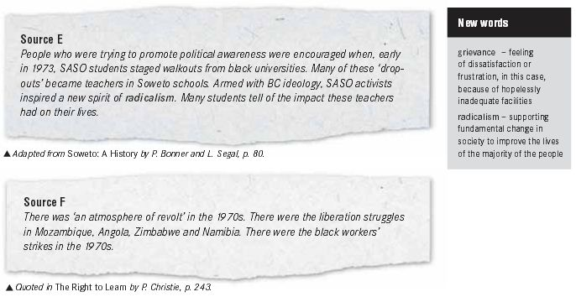

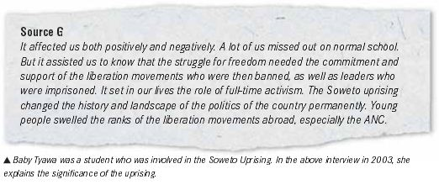
*Activity 3: The Soweto Uprising

