Citizenship in the French Revolution
French Revolution
From: Common Core Content Workshop Fall 2014, Courtney Amaya, 2014
History Standards: 10.2.4
Explain how the ideology of the French Revolution led France to develop from constitutional monarchy to democratic despotism to the Napoleonic empire.
CCSS Standards: Reading, Grades 9-10
1. Cite specific textual evidence to support analysis of primary and secondary sources, attending to such features as the date and origin of the information.
2. Determine the central ideas or information of a primary or secondary source; provide an accurate summary of how key events or ideas develop over the course of the text.
4. Determine the meaning of words and phrases as they are used in a text, including vocabulary describing political, social, or economic aspects of history/social studies.
5. Analyze how a text uses structure to emphasize key points or advance an explanation or analysis.
9. Compare and contrast treatments of the same topic in several primary and secondary sources.
Writing, Grades 9-10
1. Write arguments focused on discipline-specific content.
8. Gather relevant information from multiple authoritative print and digital sources, using advanced searches effectively; assess the usefulness of each source in answering the research question; integrate information into the text selectively to maintain the flow of ideas, avoiding plagiarism and following a standard format for citation.
Guiding Question:
How did the concerns of French revolutionaries affect their conceptualization of citizenship?
Overview of Lesson:
Students should be familiar with the origins of the French Revolution. Begin by asking students what citizenship means. What adjectives does the word evoke? What do citizens do? What do they receive? Students may take a few minutes to discuss these questions in groups before sharing answers with the class as a whole.

As a class, read through the introduction. Bring students’ attention to the ideals French citizens were fighting for. Were “liberty, equality, and fraternity” among the concepts discuss earlier? Why or why not?

Have small groups read through the Declaration of the Rights of Man together, and navigate the questions with help if they need it. Then bring the whole class back to de-brief the document and ask any outstanding questions. Repeat this process for the Declaration of the Rights of Woman and Citizen. Once students have reviewed both documents and answered all of the associated questions, ask students which document they believe is stronger. Why? Which document do they believe best exemplifies the ideals of “liberty, equality, and fraternity”? They may answer in writing as an exit ticket.

The French Revolution in Documents
Historians who have studied the French Revolution have often remarked on the way in which it created and spread lasting ideas concerning citizenship, the possession of rights made possible by belonging to a specific nation. Three of the most important rights fought for by French Revolutionaries were liberty, fraternity, and equality. These rights made previously unprotected and exploited French people, such as peasants or workers, feel like they had a stake in their nation; that they were an important part of it and that they had much to gain if the Revolution was successful. The French Revolution also made French people feel like they belonged to the same country rather than to different cities or provinces in France. The Revolution made them feel like they belonged to something greater than themselves or their local communities. They belonged to France. They were Frenchmen.
Every day, we continue to experience this history of citizenship in the United States. The founders of the United States as well as its writers, artists, and civic leaders not only shared many of the same political values as the French Revolutionaries, but also saw themselves as belonging to something greater than any individual—the United States. Today, membership in local communities (Anaheim, Los Angeles, San Francisco) and in individual states (California, Nevada, Kentucky), as well as family ties to other countries and continents (Mexico, Ireland, Africa) is usually—but not always for everyone—secondary to participation in the larger entity called the United States. Good examples of the ways in which citizens express and experience their relationship to this larger union are saying “The Pledge of Allegiance” or singing “The Star-Spangled Banner.” In singing the national anthem at sports events, we symbolically put aside our personal and local allegiances to our city and home team and show a greater allegiance to the United States.

We will now read 2 excerpts from the time of the French Revolution (primary source documents).
Source 1: Declaration of the Rights of Man, 1789 National Assembly  The Representatives of the French people...believing that ignorance, neglect, or contempt of the rights of man are the sole cause of public calamities, and of the corruption of governments, have determined to set forth in a solemn declaration the natural, inalienable, and sacred rights of man; in order that this declaration, being constantly before all the members of the Social body, shall remind them continually of their rights and duties...  Articles:  - Men are born and remain free and equal in rights. Social distinctions may be founded only upon the general good.  - The aim of all political associations is the preservation of the natural and imprescriptible rights of man. These rights are liberty, property, security, and resistance to oppression.  - The principle of all sovereignty resides essentially in the nation. No body nor individual may exercise any authority which does not proceed directly from the nation.  - (Article #11) The free communication of ideas and opinions is one of the most precious of the rights of man. Every citizen may, accordingly, speak, write, and print, with freedom, but shall be responsible for such abuses of this freedom as shall be defined by law.  - (Article #13) A common contribution is essential for the maintenance of the public forces and for the cost of administration. This should be equitably distributed among all the citizens in proportion to their means.  Taken from: Internet Modern Source Book | Contempt - the feeling with which a person regards anything considered mean, vile, or worthless  Calamities – disaster, great misfortune  Inalienable – can’t take away  Natural – to be born with  Imprescriptible – exempt from official rules or laws  Oppression – to be subject to a burdensome or harsh exercise of authority or power
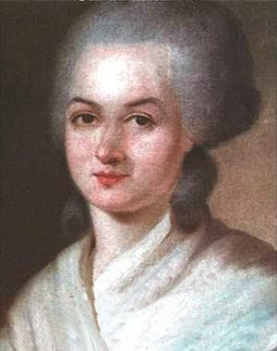
*Answer the SOURCE 1 questions on the SV handout*
...However, not all revolutionary women accepted this document...
One French Revolutionary woman, Olympe de Gouges, recognized the differences in the way that men and women were treated during the French Revolution. While revolutionary leaders talked about liberty, equality, and fraternity, they saw these rights as belonging specifically to men and not women. In 1791, Olympe de Gouges drafted "The Declaration of the Rights of Woman and Citizen" in order to draw attention to the inequalities shown to men and women during the Revolution. This document should seem very familiar to you!
Source: Declaration of the Rights of Woman and Citizen, 1791. Olympe de Gouges.  Woman, wake up; the trumpet of reason is being heard throughout the whole universe; discover your rights.  Articles:  - Woman is born free and lives equal to man in her rights. Social distinctions can be based only on the common utility.  - The purpose of any political association is the conservation of the natural and imprescriptible rights of woman and man; these rights are liberty, property, security, and especially resistance to oppression.  - The Principle of all sovereignty rests essentially with the nation, which is nothing but the union of woman and man; no body and no individual can exercise any authority which does not come expressly from it (the nation).  - The free communication of thoughts and opinions is one of the most precious rights of woman, since that liberty assures the recognition of children by their fathers.  - For the support of public force and the expenses of administration, the contributions of woman and man is equal; she shares all the duties and all the painful tasks; therefore, she must have the same share in the distribution of positions, employment, offices, honors, and jobs. | Utility - usefulness  Sovereignty – power or authority
*On the SV handout…COMPARE Olympe de Gouges' "Declarations of the Rights of Woman and Citizen" to the National Assembly's "Declaration of the Rights of Man." Though the wording of both declarations is similar, there are some very important differences.
…The majority of men did not believe that women should actively participate in politics…
On 30 October 1793, Jean–Baptiste Amar (1755–1816) spoke for the Committee of Public Safety and proposed a decree suppressing all women’s political clubs, which passed with virtually no discussion. He outlined the government’s official policy on women: women’s proper place was in the home, not in politics.

Read the following excerpt:
Discussion of Women’s Political Clubs and Their Suppression, Fabre d'Eglantine, 29 October 1793.  1. Should women exercise political rights and get mixed up in the affairs of government? Governing is ruling public affairs by laws whose making demands extended knowledge, an application and devotion without limit, a severe impassiveness and abnegation of self; governing is ceaselessly directing and rectifying the action of constituted authorities. Are women capable of these required attentions and qualities? We can respond in general no. . . .  2. Secondly, should women gather together in political associations? . . . No, because they will be obliged to sacrifice to them more important cares to which nature calls them. The private functions to which women are destined by nature itself follow from the general order of society. This social order results from the difference between man and woman. Each sex is called to a type of occupation that is appropriate to it. Its action is circumscribed in this circle that it cannot cross over, for nature, which has posed these limits on man, commands imperiously and accepts no other law. | Impassiveness - without emotion; apathetic; unmoved  Abnegation - the act of giving up a right, possession, etc.  Rectifying – making or setting something right  Obliged – required  Circumscribed – limited or confined  Imperiously – to dominate
For the majority of men, women did have a role to play in the Revolution…think about the text you just read and study the images below.
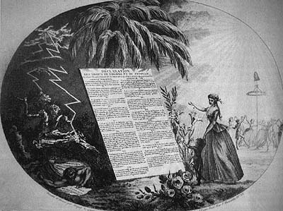 | 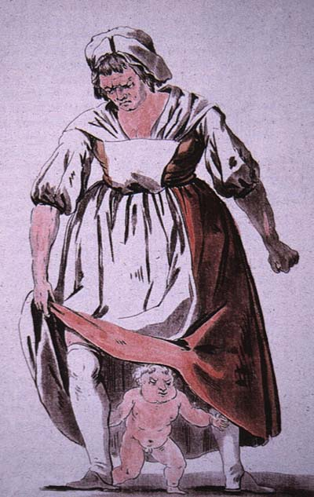
*Finish the questions on the SV – handout.

SV: The French Revolution in Documents
Questions to answer on SOURCE 1:
- For the writers of the Declaration, what are the four most important rights?

- The word "natural" appears in the Declaration several times. Keeping this word in mind, are men born with the above rights or must they be earned? What does it mean to have natural, inalienable, sacred rights?

- Look closely at article #11 - what is the main concern of the writers?

- Article #13 concerns an important duty or responsibility of all French citizens. What is that duty?

- Compare the National Assembly’s Declaration to deGouges’ Declaration. Highlight any words or phrases that deGouges includes that are different from the original Declaration.
Articles:  - Men are born and remain free and equal in rights. Social distinctions may be founded only upon the general good.  - The aim of all political associations is the preservation of the natural and imprescriptible rights of man. These rights are liberty, property, security, and resistance to oppression.  - The principle of all sovereignty resides essentially in the nation. No body nor individual may exercise any authority which does not proceed directly from the nation.  - (Article #11) The free communication of ideas and opinions is one of the most precious of the rights of man. Every citizen may, accordingly, speak, write, and print, with freedom, but shall be responsible for such abuses of this freedom as shall be defined by law.  - (Article #13) A common contribution is essential for the maintenance of the public forces and for the cost of administration. This should be equitably distributed among all the citizens in proportion to their means. | Articles:  - Woman is born free and lives equal to man in her rights. Social distinctions can be based only on the common utility.  - The purpose of any political association is the conservation of the natural and imprescriptible rights of woman and man; these rights are liberty, property, security, and especially resistance to oppression.  - The Principle of all sovereignty rests essentially with the nation, which is nothing but the union of woman and man; no body and no individual can exercise any authority which does not come expressly from it (the nation).  - The free communication of thoughts and opinions is one of the most precious rights of woman, since that liberty assures the recognition of children by their fathers.  - For the support of public force and the expenses of administration, the contributions of woman and man is equal; she shares all the duties and all the painful tasks; therefore, she must have the same share in the distribution of positions, employment, offices, honors, and jobs.

- List the similarities and differences between the National Assembly’s Declaration and de Gouges’ Declaration? Be specific!
Similarities: | Differences:
- What do you think men of the Revolution saw as the proper role of women?

- Although Olympe de Gouges criticizes the roles that revolutionary men have given revolutionary women, in what important aspect does she agree with them?

