Portraying the Death of Marat
Art in the French Revolution
From: Common Core Content Workshop Fall 2014, Simon Fellowes, 2014
History Standards: 10.2.4
Explain how the ideology of the French Revolution led France to develop from constitutional monarchy to democratic despotism to the Napoleonic empire.
CCSS Standards: Reading, Grades 9-10
1. Cite specific textual evidence to support analysis of primary and secondary sources, attending to such features as the date and origin of the information.
5. Analyze how a text uses structure to emphasize key points or advance an explanation or analysis.
6. Compare the point of view of two or more authors for how they treat the same or similar topics, including which details they include and emphasize in their respective accounts.
8. Assess the extent to which the reasoning and evidence in a text support the author’s claims.
9. Compare and contrast treatments of the same topic in several primary and secondary sources.
Guiding Question:
How does perspective change the portrayal of Marat’s death?
Overview of Lesson:
If time permits, view the PowerPoint “French Revolution: Art As a Weapon” for introductory purposes. Students should be familiar with French Revolution personalities, including Marat and the circumstances of his death.

Begin by giving students the tools to examine a source, and asking them to select the papers that deal with VISUAL evidence. Show The Death of Marat and have students take notes on whatever they see for 2 minutes (timed). Then give students a chance to share what they see.

Have students read (aloud or independently) the description of the painting and fill out the graphic organizer as best they can. Once they have completed the detail work, ask them how the painting presents Marat. Heroic? Tragic? Pathetic? Powerful? Have each group of partners come up with three adjectives they believe apply to the figure.

Then divide the class in half and give each half one of the two written depictions of Marat’s death. Have them complete the “Fill the Bowls” questions and graphic organizer for their source, and then find a partner from the other side and share their conclusions. Students should walk away with notes on both sources.

As a summarizing activity, ask students to explain what the sources revealed. What did they tell us about Marat? More importantly, what did they tell us about the authors/artists? Why do their versions diverge so wildly? What did each side have to gain by telling their version of Marat’s death?

For a homework assignment, have students write an obituary for Marat that they believe is impartial.

ANALYSIS OF A VISUAL SOURCE

Think like an artist
- How has the artist composed (arranged) the figures in space? How does this composition communicate meaning?
- How is color used? Are there areas that are lighter or darker? Do some things seem more highlighted? Why do you think this was done?
- What do you think is the focal point of this visual? What makes you say so? Why do you think this was done?

Evoking meaning
- What feeling or mood do you get from this visual? What makes you say that?
- What do you think the artist wanted to communicate? How do the details we have identified support your reasoning?
- Is there a caption? How does that impact on the visual images? If there are any words or phrases that are unclear, be sure to question meaning.

Contextual Analysis
- Where did this visual appear? Who do you think was the intended audience?
- Why was this visual made? Was it commissioned?
- Is the artist’s name known to you? Was he famous for any particular types of work?
- Based on your knowledge of the era so far, in what ways is the work a reflection of society or a product of its time?
- What expectations might the artist have been responding to?

Synthesis
- What do you think the artist was trying to convey about this person, event, or period in history?
- What do you believe were the motivations behind the creation of this image?
- Does the artwork reflect a particular point of view?
- Is there any missing information or information that requires further investigation?
This close read of visual sources is based on guidelines provided by the Terra Foundation of American Art Terra “Look Learn Connect” and on strategies currently being compiled by the Newberry Library in consultation with many of the major cultural institutions in Chicago.

FILL THE BOWLS:
GUIDING QUESTIONS

Use the questions below to help you complete the historical source analysis chart (Not all of the questions will necessarily apply the sources that you are analyzing). Please write in complete ideas.

sourcing
- Who wrote this?
- When was this document written?
- Where do the actions/events in the source take place?
- What are the main actions and events taking place?
- Why was it written?
- What is the author’s perspective?

CONtextualization
- What was happening at this time in history?
- What was different at this time in history?
- What was the same?
- How might the circumstances in which the document was created affect its content?

Close reading
- What claims does the author make?
- What evidence does the author use?
- Who do you think might have owned or read this source?
- What language does the author use to persuade the document’s audience?
- How does the document’s language indicate the author’s perspective?

CONCLUSION/corroboration
- How does this historical source help us to answer the essential question?
- How helpful and useful was this source in helping us to answer the essential question?
- What do other documents say?
- Do the documents agree? If not, why?

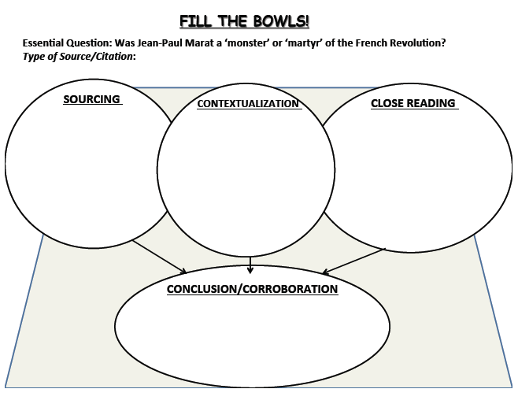

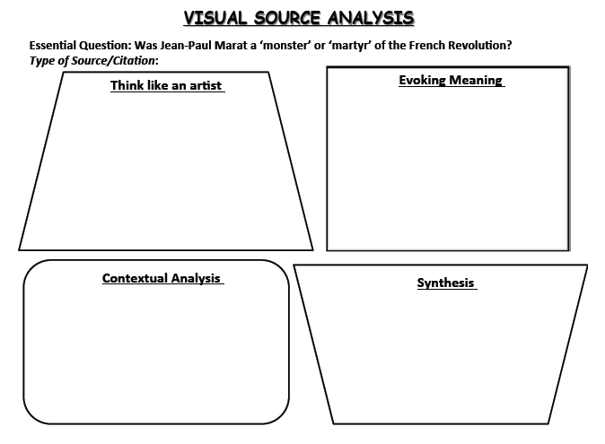
Viva la Revolucion!
This was the cry of the 18th century as France, fed up with the aristocrats and monarch of Louis XVI and his wife, Marie Antoinette. It began with the Fall of the Bastille on July 14, 1789. From that point, powers turned, people raised their voices and...heads began to roll. Much like the American Revolution, the French Revolution saw death, turmoil and success for the French people as they moved toward independence. But the fight against the bigger power gave onset to fighting between those who wanted the revolution. The Reign of Terror was a fight for the top between the Girondins, the group of individuals who held certain opinions and principles in common rather than an organized party, and the Jacobins, the largest party of the two who were more radical and had more left-wing and extremist views. With each group fighting, more and more people were sent to meet Madame Guillotine. Each side lost players in the game of Revolution but it was not until July 13, 1793, almost four years since the beginning of the Revolution.
The Death of Marat, painted by Jacques-Louis David in 1793, depicts Jacobin leader and radical journalist, John-Paul Marat in his last breath as he laid assassinated by Girondin follower, Charlotte Corday. It was known that Marat, because of a skin disease, would bathe in a cold bath to be soothe himself. Marat was in the process of taking one of these comforting baths when he was murdered by Corday. At the time of Marat, who is seen as a martyr during that time and in this painting, was penning his letter to his peers titled, L'Ami du peuple ("The Friend of the People"). Marat was seen as a righteous leader who would bring down the tyranny for a greater established government though he and his followers were more radical than those of the monarch. The image of his death is designed to commemorate a personable hero: although the name Charlotte Corday can be seen on the paper held in Marat's left hand, the assassin has been withdrawn.
The background is dark as a light source, unknown, brightens the death scene of martyr Marat. He lies in the bathtub, a green cloth covering him as a white sheet envelopes him. The sheet and the position of Marat's body is a mirror image of Michaelangleo's La Pieta as Marat lies in the position such as Jesus did as he laid across Mary's lap. Within Marat's hands are his papers and his pen, showing that he worked for the revolution until his dying breath. It is strange as we look upon his face that it seems as if he is smiling, as if he knew that he was to be a martyr for the Revolution in the eyes of other Jacobins. Seen as an "awful beautiful lie", David's painting not only depicts Marat in the sense of a martyr but also not as accurate as that day. It was said once Corday entered his home, the third try with lies of a Girondist uprising. She was turned away at noon but returned later and was admitted by Marat himself. Marat took the names of the Girondist that Corday gave him on the uprising and then pulled out the six inch knife she had and plunged it into Marat. Within David's painting, the knife is seen on the ground not in Marat's body as it was left by Corday. Also Corday never ran away but remained in the room with the body until officials came and arrested her. Marat's last words were Aidez, ma chère amie! ("Help me, my dear friend!").
Widely admired during the Terror whose leaders ordered several copies of the original work, The Death of Marat had begun to fall into disfavor after Robespierre, another Jacobin leader and seen as the most radical and terrifying during the Reign, was overthrown and executed. It was returned to David in 1795, before he himself was prosecuted for his involvement in the Terror as a close friend of Robespierre (he would have to wait for Napoleon's rise to become prominent in the arts once more).
As to any story, there is another side. The story of the Girondin heroine, Charlotte Corday. A young woman of 25 years old, Corday believed that Marat was threatening the Republic, and that his death would end violence throughout the nation. Corday was named the l'ange de l'assassinat or the Angel of Assassination. Painted by Paul Jacques Aimé Baudry. Titled Charlotte Corday, the painting shows the young girl in the corner of the room, Marat's body still in the tub, as she stands bravely over the deed she has done. The room is clearly seen in Baudry's painting with a chair overturned and papers scattered everywhere. Marat was seen as a revolutionary monster and Corday as a heroine of France, represented in the wall-map behind her. Marat's assassination provoked reprisals in which thousands of the Jacobins' adversaries – both royalists and Girondins – were executed on supposed charges of treason. She was guillotined on 17 July 1793 for the murder. During her four-day trial, she had testified that she had carried out the assassination alone, saying "I killed one man to save 100,000."
The assassination did not stop the Jacobins or the Terror: Marat became a martyr, and busts of Marat replaced crucifixes and religious statues that were no longer welcome under the new regime. The misogyny of many revolutionary leaders was increased by Corday's act. The iconic pose of Marat dead in his bath has been reviewed from a different angle in Baudry's painting of 1860, both literally and interpretively: Corday, rather than Marat, has been made the hero of the action. History will tells that the Reign of Terror and the Revolution continued until the uprising of Napoleon Bonaparte and the coup d'etat on November 9 1799 in which Napoleon first stepped into his dictatorship position.
Note: David's Marat-Note on the writer's block Marat's name above David's as a tombstone and memorial to the revolutionary. Baudry's Charlotte- unlike David's painting the knife is still plunged into Marat's body.

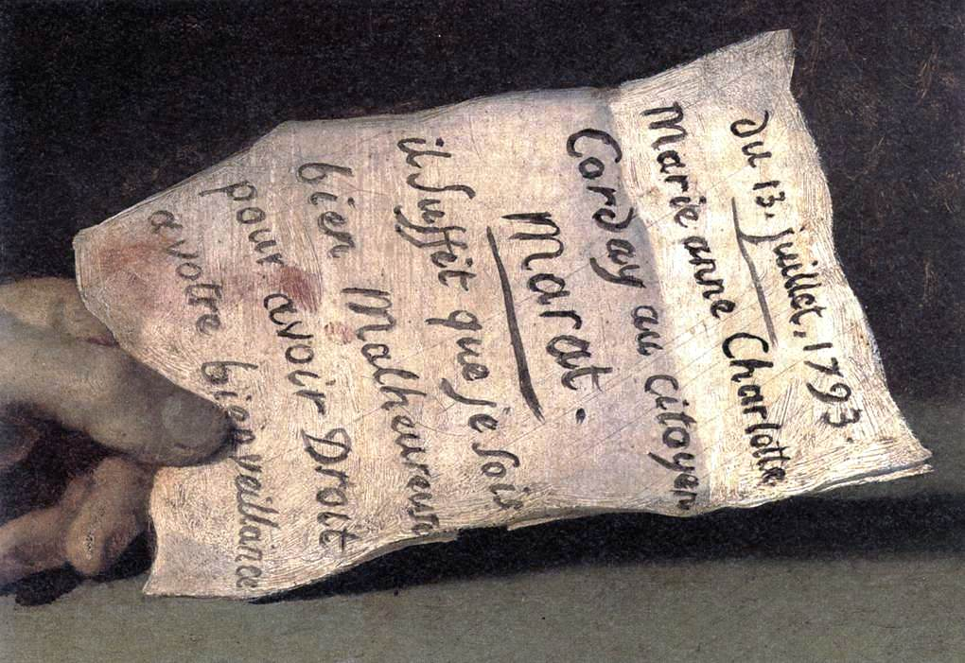
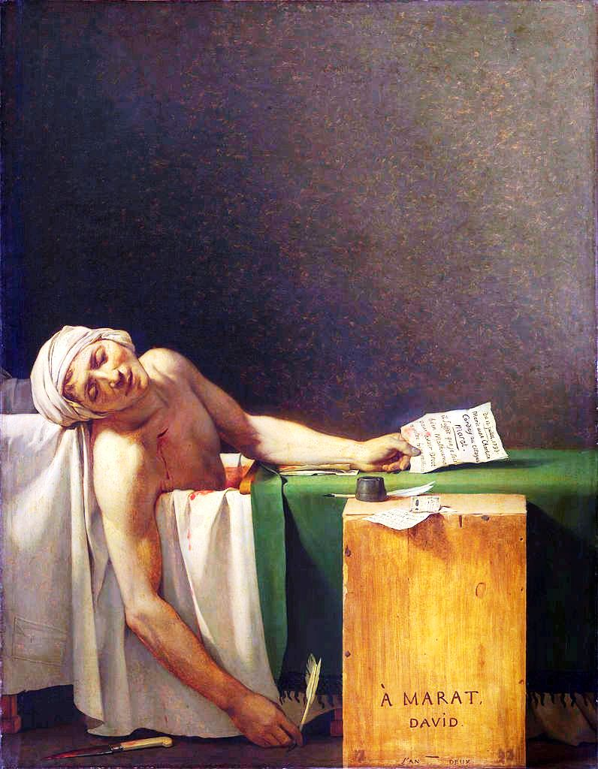
The Death of Marat, painted by Jacques-Louis David in 1793, depicts Jacobin leader and radical journalist, John-Paul Marat in his last breath as he laid assassinated by Girondin follower, Charlotte Corday. It was known that Marat, because of a skin disease, would bathe in a cold bath to be soothe himself. Marat was in the process of taking one of these comforting baths when he was murdered by Corday.
Contemporary account by Rene Lebois of the murder of Jean-Paul Marat in 1793.

Republicans:
It’s time for the permanent guillotine. A conspiracy to assassinate our best, our firmest supporters, our faithful representatives has revealed itself. Already, yesterday a sacrilegious hand dared stab the firmest supporter, the most zealous defender of the people…..
For quite some time he was threatened by a horde of bandits who were located in Paris.
Not a one of these scoundrels dared raise his hand against him, since they knew that the people would take their vengeance and made them suffer the penalty due their crimes.
Posterity will tremble with horror when it learns that it was a woman who committed this crime against a representative of the people.
Yesterday this patricidal woman went to Marat’s home to speak to him on an affair of importance. Marat, always concerned about public safety, asked her to return during the evening.
Marat arrived from the Convention around seven or eight o'clock in the evening, the time when the assassin was supposed to present herself.
Suffering for a while from illness, Marat regularly took baths. Upon his arrival at home he got into bath.
This scoundrel woman presented herself at about eight o'clock and asked to speak to him. It was announced to Marat that the person who had come in the morning and whom he had told to return in the evening was asking to speak to him.
Marat, always worried about the lot of the people, and believing it was a matter of some information or denunciations – especially at a time when the Republic is in the greatest danger, and when the people fears for the lives of its faithful representatives………left his bath and said to have her come in.
The patricidal woman presented herself to him and, holding a dagger, plunged it into his breast.
Marat, the intrepid Marat, falling immediately under the murderous steel, still had the courage to call for the guard, but soon Marat, the friend of the people, its true defender, was no more.
Immediately, the people who were in another room off to the side ran in and cried out “Murderer! Close the doors!”
Neighbors heard the cries, entered, began by closing the doors, and took hold of the patricidal woman.
The armed force was immediately called for; they came and surrounded Marat’s house. Four doctors were sent for at Saint Come, and he had just expired when they arrived.
Soon Municipal Officers and Police Administrators arrived.
Immediately the writing of the official account was undertaken, as well as the interrogation of the accused.
I want only to give an account of the sad events and to recount the interrogation, but given that it would only be founded on hearsay, since no one could enter the house of the deceased, all I can say is that everyone was in agreement that it was a woman who had arrived from Caen named Charotte Corday.
None of the citizens who were gathered there in great numbers could hold back their tears, and shouts of indignation could be heard from everywhere.
Danton, Robespierre, Barrère, Thuriot, Héraut-Sechelles, all of the true Mountain; beware! Perhaps the daggers that will be thrown at you have already been sharpened, and the assassins chosen.
Pache, Chaumet, Hébert and all the patriots of the municipality; be on your guard as well. You demanded the punishment of the guilty, and the traitors are still conspiring in the prisons where they are being held, and perhaps they've already put a price on your heads.
You brave and intrepid Jacobins, redouble your efforts and your courage. With the Paris municipality, immediately go and ask the National Convention which tribunal will judge those who bore a sacrilegious hand to strike the breast of one of your friends, one of your members.
Demand of it that the paralytic side, once known as the Marais and the Vendée be immediately replaced; that most, and even all be arrested because they are guilty, have no doubt about it.
Sans Culottes, my friends, let us avenge, avenge the death of one of our friends, a Montagnard. Let the head of the patricidal woman fall under the sword of the law. Let the guillotine be permanent and let those who did us so much harm, who desire the destruction of the republic and to give us a king, be punished.
If you follow this advice, hastily given, the lives of our faithful representatives will no longer be in danger.

LEBOIS, friend of the Sans Culottes.

British Newspaper Coverage of the French Revolution:
Death of Marat and Execution of Charlotte Corday.
London Times
July 30, 1793
France. [page 3]
[ . . . ] Marat's funeral obsequies were performed on the 16th, in the evening—a great concourse of citizens, the Convention in a body, the constituted authorities and the popular societies formed the procession, which followed the body in profound silence to the sound of mournful music. The cannon was fired in several quarters of the city. Marat was interred under the trees of the garden of the ci-devant Convent of Cordeliers, at two in the morning. His tomb is a rough stone without any ornament.
In the evening of the 17th, the execution of Charlotte Cordé, the assassin of Marat, took place in the Place de la Revolution. Her undaunted composure in her last moments, will serve, perhaps,more than her crime, to transmit her name to posterity. During her interrogatory, she astonished her judges and the spectators by her calm, decent and unaffected deportment; and even on the approach of death she expressed herself with the greatest ease, and in terms of pleasantry. She absolutely refused the assistance of a Confessor. In the cart which carried her to the place of execution, and even on the scaffold, her air and motions were graceful and decent. She placed her had, without any visible emotion, under the fatal instrument which severed it from her body—the most profound silence was observed. The executioner, on shewing the head to the spectators, gave it a blow—on which, by an almost universal murmur, the people expressed this sentiment—
La loi punit et ne venge pas.
The law punishes and does not avenge.
The head was then pale, but perfectly beautiful. The Executioner shewed it a second time t the people, and the blood which was then extravasated, had restored to her cheeks its former animated glow: —shouts of Vive la Republique were now heard, and the spectators dispersed less impressed with the recollection of her crime, than of her courage and beauty.

