The Opening Up of japan
Japan’s Transition to a Modern Society
From: Sites of Encounter: Empires, Courtney Amaya, 2012

History Standards: 10.3
Students analyze the effects of the Industrial Revolution in England, France, Germany, Japan, and the United States.
CCSS Standards: Writing, Grade 9-10
1. Write arguments focused on discipline-specific content.
8. Gather relevant information from multiple authoritative print and digital sources, using advanced searches effectively; assess the usefulness of each source in answering the research question; integrate information into the text selectively to maintain the flow of ideas, avoiding plagiarism and following a standard format for citation.
9. Draw evidence from informational texts to support analysis, reflection, and research.
Guiding Question:
Would you consider the initial encounters between the Japanese and the Americans and the opening up of this isolated island nation as positive or negative for Japan?
Overview of Lesson:

Visualizing Cultures Website – The Opening Up of Japan

Purpose: The Visualizing Cultures website is an excellent visual tool to use with your class, as well as a rich source for teachers to access in-depth information on China and Japan. The following assignment is an example of how I introduce the opening up of Japan to the West and its transition from a feudal to modern society. I will first utilize the Visualizing Cultures Website and then move on to a lesson from the HOT Curriculum.

Materials:
- Computer
- LCD Projector
- Internet Access
- Student Handout

Encounters Facing East - Step 1:
Go to: http://ocw.mit.edu/ans7870/21f/21f.027/black_ships_and_samurai/bss_visnav01.html

The “Facing East” page documents Commodore Matthew Perry’s encounters with Japan. The visuals were taken by William Heine.

- Scroll to the right. Read aloud the narrative to your students as you show them the visuals.
  - It is helpful for students to expand upon the narrative information about Perry’s encounter with Japanese officials (either using your textbook and/or the ESSAY by John Dower - located on this site).
    - http://ocw.mit.edu/ans7870/21f/21f.027/black_ships_and_samurai/bss_essay01.html (essay link)

- Ask students to answer the following questions while viewing the page:
  - In the first few visuals Heine documents many of the places visited while en route to Japan. What words would you use to describe his paintings of Ceylon, Mauritius, etc…?
  - What do these paintings all have in common; is there a particular focus?
  - What words would you use to describe the paintings of Japan?
  - What do the paintings of Japan all have in common; is there a particular focus for most of them?
  - Describe the clothing differences between the Japanese and Americans.
  - Do you think Heine viewed the Japanese in a positive or negative way? Explain.

Encounters Facing West – Step 2
The “Facing West” page documents the Japanese perspective of Commodore Matthew Perry’s arrival in Japan.

- Scroll to the right. Read aloud the narrative to your students as you show them the visuals.

- Ask students to answer the following questions while viewing the page:
  - In what ways are the Japanese paintings different from William Heine’s paintings?
  - What words would you use to describe the Japanese artwork?
- What is the focus of most of the paintings?
- Do you think the Japanese viewed the Americans in a positive or negative way? Explain.

Black Ships – Step 3:
- Show students the picture of the USS Powhatan (which sailed on Perry’s second Japan mission)
  - Explain to students that the Powhatan was Perry’s flagship and showed off the newly mechanized American navy. The Powhatan is a steamship (you can point out the waterwheel in the middle of the vessel).
    - Perry’s fleet included both sail and steam-driven ships. In response to the wind, the steamers conserved fuel by hoisting sails. At times, they towed the sail ships to speed the journey along.

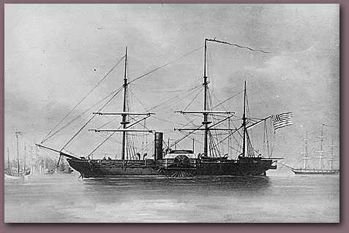

- Now go back to the website and click on Black Ships Facing West: (http://ocw.mit.edu/ans7870/21f/21f.027/black_ships_and_samurai/bss_visnav04.html)
- Read the introduction and show them the first image ONLY (see below).
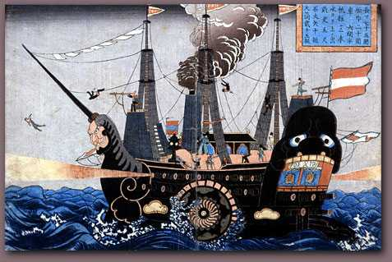

- Students should write down their initial impressions of this image.
- Now scroll to the right. Read aloud the narrative to your students as you show them the visuals.
  - I only go through the images that breakdown the image above.

Step 4 - Writing Assessment:
- Now that students have seen and heard about the American encounter with the Japanese in 1853-54, it is important that they synthesize the information they’ve learned. Students will write a paragraph (5 sentences minimum, including a thesis) answering this prompt: Would you consider the initial encounters between the Japanese and the Americans and the opening up of this isolated island nation as positive or negative for Japan?

Step 6 - Video
- Show the video clip – “History vs. Hollywood” from The Last Samurai

The Opening Up of Japan
Website: http://ocw.mit.edu/ans7870/21f/21f.027/black_ships_and_samurai/bss_visnav01.html

Directions: Answer the following questions as you work your way through the Visualizing Cultures website.
Facing East Questions:
- In the first few visuals Heine documents many of the places visited while en route to Japan.
What words would you use to describe his paintings of Ceylon, Mauritius, etc…?

- What do these paintings all have in common; is there a particular focus?

- What words would you use to describe the paintings of Japan?

- What do the paintings of Japan all have in common; is there a particular focus for most of them?

- Describe the clothing differences between the Japanese and Americans.

- Do you think Heine (the artist) viewed the Japanese in a positive or negative way? Explain.

Facing West Questions:
- In what ways are the Japanese paintings different from William Heine’s paintings?

- What words would you use to describe the Japanese artwork?

- What is the focus of most of the paintings?

- Do you think the Japanese viewed the Americans in a positive or negative way? Explain.

Part 2: “Black Ships” – The Japanese perspective of the American fleet.

- List the first thoughts that came to your mind when you viewed this image:

- Would you consider this painting of an American ship positive or negative? Explain.

- “The warship was pitch black and the figure-head on the prow was a leering monster”. Why do you think the artist portrayed parts of the ship as a monster?

Final Assessment - Writing for Understanding:
Now that you’ve seen visuals and listened to the historical context surrounding the encounter between America and Japan that began in 1853, you will write a paragraph (minimum of 5 sentences, including a thesis) answering the following prompt:
- Would you consider the initial encounters between the Japanese and the Americans and the opening up of this isolated island nation as positive or negative for Japan?

