**The Pacific War: Japan and Southeast Asia**

World War II

From: Humanities Out There, Kate Merkel-Hess

**History Standards: 10.8.3**

Identify and locate the Allied and Axis powers on a map and discuss the major turning points of the war, the principal theaters of conflict, key strategic decisions, and the resulting war conferences and political resolutions, with emphasis on the importance of geographic factors.

**CCSS Standards: Reading, Grades 9-10**1. Cite specific textual evidence to support analysis of primary and secondary sources, attending to such features as the date and origin of the

information.

3. Analyze in detail a series of events described in a text; determine whether earlier events caused later ones or simply preceded them.

10. By the end of grade 10, read and comprehend history/social studies texts in the grades 9–10 text complexity band independently and proficiently.

**Guiding Question:**What were the hallmarks of the Japanese occupation of Southeast Asia?

**Overview of Lesson:**Students will be well versed in the European theater of World War II. They will also be familiar with Japan’s rapid modernization and their imperial drive.

Depending on the level of your class, it may be helpful to read the first section aloud, asking text-dependent questions and clarifying thoughts as you go. You may also want to answer the accompanying question for the first section on an overhead, so that students can see what you expect in a full and complete answer.

After modeling, students may work in partners or independently to complete the readings and accompanying questions. As an exit ticket, students can compare and contrast Pacific and European theaters, or make a prediction about how to war with Japan will end.

**The Pacific War:**

Japan and Southeast Asia

**Part One: The Japanese in Southeast Asia**

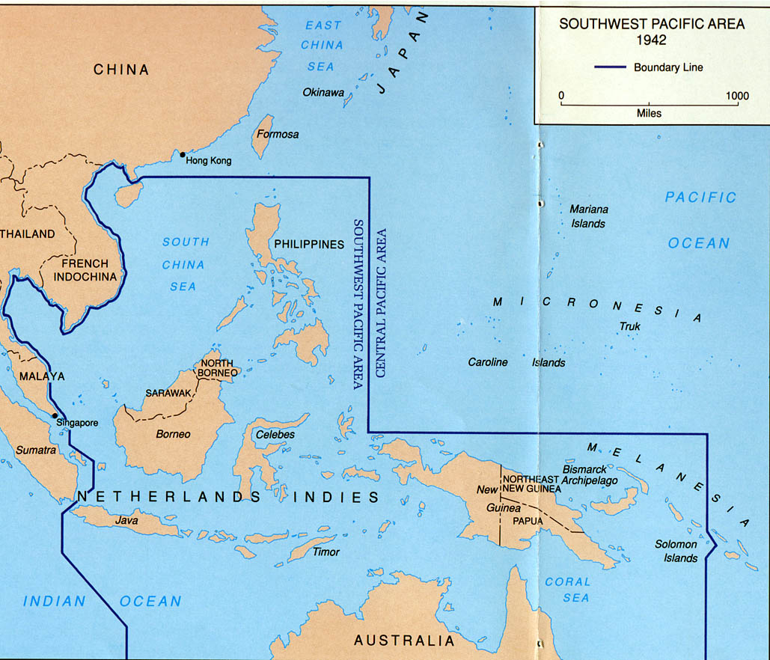

This map shows the political divisions in Southeast Asia in 1942. Can you find any countries on this map that you think might be colonies of European nations? Why do you think so?

We often think of water as a divider, a barrier. And if we believe that is true, then the map on the previous page has many “divisions.” But, in fact, water can also help humans to make connections with one another. If you think of water as a “connector” rather than a “divider,” how does the map on the previous page look different?

**New Words**

*milieu*: an environment, a setting

*puppet government*: a government controlled by an outside force, as a puppet is controlled by a puppeteer

For hundreds of years, the area of the world—called *Southeast Asia*—depicted on this map has been the center of vibrant trade and cultural exchange. When the Europeans set out across the sea, they were hoping to find a shorter route to “the Indies,” or Southeast Asia. The variety of goods traded here, like spices, cloth, sugar, and other luxury products like ceramics and silver, were enough to propel this exploration.

Japanese traders and adventurers were also part of this international **milieu**. In the nineteenth century, when Japan began its efforts to modernize, Japanese people began to talk about moving into the “South Seas,” an expansion initially focused on Micronesia, but that came to include Indonesia, the Philippines, and other parts of Southeast Asia. Many Japanese began to move abroad to start businesses and establish connections and communities in this part of Asia.

Japan officially began to acquire lands throughout Asia in the early twentieth century. Japan seized Taiwan in 1895 and Korea in 1910, and in 1914, at the beginning of World War I, took over Micronesia. During World War II, Japan’s imperial holdings stretched from Indonesia in the south to Manchuria in the north. The Japanese installed **puppet governments** throughout the region, often saying that the Japanese were there to help the local populations liberate themselves from Western colonizers. In some places, however, by the end of the war, Japanese settlers and soldiers outnumbered members of the local population.

Please decide if, based on your reading, the following statements are true or false.

1. Southeast Asia didn’t have much of an economy before the Europeans arrived. T F
2. The Japanese imperial expansion happened in about ten years. T F
3. The governments established by the Japanese in areas like the Philippines and Micronesia were independent in name only. T F
4. A “puppet government” is a government controlled by outside forces. T F
5. Japan did not take over any lands controlled by European powers. T F

**Part Two: “Keeping Order in the Indies”**

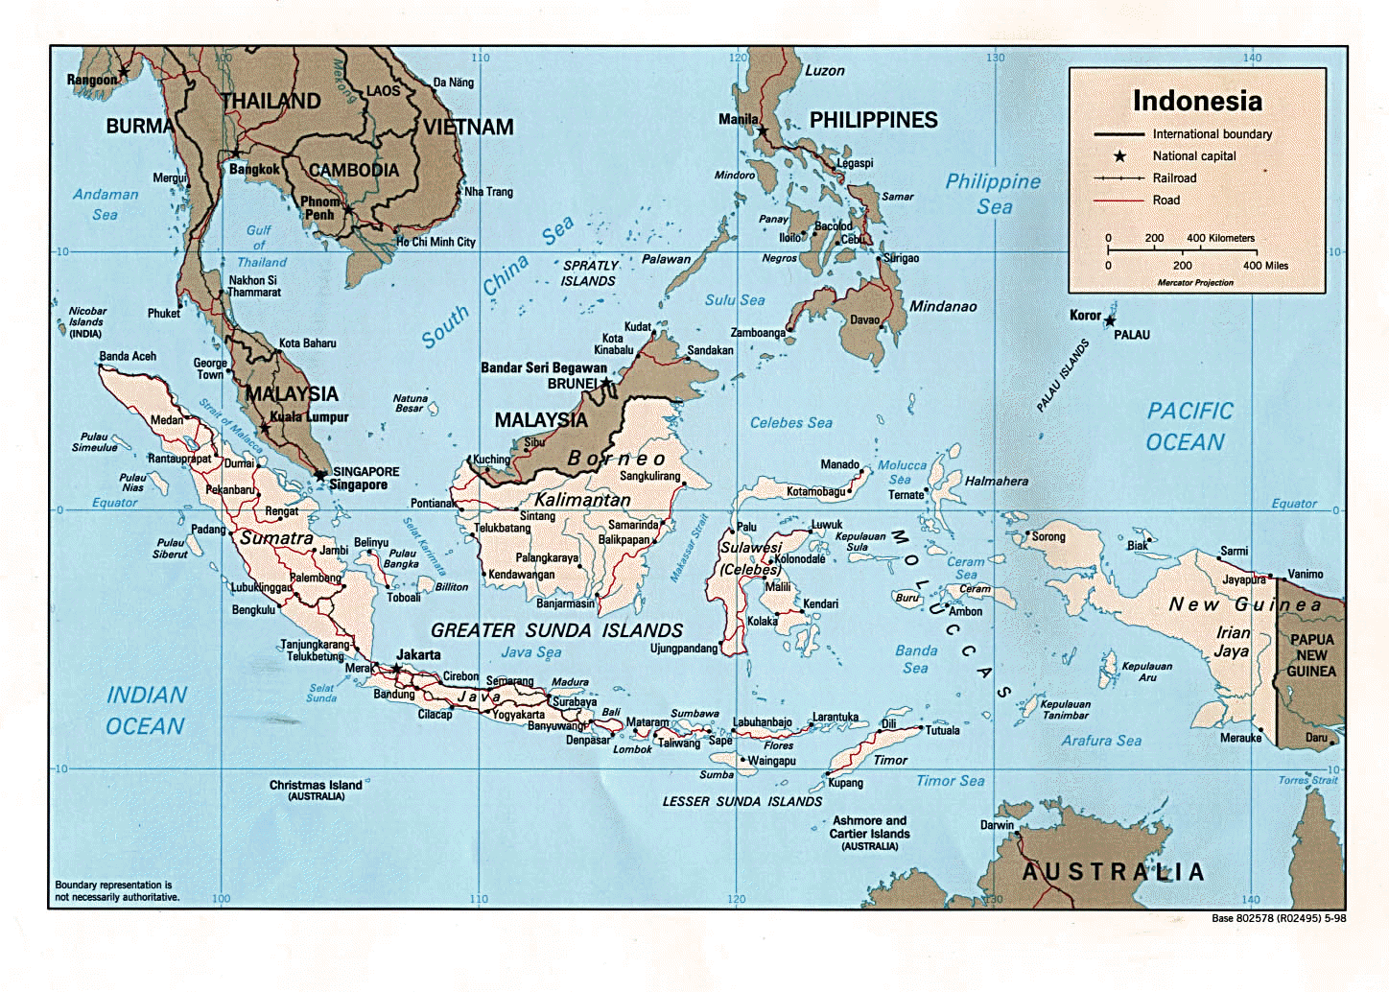

In 1942, Japan conquered the islands that today make up Indonesia (the fourth most populous country, and the largest majority Muslim country, in the world). Japan wrested control of Indonesia away from the Netherlands, which had held the “Indies” as a colony since 1815.

Unlike other regions, the Japanese chose to put a Japanese military government in place in Indonesia, rather than allowing rule by a “puppet government.” Here is a description of the occupation, given by Nogi Harumichi, a member of the Japanese Navy administration:

“In 1942 I thought occupying a country was a wonderful thing. When our ship arrived at the Celebes, in Indonesia, I saw wide stretches of uncultivated soil. ‘We can develop this land and introduce Japanese technology here,’ I thought…

The building we used as our headquarters had housed the offices of the Netherlands governor general. It was in Greco-Roman style, enormous fans turning overhead in each room. It even had running hot water. Japan didn’t have such things. In this occupied area I learned for the first time how developed Europe was…

We Japanese were being treated as liberators who had expelled the Dutch for the Indonesians. The haughty Dutch who had lorded it over the Indies found themselves prisoners overnight. When I got to areas where Japanese forces had never been, village chiefs welcomed me…They waved the Sun flag and the Indonesian flag too. I felt we were doing something wonderful there…This lasted through the end of 1942. Then the military demanded an allotment of the rice harvest from the depths of the Celebes. There was a stirring of tension among the locals and troops had to be mobilized to control it….

I felt we were only turning them into our own colony. I had once imagined we would be leading Indonesians in singing their independence anthem, “Indonesia Raia,” but now we banned it…Among the Japanese forces the atmosphere became more and more brutal. Violent incidents occurred regularly.”[1]

1. Why is the author optimistic about what the Japanese proposed to do in Indonesia?
2. What event, according to the author, changes the relationship between the Indonesians and the Japanese forces?

**Part Three: The Vietnamese Famine of 1943-1945**

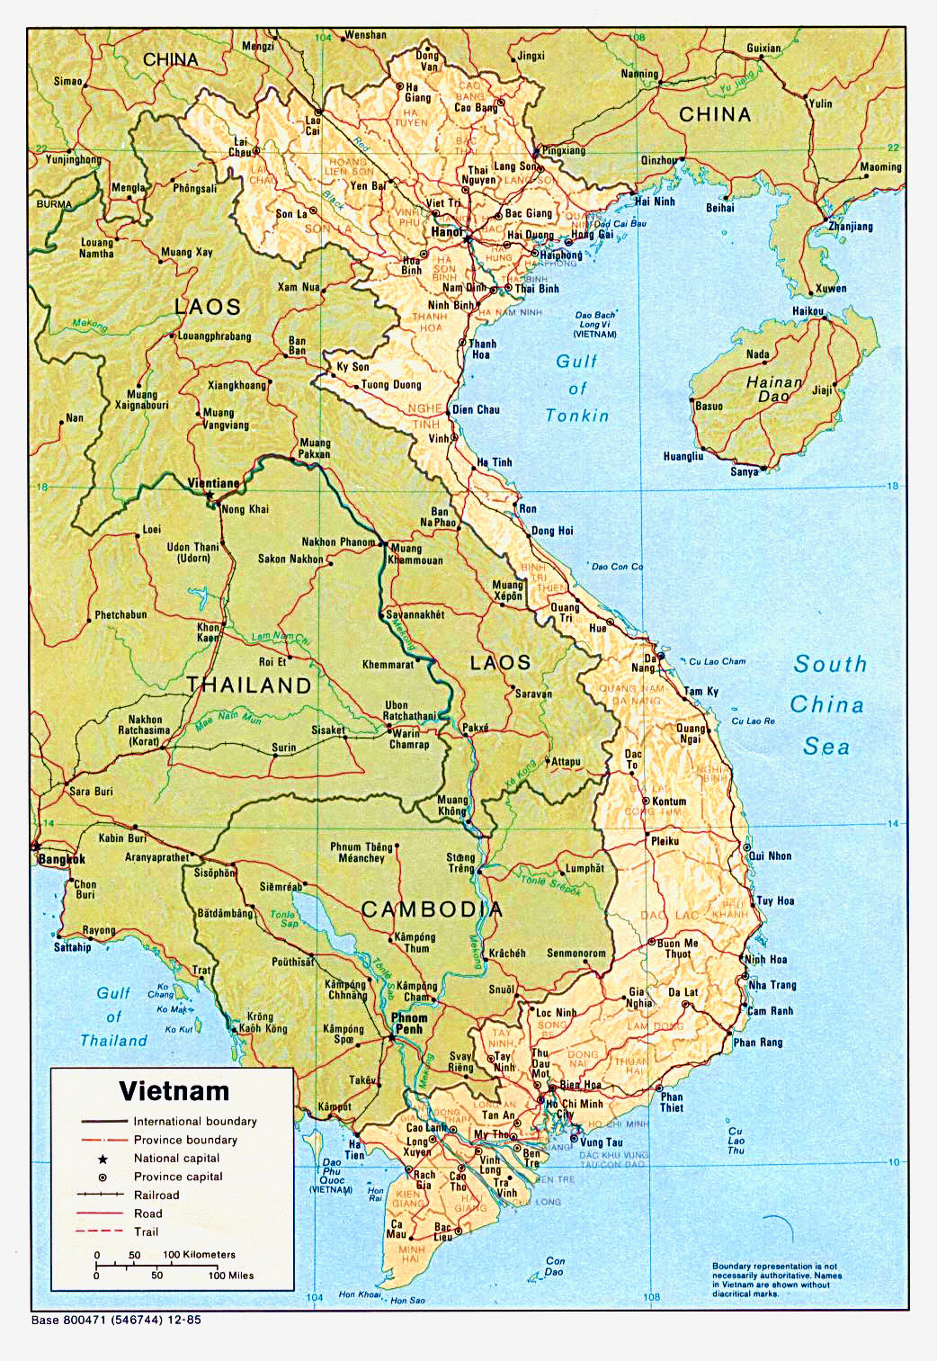

In the previous reading, Nogi Harumichi mentions that one of the things that upset Indonesians was the Japanese demand for part of the rice harvest. Rice is a staple crop in Asia, and many people depended on it both to sell for money and to eat. The Japanese also depended on **procurements** of rice to sustain their military as it expanded throughout Asia. As you’ll remember from last week, the Japanese in China limited Shanghai’s supply of rice.

Parts of Vietnam were occupied by Japan beginning in 1940. Prior to that time, Vietnam was a colony of France. Can you find Vietnam on the map of Southeast Asia on page 1 of your handout? (Hint: It had a different name then.)

From 1943 to 1945, due to Japanese demand for rice as well as several other factors, the Vietnamese people experienced a devastating famine. It is estimated that between 400,000 and 2 million people died during this time.

Here is an excerpt of one story from this famine:

“Although in normal times the Vuoc family was poor, they had always been comfortable. The husband and wife were around thirty years old, but they already had six children…Living in the country as they did, the Vuocs were accustomed to getting up very early to go to the rural labor market and stand there waiting for people to hire them as field laborers…People shone their lamps on the laborers, examining them one by one, and when they came across someone who looked as if he would be a strong and steady worker, they would bargain for the price of hiring him…

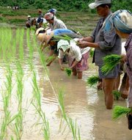

Workers plant rice crops in

Southeast Asia.

“After the flood of the ninth month in the year of the monkey [1944], the Vuocs realized that famine was unavoidable…When the tenth month of the year of the monkey came, the husband and wife went out together to the market very early every morning, but they usually had to come home, shouldering their hoes and sickles, without any work. The eleventh and twelfth month passed, and there were many of the village inhabitants who died, but the Vuoc family was still intact.

“In the early part of the year of the chicken [1945], the Vuocs lost their youngest daughter, who was two years old…Several days later, they lost another child…Whenever they could get a handful of rice, the Vuocs had to divide it into five or six portions, which was not enough to give each member of the family a mouthful.

**New Words**

*procurement*: to get possession of, obtain

*raven*: a black bird

“The husband realized that, if such a situation continued, in only a few days he would have to follow his children into the grave. He said to his wife, ‘If we keep on dividing the food this way, we will die, first of all myself. We will have to leave the four children to their fates. They will have to try to find food for themselves. Both of us are still young and strong, and even if heaven should cause them to die, after this famine is over, if we are still alive, we can still give birth.’

“Mrs. Vuoc shook her head and covered her face with her hands, crying. Looking at his wife, her hair tangled like a **raven’s** nest…he wanted to cry, too, and take his chance with death.”[2]

1. What does Mr. Vuoc mean when he says, “We will have to leave the four children to their fates”?
2. What do you think will happen to the Vuoc children? What will happen to the Vuoc parents?
3. What choice would you have made?

1. “Keeping Order in the Indies,” from Japan at War: An Oral History, ed. Haruko Taya Cook and Theodore F. Cook. New York: The New Press, 1992. Excerpts from pp. 105-109.
2. Excerpted from “Who Committed This Crime?” (Ai Gay Nen Toi?), by Tran Van Mai, reproduced in translation in Before the Revolution: The Vietnamese Peasants Under the French, by Ngo Vinh Long. Cambridge, Ma.: The MIT Press, 1973. pp. 246-249.