Chinese Revolution DBQ
The Dawn of Chinese Communism
From: Nations in the 20th Century

History Standards: 10.9.4
Analyze the Chinese Civil War, the rise of Mao Tse-tung, and the subsequent political and economic upheavals in China (e.g., the Great Leap Forward, the Cultural Revolution, and the Tiananmen Square uprising).

CCSS Standards: Writing, Grade 9-10
2. Write informative/explanatory texts, including the narration of historical events, scientific procedures/ experiments, or technical processes.
4. Produce clear and coherent writing in which the development, organization, and style are appropriate to task, purpose, and audience.
8. Gather relevant information from multiple authoritative print and digital sources, using advanced searches effectively; assess the usefulness of each source in answering the research question; integrate information into the text selectively to maintain the flow of ideas, avoiding plagiarism and following a standard format for citation.
10. Write routinely over extended time frames (time for reflection and revision) and shorter time frames (a single sitting or a day or two) for a range of discipline-specific tasks, purposes, and audiences.
Guiding Question:
Why did Chinese peasants embrace Communism?
Overview of Lesson:
Students will use visual and text primary sources to examine what factors led Chinese peasantry to embrace Communism. A graphic organizer is provided for planning, in addition to an essay outline.

Using the sources, analyze and explain why Chinese peasants embraced Communism?
Document 1
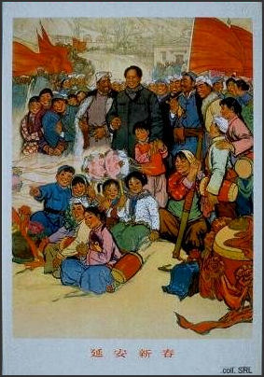
Type of Source (primary or secondary?):
Summary/main idea:

How does this document positively promote communism?

Document 2
“The Nationalists were the nominal government of China from 1928 to 1937. During that period, they had little opportunity to initiate the far-reaching changes that they promised. Instead, the Nationalist government solely concerned itself with maintaining order in a country that was flying apart at the seams…While the Nationalists were able to bring about some financial and industrial reforms, on the whole they neglected the Nationalist project of alleviating poverty and equalizing the economy, the third of the People's Principles of Sun Yat-sen. The neglect of the peasantry eventually proved to be their downfall at the end of the Japanese occupation when the communists were swept into power with a peasant revolt”.
Taken from: http://www.wsu.edu:8080/~dee/MODCHINA/NATIONAL.HTM
Type of Source (primary or secondary?):
Summary/main idea:

How does this document positively promote communism?

Document 3
The two excerpts below are written by Mao Zedong in a 1927 report to the Central Committee of the CCP about the peasant movement in the central province of Hunan. Mao notes the tremendous potential power of the peasants to make revolution.
“The present upsurge of the peasant movement is a colossal event. In a very short time, in China’s central, southern, and northern provinces, several hundred million peasants will rise like a mighty storm, like a hurricane, a force so swift and violent that no power, however great, will be able to hold it back. They will smash all the shackles that bind them and rush forward along the road to liberation. They will sweep all the imperialists, warlords, corrupt officials, local tyrants, and evil gentry into their graves.”
“The main targets of attack by the peasants are the local tyrants, the evil gentry, and the lawless landlords, but in passing they also hit out against patriarchal ideas and institutions, against corrupt officials in the cities and against bad practices and customs in the rural areas.”
Type of Source (primary or secondary?):
Summary/main idea:

How does this document positively promote communism?

Document 4
Fable told by Mao Zedong in 1945
There is an ancient Chinese fable called ‘The Foolish Old Man Who Removed
the Mountains.’ It tells of an old man who lived in northern China long, long
ago and was known as the Foolish Old Man of North Mountain. His house
faced south, and beyond his doorway stood the two great mountain peaks,
blocking the way. He called his sons, and hoe in hand they began to dig up
these mountains. Another person from the village, known as Wise Old Man,
saw them and said, ‘How silly of you to do this! It is quite impossible for you
to dig up these two huge mountains’. The Foolish Old Man replied, ‘When I
die, my sons will carry on; when they die, there will be my grandsons, and
then their sons and grandsons, and so on to infinity. High as they are, the
mountains can not grow any higher and with every bit we dig, they will
be that much lower. Why can’t we clear them away?’ Having proved the
Wise Old Man’s view wrong, he went on digging every day, unshaken in his
belief. God was moved by this, and he sent down two angels, who carried
the mountains away on their backs. Today, two big mountains lie like a dead
weight on the Chinese people. One is imperialism, the other is feudalism.
The Chinese Communist Party has long made up its mind to dig them up. We
must work unceasingly, and we, too, will touch God’s heart. Our God is none
other than the masses of the Chinese people. If they stand up and dig together
with us, why can’t these two mountains be cleared away?
Taken from HOT: The Chinese Revolution

Type of Source (primary or secondary?):
Summary/main idea:

How does this document positively promote communism?

Document 5
The Communist Party’s military forces were known as the “Red Army.” Communist leaders
enforced very strict discipline in their army.
Here are some of the rules for Red Army Soldiers:
1. Replace all doors when you leave a house.
2. Be courteous and polite to the people and help them when you can.
3. Return all borrowed articles.
4. Replace all damaged articles.
5. Be honest in all transactions with the peasants.
6. Be sanitary, and, especially, establish latrines a safe distance from people’s houses.
Taken from HOT: The Chinese Revolution
Type of Source (primary or secondary?):
Summary/main idea:

How does this document positively promote communism?

Document 6
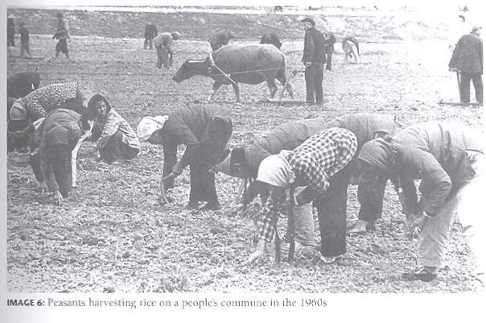
Taken from HOT: The Chinese Revolution
Type of Source (primary or secondary?):
Summary/main idea:

How does this document positively promote communism?

Writing prompt: Why do you think Chinese peasants embraced communism?

- Set the stage (place, time, leadership)

- Define Mao’s ideas of communism:

- Identify 2 main reasons why (according to the docs above) Chinese peasants embraced communism:

Reason #1 and the docs that support it:

Reason #2 and the docs that support it:

DBQ:
Thesis Statement:
Topic: 1. Time Period with distinguishing characteristics 2. Categories
Thesis: Makes an argument.
Answer the question by turning that question into a sentence.
Prove that your answer is correct.
Topic Sentence: Introduces the category and how it connects to the
topic/thesis.
Evidence: Paraphrase the main idea of the document. Cite for example doc 1
or by Author
Analysis: Analyze why the evidence is important to the category and
argument.
Evidence: Paraphrase the main idea of the document.
Analysis: Analyze why the evidence is important to the category and
argument.
Point of View: What does the author think about this topic and why?
Additional documents: What other types of sources are needed to better
understand the topic and why?
Citation: According to document 1,……………
………………. (Doc1)
Point of View:
Who might the author be?
Why did the author create this source?
Is the author’s message positive or negative? why?
What does the author want us to think or feel?
The author’s point of view is…

