Syncretism Buddhism Lesson
How Religion Traveled the Silk Road
From: Secrets of the Silk Road Workshop, Sara Jordan, 2012

History Standards: 7.3.1
Describe the reunification of China under the Tang Dynasty and reasons for the spread of Buddhism in Tang China, Korea, and Japan.

CCSS Standards: Reading, Grade 6-8
7. Integrate visual information (e.g., in charts, graphs, photographs, videos, or maps) with other information in print and digital texts.
Guiding Question:
How can we study Buddhist art to learn about the movement of goods, peoples, and ideas across the Silk Roads?
Overview of Lesson:
Adapted From Silk to Oil: Art Along the Silk Roads and Religions Along the Silk Roads

Part 1: Syncretism
In this lesson we will study examples of Buddhist sculptures to consider how the religion, religious images, and peoples traveled across the Silk Road. The Silk Road stretched across Asia from contemporary Afghanistan to Korea. You may want to study an interactive map to learn more about Buddhism in each of these locations:

http://pilgrimage.asiasociety.org/map/

As Buddhism spread across Asia so did the cultural images and art associated with this religion. The spread of Buddhism occurred through conversion as a result of travelers, merchants, and pilgrims traveling the trade routes of the Silk Road. As Buddhism spread from India to other parts of Asia, the ideas and images of the religion were not exactly duplicated, or copied in each location. Instead, aspects of the religion and the art were adapted to the existing culture, merging the two cultures together. This process of cultural exchange is called syncretism. Can you think of an example of syncretism in your life?

Part 2: Buddhist Art Across Asia
Buddhist art was a visual representation of the Buddhist communities that lived across Asia. These communities often centered on trade routes and provided a place for travelers, merchants, and religious pilgrims to meet, rest, worship, and trade. A common aspect of these communities was the creation of Buddhist sculptures in caves and grottos. We will study some of these sculptures and ask the following questions of each of them:
- What is represented in the image?
- What is the sculpture made of? Where is the sculpture located?
- What are some important visual aspects of the Buddha image? Explain your answer by using examples from the sculpture that seem important to you.
- What message do you think this sculpture would give to people who viewed it on their travels on the Silk Road?

Jigsaw: You will study the images and answer the questions as a group. Once you have analyzed the image, you will join a group made up of students who have studied another image, so each person in the group will be an expert on each of the images. Each student should report on their image. As a group, students should answer the following questions;
- What aspects of the sculptures are similar? Explain your answer by using examples from the sculpture that seem important to you.
- What aspects of sculptures are different? Explain your answer by using examples from the sculpture that seem important to you.
- Why were these sculptures important across the Silk Road?
- How are these sculptures examples of syncretism?

Image 1: Bamiyan Buddha

To the northeast of the royal city there is a mountain, on the side of which is placed the stone figure of Buddha standing, in height one hundred or one hundred and fifty feet. Its golden colors sparkle on every side and its precious ornaments dazzle the eyes with their brightness.
[Wriggins 1996: 44) from Silk to Oil Lesson]
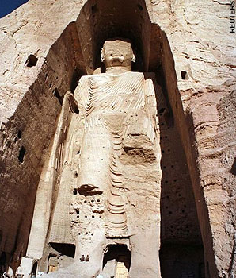  Photo From Guardian UK | Citation:  Bamiyan, Afghanistan north of Kabul. One of two Buddha figures that were made of stucco and stone in 300-500 C.E.  These were destroyed by the Taliban in 2001.

For more information see the USA Today article, “Why the Taliban are Destroying the Buddhas”
http://www.usatoday.com/news/science/archaeology/2001-03-22-afghan-buddhas.htm

Image 2: Vairocana Buddha
The Longmen Grottoes (lit. = Dragon Gate Grottoes) were designated a World Heritage Site in November 2000. The Longmen caves and cliff sculptures of Buddhist divinities are an outstanding example of China's artistic impulse to carve in stone (in this case, limestone). The grottoes and niches were created in phases over the centuries, with the oldest dating back to the late 5th century (Northern Wei Dynasty 386 - 534 AD), and the most recent completed in the 10th century (Tang Dynasty 618 - 907 AD). The grottoes are situated on both sides of the Yi River, and include some 2,300 caves and niches, over 100,000 Buddhist images, and more than 2,800 inscriptions, all commissioned by various imperial dynasties, top-ranking officers, powerful families, religious leaders, merchants, and even common people (who could only afford the smaller niches).
[Mark Schumaker’s website, Buddhism and Shintoism in Japan A to Z Photo Dictionary of Japanese Sculpture and Art]
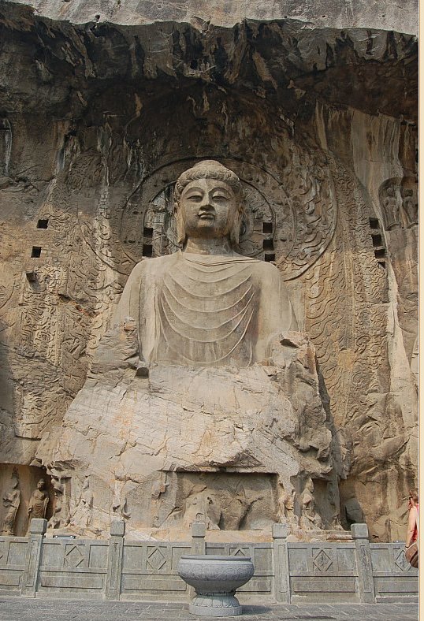  Mark Schumaker’s website, Buddhism and Shintoism in Japan A to Z Photo Dictionary of Japanese Sculpture and Art http://www.onmarkproductions.com/html/longmen_45.html | China, Tang Dynasty Fengxian Temple  Fengxian Temple  Ancestor Worshipping Temple  Carving began in 672, completed circa 672-675 AD  Central Image = Vairocana Buddha  Seated atop lotus; 17 meters in height; limestone.  Commissioned by Empress Wu Zetian, and  reportedly made to resemble her facial features.

Image 3: Buddha Shakyamuni
This image of the Buddha, shown performing the earth-touching gesture (bhumisparsha mudra), evokes Bodh Gaya, the place of the Buddha's enlightenment. The carving in the lower register shows the earth as a female with a water vessel, who witnesses the enlightenment. To the right is a kneeling male figure holding a flower garland, enacting a pilgrimage custom. The Bodhi Tree, under which the Buddha attained enlightenment, is indicated by leafy branches that curl above the figure of the Buddha. The abraded surface of this relief suggests that it received repeated touching and libations in the course of rituals.
[Pilgrimage and Buddhist Art, Asia Society]
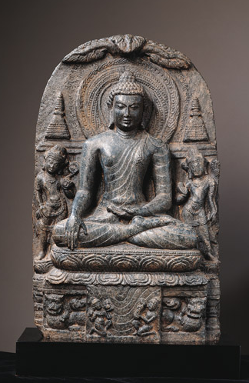  http://pilgrimage.asiasociety.org/artifacts/buddha-shakyamuni | Citation: India, Bihar  Date: Pala period, late 9th–early 10th century  • Site: Bodh Gaya

Image 4: Buddha in Nirvana

This Buddha is located in a cave in Dunhuang in the far west of China’s Gansu province, where the two branches of the Silk Roads that circled the Tarim Basin come together. In addition to being an important commercial town, Dunhuang was a center of Buddhism from 366 CE. It was one of the main points of entry from Central Asia into China for Buddhist missionaries and monks. The name “Dunhuang” means “blazing beacon.” This refers to the signal fires set in watchtowers by Chinese troops. Twelve miles outside of Dunhuang is a half-mile-long cliff that, over a thousand years, became studded with caves. Many of them are decorated with Buddhist murals. They are called the Mogao (“Peerless” or “None Loftier”) Caves or “The Caves of the Thousand Buddhas.”
[Dunhuang Art Exhibition]

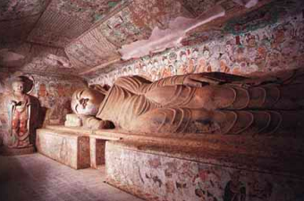
http://english.people.com.cn/features/dunhuang/pages/cave158.htm
Citation: Cave 158, Mogao Grotto
Buddha in Nirvana
Mid-Tang Dynasty, 781 - 847 C.E.

Image 5: Sokkuram Grotto

Established in the 8th century on the slopes of Mount T'oham, the Sokkuram Grotto contains a monumental statue of the Buddha looking at the East Sea, separating Japan and Korea. With the surrounding portrayals of gods, Bodhisattvas and disciples, all realistically and delicately sculpted in high and low relief, it is considered a masterpiece of Buddhist art in the Far East. The Temple of Bulguksa (built in 774) and the Seokguram Grotto form a religious architectural complex of exceptional significance.

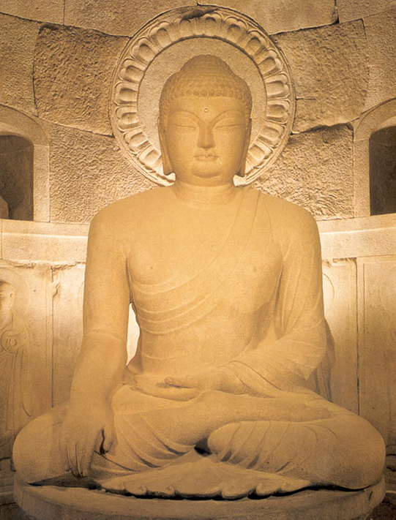  http://discoverkorea.co.kr/bbs/zboard.php?id=temples | Citation: Sokkuram Grotto 774  Stone Sculpture  Korea  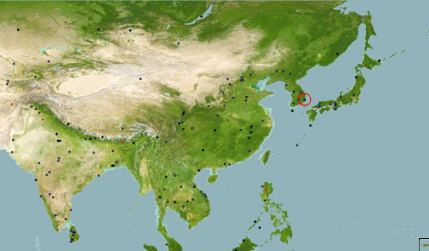

Useful Websites for Information:

The Buddha Documentary on PBS website excerpts from the documentary, timelines, maps, lessons, and game.
http://www.pbs.org/thebuddha/

Pilgrimage and Buddhist Art: Asia Society Exhibit on Buddhist Pilgrimage with images, background, and maps.
http://pilgrimage.asiasociety.org/

