Effects of the Crusades
The Crusades
From: UCI History Project
History Standards: 7.6.6
Discuss the causes and course of the religious Crusades and their effects on the Christian, Muslim, and Jewish populations in Europe, with emphasis on the increasing contact by Europeans with cultures of the Eastern Mediterranean world.
CCSS Standards: Reading, Grades 6-8
1. Cite specific textual evidence to support analysis of primary and secondary sources.
2. Determine the central ideas or information of a primary or secondary source; provide an accurate summary of the source distinct from prior knowledge or opinions.
4. Determine the meaning of words and phrases as they are used in a text, including vocabulary specific to domains related to history/social studies.
5. Describe how a text presents information (e.g., sequentially, comparatively, causally).
7. Integrate visual information (e.g., in charts, graphs, photographs, videos, or maps) with other information in print and digital texts.
9. Analyze the relationship between a primary and secondary source on the same topic.
10. By the end of grade 8, read and comprehend history/social studies texts in the grades 6–8 text complexity band independently and proficiently.
Writing, Grades 6-8
2. Write informative/explanatory texts, including the narration of historical events, scientific procedures/ experiments, or technical processes.
4. Produce clear and coherent writing in which the development, organization, and style are appropriate to task, purpose, and audience.
8. Gather relevant information from multiple print and digital sources, using search terms effectively; assess the credibility and accuracy of each source; and quote or paraphrase the data and conclusions of others while avoiding plagiarism and following a standard format for citation.
9. Draw evidence from informational texts to support analysis reflection, and research.
Guiding Question:
What were the effects of the Crusades?
Overview of Lesson:
The lesson below should be projected overhead so that students can see it.
Teacher’s should walk students through the discussion of writing and paragraph dissection. After modeling how to annotate the first paragraph, teachers should let students work in groups or pairs to complete textbook paragraphs 3 & 4. You may bring them back as a whole class to discuss and list the effects of the Crusades, or allow them to continue in groups.
Read the primary source aloud, then have students re-read individually and list the effects and examples. Ask for volunteers to read theirs aloud. Then have students complete the paragraph frame individually.

Effects of the Crusades

Today we will learn two things:
- The parts of a paragraph
- The major effects of the Crusades

Let’s start by talking about writing. What do you think are important things to know about writing in the history classroom? What types of things do you write about? How is your writing organized? Answer the question below.
______________________________________________________________________________________________________________________________________________________________________________________________________________________________________________________________________________________________________________________________________________________________________________________________________

Today we will look at the components, or parts, of a paragraph. Paragraphs have 4 components. Try to list each one below and explain what they are.

1. __________________________________________________________________________________________________________________________________
2.
_________________________________________________________________________________________________________________________________
3. __________________________________________________________________________________________________________________________________
4. __________________________________________________________________________________________________________________________________

Now we will read a model paragraph from the textbook, while learning about each of these components of a paragraph in order to answer our question: What were the effects of the Crusades?

Each paragraph will provide us with information about the effects of the Crusades so we can answer our question.

Effects of the Crusades

Excerpt from Text | Working with the Text
Paragraph 1:  Crusaders failed to regain the Holy Land, but the Crusades did have lasting effects. They opened Europeans’ eyes to the rest of the world. Peasants who had never been farther from home than the next village suddenly saw new lands, peoples, and ways of life. Even nobles had never traveled to lands so far away.  Paragraph 2:  The Crusades also enriched European life. For example, they stimulated economic growth by increasing trade between cities bordering the Mediterranean Sea. The Italian cities of Venice, Genoa, and Pisa profited by carrying crusaders and supplies to the Middle East. These cities gained trading privileges in territories conquered during the Crusades. The cities became rich and powerful handling trade in Asian goods that passed through the conquered territories on the way to Europe | Underline the topic sentence (TS).  What is the main idea of the topic sentence?  This second sentence is the concrete detail (CD). The concrete details that an author can include are: explanations of what happened, descriptions of who was involved in the event, and when it happened. Circle the actions and people who in this sentence.  The third sentence contains the commentary (CM) and answers the question: Why is this important? This part of the paragraph is also called ANALYSIS and is the most important part of the paragraph because this is where you make your claim. Underline the parts of sentence 3 you think are most important.  The fourth part of a paragraph is the concluding sentence (CS). Why is a conclusion an important part of a paragraph?  Sometimes paragraphs do not have only 4 sentences, but they still follow the model.  Underline the topic sentence.  Circle the concrete details.  Look at the map on the next page and put a star on each of the Italian cities mentioned in this sentence.  Draw arrows from each of these cities to the Middle East.  According to the map, what were some important cities of the Middle East, also known as the Holy Land?  The commentary sentence gives the reader information about the effects of the Crusades in Italy  According to the concluding sentence (CS), what was an effect of the Crusades on the Italian cities?
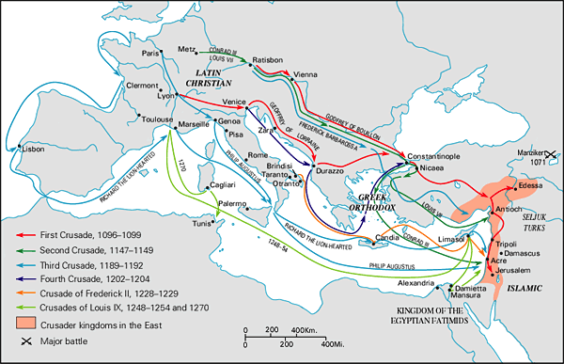
Paragraph 3:  The Crusades increased trade with the East. Crusaders returned home with silks, spices, and other exotic goods. Demand for these products at home caused European traders to expand their business to Asia. | Sometimes paragraphs do not have 4 sentences, but do contain enough information to allow us to answer our question.  What are the concrete details in this paragraph? List them below.  Why did trade increase after the Crusades?  Explain how this allows you to answer your question:  What was the effect of the Crusades?

The effects of the Crusades were both positive and negative on the peoples of medieval Europe and the Middle East. The paragraphs you read above give many positive effects of the Crusades. List the positive effects of the Crusades based on the text above.

We must remember that this was over 100 years of warfare. List some of the effects of war on people and places.

Read the primary source about the capture of Jerusalem in 1244 below.

The enemy, who, surrounding them on all sides, attacked them with swords, arrows, stones and other weapons, killed and cut to pieces about seven thousand men and women, and caused such a massacre that the blood ran down the sides of the mountain like water. Young men and women they hurried off with them into captivity, and retired into the Holy City, where they cut the throats, as of sheep doomed to the slaughter, of the nuns, and old and infirm men, who, unable to endure the toils of the journey and fight, had fled to the church… such a crime as the eyes of men had never seen since the commencement of the world.

Reread the source and underline the negative effects of the Crusades.

What are some examples of violence that occurred during this battle? List them below.

Now it is your turn to try to write a paragraph about the negative effects of war. Some parts of the paragraph have been written already, so you need to provide the rest of the components.

While the Crusades had many positive effects on people in the medieval world, the Crusades also brought many negative consequences (TS). For example,________________________________________________________
________________________________________________________________________________________________________________________________________(CD). Men and women, both Europeans and people from the Middle East lost their lives during the conflict of the Crusades (CM). The period of the Crusades lasted from _______ to __________ and _______________________________
________________________________ was a major effect (CS).

