Teaching with Primary Sources |  | 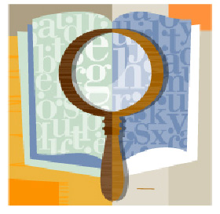
A historical investigation question requires students to interpret a lesson’s historical content in order to make their own claims.   | Rationale  These six sources provide a view of the Explorations and conquest of the Americas from a native rather than a European perspective. Teachers could expand the source set and include the writings of the explorers and discuss the difference in the two views. However, since textbooks and other materials tend to focus mainly on the European side of exploration or discuss only a few of the most well-known native sources; this exercise would provide a more in-depth analysis of native culture just before and during the period in which they are conquered by European forces.

Historical Investigation Question(s)

What do the images and accounts of conquest tell us about native life before the arrival of the Europeans?

What do the painting and the accounts of conquest tell us about the Spanish victory over the Inca’s and Aztecs?

Standards

7.7 Students compare and contrast the geographic, political, economic, religious, and social structures of the Meso-American and Andean civilizations.

3. Explain how and where each empire arose and how the Aztec and Incan empires were defeated by the Spanish.

Christopher Columbus’s voyages began a centuries-long series of encounters between peoples of the Americas and Europe. The Kislak Collection includes a selection of dramatic objects and records that reflect this complicated and extraordinary epoch. This section presents materials from the voyages of exploration of Christopher Columbus (1451–1506), Hernán Cortés (1485–1547), and Francisco Pizarro (ca. 1475–1541) and material about the natives of the Americas they encountered. It also features the Conquest of Mexico paintings, created in the seventeenth century, which depict the cataclysmic encounter between Cortés and the conquistadors and Moctezuma and his people. When Christopher Columbus arrived on the Bahamian Island of Guanahani (San Salvador) in 1492, he encountered the Taíno people, whom he described in letters as “naked as the day they were born.” The Taíno had complex hierarchical religious, political, and social systems. At the time of Columbus’s exploration, the Taíno were the most numerous indigenous people of the Caribbean and inhabited what are now Cuba, Jamaica, Haiti, the Dominican Republic, Puerto Rico, and the Virgin Islands. By 1550, the Taíno were close to extinction, many having succumbed to diseases brought by the Spaniards. In 1519, inspired by rumors of gold and the existence of large, sophisticated cities in the Mexican interior, Hernán Cortés (1485–1547) was appointed to head an expedition of eleven ships and five hundred men to Mexico. At that time the great empire of the Mexica—now known as the Aztecs—dominated much of Mesoamerica. Their capital, Tenochtitlán, had become such a splendid city that, according to records, it dazzled the Spaniards, exceeding anything they had seen before. Two years after the arrival of Cortés and his conquistadors, constant war and diseases new to the Americas had destroyed Tenochtitlán, and the Aztec Empire was no more. Francisco Pizarro (ca. 1475–1541) arrived in present-day northern Peru late in 1531 with a small force of about 180 men and 30 horses. Taking advantage of a civil war, he and his compatriots toppled the ruler, Atahualpa, in 1532. Over the next several decades the Spanish suppressed several Inca rebellions, achieving complete control by 1572. Pizarro’s Spanish rivals assassinated him in 1541 in Lima, the city he had founded in 1535.

(Background from Library of Congress Website).
Secondary Source

Primary Sources
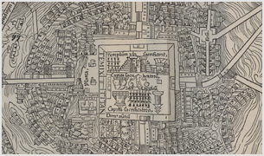 | Map of Tenochtitlan  Hernán Cortés. Praeclara Ferdina[n]di Cortesii de noua maris oceani. . . (Enlightenment of Ferdinand Cortés concerning new facts about the new sea and the ocean . . .). Nuremberg: Peypus, 1524. Facsimile. Jay I. Kislak Collection,Rare Book and Special Collections Division, Library of Congress (060.02.00)  http://myloc.gov/Exhibitions/EarlyAmericas/ExplorationsandEncounters/CortesandtheAztecs/ExhibitObjects/MapofTenochtitl%C3%A1n.aspx
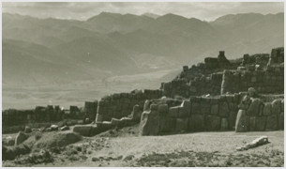 | Peruvian Ruins  William E. Warne. Ruins of Sacsahuamán (Cusco City, Peru), 1950. Copyprint.  Prints and Photographs Division, Library of Congress (075.00.00)  http://myloc.gov/Exhibitions/EarlyAmericas/ExplorationsandEncounters/PizarroandtheIncas/ExhibitObjects/PeruvianRuins.aspx
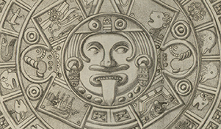 | Finding the Past  Antonio de León y Gama (1735–1802). Descripción histórica y cronológica de las dos piedras en la plaza principal de México. Mexico: F. de ZúΖiga y Ontiveros, 1792. Rare Book and Special Collections Division, Library of Congress (042.01.01)  http://myloc.gov/Exhibitions/EarlyAmericas/PreContactWorld/Pages/default.aspx
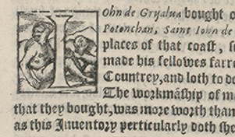 | Early History of the Spanish Conquests  Francisco López de Gómara (1511–1564). The pleasant historie of the conquest of the West India, now called New Spayne: atchieued by the worthy prince Hernando Cortes, marques of the valley of Huaxacac, most delectable to reade/translated out of the Spanishe tongue by T.N., anno 1578. London: Henry Bynneman, [1578]. Rare Book and Special Collections Division, Library of Congress (062.01.02).  http://myloc.gov/Exhibitions/EarlyAmericas/ExplorationsandEncounters/Pages/SlObjectList.aspx
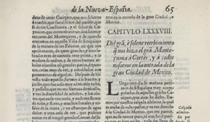 | A different View of Conquest  Bernal Díaz del Castillo (1496–1584). Historia verdadera de la conqvista de la Nueva--España (True history of the conquest of New Spain). Madrid: Imprenta del Reyno, 1632. Jay I. Kislak Collection, Rare Book and Special Collections Division, Library of Congress (063.00.02  http://myloc.gov/Exhibitions/EarlyAmericas/ExplorationsandEncounters/CortesandtheAztecs/ExhibitObjects/ADifferentViewofConquest.aspx
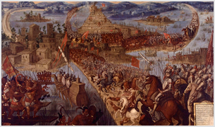 | “The Capture of Tenochtitlan”  Second half of the seventeenth century. Oil on canvas. Jay I. Kislak Collection, Rare Book and Special Collections Division, Library of Congress (096.00.00)  http://myloc.gov/Exhibitions/EarlyAmericas/ExplorationsandEncounters/ConquestPaintings/ExhibitObjects/TheCaptureofTenochtitl%C3%A1n.aspx
The California History-Social Science Project
University of California, Davis
One Shields Avenue
Davis, CA 95616
Office: (530) 752-0572
Website: http://csmp.ucop.edu/chssp

