“A Period Is Questioned”: The Declaration of Independence
Founding Documents and the American Revolution
From: UCI History Project, Nicole Gilbertson, 2014
History Standards: 8.1.2
Analyze the philosophy of the government expressed in the Declaration of Independence, with an emphasis on government as a means of securing individual rights (e.g., key phrases such as “all men are created equal, that they are endowed by their Creator with certain unalienable Rights”).
CCSS Standards: Reading, Grades 6-8
1. Cite specific textual evidence to support analysis of primary and secondary sources.
2. Determine the central ideas or information of a primary or secondary source; provide an accurate summary of the source distinct from prior knowledge or opinions.
4. Determine the meaning of words and phrases as they are used in a text, including vocabulary specific to domains related to history/social studies.
5. Describe how a text presents information (e.g., sequentially, comparatively, causally).
6. Identify aspects of a text that reveal an author’s point of view or purpose (e.g., loaded language, inclusion or avoidance of particular facts).
7. Integrate visual information (e.g., in charts, graphs, photographs, videos, or maps) with other information in print and digital texts.
8. Distinguish among fact, opinion, and reasoned judgment in a text.
Guiding Question:
How does punctuation affect the meaning of the Declaration of Independence?
Overview of Lesson:
Introduce students to the subject matter by asking them what they know about the Declaration of Independence. What is it? What does it say? Why is it important? Ask students if there’s anything still to be studied in the Declaration of Independence.
Pass out the assigned reading. Have students read through the article once for comprehension, making stars in the margins where they have questions and circling any vocabulary words. then read through the article stopping to model think alouds, have students ask questions, and clarify vocabulary.
Once complete, ask students the “tweet” their summaries and one important questions about the article using the worksheet attached. Give them 5-10 minutes to do this. Once they’re done, have them share their answers with a partner, then with the whole class as time allows.
Ask students whether they think the period is there or not. Then ask them if they think this piece of punctuation matters. What is the difference in the sentence, with or without (use the accompanying handout)? What difference does this make to the communication of ideas?
Finally, as an exit ticket, have students write down their thoughts on what this discovery might mean for history. Are they surprised that we are still learning from a single document written over 200 years ago?

If Only Thomas Jefferson Could Settle the Issue
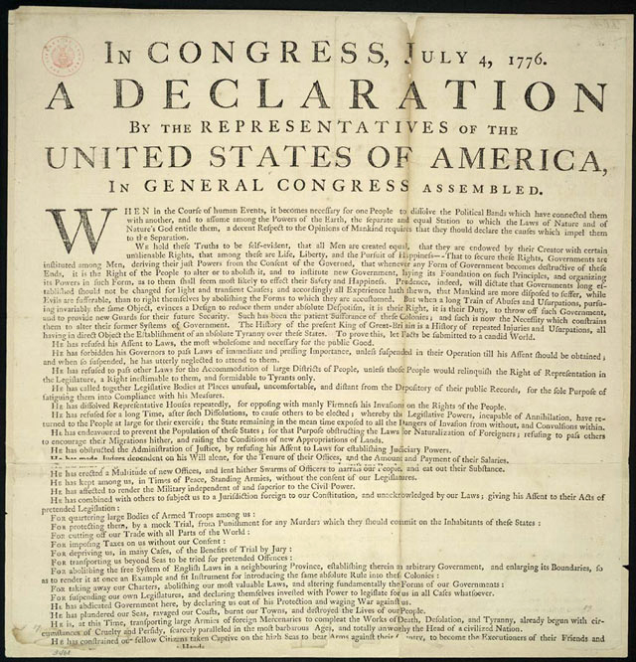

Comma or Period? That is the question.

“We hold these truths to be self-evident, that all men are created equal, that they are endowed by their Creator with certain unalienable Rights, that among these are Life, Liberty and the pursuit of Happiness.--That to secure these rights, Governments are instituted among Men, deriving their just powers from the consent of the governed, --That whenever any Form of Government becomes destructive of these ends, it is the Right of the People to alter or to abolish it, and to institute new Government, laying its foundation on such principles and organizing its powers in such form, as to them shall seem most likely to effect their Safety and Happiness.”

OR!

“We hold these truths to be self-evident, that all men are created equal, that they are endowed by their Creator with certain unalienable Rights, that among these are Life, Liberty and the pursuit of Happiness, --That to secure these rights, Governments are instituted among Men, deriving their just powers from the consent of the governed, --That whenever any Form of Government becomes destructive of these ends, it is the Right of the People to alter or to abolish it, and to institute new Government, laying its foundation on such principles and organizing its powers in such form, as to them shall seem most likely to effect their Safety and Happiness.”

Tweet your response:

How does the article change your point of view of the Declaration of Independence?

- Tweet a summary in 140 characters or less
- Ask a question about the article in 140 characters or less

If Only Thomas Jefferson Could Settle the Issue
A Period Is Questioned in the Declaration of Independence
By JENNIFER SCHUESSLERJULY 2, 2014
New York Times

Every Fourth of July, some Americans sit down to read the Declaration of Independence, reacquainting themselves with the nation’s founding charter exactly as it was signed by the Second Continental Congress in 1776.
Or almost exactly? A scholar is now saying that the official transcript of the document produced by the National Archives and Records Administration contains a significant error — smack in the middle of the sentence beginning “We hold these truths to be self-evident,” no less.
The error, according to Danielle Allen, a professor at the Institute for Advanced Study in Princeton, N.J., concerns a period that appears right after the phrase “life, liberty and the pursuit of happiness” in the transcript, but almost certainly not, she maintains, on the badly faded parchment original.
That errant spot of ink, she believes, makes a difference, contributing to what she calls a “routine but serious misunderstanding” of the document.
The period creates the impression that the list of self-evident truths ends with the right to “life, liberty and the pursuit of happiness,” she says. But as intended by Thomas Jefferson, she argues, what comes next is just as important: the essential role of governments — “instituted among men, deriving their just powers from the consent of the governed” — in securing those rights.
“The logic of the sentence moves from the value of individual rights to the importance of government as a tool for protecting those rights,” Ms. Allen said. “You lose that connection when the period gets added.”
Correcting the punctuation, if indeed it is wrong, is unlikely to quell the never-ending debates about the deeper meaning of the Declaration of Independence. But scholars who have reviewed Ms. Allen’s research say she has raised a serious question.
“Are the parts about the importance of government part of one cumulative argument, or — as Americans have tended to read the document — subordinate to ‘life, liberty and the pursuit of happiness’?” said Jack Rakove, a historian at Stanford and a member of the National Archives’ Founding Fathers Advisory Committee. “You could make the argument without the punctuation, but clarifying it would help.”
Ms. Allen first wondered about the period two years ago, while researching her book “Our Declaration: A Reading of the Declaration of Independence in Defense of Equality,” published last week by Liveright. The period does not appear on the other known versions produced with Congressional oversight in 1776, or for that matter in most major 20th-century scholarly books on the document. So what was it doing in the National Archives’ transcription?
Ms. Allen wrote to the archives in 2012 raising the question, and received a response saying its researchers would look into the matter, followed by silence.
But over the past several months, she has quietly enlisted a number of scholars and manuscript experts in what the historian Joseph J. Ellis, who supports her efforts to open the question, wryly called “the battle of the period.”
And now the archives, after a meeting last month with Ms. Allen, says it is weighing changes to its online presentation of the Declaration of Independence.
“We want to take advantage of this possible new discovery,” William A. Mayer, the archives’ executive for research services, said in an email.
A discussion of ways to safely re-examine the badly deteriorated parchment, he added, is now “a top priority.”
That parchment, created in late July 1776 and credited to the hand of Timothy Matlack, is visible to anyone. Last year, more than a million people lined up to see the document at the National Archives Museum in Washington, where it is kept in a bulletproof glass case filled with stabilizing argon gas that is lowered each evening into an underground vault.
But that document has faded almost to the point of illegibility, leaving scholars to look to other versions from 1776 to determine the “original” text.
And there, Ms. Allen argues, while those versions show subtle variations in punctuation and capitalization, the founders’ intent is clear: no period after “pursuit of happiness.”
The period does not appear in Jefferson’s so-called original rough draft (held in the Library of Congress), or in the broadside that Congress ordered from the Philadelphia printer John Dunlap on July 4. It also does not appear in the version that was copied into Congress’s official records, known as its “corrected journal,” in mid-July.
According to historical records, the Matlack parchment was signed on Aug. 2 after being compared with official texts — making it unlikely, Ms. Allen argues, that it would have contained a period after “pursuit of happiness.”
Defenders of the period are not without ammunition. The mark does appear in some official and unofficial early printings, including the broadside that Congress commissioned from the Baltimore printer Mary Katherine Goddard in January 1777, for distribution to the states.
Most fatefully, it also clearly appears on the 1823 copperplate created by the engraver William Stone to replicate the original parchment, which was already fading. The copperplate, which Stone took three years to create, has long been presumed to be a precise copy and has become the basis for most modern reproductions, including the one that has appeared every July 4 since 1922 in The New York Times.
Ms. Allen, who has analyzed variations in more than 70 versions of the Declaration of Independence created between 1776 and 1823, argues that the parchment was already “significantly illegible” by the time Stone began his work. When faced with an unreadable passage, she argues, he probably consulted other versions of the document, including some with the errant period. In short, she writes in a draft paper of her research posted on her website, Stone made “an honest mistake.”
Jack P. Greene, a historian of the American Revolution at Brown University, called Ms. Allen’s paper “a remarkably convincing piece of detective work.” But ultimately, the debate over the accuracy of the period all comes down to the faded ink on Matlack’s parchment.
And there, some manuscript experts say, existing high-resolution images show little evidence of a period. In a memo to the National Archives, James P. McClure, general editor of the Papers of Thomas Jefferson, said that the faint mark after “pursuit of happiness” resembles other marks on the parchment that are accepted as commas, rather than the obvious periods at the end of other sentences.
Heather Wolfe, curator of manuscripts at the Folger Shakespeare Library, agrees. With the other periods, “you can tell, the quill was held down and more ink came out,” she said. “That’s not happening after the word ‘happiness.’ ”
There may yet be clearer pictures to ponder. Mr. Mayer of the archives said it was testing the feasibility of doing new types of imaging, including hyperspectral imaging, through the document’s protective glass encasement. “We don’t yet know what’s possible,” he said.
Such imaging may prove inconclusive — or, of course, prove Ms. Allen wrong. But so be it, she said.
“We are having a national conversation about the value of government, and it does get connected to our founding documents,” she said. “We should get right what’s in them.”
Pursuit of Punctuation
An excerpt from the National Archives’ official transcript of the Declaration of Independence. A scholar is arguing that the period after “the pursuit of happiness” — shown in an 1823 engraving — does not appear on the 1776 parchment original.
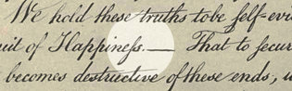
“We hold these truths to be self-evident, that all men are created equal, that they are endowed by their Creator with certain unalienable Rights, that among these are Life, Liberty and the pursuit of Happiness. — That to secure these rights, Governments are instituted among Men, deriving their just powers from the consent of the governed, — That whenever any Form of Government becomes destructive of these ends, it is the Right of the People to alter or to abolish it, and to institute new Government, laying its foundation on such principles and organizing its powers in such form, as to them shall seem most likely to effect their Safety and Happiness.”

From: http://www.nytimes.com/2014/07/03/us/politics/a-period-is-questioned-in-the-declaration-of-independence.html?module=Search&mabReward=relbias%3Ar

