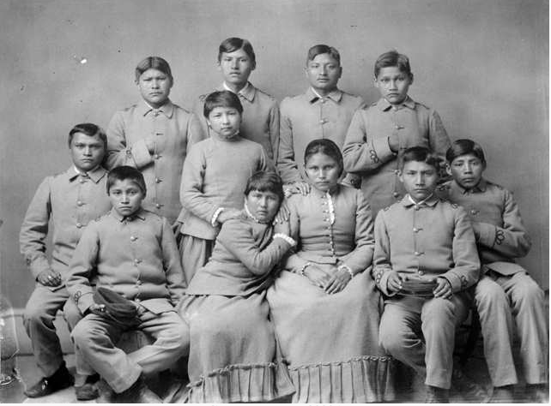

Choate, J.N. “Chiricahua Apaches Four Months after Arriving at Carlisle.” Photograph. 1886. From Library of Congress, History of the American West, 1860-1920: Photographs from the Collection of the Denver Public Library. http://memory.loc.gov/cgi-bin/query/r?ammem/hawp:@field(NUMBER+@band(codhawp+10032904))

