8.12.7 Immigration in California: The Chinese Experience

California – a Force in the National Economy

The story of California between 1850 and the first decade of the 20th century is one of increasing interdependence between state and nation. California gold was used to pay for the Civil War. The massive construction of the transcontinental railroad in the 1860s linked California with the Atlantic states. Raw materials and gold were shipped by rail from California to the East, and tens of thousands of U.S. citizens traveled westward to California.

Immigration in the US and California

Between 1850 and 1920 millions of immigrants came to the United States. By 1910, nearly 15 percent of the U.S. population was foreign-born. The growth of the population coincided with the rise of the cities and industry. In 1850 the U.S. was a largely rural nation, but by 1910 most Americans lived in cities.

- What are some major demographic changes in the US at the turn of the century?

Individuals from around the globe also came to California in droves. Following the discovery of gold in 1848, fortune seekers from China, Chile, Mexico, Australia, France, and many other nations journeyed to the goldfields.  Find from China, Chile, Mexico, and Australia on the map and draw a line to California. | 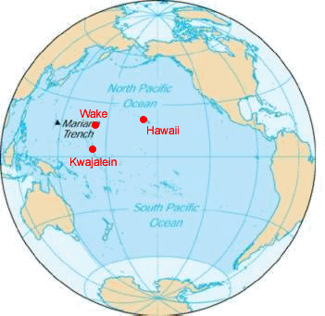

After the completion of the railroad in 1869, some 70,000 passengers arrived on the West Coast every year. In 1886, the second transcontinental railroad route, the Santa Fe Line, was completed.

Image:
http://c2cbeta.calhum.org/index.php/en/era/1850s-WWI/overview_3.html

Chinese Immigrants

Push factors
http://c2cbeta.calhum.org/index.php/en/era/1850s-WWI/chinese.html

Pull factors
http://content.cdlib.org/dynaxml/data/13030/f6/hb958006f6/files/hb958006f6-FID4.jpg

Effects
China towns
http://content.cdlib.org/ark:/13030/hb800005nr/?
Integration
http://content.cdlib.org/ark:/13030/hb538nb0cp/?
Chinese exclusion
http://c2cbeta.calhum.org/index.php/en/era/1850s-WWI/chinese_3.html

